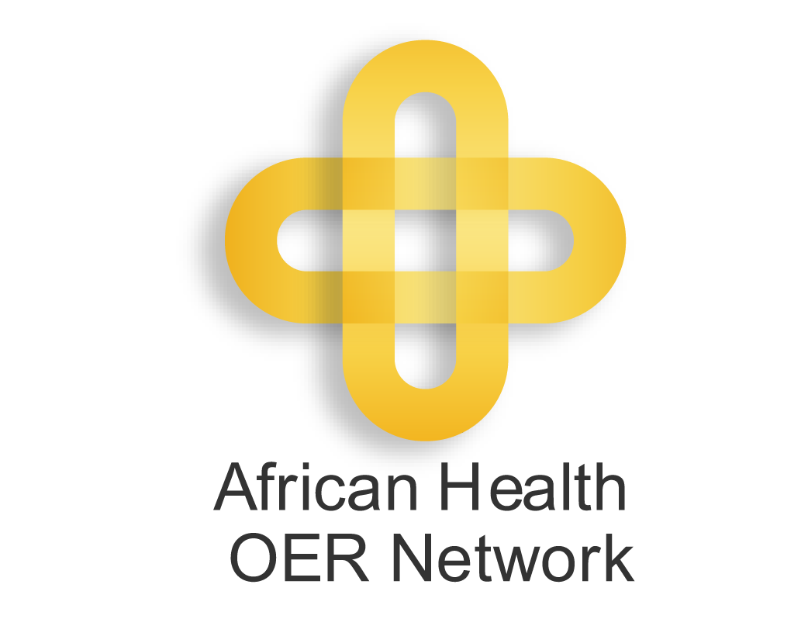 | 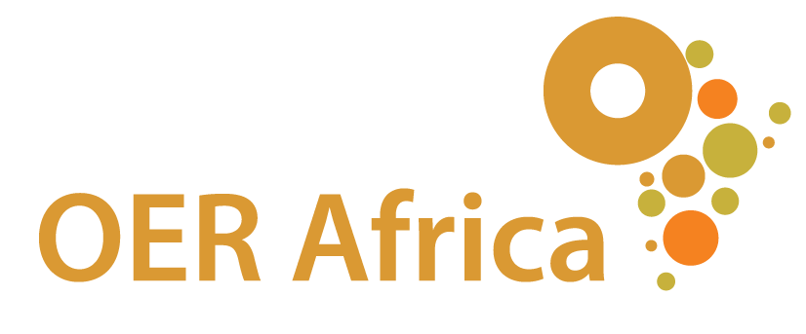 | 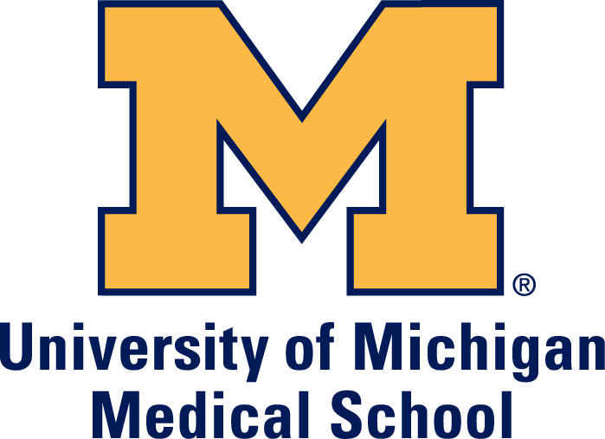

Introduction

Open Educational Resources (OER) are learning materials offered freely and openly for anyone to use and, under some licenses, to adapt, copy, and redistribute. The mission of the African Health OER Network (“the Network”) is to advance health education in Africa by using OER to share knowledge, address curriculum gaps, and support communities around health education.

OER Africa (OERA), an initiative of Saide (the South African Institute for Distance Education), and the University of Michigan (U-M) Medical School's Office of
Enabling Technologies co-facilitate the Network.

Value proposition for the network

Global visibility for the university and teaching and support staff
Completed OER will be published on the OERA and U-M websites and distributed to well-known global OER search facilities.

Integration into a community of educators
We have partnerships with universities across Africa, as well as globally, and can introduce members to other relevant continental and global health education networks.

Assistance in finding relevant OER
We are able to assist with conducting targeted searches – by searching open repositories and engaging directly with other institutions – to help institutions to find content that is related to their specified curriculum needs, as well as training teaching and support staff to undertake these activities themselves. Network members can also assist us by directing us to relevant, good quality OER that we can add to our growing database of resources.

Access to a variety of OER and OER repositories
The Network website has over 200 original OER produced by Africans, which can be accessed freely. We also maintain an extensive list of health OER repositories.

Improving quality of teaching and learning materials
As Network members and their students, and other educators and learners worldwide make use of the OER that are available, they have the potential to improve its quality by providing feedback that can enhance this material. Using materials created by others will also enable them to develop an eye for aspects that make for good design of OER, which they can then use to enhance their own learning materials.

Services

Depending on needed expertise or geography, the following services could be provided by staff of OERA, U-M, or other Network participants. These services may be provided as a complete package or customized according to interest and budgetary constraints.

Inquiries regarding Network services and budget should be directed to healthoer@oerafrica.org

Training and workshops

OER and copyright awareness workshops
OER awareness workshops introduce teaching and support staff to the underlying value proposition and principles of OER, as well as to the notion of open licenses such as Creative Commons. These workshops explore the conditions of various open licensing arrangements and considerations of how institutional and governmental policy environments affect use of OER and open licensing. Longer workshops will address the economic benefits of OER, both in terms of marketing institutions, programmes, and individuals and in cost-effectiveness of materials production, and arguments in support of and against use of OER.

Typical Duration: 0.5 – 2 Days
Intended Audience: Administrators, teaching staff, librarians, instructional designers, graphic designers and artists, technology support staff

Policy review workshops
Policy review workshops introduce participants to the policy environment needed for effective use of OER, addressing relevant policies at the faculty, institutional, national, or association level. Policy review is integral to advocacy for OER, by allowing institutions to appreciate which of their policies, (e.g., remuneration, promotion, intellectual property, quality assurance, etc.), serve to hinder or support the use of OER. Ideally, we will conduct a review of existing policies prior to the workshop, so that the workshop can focus concretely on the current policy environment within which participants operate.

Typical Duration: 1 - 2 Days
Intended Audience: Administrators, teaching staff, librarians, technology support staff

OER production workshops
OER production workshops focus on teaching and learning materials development, helping teaching staff to acquire new pedagogical and information literacy skills in order to use, create, adapt, and share educational content under open licenses. The workshops also address how to review existing content in order to ensure that all necessary copyrights and privacy rights are cleared before content is released under an open license.

Typical Duration: 1 – 5 Days
Intended Audience: Teaching staff, librarians, instructional designers, graphic designers and artists, technology support staff

Mentoring and consulting

Policy reviews and development
We are able to conduct a comprehensive review of current policies to support institutions in determining the existence of or possibilities for copyright assignment, academic recognition for open publishing, curriculum design, content standards and quality assurance, technology infrastructure, and financial sustainability. Where required, this can lead to support in adapting policies or designing new ones so that the operational environment supports more effective use and sharing of OER.

Content identification services
Using our extensive global networks and reference skills, we are able to support our partners to locate relevant open content that they may wish to consider integrating into their teaching. This activity can help to significantly reduce the time required to develop new programs or courses or to update existing ones. We will conduct targeted searches across several OER search engines and repositories. As part of this service, we will also post requests to the health OER request facility, which was developed by OERA to provide a public, online space for academics to solicit health-related OER. Through the online facility, anyone worldwide may create or respond to a request.

Content audits for openness
We will conduct an initial audit of existing teaching and learning material within an institution or department to provide an estimate of effort necessary to make the material(s) available as OER. The audit will focus on copyright, privacy, product endorsement, technical (e.g. software) constraints, and other relevant criteria. Based on the audit, we will estimate the resources and skills necessary to clear and edit the content, including replacing copyright-restricted images with openly licensed ones. If desired, we are also available to complete the clearing and editing stages.

Instructional design and materials development
We have a thorough understanding of pedagogy, higher education across Africa, and open, distance, electronic and blended learning models and their respective merits. Our staff is able to provide support in adapting and integrating OER coherently into contextualized program and course curricula. This service provides a pedagogical analysis of what is necessary in order to use, create, adapt, and share OER with specific audiences of learners. Service components may include needs assessment, curricular design, design of formative and summative assessments, and capacity building in development of materials across all media.

Monitoring and evaluation
We are able to support the design and implementation of formative evaluation processes, as well as longer-term summative evaluation and/or impact assessment activities that determine the extent to which use of open licensing has led to improvements in quality of teaching and learning, greater productivity, enhanced cost-effectiveness, etc.

Online platform and technical support services

Software platforms for hosting OER
U-M has designed and deployed OERbit (http://open.umich.edu/oerbit), an open source publishing platform for OER. OERbit provides a basic set of functionality for OER publishers, including course and resource-based navigation, flexible content hierarchies, Creative Commons license integration, and RSS feeds to indicate recently updated content, as well as RDFa output to describe the published resources. OERA and U-M are available to support with the OERbit installation, training, system upgrades, and maintenance of system.

Software platforms for content analysis
To help manage the process of gathering and reviewing course material U-M has developed an open source system called OERca (https://open.umich.edu/wiki/OERca). OERca is a web-based application that can be used by individuals involved in clearing materials of copyright, trademark, privacy, and other policy concerns before publishing the materials under open licenses. OERA and U-M are able to provide institutions with installation support for OERca as well as on-going support and maintenance. As part of this service, we can also facilitate “train the trainers” workshops, which may last 0.5 – 5 days depending on scope, for developing local expertise in using and supporting OERca.

Discussion lists and periodic community calls
We facilitate three discussion lists to connect individuals with others who play similar roles at other organizations and institutions: one for technical support staff, a second for copyright and student engagement for OER, and a third for general health OER. In addition, we coordinate periodic (e.g. bimonthly) community conference calls for the technical support and copyright support groups.

Distribution of OER
Completed OER will be made available on the primary Network website (http://www.oerafrica.org/healthoer) located in South Africa, and the secondary website (http://open.umich.edu/education/med/oernetwork/), located in the U.S. OERA and U-M will include the hosted content in their relevant distribution networks, such as OER Commons (http://www.oercommons.org), GLOBE (http://www.globe-info.org/), and YouTube (http://www.youtube.com). If desired, we will also provide assistance in submitting content to peer-reviewed OER repositories such as MedEdPORTAL (http://www.mededportal.org/) and MERLOT (http://www.merlot.org/).

