Module 4
Food behaviour and nutrition
Module code: PHFS04N

DRAFT DOCUMENT
Project leader: | A Barlow-Zambodla
Programme coordinator &  Curriculum coordinator | FM Ferreira
First authors: | Food and Nutrition team
Critical reader: | Nutritionist
Educational consultants: | C Randell  E Whitlock
Language editor: | Not done yet
Layout artist: | Not done yet
University of South Africa 2010

This draft study guide, PHFS04N for Food Behaviour and Nutrition, was reworked to incorporate some lessons learned from the pilot of the Programme for Household Food Security in agreement between the South African Institute Distance Education and the University of South Africa.

This work is licensed under the Creative Commons Attribution – Share Alike License.

This means you are free:
to Share — to copy, distribute and transmit the work
to Remix — to adapt the work

Under the following conditions:
Attribution — You must attribute the work in the manner specified by the author or licensor (but not in any way that suggests that they endorse you or your use of the work).
Share Alike — If you alter, transform, or build upon this work, you may distribute the resulting work only under the same or similar license to this one.

Acknowledgement

This project for training household food security facilitators was initiated by the South African Institute for Distance Education (Saide) using funding from the WK Kellogg Foundation. The funding was used to help facilitate the design, development and implementation of a programme aimed at further upgrading the skills of rural and peri-urban community development workers and volunteers. Saide partnered with the College of Agriculture and Environmental Sciences of the University of South Africa to develop a 6 module short learning programme worth 72 credits.

This Study Guide for the Module PHFS04N Food Behaviour and Nutrition is the fourth of the six modules initially piloted with groups of volunteers linked to non-governmental organizations (NGOs) and community development workers (CDWs) working for the department of local government in the Eastern Cape.

The Eastern Cape NGO Coalition (ECNGOC) is an umbrella non-profit organization for over 400 non-governmental, community and faith-based organizations (NGOs, CBOs and FBOs) in the Eastern Cape region. The ECNGOC supported the intervention through advocacy and assistance to link organizations with the project thus enabling the recruitment of practicing volunteers and community development workers who needed training in facilitating Household Food Security. During 2009 organizations such as Student Partnership Worldwide (SPW), Transkei Land Services Organization (TRALSO) as well the Directorate for Social Responsibility in the Anglican Diocese of Grahamstown had students on the pilot programme. Other organizations as well as the Provincial Department of Local Government in the Eastern Cape and the Mbashe Local Municipality came on board during 2010.

The project was managed by a Project leader from Saide, Dr Alice Barlow-Zambodla, and had a designated Programme Coordinator, Mrs Fransa M Ferreira from the CAES, Unisa. Six writing teams participated in the initial curriculum design and development process together with other stakeholders. Their names are listed on the front page of each Study Guide.

The Programme in Household Food Security is an approved UNISA Short Learning Programme that serves to promote community engagement by linking curriculum and tuition, research, and community service in the delivery of higher education. This is in line with the UNISA vision: The African University in service of humanity.

Main references used
We acknowledge the use of the following publications in the development of this study guide.
Savage-King, F. and Burgess, A. 1995. Nutrition in Developing Countries. 2nd Edition. Oxford University Press: London.

Other sources
Callens, K. Seiffert, B. and Sontheimer, S 1999. "Conducting a PRA Training and Modifying PRA Tools to Your Needs. An Example from a Participatory Household Food Security and Nutrition Project in Ethiopia."

Carter, I. 2001 Building the capacity of local groups: A PILLARS Guide. Tearfund, Teddington, UK

Food and Agriculture Organisation. 2004. Rural households and resources: A guide for extension workers. Socio-economic and gender analysis programme. Rome, FAO.

Food and Agriculture Organisation. 2005. Protecting and promoting good nutrition in crisis and recovery: Resource guide. Rome, FAO.

Food and Agriculture Organisation. 2007. Guidelines for Measuring Household and Individual Dietary Diversity. Rome, FAO.

Food and Agriculture Organisation. 2008. Practical Guides: An Introduction to the Basic Concepts of Food Security, FAO. http://www.foodsec.org/docs/concepts_guide.pdf

Food and Agriculture Organisation. 2011. Guidelines for measuring household and individual dietary diversity. Rome, FAO.

Table of Contents

Introduction to the module.…………………………………………………………….viii
Purpose of the module......................................................................................................ix
How Module 4 fits into the programme.............................................................................ix
Programme map…….........................................................................................................x
Module 4 map …………………………………………………………………………………..xi
Module 4 learning outcomes ...........................................................................................xi
What is in the units?........................................................................................................xii
The learning and teaching approaches in this programme ............................................xiv
What is in your study pack?.............................................................................................xv
Finding your way in the study guide.…...........................................................................xvi
How to work with the learning materials and assessment tasks……………..................xvii

UNIT 1: Challenges for food and nutrition security
Introduction………………………………………………………………………….............. 1
Learning outcomes.....................................................................................................…. 2
Key words....................................................................................................................... 3
- Protecting household food security, nutrition and livelihoods ......................... 4
  - The right to food………………………………………………………………………..5
  - The big picture of household food security, nutrition and livelihoods…………….7

- Threats to food security and nutritional health of households .........................19
  - Threats to food security impact negatively on dietary intake ...........................20
  - Threats to adequate maternal and child care feeding practices ......................23
  - Threats to adequate health services………………………............................... 26
  - Interaction between inadequate dietary intake and infection........................... 26

- The food nutrients needed for adequate food intake………………………...…...27
  - Carbohydrates and their importance………………………………………….......30
  - Proteins and their importance…………………………………………………..... 32
  - Fats and their importance…………………………………………….…………….32
  - Vitamins and their importance…………………………………………................ 34
  - Minerals and their importance…………………………………………………….. 35
  - Water and its importance……………………………………………….................35

- Nutritional health versus being malnourished…………………………………… 37
  - Over-nutrition.................................................................................................. 37
  - Under-nutrition................................................................................................ 40
  - Micronutrient deficiencies.............................................................................. 45

- Healthy environment, food safety and hygiene………………………………….. 51
  - The importance of a healthy environment.......................................................51
  - Food and water safety for healthy households...............................................54
  - Food safety practices and personal hygiene……………..……………………..61
  - Water safety and health……………………………………………..…………….65
  - Clean environment: disposal of food and human waste products…………….69
Concluding comments................................................................................................70
UNIT 2: Nutrition of the vulnerable during the lifecycle
Introduction……………................................................................................................ 71
Learning outcomes………………………....................................................................... 72
Key words……………………………………………………………....................................73
- Nutrition across the life cyle................................................................................ 74

- What is good nutrition during pregnancy?......................................................... 78
  - What extra nutrients does a pregnant mother need?...................................... 78

- What is good child nutrition?................................................................................81
  - Infant Nutrition…………………………………..…………………………..............81
  - Growth Monitoring of children……………………………………………..............85
  - Immunization ………………………………………………………………………...94
  - Caring for the sick child…………………………………………………………......95

- Nutrition of school age children……………………………………………………..102
  - Who does the NSNP target and who pays for it?............................................102
  - Factors contributing to hunger in school children……....................................104
  - How the National School Nutrition Programme works....................................105
  - School food gardens……………………………………………………………....109
  - Strengthening school-based household food security interventions………….111

- What is good nutrition for the elderly……………………………………………...113
  - What and how should the elderly eat?............................................................113
  - Elderly women and indigenous knowledge……………………………..……….114
  - Social support systems for elderly people……………………………………….117

- What is good nutrition for people living with HIV/AIDS?..................................117
  - The HIV/AIDS and the nutrition cycle…………………………………………....118
  - Breaking the cycle: a varied mixed meal………………………………………...119
  - HIV/AIDS and food and water hygiene……………………………………….….119
  - Baby feeding and HIV: the dilemma……………………………………………..120
  - The role of home-based care givers………....................................................121
Concluding comments…….......................................................................................123
UNIT 3: Food behaviour change for diet diversity
Introduction……………...............................................................................................125
Learning outcomes……………….................................................................................126
Key concepts……………………………………………………………………...................127
- Why do we eat the food we eat?..........................................................................129
  - Natural and physical environmental influences…….........................................134
  - Socio-cultural influences..……………………………………………………...…..140
  - Individual preferences………………………………………………………….….. 143
  - How people develop and change food behaviours………………………………144

- Eating a variety of food – Food based dietary guidelines.................................145
  - Why divide food into food groups? ……………………………………………….146
  - The Food-based Dietary Guidelines for a healthy diet …………………………149

- What is dietary diversity………………………………………………..…................152
  - The food groups used for assessing and planning diet diversity ……………..153
  - Dietary diversity in the diet ……………………………………………..…………178
  - The dietary diversity score…………………………………………………………179

- Planning meals using a variety of foods……………………………..…………….185
  - Number of meals..............................................................................................185
  - Meal Composition…………………………………………………………………...185
  - Food Combinations…………………………………………………………............187
  - Food preparation and food practices………………………………………………190
Concluding comments...............................................................................................197
TAKE ACTION
- How to approach portfolio activities .......................................................................198
- The Portfolio activities for Module 4…………………………………………………….200
Portfolio activity 4.1 Assess household risk to malnutrition and food insecurity……...203
Portfolio activity 4.2 Analyze the causes and effects of malnutrition. ………...............212
Portfolio activity 4.3 Assess diet diversity and food variety .........................................221
Portfolio activity 4.4 The seasonal calendar and household food security…................231
Portfolio activity 4.5 Household food security improvement action plan.......................239

Glossary ………………………...........................................................................................246

Introduction to the module

Congratulations on choosing to take a leadership role by engaging in community development, as only a few feel called to facilitate the improvement of lives in their community. Credo Mutwa, an internationally acclaimed cultural historian, spiritual leader and author, uses the following Zulu instruction to learner healers. It has particular relevance for community development facilitators.
“Learn from the hornbill, the bird of unconquerable hope – no matter how bad the drought, no matter how desperate the famine, the hornbill always holds its head high, its beak pointed toward a better tomorrow. Never be like a crow whose ugly beak points earthwards in pessimism – be ever like a hornbill my child. ”
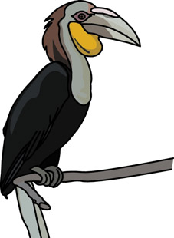

This inspiring thought encourages you to remain optimistic when carrying out your important work with households in rural and urban communities across the country.

We commend you on your decision to improve your knowledge, skills and attitudes in the important field of Household Food Security. As you work through this module you will gain a much better understanding of the concepts that are relevant to the field of food security. The key words and concepts in each unit are used throughout the programme. The module has been designed to assist you to help support people in your community to find their own solutions and gain access to the range of services provided by government. As a household food security facilitator you are in a unique position: you can communicate to households how government services work and give feedback to government structures on your community’s needs and resources.

The central theme in this fourth module is about working together with households to assess their own knowledge and learn about basic nutrition principles and food based guidelines. You will help them assess their own dietary habits and practices, both cultural and behavioural, in order to determine how they can improve their food and nutritional security. Before you can take action you have to know what challenges households face in relation to food and nutrition security and what their nutritional needs are during different phases of their lifecycle. You also need to learn about the various care practices required to ensure that household caregivers are able to provide nutritious meals. The most important aspect of your role as facilitator is to assist the households to learn about and gather accurate information about their food security and nutrition situation, help them to analyze the information, and support them in their efforts to take action to achieve sustainable food and nutrition security.

Purpose of the module
In Module 4 you are revising important concepts from Module 1 such as food security, food insecurity, nutrition security and livelihood security. Added to these are: nutrition for the vulnerable, food behaviour, food choices, dietary patterns and diet diversity. Together with the households you will gain knowledge about these issues within the context of the environment in which the households live.

The most important set of skills you will learn is how to work with households as a facilitator. You will walk alongside them on this journey, listening and learning from them. At the same time you will share with them what you know and facilitate a variety of activities that encourage households to participate in finding their own solutions. Before households can take action to improve their food behaviours and practices, they need to gather information about their nutrition related problems, vulnerability, risks and malnutrition. By using a variety of tools and techniques you will enable the households to analyze the causes of these problems on different levels, from the micro to the macro level.

Another important skill you will acquire is how to report on household food security issues relating to hunger, lack of sufficient food, malnutrition, and food vulnerability. Such reporting brings household malnutrition and food security issues to the attention of relevant authorities for appropriate action.

An important part of your role is to liaise with relevant community development people who work in health, food security, agriculture and local government projects and programmes. . Your contact with relevant stakeholders involved in food security enables you and them to identify how you can work together to provide ongoing support to the households in their quest for nutrition and food security.

How Module 4 fits into the programme
Each module is an important part of the Household Food Security Programme. The modules for the programme are:
Module 1 PHFS01K: Introduction to household food security
Module 2 PHFS02L: Introduction to methods of working with households
Module 3 PHFS03M: Sustainable natural resources use
Module 4 PHFS04N: Food behaviour and nutrition
Module 5 PHFS05P: Optimising household food production
Module 6 PHFS06Q: Food resources management
The modules are linked and what you learn in one module will also help you in another.

Programme map
The diagram below is a programme map that provides you with an overall picture of the programme. It shows you the main purpose of the programme and the focus of each of the six modules.

The first two modules are part of your orientation to the field of food security and the methods you will use when working with households. Modules 3 – 6 require you to work with the households in each of four key areas of household food security.

Programme in household food security
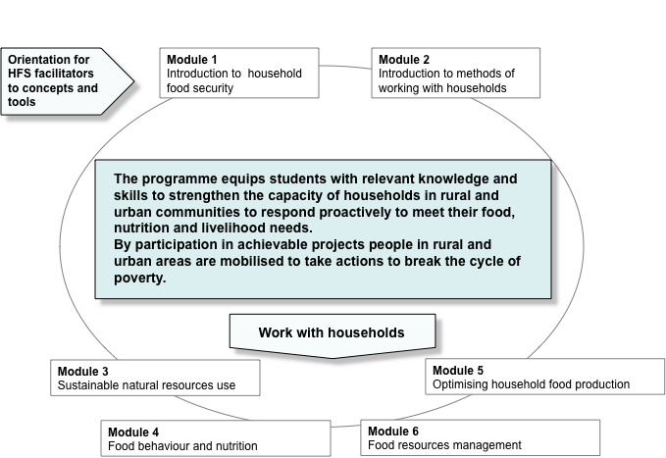

Module 4 map
The module map below gives you an overall picture of Module 4.
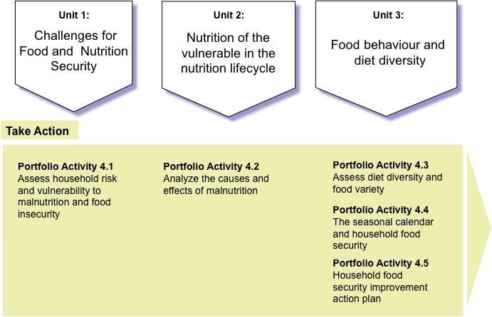

Module 4 learning outcomes
The table below shows the topics of the three units in Module 4 and gives you a good idea of what you are expected to know and do. The assessment in this module is closely linked to the outcomes. It includes two assignments, workbook activities and portfolio activities. You will find detailed information about the assessment activities in the General Tutorial Letter.

Unit |  | Learning Outcomes | Assessment
1. | Challenges for food and nutrition security | Determine household nutrition knowledge, food habits, cultural and behavioural practices. | Assignment 1  (10%)
2. | Nutrition of the vulnerable during the lifecycle | Together with the household, assess household food choices and behaviours, nutritional practices, health and sanitation practices, and environment and personal hygiene influences.  Encourage the use of local health and social services provided within a team approach. | Assignment 2  (20%)
3. | Food behaviour change for diet diversity | Apply food-based dietary guidelines based on basic nutrition principles to assist households to improve diet quality and prevent nutrition deficiency.  Optimize the use of available food for meal planning, preparation and consumption.  consumptionthe application of food safety principles.
 |  |  | Portfolio activities (60%)
Workbook
(10%)
Selected activities from all units

What is in the units?
All three units are linked and provide a good introduction to the field of food and nutrition security. The emphasis is on helping you understand nutrition security concepts and see them within an overall food security framework. When you have completed Module 4 you should be able to link the vulnerability of households to food security on a micro and macro level and identify relevant stakeholders that are able to provide services and support to households.

Unit 1 – Challenges for food and nutrition security
Unit 1 starts with a short reflection on the human right to food for everyone and we explore the threats to this basic human right for food security and nutritional health. You are introduced to the concepts of vulnerability, risks and shocks in the context of food security and examine them in terms of food access, food availability, food utilization and food stability. These dimensions are an important part of the food security model, which shows the threats that challenge household food and nutrition security on different levels. An analysis and understanding of threats to vulnerable households enables you to work collaboratively with households and relevant stakeholders in the community to search for solutions that are appropriate for the particular context in which households live.

Unit 2 – Nutrition of the vulnerable during the lifecycle
Unit 2 examines how food security is linked to the nutrition of people at different stages of the lifecycle. You become aware of the specific nutrition needs of vulnerable members of the household, namely pregnant women, infants and young children, school children, the elderly and people living with HIV/AIDS. Concepts such as malnutrition, hunger, vulnerability and poverty are explained in terms of how it affects these vulnerable groups. The main idea in the unit is that the body’s needs at different life stages demands specific nutrients for normal growth and development and body functioning. Everyone needs a varied nutritious diet of protein, carbohydrates, fats, vitamins and minerals. But in each life stage we need to consider specific dietary and food needs.

Unit 3 – Food behavior and diet diversity
Unit 3 looks at food choices, the diet and the changing dietary patterns that constitute the food behavior of people. We examine the different factors that influence food behaviours and practices. You are introduced to the South African Food Based Dietary Guidelines, which promote ‘eating a variety of food’ for healthy living. These guidelines should inform all aspects of the household’s food behaviour and practices, namely, buying food, growing food, storing food, planning and preparing nutritious, well-balanced meals. An assessment of the household’s current diet is done using the Household Dietary Diversity Score tool. This reveals how diverse a household’s diet is. The insight gained from this activity helps to motivate the households to get involved in improving the diversity of foods they consume. Two important suggestions for improving access to diverse foods are: rediscovering African or traditional foods and keeping a household garden. The households use the information they have learned to develop a nutrition improvement action plan that guides their choice of foods and informs their meal planning and food consumption practices.

Portfolio activities
The section at the back of Module 4 called Take Action gives you detailed information about the portfolio activities for this module. Start your Module 4 learning journey by identifying the portfolio activities as this helps you to plan them as linked and not separate activities.

The learning and teaching approaches in this programme
There are three main learning approaches and methods used in this programme these are: the “Triple A” Approach, individual and group learning from learning resources and facilitated group learning.

The “Triple A” Approach
What we do flows from the plans we make. These plans are based on information we have at the time and how we understand that information. As we start implementing our plans we learn more and can improve our plans and actions. In all the modules in this programme we use a reflective approach known as the “Triple A” Approach, which is illustrated below.
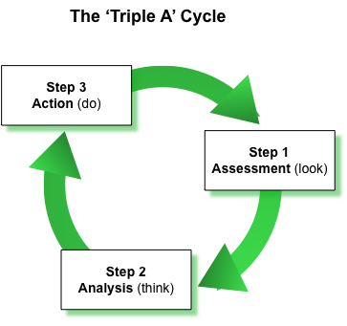

Figure 1.2 The “Triple A” Approach
(Adapted from FAO, 2005)

The “Triple A” is a well-known community development method in which ongoing planning and re-planning happens. We gather information (assess), think about it and use it to come up with plans (analyze). We then implement those plans (act), and we continue gathering new information. The “Triple A” Approach engages you in an ongoing cyclical process of assessing, analyzing and acting based on the new information, which you have learned.
How is the “Triple A” Approach implemented in this module?
- Unit 1 provides information about the threats to the basic human right of each household to nutritional health and food security and the HFS facilitator’s role to assist households to identify these threats. (assess)
- Unit 2 provides insights on participatory learning methods and tools the HFS facilitator can use to enable the households to reflect on and understand their food behaviour and practices. (analyze)
- Unit 3 focuses on the practical steps households can take to improve the diversity of foods in their diet that provide the members of the household with the nutrients they need for health and wellbeing. (act)
In the portfolio activities that are linked to the three units you apply relevant knowledge and skills that enable you to work with households to improve their nutrition and food security.

Learning from learning resources
For most students learning from resources such as study guides may be a new experience. The study guides have been designed specifically to guide you in your learning journey. You can call your study guides your ‘portable teachers’ as you can take them with you wherever you go and learn from them when it suits you. Get used to engaging with the study guides daily. If you experience difficulties understanding something then, ask questions at the next group session. Form a study group with interested other students in the programme that live close to you. Research has shown that small study groups can be particularly helpful in the learning process and the support of others can keep you motivated to achieve success.

Learning in facilitated group sessions
Trained facilitators have been appointed to run regular structured group sessions. The main purpose of the group sessions is to give you an opportunity to explore food security issues in some depth, to clarify issues that you are unsure of, to reflect on your actions with the households and the contextual challenges, and to give you opportunities to practice practical skills. Come to the group sessions well prepared. Ask questions, raise issues, and contribute to the discussions.

What is in your study pack?
Check your study pack for this module. It should contain the following:

This study guide
A module workbook
Portfolio evidence sheets
Tutorial letter 101 (TUT 101) with information about your assignments and when you should submit them
Tutorial letter 301 (TUT 301) with general information and details about portfolios

During the year you will receive additional tutorial letters that give you general feedback on the assignments submitted.

Finding your way in the study guide
We make use of symbols or icons to show what you are expected to do. Here is a list of icons you will find in each module.

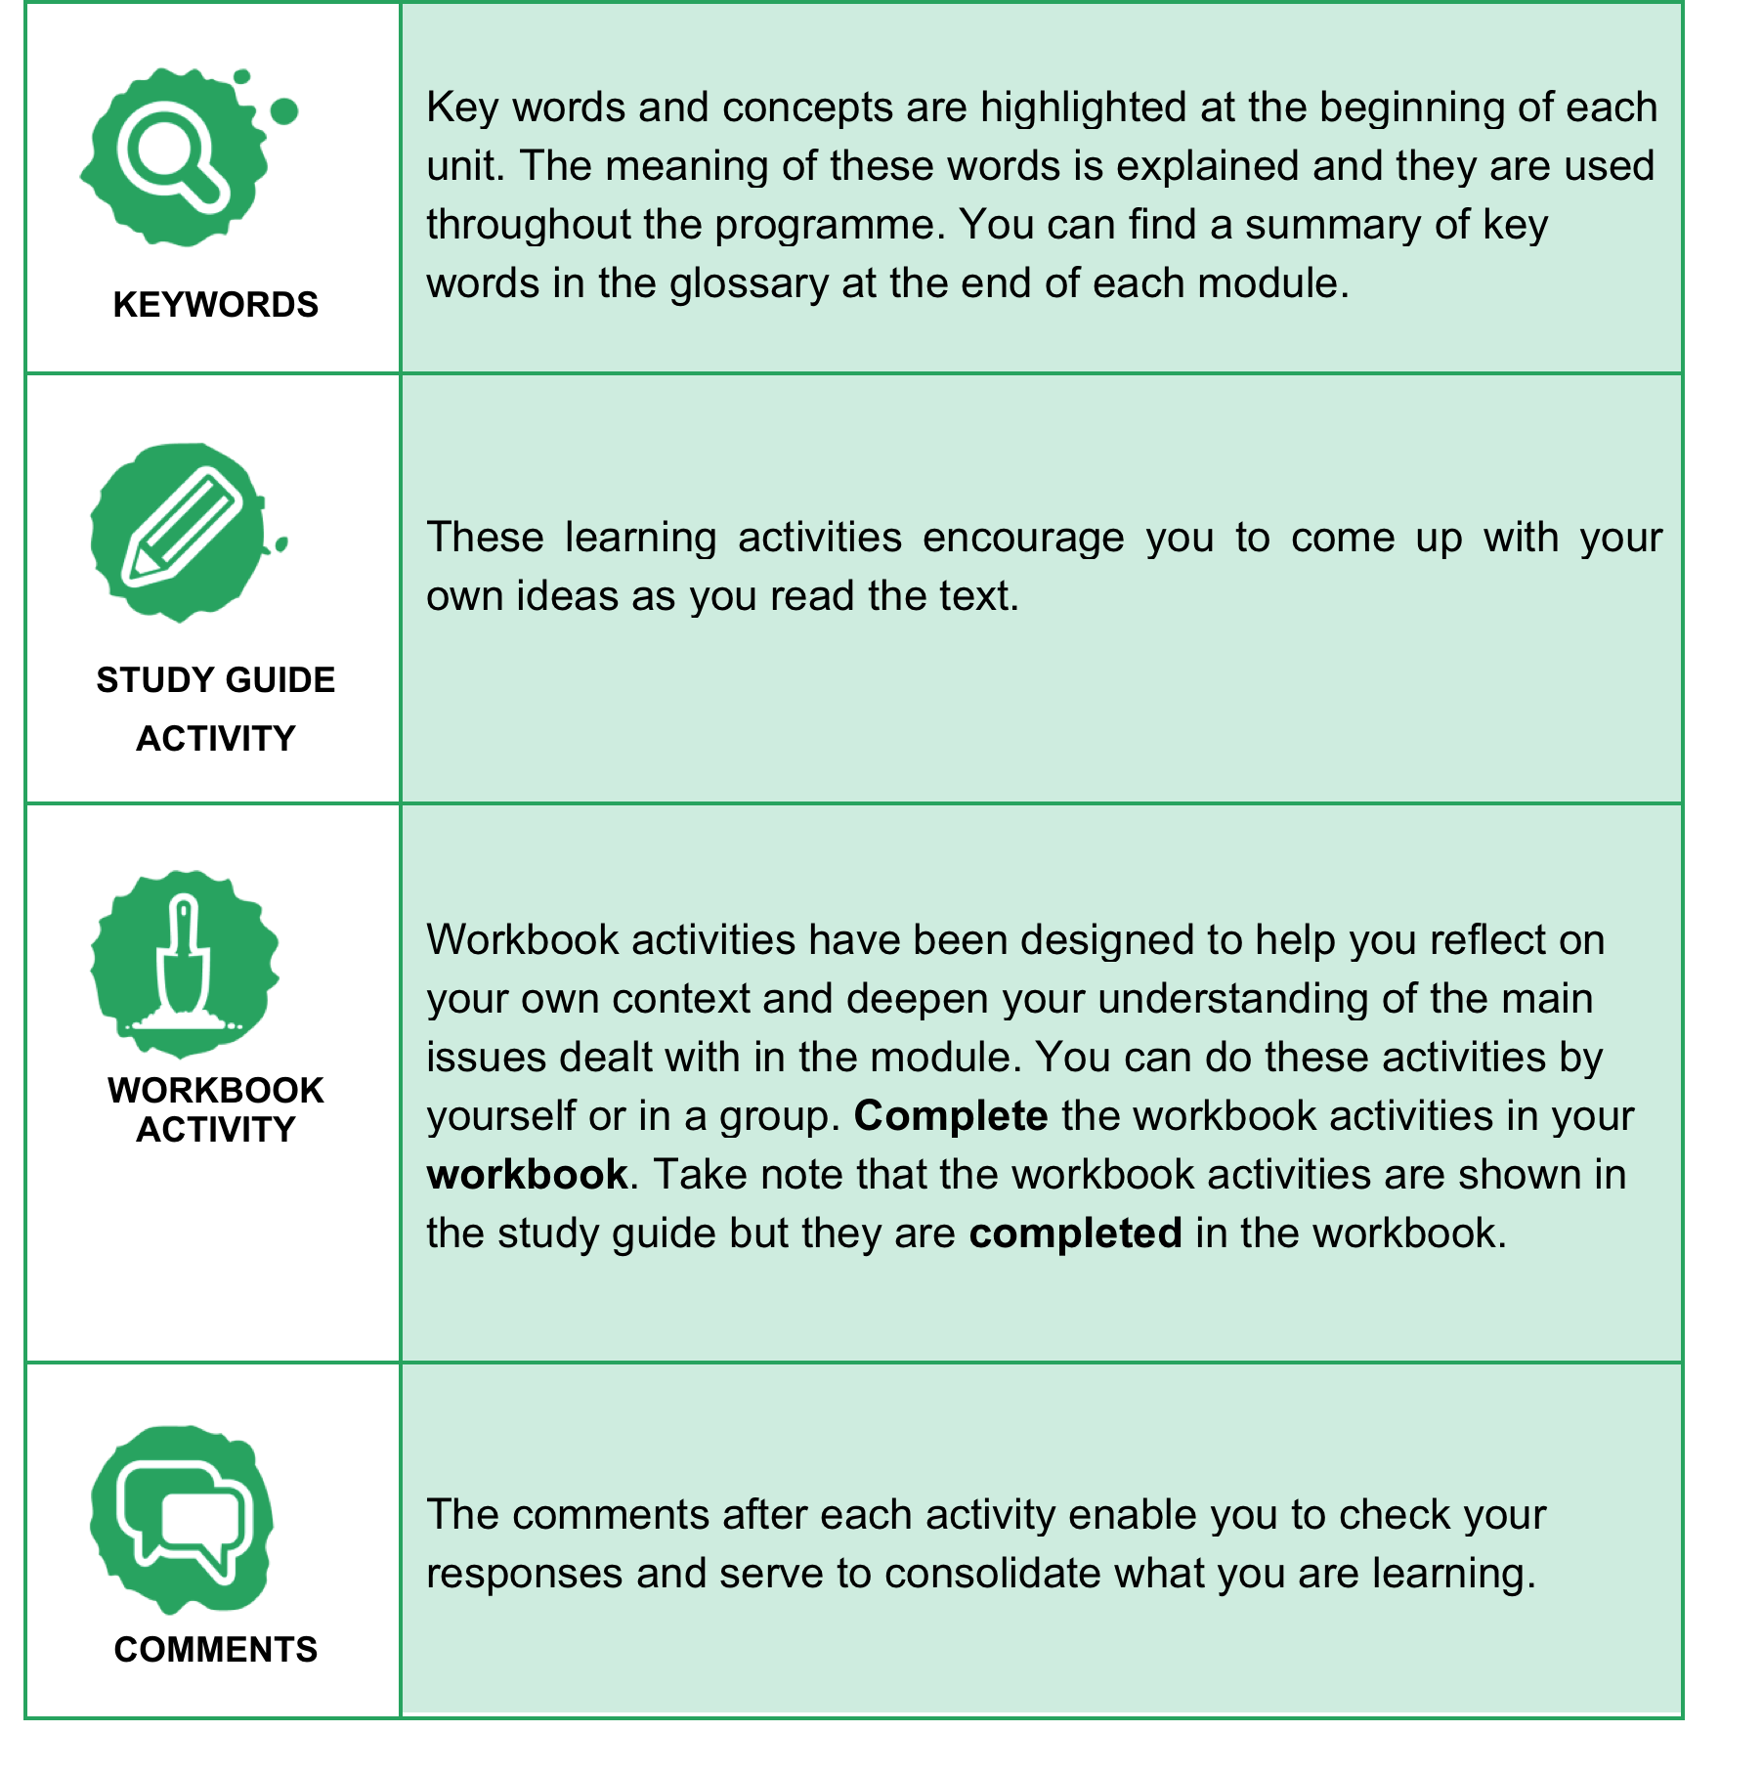

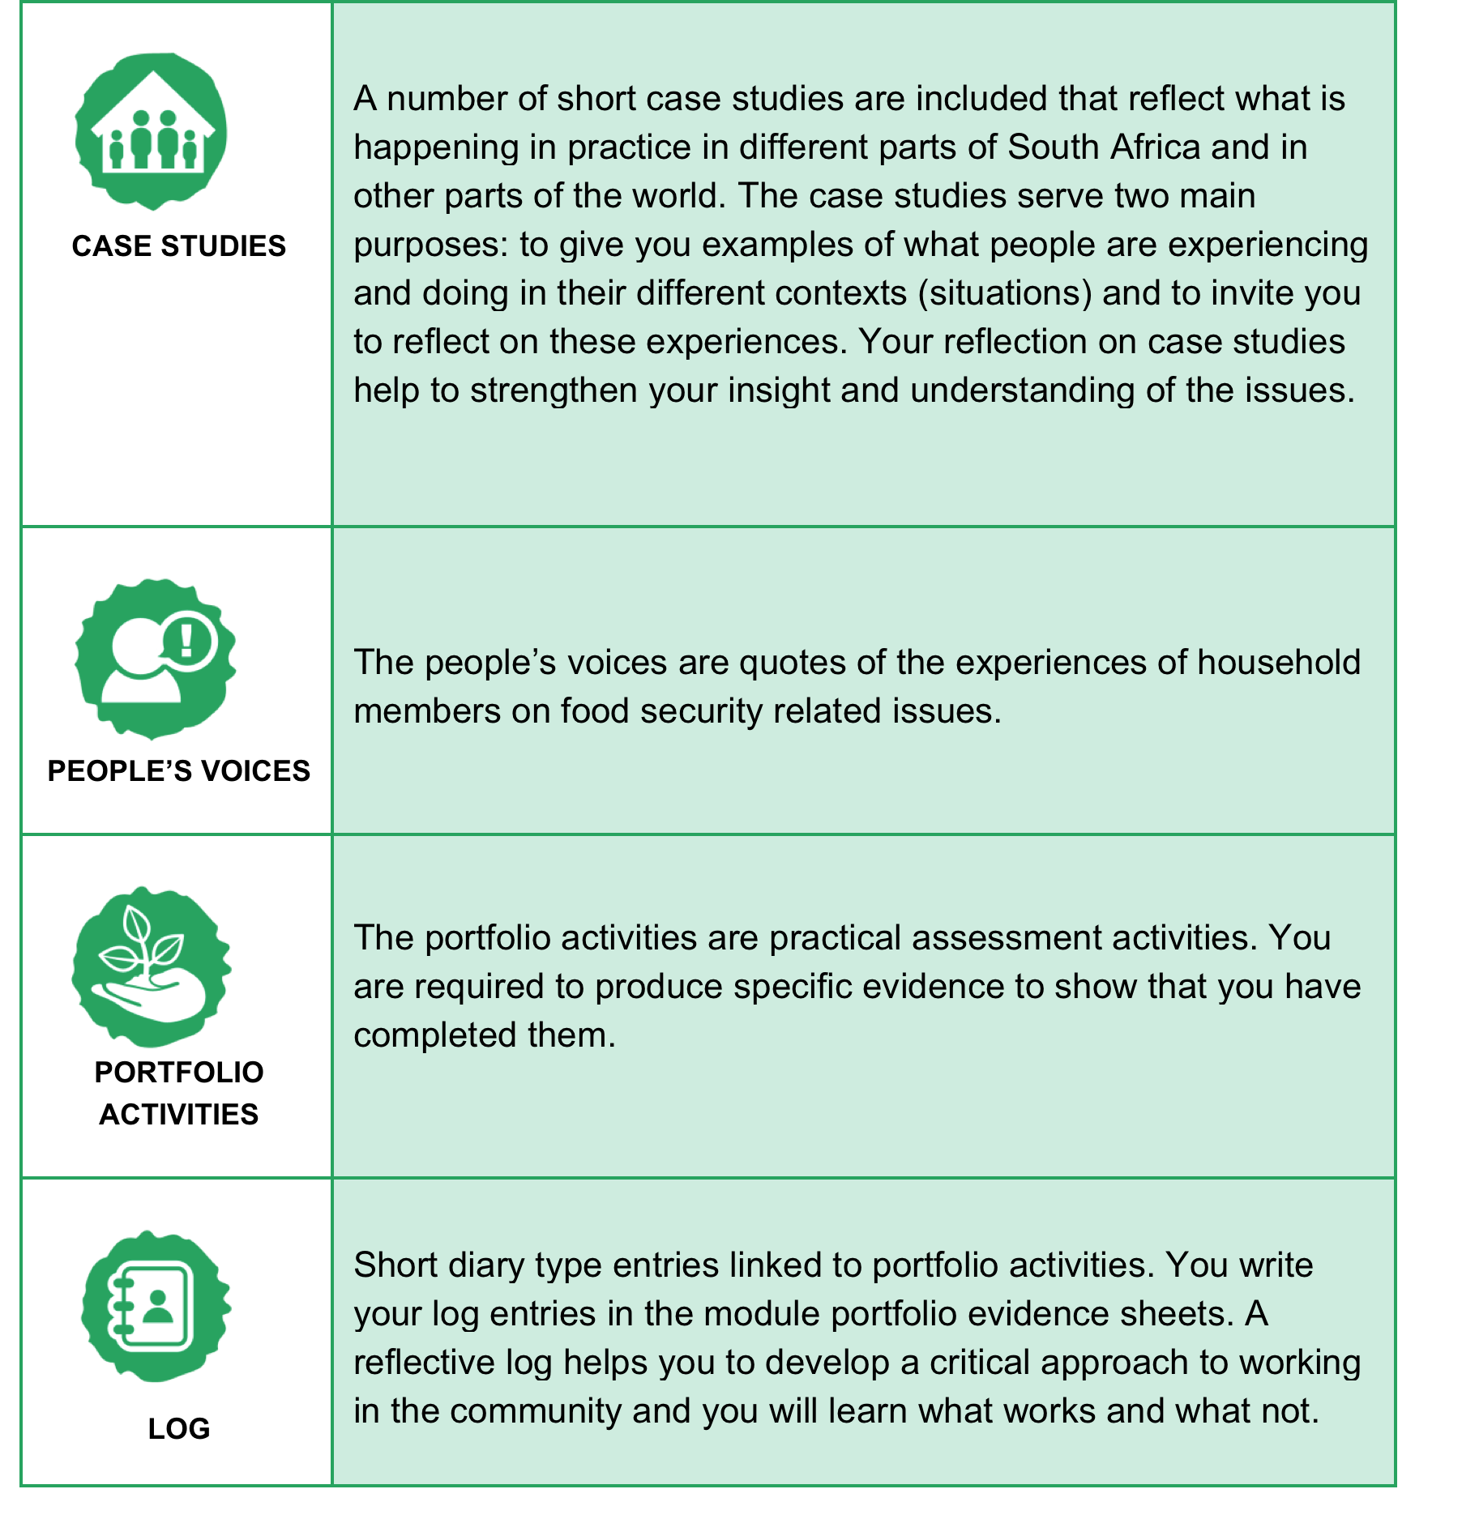
Note that extracts from articles and food security reports are shown in shaded blocks.

How to work with the materials and assessment tasks
Here is a suggestion for working through the programme:

- Work through each unit in sequence. For each unit do the following:
- Start by making sure you understand the different concepts associated with the unit.
- Complete the activities for the unit in both your study guide and workbook.
- Complete the portfolio task linked to each unit. For example when you complete Unit 1 of this module you should complete Portfolio task 4.1
- Complete the assignments. You will find it easy to do them after having had some experience doing the portfolio tasks and engaging with the content in your study guide.

