Year 3 Medical Student Portfolio Task

Health Sciences Faculty Human Rights Key

University of Cape Town

Women’s Health in Obstetrics and Gynaecology Department

COMMUNITY

This patient was well-supported by her family and community. This was demonstrated in her neighbour’s willingness to take the day off work with her to drive her to her local CHC.

She thought the quality of care at the CHC was good and that she was well-treated, however the queues to be seen by a doctor were very long and she often had to wait more than six hours, despite the fact that she was very ill.

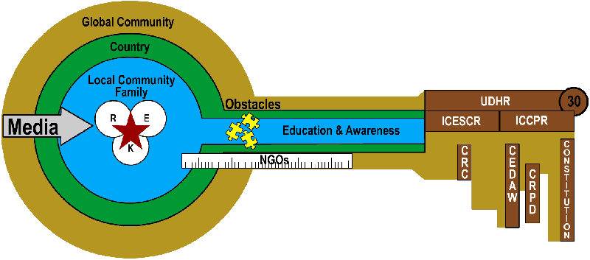

NGOs

The Family and Marriage Association of South Africa (FAMSA) is an NGO offering a community development project which includes, among other things, confidential support, counselling, legal advice and care for women who are victims of domestic violence.

[www.famsa.org.za](http://www.famsa.org.za)

Observatory office tel: 021 447 7951

Other offices in CPT:

Dunoon, Factreton, Elsiesriver, Khayelitsha, Mitchell’s Plein, Tygerberg

EDUCATION

It was valuable for this young woman to learn that there were people she could speak to about her problems.

She was also counselled about various contraceptive methods she can use that do not depend on the male (for example, she could use an oral contraceptive rather than leave the decision to her partner to use a condom)

INTEGRATED HEALTH PROFESSIONAL

My knowing dimension was challenged in taking a thorough history and recognising the signs and symptoms of pelvic inflammatory disease.

My empathic dimension was tested when the patient confessed to being abused, and started crying. It was difficult, but not impossible, to comfort her without feeling too sad for her. I realised I had to distance myself to a point but still listen and offer support to her, without getting too involved.

My reflective dimension came into play that evening, when reflecting back on the day’s events. I realised how much of a shock to me her confession had been, and that I need to be better informed about support structures to which I could have referred her.

OBSTACLES

This woman’s partner is definitely an obstacle in terms of her health and human rights – he watches over her all the time, and she is afraid to do anything wrong in his eyes. This may affect her health-seeking behaviour in that she might not seek medical help at a clinic if he did not approve, or even if he was the cause of her injury.