Creative Commons Licences Compatibility Wizard
There is a useful tool called an interactive compatibility wizard, available at (http://creativecommons.org.tw/licwiz/english.html), which can assist users in understanding and dealing with issues of interoperability.
The user starts with a clear compatibility wizard (which can be reset at any time)
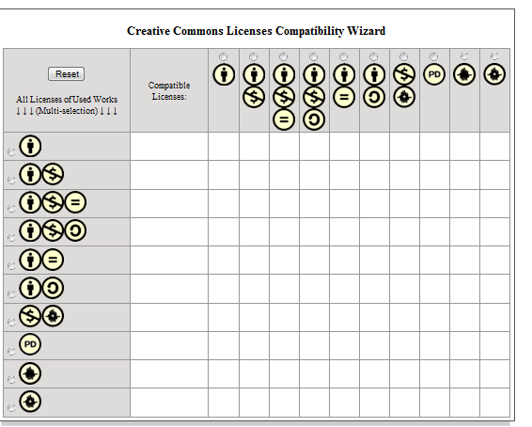
By placing the mouse over the icon, one can see the written code form of the licence type.
Option 1: With different works with different CC licences used, what CC licence can be used to relicense the work?
- According to those Creative Commons-licensed works you used, check the corresponding Creative Commons license in the left side (vertical-axis) of the chart.
- Some smiley faces ☻ may appear in the chart to mark those compatible licenses for each license of works you are used.
- For the intersection of compatible licenses, a light-blue background colour will appear in the chart above.
An example is shown below:
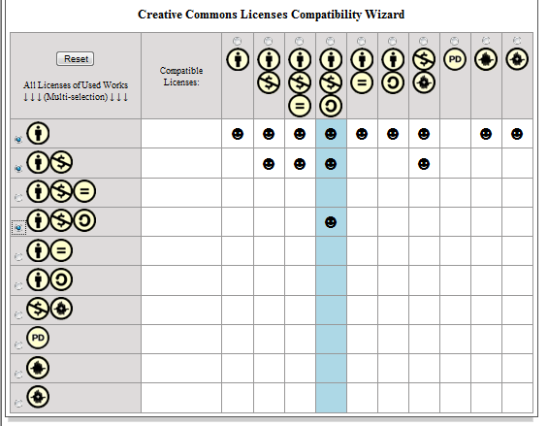
In this example, some of the works used have an attribution licence (cc by), some have a non commercial use licence (cc-by-nc) and some have an attribution non-commercial share alike licence (cc by-nc-sa).
Only one column is highlighted in blue, this is the attribution non-commercial share alike licence (cc by-nc-sa), and the only licence which can be used to relicense the work (the smiley faces indicate which are the most restrictive licences).

- If there is no light-blue background cell at the end, it might be that incompatible works are being used:
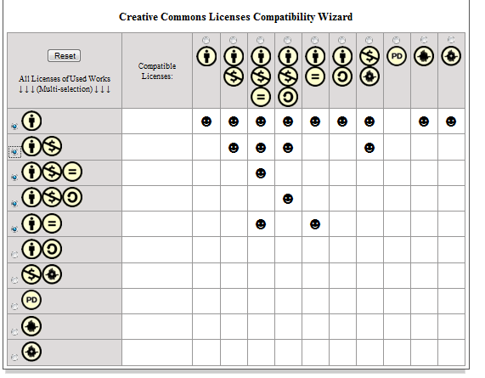
In this example one can still look into the smiley faces to figure out which work to drop out to ensure license compatibility or which work to contact the author about to gain extra permissions or rights to use that work.

Option 2: If one is intending on using a particular licence, what types of works can be considered?
- According to the Creative Commons license you'd like to relicense your work under, check the corresponding license in the upper side (horizontal-axis) of the chart
- Some licenses will be highlighted with blue background in the left side (vertical-axis) of the chart above. These are usable up-stream licenses compatible with the licence that one wants to relicense the work under.

Example 1: Relicensing a work under an attribution (cc-by) licence
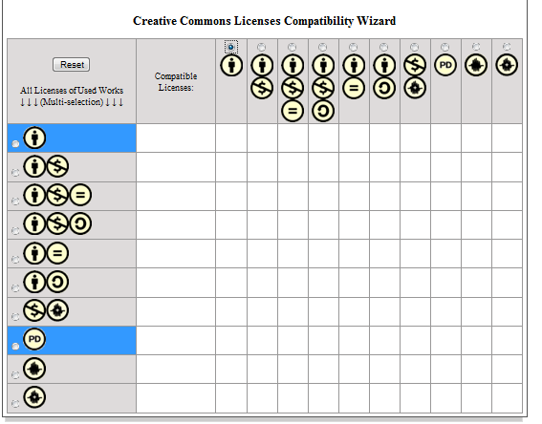
This shows that only works with an attribution licence (cc by) or public domain works can be used if additional permissions are not sought from the copyright holders.

Example 2: Relicensing a work under an attribution non commercial share alike (cc-by-nc-sa) licence

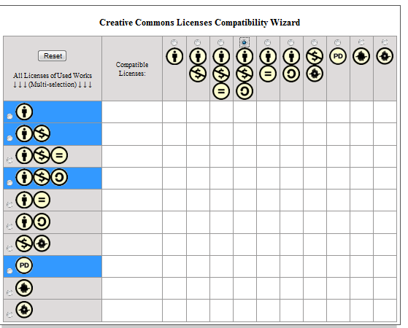

This shows that works with an attribution licence (cc by), cc by-nc, cc-by-nc-sa and public domain works can be used.

The compatibility wizard can be reset and different variations can be tried. This is also a useful tool in understanding the different interoperability issues that arise in creative commons licences.

