Unit 6: Size and Measurement

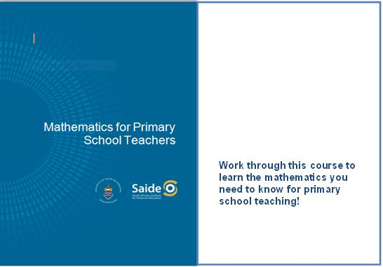
Unit 6: Size and Measurement 3
Introduction 3
Introduction to concepts and relevant ideas 3
Conservation of size – some practical exercises 9
Unit summary 14
Assessment 15

© Saide, with the Wits School of Education, University of the Witwatersrand
Permission is granted under a Creative Commons Attribution license to replicate, copy, distribute, transmit, or adapt this work freely provided that attribution is provided as illustrated in the citation below. To view a copy of this licence visit http://creativecommons.org/licenses/by/3.0/ or send a letter to Creative Commons, 559 Nathan Abbott Way, Stanford, California, 94305, USA.

Citation
Sapire, I. (2010). Mathematics for Primary School Teachers. Saide and the Wits School of Education, University of the Witwatersrand, Johannesburg.
ISBN: 978-0-9869837-5-7

Saide
Fax: +27 11 4032813
E-mail: info@saide.org.za
Website: www.saide.org.za
P O Box 31822
Braamfontein
2017 Johannesburg
South Africa

Unit 6: Size and Measurement

Introduction
The topic of "size" or "measurement" is one in which we teach our learners how to measure. We need to ensure that our learners understand the measuring process fully. To do so, we need to look carefully at the concepts involved in measuring different physical characteristics of physical objects. It is most effective to teach for understanding and to teach skills. We must remember this in our teaching of measurement and facilitate it by giving a good conceptual grounding followed by sufficient practical exercises. In the first section of this unit we will look at the conceptual groundwork needed for the topic of measurement. In the second part of the unit we will investigate some of the conservation tests for measurement concepts. These give us a way to establish whether or not a learner has understood a certain measurement concept.
Upon completion of this unit you will be able to:
Outcomes | - Explain and cite examples of general measurement concepts as they may be used in the primary school to lay a foundation for measurement and calculations with measurements in later years.  - Apply the conservation tests of Piaget to establish a learner’s understanding of length, mass, area, volume and capacity.

Introduction to concepts and relevant ideas
Measurement involves quantifying physical characteristics. When we quantify we assign a numeric value to something. For example, we can say that a belt is 90cm long, or a cup holds 250ml, or the mass of the child is 34kg. We cannot quantify things to which we cannot assign a numeric value. For example, if the belt is black, we cannot say how black it is by giving a number ... black.
The topic of "money" traditionally falls into this part of the curriculum. Monetary value does not relate to physical characteristics. The monetary value which a coin has is assigned by the Central Reserve Bank and is printed on the coin. An old one cent coin and a new one cent coin will both be worth only one cent, even if the new coin is much smaller than the old one.
Children are aware of physical objects and their characteristics before they develop a concept of number and measurement. We must ensure that they fully understand the concepts (of volume or capacity for instance) of the things that we measure before we teach them how these are measured. This is because the way in which we assign numeric values to quantities is by comparing them to other quantities similar to themselves.
We can measure length in centimetres. For example, centimetres are just "little bits of length" which have been assigned an amount in terms of length and a name. In this unit, these concepts will be discussed in detail.

Reflection | Think about physical characteristics such as "motion", "time" and "surface".  How do these show themselves?  What characteristics do they display?

Some of the characteristics of physical objects have size or amount. We will call these physical quantities. Ultimately it is the physical quantities that we measure.
Think of some of the learners in your class.
- They have physical characteristics such as height and personality; they are made of substance; they are attracted by the force of gravity; they have eye colour, hair, a smile, length of hair, academic ability, artistic ability, sporting ability, shoe size; they take up space, and so on ...
- Some of these characteristics have size or amount – we call these physical quantities: length, mass, weight, volume ... (think to yourself which of the characteristics above relate to which of the quantities mentioned and write them as pairs in your notebooks).
- Ultimately we will be able to measure the characteristics which have “size”. For example,
  - How much space do they take up?
  - What is their volume?
  - What is their height?
  - What is their length from top to toe?
Remember this: we measure physical quantities not physical objects!
This must affect the language that we use in giving instructions and in phrasing questions. We must not say: "measure that boy" – we must specify which quantity relating to the boy must be measured, for example by saying "measure the height/mass/weight/volume/waistline ... of the boy".
Here then are some key questions relating to our teaching of size and measurement:
What do we measure? We measure the size (amount) of a physical quantity pertaining to a physical object. Length, for instance, may be great or small. We measure the length of an edge, not the edge itself. We may measure the mass of a ball. Then we would say "the mass of the ball = 3 kg". (We DO NOT say the ball = 3 kg.)
This shows the need for careful use of language in this topic of measurement, if we are to avoid speaking unclearly or ambiguously. We must say exactly what we mean, and give clear instructions to our learners, so that they will know to which quantities we are referring. We must not allow any confusion between a thing itself and its quantifiable characteristics.

Reflection | Write out a few clear instructions to learners, calling on them to measure some different physical quantities.

Is size absolute or relative?
Things which are absolute cannot be measured in degrees. They are, or they are not. They stand independent. Can you think of any absolutes? SIZE IS NOT ABSOLUTE. Size is relative and it is arrived at by comparison. We could say that something is long. What does this mean? How "long" is long? On the other hand, what is short? Perspectives differ, and different answers to these questions exist. That is what we mean by "size is relative" – it is given in relation to something else. It is this property of size that we use to quantify things. We compare them to "standard units" of themselves. Relativity of size is an idea we need to communicate to learners, even if in an intuitive way, without referring to relatives and absolutes!
Reflection | Use the example of the speed of a car compared to the speed of an aeroplane to discuss the idea of the relativity of size.

What is a standard unit?
We choose suitable units to measure with. The units must possess the property of that which we are trying to measure. For example, to measure the length of the edge of a desk we could use a pencil. Then a pencil = 1 unit, and the length of the desk would be … units. The pencil is then our chosen standard, its size taken to be 1.
Clearly, problems could arise if such a standard were used. More particularly, we call such a standard an ARBITRARY standard. There are certain accepted standard units used for measuring all of the physical quantities (for example, cm and mm). These are part of what we will teach when we teach about measurement.
Activity | Activity 6.1  - Name some other arbitrary units for length.  - Name some arbitrary units for area.  - Name some arbitrary units for mass.  - Name some arbitrary units for volume.

What is measuring?
Measuring is the process whereby we assign a number to a physical quantity by comparing it with a standard physical quantity, whose size we arbitrarily decide shall be the unit size (i.e. its size is taken to be one). In our teaching of measurement, we will use ARBITRARY standards to assist the formation of the concept we are teaching BEFORE we go on to teach the accepted standard units applicable to that which is being measured. It is vital that you understand the difference between arbitrary standards (used in concept development, such as the pencil, and your other examples, mentioned above) and internationally accepted standards (such as millimetres, litres, kilograms, newtons etc). You will use both in your teaching of size.

What are pure numbers and denominate numbers?
Pure numbers relate simply to the concept of number, of "how much", without concerning themselves with "of what". Denominate numbers specify what they are counting. "5" is a pure number, whereas "5 dogs" is a denominate number (dogs is the denomination). This is an important distinction for you to remember in the teaching of size, since all measurements will be denominate numbers.

Reflection | Why are all measurements given as denominate numbers?

You must teach your students to record their measurements correctly, giving the unit of measurement each time. (Arbitrary standards and standards will be used.) The denominate numbers (units) need to be properly used when it comes to computations involving these numbers, which we do teach, once the concepts and measuring skills have been taught.

Reflection | What is the key skill that learners need in order to perform operations correctly using denominate numbers?

Can a measurement be precise?
This is a similar question to "is size absolute?" NO. Because size is relative, a measurement will be as accurate/precise as the measuring instrument you are using allows you to be. If you use the same measuring instrument to measure two separate quantities, your measurements will have the same precision (if we take it that the same maximum error will occur in both instances) but the accuracy of the measurement will refer to the relative error possible in the measurement.
So these ideas relate to the errors involved in measuring. Precision relates to maximum error, while accuracy relates to relative error.
Here is an example of maximum error and relative error, which could occur if you were measuring amounts of liquid in a cylinder marked in ml. You find one amount of 15 ml and another amount of 60 ml – these measurements are equally precise since each time the maximum error is taken to be 0,5 ml. The second measurement is more accurate though, since the relative error in the first one is a $\frac{0.5}{15} =\frac{1}{30}$ error and in the second one is a $\frac{0.5}{60}=\frac{1}{120}$ error. The accuracy of the larger measurement is higher, since the error is relative to a larger measurement. This example shows you how the errors are computed – you will not be asked to do such computations yourself in the exams.
The precision measurements are affected by the instruments we use to measure. A measurement could be faulty if the instrument is faulty, or if an inappropriate instrument is used (such as using a 9 litre bucket to measure 250 ml). Human error can also lead to faulty measurements: simple errors of carelessness or incorrect reading of the instrument. Exact measurements are not possible, but a level of accuracy can be chosen which is appropriate to a situation. This is another of the elements in our teaching of size.

Reflection | Why do we say that no measurement can be exact?

What is indirect measurement?
Certain quantities can be measured directly. Think about the lengths of the edges of a piece of paper. A ruler can be used. Think about the volume of a cube. Unit cubes can be used. But what about the perimeter of a piece of paper which has been cut into an irregularly shaped region, or the volume of an irregularly shaped stone? They cannot be measured directly, but both of these measurements can be found by using a procedure we call indirect measurement. This requires a certain level of abstraction and a clear understanding of the concepts involved if it is to be grasped.
Let us look at the example of the perimeter of the irregular region. Remember that perimeter is the outside boundary of a shape. To measure the irregular perimeter we can use a piece of string. We take the string and lay it down carefully all along the border of our shape.
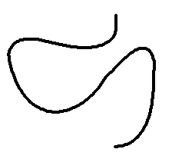 | 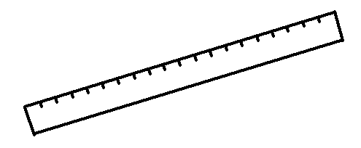
String | Measure length of ruler using string

Then we take the string away from the shape, straighten it up, and measure how long the perimeter of the shape is. This is indirect because we did not place the ruler along the boundary, because we could not. We used an indirect method which successfully enabled us to find out the perimeter.
To measure the volume of the stone we can submerge it in water and find out how much water it displaces.

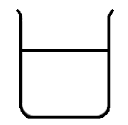 | 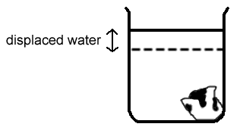
The amount of water displaced will equal the volume of the submerged stone.

Reflection | When you get into a bath, what happens to the level of the water in the bath?  Why do you think this happens?  What does this show you?

These ideas relate to the teaching of measurement in all grades. You need to understand and be able to apply all of them yourselves in order to teach the topic well to all grades. The topic of measurement should be taught using apparatus and practical exercises wherever possible. In the next section we look at some introductory exercises that can be used in the establishment of the size concepts.

Conservation of size – some practical exercises

Piaget's conservation tests
In the numeration module the psychologist Piaget was mentioned with respect to his ideas on conservation of number. In this topic of size and measurement we use his ideas again, to check our learners' readiness to proceed with the measurement of things such as length, mass, area, volume and capacity. As with number concept, we need to check that the learner has achieved conservation of these concepts before we can teach about their measurement. Conservation of the concept means that they have a clear understanding of the constancy or unchanging nature of length, mass, area, volume and capacity.
In this unit we will look at conservation tests for each of length, mass area, volume and capacity. As an example, in brief, before we look at each test separately, we could say that a child has achieved conservation of length once they are aware that the length of a piece of string remains the same, no matter if we lay it straight, curve it, roll it up or even cut it up. So the conservation tests are all designed to check whether the learners know that equal amounts remain equal even when their appearances have been distorted.
Why is it important that a child achieves conservation of length (for instance) before we teach the child to measure length?
Different children develop at different paces, and we cannot assume that "all 12 year olds" should have achieved conservation of the size concepts. It does not take very long to test for the conservation of these concepts, so we should always just take that little extra step to check for conservation before we proceed to teach the measurement of different amounts.
Piaget went further to say that if the learner was able to explain that the distorted amounts could be restored to their original appearance, then the learner has achieved the concept of reversibility.
Reflection | Give an example of what you think is meant by reversibility in relation to the concept of area.

Conservation of length
Length is the size of the edge (whether it be straight or curved). To check for conservation of length, show the learner two pieces of string that are the same length. Let her satisfy herself that they are the same length.
Now take one of the pieces of string and twist it around into a coil. Ask the learner if the two pieces of string are same length, or if their lengths are different (second display). You could then further distort the one piece of string by cutting it up into a few pieces (third display). Then ask again if the two displays contain the same length of string.

 | 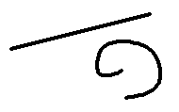 | 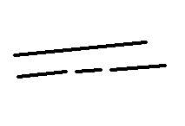
Initial display | Second display | Third display

If the child answers that the pieces of string are the same length, she has achieved conservation of length. If she answers no at any stage, then she is not sure that the length of the string remains the same even if its appearance is changed, and she has NOT achieved conservation of length.
If she can explain why they are still the same lengths in terms of restoring them to their original shapes, she has achieved reversibility of the concept of length.

Reflection | What other apparatus would be useful in tests for conservation of length?

Conservation of mass
Mass is the amount of matter which makes up an object. The density of the matter affects the mass of the object.

Reflection | In what way will density affect mass?

To test for conservation of mass, show the learner two balls of clay which have the same mass. Let her satisfy herself that they have the same mass.

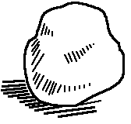

Now take one of the balls of clay and roll it into a thin sausage (second display). Ask the learner if the two pieces of clay have the same mass, or if their masses are different. You could then further distort the one lump of clay by cutting it up into a few pieces (third display). Then ask again if the two displays contain the same mass of clay.
 |  | 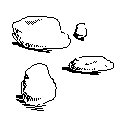
Initial display | Second display | Third display

If the child answers that the lumps of clay have the same mass, she has achieved conservation of mass. If she answers no at any stage, then she is not sure that the mass of the clay remains the same even if its appearance is changed, and she has NOT achieved conservation of mass.
If she can explain why they still have the same mass in terms of restoring them to their original shapes, she has achieved reversibility of the concept of mass.

Reflection | What other apparatus would be useful in tests for conservation of mass?

Conservation of area
Area is the amount of surface covered by a shape. To test for conservation of area, show the learner two postcards which are exactly the same. They have the same area. Let her satisfy herself that they have the same area.
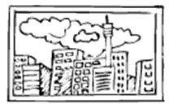

Now take one of the postcards and cut it into two parts (second display). Ask the learner if the two areas covered are still the same, or if they cover different areas. You could then further distort the one postcard by cutting it up into a few pieces (third display). Then ask again if the two displays still cover the same area.
 | 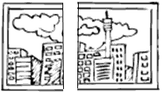 | 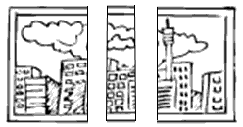
Initial display | Second display | Third display

Activity | Activity 6.2  - What will you ask the child as you show her the displays?  - How will you assess her responses in relation to conservation of area?  - If she can explain why they still have the same area in terms of restoring them to their original shapes, she has achieved reversibility of the concept of area.  - What other apparatus would be useful in tests for conservation of area?

Conservation of volume
Volume is the amount of space taken up. In testing for conservation of volume you could use the same balls of clay that you used in the tests for conservation of mass. Show the learner two balls of clay which have the same mass, and which therefore have the same volume. Let her satisfy herself that they have the same volume.
Activity | Activity 6.3  - What steps would you now go through to test the learner for conservation of volume? Explain in writing and illustrate your demonstrations for the initial, second and third displays.  - How would you know whether or not the child has achieved conservation of volume?  - How would you check whether or not the child has achieved reversibility of the concept of volume?  - What other apparatus would be useful in tests for conservation of volume?

Conservation of capacity
Capacity is the amount of space inside, or the ability of an item to hold something. You should have a good idea of the procedure for testing for conservation by now.

Reflection | Describe a test for the conservation of capacity, using the apparatus of your choice.  Draw sketches to add to your explanation.

Unit summary
In this unit you learned how to:
- Explain and cite examples of general measurement concepts as they may be used in the primary school to lay a foundation for measurement and calculations with measurements in later years.
- Apply the conservation tests of Piaget to establish a learner’s understanding of length, mass, area, volume and capacity.

Assessment
Measurement concepts
Give your own examples to explain the following:
- How do we measure?
- Why do we say that no measurement can be exact?
- What is indirect measurement?
- What is an arbitrary unit?
- Name five physical quantities that we can measure, and state one of the commonly used standard units for measuring each one.
- Describe a conservation test for capacity. Illustrate your explanation.

