WEEK 6

UNIT 2-3 : LIPIDS | Where? How long? | Explanations  /Questions
Introduction  Lipids, commonly referred to as fats, are organic compounds from both animals and plants, they are water insoluble but soluble in most of nonpolar organic solvents. Lipids share in common the same property of having hydrophobic regions and are made from a small number of molecules in their backbone. These include mainly fatty acids, glycerol and sphingosine. There are different classes of lipids; here we will talk about three classes: triglycerides, phospholipids and sterols. | 10 minutes | Where is this from?
 | 10 minutes | Explain here what it is they are going to be learning and why they need to know about Lipids  Also what the expectations are in terms of time commitment, tutor support and so on.
Expectation  In this lesson, we will learn more about the chemical structure and biological function of various lipids. | 10 minutes
Course outline  Fatty acids  triglycerides,  phospholipids  sterols | 10 minutes
Learning outcomes | 10 minutes
At the end of this unit, you should be able to:  - Define and classify lipids  - Differentiate between saturated and unsaturated fatty Acids  - Define the basic structure of a steroid | 10 minutes

ACTIVITY AHEAD OF LESSON :LIPIDS |  | 30 minutes | For the video activate the subtitle in English.
Purpose: | Lipids are an important source of energy .You will learn how the hydrocarbon tails in triglycerides contain energy available for life, and how phospholipids with cholesterol molecules are structures of the cell membrane. | 30 minutes | For the video activate the subtitle in English.
Over to you: | Watch this video and read this course about structure of lipids  Be certain to note anything that you don’t understand | 30 minutes | For the video activate the subtitle in English.
Activity: | Answer following questions:  Define lipids  Draw the primary structure of triglycerides, phospholipids and sterols and provide an example for each class of lipids.  What are the main functions of lipids in Cell.  Bring your answers to the class. | 30 minutes | For the video activate the subtitle in English.

TYPES OF LIPIDS | 20 minutes | Notes to tutor
- Fatty acids  Fatty acids are linear hydrocarbon compound of varying lengths.  They are the building blocks for triglycerides and phospholipids and have two regions: a long nonpolar, hydrophobic hydrocarbon chain and a polar, hydrophilic carboxyl (–COOH) head. These two chemically distinct (polar and nonpolar) regions make fatty acids amphiphilic. They may be saturated or unsaturated; saturated fatty acids are solid for example palmitic acid, while unsaturated ones are liquids for example linolenic acid. | 20 minutes
Figure 2.10: Saturated fatty acids versus unsaturated fatty acid (have a double bound) . By Liantai Lin [ Illustration], uploaded on January 28, 2018. Accessed on the February 20, 2019. https://www.flickr.com/photos/fossil_lin/28161978809 | 20 minutes | Fatty acids found in biological organisms are in cis conformation.

IN CLASS ACTIVITY: SATURATED VS UNSATURATED FATTY ACIDS. |  | 10 minutes for search  15 for feedback | Use group of 4 students  To stimulate students to ask questions.
Purpose: | Compare and contrast Saturate and unsaturated fatty acids | 10 minutes for search  15 for feedback
Over to you: | Using a laptop look on the website the difference of saturate and unsaturated fatty acids, then look for various shape of unsaturated fatty acids).  Give an example for each type of lipids . | 10 minutes for search  15 for feedback
Activity: | Using a PPT of 2 slides the group representative will present to the class their search | 10 minutes for search  15 for feedback

- Quick review of fatty acids  Structure : Carbon and hydrogen chain, carboxylic acid, methyl group  Fatty acids are the basic structural units of triglycerides and phospholipids  Differ in chain length, degree of saturation, shape  - Saturated fatty acids: no carbon to carbon double bonds  - Monounsaturated fatty acids: one C=C double bond  - Polyunsaturated fatty acids: two or more C=C double bonds  Types of essential fatty acids  - Linoleic  - Alpha-linolenic acid  Food manufactures hydrogenate or add antioxidants to unsaturated fatty acids to reduce susceptibility to rancidity | 30 minutes | Notes to tutor  Discusses with students and check if they understand all important information about fatty acids.
Fatty acids an health  What is an essential fatty acids?  What is rancidity  What are the effects of rancidity of heath ?  What is prostaglandin? |  | Orient the discussion around the question on the right column.

Triglycerides  Triglycerides or Triacylglycerols also called fats and oils are lipids containing three fatty acid molecules attached to one molecule of glycerol by ester bonds. | 20 minutes | Note to tutor
Figure 2.11: Triglycerides components. By Allison Soult. November 2, 2018. Accessed on the February 20, 2019.  https://chem.libretexts.org/Courses/University_of_Kentucky/UK%3A_CHE_103_Chemistry_for_Allied_Health_(Soult)/Chapters/Chapter_14%3A_Biological_Molecules/14.2%3A_Lipids_and_Triglycerides  Each fatty acid in the triglyceride molecule can potentially be different in structure, thus producing many possible structural forms of triglycerides. Most triglycerides from plant sources, such as corn, sunflower seeds, and safflower seeds, are rich in polyunsaturated fatty acids and are oils, whereas triglycerides from animal sources contain mostly saturated fatty acids and are usually solid at room temperature. In the cell, triglycerides are found as tiny droplets in cytosol and they function as storage lipids in animals and in plants.  A triglyceride is called a fat if it is a solid at 25°C; it is called an oil if it is a liquid at that temperature.  Pure fats and oils are colorless, odorless, and tasteless and can participate in a variety of chemical reactions.  Example :Saponification is the hydrolysis of esters in fats and oils in the presence of a base is used to produce soap. | 20 minutes | Discuss about the saponification.

IN CLASS ACTIVITY: FATS AND OILS. |  | 10 minutes for search  15 for feedback | Use group of 4 students  To stimulate students to ask questions.
Purpose: | Differentiate fats and oils | 10 minutes for search  15 for feedback
Over to you: | Using a laptop look on the website the difference of fats and oils | 10 minutes for search  15 for feedback
Activity: | After compare fats and oils use a table , then answer the questions below:  - Explain how fats function as energy-storage molecules.  - List the functions of fat in the body.  - Why does fat keep the body from being hungry?  Provide feedback in class for discussion. | 10 minutes for search  15 for feedback

- PHOSPHOLIPIDS  Phospholipids which are the main component of biological membranes are similar in structure to triglycerides except that they only have two esterified fatty acids. The third position on the glycerol backbone instead, contains a phosphate head group, to which a varied number of chemical groups can be attached.  Figure 2.12: Phospholipids have polar hydrophilic head and non-polar hydrophobic tails. By OpenStax Biology 2nd Edition, Biology 2e. OpenStax CNX. Feb 13, 2019, accessed February 24, 2019. https://cnx.org/contents/jVCgr5SL@15.3:lQpWuQGI@10/3-3-Lipids  A phospholipid is an amphipathic molecule, meaning it has a hydrophobic and a hydrophilic part. The fatty acid chains are hydrophobic and cannot interact with water; whereas, the phosphate-containing group is hydrophilic and interacts with water. Because they are amphipathic, phospholipids are effective as emulsifying agents, compounds that make or stabilize emulsions  There are two classes of phospholipids:  - Glycerophospholipid ( contains glycerol as alcohol)  - Sphingophospholipids (contain sphingosine as alcohol) | 20 minutes
- Glycerophospholipid  1,2-diacylglycerol (the fatty acids) with a phosphate group at position 3  Essential components of cell membranes and other cellular structures  You can have additional compounds esterified to the phosphate group  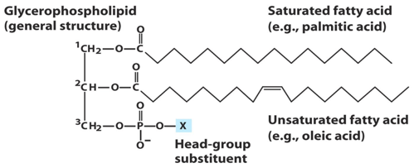  Figure 2.13: General structure of Glycerophospholipid: Lafer, Eileen. “Membrane Lipids I and II: Glycerophospholipids and Sphingolipids.” Lecture. San Antonio, Texas. December 6, 2011, Accessed on February 24,2019. http://biochem.uthscsa.edu/~lafer/VIRGIL/MembraneLipids/MembraneLipidsNotes2011FIN.pdf | 10 minutes
The parent molecule is phosphatidic acid.  The presence of an additional group attached to the phosphate allows for many different phosphoglycerides.  Each derivative is named for the head-group alcohol (X) with the pre-fix "phosphatidyl-"  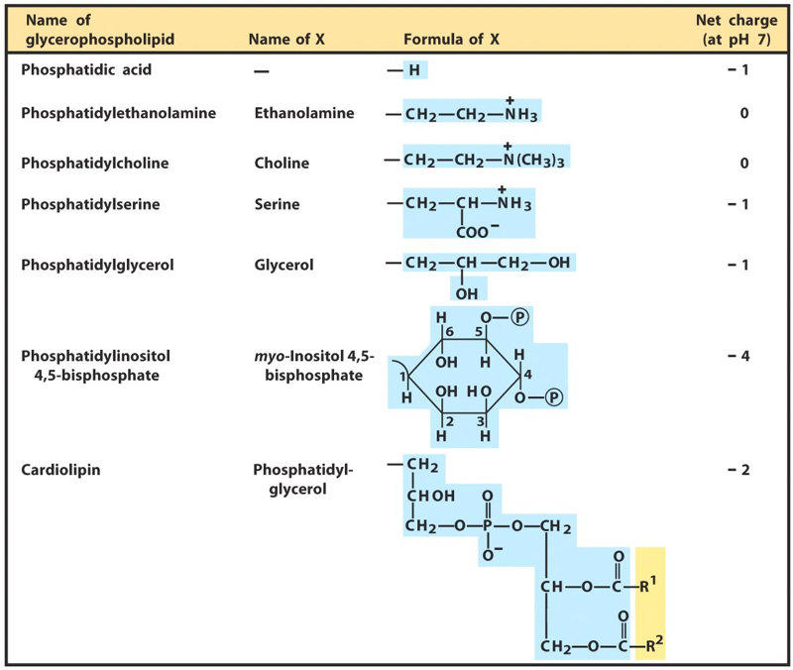  Figure 2.14: Common head groups found in glycerophospholipids and their basic characteristics. Source: Lafer, Eileen. “Membrane Lipids I and II: Glycerophospholipids and Sphingolipids.” Lecture. San Antonio, Texas. December 6, 2011.Accessed on February 24,2019. http://biochem.uthscsa.edu/~lafer/VIRGIL/MembraneLipids/MembraneLipidsNotes2011FIN.pdf | 10 minutes | Phosphatidylcholine or lecithin
- Sphingophospholipids
Shingolipids are typically found in brain tissues (eg. brain lipids).
Based upon sphingosine (or dihydrosphingosine), an amino alcohol.
Sphingosine is rare in plants and animals while sphingolipids are common
Simplest sphingolipids are ceramides
Sphingosine + N-linked fatty acid = ceramide

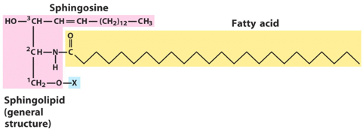  Figure 2.15: Sphingolipid general structure. Source: Lafer, Eileen. “Membrane Lipids I and II: Glycerophospholipids and Sphingolipids.” Lecture. San Antonio, Texas. December 6, 2011.Accessed on February 24,2019. http://biochem.uthscsa.edu/~lafer/VIRGIL/MembraneLipids/MembraneLipidsNotes2011FIN.pdf  The 3- carbon backbone is analogous to the 3-carbons of glycerol.  At C3 there is the long chain amino alcohol sphingosine.  At C2 there is a fatty acid which is usually saturated or mono- unsaturated, and can be either 16,18, 22, or 24 carbons long.  Ceramide is the parent compound.  Other polar head groups can be attached at position X  Glycosphingolipids are a sub-group of sphingolipids that contain saccharide headgroups. | 20 minutes
Some common sphingolipids headgroups  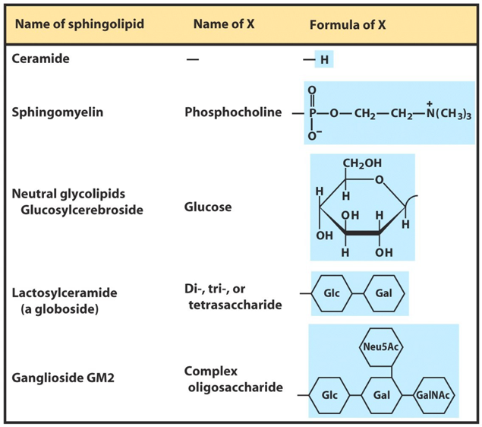  Figure 2.15: Sphingolipid structure and common head groups. Source: Lafer, Eileen. “Membrane Lipids I and II: Glycerophospholipids and Sphingolipids.” Lecture. San Antonio, Texas. December 6, 2011.Accessed on February 24,2019. http://biochem.uthscsa.edu/~lafer/VIRGIL/MembraneLipids/MembraneLipidsNotes2011FIN.pdf | 10 minutes

Glycolipids  Glycolipids contain a sub-group of sphingolipids and a mono- or oligosaccharide bound to the C3group  Glycosphingolipids are a sub-group of sphingolipids that contain saccharide headgroups.  The human blood groups (O, A, B) are determined in part by the oligosaccharide head groups of these glycosphingolipids.  Glc:D-glucose  Gal:D-galactose  GalNAc:N-acetyl-D- galactosamine  Fuc:fucose  Glycosphingolipids are especially relevant to neuronal membranes, where D-glucose is added to the hydroxyl group of ceramide to create GlcCer.  If the headgroup has any (one to four) silica acid(s) attached to it, the new molecule is referred to as a ganglioside . | 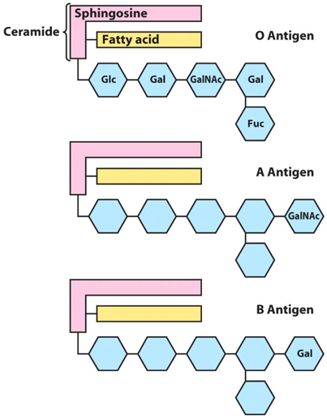  Figure 2.16: Blood group types in humans are determined by the glycolipid headgroup.Source: Lafer, Eileen. “Membrane Lipids I and II: Glycerophospholipids and Sphingolipids.” Lecture. San Antonio, Texas. December 6, 2011.Accessed on February 24,2019. http://biochem.uthscsa.edu/~lafer/VIRGIL/MembraneLipids/MembraneLipidsNotes2011FIN.pdf. | 10 minutes
Gangliosides are degraded by a set of lysosomal enzymes  These enzymes catalyze the stepwise removal of sugar units, finally Yielding a ceramide.  A genetic defect in any one of these hydrolytic enzymes leads to the Accumulation of gangliosides in the cell, with severe medical consequences.  Example : defect in Sphingomyelinase leads to accumulation of Sphingomyelin in the brain, spleen, and liver causing a disease called : Niemann-pick disease. |  | 10 minutes

IN CLASS ACTIVITY: PHOSPHOLIPIDS |  | 10 minutes
Purpose: | To Apply knowledge of the structure of phospholipids to the formation of membranes | 10 minutes
Over to you: | After the class lecturer and pre-class reading activities answer the questions bellow: | 10 minutes
Activity: | Explain how the structure and properties of phospholipids help to maintain the structure of cell membranes.  Why would a molecule need to be soluble in water, but also not soluble in water? | 10 minutes

STEROIDS  Lipids mainly made of four fused rings known as steroid nucleus and named as cyclopentano-perhydro-phenanthrene. Rings are numbered through ABCD and carbon backbone is numbered from 1 to 17.  All steroids have the steroids nucleus in their structure. The difference comes from chemical modifications on rings. These modifications may be the replacement of hydrogen atoms with other chemical groups such as hydrocarbon chains or functional groups such as hydroxyl and carboxyl or aldehyde groups. Modification can be created by introducing carbon-carbon double bonds into one or more of the cyclohexane rings.  The most known steroid in animals is cholesterol. It is found in cell membranes where it contributes to the proper functioning of the membranes. | Figure 2.17: Cholesterol Structure. By Wesalius . May 17, 2017. Accessed on February 24, 2019. https://commons.wikimedia.org/wiki/File:Cholesterol_(chemical_structure).svg#/media/File:Cholesterol_(chemical_structure).svg. | 10 minutes
Anticipated time required for Unit 2-3 activities :
Theory : 2h all activities + 2h self-learning

