WEEK 6

UNIT 2_4 PROTEINS | Where? How long? | Explanations  /Questions
Introduction  Proteins are of the primary importance in cellular life as they are found in all aspects of cell structure and function. Some are enzymes, hormones, storage proteins, contractile proteins, transport proteins, structural proteins, protective proteins and toxins. A protein is composed of one or more long chains composed of amino acids. The individual amino acid subunits are joined by amide linkages called peptide bonds. | 10 minutes | Where is this from?
 | 10 minutes | Explain here what it is they are going to be learning and why they need to know about proteins  Also what the expectations are in terms of time commitment, tutor support and so on.
Expectation  In this lesson, you'll learn about the primary structure, function, and sources of protein molecules while exploring some real-world examples and illustrations. | 10 minutes
Course outline  Amino Acids  Peptide bonds  Proteins | 10 minutes
Learning outcomes | 10 minutes
At the end of this unit, you should be able to:  - Recognize the chemical structure of each of the 20 standard amino acids  - Describe the two basic building blocks of protein structure (α-helix and β-sheet)  - Describe levels of protein structure  - Describe the forces and interactions that promote protein folding  - Define the process of protein denaturation | 10 minutes

ACTIVITY AHEAD OF LESSON :PROTEINS |  | 30 minutes | Amino Acids  You must know:  Their names  Their structure  Their three letter code  Their one letter code
Purpose: | All proteins in all living cells are constructed from the same set of 20 amino acids (AA). These are called standard amino acids. The diversity observed within living organisms is because cells can produce proteins with strikingly different properties and activities by joining the same 20 amino acids in many different combinations and sequences. | 30 minutes
Over to you: | You will learn about the structure of AA and Proteins .Go to this open resource  Be certain to note anything that you don’t understand | 30 minutes
Activity: | Do the MCQ associated with this lesson . | 30 minutes

The structure of an amino acid | 20 minutes | Notes to tutor
An amino acid consists of amino group, a carboxyl group, hydrogen atom and a functional R-group, which are bonded to a α-carbon atom. | 20 minutes
Figure 2.18 : General structure for amino acids  OpenStax Biology 2nd Edition, Biology 2e. OpenStax CNX. Feb 13, 2019,accessed February 15, 2019. https://cnx.org/contents/jVCgr5SL@15.3:IRyJF0BE@11/3-4-Proteins | 20 minutes | Explain that the R-group (side chain) is what makes each amino acid unique.  Each of the 20 amino acids has a different side chain structure. Side chains contain mainly hydrogen, carbon, and oxygen atoms.  Some amino acids have sulfur or nitrogen atoms in their R-group
Classification of amino acids  Each amino acid has unique chemical properties determined by the nature of the side group (indicated by R) covalently bonded to the central carbon atom. Each amino acid has the same chemical backbone, but differs in the side, or R, group it possesses. The 20 common AA are classified based on their side groups:  Figure 2.18 : Classification of amino acids according to the polarity of their side chains  OpenStax Biology 2nd Edition, Biology 2e. OpenStax CNX. Feb 13, 2019,accessed February 15, 2019. https://cnx.org/contents/jVCgr5SL@15.3:IRyJF0BE@11/3-4-Proteins | 20 minutes

Properties of amino acids  Acid base property  Amino acids behave as acids and bases at the same time because they have both a basic amine group and an acidic carboxylic acid group. When dissolved in water at they form neutral hybrid ions (ones having equal number of negative and positive signs at the same time) called zwitterions.  The pH at which an amino acid has equal number of negative and positive signs is called isoelectric point abbreviated as pl  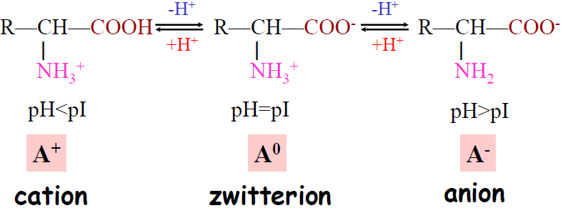  Figure 2.19. In solutions, carboxylic and amine groups are in their ionic state. The predominant charge depends on the pH of the solution. | 10 minutes  20 minutes | Notes to tutor
Types of Amino Acids  The 20 common amino acids are grouped into five chemical classes, based on their R group:  - Nonpolar amino acids, such as leucine, often have R groups that contain —CH2 or —CH3.  - Polar uncharged amino acids, such as threonine, have R groups that contain oxygen (or —OH).  - Charged amino acids, such as glutamic acid, have R groups that contain acids or bases that can ionize.  - Aromatic amino acids, such as phenylalanine, have R groups that contain an organic (carbon) ring with alternating single and double bonds. These are also nonpolar.  - Amino acids that have special functions have unique properties. Some examples are methionine, which is often the first amino acid in a chain of amino acids; proline, which causes kinks in chains; and cysteine, which links chains together. | 10 minutes  20 minutes

IN CLASS ACTIVITY: AMINO ACIDS |  | 30 minutes | Do no to use the internet  Discuss in group.
Purpose: | To learn the 20 essential AAs. | 30 minutes | Do no to use the internet  Discuss in group.
Over to you: | Use the previous group of 4 , take a white paper and draw a table with 3 heading in the Columns: Amino Acid, Abbreviation and R-group Linea Formula | 30 minutes | Do no to use the internet  Discuss in group.
Activity: | Fill the table with the 20 essentials AAs, after the 10 minutes the group will exchange their  answers sheet with other groups for marking.  Fills the table on the board for corrections.  Answer these questions:  What are the non-polar AA and polar AA?  What are the uncharged AA?  What are the Aromatic AA?  Answer this problem:  How Much Alanine Is Present as the Completely Uncharged Species? At a pH equal to the isoelectric point, the net charge on alanine is zero. Two structures can be drawn that have a net charge of zero (zwitterionic and uncharged forms), but the predominant form of alanine at its pI is zwitterionic.  (a) Explain why the form of alanine at its pI is zwitterionic rather than completely uncharged.  (b) Estimate the fraction of alanine present at its pI as the completely uncharged form. Justify your assumption | 30 minutes | Do no to use the internet  Discuss in group.

PEPTIDE BOND  Two or more amino acid can form a bond between the carboxyl group of one amino acid and the -amino group of another with release of water. The formed bond is called peptide bond. When a few amino acids are joined in this fashion, the structure is called an oligopeptide. When many amino acids are joined, the product is called a polypeptide. Proteins may have thousands of amino acid residues.  Figure 2.20 : Peptide bond formation  OpenStax Biology 2nd Edition, Biology 2e. OpenStax CNX. Feb 13, 2019,accessed February 15, 2019. https://cnx.org/contents/jVCgr5SL@15.3:IRyJF0BE@11/3-4-Proteins | 10 minutes

PROTEIN STRUCTURE

The shape of a protein determines its function. The structure of proteins is usually discussed in terms of a hierarchy of four levels: primary, secondary, tertiary, and quaternary .
Primary structure: order of the amino acids joined together to make a protein. it includes all features of a protein which are a result of covalent bonds; peptide bonds & sulphur bridges.  Secondary structure: refers to particularly stable arrangements of amino acid residues by forming bond hydrogen between its backbone amide and carbonyl groups. Hydrogen bond can form in the same polypeptide so that all amide and carbonyl groups are engaged in bonding; the formed helical structure is called α helix. The helical twist of the α-helix found in all proteins is right-handed. Hydrogen bond can be formed between adjacent segments of polypeptide chain forming a sheet structure called β sheet.  Tertiary structure: the final three dimensional structure of an entire polypeptide chain (polypeptide backbone and amino acid side chain). A protein is initially driven into its tertiary structure by hydrophobic exclusion from water. Ionic bonds between oppositely charged R groups bring regions into close proximity, and disulfide bonds (covalent links between two cysteine R groups) lock particular regions together.  Quaternary structure: spacial arrangement of subunits for proteins composed of two or more polypeptide. | 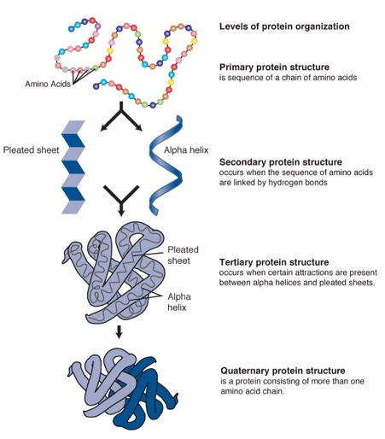  Figure 2.21: Four levels of protein structure. By Darryl Leja,NCBI Accessed February 24, 2019.  https://www.genome.gov/glossary/index.cfm?id=169 | 20 minutes | Notes to tutor  Project this video about protein structure.

PROTEIN FOLDING  During protein synthesis, the sequence of nucleotides in DNA is converted into the sequence of amino acids in a polypeptide chain. But this polypeptide is not yet a functional protein. To be functional polypeptides must fold into distinct three-dimensional conformations, and in many cases multiple polypeptide chains must assemble into a functional complex.  Several types of non-covalent forces help maintain the folded structure. These include the covalent peptide backbone of a polypeptide, covalent disulfide bond that may form between pairs of cysteine side-chains, hydrogen bonds formed between hydrogens covalently bonded to oxygen or nitrogen and lone pairs on oxygen or and nitrogen, hydrophobic interactions between non-polar side chains, electrostatic interactions formed by either ionizable residue side-chains, or by the free ionized groups of the amino- and carboxy-termini and van der Waals interactions resulting from transient induced dipoles in the electron cloud surrounding an atom.  Chaperones  The proper folding of proteins within cells is assisted by specialized molecules (proteins) called chaperones.  Chaperons bind and stabilize unfolded or partially folded polypeptides and help them to fold properly. In the absence of chaperones, unfolded or partially folded polypeptide chains would be unstable within the cell, frequently folding incorrectly or aggregating into insoluble complexes. Chaperons bind to a nascent polypeptide chains that are still being translated on ribosomes, thereby preventing incorrect folding or aggregation of the amino-terminal portion of the polypeptide before synthesis of the chain is finished.  Mis folded proteins  Mis folded proteins act as non-function or malfunction proteins which may result in disease process.  Example: Amyloid protein result in Alzheimer disease | 20 minutes | Note to tutor  Project this video about folding  Explain what is Alzheimer disease.

PROTEIN DENATURATION  It is a change in native state (physical, chemical, and biological properties) of proteins due to the change of its surrounding solution. Proteins denaturation occurs without destruction of their peptide linkages, but destruction of secondary bonds leading to unfolding protein molecules.  Denaturating agents may be physical (High temperature, high pressure, X-ray, ultraviolet rays-mechanical agitation. organic alkalies) or chemical (Strong acids, strong alkalis, organic solvents and heavy metal)  Among these denaturating agents, the most common are heat and pH. Heat causes some proteins to coagulate.  Example: egg albumin. When egg white is heated, the albumins unfold and coagulate to produce solid rubbery mas. | 10 minutes

IN CLASS ACTIVITY: PROTEINS |  | 30 minutes
Purpose: | These are review questions that will help you to assess if you understand the content of this lessons | 30 minutes
Over to you: | Sit in groups and discuss following review questions: | 30 minutes
Activity: | Answer and discuss following questions:  - Which level of protein organization is the most important in determining the final conformation?  What is the difference between alpha-helix and beta-sheet protein conformations?  Do changes in the primary, secondary or tertiary structure of a protein normally have consequences for their function? | 30 minutes

LABORATORY PRACTICALS : DETERMINATION OF TOTAL PROTEINS |  | 120 minutes | For lab this exercises make sure materials in the lab manual are available and the lab prepared.  In case the reagents are not available you can propose another method to determine total protein
Purpose: | Some functional groups in proteins can react to produce characteristically colored products.  The color intensity of the product formed by a particular group varies among proteins in proportion to the number of reacting functional or free groups present and their accessibility to the reagent. | 120 minutes
Over to you: | This test is specific for the peptide bond. It allows to detect the presence of peptides or proteins in a sample. | 120 minutes
Activity | Under alkaline conditions copper ions present in Biuret reagent interact with –CO-NH-groups present in adjacent dipeptide and form a purple coloured complex.  This can be measured spectrophotometrically at 540nm. The method is fairly specific and there is little interference with other compound containing – CO-NH-groups like urea and other like reducing sugar that can interact with cupric ions. | 120 minutes
Anticipated time required for Unit 2-4 activities :
Theory : 2h all activities + 2h self-learning
Practical : 2h

