WEEK 7
UNIT 2_5 :NUCLEIC ACIDS | Where?  How long? | Explanations  /Questions
Introduction  Nucleic acids are the information storage devices of cells. They occur in two forms: deoxyribonucleic acid (DNA) and ribonucleic acid (RNA). DNA is found in the nucleus of eukaryotes and the cytoplasm or nucleoid of prokaryotes and functions as the molecule of heredity. RNA molecules are synthesized on DNA templates and participate in protein synthesis in the cytoplasm. Both DNA and RNA are linear, unbranched polymers of subunits termed nucleotides. | 10 minutes | Where is this from?
 | 10 minutes | Before embarking on a description of nucleotide and nucleic acid structures, let us examine the biological importance of this class of molecules and find out why their structural principles should be known at the atomic level.
Expectation  This lesson provides an overview of the chemical nature of the nucleotides and nucleic acids found in most cells . In addition , it will provide to students with the understanding and appreciation of the main differences between DNA and RNA and how the differences influence their respective functions | 10 minutes
Course outline  Nucleotides  DNA structure  RNA structure | 10 minutes
Learning outcomes | 10 minutes
At the end of this unit, you should be able to:  - Define and describe nucleotides as building blocks of nucleic acids  - Identify key features that differentiate nucleic acids  - Identify and explain how nucleotides are linked together to form nucleic acids  - Recognize the difference between RNA and DNA and draw structures of a ribonucleotide and deoxyribonucleotide. | 10 minutes

ACTIVITY AHEAD OF LESSON: NUCLEIC ACIDS |  | 30 minutes | To student  Note anything you do not understand for asking questions during face to face teaching
Purpose: | This introduction to nucleic acids , their structure and how they form phosphodiester bond. | 30 minutes
Over to you: | Click to this link and read the content | 30 minutes
Activity: | Perform quiz activities related to the lesson. | 30 minutes

Nucleic acids are polymers of individual nucleotide monomers. |  | 20 minutes | Notes to tutor
NUCLEOTIDES  Each nucleotide consists of three major parts:  - a five-carbon sugar (pentose);  - a flat, heterocyclic, nitrogen-containing organic base  - a negatively charged phosphate group, which gives the polymer its acidic property. |  | 20 minutes | Explain the difference between the β-D-ribose and the 2-deoxy-β-D-ribose. Monomers of DNA differ from that in RNA in the absence of oxygen at the carbon 2  Carbon residues in the pentose are numbered 1′ through 5′ (the prime distinguishes these residues from those in the base, which are numbered without using a prime notation). The base is attached to the ribose's 1′ position, and the phosphate is attached to the 5′ position. When a polynucleotide forms, the incoming nucleotide's 5′ phosphate attaches to the 3′ hydroxyl group at the end of the growing chain.
Pentose sugar:  - In RNA : β-D-ribose  - In DNA : 2-deoxy-β-D-ribose.  The purines are  - Adenine (A)  - Guanine (G).  The pyrimidines are  - Cytosine (C),  - Thymine (T ) in DNA  - Uracil (U) in RNA.  Figure 2.22: Three components comprise a nucleotide: a nitrogenous base, a pentose sugar, and one or more phosphate groups. OpenStax Biology 2nd Edition, Biology 2e. OpenStax CNX. Feb 13, 2019. Accessed on February 27, 2019. https://cnx.org/contents/jVCgr5SL@15.3:EGAbdYfO@10/3-5-Nucleic-Acids | 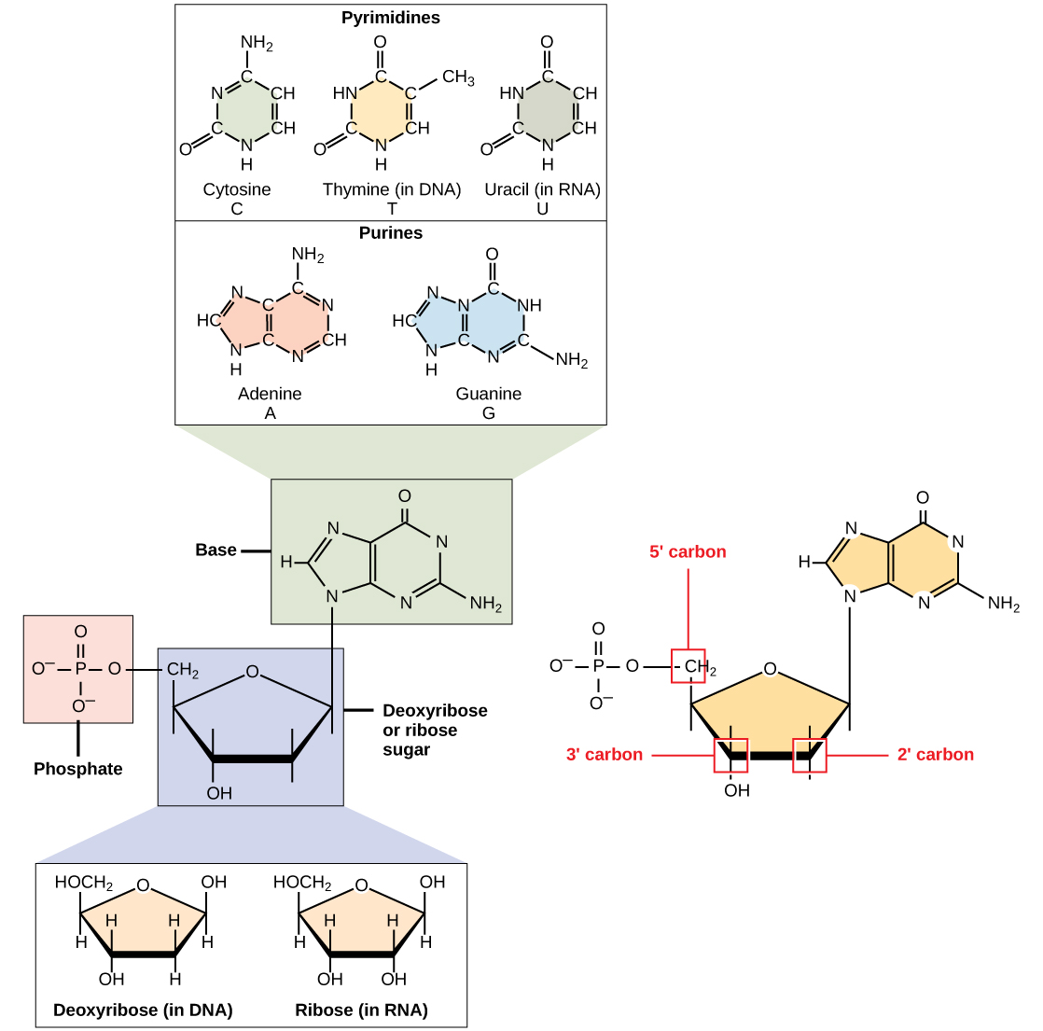 | 20 minutes

IN CLASS ACTIVITY: NUCLEOTIDE VS NUCLEOSIDES |  | 30 minutes | Do no to use the internet  Discuss in group.
Purpose: | Compare and contrast nucleotide and nucleoside | 30 minutes | Do no to use the internet  Discuss in group.
Over to you: | Use your laptop and go to the internet search the definition of nucleosides. | 30 minutes | Do no to use the internet  Discuss in group.
Activity: | Using a comparison chart differentiate nucleotide and nucleoside  Select one group to draw the structure of nucleotide and another group the structure of nucleoside.  Discuss their relevance in medicine. | 30 minutes | Do no to use the internet  Discuss in group.

Nucleotide polymerization  When a nucleic acid polymer forms the 5’-phosphate group of one nucleotide unit is joined to the 3’-hydroxyl group of the next nucleotide with the release of water and forming a phosphodiester bond.  A nucleic acid, then, is simply a chain of five-carbon sugars linked together by phosphodiester bonds with an organic base protruding from each sugar.  Figure 2.23. Phosphodiester bonds between nucleotides. By Kes47. July 4th,2010. Accessed February 27, 2019.  https://commons.wikimedia.org/wiki/File:Phosphodiester_Bond_Diagram.svg | 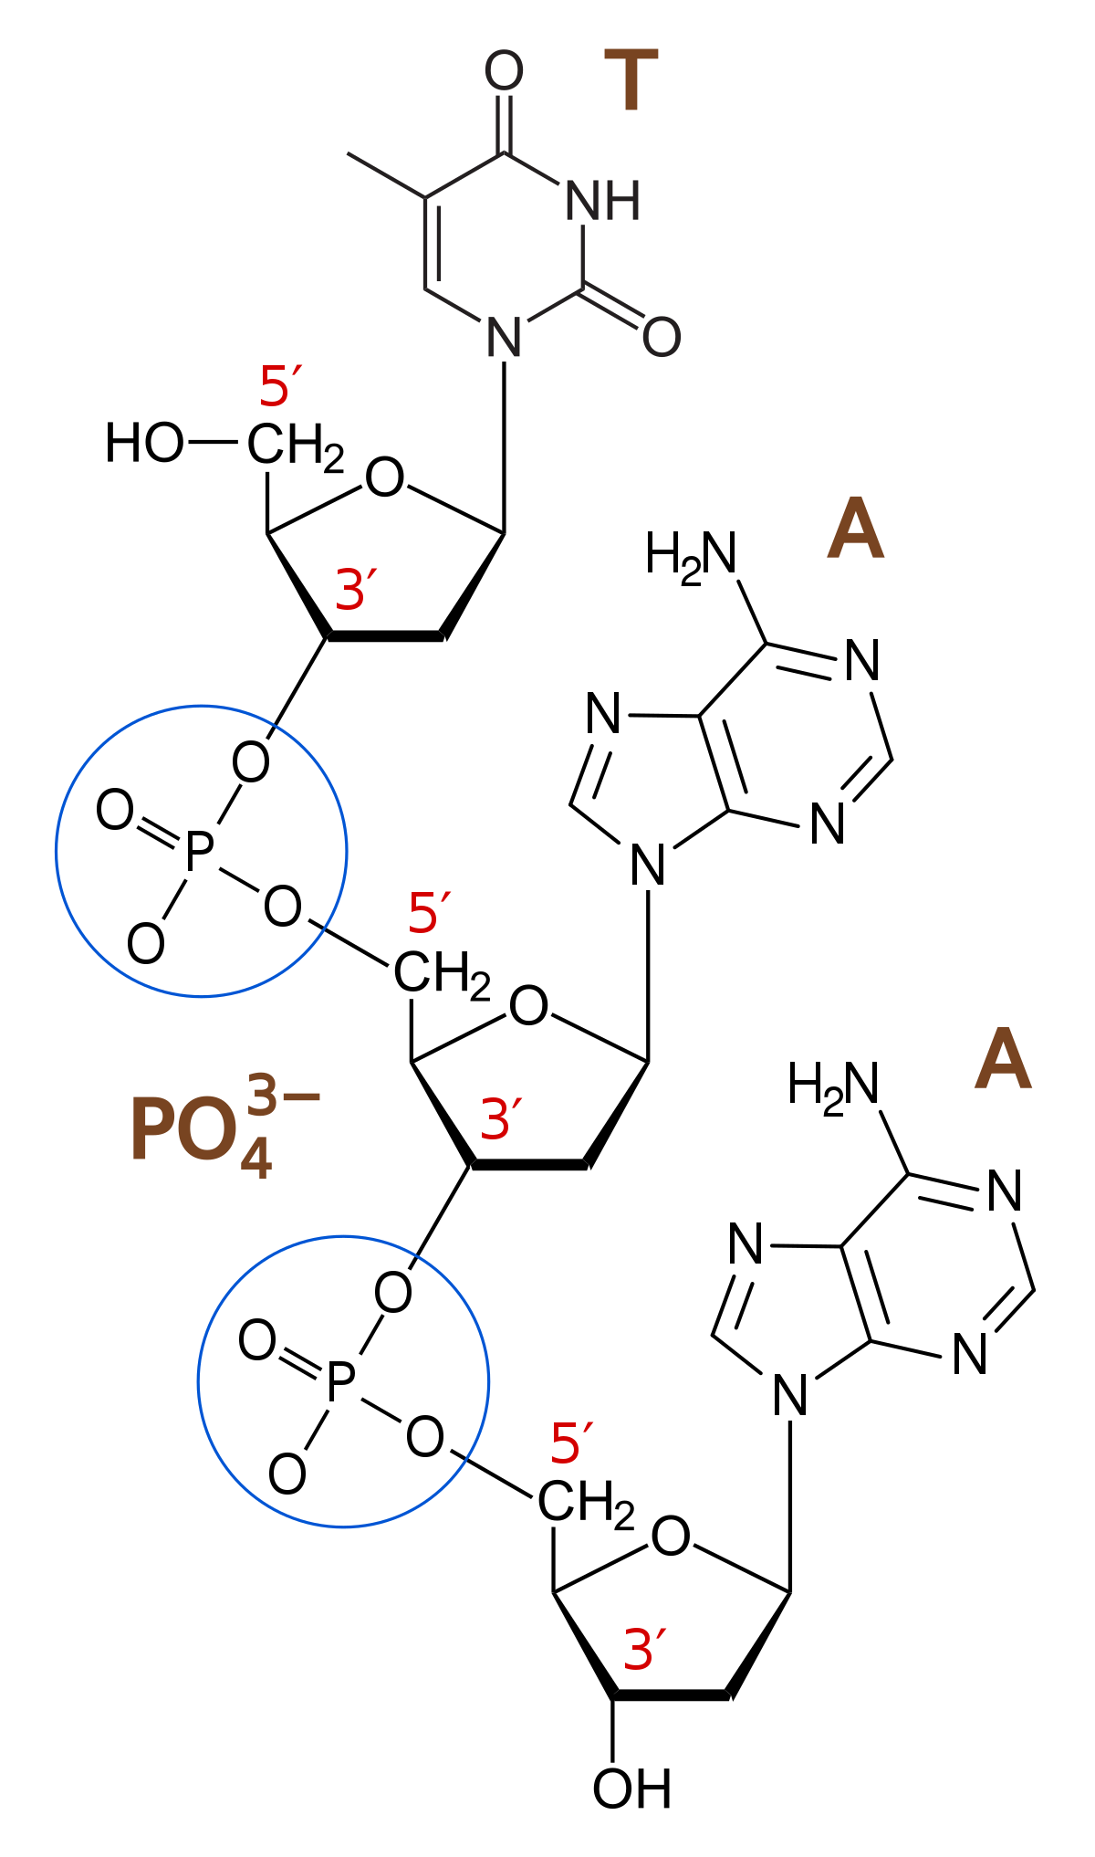 | 20 minutes | Note to tutor  Explain:  The 5’ to 3’orientation of a strand of nucleic acid refers to the ends of the strand, not the orientation of the individual phosphodiester bonds linking its constituent nucleotides

DISCOVERY OF DNA | 20 minutes | Notes to tutor
Before to the discovery of DNA as the genetic material , researchers thought "gene" to mean as the smallest unit of inheritance, but they did not know how a gene could convey the genetic information , generation after generation.  In 1928, Griffith’s transformation experiment suggested that bacteria are capable of transferring genetic material through a process known as transformation (Figure 4.1). | 20 minutes
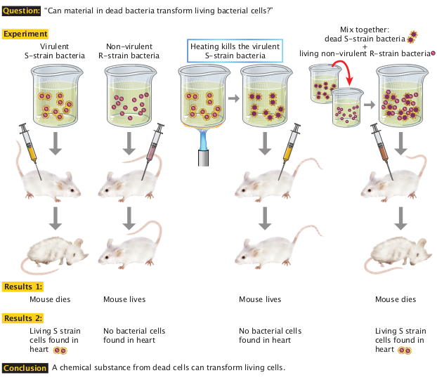  Figure 2.24 Griffith's experiment discovering the "transforming principle “in pneumococcus bacteria. By : O'Connor, C. (2008) https://www.nature.com/scitable/topicpage/isolating-hereditary-material-frederick-griffith-oswald-avery-336 | 20 minutes

DNA was known to be composed of 4 different nucleotides. A nucleotide is composed of a phosphate group, a deoxyribose sugar, and a nitrogen base.  Alexander Todd had determined that the backbone of the DNA molecule contained repeating phosphate and deoxyribose sugar groups, while Chargaff had establish the famous rule :  - The proportion of Adenine always equals that of Thymine , and the proportion of Guanine always equals that of Cytosine , or: A = T, and G = C.  - It follows that there is always an equal proportion of purines (A and G) and pyrimidines (C and T).  Franklin and Wilkins X-ray images of DNA fibers suggested a helical, corkscrew-like shape.  In 1953, Watson and Crick put it all together came up with their renowned model of the DNA | 20 minutes | Notes to tutor
 | 20 minutes | P

IN CLASS ACTIVITY: GRIFFFITH’s BACTERIAL EXPERIMENTS |  | 30 minutes
Purpose: | To explain how Griffith’s bacterial experiments showed that a hereditary factor was involved in transformation. | 30 minutes
Over to you: | Watch this video then to this activity below | 30 minutes
Activity: | By drawing a colorful diagram to illustrate this experiment and writing an explanation of this diagram show different step of Griffith’s bacterial experiments. | 30 minutes

DNA STRUCTURE  The Watson-Crick model suggested the model of DNA double-helix structure.  The secondary structure of DNA refers to its double-stranded duplex structure with (Figure.2.24) important features of the DNA structure :  - Base pairing: G pairs with C; A pairs with T  - Antiparallel strands: the two strands of DNA are always oriented in an antiparallel fashion, where one strand runs in the 3’ to 5’ direction and the other runs in the 5’ to 3’ direction.  - Right-handed double helix  - Strands held together by hydrogen bonding between base pairs.  - DNA molecule has major and minor grooves |  | 20 minutes | Note to tutor  Project this video about DNA double helix
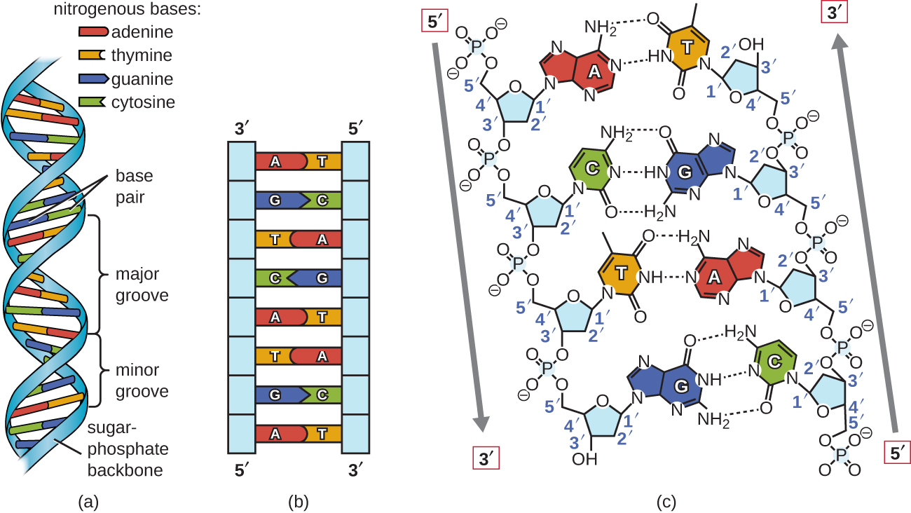  Figure 2.25: The double helix model for DNA. (a) The double helix. (b) double line consisting of two complementary strand (c) The two DNA strands are antiparallel to each other. By OpenStax College. Nov 1, 2018 OpenStax College Microbiology. accessed November 27,2018 https://cnx.org/contents/5CvTdmJL@5.28:BRkZ3N-w/Structure-and-Function-of-DNA. |  | 20 minutes
RNA STRUCTURE  Single chain  Ribose sugars  - Adenine pair only with Uracil  - Cytosine pair only with Guanine | 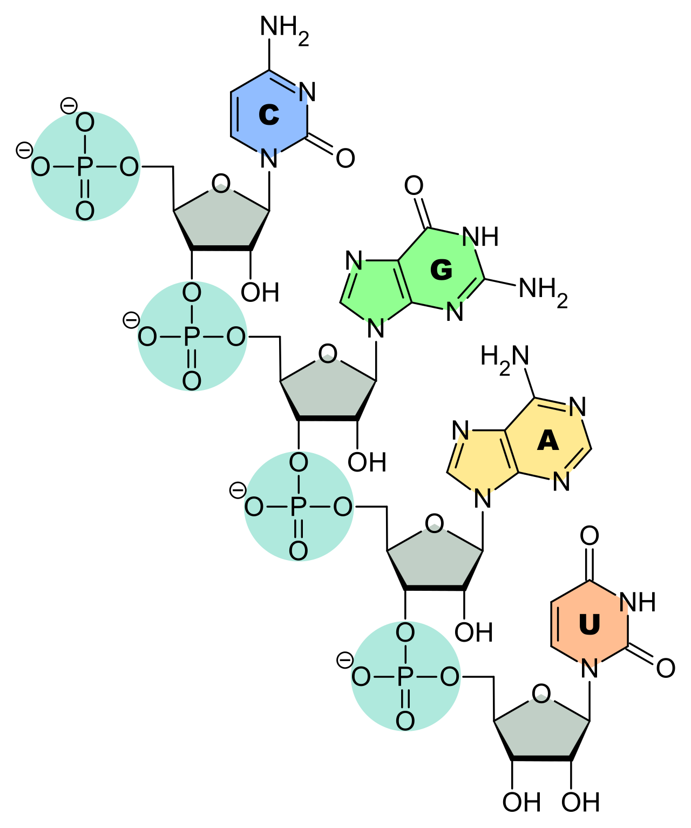 | 20 minutes
 | Figure 2.26: Single stranded RNA with ribose sugar that has a hydroxyl group at the 2′ carbon. By Sponk. March25,2010. Accessed November 28,2018. https://commons.wikimedia.org/wiki/File:RNA-Nucleobases.svg#/media/File:RNA Nucleobases.svg | 20 minutes
Types of RNA  There are several different types of RNA with different roles , that occurs in different forms within organisms.  There are four types of RNAs that have important role in protein synthesis are:  - Messenger RNA acts as the “working copy” of the gene coding for a protein. The mRNA carries the information from the genome in the nucleus to the cytosol where protein synthesis occurs.  - Ribosomal RNA participates in the structure of ribosome. rRNA, ribosomal proteins and Mg⁺⁺ constitute ribosome. The ribosome is made of two subunits big and small. The rRNA ensures the proper alignment of the mRNA and the ribosomes.  - Transfer RNAs are the adaptor molecules in proteins synthesis. They have a three-base region (anticodon region) that recognizes and hydrogen bonds to the complementary codon in mRNA, which specifies a particular amino acids.  - MicroRNAs (miRNA) are the smallest RNA molecules and their role involves the regulation of gene expression by interfering with the expression of certain mRNA messages . |  | 20 minutes | For Tutors  Just for information to students read this link about types of RNA.

IN CLASS ACTIVITY: NUCLEIC ACIDS STRUCTURES |  | 30 minutes
Purpose: | This is to assemble the different component nucleic acids | 30 minutes
Over to you: | Sit in groups and open the associated files PPT then follow instructions. | 30 minutes
Activity: | The slide from the PPT file display the components of the four nucleotides found in DNA  The slide 3 from the PPT file displays the four nucleotides. Arrange them so that they are attached together and form a small nucleic acid strand.  Rename the file with your group number in front of the title (e.g: 3-Nucleic acid Activity if you are group in group 3 ) , save the file abd submit it in the LMS. | 30 minutes

LABORATORY PRACTICALS : LABORATORY REPORT REVIEW 1 |  | 120 minutes | To tutors :  Make sure that students have submitted their laboratory report on time.  Report must have been reviewed then feedback will be provided during this time.
Purpose: | This is a to provide feedback of all laboratory report done from week 1 up to now | 120 minutes
Over to you: | Lab tutors will be available to discuss specific questions about students report, general areas of confusion and offer advice offer general advice to the lab experiments. | 120 minutes
Activity | A global correction of the report will be organized as a special lecture and will be focused on the observed errors repeatedly present in submitted reports. | 120 minutes
Anticipated time required for Unit 2-5 activities :
Theory : 2h all activities + 2h self-learning
Practical : 2h

