Unit 3_1: COMPONENTS AND STRUCTURE OF PLASMA MEMBRANE | Where?  How long? | Explanations/Questions
Introduction  A living cell is a self-reproducing system of molecules held inside a container. That container is the plasma membrane—a fatty film so thin and transparent that it cannot be seen directly in the light microscope. Every cell on Earth uses a membrane to separate and protect its chemical components from the outside environment. Without membranes there would be no cells, and thus no life. | 10 minutes
Expectations | 10 minutes
This is an exciting opportunity to discover the way that biological membranes work, their structures. | 10 minutes | Explain here what it is they are going to be learning and why they need to know about biological membranes.  Also what the expectations are in terms of time commitment, tutor support and so on.
Learning outcomes | 10 minutes
At the end of this unit, you should be able to  - Describe the structure of the cell membrane.  - Describe the fluid mosaic model of biological membranes  - State and explain the functions of phospholipids, proteins, and carbohydrates in membrane | 10 minutes
Week 8
Unit 3: BIOLOGICAL MEMBRANES :

ACTIVITY AHEAD OF LESSON: COMPONENTS AND STRUCTURE OF PLASMA MEMBRANE |  | 10 minutes
Purpose: | This is an introduction to the composition and structure of cell membrane | 10 minutes
Over to you: | Read the following link to open resource of cellular membrane  Be certain to note anything that you don’t understand | 10 minutes
Activity: | As you watch this animation, make notes of  - Type of molecules of cell membrane  Bring your notes to class so that you can participate in the conversation about passive transport across the cell membrane. | 10 minutes

IN CLASS ACTIVITY: CELL MEMBRANE STRUTURE 1 |  | 10 minutes for search,  15 minutes for feedback | In Groups of 3 or 4.  Small groups allow each student to voice an opinion.  Move among the groups, making sure (by asking probing questions of any quiet students) that no student is dominating a group.  Stick strictly to timing – DON’T allow yourself to be sidetracked!  During the feedback part, ask group spokespeople  - to give ONE point (under one of the 3 headings)  - to say which heading it belongs to, and  - only to add new points to the lists.  But make sure that every group has the opportunity to be heard.
Purpose: | To study the components of the cell membrane | 10 minutes for search,  15 minutes for feedback
Over to you: | Ask the students to  - choose a spokesperson, and  - use their laptop to search the internet for information about cell structures and to make a list of the characteristics of cells, the composition of cell membranes and the function of cell membranes. | 10 minutes for search,  15 minutes for feedback
Activity: | On the board, draw up a list with 3 columns, headed “Characteristics”, “Composition” and “Function”.  Using the answers (see suggestions for including as many as possible) as a starting place, and adding any important aspects that have not been covered, and move into teaching about the biological membrane. | 10 minutes for search,  15 minutes for feedback

BIOLOGICAL MEMBRANES | 10 minutes | Project Figure 3.1 onto the screen and, using the characteristics, composition and functions that the students researched as a starting point EXPLAIN the diagram – mentioning what it important to know about it.
Biological membranes are bilayers that are approximately 7.5 nm in width and are assembled from a mixture of lipids , proteins and carbohydrates.  Cell Membrane (also known as plasma membrane or plasmalemma) are the inner parts of the cell from the outer environment. It acts as a selectively permeable barrier to allow certain chemicals, namely water, to pass and others to not pass.  In multicellular organisms certain chemicals on the membrane surface act in the recognition of self. | 10 minutes
COMPOSITION OF CELL MEMBRANE  The plasma membrane is composed of approximately equal proportions of lipids and protein. | 10 minutes
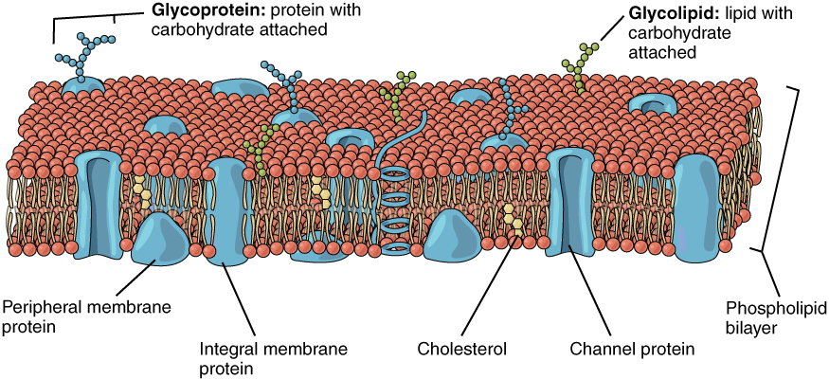  Figure 3.1: The components of plasma membrane. OpenStax Biology 2nd Edition, Biology 2e. OpenStax CNX. Feb 13, 2019. Accessed on February 15, 2019. https://cnx.org/contents/jVCgr5SL@15.3:tkYxfIqu@10/5-1-Components-and-Structure#31660 | 10 minutes

LIPIDS  Lipids are the most abundant type of macromolecule present and its properties are responsible for the general properties of all cell membranes. Plasma and organelle membranes contain between 40% and 80% lipid. There are three types of lipids are found  - Phospholipids :The most abundant of the membrane lipids are derivatives of phosphoric acid and 2 long non-polar hydrocarbon (fatty acids) chains attached to glycerol. Four major phospholipids are found in animal cells:  - phosphatidylcholine  - phosphatidylethanolamine  - phosphatidylserine, and  - sphingomyelin.  The outer leaflet of the plasma membrane consists mainly of phosphatidylcholine and sphingomyelin whereas phosphatidylethanolamine and phosphatidylserine are the predominant phospholipids of the inner leaflet.  A fifth phospholipid  - phosphatidylinositol  is also localized to the inner half of the plasma membrane. Although phosphatidylinositol is a quantitatively minor membrane component, it plays an important role in cell signaling.  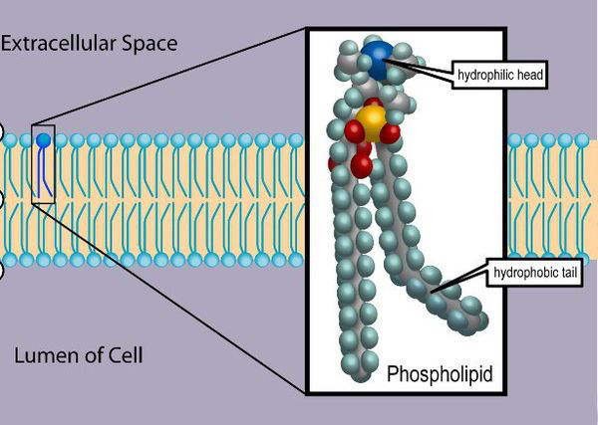  Figure 3.2: Phospholipid form bilayer in water due to amphipathic properties of the phospholipid. By Superscience 71421. November 20,2016. Illustration [diagram]. https://en.wikipedia.org/wiki/Phospholipid#/media/File:Phospholipid_TvanBrussel.edit.jpg | 15 minutes | Don’t assume that students understand what you are talking about.  - Ask questions (learn students’ names as quickly as possible after the start of the module).  - Jump around the class so that everyone pays attention !  - Make sure that you don’t always ask the same person.  - Try to give everyone at least one turn to answer.  - If someone doesn’t know an answer, move on – don’t make them feel self-conscious.
- Cholesterol: is another major component of cell membranes. Cholesterol is dispersed throughout cell membranes, intercalating between phospholipids. Cholesterol fits into the spaces created by the kinks of the unsaturated fatty acid tails, decreasing the ability of the fatty acids to undergo motion and therefore causing stiffening and strengthening of the membrane.  - Glycolipids: are a combination of a lipid and a carbohydrate with a polar head and non-polar tails, with galactose being the most common monosaccharide, while inositol, a cyclic alcohol are part of the polar head. Glycolipids are in lower concentration (about 2%) than phospholipids and cholesterol. The carbohydrate portion is always oriented toward the outside of the cell, projecting into the environment. Glycolipids help to form the carbohydrate coat observed on cells and are involved in cell- to-cell interactions | 10 minutes | The structure of Cholesterol and Glycolipids has already been learn during the unit 2-3(Lipids)

PROTEINS  The dynamic functions of the membrane are carried out by protein. Plasma membrane proteins, which are frequently glycoproteins, include hormone receptors, transports proteins, ions channels, and enzymes.  There are two basic types of membrane protein: integral and peripheral proteins (figure 3.1).  - Integral membrane proteins or gateway proteins are embedded in the lipid bilayer and cannot be removed without disrupting the bilayer. They span the lipid bilayer one or more times, and their association with the membrane is stabilized by hydrophobic interactions. Many integral proteins are transmembrane proteins, which span the lipid bilayer with portions exposed on both sides of the membrane.  - Peripheral membrane proteins are loosely associated with the membrane and can be removed by alterations in the pH, by an increase in ionic strength, or by other conditions that interfere with ionic interactions. They are bound to the membrane by interaction with the polar head groups of phospholipids or with exposed regions of other membrane proteins. | 10 minutes | - Ask the students more questions as you go along.  - Use metaphors to explain elements of complex ideas.  - Ensure that student understand the difference between integral and peripheral proteins.

IN CLASS ACTIVITY: CELL MEMBRANE STRUTURE 1 |  | 30 minutes | Sit in previous group.
Purpose: | To study the structure of the cell membrane | 30 minutes | Sit in previous group.
Over to you: | Use your laptop and go to the following links | 30 minutes | Sit in previous group.
Activity: | Construct the cell membrane using the correct molecules | 30 minutes | Sit in previous group.

PROPERTIES OF CELL MEMBRANE  The driving force for formation of lipid bilayers is the hydrophobic interaction between the fatty acid chains of the lipid components.  - Structure: the bilayer consists of two leaflets held together by hydrophobic interactions between the fatty acids in each leaflet. The polar head groups of the outer leaflet interact with the aqueous environment outside the cell, while those of the inner leaflet interact with the cytosol.  - Asymmetry: Lipids, proteins, and carbohydrates are all asymmetrically distributed across the lipid bilayer. Some phospholipids are found on the outer leaflet while others are more commonly seen on the inner leaflet. In addition, glycolipids are differentially arranged as well and are always on the outer leaflet with their attached carbohydrate projecting away from the cell.  - The fluid mosaic model: In 1972, (Singer and Nicolson, 1972) proposed the ‘Fluid Mosaic Model’ with the hypothesis that cell membranes are composed of a lipid bilayer with globular proteins embedded in the bilayer. In this model, both proteins and lipids are not static. They are in motion, behaving like protein islands in a sea of lipids. | 15 minutes | Keep the focus on the diagram that is on the screen (see above).  More questioning …  - Explain the fluid mosaic model.
- Fluidity: The fluidity of membranes is derived from their lipid content. Biological membranes act as two-dimensional fluids, where the molecules can rotate or move laterally.  Molecules rarely “flip flop” from one side of the membrane to the other. The fluidity of a membrane depends also on the temperature and the nature of the fatty acids.  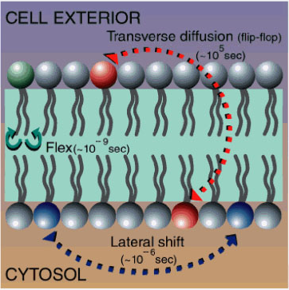  Figure 3.3: Lateral lipid movement and transverse (flipflop movement). By Hyou . November 16, 2009. Accessed February 28, 2019.  https://commons.wikimedia.org/wiki/File:Lipidmove.jpg | 10 minutes

IN CLASS ACTIVITY: FLUID MOSAIC MODEL |  | 30 minutes | Sit in previous group.
Purpose: | To describe the mosaic fluid model | 30 minutes | Sit in previous group.
Over to you: | Read this paper about the fluid mosaic model. | 30 minutes | Sit in previous group.
Activity: | Answer following question:  - Before the fluid mosaic model was adopted as the suitable model for a cell membrane, which models of plasma membrane model were proposed? Why they were not accepted?  Each group will use two PPT slides to provide their feedback , followed by class discussion. | 30 minutes | Sit in previous group.

Anticipated time required for Unit 3-1 activities :
Theory : 2h all activities + 2h self-learning

Reference

Singer, S.J., Nicolson, G.L., 1972. The fluid mosaic model of the structure of cell membranes. Science 175, 720–31.

