WEEK 8
Unit 3_2: MEMBRANE TRANSPORT MECHANISM | Where?  How long? | Explanations/Questions
Introduction  The plasma membrane is a selective barrier that maintains distinct internal and external environments by controlling the passage of molecules into and out of the cell. Several mechanisms are used for the transport of molecules across the membrane. | 10 minutes
Expectations  This lesson is on transport across the cell membrane, we will learn in detail about the types of transport across the membrane. | 10 minutes
Course outline  Transport across the plasma membrane  Passive transport  Active transport  Bulk transport | 10 minutes | As a future health practitioner , to study the membrane transport will allow to understand the involvement of membranes and membrane proteins in ion and solute transport, signal transduction and vesicular transport.
Learning outcomes | 10 minutes
At the end of this unit, you should be able to  - Distinguish different mode of transports across the biological membrane  - Compare simple diffusion and facilitated diffusion.  - Differentiate between channel proteins and carrier proteins.  - Predict the direction of water movement by osmosis.  - Distinguish between endocytosis and exocytosis.  - Illustrate how endocytosis can be specific. | 10 minutes

ACTIVITY AHEAD OF LESSON: Transport across the plasma membrane |  | 20 minutes
Purpose: | This is an introduction to the concept of passive transport across the plasma membrane | 20 minutes
Over to you: | Read the following resources about transport across the cell membrane.  Be certain to note anything that you don’t understand | 20 minutes
Activity: | As you watch this animation, make notes of  - All modes of transport | 20 minutes

TRANSPORT ACROSS THE PLASMA MEMBRANE  The plasma membrane is a selective barrier that maintains distinct internal and external environments by controlling the passage of molecules into and out of the cell.  Several mechanisms are used for the transport of molecules across the membrane: | 15 minutes | To tutors  Watched this video.  Invite them to share parts of the video that they found challenging and be certain to address any reported gaps in their understanding during class.
Selective Permeability  Plasma membranes have hydrophilic and hydrophobic regions.  This cell membrane property determines what substances can enter or leave the cell.  Lipid-soluble material can easily slip through the hydrophobic lipid core of the membrane.  Small and non-polar molecules, such as O₂and CO₂, will diffuse rapidly across the lipid bilayer, whereas it is impermeable to ions and polar molecules: glucose, sucrose, Na+, H+, Cl-.  Therefore ions and polar molecules must have a special means of penetrating plasma membranes, then they requires the presence of integral membrane proteins that function as transport proteins. | 15 minutes

PASSIVE TRANSPORT  The movement of molecules across a membrane from a region of higher concentration to a region of lower concentration is termed ‘passive transport’ because it requires no external source of energy. |  | 10 minutes | Continue to draw on the work that they did in the pre-class activity as a foundation for teaching Passive Transport..
- SIMPLE DIFFUSION  A single substance tends to move from an area of high concentration to an area of low concentration until the concentration is equal across the space.  Small uncharged molecules such as O₂ and CO₂ can pass through the lipid bilayer by simple diffusion from a region of higher concentration to a region of lower concentration; ions can move through open ion-selective protein channels via simple diffusion. | 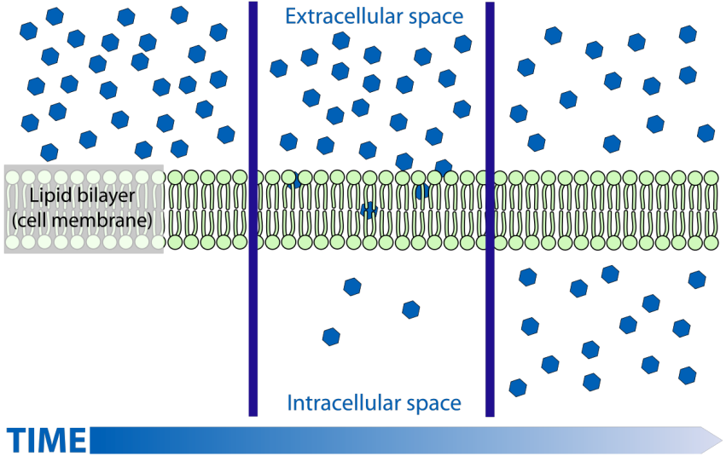  Figure 3.4: Simple diffusion, the movement of particles from an area where their concentration is high to an area that has low concentration. one of the different ways in which molecules move in cells. By Bibi Saint-Pol. May 2, 2008. Accessed February 28,2019. https://commons.wikimedia.org/wiki/File:Scheme_simple_diffusion_in_cell_membrane-en.svg | 10 minutes

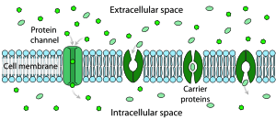  Figure 3.5: Facilitated diffusion in cell membrane, showing ion channels and carrier proteins.  By Mariana Ruiz Villarreal. February 4, 2007. Accessed February 28, 2019. https://en.wikipedia.org/wiki/Facilitated_diffusion#/media/File:Scheme_facilitated_diffusion_in_cell_membrane-en.svg | IN CLASS ACTIVITY: Ion channels and carrier proteins |  | 15 minutes
 | Purpose: | To explore the function of ion channels and carrier proteins | 15 minutes
 | Over to you: | Using laptop follow the links below the diagram and read the associated web pages. | 15 minutes
 | Activity | Using a table, make a list of  - The characteristics of ion channels  - The functions of ion channels  - The nature of carrier proteins  - The role of carrier proteins in facilitated diffusion | 15 minutes
- FACILITATED DIFFUSION  In this transport, molecules moves across the plasma membrane with the assistance of proteins carrier to move from a region of higher concentration to a region of lower concentration without the expenditure of cellular energy.  All of the transport proteins are integral membranes proteins that span the membrane multiple times.  The integral proteins involved in facilitated transport are collectively referred to as transport proteins, and they function as either channels for the material or carriers.  Three types of transport by carrier proteins  - Uniport (a single substance, moves in a single direction)  - Symport (two substances, moves in the same direction)  - Antiport (two substances, moves in opposite directions) |  |  | 20 minutes | Ask the students to feed back to the class what they learned in the In-Class activity.  Have a table with 4 columns – same headings as in activity) – on the board and write their answers (one/student – they need to say which column).  After completing the table (adding in any aspects that are missing), ask students to say if there is anything they don’t understand.  THEN re-explain the concept of facilitated diffusion, being certain to address any identified gaps in understanding.

ACTIVITY AHEAD OF LESSON: Osmosis and Tonicity: |  | 30 minutes | You may want to offer questions that they should answer from what they have watched, rather than simply asking them to make notes
Purpose: | In this activity we are going to establish our understanding of how osmosis (the movement of water, through semi-permeable membrane) works and the passive transport potential of tonicity. | 30 minutes
Over to you: | Watch this short video on osmosis and tonicity.  Then watch it again, making the notes suggested in the activity.  Be certain to note anything that you don’t understand. | 30 minutes
Activity: | As you watch this animation, make notes of what you understand by  - Polarity of molecules  - Semi-permeability of a membrane  - The trigger for osmosis to occur  - Isotonic concentration  - Hypertonic concentration  - Hypotonic concentration  Bring your notes to class so that you can participate in the conversation about osmosis. | 30 minutes

- OSMOSIS  Osmosis is diffusion of water through a semipermeable membrane according to the concentration gradient of water across the membrane.  Water moves across a cell membrane from compartment with a lower solute concentration to a compartment with a higher solute concentration. The movement of water requires no expenditure of energy.  Osmotic pressure is defined as the force that would be required to prevent the movement of water between compartment. |  | 20 minutes | You may like to start the lesson by giving examples of osmosis in the body.–
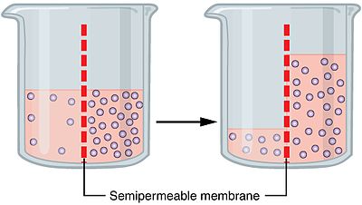 | Figure 3.6: The process of osmosis over a semi-permeable membrane. The blue dots represent particles driving the osmotic gradient. By OpenStax Biology 2nd Edition, Biology 2e. OpenStax CNX. Feb 13, 2019. Accessed February 28, 2019.  https://cnx.org/contents/jVCgr5SL@15.3:xy5C3n_j@10/5-2-Passive-Transport | 20 minutes

IN CLASS ACTIVITY: Demonstrating osmosis (Part 1 and Part 2) |  | 30 minutes | Note to instructor  Having written up the start of the experiment, the lesson can continue.  Towards the end of the lesson, or at the start of the next lesson (in which case the beakers should be labelled with students’ names and kept in a safe place), students can return to the experiment and observe the changes in level of the liquid on either side of the membrane.  They should then write up the rest of the experiment, noting the changes, and drawing conclusions from what they have watched in the pre-class activity and heard in class.
Purpose: | To demonstrate osmosis in action | 30 minutes
Over to you: | In pairs, students do an experiment using mushed potatoes | 30 minutes
Activity: | To experiment with osmosis using potatoes, you will need two shallow dishes, a potato, knife, water and salt.  Fill both of the dishes with an inch of water. Add two tablespoons of salt to only one dish, while leaving the other plain. (Be sure to label which dish is plain and which has salt added to it.)  Slice the potato lengthwise, so that you end up with several pieces that are flat on both sides.  Place a few pieces of potato into the plain water, and an equal number of pieces into the salty water.  Allow the potatoes to sit for 20 minutes, then come back and allow the students to make their observations, and explain to them what happened.  The potatoes that were in the salt water now appear mushy because of osmosis. Due to the higher concentration of salt in the water surrounding the potatoes, the water moved from the potatoes and into the surrounding water to balance it out.  This left the potatoes in the salt water mushy, while the ones in the plain water have no change to their appearance | 30 minutes

- TONICITY  Describes the ability of a solution to cause a cell to gain or lose water. It depends on the concentration of a solute.  It mostly depends on the concentration of a solute or salts on both sides of the membrane.  - Hypertonic solution  A hypertonic solution is one that has a lower water potential as compared to the other solution.  The solute concentration is higher outside the cell, water molecules move out of the cell. The cell will shrink.  Cell crenation is when an animal cell loses water and shrinks. |  | 15 minutes | Project this video about osmosis and tonicity.  Explain to students what is  Hypotonic  Isotonic  Hypertonic solution.  In living systems, the point of reference is always the cytoplasm, so the prefix hypo– means that the extracellular fluid has a lower concentration of solutes, or a lower osmolarity, than the cell cytoplasm.
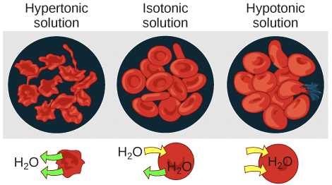 | Figure 3.7: Osmotic pressure changes the shape of red blood cells in hypertonic, isotonic, and hypotonic solutions. By Mariana Ruiz Villarreal. February 17, 2007. Accessed February 28, 2019. http://selfservice.mifotra.gov.rw/RBM/CreateTarget?contractId=230184&usertoken=53703908 | 15 minutes
- Isotonic solutions
Isotonic solutions have the same water potential. The concentration of solute is the same on both sides of a membrane, and the cell volume will not change .

- Hypotonic solution
A hypotonic solution is one that has a high water potential as compared to the other solution .
The solute concentration is lower outside the cell, water molecules move into the cell, and the cell will expand and may burst. This bursting of an animal cell caused by over stretching of the cell membrane is called lysis.

ACTIVITY AHEAD OF LESSON: Active transport |  | 30 minutes
Purpose: | To explore the mechanisms of active transport between the extracellular fluid and the cytoplasm. | 30 minutes
Over to you: | In this short video there is an animated explanation of the exchange of sodium and potassium ions between the extracellular fluid and the cytoplasm.  Watch the video. Then watch it again, making the notes suggested in the activity.  Be certain to note anything that you don’t understand. | 30 minutes
Activity: | As you watch this animation, make notes of  - The role of the Sodium-Potassium exchange pump (Na+K+ATPases pump)  Think about: what makes this an example of Active Transport (compared with the passive transport we have been studying?)  Bring your notes to class so that you can participate in the conversation about active transport across the cell membrane | 30 minutes

ACTIVE TRANSPORT  Active transport is the movement of molecules across a membrane from a region of low concentration to a region of high concentration that requires the expenditure of energy. The hydrolysis of ATP by ATPase is directly coupled to this transport, and the free energy released in hydrolysis is used to move ions up an electrical or concentration gradient.  Types of active transport: |  | 15 minutes | Draw on the pre-lesson activity that students did.  Invite one or two to tell the class what they found interesting, or difficult. If there was a concept that they found hard, ask whether another student can explain it. Even if the explanation is questionable or limited, give recognition to the student who answered – it’s quite scary – and ensure that any shortfall in the explanation is addressed in a kind way.
- Primary active transport:  This is also called direct active transport, and directly uses energy to transport molecules across a membrane. Molecules such as ions, are transported into the cell by primary active transport, and often, at the same time, a second substance is moved out of the cell.  This active transport require pumps or carrier proteins that work against electrochemical gradients and to cross membranes. |  | 15 minutes
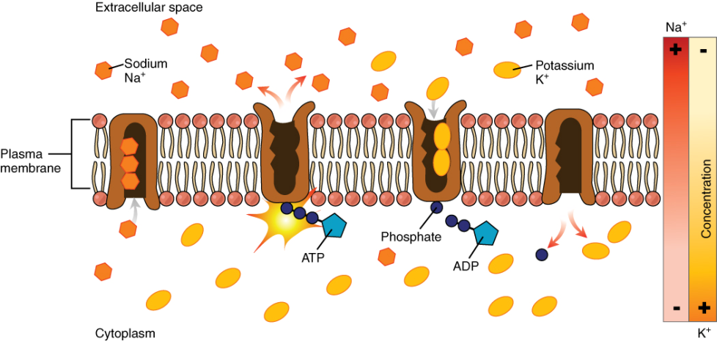 | Figure 3.8 : The sodium-potassium pump is found in many cell membranes. Powered by ATP, the pump moves sodium and potassium ions in opposite directions, each against its concentration gradient. In a single cycle of the pump, three sodium ions are extruded from and two potassium ions are imported into the cell. By OpenStax, Anatomy and Physiology. OpenStax CNX. Feb 12, 2019. Accessed on February 28, 2019. https://cnx.org/contents/FPtK1zmh@15.1:q2X995E3@16/3-1-The-Cell-Membrane | 15 minutes
- Secondary active transport:  This is also known as co-transport. It uses the energy of the electrochemical gradient created by primary active transport to move molecules against their gradients.  Co-transport allows substances such as amino acids and glucose to enter into the cell through membrane channels . |  | 20 minutes | - What is “electro-chemical gradient” needs careful explanation.
- Bulk transport  There are two types of bulk transport, exocytosis and endocytosis, that transport substances into or out the cells via vesicles, and both require the expenditure of energy (ATP).  - Endocytosis: is the movement of macromolecules from outside of the cell into the cell by active invagination of the plasma membrane.  Endocytosis has been divided into three categories:  - receptor-mediated endocytosis,  - fluid-phase endocytosis(pinocytosis),and  - phagocytosis. |  | 20 minutes
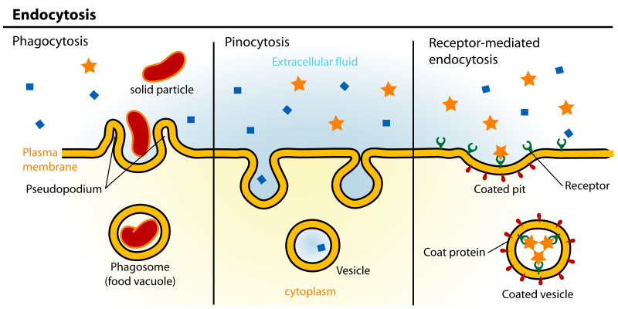 | Figure 3.9. Three variations of endocytosis are shown. (a) In one form of endocytosis, phagocytosis, the cell membrane surrounds the particle and pinches off to form an intracellular vacuole. (b) In another type of endocytosis, pinocytosis, the cell membrane surrounds a small volume of fluid and pinches off, forming a vesicle. (c) In receptor-mediated endocytosis, uptake of substances by the cell is targeted to a single type of substance that binds at the receptor on the external cell membrane.  By Mariana Ruiz Villarreal. July 27, 2007. Accessed February 28, 2019. https://en.wikipedia.org/wiki/Endocytosis#/media/File:Endocytosis_types.svg | 20 minutes

- Exocytosis  Movement of macromolecules out the cell is achieved by exocytosis. Cells use this process for both secretion and excretion of undigested food. A membrane-limited vesicle or secretory granules fuses with the plasma membrane and releases its contents into the extracellular space, without disrupting the plasma membrane. |  | 10 minutes
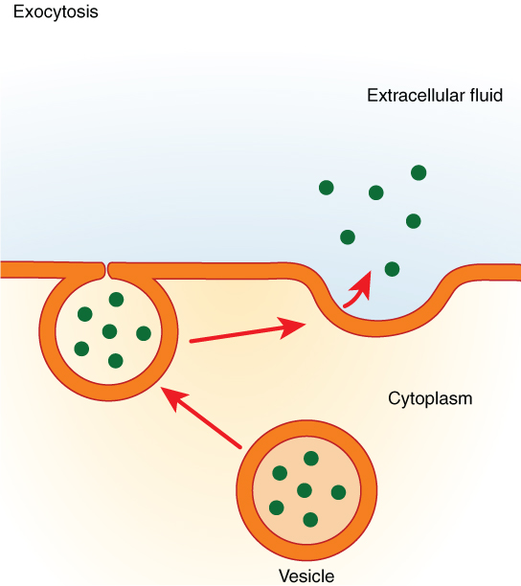 | Figure 3.10: In exocytosis, a vesicle migrates to the plasma membrane, binds, and releases its contents to the outside of the cell. By OpenStax, Anatomy and Physiology. OpenStax CNX. Feb 12, 2019. Accessed on February 28, 2019. https://cnx.org/contents/FPtK1zmh@15.1:q2X995E3@16/3-1-The-Cell-Membrane | 10 minutes

IN CLASS ACTIVITY:BULK TRANSPORT |  | 30 minutes | You can watch also this video  Volunteer will be selected to answer each question,
Purpose: | To compare endocytosis and exocytosis | 30 minutes
Over to you: | Watch this short video then complete the quiz to test your knowledge of the concept. | 30 minutes
Activity: | Answer these question:  What is pinocytosis?  Describe the process for Receptor Mediated Endocytosis?  How are pseudopods formed in order to phagocytose particles or bacteria? | 30 minutes

LABORATORY PRACTICALS : OSMOSIS AND CELLULAR PERMEABILITY |  | 120 minutes | To tutor  This paper will help you to prepare this activity.  .
Purpose: | To demonstrate osmosis in action | 120 minutes
Over to you: | Osmosis in Elodea Leaf Cells & Human Blood Cells | 120 minutes
Activity1 | Prepare a wet mount of an Elodea leaf in distilled water and a wet mount of Elodea  leaf in salt water for microscopic observation  Observe and diagram the cells in fresh water and in salt water  Compare normal cells in aquarium water to plasmolyzed cells in salt water | 120 minutes
Activity 2 | Watch this video of virtual laboratory about red blood cell hemolysis. | 120 minutes

Anticipated time required for Unit 3-2 activities :
Theory : 2h all activities + 2h self-learning
Practical : 2h

