WEEK 9
UNIT 4_1: DNA STRUCTURE AND GENOME ORGANIZATION | Where?  How long? | Explanations  /Questions
Introduction  The Watson-Crick model suggested the model of DNA double-helix structure. DNA consists of two antiparallel strand held together by hydrogen bond, and constitutes of nucleotides. Each nucleotide is composed of a nitrogenous base, a five-carbon sugar (deoxyribose), and a phosphate group. There are four nitrogenous bases in DNA, two purines (A and G) and two pyrimidines (C and T). Ribonucleic acid (RNA) a single-stranded nucleic acid. It contains ribose sugar, rather than deoxyribose, and the nucleotide uracil rather than thymine. | 10 minutes | Where is this from?
 | 10 minutes | This lesson will explore the race to find the structure of the DNA molecule, the parts of that structure and how they fit together, and how this knowledge has been used to advance mankind.
Expectation  In this chapter, brief history how DNA has been discovered as the main molecules that carry genetic information through generation. In addition, this chapter is intended to describe the structure of the main type of nucleic acid that carry genetic information: DNA . | 10 minutes
Course outline  Discovery of DNA  DNA structure  DNA packaging | 10 minutes
Learning outcomes | 10 minutes
At the end of this unit, you should be able to:  - Review the historical discoveries that led to establishing DNA as the genetic material.  - Describe how DNA is a double helix structure.  - Learn the base-pairing rule, its underlying reason and its effect on the DNA structure.  - Distinguish between DNA, gene, chromosome and genome.  - Explain the DNA structure. | 10 minutes

ACTIVITY AHEAD OF LESSON: DNA STRUCTURE |  | 30 minutes | To student  Note anything you do not understand for asking questions during face to face teaching
Purpose: | To review the structure of the DNA molecule and begin to understand how chromosomes, genes, and the base pairs, sugars, and phosphates of the DNA molecule are related. | 30 minutes
Over to you: | Watch the video about the journey into DNA and human genome project then answer the questions below: | 30 minutes
Activity: | Answer questions below:  - What is DNA?  - Where is DNA found?  - In what way does DNA provide the code of life?  - What are the four letters in a DNA molecule, and what do they represent? | 30 minutes
 | This is an interesting link for tutorials of Structure of DNA | 30 minutes

DISCOVERY OF DNA | 20 minutes | Notes to tutor
Before to the discovery of DNA as the genetic material , researchers thought "gene" to mean as the smallest unit of inheritance, but they did not know how a gene could convey the genetic information , generation after generation.  DNA was first isolated and characterized by Friedrich Miescher in 1868. He called the phosphorus-containing substance “nuclein.”  In 1928, Griffith’s transformation experiment (Griffith, 1928)suggested that bacteria are capable of transferring genetic material through a process known as transformation.  Erwin Chargaff and his colleagues in the late 1940s, found that the four nucleotide bases of DNA occur in different ratios in the DNAs of different organisms and that the amounts of certain bases are closely related. Two important findings from this work are often called Chargaff’s rules:  - The proportion of A always equals that of T, and the proportion of G always equals that of C, or: A = T, and G = C.  - The ratio of G–C to A–T varies with different species.  Avery, McLeod and McCarty showed that DNA is the genetic material in 1944. In a classic series of experiments, Oswald Avery and his coworkers Colin MacLeod and Maclyn McCarty identified the substance responsible for transformation in Griffith’s experiment.  Then in 1952, the Hershey-Chase experiment (HERSHEY & CHASE, 1952) showed that the DNA of a bacterial virus, but not its protein coat, carries the genetic message for replication of the virus in a host cell.  In 1953, Watson and Crick postulated that native DNA consists of two strands held together by formation of hydrogen bonds between bases on opposite strands. These bonds would result in specific base-pairs: Adenine (A) can form two hydrogen bonds with thymine (T) to form an A–T base- pair, and guanine (G) can form three hydrogen bonds with cytosine (C) to form a G–C base-pair. | 20 minutes | Explain what means transformation.  Introduce students to this experiments then let them perform the exercise  .  The Hershey-Chase will be explained

IN CLASS ACTIVITY: GRIFFFITH’S BACTERIAL EXPERIMENTS |  | 30 minutes | Sit in previous groups
Purpose: | To explain how Griffith’s bacterial experiments showed that a hereditary factor was involved in transformation. | 30 minutes | Sit in previous groups
Over to you: | Watch this video then to this activity below | 30 minutes | Sit in previous groups
Activity: | By drawing a colorful diagram to illustrate this experiment and writing an explanation of this diagram show different step of Griffith’s bacterial experiments.  Each group will present their work then the class with discuss about the work of each group. | 30 minutes | Sit in previous groups

GRIFFITH’S TRANSFORMATION EXPERIMENT | 20 minutes | Notes to tutor
Before to the discovery of DNA as the genetic material , researchers thought "gene" to mean as the smallest unit of inheritance, but they did not know how a gene could convey the genetic information , generation after generation.  In 1928, Griffith’s transformation experiment suggested that bacteria are capable of transferring genetic material through a process known as transformation (Figure 4.1). | 20 minutes | Explain what means transformation.  Introduce students to this experiments then let them perform the exercise  .
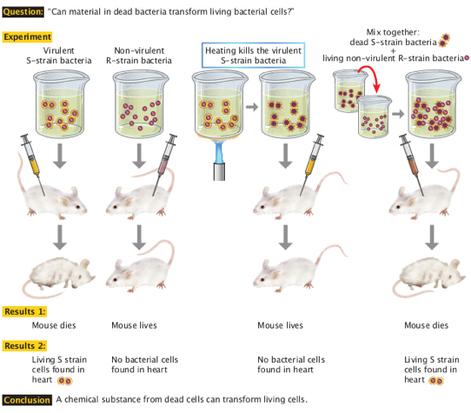  Figure 4.1: Griffith's experiment discovering the "transforming principle “in pneumococcus bacteria. By : O'Connor, C. (2008) https://www.nature.com/scitable/topicpage/isolating-hereditary-material-frederick-griffith-oswald-avery-336 | 20 minutes

The Hershey-Chase experiment | 20 minutes | Notes to tutor
In 1952, Alfred Hershey and Martha Chase conducted a series of experiments to prove that DNA was the genetic material:  - Viruses (T2 bacteriophage) were grown in one of two isotopic mediums in order to radioactively label a specific viral component  - Viruses grown in radioactive sulfur (³⁵S) had radiola belled proteins (sulfur is present in proteins but not DNA).  - Viruses grown in radioactive phosphorus (³²P) had radiolabeled DNA (phosphorus is present in DNA but not proteins)  The viruses were then allowed to infect a bacterium (E. coli) and then the virus and bacteria were separated via centrifugation  - The larger bacteria formed a solid pellet while the smaller viruses remained in the supernatant  The bacterial pellet was found to be radioactive when infected by the ³²P–viruses (DNA) but not the ³⁵S–viruses (protein)  - This demonstrated that DNA, not protein, was the genetic material because DNA was transferred to the bacteria  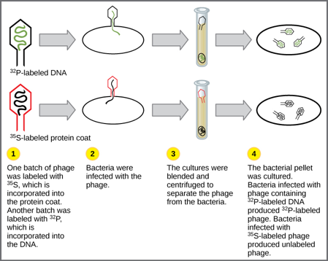  Figure 4.2: In Hershey and Chase's experiments, bacteria were infected with phage radiolabeled with either ³⁵S, which labels protein, or ³²P, which labels DNA. Only ³²P entered the bacterial cells, indicating that DNA is the genetic material. By OpenStax, Biology. OpenStax CNX. Nov 7, 2018. Accessed February 15, 2019. https://cnx.org/contents/GFy_h8cu@11.6:7c2Be-6u@7/Historical-Basis-of-Modern-Understanding | 20 minutes | Project this video about the Hershey-Chase experiment.

DNA STRUCTURE  The Watson-Crick model suggested the model of DNA double-helix structure.  The secondary structure of DNA refers to its double-stranded duplex structure with (Figure.2.24) important features of the DNA structure :  - Base pairing: G pairs with C; A pairs with T  - Antiparallel strands: the two strands of DNA are always oriented in an antiparallel fashion, where one strand runs in the 3’ to 5’ direction and the other runs in the 5’ to 3’ direction.  - Right-handed double helix  - Strands held together by hydrogen bonding between base pairs.  - DNA molecule has major and minor grooves | 20 minutes | Note to tutor  Project this video about DNA double helix
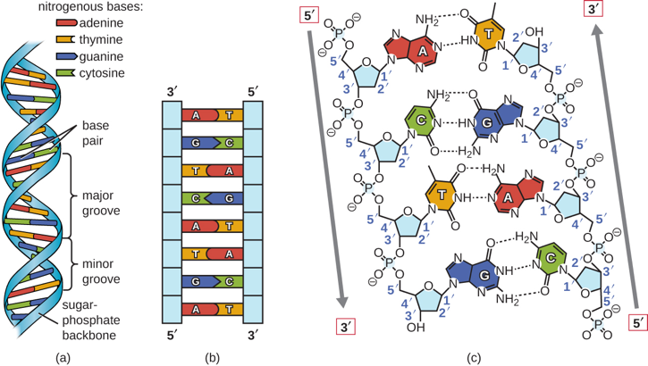  Figure 4.3: The double helix model for DNA. (a) The double helix. (b) double line consisting of two complementary strand (c) The two DNA strands are antiparallel to each other. OpenStax, Biology. OpenStax CNX. Nov 7, 2018  accessed February 27, 2019 https://cnx.org/contents/5CvTdmJL@5.28:BRkZ3N-w/Structure-and-Function-of-DNA. | 20 minutes

IN CLASS ACTIVITY: DNA STUCTURE |  | 30 minutes
Purpose: | This is review the DNA structure | 30 minutes
Over to you: | Watch this short video about DNA structure and fill the table below. | 30 minutes
Activity: | Attempt MCQ associated with the movie , then fill the table below.  Copy and paste this table and fill it | 30 minutes
  Components of DNA strand | Functions of DNA: | Example of the Shape/Structure of DNA:

ACTIVITY AHEAD OF LESSON: DNA PACKAGING |  | 30 minutes | To student
Purpose: | To how DNA can fit in the nucleus of a cell | 30 minutes | To student
Over to you: | Watch these tutorial about DNA packaging. | 30 minutes | To student
Activity: | Define following term:  - Genes,  - Genome  - Chromosome  - DNA Packaging | 30 minutes | To student
 | This is an interesting link for tutorials of Structure of DNA | 30 minutes | To student

HUMAN GENOME  A genome is an organism's complete set of DNA.  The human genome contains approximately 3 billion of these base pairs, which reside in the 23 pairs (46 chromosomes) of chromosomes within the nucleus of all our cells.  Each chromosome contains hundreds to thousands of genes, which carry the instructions for making proteins.  Each of the estimated 30,000 genes in the human genome makes an average of three proteins. | 20 minutes | Note to tutor  Make sure students understand following terms:  Chromosomes  Genes  Use this website to help students to understand what is the human genome

DNA PACKAGING IN THE CELLS:  DNA Packaging in prokaryote  In prokaryotes a well-defined nucleus is absent. The size of the genome of E.coli, is 4.6 million base pairs .  The DNA is twisted by what is known as supercoiling. Supercoiling means that DNA is either under-wound (less than one turn of the helix per 10 base pairs) or over-wound (more than 1 turn per 10 base pairs) from its normal relaxed state. Some proteins are known to be involved in the supercoiling; other proteins and enzymes such as DNA gyrase help in maintaining the supercoiled structure.  a. Negative supercoiling twists the DNA in the opposite direction from the clockwise turns of the right-handed double-helix. DNA is usually negatively supercoiled, the form required for most biological reactions.  b. Positive supercoiling adds torsional pressure and allows the DNA to be wound more tightly. In positive supercoils, the DNA is twisted in the same direction as the intrinsic winding of the double helix.  Here is a short video about the DNA gyrase activity that will explain the DNA supercoiling and supercoiling.  These figures illustrate the compaction of the eukaryotic chromosome. | 20 minutes | Note to tutor

DNA Packaging in Eukaryotes  Human Genome has about 3 billons of bases.  Human genome (in diploid cells) = 6 x 10⁹ bp  6 x 10⁹ bp X 0.34 nm/bp = 2.04 x 10⁹ nm = 2 m/cell  The Eukaryotic DNA is linear, than must use a different type of packing strategy to fit their DNA inside the nucleus (diameter of nucleus = 5-10 mm ).  DNA must be packaged to protect it, but must still be accessible to allow gene expression and cellular responsiveness  The DNA is wrapped around proteins known as histones to form structures called nucleosomes.  The histones are evolutionarily conserved proteins that are rich in basic amino acids and form an octamer.  Histones have a high density of positive charge that interacts with negatively charged phosphate groups of DNA.  There are various levels of organization of packaging.  The DNA wrapped in nucleosomes . This nucleosome is linked to the next one with the help of a linker DNA. This is also known as the “beads on a string” structure. This is further compacted into a 30 nm fiber, which is the diameter of the structure. At the metaphase stage, the chromosomes are at their most compact, are approximately 700 nm in width, and are found in association with scaffold proteins.  In interphase, eukaryotic chromosomes have two distinct regions that can be distinguished by staining. The tightly packaged region is known as heterochromatin, and the less dense region is known as euchromatin. Heterochromatin usually contains genes that are not expressed, and is found in the regions of the centromere and telomeres. The euchromatin usually contains genes that are transcribed, with DNA packaged around nucleosomes but not further compacted. | 20 minutes | Note to tutor  0.34 nm is distance between 2 bases  Term  diploid  Nucleosome  Histone

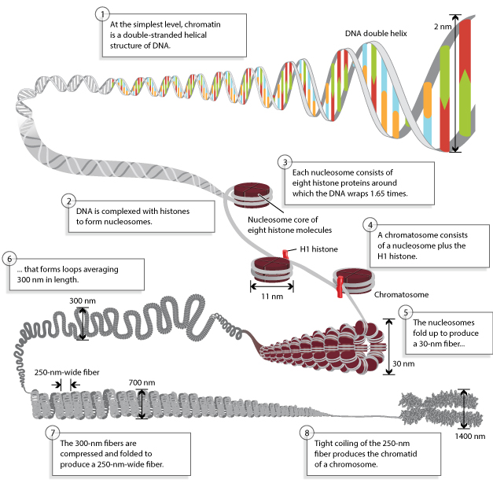  Figure 4.4: Chromosomes are composed of DNA tightly-wound around histone. By Annunziato, A. (2008) DNA Packaging: Nucleosomes and Chromatin. Nature Education 1(1):26. Accessed March 3, 2019. Accessed March 3, 2019. https://www.nature.com/scitable/topicpage/dna-packaging-nucleosomes-and-chromatin-310 | 5 minutes | Note to tutor  Explain that  Chromosomal DNA is packaged inside microscopic nuclei with the help of histones. These are positively-charged proteins that strongly adhere to negatively-charged DNA and form complexes called nucleosomes. Each nuclesome is composed of DNA wound 1.65 times around eight histone proteins. Nucleosomes fold up to form a 30-nanometer chromatin fiber, which forms loops averaging 300 nanometers in length. The 300 nm fibers are compressed and folded to produce a 250 nm-wide fiber, which is tightly coiled into the chromatid of a chromosome.

LABORATORY PRACTICALS : LABORATORY REPORT REVIEW 1 |  | 120 minutes | To tutors :  Make sure that students have submitted their laboratory report on time.  Report must have been reviewed then feedback will be provided during this time.
Purpose: | This is a to provide feedback of all laboratory report done from week 1 up to now | 120 minutes
Over to you: | Lab tutors will be available to discuss specific questions about students report, general areas of confusion and offer advice offer general advice to the lab experiments. | 120 minutes
Activity | A global correction of the report will be organized as a special lecture and will be focused on the observed errors repeatedly present in submitted reports. | 120 minutes
Anticipated time required for Unit 2-5 activities :
Theory : 2h all activities + 2h self-learning
Practical : 2h

Reference

Griffith, F. (1928). The Significance of Pneumococcal Types. The Journal of Hygiene, 27(2), 113–159. Retrieved from http://www.ncbi.nlm.nih.gov/pubmed/20474956
HERSHEY, A. D., & CHASE, M. (1952). Independent functions of viral protein and nucleic acid in growth of bacteriophage. The Journal of General Physiology, 36(1), 39–56. Retrieved from http://www.ncbi.nlm.nih.gov/pubmed/12981234

