WEEK 9
UNIT 4-1: DNA REPLICATION | Where?  How long? | Explanations  /Questions
Introduction  DNA replication is the synthesis of DNA , that occurs during the S phase of the interphase. The purpose of DNA replication is to create two daughter DNA molecules that are identical to the parental DNA. After the discovery of DNA's structure, researchers proposed three basic models for DNA replication: semi-conservative, conservative, and dispersive. | 10 minutes | Where is this from?
 | 10 minutes | Students be introduced to the components involved in the dynamic process of DNA replication, in which a cell makes a complete and accurate copy of its DNA, thereby passing on the instructions for how to build new cells.
Expectation  This unit will discuss how the genetic information is transmitted from parents to progeny by replication of parental DNA. This process of replication is different in prokaryotes and Eukaryotes. DNA replication requires a number of proteins ; some participates as enzymes in the polymerization of nucleotide (DNA polymerase); others are responsible for unwinding the double-stranded DNA helix, holding it apart at the point of replication and preventing it from twisting. Maintaining the stability of the genome depends on a number of repair systems that correct occasional mistakes made during replication. | 10 minutes
Course outline  Basic characteristics of DNA replication  Prokaryotic DNA replication  Eukaryotic DNA replication  DNA Repair | 10 minutes
Learning outcomes | 10 minutes
At the end of this unit, you should be able to:  - Describe the mode of DNA replication  - Explain the process of DNA replication in prokaryotes and eukaryotes  - List main enzymes intervening in DNA replication process  - Explain the function of telomeres in DNA replication  - Describe the process of DNA mutation  - Describe the different types of DNA repair | 10 minutes

ACTIVITY AHEAD OF LESSON: DNA REPLICATION |  | 30 minutes | To student  Note anything you do not understand for asking questions during face to face teaching
Purpose: | You will find out how cells carry out the key step in biological self-reproduction: the replication of the cell’s DNA. | 30 minutes
Over to you: | Click on this links and read about DNA replication: Link 1 , Link 2 and link 3. | 30 minutes
Activity: | Previous groups of will be tasked to present to the class within 10-15 mins about the salient points they captured from the proposed reading.  Remaining students will share their views and mention other areas they thought the presenters missed. | 30 minutes

BASIC CHARACTERISTICS OF DNA REPLICATION | 20 minutes | Notes to tutor
In 1958, Meselson and Stahl tested the different models , by labeling the DNA of bacteria across generations using isotopes of nitrogen (15N) . Results of their experiment demonstrated that DNA replicated semi-conservatively, meaning that each strand in a DNA molecule serves as a template for synthesis of a new, complementary strand (Figure 4. 1). | 20 minutes | Based on the outcome of the presentation and discussion , the instructor will tailor the rest of lecture to focus on where the instructor feel the students need further understanding
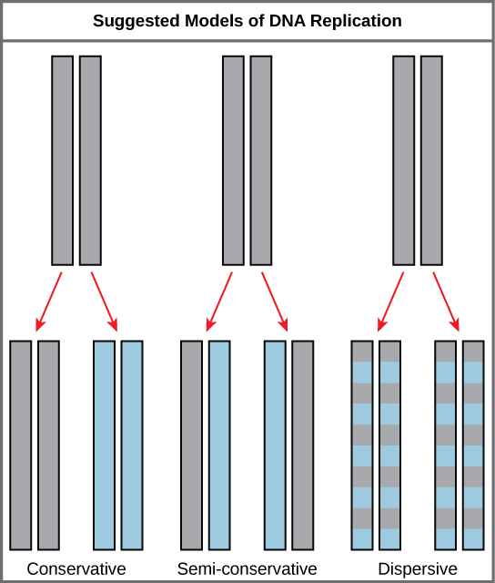  Figure 4. 5: The three proposed models of DNA replication. The conservative model produces one completely new molecule and conserves the old. The semiconservative model produces two hybrid molecules of old and new strands. The dispersive model produces hybrid molecules with each strand a mixture of old and new. OpenStax Biology 2nd Edition, Biology 2e. OpenStax CNX. Feb 13, 2019. Accessed February 17,2019. https://cnx.org/contents/jVCgr5SL@15.3:87pPoaHh@10/14-3-Basics-of-DNA-Replication | 20 minutes

PROKARYOTIC DNA REPLICATION  Prokaryotic cell have a single circular chromosome molecule with less coiling structure than eukaryotic chromosomes. Many enzymes and proteins are involved in DNA replication. The main key enzyme is :  - DNA polymerase (DNA pol) synthesize DNA by adding nucleotide that are complementary to the template strand.  - E. coli has at least three different DNA polymerases: DNA polymerase I , DNA pol II, and DNA pol III .  - Replication begins at a specific site on the bacterial chromosome called origin (oriC), and ends at a specific site, the terminus.  The oriC is a sequence of approximately 245 base pairs which a number of proteins bind to initiate the process of replication , and an AT-rich sequence that can be opened easily during initiation of replication.  Once initiated, replication proceeds bidirectionally, outward from the origin in the both direction, to the terminus.  The partial opening of a DNA helix to form two single strands has a forked appearance , is called a replication fork. Two replication forks are formed at the origin of moving in opposite direction until they meet at appoint across the circle from the origin, where replication is terminated. Each replication fork corresponds to a site where (1) the parental double helix is undergoing strand separation and (2) nucleotides are being incorporated into the newly synthesized complementary strands.  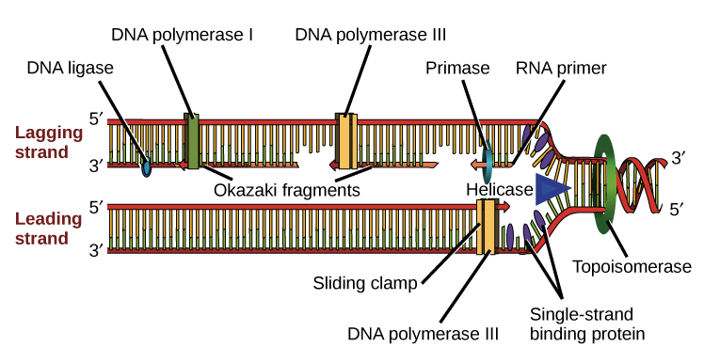  Figure 4. 6: Structural view of a replication fork and enzymes involved in prokaryotic DNA replication . OpenStax Biology 2nd Edition, Biology 2e. OpenStax CNX. Feb 13, 2019. Accessed February 17,2019. https://cnx.org/contents/jVCgr5SL@15.3:NMAkCfrD@10/14-4-DNA-Replication-in-Prokaryotes | 20 minutes | Notes to tutor
 | 20 minutes | Most of the detailed information about DNA replication has been obtained from in vitro studies with E. coli .

IN CLASS ACTIVITY: PROKARYOTES ENZYMES IN DNA REPLICATION |  | 30 minutes | Do no to use the internet  Discuss in group.
Purpose: | To list enzyme involve in Prokaryotes DNA replication | 30 minutes | Do no to use the internet  Discuss in group.
Over to you: | Use a table to summarizes the enzymes involved in prokaryotic DNA replication and the functions of each. | 30 minutes | Do no to use the internet  Discuss in group.
Activity: | In group , make a table two heading enzyme and function and fill the table. | 30 minutes | Do no to use the internet  Discuss in group.

Steps in Prokaryotic DNA replication:  Unwinding of the DNA helix at the replication fork is accomplished by helicase, bidirectionally.  The separation of the single strand is maintained by the binding of several molecules of single-strand binding (SSB) proteins.  Enzymes that can alter the topological state of DNA are called topoisomerases. Topoisomerase enzymes act to relieve the torsional strain caused by unwinding and to prevent this supercoiling from happening. DNA gyrase, a type II topoisomerase, travel along the DNA ahead the replication fork, changing the positively supercoiled DNA into negatively supercoiled DNA.  Primase synthesizes RNA primers complementary to the DNA strand: DNA polymerase is able to add nucleotides only in the 5' to 3' direction. It also requires a free 3'-OH group to which it can add nucleotides by forming a phosphodiester bond between the 3'-OH end and the 5' phosphate of the next nucleotide. The 3’OH of the last ribonucleotide in the primer serves as the site at which the first deoxyribonucleotide is added by DNA polymerase. RNA primase, synthesizes short stretches of RNA 10 to 20 bp (base-pairs) long that function as primers for DNA polymerase | 20 minutes | Note to tutor  Project video 1 before stating face to face teaching.  Project video 2 after the teaching to check if students have understand the DNA replication in Prokaryotes
DNA polymerization: DNA polymerase III starts adding nucleotides to the 3'-OH end of the primer.  DNA polymerase can only synthesize DNA in the 5' to 3' direction, while the DNA double helix is antiparallel : meaning that one strand runs in the 3′-to-5′ direction, and its complementary strand runs in the 5′-to-3′ direction. This situation puts constraints on the replication process.  Leading strand synthesis : One strand known as the leading strand is synthesized continuously in the 5’ to 3’ direction. Thus the leading strand is complementary to the parental strand that runs in the 3’ to 5’ direction.  Lagging strand synthesis : The other strand called lagging strand, complementary to the 5' to 3' parental DNA, is also synthesized in the 5’ to 3’ direction, but the synthesis occurs discontinuously, producing small DNA fragments known as Okazaki fragments, each requiring a primer to start the synthesis.  Conversion of Okazaki fragments to a continuous strand. The short DNA fragments are eventually joined to form a continuous strand that contains no RNA.  This is accomplished by two sequential reactions: RNA primers are removed by exonuclease activity : when DNA polymerase III approaches another RNA primer, it dissociates and DNA polymerase I enters. DNA polymerase I removes the ribonucleotides one at a time from 5’end (5’ to 3’ exonuclease activity), then adds complementary dNTPs to fill in the gaps.  The gap between the two DNA fragments is sealed by DNA ligase, which forms a phosphodiester bond between two adjacent DNA fragments.  Termination of Replication. The two replication forks meet on the opposite oriC on the circular chromosome.. The replication enzymes then disengage from their sites of association with the DNA, and the two daughter chromosomes separate from one another. | 20 minutes | Project video 2 after the teaching to check if students have understand the DNA replication in Prokaryotes

IN CLASS ACTIVITY: LEADING AND LAGGING STRAND |  | 30 minutes
Purpose: | To compare and contrast the synthesis of leading and lagging strand | 30 minutes
Over to you: | Sit in groups and Create a model to explain the process of DNA replication by creating a colorful poster that shows the replication fork, the correct base pairs and enzymes. | 30 minutes
Activity: | Using the model you create , differentiate between the replication of the leading strand versus the lagging strand of DNA. | 30 minutes

EUKARYOTIC DNA REPLICATION  The essentials steps of DNA replication are similar between prokaryotes and eukaryotes such as humans, but there are also some differences:  - Eukaryotic genomes have much more DNA than bacteria organized into multiple chromosomes.  - The human genome has three billion base pairs per haploid set of chromosomes , therefore humans can have up to 100,000 origins of replication with much slower rates of approximately 100 nucleotides per second.  - The number of DNA polymerases in eukaryotes is much more than prokaryotes: five are known to have major roles during replication . They are known as pol α, pol β, pol γ, pol δ, and pol ε.  - Eukaryotic chromosomes are linear. This lead to loss of some DNA from the ends of linear chromosomes in each round of replication, in the lagging strands when RNA primers are removed. | 20 minutes | Note to tutor
Telomere replication  Eukaryotes face a difficulty at the end of DNA replication that prokaryotes do not: filling in the gaps left when RNA primers are removed. When the ends of chromosomes are replicated and the primers are removed from the 5’ ends, there is no adjacent DNA strand to serve as a primer. Because DNA cannot be extended in the 3′ → 5′ direction, and single-stranded region is left at the 5’ end of the new strand, chromosomes would become shorter with each round of replication, if the gap is not filled.  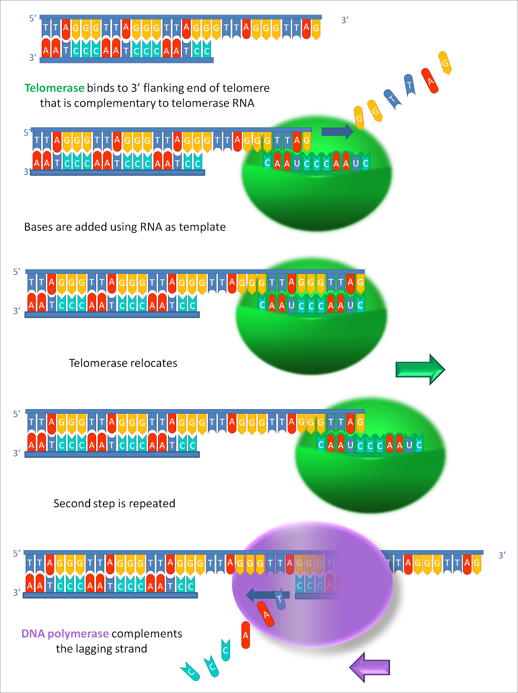  Figure 4.7: : Working principle of telomerase , by Fatma Uzbas, December 10, 2011. (accessed on the 1 December 2018).  https://commons.wikimedia.org/wiki/File:Working_principle_of_telomerase.png | 20 minutes | For tutors  Project this video about telomerase function.  Explain that telomeres function to protect the ends of chromosomes. They prevent one chromosome from binding to another  They also don't have any genetic information. This comes in handy during DNA replication because we lose a bit of DNA with each round of cell division, so the telomeres protect the chromosomes so they are not lost.
To prevent chromosomes from shortening, many eukaryotes are composed of repetitive sequences at the ends of their chromosomes called telomere. In humans, a six base pair sequence ,TTAGGG, is repeated 100 to 1000 times.  The telomerase enzyme allows ends of linear chromosomes to be replicated, it contains an RNA region that is used as a template so a DNA primer can be produced. Telomerase attaches to the end of the chromosome, and complementary bases to the RNA template are added on the 3' end of the DNA strand. Once the 3' end of the lagging strand template is sufficiently elongated, DNA polymerase can add the nucleotides complementary to the ends of the chromosomes. Hence, the ends of the chromosomes are replicated.  Telomerase, aging and cancer  Most somatic cells have their telomeres shortened because they lack telomerase activity but active in germs cells and some adult cells. This finding means that telomere shortening is associated with aging.  An association has been discovered, between telomerase and cancer. Cancer cells do continue to divide indefinitely, and this would not be possible if their chromosomes were being continually shortened. Cancer cells generally show activation of telomerase, which allows them to maintain telomere length; however, this is obviously only one aspect of conditions that allow them to escape normal growth controls. | 20 minutes | For Tutors

DNA REPAIR  The capacity to repair DNA is critical because of replication mistakes and the constant presence of damaging agents that can cause mutation. The protection of DNA and thereby the maintenance of the genome is indispensable for all living organisms.  Different types of DNA repair mechanisms involved in the restoration of the genetic information, depends on the type of damage sustained by the DNA.  These mechanisms include: proofreading, mismatch repair, Base excision repair, nucleotide excision repair Double- strand break repair  Medical importance  When DNA-repair mechanisms are defective due to absence of enzymes of DNA repair this leads to diseases.  - Xeroderma pigmentosum : this disease is due to deficiency of endonuclease involved in excision repair. It is a rare condition. The skin of the affected people is sensitive to UV light part of sun light. Skin cancer usually develops and patients die at young age because of metastasis. Other symptoms are thorny growth of skin, corneal ulceration, scarred eye lids etc.  - Ataxia telangiectasia It is a rare disease. It is due to defective DNA repair mechanism. Affected individuals are highly sensitive to exposure of x-rays. They develop skin rash on exposure to x-rays. | 20 minutes | Note to tutor  Explain the mechanism of proofreading and mismatch repair  Mismatch repair  There are 2 types of DNA Damage  - Exogenous Sources (UV, Smoking, Radiotherapy, Chemotherapy)  - Endogenous Sources (Oxidative, Deamination, Replication errors)  These diseases are inherited i.e., they are due to defective genes.

IN CLASS ACTIVITY: DNA repair |  | 30 minutes
Purpose: | To compare and contrast the synthesis of leading and lagging strand | 30 minutes
Over to you: | Watch these videos 1 and 2 then in groups answer the questions below: | 30 minutes
Activity: | - What is DNA repair?  - Describe the general nucleotide excision repair process.  - Describe the general base excision repair process.  - Compare nucleotide excision repair to base excision repair  - With all these potential sources of DNA damage, why do healthy individuals have a low mutation rate  - Xeroderma Pigmentosum occurs in 1- 4 per million of the population. This disease is caused by a defect in the early step of nucleotide excision repair Those who suffer from it develop multiple skin disorders and malignancies. Why?  - DNA can undergo spontaneous damage from the action of water that can result in mutation if not repaired. For example: the deamination of cytosine creates uracil. How would base excision repair remove it? Why would incorporating uracil result in a mutation? | 30 minutes

LABORATORY PRACTICALS : DNA EXTRACTION |  | 120 minutes | To tutors :
Purpose: | DNA is present in all living things. It can be easily extracted from split peas using materials from around the house, although other DNA sources may be used, including spinach, chicken liver, strawberries, and broccoli.  The cells must be separated and burst before their DNA may be precipitated out of solution. | 120 minutes | To tutors :
Over to you: | To extract DNA from split peas. | 120 minutes | To tutors :
Activity | Use associated manual procedure | 120 minutes | To tutors :
Anticipated time required for Unit 4-1activities :
Theory : 2h all activities + 2h self-learning
Practical : 2h

