WEEK 10
UNIT 4-2: TRANSCRIPTION | Where?  How long? | Explanations  /Questions
Introduction  Transcription is the process of making an RNA copy of a gene sequence. This copy, called a messenger RNA (mRNA) molecule, leaves the cell nucleus and enters the cytoplasm, where it directs the synthesis of the protein, which it encodes.Transcription is different in prokaryotes and eukaryotes and is composed of three steps : initiation , elongation and termination. | 10 minutes | Where is this from?
 | 10 minutes | Students will be introduced to the Transcription and Translation (next chapter) process.  This courses are designed to help you learn about gene expression and genetic codes
Expectation  This unit focuses on how transcription happens. Transcription is the first part of the protein synthesis, while the second d part : translation will be discussed in the next chapter. | 10 minutes
Course outline  Central Dogma  Prokaryotic transcription  Eukaryotic transcription  mRNA processing in Eukaryotes | 10 minutes
Learning outcomes | 10 minutes
At the end of this unit, you should be able to:  - Describe the transcription process in bacteria.  - List and explain the different steps in Eukaryotic transcription  - Compare and contrasts the three types of RNA polymerases in Eukaryotes  - Distinguish between Prokaryotic and Eukaryotic transcription  - Describe the different steps in mRNA processing | 10 minutes

ACTIVITY AHEAD OF LESSON: Prokaryote and Eukaryote transcription |  | 30 minutes | To student  Write all new term you do not understand
Purpose: | To review transcription in PROKARYOTES and EUKARYOTES | 30 minutes | To student  Write all new term you do not understand
Over to you: | Go to this website for open resources about DNA transcription | 30 minutes | To student  Write all new term you do not understand
Activity: | Answer the question below:  Identify the steps in transcription and translation.  Using a table compare and contrast transcription and translation. | 30 minutes | To student  Write all new term you do not understand

Central Dogma | 20 minutes | Notes to tutor
The Central Dogma defines the flow of genetic information from DNA to mRNA to protein by the two-step process, transcription and translation.  DNA  RNA  PROTEIN  Translation  Transcription | 20 minutes
The two main processes involved in protein synthesis are  - the formation of mRNA from DNA (transcription);  - the conversion by tRNA to protein at the ribosome (translation). | 20 minutes
STRUCTURE OF A GENE  A gene is a sequence of DNA which is transcribed into RNA and contain three main parts:  - Promoter: Responsible for the initiation of transcription  - Coding Sequence: The sequence of DNA that is actually transcribed  Terminator: Sequence that serves to terminate transcription | 20 minutes
RNA INVOLVED IN PROTEIN SYNTHESIS  Cells contain three types of RNA, each having a different function:  - Messenger RNA (mRNA) carries the information specifying the amino acid sequence of proteins.  - Transfer RNA (tRNA)  - Ribosomal RNA (rRNA) play important roles in protein synthesis. | 20 minutes

IN CLASS ACTIVITY: TRANSCRIPTION VS REPLICATION |  | 30 minutes | Use different color pencils for DNA bases.
Purpose: | To differentiate Rho- independent termination and Rho-dependent termination | 30 minutes | Use different color pencils for DNA bases.
Over to you: | Use your laptop , go to the internet and search the difference between the two types of bacterial termination | 30 minutes | Use different color pencils for DNA bases.
Activity: | Transcription resembles replication in its fundamental chemical mechanism, direction of synthesis, and its use of a template. Transcription has three phases, initiation, elongation, and termination. Transcription differs from replication in that it does not require a primer and involves only limited segments of a DNA molecule. Additionally, within transcribed segments only one DNA strand serves as a template for a particular RNA molecule. | 30 minutes | Use different color pencils for DNA bases.

 | 10 minutes | Notes to tutor
DEFINITIONS | 10 minutes
Promoter – A region of DNA where RNA polymerase binds to initiate transcription.  Startpoint – The position on DNA corresponding to the first base incorporated into RNA.  Terminator – A sequence of DNA that causes RNA polymerase to terminate transcription.  Transcription unit – The sequence between sites of initiation and termination by RNA polymerase; it may include more than one gene.  Upstream – Sequences in the opposite direction from expression.  Downstream – Sequences proceeding farther in the direction of expression within the transcription unit.  Primary transcript – The original unmodified RNA product corresponding to a transcription unit.  Consensus sequence - is an idealized sequence in which each position represents the base most often found when many actual sequences are compared. | 10 minutes | Explain these definitions

PROKARYOTIC TRANSCRIPTION  During the process of transcription , only one of the two DNA strands is transcribed into RNA.  The RNA strand is always synthesized in a 5’ to 3’ direction, but from an antiparallel and complementary DNA template strand: Coding (non-template) strand.  Coding strand is the DNA strand that has the same sequence as the mRNA and is related by the genetic code to the protein sequence that it represents.  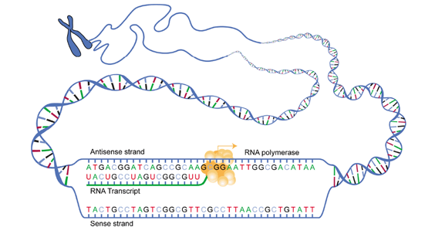  Figure 4.8: DNA transcription : Antisense strand (or coding strand) . By National Human Genome Research Institute. January 21, 2009. Accessed on March 4, 2019. https://www.genome.gov/images/edkit/bio2c_large.gif | 20 minutes | Notes to tutor
Bacterial promoter region. The region of DNA that binds RNA polymerase and allows transcription to be initiated is known as the promoter region (Figure 4.9) , the promoter region contains a starting point at which transcription is initiated and two consensus sequences that are recognized by RNA Polymerase. The sequences at which RNA polymerase bind are located at position -10 and -35. By convention, the starting point is designated as + 1.  - Pribnow box: is an A-T rich sequence (TATATT) located 10 base pairs upstream from the site at which transcription begins. This sequence is present in almost all promoters and is involved in the initial unwinding of DNA by RNA polymerase.  - Hexamer at -35 position. Another consensus sequence of six nucleotides is located 35 base pairs upstream from the start site for transcription. This TTGACA sequence is involved in the initial recognition of the promoter by RNA polymerase.  - Start site. The first nucleotide transcribed into RNA is usually a purine, either A or G.  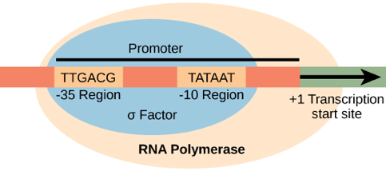  Figure 4.9: Bacterial promoter region. By OpenStax Biology 2nd Edition, Biology 2e. OpenStax CNX. Feb 13, 2019. Accessed March 4, 2019. https://cnx.org/contents/jVCgr5SL@15.3:PxuX1oI_@10/15-2-Prokaryotic-Transcription | 20 minutes | Note to tutor  In prokaryotes, a number of genes may be regulated by a single promoter - this is an operon).  In eukaryotes coding sequences contains introns.

B. Transcriptional machinery. In prokaryotic systems, a single RNA polymerase synthesizes all forms of RNA.  - Structure of RNA polymerase: consist of :  Core enzyme that has five subunits (α2ßß’ω). It is capable of polymerizing ribonucleotides but it does not recognize promoter region in the DNA.  Holoenzyme enzyme has an additional sigma σ-subunit that allows the enzyme to recognize promoter sequences. | 20 minutes | Note to tutor  Project video 1 before stating face to face teaching.

Steps involved in transcription  Transcription in prokaryotes involves three steps: initiation, elongation and termination.  - Initiation.  The sigma subunit of the holoenzyme recognizes consensus sequences in the promoter, binds to DNA, and helps unwind the DNA double helix so that one strand can serve as a template.  The initiating ribonucleotide triphosphate is usually a purine .  After the first few phosphodiester bonds are formed, the sigma subunit dissociates from the holoenzyme and the core begins elongation.  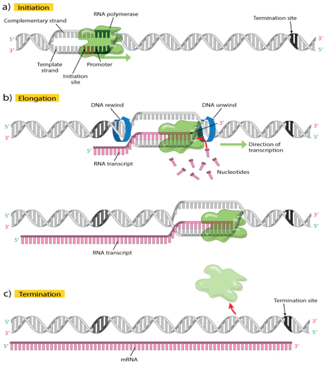  Figure 4.10: The three stages of transcription. By Clancy, S. (2008) DNA transcription. Nature Education 1(1):41. Accessed on March 4, 2019. https://www.nature.com/scitable/topicpage/dna-transcription-426. | 20 minutes | Note to tutor  Project this video  Explain  Holoenzyme  Core enzyme
- Elongation.  The cores enzyme moves along the template extending The RNA chain, and the region of local unwinding moves with it. As the enzyme leaves a region, the DNA duplex reforms and RNA is displaced as a growing polynucleotide chain. Growth of the chain is always in the 5’ to 3’ direction. RNA polymerase moves along the DNA template strand in the 3’ to 5’ direction.  - Termination. The DNA template contains stop signals for transcription. Termination of transcription involves the release of both the DNA template and the newly synthesized RNA from RNA polymerase. Bacterial RNA polymerase has two methods of termination.  - Rho- independent termination occurs when the newly synthesized RNA folds back on itself and forms a hairpin loop that is stabilized by hydrogen bonding between complementary bases. The hairpin loop must be followed by a run of 6-8 U residues that form weak bonds with the complementary run of 6-8 A residues in DNA template. These two structural features of the newly synthesized RNA promote dissociation of the RNA from the DNA Template.  - Rho-dependent termination. Rho factor is a protein that terminates transcription. It binds to the newly  formed RNA and moves toward the RNA polymerase that has paused at a termination site. Rho then displaces the RNA polymerase from 3’ OH end of the RNA. Rho factor has ATPase activity that is RNA dependent, and it requires a polyribonucleotides that is greater than 50 bases long. | 20 minutes
In prokaryotes, transcription is coupled with translation. As 5′ end of the mRNA becomes accessible, ribosomes are loaded onto this to begin translation. Prokaryotic genes are frequently organized such that genes encoding related functions are clustered together. This grouping of functionally related genes is referred to as an operon. An operon is a single transcription unit that encodes multiple enzymes necessary for a biochemical pathway, for example the operon lactose.  D. Inhibitors of prokaryotic transcription. Many antibiotics exert their action by interfering with bacterial RNA or protein synthesis while having no effect on eukaryotic RNA and protein synthesis.  - Rifampin inhibits initiation of RNA synthesis.  - Actinomycin D binds to DNA and inhibits RNA synthesis by blocking movement of RNA polymerase along the template.  - Streptolydigin binds to the β subunit of RNA polymerase and blocks elongation. | 20 minutes | For tutors

IN CLASS ACTIVITY: PROKARYOTES TRANSCRIPTION TERMINATION |  | 30 minutes | Use different color pencils for DNA bases.
Purpose: | To differentiate Rho- independent termination and Rho-dependent termination | 30 minutes | Use different color pencils for DNA bases.
Over to you: | Use your laptop , go to the internet and search the difference between the two types of bacterial termination | 30 minutes | Use different color pencils for DNA bases.
Activity: | Using an illustration and a table, compare and contrast Rho- independent termination and Rho-dependent termination.  Each group will be allocated 5 min for presenting their illustrations and table. | 30 minutes | Use different color pencils for DNA bases.

EUKARYOTIC TRANSCRIPTION  Both the structure of eukaryotic genes and the mechanisms for transcription are more complex than in prokaryotic systems.  Initiation  Eukaryotes require several other proteins, called transcription factors, to first bind to the promoter region and then to help recruit the appropriate RNA polymerase.  The eukaryotes have three polymerases that are each made up of 10 subunits or more.  Different RNA polymerase transcribes each type of RNA. The requirement of each of these enzymes are the same as for prokaryotic RNA polymerase. None of the RNA polymerases have the proofreading activities that DNA polymerases have.  - RNA polymerase I is localized in the nucleus and transcribes the genes for three types of rRNA: 28S, 18S, and 5.8S rRNA .  - RNA polymerase II is found in the nucleoplasm, transcribes mRNA and snRNA .  - RNA polymerase III is located in the nucleoplasm and transcribes the genes for transfer RNA (tRNA) and 5S rRNA.  Eukaryotic genes consists of  - Start site. The initial nucleotide in position +1 of the RNA transcript is usually A, flanked by pyrimidines.  - TATA box (Hogness box). This sequence is important in the initiation of transcription, is found in all eukaryotes. It is located approximately 25 base pairs upstream (-25) from the start point, and is almost identical to the Pribnow box found in bacterial systems; TFIID, the critical transcription factor for RNA polymerase II binds here.  - CAAT box. This sequence is located between position -75 and -80.Binding of transcription factors at this site may influence the formation of initiation complexes at other sites.  Figure 4.11: The structure of a typical gene transcribed by RNA polymerase II. (Self-made illustration). | 20 minutes | Note to tutor  Explain the functions of Transcription Factors  RNA polymerase
- Regulatory regions. Sequences that either increase or decrease the rate at which transcription is initiated by RNA polymerase II exist at various places in the gene. Although they are usually located upstream from start site, they may also be internal to the gene or downstream from the gene.  Regulatory regions consist:  - Enhancer sequences bind transcription factors that increase the rate of transcription.  - Silencer sequences bind factors that decrease the rate of transcription.  - Exon and introns. The segment(s) of the gene that are maintained in the mature mRNA and the code for protein are known as exons while introns are the portions of the primary RNA transcript that are removed by splicing. | 20 minutes
TRANSCRIPTIONAL REGULATION  Transcriptional regulation is the change in gene expression levels by altering the rate of transcription ..  This regulation can be achieved in one of two main ways: | 20 minutes
Transcription Factors (TF)  - TF are proteins that are needed to facilitate the binding of RNA polymerase to the promoter.  - Without transcription factors, RNA polymerase cannot be released to transcribe the mRNA. | 20 minutes
Regulatory Proteins:  These proteins bind to non-coding sequences near the promoter and regulate transcription  Repressors impede the movement of RNA polymerase along the gene's coding sequence, and thus impede transcription.  Activators bind to enhancer sites near the promoter in order to increase the affinity of RNA polymerase for the promoter. | 20 minutes
ELONGATION AND TERMINATION IN EUKARYOTIC TRANSCRIPTION  RNA polymerase is released from transcription factors, and elongation is allowed to proceed as it does in prokaryotes with the polymerase synthesizing pre-mRNA in the 5' to 3' direction.  The termination of transcription is different for the different polymerases. RNA polymerases I and III require termination signals while the process of termination in RNA polymerase III involves an mRNA hairpin similar to rho-independent termination of transcription in prokaryotes. | 20 minutes

IN CLASS ACTIVITY: EUKARYOTIC TRANSCRIPTION VS PROKARYOTIC TRANSCRIPTION |  | 30 minutes
Purpose: | To differentiate prokaryotic and eukaryotic transcription | 30 minutes
Over to you: | Following the face to face teaching , sit in group and discuss about differences in eukaryotic and prokaryotic transcription. | 30 minutes
Activity: | Answer this question :  What are differences between transcription in eukaryotes and that in prokaryotes?  Discuss about theses differences:  - Location  - RNA polymerase  - Initiation  - Termination  - mRNA structure | 30 minutes

POST-TRANSCRIPTIONAL MODIFICATION  Transcription completed, eukaryotic pre-mRNAs must undergo several modifications before translation. The primary transcripts synthesized by RNA polymerase II are known as heterogeneous nuclear RNA (hnRNA), which are precursors for mRNA, have to leave the nucleus as mRNA.  Processing involves three main steps:  Capping: The 5’end of the RNA is “capped” shortly after the initiation of RNA synthesis. This process involves the addition of an “inverted “ methylated guanosine molecule to the first nucleotide in the RNA transcript. The 7-methyl-guanosine is linked through a 5’-5’ triphosphate linkage. The 5’cap plays an important role in the initiation of protein synthesis and protecting the mRNA chain from degradation.  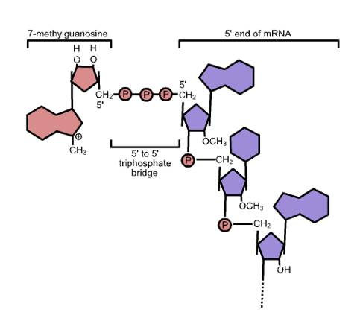  Figure 4.12: The 5' cap structure on mRNA. By Zephyris (November 28,2005). Accessed on the March 5, 2019. https://commons.wikimedia.org/wiki/File:5%27_cap_structure.png.  Polyadenylation: A 3'-poly(A) tail is added to provide protection against digestion and facilitate the export of the mRNA from the nucleus.  Splicing: Non-coding intervening sequences (introns) are removed to leave the sequences that will be expressed (exons) | 20 minutes | Note to tutor  Project this video about splicing and this video
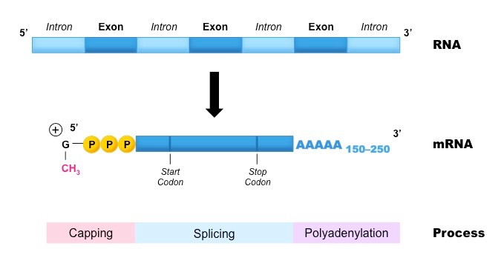  Figure 4.13 : Post-Transcriptional Modifications Cornell, B. 2016. Referencing. [ONLINE] . Accessed on March 5, 2019.  Available at: http://www.vce.bioninja.com.au/aos-3-heredity/molecular-genetics/transcription.html#previous-photo | 20 minutes | Note to tutor

LABORATORY PRACTICALS : QUALITATIVE ANALYSIS OF PROTEINS |  | 120 minutes | To tutors :
Purpose: | To detect the presence of peptides or proteins in a sample  Certain functional groups in proteins can react to produce characteristically colored products.  The color intensity of the product formed by a particular group varies among proteins in proportion to the number of reacting functional or free groups present and their accessibility to the reagent.  The cells must be separated and burst before their DNA may be precipitated out of solution. | 120 minutes | To tutors :
Over to you: | To detect the presence of peptides or proteins in a sample | 120 minutes | To tutors :
Activity | Use the Biuret test | 120 minutes | To tutors :

Anticipated time required for Unit 4-3 activities :
Theory : 2h all activities + 2h self-learning
Practical : 2h

