WEEK 10
UNIT 4-3: TRANSLATION | Where?  How long? | Explanations  /Questions
Introduction  Translation is the process by which the base sequence in mRNA is decoded into an amino acid sequence. All three types of RNA play different roles in translation. | 10 minutes | Where is this from?
 | 10 minutes | Translation, the second part of the central dogma of molecular biology, describes how the genetic code is used to make amino acid chains.
Expectation  In this unit, explore the mechanics involved in polypeptide synthesis. Learn the three major steps of translation as you watch tRNA, mRNA, and ribosomes go to work. | 10 minutes
Course outline  The genetic code  Role of RNA protein synthesis  Steps of process of translation  Differences between Prokaryotic and Eukaryotic genes expression | 10 minutes
Learning outcomes | 10 minutes
At the end of this unit, you should be able to:  - Describe the characteristics of the genetic code.  - Describe the different steps in Prokaryotic and eukaryotic translation  - Discuss the function ribosomes in translation  - Compare and contrast Prokaryotic and eukaryotic gene expression  - Distinguish different types of genes mutation. | 10 minutes

ACTIVITY AHEAD OF LESSON: TRANSLATION |  | 30 minutes | To student
Purpose: | . To review the process of translation | 30 minutes | To student
Over to you: | Go to the following open ressources and this link for more ressources. | 30 minutes | To student
Activity: | Write down function of following elements involved in translation:  - Ribosome  - mRNA, tRNA  What is the genetic code? Why it is universal? | 30 minutes | To student

THE GENETIC CODE  The genetic code is the set of instructions in a gene that tell the cell how to make a specific protein.  A, T, G, and C are the "letters" of the DNA code.  They stand for the chemicals adenine, thymine, guanine, and cytosine, respectively, that make up the nucleotide bases of DNA.  - Codons call for amino acids and are triplets of nucleotides;  - Code includes initiation and termination codons;  - No internal punctuation;  - Code is universal .  The genetic code is Degenerate  Amino acids may be encoded by more than one codon  Amino acids have up to 6 different codons  The genetic code summary  64 codons  61 call for amino acids (1 to 6 each)  3 triplets are stop signals: UAA, UAG, UGA  AUG is for methionine and also is the initiation | 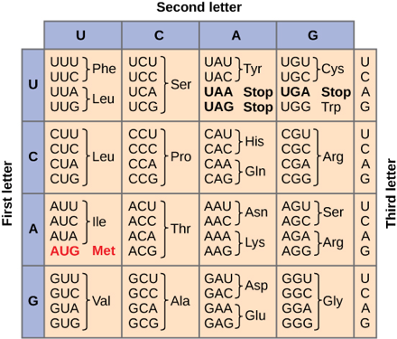  Figure 4.14 : The genetic code. By OpenStax Biology 2nd Edition, Biology 2e. OpenStax CNX. Feb 13, 2019. Accessed on March 6, 2019. https://cnx.org/contents/jVCgr5SL@15.3:aXYynRWE@10/15-1-The-Genetic-Code | 20 minutes | Notes to tutor  This link is relevant for understanding the genetic code.

ROLE OF RNA PROTEIN SYNTHESIS  Each of the three major types of RNA plays an essential role in protein synthesis.  - Messenger RNA (mRNA) acts as the “working copy” of the gene coding for a protein. The mRNA carries the information from the genome in the nucleus to the cytosol where protein synthesis occurs. The length of mRNA is related to the size of the gene.  - Ribosomal RNA (rRNA): Ribosomes, the machines for synthesizing protein, are complexes containing protein and rRNA.  In prokaryotic systems there are three forms of rRNA: 23S, 16S, and 5SrRNA.  Eukaryotic rRNA, has four forms of rRNA: 28S, 18S; 5.8S and 5s. In eukaryotic systems , all of the forms of rRNA except 5S rRNA are synthesized in the nucleolus.  - Transfer RNAs (tRNAs) are the adaptor molecules in proteins synthesis. They have an anticodon region complementary codon in mRNA, specific for a particular amino acids. The tRNAs react with amino acids at their 3’ ends. Transfer RNAs are small, containing approximately 80 nucleotides.  - The 5’ end of tRNA is a monophosphate, rather than a triphosphate and the base is usually G.  - The 3’end of tRNA has the sequence CCA. The” activated amino acids” is covalently attached to the 3’OH of the terminal adenosine the bond linking the amino acid to tRNA.  - Unique structure features of tRNA include three loops and an “extra arm” created by internal hydrogen bond formation. The anticodon loops contains three bases that are antiparallel and complementary to the bases in the codon of mRNA. | 20 minutes | Notes to tutor
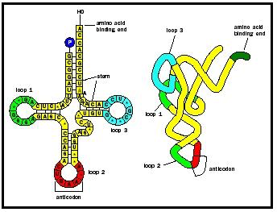  Figure 4.15 : Unfolded transfer RNA (left) has a clover-leaf shape. In the cell, it folds into a more compact L shape (right).By Blankenship James (2019). Accessed on March 6, 2019. http://www.biologyreference.com/Ta-Va/Transfer-RNA.html | 20 minutes
Steps of process of translation  The process of translating involves three steps: initiation, elongation and termination.  Protein synthesis occurs in the direction of amino terminal to carboxyl terminal, and the mRNA is read from the 5’end to the 3’end.  - Initiation of protein synthesis. Initiation of protein synthesis requires special tRNA molecules and the formation of an initiation complex. The codon AUG in mRNA usually signals the beginning of protein synthesis. AUG is the codon for methionine. | 20 minutes
Prokaryotic initiation  The initial methionine residue has a formyl group attached to it (fMet). The initiating tRNA is known as tRNA^{fmet}.  Formation of initiation complex. The assembly of the 70S initiation complex found in prokaryotes is a stepwise process involving the formation of an intermediate 30s complex.  - Assembly of the 30S complex. Formation of the 30S complex requires mRNA, the 30S ribosomal subunit, three initiation factors (IF-1, IF-2 and IF-3), GTP and tRNA^{tmet}. The mRNA contains the start codon (AUG or GUG) that recognizes tRNAtmet. There is a special sequence of bases upstream from the AUG codon called the Shine-Dalgano sequence. This sequence of bases binds with the 16s rRNA to the 30S ribosomal subunit requires the transient help of IF-3. After mRNA binds to the 30S ribosomal subunit; IF-3 dissociates. The complex between mRNA and the 30S ribosomal subunit then binds IF-2,GTP and tRNAfMet to produce an active 30S initiation complex.  - Assembly of the 70S initiation complex occurs by the interaction of the 50S ribosomal subunit with the 30S complex. The formation of the70S complex results in the hydrolysis of GTP to GDP and Pi as well as the dissociation of both IF-1 and IF-2.  The ribosome has three sites:  - The aminoacyl site (A site) binds to incoming tRNA molecule carrying and activated amino acid.  - The peptidyl site (P site) is the site at which tRNA^{fMet} initially binds. After formation of the first peptide bond, the P site is occupied by the growing peptide chain . The tRNA ^{fmet} recognizes two sites, the P site on the ribosome and the start site (AUG) on the mRNA.  - The exit site (E site) .  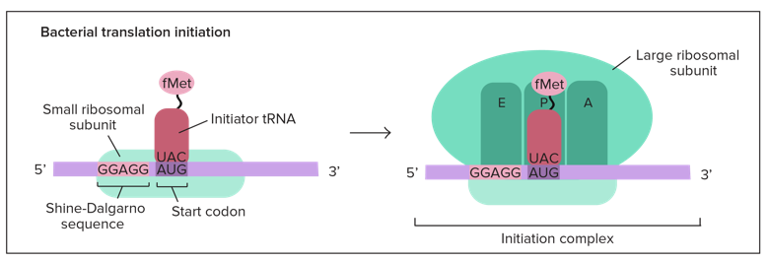  Figure 4.16: Bacterial translation initiation,, by khan academy, (2019).Accessed on March 6, 2019. https://www.khanacademy.org/science/biology/gene-expression-central-dogma/translation-polypeptides/a/the-stages-of-translation. | 20 minutes | Note to tutors  70 S is referred as the large subunit of ribosome while the 30 S is the small subunit of Ribosome.

Eukaryotic initiation  The process is similar in eukaryotes and prokaryotes.  The initiating tRNA is nown as tRNA ^{iMet} and the initiation complex is far more complicated than in prokaryotes, containing many IFs (initiation factors) .  The small ribosome subunit binds to the mRNA initially by binding to the 7-methylguanosine cap at the 5' end of the mRNA and track along the mRNA in the 5' to 3' direction, searching for the AUG start codon. Eukaryotic initiation site consists of a ten-nucleotide sequence (5'-gccRccAUGG-3' and R: purine ) that includes an AUG codon = Kozak sequence, then the 60S ribosomal subunits join the complex at the initiation site.  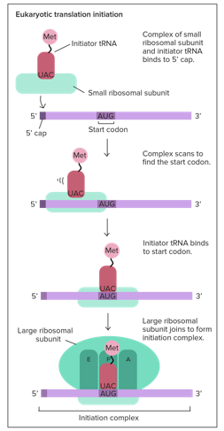  Figure 4.17: Eukaryotic translation initiation, by khan academy, (2019).Accessed on March 6, 2019. https://www.khanacademy.org/science/biology/gene-expression-central-dogma/translation-polypeptides/a/the-stages-of-translation. | 20 minutes | Note to tutor  Project video 1 before stating face to face teaching.

IN CLASS ACTIVITY: TRANSCRIPTION INITIATION |  | 10 minutes
Purpose: | To describe the process of initiation | 10 minutes
Over to you: | Use your laptop , go to internet and watch this short video about translation. | 10 minutes
Activity: | Attempt the MCQ | 10 minutes

Elongation of translation in E.coli  This process is a three-step cycle similar in prokaryotes and eukaryotes.  - Binding of aminoacyl-tRNA to the A site: The EF-Tu-GTP-aminoacyl-tRNA complex binds to the ribosome A site.  - Peptide bond formation: Peptidyl transferase forms a peptide bond between the peptide in the P site and the newly arrived aminoacyl-tRNA in the A site.  - Translocation: EF-G, with GTP translocates the growing peptidyl-tRNA, with its mRNA codon to the P site. leaving the A site free for the next aminoacyl-tRNA.  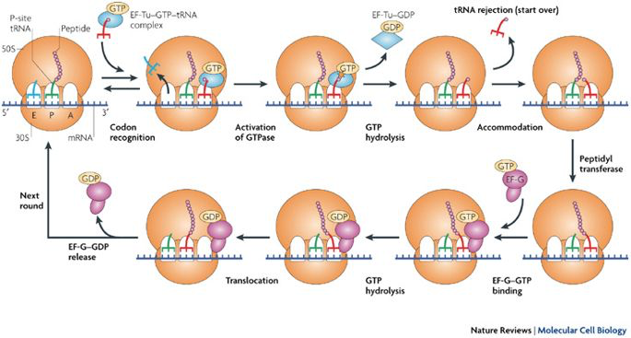  Figure 4.18 : An overview of ribosomal structure and mRNA translation, by Steitz Thomas A. . Nature Reviews Molecular Cell Biology (2008). https://www.nature.com/articles/nrm2352#auth-1 | 20 minutes | Note to tutor  The A, P and E site of Ribosome (Figure 4.16)
Termination of protein synthesis  Termination occurs when one of the three stop codons moves into the A site .  - Prokaryotic translation termination is mediated by three factors: RF1 (release factor 1), RF2 and RF3. RF1 recognizes UAA and UGA. RF3 is a GTP-binding protein that facilitates binding of RF1 and RF2 to the ribosome. The release factors release the newly formed protein, the mRNA, and the last tRNA used, the ribosome dissociates into its two subunits, which are then reused.  - Protein targeting : In eukaryotes, translation can occur either in the cytoplasm or on the RER (rough endoplasmic reticulum). Many proteins are destined to perform their functions within specific cellular organelles. Such proteins usually contain amino acid sequences called signal sequence that direct these proteins to their final locations | 20 minutes | For tutors

IN CLASS ACTIVITY: TO UNDERSTAND TRANSLATION |  | 30 minutes | .
Purpose: | To understand the all process of translation | 30 minutes | .
Over to you: | Use the knowledge acquire to answer the questions below. | 30 minutes | .
Activity: | Answer these questions:  - What is the nucleotide sequence of the complementary strand of this DNA molecule:  AA TGCGA?  - What is the nucleotide sequence of the mRNA transcribed from this DNA molecule: TACAAAAAG?  - If the mRNA sequence you obtained in question 2 were to be translated, what would be the sequence of amino acids?  - Does every possible triplet in the genetic code specify an amino acid?  - If a polypeptide contains 146 amino acids, what is the minimum number of nucleotides required in the mRNA from which this polypeptide is translated? | 30 minutes | .

\

Anticipated time required for Unit 4-4 activities :
Theory : 2h all activities + 2h self-learning

