An Open Knowledge Primer for

OER Africa

Lisbeth Levey

Introduction
First there were Open Educational Resources (OER). Then there was Open Access (OA). Increasingly academics and researchers are making Open Data integral to scholarly communication. Rather than segmenting the three, many practitioners use the phrase “Open Knowledge.” This primer is meant to complement work carried out at OER Africa on OER and IPR/copyright. It broadens the discussion to include open access and open data, issues that impact on sub-Saharan African universities but that are not discussed as extensively within sub-Saharan African universities as they should be.

There are three sections: open access publishing; African university repositories and policies; and creating enabling policies for open access publishing. These sections are followed by an appendix with an annotated list of major university repositories in Anglophone sub-Saharan Africa.

1. Open access publishing

1.1 Definition and relevance to Africa
Open access publishing means that resources are free to users worldwide and that they may be distributed without requesting permission. Research has demonstrated that open access brings increased visibility, usage, and impact to the work of academics, researchers, and students. In 2014 the European branch of the Scholarly Publishing and Academic Resources Coalition (SPARC) enumerated how open access benefits different stakeholder communities—authors, researchers, students, universities, libraries, and others. SPARC Europe also maintains an annotated list of studies and results in different discipines on the citation advantage of open access publishing. SPARC is an important organization because it represents the interests of national libraries, library consortia, and universities in the United States and in Europe.

Open access is compatible with copyright, peer review, prestige, quality, and indexing. Open access resources must still be cited when used. In fact, there is even an open access search engine in order to detect plagiarism.

Universities worldwide have cut back on journal subscriptions because the costs have become overwhelming. Price increases are usually higher than inflation costs. But in Africa, where budgets are far smaller, the burden is even greater. Even though most African universities and research institutions can read journals in the agricultural sciences online at no charge through the Food and Agriculture Organization’s AGORA for agriculture, the World Health Organization’s HINARI for health, the UN Environmental Program’s OARE for the environmental sciences and the e-journals delivery service for physical and mathematical sciences organized by the International Centre for Theoretical Physics, these services will not last forever. The open access model can benefit African universities just as much as it helps university libraries, academics, and students elsewhere in the world. Open access is revolutionizing the traditional subscription-based publishing system. Moreover, if access to quality research information worldwide is important, so to is the need to ensure that Africa’s research output reaches the scientific community globally. Open access to Africa’s research results can demonstrate that African scholars and students both consume and produce knowledge.

1.2 Basic facts on open access and Journals
The number of African journals employing open access models is growing. These include journals, such as the African Health Sciences published by Makerere University, which maintains an open access license for the entire journal, and journals, primarily those published by commercial publishers, which have more complicated arrangements. Some subscription-based journals permit authors to publish their articles in an open access format for a special fee. These are referred to as “hybrid” journals. The Journal of African Economies, which is published by Oxford University Press, is an example of a hybrid journal. Oxford University Press charges authors between £1000-£2500, depending on the journal title in order to publish their article in an open access format, with a Creative Commons license. But African authors can receive a partial or full waiver. These charges are frequently called an author processing charge (APC). Thus, there are three types of business models for academic journals:

Table One: academic journal business models
Type of Journal | Explanation
Subscription-based journals | The reader pays—either for an annual subscription or, for non-subscribers. Authors transfer copyright to the publisher. This means that both authors and readers must abide by the publisher’s typically restrictive terms and conditions.
Hybrid journals | Some subscription-based journal publishers allow authors to select an open access publishing option for a fee. The author retains copyright. The publisher is making an extra profit—through subscriptions and the author’s APC
Open access journals | The author usually pays an APC and retains copyright. APC charges are frequently lower than those charged through the hybrid journal model.  Some commercial publishers, such as Elsevier, are now publishing open access journals in addition to their regular subscription-based journals.

The bottom line, however, is that publishers must cover their costs—if not from the reader than from the author.

To complicate matters still further, some journals, such as Crop Science, will permit authors to place a pre-print or some other version of their article in a personal or institutional repository, This would include university repositories or discipline specific repositories, such as in the one maintained by the Regional Universities Forum for Capacity Building in Agriculture (RUFORUM). This is discussed in more detail in section 1.5 below.

1.3 Open Data
Just as journals are opening up, so is the practice of researchers pertaining to the data they collect. Open data is a relatively new development in Africa, but the concept is growing quickly. Open data means that users can make free use of data without requesting permission and without copyright or patent restrictions. The data is stored in a non-image, non-proprietary format, which allows manipulation. This can streamline teaching, learning, and research and promote transparency. In all instances, full attribution must be given. Researchers can protect sensitive data to protect confidentiality and anonymity, when necessary.

Many open-access journals require authors to make their data publicly available, sometimes by depositing them in an appropriate data repository. In addition, the same donors that require grantees to publish in open-open access format are also likely to have rules about open data. It is always best to consult the journal in which you are publishing or the funder who is supporting your research. If you are interested in knowing more about data repositories, visit the Registry of Research Data Repositories at http://www.re3data.org/.

African governments and research organizations are also involved in the open data movement, although not yet extensively. Kenya established the first African governmental open data portal in 2011. The African Development Bank Group maintains a portal for data, statistics, and visualizations for the continent.African health and population data can be found at the InDepth health and demographic surveillance system, which is headquartered in Ghana and has participating centers throughout the continent. The InDepth Data Repository catalogs all surveys and datasets undetaken by network members and relevant resources from non-member centers. It is possible to browse the data repository or to search by keyword. Moreover, InDepth tracks publications in which data has been cited.

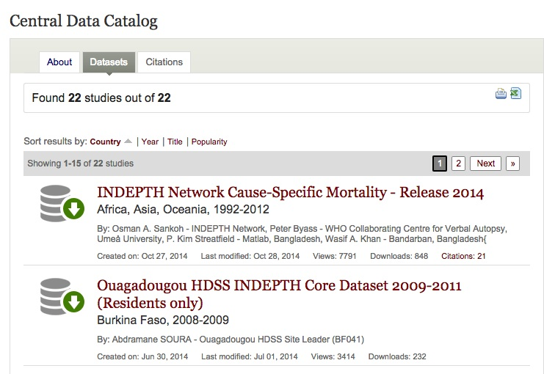
There are currently 22 surveys in the Data Repository, which have been cited almost 3,200 times. InDepth also maintains an active training program.

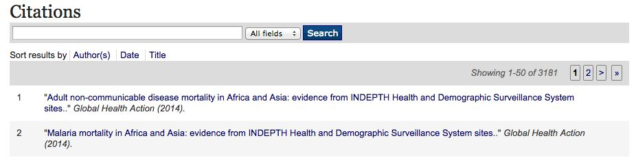

1.4 Open Access and Intellectual Property Rights
By default, copyright is automatic, with “all rights reserved.” It is therefore necessary to modify, but not replace, traditional copyright with a policy that allows for an open paradigm rather than one that is closed. Creative Commons (CC), a US non-profit organization was created to do just that. CC has created a range of easy-to-use copyright licenses that offer a simple, standardized way to give the public permission to share and use an author’s creative work — on the conditions of his or her choice. Some licenses are very permissive and allow adaptation; others are more restrictive and permit users to read and distribute, but not to adapt. It is important to remember that CC licenses are not an alternative to copyright; they let you easily change your copyright terms from the default of “all rights reserved” to “some rights reserved.” Open access journals therefore usually use a CC license. Others use a CC equivalent.

1.5 Publisher policies and author rights
Another issue pertains to the rights of authors to deposit copies of their research in a personal or institutional archive. Journal publishers will make the articles they publish available on their websites, of course. But subscription only journals charge a fee for access. But, as stated above, publishers frequently permit authors to mount a version of their articles on personal or institutional websites. Many authors opt to use both mechanisms to ensure that their research is circulated as widely as possible.

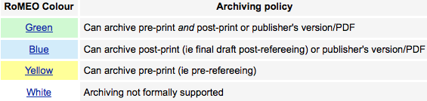
How is it possible to determine a journal’s policies pertaining to archiving and licensing? The University of Nottingham in the UK maintains an excellent site called SHERPA/RoMEO on publisher copyright policies and self-archiving. Sherpa/RoMEO uses four colors, as shown above, to categorize publisher policies, and this color sequence is now widely used when discussing different licensing arrangements. Green is the most permissive, while white is the most restrictive. Authors should aim for green and never settle for white. SHERPA/RoMEO will also give users information on a journal’s licensing status, when it is available. The screen capture below is an example of a SHERPA/RoMEO journal record.
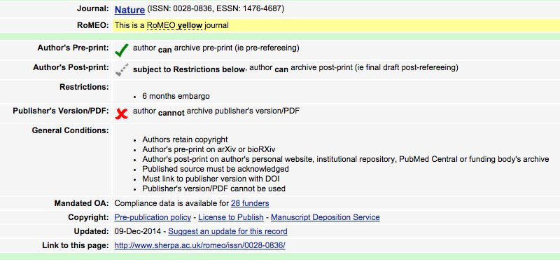

Authors should also check the publisher’s website to ascertain open access and archiving information. When in doubt, write the publisher. Authors require answers to the following questions:

- What are the journal’s copyright policies
- If the journal is fully copyrighted, does the publisher offer an open access option?
- If so, how much does it cost and is there a discount for developing-country authors?
- Is the author permitted to deposit a version of his or her article in a repository?
- If so, which version and what are the conditions?
- Is there an embargo period before the journal article is made freely available? (It is usually 12 months.)

In addition, many publishers now publish both subscription-based/copyright protected journals and open access journals. This is true of the Nature Publishing Group, Elsevier, and the American Physical Society, to name just three. This has been done in part to make it easier to conform to new funder open access guidelines, which are discussed below. Authors will find these journals in SHERPA/RoMEO, as well.

1.6 Not all open access publishers produce quality journals
Although many open access publishers are legitimate, there are shoddy publishers everywhere. Some open access publishers appear to be particularly unscrupulous and have come in for a good deal of criticism by librarians and scientists. These publishers are attempting to profit from the open access movement. The fees they charge authors are high; the peer review and editing they provide are almost non-existent. Jeffrey Beall, a US university librarian writes extensively on “predatory journals.” There was also an excellent article in the journal, Nature, on “the dark side of publishing.” Finally, Monica Berger and Jill Cirasella, two academic librarians, wrote an excellent article analyzing the predatory publisher phenomenon, how to avoid falling into the clutches of one, and the importance of librarians. Perhaps most significant for developing country authors, they also discussed what some seem to believe is Beall’s growing mistrust of open access publishers in general and those located in developing countries in particular. Thus, by all means, use Beall, but also read the article in Nature and the one by Berger and Cirasella. You may also want to discuss these issues with relevant members of the university community.

There are a number of ways that you can seek to mitigate the risk of selecting an unreliable publisher. The goal is to select the best publisher for your research. In addition to the list in the previous section, the bullets below provide steps for ascertaining a journal’s legitimacy. Below is a “due diligence” checklist.
- Use the Directory of Open Access Journals (DOAJ). DOAJ has recently toughened its procedures for accepting new journals and journals that were in the database must reapply. You can use DOAJ to search by journal title or by subject.
- Many universities encourage academics to publish in open access journals. Ascertain whether your institution does so and whether it offers assistance in covering author charges.
- Be wary of journal publishers who email you to solicit an article, particularly if you are not familiar with the journal title.
- Be wary of any journal title that does not give full contact information, including address.
- Ensure that the editorial board is composed of experts in the field. You may want to write one or two of them to see whether they are really on the editorial board.
- The journal should prominently display on its web site author fees and its peer review process.
- Carefully read the author guidelines. If there are none, this might not be a journal in which you want to publish.
- Journals typically list the indexing and abstracting databases in which they are included. Check to ensure that this is the case. Some journals falsely claim to be included in legitimate indexing and abstracting services.
- Ascertain that the journal publishes regularly and that the publication schedule meets your needs. Some journals have faster review and editorial processes than others. But beware of journals that promise too fast a turnaround time for peer review and acceptance. Unfortunately, there is no standard. You can check other journals in your discipline to ascertain how long the process takes.
- Read a few articles to ascertain their quality and check to see whether those articles are indexed in the most relevant citation and abstracting services. These include Scopus, CAB Abstracts, EconLit, ERIC, PubMed, and the Web of Science.
- Talk with your supervisor and colleagues. Ask whether they are familiar with the journal.

1.7 An open-access publishing to-do list
- Be sure to include a line item for page charges in your research budget. Open access fees can be as high as $3,500. This is in addition to the page charges that some subscription-based publications require. Thus, if you are thinking about publishing in a “hybrid” publication, you should reserve additional funds.
- Think carefully about where you want to publish, and do your homework to ensure that you are selecting an appropriate journal. Remember the due diligence checklist above.
- If your university has a repository, use it to archive your work. In addition, why not join ResearchGate, which will provide you with worldwide visibility? Many African researchers have done so. Academia.Edu is another excellent repository. Other academic self-archiving services include EconPapers, AgEcon Search, the Social Science Research Network, and arXiv for physics, mathematics, computer science, quantitative biology, and quantitative finance and statistics. These services have also become major networking platforms to share and follow research. Authors can create research profiles, upload publications, and find and track other researchers. Registration is free at all them. Another possibility is to archive your work on your own personal webpage. And remember—none of these options are mutually exclusive.

1.8 Open access and donors
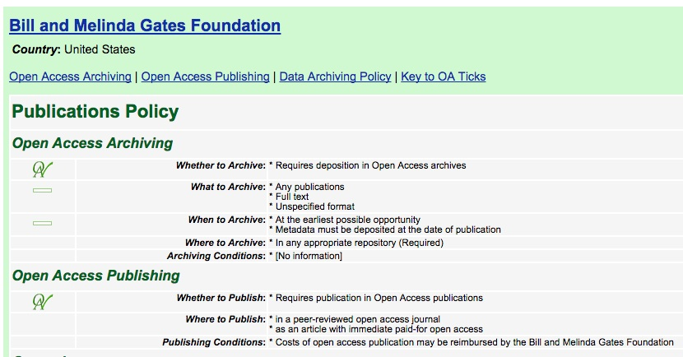
Governments and foundations in North America and in Europe require that all research they fund be made freely available to the public. Examples include the European Union and the Horizon 2020 project, the UK Department for International Development (DFID), Wellcome Trust, the US National Institutes of Health (NIH), the Ford Foundation, and the Bill and Melinda Gates Foundation. This has implications for universities and individual researchers because they must be sure to make the research resulting from grants accessible at no cost and to be sure that grants have sufficient funds to pay for any resulting author fees, if necessary.

Some donors are more flexible than others in that they require that research be made freely available, but do not mandate publication in a fully open access journal. They also permit embargo periods of between six months and a year. This is true of NIH and Wellcome Trust, for example. Other funders, such as the Gates Foundation, require publication in an open access format. There is some flexibility in the policy this year, but beginning 2016 all research supported by Gates must be published immediately in an open access journal, with a Creative Commons Attribution 4.0 generic license.

There are a number of organizations that track donor policies. SHERPA/JULIET, for example, will provide users with all the information they need about their donor’s policies—although it is always best to ask relevant program officers because policies can change. Above is a SHERPA/JULIET screen capture for a search on the Gates Foundation. Creative Commons also tracks donor policies.

In addition, many donors, such as the World Bank and the International centers affiliated to the CG system, now make their own research freely available, usually with a Creative Commons license.

2. African university repositories and policies

2.1 Definitions
An institutional repository is an online library that collects preserves, and disseminates digital copies of the intellectual output of an institution, particularly a research institution. Books, research articles, theses and dissertations, and other scholarly resources are included in these repositories, most of which practice open access principles. Universities throughout North America, Europe, and elsewhere have established repositories to promote wide and freely accessible distribution of the research carried out at their institutions. Compared to the North, however, the number of African university repositories is small. But the numbers are growing, with a concomitant increase in quality.

2.2 University repositories in Africa
The Directory of Open Access Repositories (OpenDOAR) maintains a list of institutional repositories in Africa. But because OpenDOAR is primarily a self-reporting effort, it is not entirely current. Even so, OpenDoar includes 57 universities in 18 sub-Saharan African countries in its database. An annotated list of some of the major university repositories in Anglophone sub-Saharan Africa will be found in Appendix 1.

Repositories are important everywhere, particularly within the African context because universities on the Continent are not as well known as they should be. Repositories can increase the international visibility and prestige of a university, its research, and its scholars. They thus ensure that African research information can reach the global knowledge pool and be recognized for its quality. These are just a few of the reasons why repositories are essential for any university interested in strengthening its impact. On pages 6-7 of the University of Namibia’s scholarly communications policy, the university lists 18 principles that form the lynchpin to its repository and open access policies. In addition, SPARC (the Scholarly Publishing and Academic Resources Coalition), an international alliance of academic and research libraries, has published an institutional repository checklist and resource guide. Stellenbosch University also maintains a Wiki with practical guidelines for starting an institutional repository. As a final source of assistance, consult the Confederation of Open Access Repositories, which has training materials in a number of areas, including setting up and running repositories; advocacy to different stakeholders; research data management; etc.

Some African universities have specific policies for their repositories; others have created policies for open access and Creative Commons licensing more broadly. Policies range from encouraging, but not requiring, authors to submit their resources to the institution’s repository to mandating that all scholarly outputs be made freely available. It is very complicated. Visitors will sometimes find that not all content is open and accessible. Some contain bibliographic references or abstracts without full text. Not every repository clearly defines its content policy, unfortunately. Appendix 1 provides more detailed information on selected African university repositories and their policies.

2.3 Theses and dissertations
How to handle making theses and dissertations freely accessible can be complicated. Some postgraduate students plan to publish their research results and journals have different policies about accepting papers based on a thesis or dissertation that has been made available online. Some publishers consider making a thesis or dissertation publicly available as prior publication.

In the United States, many universities typically allow an embargo period of between six months and two years to allow graduates time to publish. The thesis or dissertation is deposited with the library, but only the citation and abstract are available online for the period of the embargo period. At Columbia University, for example, embargoes are usually requested when a patent is pending, an experiment is not finished, or a manuscript has been submitted for publication in a scholarly journal or as a book. The Columbia University electronic deposit FAQs has an excellent explanation to students about why public access to their theses and dissertations is desirable:

Works appearing in the Academic Commons are available to anyone with an Internet connection. Making dissertations available openly will benefit you by broadening your audience, increasing citations, and allowing potential employers and publishers to more easily find your work. By making your work widely available online, you can better protect your intellectual property, by firmly and publicly establishing your ideas. All works deposited into the Academic Commons have a permanent URL that will never change and can be used as a citation in your CV or in bibliographies.

With the exception of Addis Ababa University in Ethiopia, South African universities are the only ones of those universities surveyed with specific policies for online access to theses and dissertations. To give two South African examples:

- At the University of the Witwatersrand, All students must submit their thesis or dissertation in electronic format. In the form that the student must complete s/he acknowledges that it will be made publicly available within four months of submission “unless permission for further embargo has been approved by the relevant Supervisor…”
- The University of Pretoria is not so specific. All students are required to deposit their theses or dissertations in the university electronic theses repository. Students who expect to publish their research results or who have some other reason may request that full text be embargoed until after the work is published.

Open access is important. But equally important are the rights of graduates to publish. African universities may want to amend their open access policies to allow students embargo periods. Those universities without policies should be sure to include publishing guidelines for students.
The key is to implement a policy that is fair both to students and the university’s interest in opening up research conducted under its auspices to scholars worldwide.

3. Creating enabling policies for open access publishing
African universities understand the importance of open access publishing to enhancing their image and knowledge of research conducted at their institutions. Moreover, many donors now require grantees to make their research publicly available and the number is growing. These are powerful incentives. Below is a list that university leaders, senior administrators, and teaching staff might want to explore.

- Members of the university community should be given incentives to publish openly, either in open access journals or through open access designation of their article, as discussed above. Universities in many countries actively encourage members of the university community to publish in open access journals or formats. South Africa has led the way in this regard.
- Authors should be encouraged to deposit a version of their research in repositories—the university’s institutional repository, if there is one, and others mentioned earlier in this paper.
- Those universities without open access policies should work towards establishing one for their institutions. There is an excellent article in SciDevNet about the University of Nairobi policy and its importance to African scientific research and the global knowledge pool.
- Populating university repositories will require more than policies. There are too many African repositories with a URL, but little else. The university as a whole needs to be brought on board. Repository management requires strategic planning and a work plan; appropriate technology and platform; an adequate budget; sufficient human resources for all functions; appropriate web analytics to evaluate utilization over time; etc. Workshops and other sensitization activities will be necessary.

Appendix 1: Examples of African university repositories and policies
The table below provides information on major African university repositories in Anglophone sub-Saharan Africa and their policies. This list is not comprehensive. Consult OpenDOAR for a more complete listing.

University and URL | Comments
Addis Ababa University  http://www.aau.edu.et/ | Addis Ababa University does not have a full-fledged institutional repository, but there is an open access repository for theses and dissertations completed at the university. All postgraduate students are required to submit an electronic copy of their thesis to the library, which is then mounted in the repository. The university is currently working on the creation of a formal open access policy. The repository can be found at: http://etd.aau.edu.et/dspace/ .
Jomo Kenyatta University of Agriculture and Technology, Kenya  http://www.jkuat.ac.ke/ | The university’s repository is relatively small, with theses and dissertations constituting the largest collection. The repository will be found at http://ir.jkuat.ac.ke/. The university has an IP policy, which does not address open access. It will be found here: http://www.jkuat.ac.ke/university-policies/.
Kenyatta University, Kenya  http://www.ku.ac.ke/ | The Kenyatta University open access policy will be found at: http://library.ku.ac.ke/wp-content/uploads/2013/01/Library-IR-Policy.pdf. The Repository is located at http://ir-library.ku.ac.ke/. Kenyatta University policy encourages students and staff to deposit their research outputs in the university repository as open access resources.
Kwame Nkrumah University of Science and Technology, Ghana  http://www.knust.edu.gh/ | The Kwame Nkrumah University of Science and Technology does not have an open access policy, but it does have one for OER, which mandates Creative Commons licensing for resources produced at the university. It was implemented in 2011 and was one of the first such policies in sub-Saharan Africa. The repository will be found here: http://ir.knust.edu.gh/. The university’s OER policy and the background leading to its implementation are located on the OER Africa website: http://www.oerafrica.org/resource/policy-development-and-use-open-educational-resources-oer-knust.  Postgraduate students are “are strongly urged to ensures soft copies of their research findings are submitted to the School of Graduate Studies for uploading to the repository,” but they are not required to do so. There are more than 5,500 theses and dissertations currently in the repository, most of them at the masters level
Makerere University, Uganda  http://mak.ac.ug/ | Makerere University does not have a repository policy, but on the repository website, there is full copyright information, including open access possibilities for the university community. The repository will be found at: http://dspace.mak.ac.ug/. Makerere University also collaborates with the Africa Portal, an online repository of open access library collections, which includes books, journals, and digital documents on African policy issues. The Africa Portal is an initiative of the Centre for International Governance Innovation, Makerere University, and the South African Institute of International Affairs. The Africa Portal is located at: http://www.africaportal.org/library.  Students must submit paper and electronic copies of their theses and dissertations to the Directorate of Research and Graduate Training. The hard copies are then sent to the Makerere University library, where abstracts are uploaded to the Makerere University institutional repository. Authors are encouraged to upload full text. The university is currently formulating appropriate policies to streamline the deposit process and copyright issues. The library is also organizing sensitization sessions on open access
Muhimbili University of Health and Allied Sciences  http://www.muchs.ac.tz/ | The Muhimbili repository policy is located at: http://www.muchs.ac.tz/index.php/policy-documents/file/30-muhas-institutional-repository-policy-2012. The repository will be found here: http://ir.muhas.ac.tz:8080/jspui/.
Open University of Tanzania, Tanzania  http://www.out.ac.tz/ | The Open University of Tanzania repository will be found at http://repository.out.ac.tz/
South Africa | The University of the Witswatersrand maintains a page with links to South Africa’s university and research repositories: http://libguides.wits.ac.za/c.php?g=145383&p=956647. In addition, The University of Cape Town coordinates a national system for mounting South African university theses and dissertations., which can be found at http://www.netd.ac.za/. The portal helps coordinate, manage, monitor and support the development of ETD programs at South African universities. Seventeen South African universities provide metadata to the portal.
University of Ghana  https://www.ug.edu.gh | The University of Ghana repository is located at http://ugspace.ug.edu.gh.
University of Nairobi, Kenya  http://www.uonbi.ac.ke/ | The University of Nairobi open access policy will be found at http://uonlibrary.uonbi.ac.ke/node/1482 and the repository at http://erepository.uonbi.ac.ke/. The repository includes a sizeable number of theses and dissertations, but many are abstracts only. Authors have the right to designate under which licensing condition their work will be stored in the repository.
University of Namibia, Namibia  http://www.unam.na | The University of Namibia repository is located at http://repository.unam.na/. The thesis/dissertations collection contains full text, abstracts, and citations. The same is true for other collections in the repository. According to the University of Namibia Scholarly Communication Policy, members of the university community are required to provide the library with copies of their scholarly output in instances where they maintain copyright control. In addition, the university encourages authors to publish in open access formats. No guidelines are provided to students concerning theses or dissertations. The policy will be found at http://www.unam.edu.na/wp-content/uploads/2014/11/UNAM-Scholarly-Communication-Policy.pdf.
University of Nigeria, Nigeria  http://www.unn.edu.ng/ | The University of Nigeria repository is located at http://unn.edu.ng/chart/repo. Its policy is waiting for final approval from Senate. Currently, students submit an electronic copy of their thesis or dissertation to the library and understand that they will be mounted online in the repository.
University of Zimbabwe, Zimbabwe  http://www.uz.ac.zw/ | The University of Zimbabwe has a repository will be found at: http://ir.uz.ac.zw/jspui/ and full text is freely available. But all Items are “protected by copyright, with all rights reserved.” Theses and dissertatons are located at: http://ir.uz.ac.zw/jspui/handle/10646/585. Here, too, full text is freely available, but fully copyrighted. The University of Zimbabwe does not have an open access policy.

Go to http://sparceurope.org/open-access/benefits-of-open-access/.
http://sparceurope.org/oaca_table/
http://oaps.eu
http://www.aginternetwork.org/en/
http://www.who.int/hinari/en/
http://www.teeal.org
http://ejds.ictp.it/ejds/
Unfortunately, there is no equivalent program for the social sciences and humanities. But JSTOR (Journal Storage Online Repository) does offer free subscriptions to African not-for-profit institutions, including universities. For more information about the African Access Initiative, go to http://about.jstor.org/libraries/african-access-initiative.
http://www.ajol.info/index.php/ahs
Go to http://www.oxfordjournals.org/en/access-purchase/rights-and-permissions.html for information on OUP and open access. There are links on this page to information on charges and waivers.
For an analysis on the transformation of journal business models, go to Disrupting the subscription journals’ business model for the necessary large-scale transformation to open access, Max Planck Digital Library Open Access Policy White Paper, 28 April 2015, http://pubman.mpdl.mpg.de/pubman/item/escidoc:2148961:7/component/escidoc:2149096/MPDL_OA-Transition_White_Paper.pdf
http://repository.ruforum.org
Go to the Open Data Handbook for more information on the legal, social, and technical aspects of open data: http://opendatahandbook.org/en/index.html.
https://opendata.go.ke/
http://opendataforafrica.org/
http://creativecommons.org/
http://www.sherpa.ac.uk/romeo/index.php?la=en
Go to http://scholarlyoa.com/2012/11/30/criteria-for-determining-predatory-open-access-publishers-2nd-edition/.
http://www.nature.com/news/investigating-journals-the-dark-side-of-publishing-1.12666
http://crln.acrl.org/content/76/3/132.full.pdf
http://www.doaj.org/
For more information on DOAJ new journal acceptance criteria, to Richard Van Noorden, “Open access website gets tough,” Nature, 6 August 2014, http://www.nature.com/news/open-access-website-gets-tough-1.15674
http://www.researchgate.net/
http://www.academia.edu
http://econpapers.repec.org/
http://ageconsearch.umn.edu/
http://www.ssrn.com/en/
http://arxiv.org/
https://ec.europa.eu/programmes/horizon2020/sites/horizon2020/files/FactSheet_Open_Access.pdf
https://www.gov.uk/government/publications/dfid-research-open-and-enhanced-access-policy
http://www.wellcome.ac.uk/about-us/policy/spotlight-issues/Open-access/index.htm
https://publicaccess.nih.gov/
http://www.fordfoundation.org/newsroom/news-from-ford/934
http://www.gatesfoundation.org/how-we-work/general-information/open-access-policy
http://creativecommons.org/licenses/by/4.0/
http://www.sherpa.ac.uk/juliet/index.php?la=en
http://creativecommons.org/tag/open-licensing
Wikipedia has an excellent article on repositories. Go to: http://en.wikipedia.org/wiki/Institutional_repository.
http://www.opendoar.org/countrylist.php
Widespread availability of a scholar’s output should be encouraged. Utilization of university repositories and self-archiving through the open access services listed above can maximize impact.
http://www.unam.edu.na/wp-content/uploads/2014/11/UNAM-Scholarly-Communication-Policy.pdf
http://www.sparc.arl.org/resource/sparc-institutional-repository-checklist-resource-guide
http://wiki.lib.sun.ac.za/index.php/SUNScholar/Practical_guidelines_for_starting_an_institutional_repository_(IR)
https://www.coar-repositories.org/activities/support-and-training/training-materials/
Cornell University allows up to five years.
http://gsas.columbia.edu/content/electronic-deposit-faqs
? http://gsas.columbia.edu/content/electronic-deposit-faqs
See table in Appendix one.
http://www.wits.ac.za/library/researchresources/additionalresources/557/electronic_theses_dissertations_etd.html
http://upetd.up.ac.za/copyright.htm
The Department of Higher Education and Training (DHET) maintains a list of accredited open access journals. Go to the University of Pretoria page on open access journals for more information: http://www.library.up.ac.za/aoajsa.htm
http://www.scidev.net/global/r-d/news/kenya-s-top-university-opens-up-its-research.html
In addition to the resources discussed on page seven, you may want to consult an excellent presentation made by Irina Kuchma, the open access program manager for EIFL, made an excellon management of open access repositories.
Email to Lisbeth Levey from Mesfin Gezahegn, University Librarian 25 April 2015
http://ir.knust.edu.gh/handle/123456789/2
Emails to Lisbeth Levey from Dr. Chimwe Ezeani, University Librarian, 27 and 29 April 2015

