E-tivity 6: Develop your e-tivities
6 | 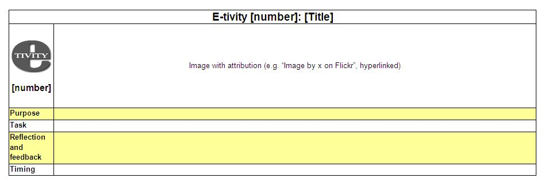
Purpose | To generate one or more e-tivities for your course, ensuring alignment with your Storyboard and course map.
Task | 1. With your colleagues in the course team, look at the e-tivity template. Start by writing the purpose of your e-tivity. (Take this from your storyboard. Check storyboard for alignment to outcomes, assessment and content. Modify storyboard if necessary.)  2. Decide which technology would be best suited to achieve the purpose. (Blogs, wikis, discussion forum or something else?) If you need help, see What Technology Can I Use for…?  3. Write the steps in the Task, being sure to make it clear where the students should go to do the e-tivity. Include any information about deadlines, word limits, and how performance will be assessed, if at all.  4. Write the "Reflection, response and feedback" section. You may want to have two separate rows for these. "Feedback" usually refers to the tutor's feedback, and "response" refers to the learners' responses to each other's contributions (e.g. a reply to a message on a discussion board, a comment on a blog, or an addition to a wiki page). The response section is critical to ensuring interaction between students.  5. Once you have completed the instructions for your e-tivity, please add it to the relevant page of the wiki, adding a commentary if you wish.  6. Repeat the above steps to create as many e-tivities as possible, taking into account feedback from colleagues (under “Response and feedback” below) as you go. Please add each new e-tivity to the wiki as soon as it is ready, to enable colleagues to comment as early as possible. That way you will be able to benefit more from the feedback.
Response and feedback | Please keep a watch on the wiki pages of the other course teams, and as you see draft e-tivities being posted, give your feedback by posting a reply in the “Comments”. Please think carefully about how to phrase your feedback so that it is as constructive and useful as possible to your colleagues.
Timing | Please complete this e-tivity in the time given in the Workshop.
Beyond Distance Research Alliance, University of Leicester, 2012

