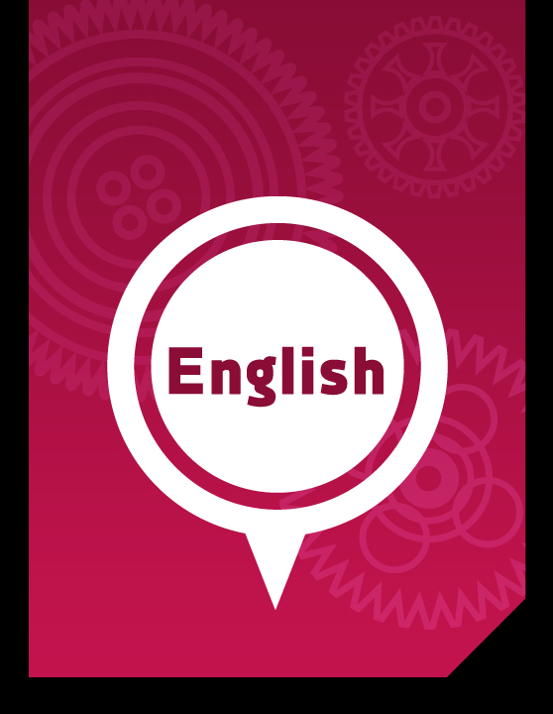

Part 5:

Anti-Corruption Education

English Literacy & Language Development, Workshop Series 2010

Part 5: Anti-corruption education

1. Introduction
Press reports are often used to communicate the message that important members of our society are corrupt. Public and private sector officials are often fingered (identified) by the press as agents of contestable (debatable) and corrupt practices. As disconcerting (alarming) are the amounts of money involved – often, millions are mentioned. The fight against corruption, we often hear, is on-going. We hear of corrupt relationships between business men and politicians. We read in the newspapers that tender-processes involving millions are compromised or manipulated for personal gain.

What should our attitude be? Part 6 of this module focuses on the values that we should work on if we want to make a positive contribution to the country. In fact, we explore the arguments in favour of anti-corruption education, proposed by Transparency International. What is your view?

Learning outcomes
By the end of Part 6 of this module, students will demonstrate their ability to
- work through pre-reading activities that promote understanding of form-meaning relationships in a text;
- argue a coherent and cohesive case on values and attitudes towards corruption and other destructive dynamics;
- produce extended texts, both spoken and written, on the topic of corruption; and
- use various modes of learning, including group work, group presentations, PowerPoint presentations, speaking-directed and writing-directed learning

2. Learning Activities
Scan the text on anti-corruption education below before you continue with the pre-reading activities.

Pre Reading Activity
Learning activity 2.1: [±30 minutes]

TASK 1:
Matching words, their meanings and the contexts in which they are used

‘Word and phrase’ bank:
transcend; sanctioned; sophisticated; depriving; dilemmas; accountability;
unethical behaviour; impartial; incentives; extort payments

Use the words from the word bank above to fill the spaces in the sentences below:
- The destructive behaviour of the mob was ___________ by the regional leadership: they expressed their dismay (shock/disappointment) at what happened.

- When the mob dispersed (spread), they accused the regional leadership of corrupt practices, shouting that their __________ _____________ would be exposed.

- In turn, the regional leadership urged (advised) the mob to ____________ their destructive approach for the good of the organisation.

- Meanwhile the local police had deployed (organised) ____________ monitoring systems to ensure that the mob did not deviate (move away) from the pre-determined and approved route of their march.

- The march became nasty when some of the marchers were seen to _____________ _____________ for protection. The police were too late to catch the perpetrators.

- The organisers of the march now face a number of _____________; the _____________ they offered to the marchers to keep them in a peaceful frame of mind had failed.

- Later in the evening, the police were accused that they had not been ____________ and had allowed the marchers to threaten shop owners.

- It was clear that the issue of _____________ was at stake: who was to blame for the anarchy (chaos/disorder)?

- The regional leadership felt that the mob had been unreasonable, and had merely disrupted (disturbed/interrupted) a process of consultation; everyone agreed that their aim was to ________ everyone of a negotiated settlement.

 | TIME  CHECK | Sections | Suggested time input | Actual time spent
 |  | Pre-reading learning activity 2.1 | ±30 minutes

TASK 2:
Fictitious (fabricated/invented/make-believe) Scenarios [±60 minutes]

Consider the following scenarios before you answer the questions that follow after them:
- Peter X is a teacher in a local high school. He is desperate to make more money – he has become impatient (annoyed/irritated). Why should he wait for the big time? He would like to have much money and feel that he can do whatever he likes. In fact, he has had enough of what he sees as “scrounging out a life”. He decides that he will set up an additional source of income. He is responsible for the school’s rugby side, and parents are more than willing to make donations. So, perhaps that is where he can actually build in his system – he’ll take 5% of each donation as an incentive. Seeing that he is in charge of funding, and there are no controls, he is sure his system will work. Besides, he needs the money, and he is the coach after all.

- Sarah B is a journalist at a local newspaper. She decides that she would like to gain experience as a financial journalist. She approaches the editor who is immediately positive about her aspirations (goals). The editor expresses her hope that she will persist (continue/persevere) and not give up on this dream. She advises Susan to apply for a bursary from the Regional Editors’ Forum. Sarah phones the forum where she speaks to one of the managers. She explains her intention (aim/goal), requesting (asking for) information and the relevant documentation. The manager tells her that he would like to see her, and that he will arrange for her to meet some of the editors on the selection panel. She arrives in Johannesburg where she meets the manager. To her dismay (disappointment), he then suggests that for a “bit of fun” he can actually ensure that she is selected for the programme and be assigned a bursary.

- Consider the two scenarios. Decide (a) whether they involve corrupt practices, and (b) what action those affected by these practices might take to counter (oppose) them.
- In pairs, decide on five principles you would apply to counter corrupt practices and attitudes in society. In a report-back, you have to discuss these with your fellow-students.
- What are the possible consequences of the corrupt practices referred to in the two scenarios above? In pairs, discuss these consequences and prepare a list to share with the group.
- In pairs, outline five instances (examples) of corrupt actions or practices. You have to be able to state why these practices are corrupt.

 | TIME  CHECK | Sections | Suggested time input | Actual time spent
 |  | Task 2: Fictitious Scenarios | ±60 minutes

While & post reading Learning activity 2.2: [±90 minutes]

Using the SQ4R and other techniques, study-read the following text before you answer the questions and complete the tasks that follow after it:

Reading 1: Anti-corruption education
Anti-corruption education
"Two things fill the mind with ever new and increasing wonder and awe - the starry heavens above me and the moral law within me."
Immanuel Kant (1788)
1.

Anti-corruption education is a vital component of any anti-corruption strategy. Informed citizens are probably more effective in preventing corrupt and unethical behaviour of public servants than the most sophisticated codes of conduct, laws and regulations. Anti-corruption laws and institutions need people who do not tolerate corruption and who actively act against it: Without reports of corruption, corrupt acts cannot be sanctioned (allowed/
authorised), ombudsmen cannot follow up on complaints, the judiciary cannot prosecute.
2.
The goal of anti-corruption education is to build demand for accountability. Anti-corruption education promotes values, attitudes and expectations that condemn corruption, and skills to resist it. Anti-corruption education develops people's understanding of their rights and responsibilities for preserving the public good. It highlights the damage done by minor acts of corruption: The traffic officer who lets a drunk driver go in exchange for a small bribe, the nurse who denies patients treatment if they are unable to pay 'an additional fee', the customs officer who extorts payments from small traders and enterprise: These acts potentially kill, ruin small enterprises, and deprive people of their human rights to health, education and security.
3.
Anti-corruption education impacts at two levels:
First, it aims at strengthening individuals in their ethical decision-making. Value conflicts and ethical dilemma (problems) frequently arise in the daily lives of people, for example when family values, such as loyalty, clash with work ethics, such as impartiality (detachment/neutral- ity). Ethics education should provide the skill to identify such conflicts, and instil the motivation for solving them in the best interest.
Second, it aims at building a culture of zero-tolerance for corruption, through strengthening public awareness and participation in political life, and through mobilising the public to stand up against corruption.
4.
Anti-corruption education is not an agenda on its own, but should be regarded as part of broader approaches to ethics and citizenship:
5.
Citizenship and democracy education aims at strengthening democratic processes and participation in politics, and promotes values such as representation, solidarity (unity), participation, responsibility and pluralism (diversity). Human rights education promotes inherent (natural/inborn) human dignity, enshrined (protected) in the equal and inalienable (undeniable) rights to for example take part in government, fair employment, adequate standard of living and many others, as stated in the Universal Declaration of Human Rights (1948). Voter education, in that it builds citizens' awareness of electoral processes, should also be considered anti-corruption education. Finally, public and private sector ethics and organisational ethics do have strong anti-corruption components, as they build on values such as accountability, fairness, impartiality and lawfulness.
6.
A corruption-resistant culture needs political commitment from the top, as well as an appropriate legal framework. It can develop in an environment where people have the skills and social power to stand up against corruption. It will be difficult to credibly (convincingly/ realistically) promote anti-corruption in a culture of impunity (immunity), or in a situation of extremely low salaries and in absence of other incentives for ethical behaviour. Can anti-corruption education in such an environment still be credible (likely/realistic)? Yes, if it addresses ethics and corruption honestly, and if it comes from people who transcend (rise above) integrity and high ethical standards.

Transparency International e.V. copyright © 1994-2007
http://www.transparency.org/global_priorities/other_thematic_issues/education/anti_corruption_education

Answer the questions that follow in your own words – use the spaces provided for your answers:

Read the quote preceding (before) paragraph 1:
- In a response of approximately 50 words, what do you think the quote means?

Read paragraph 1
- What role does the author think anti-corruption education plays?

- What is the logical link between the first and the second sentences of the paragraph?

- What role does the informed citizen often take when faced by corrupt practices?

- Rewrite the first sentence. Add subjects to the sentence.

- What is an ombudsman?

Read paragraph 2
- How would you define the word “accountability”?

- What does “it” in the fourth sentence refer to in the previous sentences?

- What do you think are the two most important goals of anti-corruption education?

- What do “they” and “these acts” in sentence 4 refer back to in the text?

- According to the author, what are the negative consequences of corruption?

Read the heading and paragraph 3
- Provide a twenty-word outline of the double impact of anti-corruption education.

- How does the author use the heading and discourse markers to promote structure and unity in the text?

Read paragraphs 4 and 5

- Give a brief outline of two important points in anti-corruption education you would see as intimately (closely) linked to a wider approach to moral values and public education.

- In the text, how are the highlighted phrases in paragraph 5 linked to the sentence in paragraph 4?

Read paragraph 6
- What are the two most important ideas you would select as relevant in this paragraph? Give reasons for your choice.

- The impersonal pronoun “it” is used several times in this paragraph. In each case, explain what each “it” refers to.

 | TIME  CHECK | Sections | Suggested time input | Actual time spent
 |  | While- and post-reading Learning Activity 2. | ±90 minutes

group activity 2.3: [±120 minutes]

- Task 1: In groups of four, prepare a presentation in which you argue a case for anti-corruption education. Each member of the group must take responsibility for at least one of the PowerPoint slides.

- Task 2: In groups of four, draw up a code of conduct for politicians from a anti-corruption point of view.

 | TIME  CHECK | Sections | Suggested time input | Actual time spent
 |  | Group Learning Activity 2.3 | ±120 minutes

3. Assessment Activities
Assessment activity 3.1:
Scenario-based reasoning [±120 minutes]

The purpose of this assessment task is to determine whether students are able to write a logical and organised essay on a socially significant topic.

First, look at the four tasks you completed on the scenarios we presented in the section on starting up activities. Then, write a 400-word essay in which you state your position on corruption in society. In your response, you have to deal with the following headings, and follow the guidelines given below:

- Introduction: A brief statement of your position, and the main ideas to be dealt with in the essay. Use discourse markers (connective words) to signal to the reader what arguments you will be including in your essay.

- Body of the essay: You may use headings. In your reasoning, you have to include a definition of corruption, its negative consequences, why it should be countered and rooted out, and how you propose to do so. You need to give examples to support your reasoning. Here you decide on the number of paragraphs you will need.

- Conclusion: This will be the concluding statement. You need to capture the essence (core) of your reasoning.

The following rubric will be used:

Dimension [Poor] | Scale | Dimension [Excellent]
Coherence: illogical ideas, confusing and incomplete | 1 2 3 4 5 6 7 8 9 10 | Coherent, integrated, holistic response
Cohesion: Sentence and paragraph inconsistency | 1 2 3 4 5 6 7 8 9 10 | Sentence and paragraph consistency and balance
Grammar and communication errors | 1 2 3 4 5 6 7 8 9 10 | Very accurate and style excellent
“Heavy” and abstract nouns are used, and subjects cannot be identified clearly. | 1 2 3 4 5 6 7 8 9 10 | Denominalised (nouns changed into verbs) text is used; subjects and their actions are specified; active rather than passive verbs.
Reasoning is unsupported and the structural guidelines have not been followed. | 1 2 3 4 5 6 7 8 9 10 | Reasoning is supported and the structural guidelines have been followed.
Score
Performance-enhancing feedback:

Assessment activity 3.1:
Presentations [±120 minutes]

The purpose of this assessment task is to judge learners’ ability to use PowerPoint in presenting their personal views on anti-corruption education.

For this section, students have to produce two presentations. Review group activities (Tasks 2.3.1 and 2.3.2 above).

Prepare two presentations. Each member of the group must be given an equal part of the task as they will be assessed individually in terms of the following rubric:

PowerPoint Presentation Rubrics [30 marks per presentation]
Criteria [Unacceptable] | Scale | Criteria [Exemplary]
Content and ideas are not at all clear | 1/2 3/4 5/6 7/8 9/10 | Content and ideas are clear
The presentation is poorly organised (with no introduction or conclusion) | 1/2 3/4 5/6 7/8 9/10 | The presentation is well organised (with a clear introduction and conclusion)
Language use (e.g., spelling; grammar) is very poor | 1/2 3/4 5/6 7/8 9/10 | Language use (e.g., spelling; grammar) is excellent
Comments and Suggestions for Improvement:

Score:________________ / 30/3 = 10 MARKS

 | TIME  CHECK | Sections | Suggested time input | Actual time spent
 |  | Assessment Activities 3 | ±120 minutes

4. End of section comments
The aim of these assessment tasks is to allow us to assess the ability of students to produce extended texts, both spoken and written. The critical test of students’ proficiency is whether they are able to produce original texts and messages as they respond to communicative tasks.

5. Feedback
As stated in other parts of the module, you will receive feedback from your facilitator once you have completed the activities. You need to re-visit your responses, comparing your attempts with our sample responses. Remember that language is novel – in open-ended activities, we cannot produce definitive responses. It is also vital that you engage in further activities based on the feedback. Your facilitator will attend to this cycle in the feedback loop.

6. Tracking my progress
You have reached the end of this section. Check whether you have achieved the learning outcomes for this section.

Learning outcomes | I feel confident | I don’t feel confident
Deal with pre-reading activities aimed at allowing them to access the form-meaning relationships in a text
Argue a logical and organised case on their values and attitudes towards corruption and other destructive dynamics
Produce extended text, both spoken and written, on the topic of corruption
Use various modes of learning, including group work, group presentations, PowerPoint presentations, speaking-directed and writing-directed learning

Now answer the following questions honestly:

- What did you like best about this section?

- What did you find most difficult in this section?

- What do you need to improve on?

- How will you do this?

- How has your journaling helped you in becoming more productive?

 | TIME  CHECK | Sections | Suggested time input | Actual time spent
 |  | Tracking my progress | ±30 minutes

PART 5 – Anti-corruption education:
Glossary of difficult words [±40 minutes]

Complete the crossword activity below by finding suitable synonyms in the word bank.

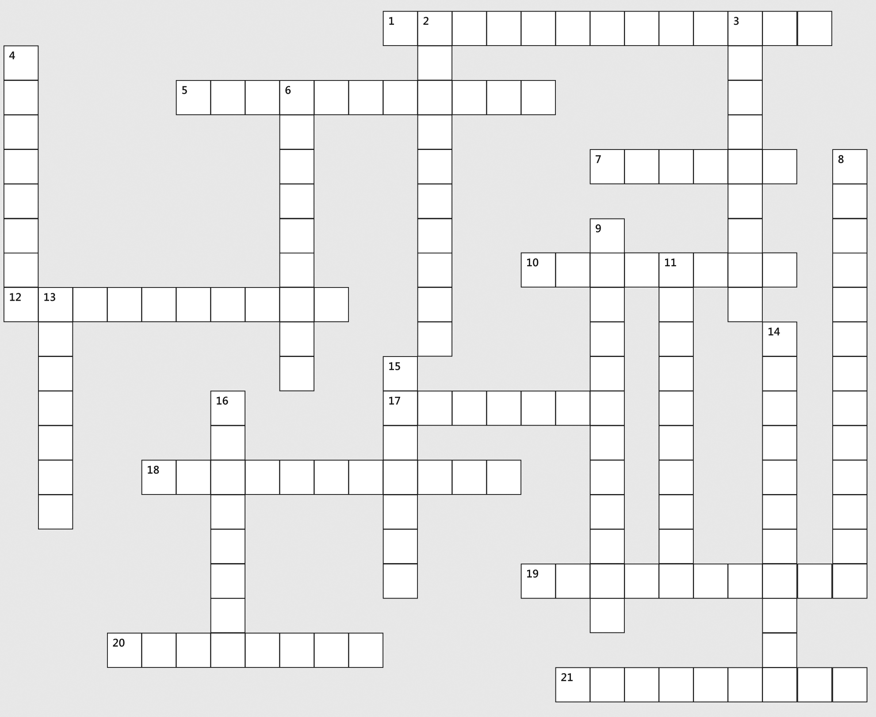

Across | Down
1. alarming | 2. closely
5. debatable | 3. examples
7. shock/disappointment | 4. problems
10. identified | 6. rise above
12. allowed/authorised | 8. detachment/neutrality
17. core | 9. undeniable
18. goals | 11. protected
19. unity | 13. chaos/disorder
20. convincingly/realistically | 14. fabricated/invented
21. spread | 15. move away

Part 5 – Overall time check
 | TIME  CHECK | Sections | Suggested time input | Actual time spent
 |  | Pre-reading Learning Activity 2.1 | ±30 minutes
 |  | Fictitious Scenarios: TASK 2.1.2 | ±60 minutes
 |  | While- and post-reading Learning Activity 2.2 | ±90 minutes
 |  | Group Learning Activity 2.3 | ±120 minutes
 |  | Assessment Activities 3 | ±120 minutes
 |  | Tracking my progress | ±30 minutes
 |  | Approximated source consultation time | ±60 minutes
 |  | Total time for Part 5 | ±8.5 hours

References
WEB-BASED REFERENCES
Transparency International (2008) Anti-Corruption Education, at the following URL:
http://www.transparency.org/global_priorities/other_thematic_issues/education/anti_corruption_education

Skills Pack: Common Errors, page 21
Skills Pack: Common Errors, page 23

