Part 2:

Using PowerPoint to Present

ICT Module, Workshop Series 2010

Part 2: Using PowerPoint to Present

1. Structuring Your Presentation
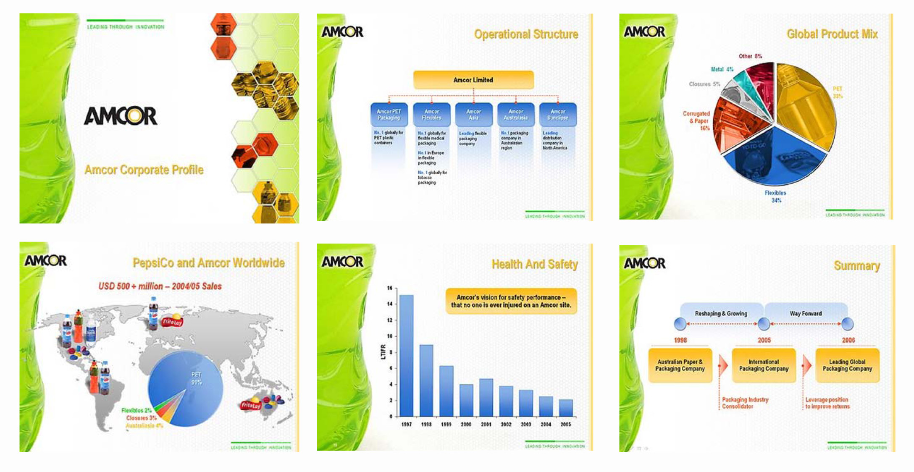

http://www.propointgraphics.com/samples2.php?pop=&page=2&apage=1&isalbum=album-17&gal=3&ai=5&view=

It does NOT have to be death by PowerPoint! With a bit of knowledge and a hint of creativity, you can create an impressive PowerPoint presentation, such as the one above. It is actually quite an exciting programme once you know how it works – you can insert graphics, sound, pictures, effects, etc. However, let’s start with the basics first.

Outcomes
Upon the completion of this Part, learners will be able to:

- Demonstrate basic PowerPoint skills
- Present information by means of a PowerPoint presentation
- Insert media and graphics into a PowerPoint presentation

Presentations
A presentation involves you speaking to an individual or a group of other people in order to make point or share information.

What is expected of you in terms of a presentation?

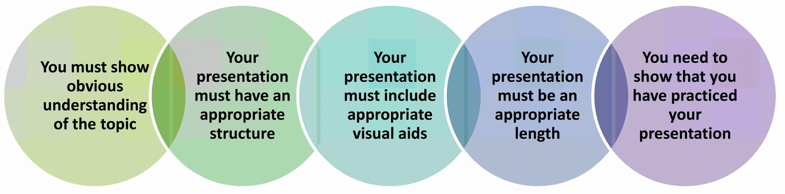

PowerPoint can be used to:
- persuade
- teach
- sell
- train
- entertain

The Basics

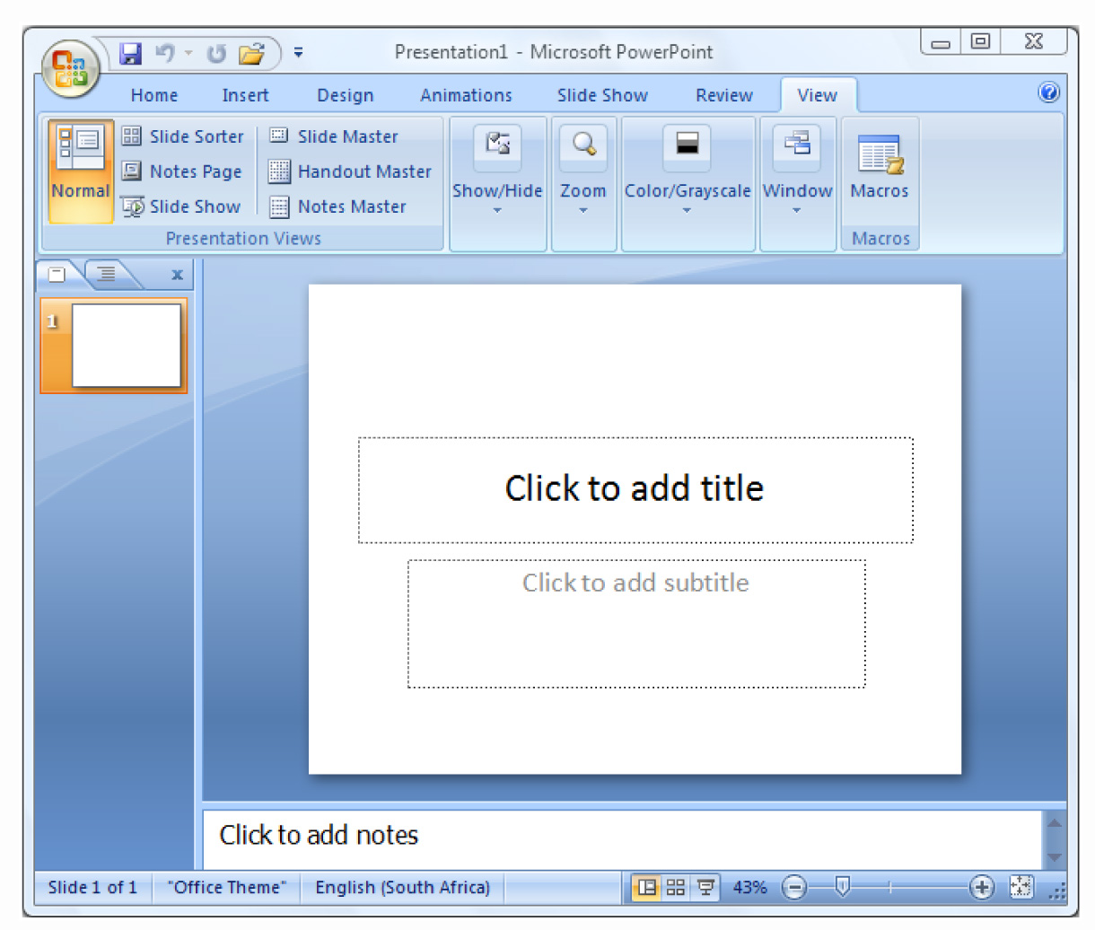 | Opening PowerPoint  Click on:  Start button>> Programs>> Microsoft Office>> PowerPoint
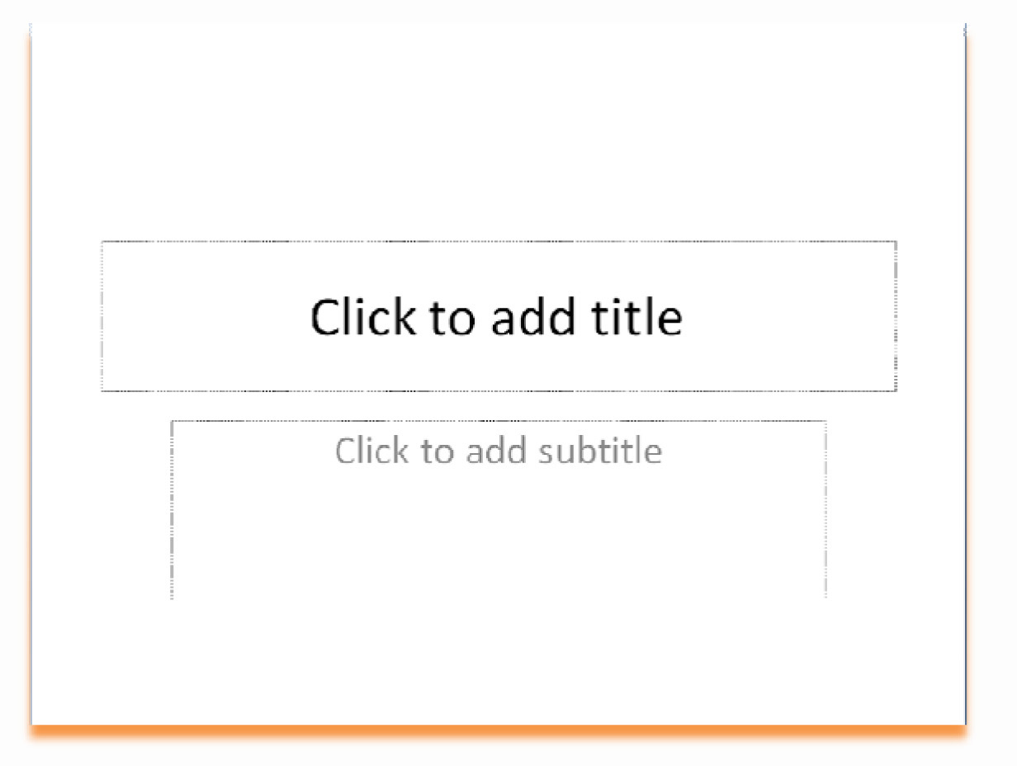 | A slide  a single page within a presentation
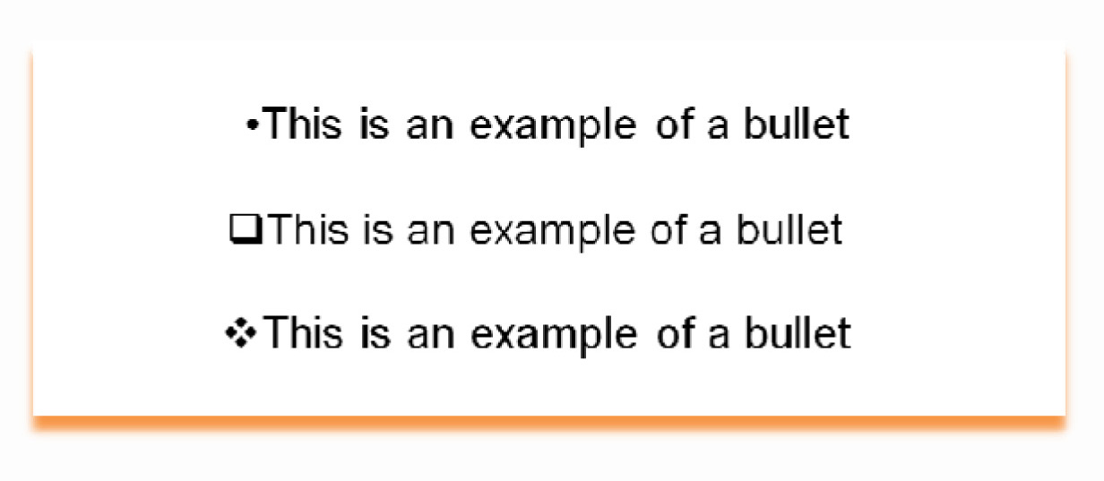 | A bullet  a shape that appears in front of a sentence
Layout

the arrangement of text and objects
Placeholder

the place where you put content on a slide
Sizing Handles

a way of adjusting the size of your slide show
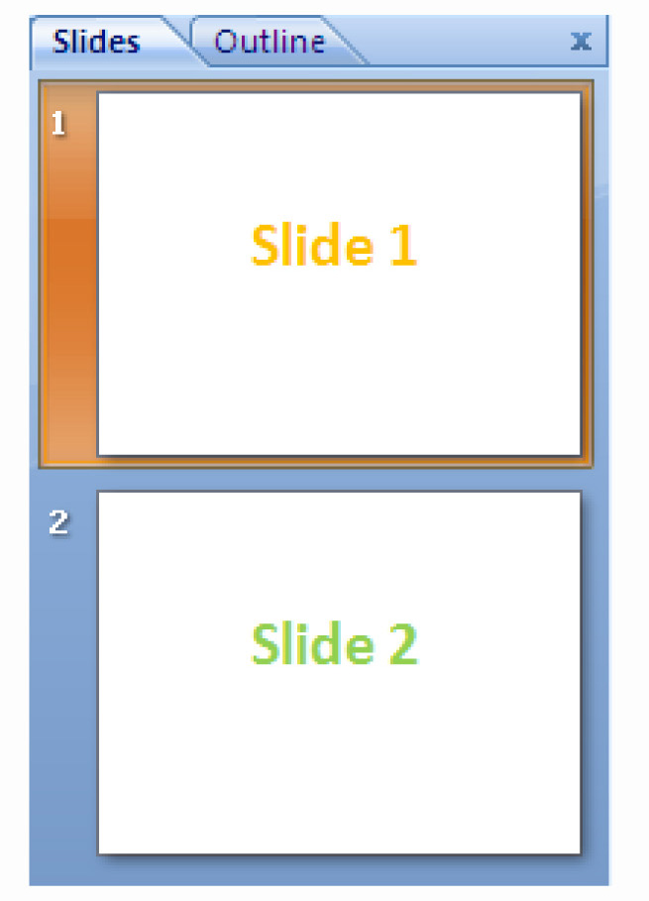 | Slide Transition  the visual transformation from slide to slide.
Design Theme

file that contains the styles in a presentation

Group Learning activity 2.1

Now it is time to experiment. In pairs, see if you can work out how to do the following. Use the space provided to write down the steps involved. Ask your facilitator for help if you really get stuck.

- Add a Slide
- Transform a list into bullet points
- Modify the layouts
- Add text to a placeholder
- Use sizing handles to rotate and move the a place holder
- Select a Slide Transition
- Apply a Design Theme to the Slide Show

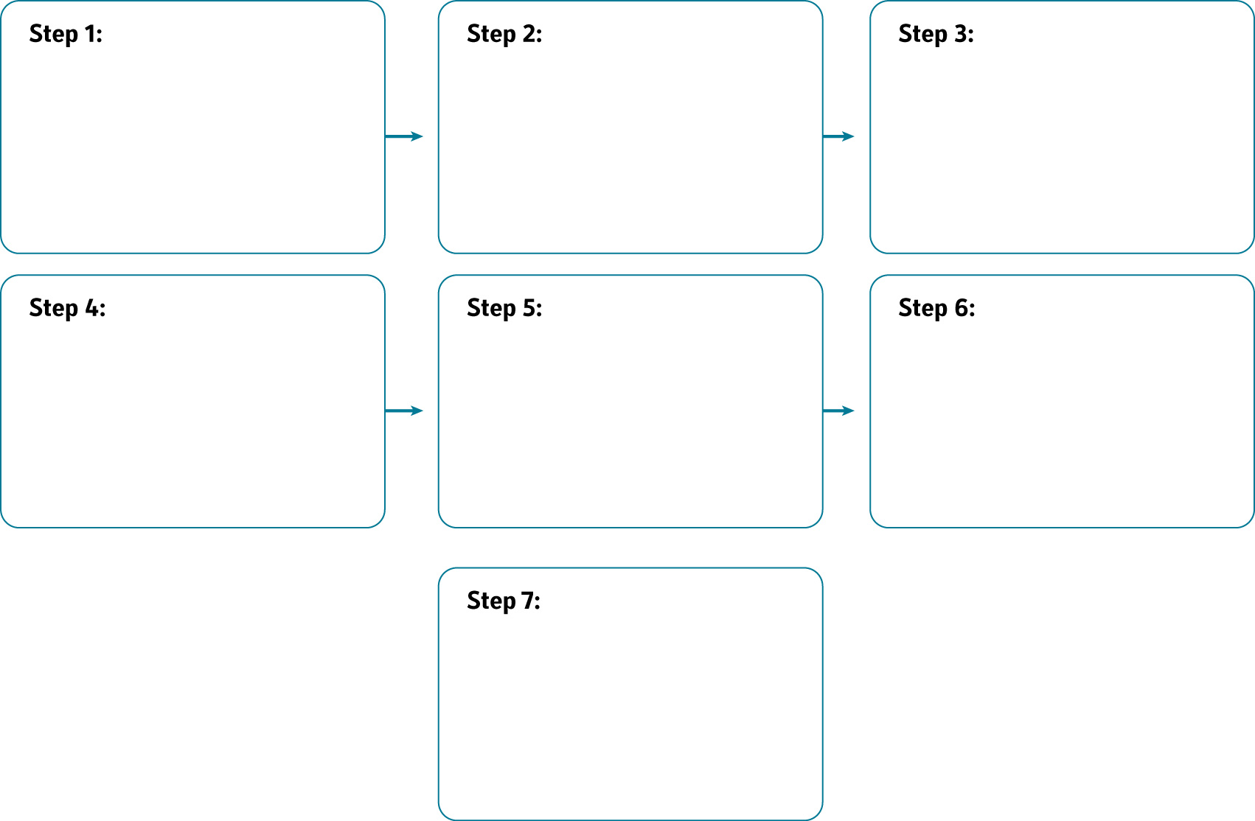

2. Inserting Media and Graphics
The following focuses on adding pictures, graphs, sound, videos, text and animation to your presentations. This is fun to do and will improve the quality of your presentation; it will also make it more interesting and enjoyable for those whom you are doing the presentation for.

The term ‘multimedia’ refers to any combination of media that is delivered electronically and can be accessed interactively.

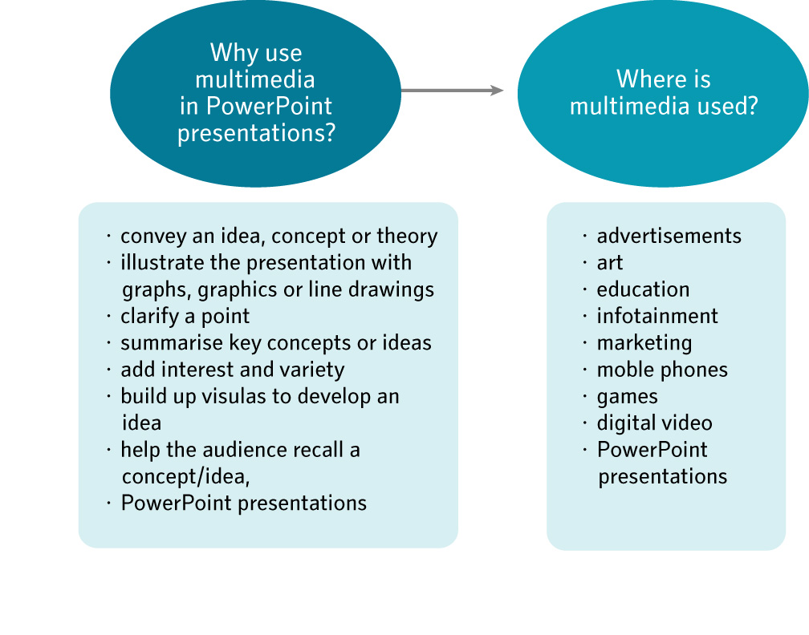

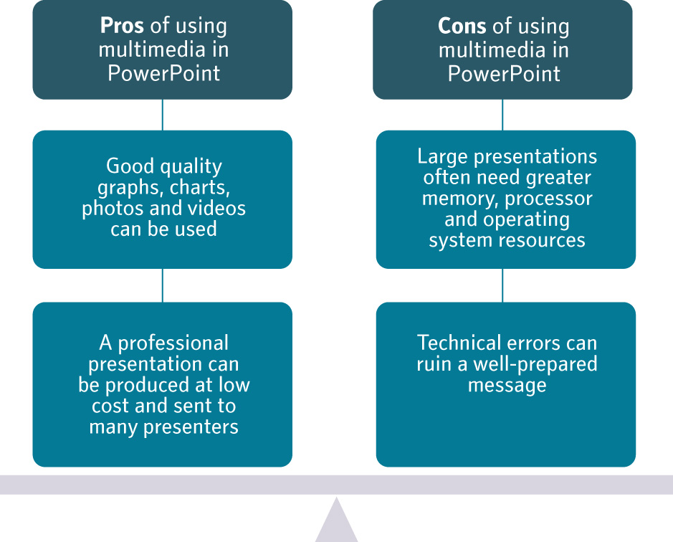

STEPS to inserting multimedia:

Clipart | Click Insert > Clip Art...  * Use a keyword to search for the clip art you want.  * Scroll down through the Clip Gallery to preview the clip art selection  * Select the Clip Art and click it  * The Clip Art will appear on your slide  * When you are finished using the Clip Gallery, click the Close button in the Clip Gallery title bar
Photographs | Click Insert > Picture…  * Find the folder where the picture is stored  * Scroll down through the folder to preview the photographs  * Select the file and click insert  * The photograph will appear on your slide
Sounds | Click Insert > Click the arrow below the sound icon  * Find the file on your computer  * Select a pre-recorded sound in the clip organiser  * Play a CD track  * Record your own sound.  * Decide whether you want the sound to start automatically or when clicked.  * The sound icon will appear in the centre of your slide
Motion Clip | For animations …  Click Insert > Click the arrow below the Movie Icon  Select a pre recorded motion clip in the clip organiser (usually an animation)
Motion Clip | For Movies…  Click Insert > the Movie Icon  * Find the file on your computer  * Decide whether you want the movie to start automatically or when clicked.  * The motion clip will appear in the centre of your slide

Group Learning activity 2.2.1

In groups, try and duplicate the following PowerPoint slide. Use the space provided to make notes.

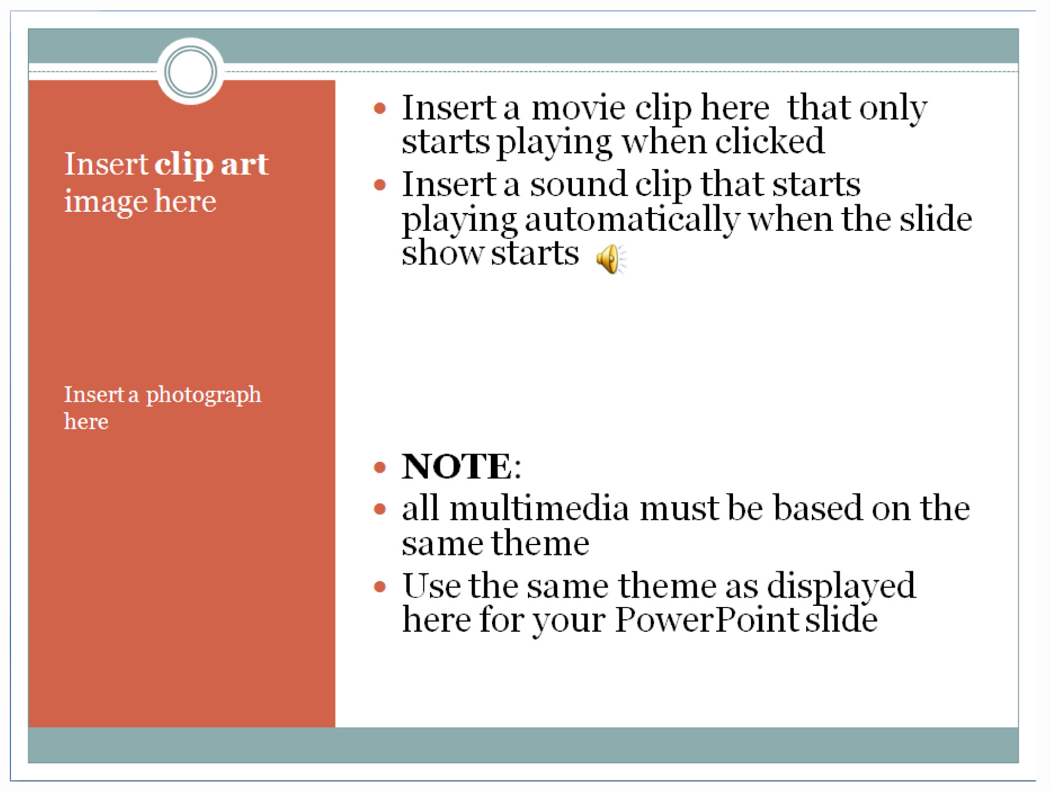

NOTES:

5. Tracking my progress
You have reached the end of this section. Check whether you have achieved the learning outcomes for this section.

Learning outcomes | I feel confident | I still need practice
Demonstrate basic PowerPoint skills
Present information by means of a PowerPoint presentation
Insert media and graphics into a PowerPoint presentation

What did you like best about this section?

What did you find most difficult in this section?

What do you need to improve on? How will you do this?

