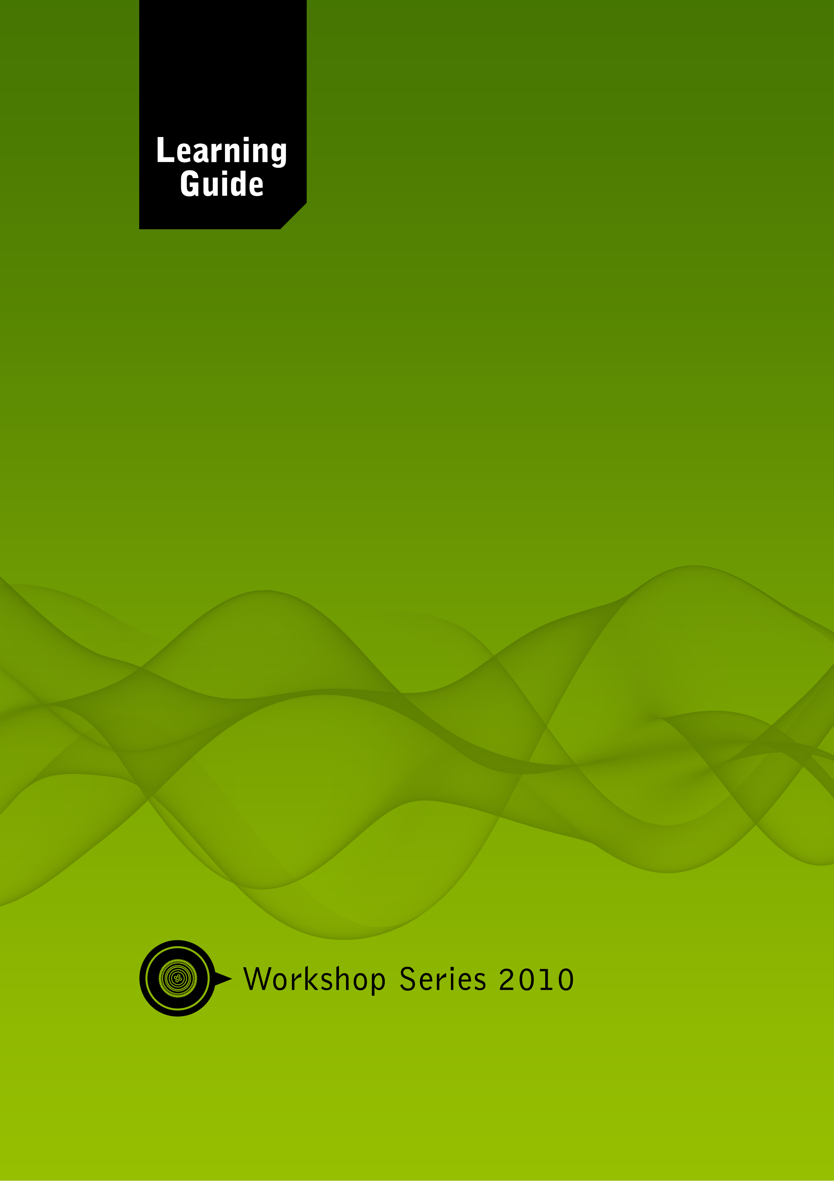

ICT Module
Skills for a Changing World

Module Development Team

Module
Co-ordinator: Andrew Moore

Authors: Andrew Moore
Donna Preston
Derek Moore

Co-writers: Catherine MacDonald

A Project of the: Free State Education and Training Trust (FSETT), led by the University of the Free State
PO Box 4345
Bloemfontein, South Africa, 9300
Telephone: +27 (0)51 5051222
Fax: +27 (0)51 5051277

Materials can be downloaded from: http://www.oerafrica.org

Creative Commons License:
Attribution Non-commercial Share Alike

Acknowledgements
The development of this programme was made possible through the generous donation of the Ford Foundation. The materials are the product of a collaborative endeavour involving representatives of the following organisations:

University of the Free State
Free State School of Nursing
Central University of Technology, Free State
Mindset Network
OER Africa

Sincere thanks are extended to the authors, co-writers, academic assistants and the numerous experts who acted as critical readers, evaluators and language editors during the drafting of these learning materials.

Module Coordinators can add additional acknowledgements as needed

Introduction

Programme Map

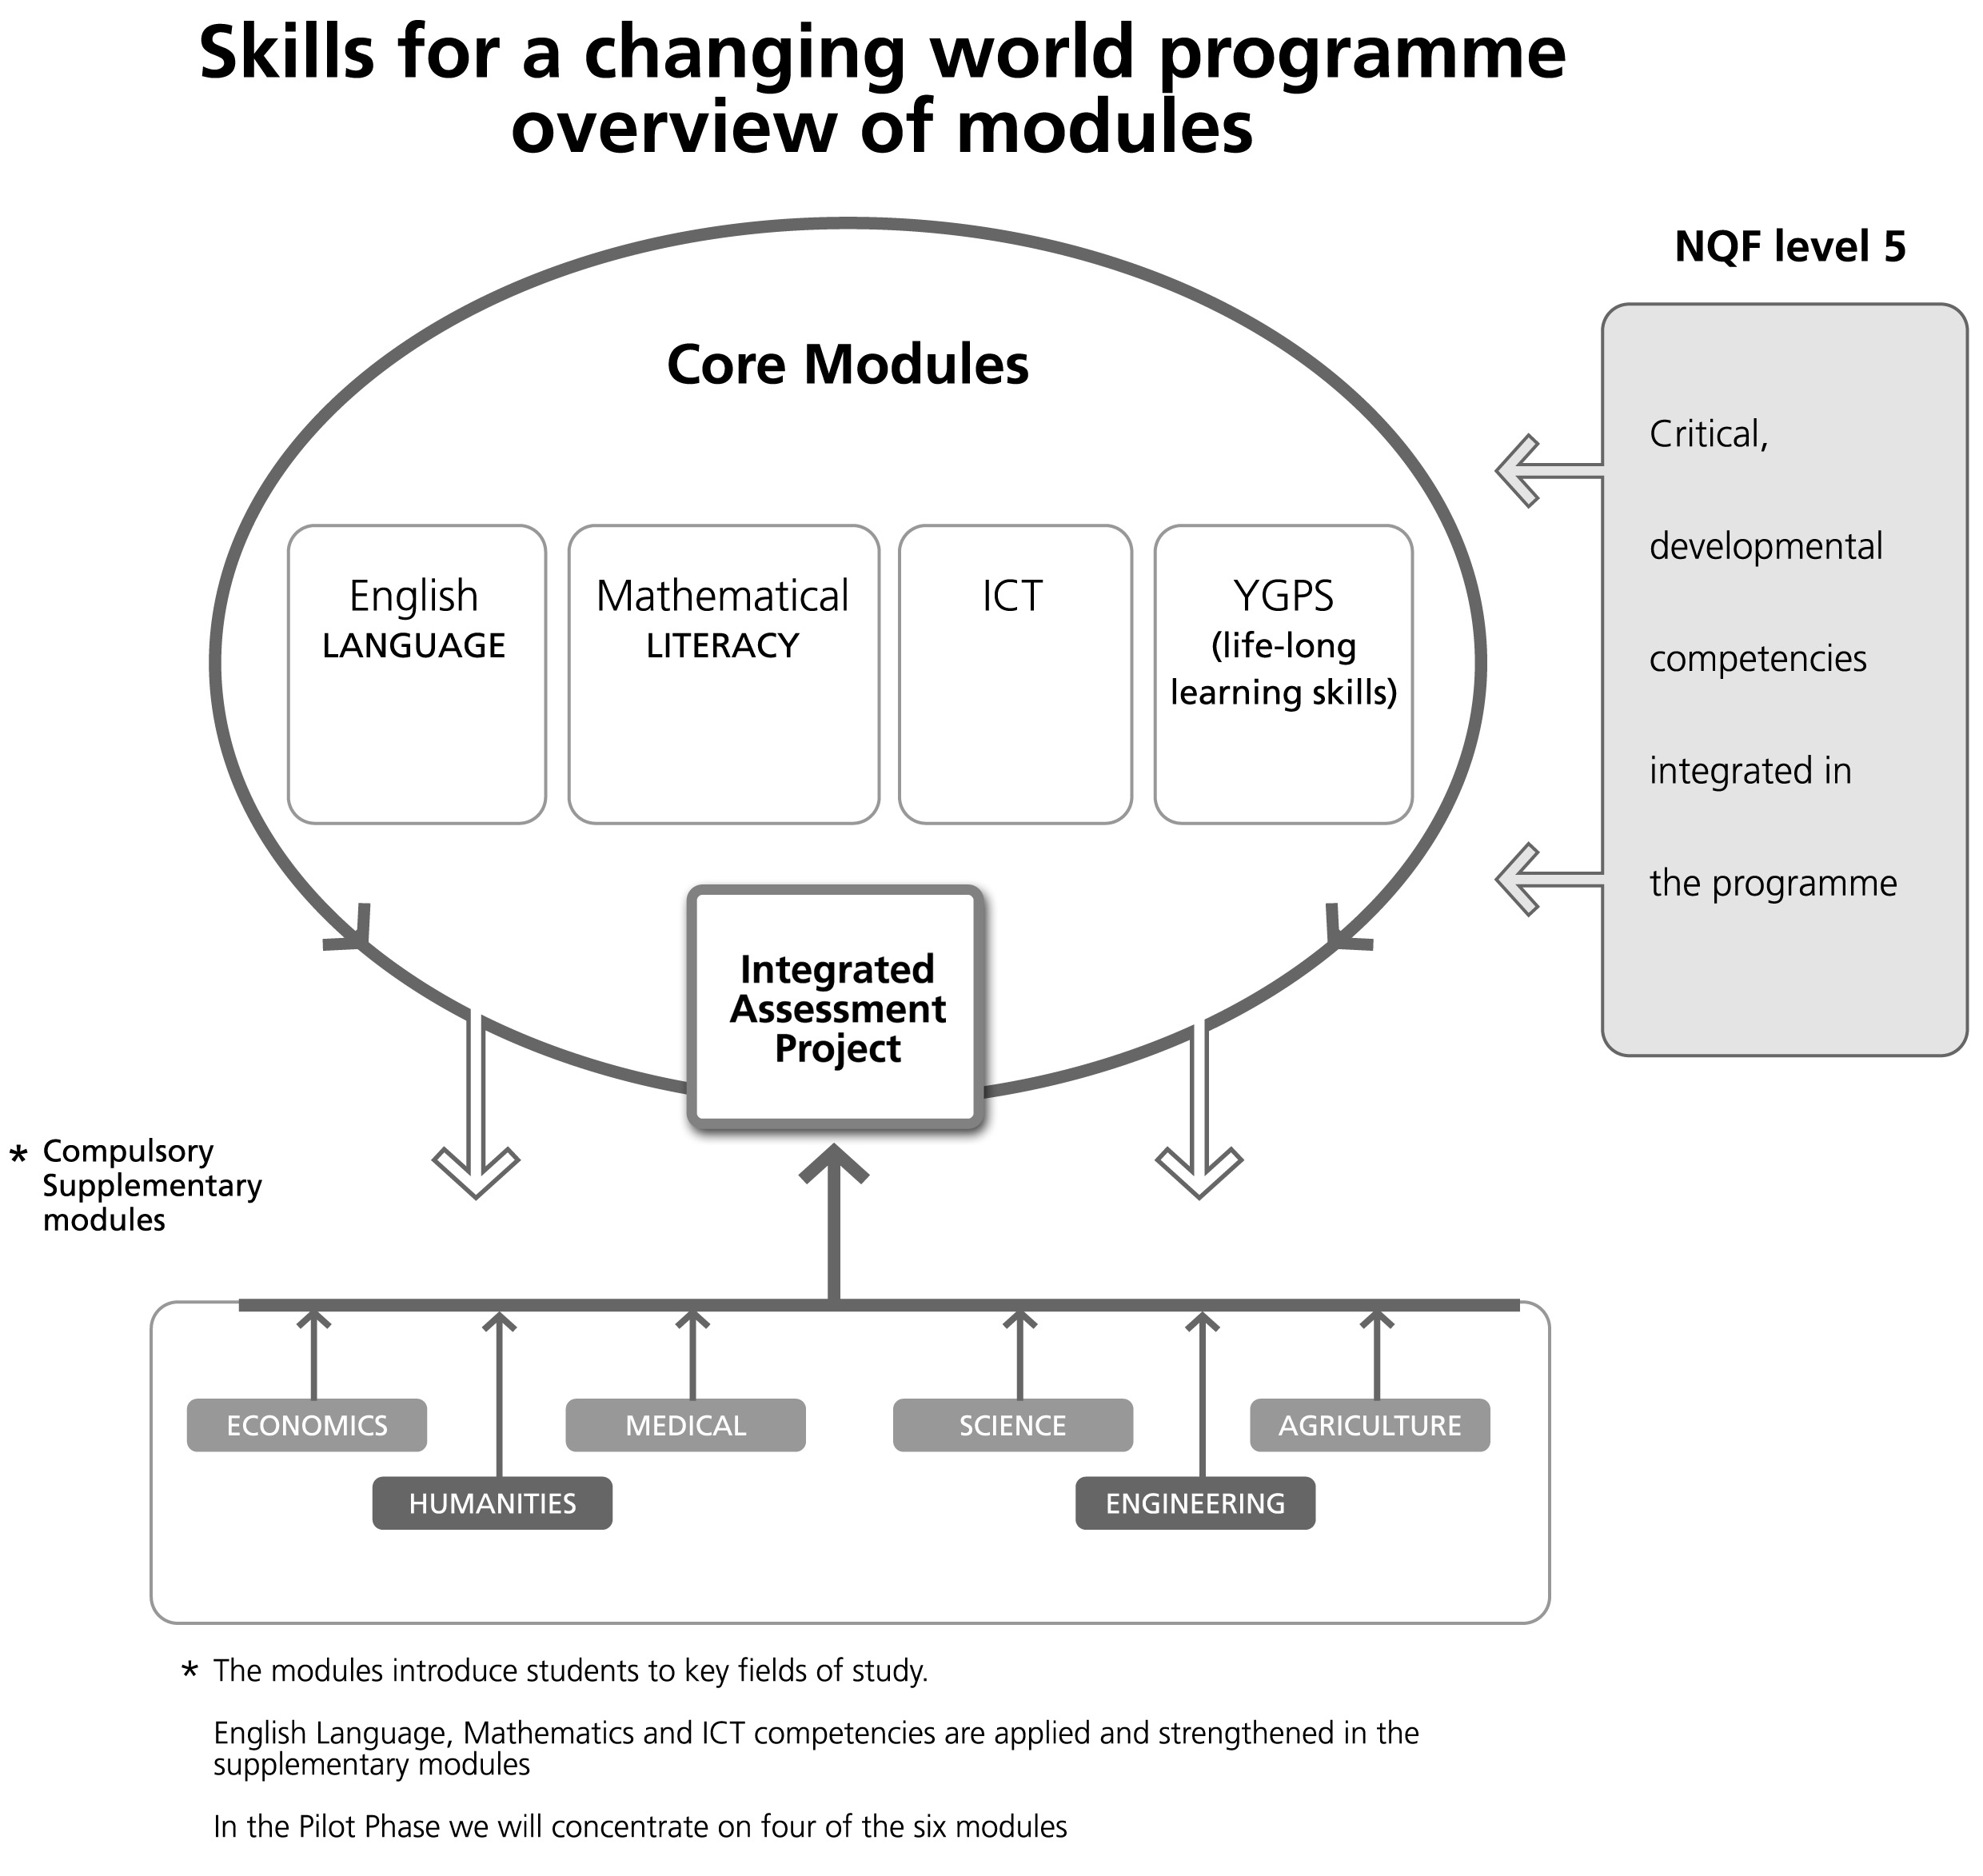

ICT Module Map

Information about the module
This module will provide you with a solid grounding on how best to use technology in the world of work and tertiary education. While the skills and knowledge you will learn here can be applied broadly to all avenues of life we have fashioned them specifically to support you complete the Skills for a Changing World programme. Consequently the word processing skills you will learn in this course will be used later in the language course, spreadsheets will come in handy during some of the Maths exercises while your presentation skills will be needed in the YGPS module. We have ordered the lessons in an attempt to provide you with the right skill at the right time so follow the ICT Module section order to stay in ‘synch’ with what is happening elsewhere in the programme.

As an additional outcome our module you will enable you to construct your own electronic portfolio on CD-ROM. This electronic document will contain your best work from each ICT module sections as well as reflect your taste and interests. This document also contains a short CV so it can be used to persuade prospective employers when you are looking for a job or wanting to start a career.

What is this module about?
This module will introduce computers and other ICTs (Information and Communication Technologies). While you will have a little theory to familiarise yourself with, most of the course is practical and will require you to practice various computer skills. We will use mostly practical sessions in the computer room rather than lectures or tutorials. There will also be a healthy dose of self directed study when you will be required to practice your new skills or use the programs to find out additional information. For this you will need to be able to access the institutional computer room after the allotted time allocated to official practicals and tutorials. Access to a computer at home would also be beneficial although is not a compulsory requirement.

What will you learn?
Each section part has its own outcomes which are stipulated at the beginning of each lesson. However, at the end of this module you are expected to show evidence that you have achieved the following main learning outcomes:

My learning journey
What I am expected to know and do | I feel confident | I still need practice
Demonstrate a basic knowledge of how the computer system works,
Describe the parts of a PC using the correct terminology.
Log into the institutional network
Demonstrate competency at creating and presenting a PowerPoint presentation.
Demonstrate competency at writing and editing a word processor document.
Demonstrate competency at creating a spreadsheet document
Demonstrate competency at receiving, writing, sending and storing e-mail correspondence.
Demonstrate competency at interacting with members and extracting information from Social Networking Sites
Demonstrate an ability to search competently for information on the Internet
Demonstrate an ability to search competently for information using online and multimedia encyclopedias
Demonstrate an ability to correctly reference sources extracted from ICT sources using online citation tools.

How much learning time do you need?
This module carries 16 credits. It should take approximately 160 hours to successfully complete the module. This includes contact session time with your facilitators and tutors, reading time, your own research time and time spent on doing the assessment activities.

A Time Check is included at the beginning of each module. It is a useful time management tool as it shows how much time you are expected to spend on each of the sections and it allows you to record how much time you actually spent.

Time Check
Sections | Suggested time input | Actual time spent
- Orientation | 20 hours
- Introduction to ICTs | 27 hours
- Presenting Information and Portfolio Work | 23 hours
- Assignment Writing using a Word Processor | 30 hours
- Data Processing with Spreadsheets | 26 hours
- Communication with e-Mail and Social Networks | 21 hours
- Researching Skills using ICTs. | 13 hours
Total | 160 hours

How will you learn?
This module, like the whole of the Skills for a Changing World Programme uses different ways of learning. Experienced facilitators will guide and support you throughout the programme. They will plan and organize suitable contact sessions during which you will use the student guide and various other learning materials.

Trained tutors will further help you with individual and group learning activities. By working with your fellow students on group activities you can give each other support and learn important teamwork and communication skills.

Much of what you will achieve depends on your own effort and commitment. The most successful students are not necessarily the cleverest or the most experienced, but rather those who are most disciplined, most organised, most willing to reflect critically on their own learning, most able to practice what they are learning, and most successful in managing their time.

To support you in your learning in the ICT module, there are two kinds of learning resources that you can use – a Student Guide, and a Resource CD. Each of these learning resources has a specific purpose:

The Student Guide outlines the learning path for the ICT module and provides you with basic information, guides you through activities and stimulates you to ask questions, find answers and share what you learn with your fellow students. The information in the Student Guide is not a sufficient source of learning in itself. You, the learner, have to complement the information contained in the Student Guide by reading, researching, discussing/debating and reflecting. Only then will your learning be an enriching experience.

The Resource/CD contains a number of electronic materials that are part of your learning path outlined in the Student Guide These materials include multimedia tutorials, word processor templates and exercise files, presentation templates and spreadsheet activity files. You will be required to access these documents from the CD at the appropriate time as stipulated in the guide.

How will you be assessed?
In the ICT module you will be assessed in two ways: individual assessment tasks after each section and also through the submission of a completed electronic portfolio for an overall semester mark:

All section assessment tasks and tests (7 in total) will be marked individually after the completion of each section. These tasks are worth 10% of the final module mark. The student then has the prerogative of revising these documents before storing them on an electronic portfolio prepared by themselves and the focus of Section 3 activities. The portfolio will also store any additional work generated by each student in the other modules where there is an overlap. Besides a repository of work the portfolio also contains a student journal for self reflective activities, a student CV, personal profile that includes collected media etc. The portfolio will be taken in for marking and will be allocated 30% of the students ICT Module semester mark.

How to find your way in the student guide
This guide is prepared especially for you. It contains all kinds of activities that invite you to take an active part in learning important skills and behaviours that will help you to be successful not only in this programme but that will also prepare you for your future role in the world of study and work. Learning can be an exciting adventure when you start doing things for yourself.

Icons
Icons are visual ‘signposts’ that give clear signals of what is expected of you. The following icons are used in the Student Guides for all the modules. You will soon become used to recognising each icon and the message it conveys.

Learning activity
When you see this icon, you will know that you have to do an activity to show how well you understand what you have read and learned. For some of the learning activities the writer will include some comments or advice. These comments should never be read before you have completed the preceding activity. These comments are also not intended to provide the final ‘answer’, since your opinion may be completely different from the writer’s and still be acceptable. The writer is simply providing you with an informed opinion.
Group activity
Whenever you see this icon you will know that you will work with some of your fellow learners on a team activity.
Assessment activity
This is the sign for assessment activities that you will complete and include in your portfolio. All these activities are marked by the facilitator and they will contribute to your total mark for the programme.
Resource file
When you see this sign you will know that you need to refer to the resource file/CD. It contains additional readings and articles that you may be asked to use to complete an activity.

Module Sections
Section 1: Orientation
- Computer Room Usage
- Basic Operations
- Terminology
- Electronic Portfolio
- Assessment Task

Section 2: Introduction to ICTs
- Hardware I
- Hardware II
- Software I
- Software II
- Networks
- Assessment Task

Section 3: Presenting Information & Portfolio Work
- Structuring Your Presentation
- Inserting Media and Graphics
- Presentation Interactivity
- Assessment Task

Section 4: Assignment Writing with a Word Processor
- Writing and Typing Skills
- Formatting your Assignment
- Inserting appropriate Media and Graphics
- Using Tables
- Reviewing, Proofing and Printing
- Assessment Task

Section 5: Data Processing with Spreadsheets
- Spreadsheet Orientation
- Formulas and Functions
- Graphing a Trend
- Assessment Task

Section 6: Communication with e-Mail and Social Networks
- Setting up a Webmail Account
- Organising your e-Mail Program
- Forming or Joining an Online Group
- Assessment Task

Section 7: Research Skills using ICT
- Finding Information Online
- Online and Multimedia Encyclopaedias
- Referencing Sources and Copyright
- Assessment Task

Glossary

Special terms and phrases used in this learning guide are explained here.

Word | Explanation
Input | The action of inserting data into a computer system
Output | The action of extraction information out of a computer system
Processing | The action of manipulating data to be able to turn it into something of meaning. This is normally done by a computers Central Processing Unit or processor.
Portfolio | A collection of work presented as evidence of the students proficiencies.
Mainframes | Very large computers used by companies such as banks to process the thousands of transactions that take place daily
Hardware | Components of a computer system you can touch
Software | Components of a computer system made up of machine code for example programs
Microcomputers | Very small computers such as cell-phones or watches that have a specific function
Peripherals | Devices that are attached to a computer system
Ports | Openings on a computer system that allows a peripheral to be attached to the computer and by which communication between the peripheral and the computers takes place
Operating System | System software essential to the running of a computer system as it coordinates the interaction between hardware and software
Byte | A measurement of binary code. 1 byte is made up of 8 bits.
Megabyte | A measurement of binary code. 1024 kilobytes is 1 Megabyte. The abbreviation MB is used to denote a Megabyte
Application Software | Software that is customised for a user to employ. Software like a word processor or spreadsheet is an example of application software
System Software | Software or utilities that are used to coordinate the operations of the computer seamlessly behind the scenes. A virus checker is and example of system software
Proprietary Software | Software that requires uses to aquire a license to use the code. Microsoft is an example of a software manufacturer who distributes proprietary software
Open Source | Software whose kernel or core functions does not require the user or programmer to purchase the software
Username | A term by which a user is known on a network or social network site. It does not have to relate to areal name.
Password | A word, phrase or combination of letters and/or numerals that is used to access closed or protected areas of a network or Internet.
Word Art | A graphic option in MS Word to customise the look or your writing. Used mostly for titles.
AutoShapes | A graphic option in MS Word that allows the user to insert objects that are non alphabetic nor numeral. Squares, Circles and arrows are popular
Digital | Denotes technology that uses binary manipulation of data as opposed to analogue. (Computer vs. landline telephones)
Ribbon | The dashboard devise in many Office 2007 applications that graphically represents the most common actions.

