T arou

Section 3a:

Statistics Inference

Maths Literacy, Workshop Series 2010

Section 3a: Statistics Inference

# 1. Introduction

Sometimes someone will try to tell you something in an implicit and disguised way, without coming right out and saying it directly and explicitly. When you understand what is implied, you have inferred correctly. Sometimes you can infer the truth even when the speaker or writer isn’t really helpful. That’s called “reading between the lines.”

See if you can infer an implied or hidden message in each of the following selections.

|  |  |
| --- | --- |
| *Turner almost wished that he hadn’t listened to the radio. He went to the closet and grabbed his umbrella. He would feel silly carrying it to the bus stop on such a sunny morning.* | **Which one of the following probably happened?**   1. Turner realized that he had an unnatural fear of falling radio parts. 2. Turner had promised himself to do something silly that morning. 3. Turner had heard a weather forecast that predicted rain. 4. Turner planned to trade his umbrella for a bus ride. |
| *“Larry, as your boss, I must say it’s been very interesting working with you,” Miss Valdez said. “However, it seems that our company’s needs and your performance style are not well-matched. Therefore, it makes me very sad to have to ask you to resign your position effectively from today.”* | **What was Miss Valdez telling Larry?**   1. She would feel really bad if he decided to quit. 2. He was being fired. 3. He was getting a salary raise. 4. She really enjoyed having him in the office. |
| *No, Honey, I don’t want you to spend a lot of money on my birthday present. Just having you for a husband is the only gift I need. In fact, I’ll just drive my old rusty bucket of bolts down to the mall and buy myself a little present. And if the poor old car doesn't break down, I’ll be back soon.* | **What is the message?**   1. I don’t want a gift. 2. Buy me a new car. 3. The mall is fun. 4. I’ll carry a bucket for you. |
| *Bill and Jessica were almost done taking turns choosing the players for their teams. It was Jessica’s turn to choose, and only Kurt was left. Jessica said “Kurt.”* | **We can infer that \_\_\_\_\_\_\_\_**   1. Kurt is not a very good player. 2. Jessica was pleased to have Kurt on her team. 3. Kurt was the best player on either team. 4. Jessica was inconsiderate of Kurt’s feelings. |

[*http://www.rhlschool.com/read6n3.htm*](http://www.rhlschool.com/read6n3.htm)

(03-03-2009)

Check your answers at the end of the section.

## Learning outcomes

At the end of this section you should be able to draw conclusions from a set of facts (i.e. make an inference).

|  |  |
| --- | --- |
| Maths Literacy icon_2.jpg | Start up activity 3.1:  What can I infer from the following information? |

Read the following report. Then answer the questions below.

**The cost of treating serious abdominal firearm-related injuries in South Africa.**

The study was conducted at GF Jooste Hospital (GFJH), a 188-bed state hospital within the municipal boundaries of Cape Town. The folders of all patients who underwent emergency surgery for a firearm-related abdominal injury, during the seven-month period 01 October 2002 to 30 April 2003, were reviewed.

Twenty-three serious abdominal gunshot injuries were admitted. Twenty one (91%) were treated at the hospital from admission until discharge.

A cost analysis, based on five variables, was performed. All costs were calculated in South African rand (ZAR) and then converted to US dollar (US$), using an exchange rate of

1 US$ = 7 ZAR (December 2003). Values were rounded off to the nearest US$. The five cost variables studied were:

* Operating theatre time (ZAR per minute)
* Duration of hospital stay, including High Care Unit admission, in days (ZAR per day)
* Therapy i.e. pharmaceuticals and blood products (ZAR per unit)
* Laboratory services used (ZAR per unit)
* Diagnostic imaging studies performed (ZAR per unit)

Operating theatre costs (3.4 US$ (24 ZAR) per minute) and duration of hospital stay (general ward 74 US$ (518 ZAR), High Care Unit 198 US$ (1384 ZAR)) costs were calculated using standard cost tables published annually by the Department of Health.

Table 2 highlights the variation in cost for each of the variables studied. The average cost per variable, expressed as a percentage of the total cost was: 47% (hospital stay), 30% (operating theatre), 2% (laboratory services) and 1% (imaging studies). The most expensive unit of cost per patient was the hospital stay; a median cost of 592 US$ for an average stay of 6.5 days. The median cost of theatre facilities was 444 US$ per patient; an average operating time of approximately 130 minutes per laparotomy. Overall, money spent on laboratory services and diagnostic imaging studies was limited by the very selective use of investigations post-operatively. Less than 50% of patients (10 of 21) underwent laboratory tests post-operatively, only 19% of patients (4 of 21) required tests in excess of 50 US$, and expensive imaging studies, costing more than 50 US$ per unit e.g. computerized tomography (CT) of the abdomen, were performed on patient ST only (Table 2).

As shown in Table 2, the hospital spent a minimum of 30 803 US$ on the treatment of 21 abdominal gunshot victims over a period of six months.

**Table 2: Cost analysis per variable (n = 21)**

|  |  |  |  |  |  |  |
| --- | --- | --- | --- | --- | --- | --- |
|  | **Basic minimum cost (US $)** | | | | | |
| **Operating theatre** | **Hospital stay** | **Therapy and blood products** | **Laboratory services** | **Imaging studies** | **TOTAL** |
| **TOTAL** | 9326 | 14 625 | 6081 | 548 | 223 | 30 803 |
| **Mean + std. dev.** | 444 + 194 | 696 + 441 | 290 + 406 | 26 + 47 | 11 + 22 | 1467 + 984 |
| **Median and range** | 411  137 - 926 | 592  193 – 1802 | 86  11 - 1425 | 4  0 - 207 | 6  0 - 105 | 1106  303 - 4345 |

[www.traumasa.co.za/%7DuploadedFiles/journals/The%20cost%20of%20treating%20firearm%20injuries%20in](http://www.traumasa.co.za/%7DuploadedFiles/journals/The%20cost%20of%20treating%20firearm%20injuries%20in)...

1. Firearms claim approximately 15 000 lives annually in SA. Calculate the average number of deaths per day.
2. Calculate the average cost for therapy and blood products, expressed as a percentage of the total cost.
3. The most expensive unit of cost per patient was the hospital stay; a median cost of 592 US$ for an average stay of 6,5 days.
   1. Calculate this amount (592 US$) in rand.
   2. Calculate the average cost per day per patient.
4. The median cost of theatre facilities was 444 US$ per patient; an average operating time of approximately 130 minutes per laparotomy. Calculate the cost per minute in rand for a patient undergoing a laparotomy. Compare your answer with the number given in the above study.
5. Doctors in the public health system, currently employed at a rate of 22 per 100 000 population, provide health care services for almost 85% of SA residents who do not have any form of private health insurance.
   1. Suppose the current population in SA is 46 888 200, estimate the number of Doctors in the public health system.
   2. For every 66 trauma cases seeking medical attention in SA, calculate the number of patients that will be treated by doctors working in the public health care system.
6. Calculate the average cost that each victim costs the state health service, in rand.

# 2.Tables

The most convenient way to present data is in a table. Sometimes, when you collect information, you will automatically store it in a table.

Tables should ideally be self-explanatory. The reader should be able to understand them without detailed reference to the text, on the grounds that users may well pick things up from the tables without reading the whole text. The title should be informative, and rows and columns of tables should be clearly labeled.

|  |  |
| --- | --- |
| Maths Literacy icon_2.jpg | Start up activity 3.2 |

1. Mid-year estimates for South Africa by population group and sex (2005)

|  |  |  |  |  |
| --- | --- | --- | --- | --- |
| **Population group** | **Male Number** | **Female Number** | **Total Number** | **% of  total pop** |
| African | 18 320 400 | 18 885 300 | 37 205 700 | 79,4 |
| Coloured | 2 036 700 | 2 112 100 | 4 148 800 | 8,8 |
| Indian/Asian | 565 100 | 588 800 | 1 153 900 | 2,5 |
| White | 2 148 100 | 2 231 700 | 4 379 800 | 9,3 |
| **Total** | **23 070 300** | **23 817 900** | **46 888 200** | **100,0** |

<http://www.statssa.gov.za/PublicationsHTML/P03022005/html/P03022005_5.html?gInitialPosX=10px&gInitialPosY=10px&gZoomValue=100>

(03-03-2009)

* 1. What is the total population in South Africa?
  2. Round the number in 1.1 off to the nearest thousand.
  3. Write the number of males in South Africa out in words.
  4. Order the population groups from the biggest to the smallest.
  5. Give the percentage Africans of the total population in South Africa.
  6. What is the difference in the number of White females and White males?
  7. Evaluate the percentage Coloured females of the total population in South Africa.
  8. Evaluate the percentage females of the total population in South Africa.
  9. Estimate the ratio of the Male to the Female population in SA.

1. Provincial murder statistics ranked from smallest to highest increase between the financial years 2005/2006 and 2006/2007

|  |  |  |  |
| --- | --- | --- | --- |
| **Province** | **2005/2006** | **2006/2007** | **% Increase** |
| Mpumalanga | 874 | 824 | -5,7 |
| Eastern Cape | 3 726 | 3 705 | -0,6 |
| KwaZulu-Natal | 4 847 | 4 923 | 1,6 |
| Western Cape | 2 748 | 2 881 | 4,8 |
| Gauteng | 3 430 | 3 666 | 6,9 |
| Northern Cape | 374 | 400 | 7,0 |
| Free State | 871 | 953 | 9,4 |
| North West | 956 | 1 053 | 10,1 |
| Limpopo | 702 | 797 | 13,5 |
| **RSA Total** | **18 528** | **19 202** | **3,6** |

<http://www.saps.gov.za/statistics/reports/crimestats/2007/_pdf/crime_situation1.pdf>

(03-03-2009)

* 1. Calculate the percentage people murdered in the Eastern Cape to the total number of murders in 2006/2007.
  2. Suppose the total population was 46 888 200 in 2005. Calculate the percentage people murdered in 2005/2006 of the total population.
  3. Calculate the average number of murders per day in KwaZulu-Natal in 2006/2007.
  4. Show how the percentage increase for Limpopo was calculated.
  5. Show how the percentage decrease for Mpumalanga was calculated.

1. Responses from 9 law firms, representing 57 partners, of whom 13 are conveyancing partners, were received from Bloemfontein.

Responses from 56 law firms, representing 298 partners, of whom 91 are conveyancing partners, were received from Cape Town.

The findings read as follows:

|  |  |  |
| --- | --- | --- |
| **Province** | **2005/2006** | **2006/2007** |
| Internet connectivity: Permanent connection | 78% | 82% |
| Firms that have increased the recommended tariff | 22% | 18% |
| Firms that charge a minimum fee | 11% | 6% |
| Ratio of senior secretaries to junior secretaries | 1 : 0,6 | 1 : 0,4 |

[*http://www.ghostdigest.co.za*](http://www.ghostdigest.co.za)

*(03-03-2009)*

* 1. If 78% of the Bloemfontein firms make use of permanent internet connection, find the percentage of these firms that make use of dial up internet connection.
  2. Evaluate the number of Cape Town firms that have increased the recommended tariff.
  3. Evaluate the number of Bloemfontein firms that charge a minimum fee.
  4. Suppose that a firm in Bloemfontein has a total of 30 secretaries, evaluate the number of senior and junior secretaries.

|  |  |
| --- | --- |
| Maths Literacy icon_1.jpg | Assessment activity 3.3 |

1. Use the following information to answer the questions below:

|  |  |  |  |  |  |  |
| --- | --- | --- | --- | --- | --- | --- |
|  | **2002** | **2003** | **2004** | **2005** | **2006** | **2007** |
| Population of SA (Thousands) | 45 533 | 46 007 | 46 459 | 46 913 | 47 391 | 47 851 |
| **Education:** |  |  |  |  |  |  |
| Percentage of persons aged 7–15 attending an  educational institution | 96,3 | 97,1 | 97,8 | 97,9 | 97,7 | 97,9 |
| Number of persons aged 7–24 years not attending an educational institution\* (Thousands) | 4 120 | 4 076 | 3 815 | 4 061 | 4 077 | 4 130 |
| Percentage (aged 7 to 24 years) not attending an educational institution because of lack of funds | 39,6 | 38,5 | 37,1 | 35,6 | 37,0 | 34,6 |
| Number of teenage girls (13 –19 years) (Thousands) | 3 217 | 3 260 | 3 247 | 3 375 | 3 317 | 3 423 |
| Percentage (aged 13 to 19 years) not in an educational institution because of pregnancy | 11,9 | 13,5 | 17,7 | 13,3 | 14,2 | 13,4 |
| Number of persons aged 20 years and older (Thousands) | 25 550 | 26 012 | 26 423 | 26 801 | 27 160 | 27 571 |
| Percentage (aged 20 and older) with no formal education | 11,8 | 11,1 | 10,8 | 10,4 | 10,4 | 9,3 |
| Percentage (aged 20 and older) with matric (Grade 12) | 21,1 | 21,5 | 23,4 | 22,5 | 23,9 | 23,6 |

<http://www.statssa.gov.za/publications/P0318/P0318July2007.pdf>

*(03-03-2009)*

* 1. Can we find the number of people aged 7-15 years not attending an educational institution during 2007? Explain your answer.
  2. Can we find the number of people aged 7-24 years not attending an educational institution because of lack of funds during 2007? Explain your answer.
  3. Calculate the number of teenage girls (13 -19 years) not in an educational institution because of pregnancy during 2005.
  4. Calculate the percentage of teenage girls (13 -19 years), of the total population, not in an educational institution because of pregnancy, during 2007.
  5. How many people were younger than 20 years in 2007? What is your conclusion?
  6. Determine the decrease in the percentage of people (aged 20 and older) with no formal education from 2002 to 2007. Is this decrease a good thing or a bad thing?
  7. Calculate the percentage increase of people (aged 20 and older) with matric (Grade 12) from 2002 to 2007.
  8. What conclusion can you make about the formal education of people (aged 20 and older) over the years?

1. Estimated net migration figures: 1991 – 2010

|  |  |  |
| --- | --- | --- |
| **Period** | **White** | **African** |
| **1991–1995** | **-284 000** | **81 000** |
| 1996–2000 | -325 000 | 145 000 |
| 2001–2005 | -139 000 | 192 000 |
| 2006–2010 | -48 000 | 205 000 |

<http://www.statssa.gov.za/PublicationsHTML/P03022005/html/P03022005_10.html?gInitialPosX=10px&gInitialPosY=10px&gZoomValue=100>

*(03-03-2009)*

* 1. Define in your own words what migration means.
  2. Explain the meaning of the negative figures for White people and positive figures for African people.
  3. Can you explain the high number for migration of White people in 1991-1995?
  4. What happened to the White people migrating over the period 1991 to 2010?
  5. What happens to the African people migrating over the period 1991 to 2010?
  6. Determine the total number of White people that migrated during the period 1991-2010.
  7. Determine the total number of African people that migrated during the period 1991-2010.
  8. Calculate the percentage decrease in the number of White people that migrated during 2001-2005, and during 2006-2010.

1. Key elements of the labour market for those of working age:

|  |  |  |  |  |  |
| --- | --- | --- | --- | --- | --- |
|  | **Labour Force Survey** | | | | |
| **Mar’05** | **Sep’05** | **Mar’06** | **Sep’06** | **Mar’07** |
| **Thousands** | **Thousands** | **Thousands** | **Thousands** | **Thousands** |
| **Employed** | 11 907 | 12 301 | 12 541 | 12 800 | 12 648 |
| **Unemployed** | 4 283 | 4 487 | 4 275 | 4 391 | 4 336 |
| **Not economically active** | 13 334 | 12 909 | 13 126 | 12 815 | 13 211 |
|  |  |  |  |  |  |
| **Labour force** | 16 190 | 16 788 | 16 726 | 17 191 | 16 984 |
| **Working age** | 29 524 | 29 697 | 29 852 | 30 006 | 30 195 |
|  |  |  |  |  |  |
| **Unemployment rate** | 26,5 | 26,7 | 25,6 | 25,5 | 25,5 |
| **Labour force participation rate** | 54,8 | 56,5 | 56,0 | 57,3 | 56,2 |

<http://www.statssa.gov.za/publications/P0318/P0318July2007.pdf>

*(10-02-2009)*

* Employed  persons  are  those  aged  15–64  years  who,  during  the reference week, did any work for at least one hour, or had a job or business but were not at work (temporarily absent).
* Unemployment rate is the proportion (as a percentage) of the labour force that is unemployed.
  1. Define in your own words what “unemployment” means.
  2. Define in your own words what “not economically active” means.
  3. Define in your own words what “labour force” means.
  4. Give the number of employed people in Sep’05.
  5. Write down (in words) the size of the labour force in Sep’06.
  6. Give the difference in the number of employed people in Mar’05 compared to Mar’07.
  7. Estimate the ratio of the employed people to the unemployed people in Sep’05.
  8. Give the percentage increase in the number of employed people from Mar’05 to Mar’07.
  9. Show how the unemployment rate was determined for Mar’07.
  10. Show how the labour force participation rate was determined for Mar’07.

# 3. Pictogram

These are often used in newspapers, books and pamphlets to represent data in readable form. A pictogram is a diagram in which pictures are used to display data. There are no official rules for drawing a pictogram, although they can often be quite effective in illustrating data.

Look at the following signs. It seems as if they can be used to communicate to people from all over the world. One doesn’t need any specific language to understand them.



Consider the following pictogram.

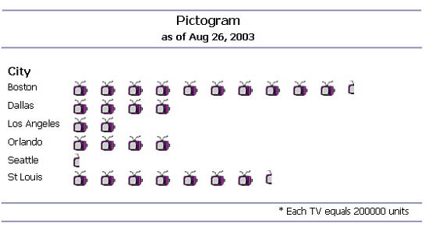

<http://www.informationbuilders.com/support/developers/images/pictogram.jpg>

*(03-03-2009)*

Notice the scale. One TV-symbol equals 200 000 units. So, in Dallas there are TV sets. In Seattle there is only half a TV-symbol, in other words, 100 000 TV sets. Can you find the number of TV sets in Boston?



|  |  |
| --- | --- |
| Maths Literacy icon_2.jpg | Learning activity 3.4 |

1. The following information illustrates the physical development of most infants at different ages.

Sits without support

Walks with help

Something furniture

Walks well by herself

Rolls over



2 3 4 5 6 7 8 9 10 11 12 13 14 15

**Age (months)**

* 1. What is the first physical development that a baby must master?
  2. At what stage does a baby starts to walk well by herself?
  3. What physical activity starts developing at the age of to 8 months?



* 1. Which physical activity takes the longest to develop?

1. Magazines and newspapers sometimes use other ways to represent data.

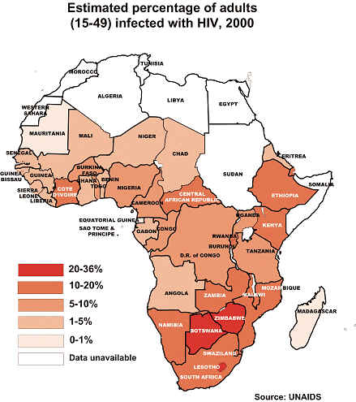

<http://maps.unomaha.edu/peterson/funda/MapLinks/Africa-2/Africa2_files/image024.jpg>

*(03-03-2009)*

* 1. What is the adult-percentage infected with HIV in South Africa?
  2. Which countries had the highest percentage of adults infected with HIV?
  3. Suppose the population of South Africa in 2000 was 43 000 000. Calculate the number of adults in SA that was infected with HIV.
  4. In the year 2000, there was worldwide an exponential increase of HIV/AIDS patients. In an East African country, the number of infected people increased by 30% per year. This means that if, for example, 1000 people were infected in the year 2000, then the number of people infected during the years following 2000, would have been: 1300; 1690; 2197, etc. Notice that the number more than doubles within three years.
     1. Show how this calculation was done.
     2. Is ?



* + 1. Use your answer in 2.3 to estimate the number of infected people with HIV in the year 2009 assuming the growth rate given above. Can this growth be curbed? Discuss.

1. Employment in the main non-agricultural sectors of the South African economy in 1998.

|  |  |
| --- | --- |
| **SECTOR** | **Employment in the main non-agricultural sectors of the South African economy in 1998.** |
| **A2.png**  **SCALE 🡪 represents 500 000 workers** | |
| **General** | A1.png A1.png A1.png |
| **Mining** | A1.png A1.png |
| **Manufacturing** | A1.png A1.png A1.png |
| **Construction** | A1.png |

* 1. How many workers were there in 1998 in the Manufacturing sector?
  2. Estimate how many workers were there in 1998 in the General sector?
  3. How many more workers were there in the Manufacturing sector compared to the Mining sector in 1998?
  4. Estimate how many more workers were there in the General sector than in the Construction sector in 1998?
  5. Give the ratio for the number of manufacturing workers to the number of mining workers in 1998.

# 4. Pie graphs

A pie graph (or pie chart) is another type of diagram for displaying information. It is particularly suitable if you want to show the relation of the parts to the whole and to each other.

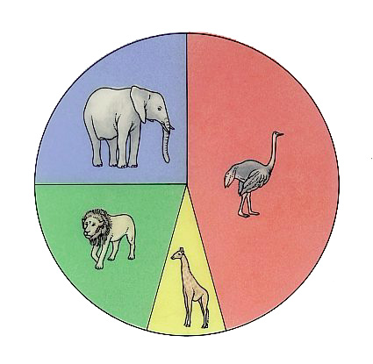A pie graph partitions a circular disk into sectors of various sizes to show pictorially how a total amount is divided into parts.

<http://www.dkimages.com/discover/previews/822/5104468.JPG>

*(03-03-2009)*

Looking at the above pie graph for a specific nature reserve, we can see that ±45% of the parks animals consist of ostriches. The smallest percentage of the parks animals consists of giraffes. Can you give the percentage elephants in the park?

#### Example 3.1

The pie graph below gives the total exports of South Africa. What kind of information does this graph give us? How do we read such a graph?

###### Exports of South Africa

*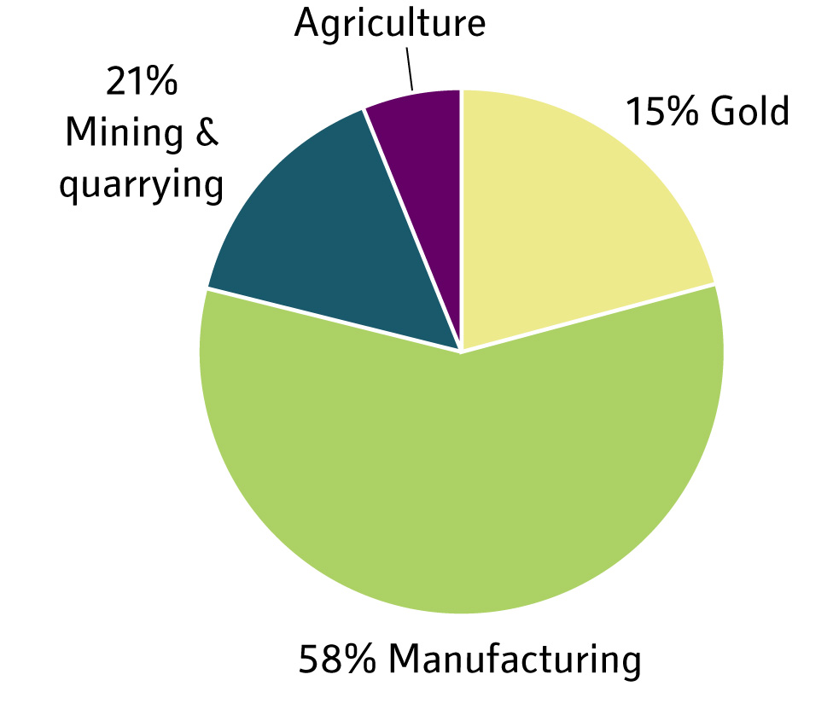*

1. Which sector had the biggest export?
2. From which sector was the export 15%?
3. Find the percentage of exports from the Agriculture sector.
4. Suppose our total exports amount to R2 500 million. Find the income from gold exports.

##### Solution

1. The Manufacturing sector.
2. The Gold sector.
3. All the sectors must add up to 100%, so

Agriculture =



1. Revenues for gold exports



|  |  |
| --- | --- |
| Maths Literacy icon_2.jpg | Learning activity 3.5 |

1. Use the following pie graph to answer the questions below.

###### Percentage of different religion groups in South Africa



* 1. Which religion group is the most representative?
  2. Which religion group is the least representative?
  3. Evaluate the percentage people in the Secular religion group.
  4. Suppose the population of SA is 43 million. Evaluate the number of Christians in SA.
  5. Find the fraction of people in SA that practises Traditional religion.

1. Below are the responses from 56 law firms in Cape Town, representing 298 partners, to the following question:

###### How long will the property boom last?

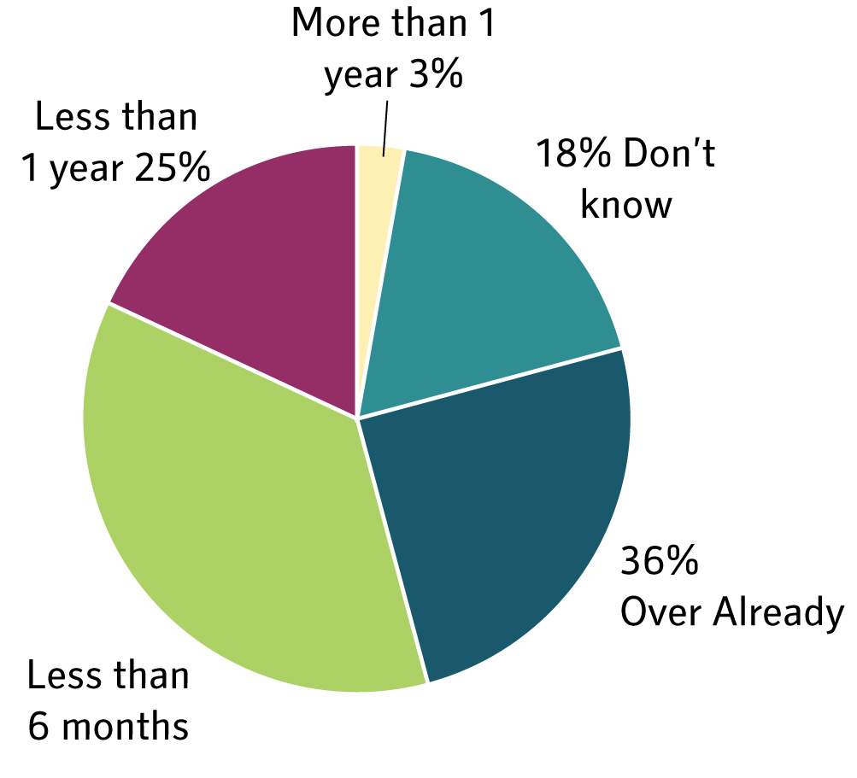

<http://www.ghostdigest.co.za>

*(03-03-2009)*

* 1. How many firms participated in this survey?
  2. Give the average number of partners per law firm.
  3. What percentage of the firms answered that they do not know how long the boom will last?
  4. What was the answer of 3% of the law firms?
  5. Give the fraction of law firms that said that the boom will last less than 1 year.
  6. Give the percentage of law firms that answered that the boom will last less than six months.
  7. Give the number of law firms that answered that the boom is already over.

#### Example 3.2

The pie graph below shows the percentages of students enrolled in different disciplines of a university. Suppose there are 220 students in Construction.

###### Number of Students

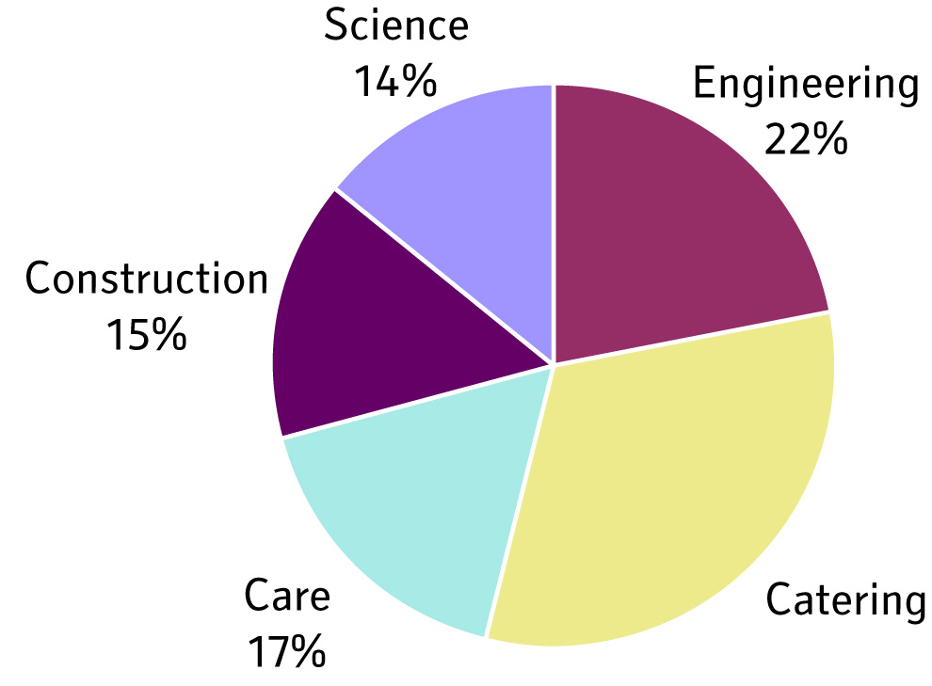

Find the percentage of students enrolled in Catering.

1. How many students are enrolled in Science?
2. What is the total number of students enrolled at the university?

##### Solution:

1. All the sectors must add up to 100%, so

Catering



1. 220 students in Construction amounts to15% of the total.

We have to find the number of students enrolled in Science that is equal to 14%.

The ratio is: 220: *x* =15 :14



205 students are enrolled in Science

1. 220 students in Construction amounts to 15% of the total.

We have to find the total number of students enrolled at the university (i.e., 100% of the students).

The ratio is: 220: *x* =15:100



The total number of students is 1467.

|  |  |
| --- | --- |
| Maths Literacy icon_1.jpg | Assessment activity 3.6 |

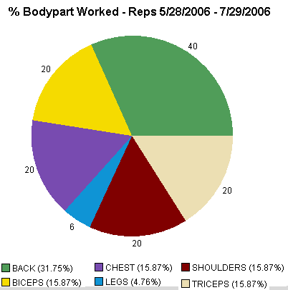

<http://www.bodybuildinglog.com/cms/articleimages/673/StrengthPie.gif>

*(03-03-2009)*

1. Use the graph from the webpage above to answer the following questions:
   1. Give the number of repetitions for the shoulders.
   2. Give the number of repetitions for the chest.
   3. Evaluate the total number of repetitions.
   4. Which body part has to be exercised most?
   5. Give the ratio for the repetitions for the triceps to repetitions for the back.
   6. Evaluate the percentage repetitions for the legs.

###### Age distribution of 120 employers in your firm

**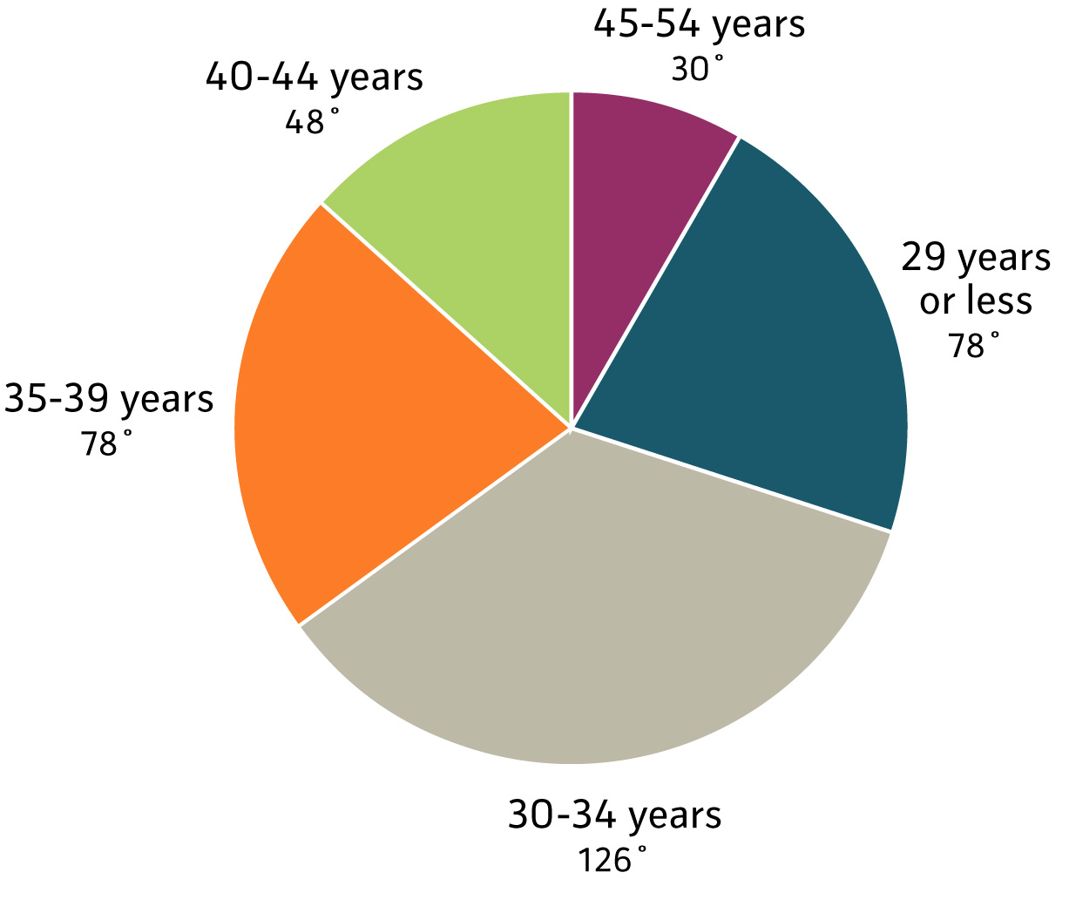**

1. Use the pie graph to answer the following questions:
   1. How many employers do you have in your firm?
   2. Which age group contains the highest number of employers?
   3. State the age groups containing the same number of employers.
   4. Find the fraction of employers in the age group 45 - 54.
   5. Find the percentage of employers in the age group 40 - 44 years.
   6. Evaluate the number of employers in the age group 35 - 39 years.
2. During the past financial year (year ending March 2005), the nine deeds registries experienced a 10,3% increase in the volume of transactions registered. Despite this significant increase, the registries maintained an average turnaround time of 10 working days from lodgement to registration. These figures have been taken from the Department of Land Affairs’ Annual Report and have been accurately reproduced here.

###### Number of registrations and recordals in the deeds registries.



[*http://ghostdigest.co.za*](http://ghostdigest.co.za)

*03-03-2009)*

* 1. Which town had the highest number of deeds registrations?
  2. Which town had the least number of deeds registrations?
  3. How many deeds were jointly registered in Pretoria and Johannesburg?
  4. How many more deeds were registered in Kimberley than in Umtata?
  5. If Cape Town had 28% of the deeds registrations, find the percentage of deeds registrations in Vryburg.
  6. Find the total number of deeds registrations for 2005.
  7. Calculate the average number of deeds registered by the registries per day. Assume 5 working days per week and that the office closes only 2 weeks per year.
  8. Evaluate the total number of deeds registrations for the financial year ending March 2004.

|  |  |
| --- | --- |
| Maths Literacy icon_1.jpg | Assessment activity 3.7 |

In 2004, there were almost 390 000 admissions to substance abuse treatment among young adults aged 18-25.

###### Characteristics of Young Adult (Aged 18-25) and Youth (Aged 12-17) Admissions: 2004

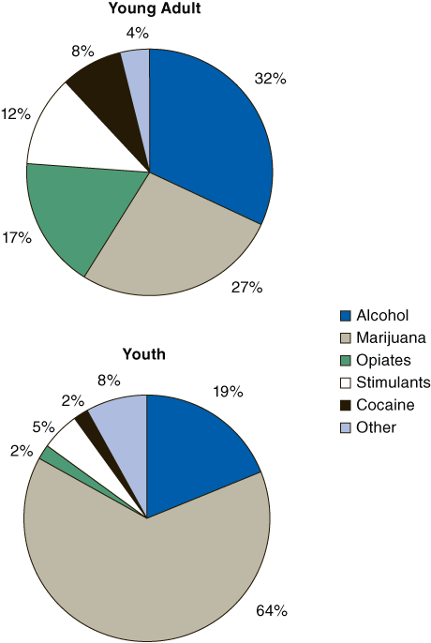

<http://www.oas.samhsa.gov/2k6/youngTX/160YAFig1.gif>

*(03-03-2009)*

1. Use the pie graph above and write a detailed report on the difference between young adults and youths on admissions to substance abuse treatment.
2. Use the web site below and write a summary on the effects that the abuse of a substance, of your choice, will have on a person. (Not more than 500 words)

<http://www.stopaddiction.co.za/stopaddiction/P20050319092527713.htm>

*(03-03-2009)*

# 5. Bar graphs

Bar graphs are one of the many techniques used to present data in a visual form so that the reader may readily recognize patterns or trends.

A bar graph is a diagram consisting of [rectangular](http://en.wikipedia.org/wiki/Rectangle) bars with [lengths](http://en.wikipedia.org/wiki/Length) proportional to the frequencies of different values of a variable. The bars can be horizontal or vertical.

|  |
| --- |
| **Features of bar graphs**   * The bar graph must have a heading. * The widths of the columns are all equal. * It is also common to leave “gaps” between the bars. |

There are different types of bar graphs:

* vertical bar graph;
* horizontal bar graph;
* stacked bar graph.

We will now look at the different types.

## Vertical bar graphs

We make use of an example to explain vertical bar graphs.

|  |  |
| --- | --- |
| **Province** | **Percentage of the total SA population residing in each of the provinces during 2006** |
| Eastern Cape | 14,6 |
| Free State | 6,2 |
| Gauteng | 20,1 |
| Kwazulu-Natal | 20,9 |
| Limpopo | 11,3 |
| Mpumalanga | 7,4 |
| Northern Cape | 2,3 |
| North West | 7,1 |
| Western Cape | 10,0 |

The following information can be shown on a vertical bar graph, as follows:

###### Percentage distribution of the projected provincial share of the total population in 2006

Percentage of total population



A vertical bar graph consists of several parallel bars of lengths proportional to the frequencies shown by each bar. Each bar stands for a fixed category, and the length of the bar shows the measure or value (frequency) of that category.

|  |
| --- |
| **Features of a vertical bar graph**   * Variables are indicated on the horizontal axis. * Frequencies are indicated on the vertical axis. |

A disadvantage of vertical bar graphs is that they lack space for text labeling, at the foot of each bar. In such a case you might find a horizontal bar graph better for displaying information.

Use the above bar graph to answer the following questions.

1. Which province had the smallest number of people?
2. Order the provinces from the largest to the smallest number of inhabitants.
3. What percentage of the total lived in the province with the second largest number of inhabitants in 2006?
4. What percentage of the people lived in North West in 2006?
5. Suppose the population of South Africa was 47 million in 2006. Find the number of people that lived in Limpopo in 2006. Write this number out in words.
6. Find the difference in the population of Kwazulu-Natal compared to the Northern Cape.

##### Solution:

1. The Northern Cape had the lowest number of people.

|  |  |
| --- | --- |
| Kwazulu-Natal | 20,9 |
| Gauteng | 20,1 |
| Eastern Cape | 14,6 |
| Limpopo | 11,3 |
| Western Cape | 10,0 |
| Mpumalanga | 7,4 |
| North West | 7,1 |
| Free State | 6,2 |
| Northern Cape | 2,3 |

1. The province with the second largest number of inhabitants was Gauteng with 20,1% of the total population.
2. 7,1% of the total population lived in North West.
3. Number of people that lived in Limpopo = million



Write the number out: 5 million 311 thousand

1. Number of people that lived in Kwazulu-Natal = million



Number of people that lived in the Northern Cape = million



There were 8,742 million more people in Kwazulu-Natal than the Northern Cape.

|  |  |
| --- | --- |
| Maths Literacy icon_1.jpg | Assessment activity 3.8 |

1. The total amount of crimes reported in SA during 2006 was 3 422 740. The bar graph below states some of them.

###### Number of different crimes reported in SA during 2006

* 1. Give the number of car thefts reported.
  2. How many more burglaries than robberies were reported?
  3. Estimate the number of murders reported.
  4. What was the percentage of rape cases with respect to all crimes reported?
  5. Give the ratio of car thefts to robberies reported.

1. Use the following graph to answer the questions below.

###### Estimated percentages of deaths from various causes related to the use of alcohol.

**Cause of death**



**Estimated percentage of deaths**

Railway

accidents

Motor vehicle

accidents

Suicides

Homicides

Accidents caused by fires

Boating

Accidental falls

* 1. Alcohol use is apparently involved in 10% of the deaths of what type of accident?
  2. Alcohol use is apparently involved in half of the deaths of what type of accident?
  3. Find the percentage of people dying in suicides where alcohol use is apparently involved.

Find the fraction of people dying in railway accidents where alcohol use is apparently involved.

* 1. Find the percentage of people dying in suicides where alcohol use is apparently not involved.
  2. Find the fraction of people dying in boating accidents where alcohol use is apparently not involved.

1. Use the following graph to answer the questions below.

###### % commission of each estate agency per country



[*http://www.ghostdigest*](http://www.ghostdigest)

*(03-03-2009)*

* 1. Which country has the lowest estate agency percentage commission? Estimate this percentage.
  2. What can we say about the estate agency percentage commission in South Africa and in Canada?
  3. If a house costs R350 000 in South Africa, evaluate the estate agency commission.
  4. If R1,00 = £0,06, evaluate the same estate agency commission in Pounds for a R350 000 house in the UK.

## Comparative bar graphs

The comparative vertical bar graph gives two or more types of data for each category on the x-axis instead of just one. This allows you to make direct comparisons on the same graph by amounts of imports, amounts of exports, or anything else you wish to compare. However, if a comparative vertical bar graph has too many sets of data, the graph can become a bit confusing.

The comparative vertical bar graph below compares two sets of data: the monetary values of exports and imports for SA from 1985 to 2005. One bar represents the exports and the other the imports for the same year.

###### South Africa : total imports and exports levels (US$ millions)



**Year**

Use this comparative vertical bar graph to answer the following questions:

1. What can we say about our imports and exports over the years 1985 – 2005?
2. How much more were our exports compared to our imports in 1995?
3. Estimate the level of exports in 2004 (in US$).
4. Find the level of imports in 1995 (in US$).
5. Estimate the percentage increase in imports from 1985 to 1995.
6. Find the level of imports in 1995 in Rand if the exchange rate was R9,80 = 1 US$.

##### Solution:

1. Both import and export levels increased over these years. Also, we exported more than we imported over these years.
2. Estimated export level was 35 000 million US$, while the import level was 30 000 million US$, i.e., 5 000 million US$ less.
3. 57 000 million US$.
4. 30 000 million US$.
5. Percentage increase / decrease



173% increase



1. The import level was 30 000 million US$. In Rand, this amount was
   1. R294 000 million.



|  |  |
| --- | --- |
| Maths Literacy icon_1.jpg | Assessment activity 3.9 |

1. Use the following comparative bar graph to answer the questions below.

###### Gender and population group breakdown in Kwazulu-Natal, 2006.

**Number of people**



Male

Female

**1:** Black

**2:** Coloured

**3:** Indian/Asian

**4:** White

Male

Female

* 1. What can we say about the population group breakdown?
  2. What can we say about the gender breakdown for each population group?
  3. Find the number of Black males in Kwazulu-Natal.
  4. Find the number of White females in Kwazulu-Natal.
  5. Find the total number of Coloured people in Kwazulu-Natal.
  6. Find the total number of females in Kwazulu-Natal.
  7. Find the total population (in 2006) for Kwazulu-Natal.
  8. What was the percentage Indian/Asian females of the total in Kwazulu-Natal in 2006?

1. Use the following comparative bar graph to answer the questions below.

###### Mid-year population estimates for the 20 – 24 year age group for 2006 by province and gender.



* 1. In which province(s) are the males exceeded by the females?
  2. In which province(s) are the females exceeded by the males?
  3. Estimate the number of females in Mpumalanga.
  4. Which province has the largest number of 20 –24 year old inhabitants? Estimate this number.
  5. Estimate the difference in the number of 20 –24 year olds between the Eastern Cape and the Free Sate.

1. Use the following bar graph to answer the questions below.

###### Relationship between blood-alcohol and alcohol intake after 6 glasses of wine or 6 cans of beer



45kg 68kg 90kg



**Amount of alcohol in the bloodstream (g/100ml)**

**Body weight**

**Women**

**Men**

* 1. In South Africa it is a criminal offence to drive a vehicle with a blood-alcohol content higher than 0,05 g/100ml. Which of the genders and weight groups shown in the diagram will drive illegally?
  2. A given amount of alcohol will have more effect on a larger or a smaller person? Explain.
  3. Do women become intoxicated sooner or later than men? Explain.
  4. We can categorize three levels of blood alcohol:

**A:** At a level of 0,05 thinking and judgment may in some cases already be slightly affected.

**B:** At a level of 0,1 most sensory and motor functions are seriously affected.

**C:** At 0,2 a person can be regarded as highly intoxicated.

* + 1. In which category do the 45kg men and women fall?



* + 1. In which category do the 90kg men fall?



1. Use the following comparative bar graph to answer the questions below.

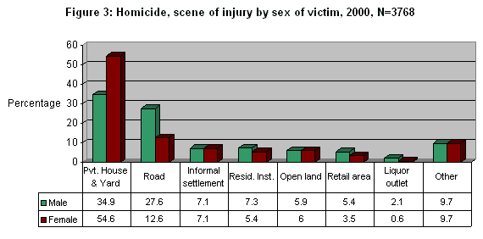

[*http://www.brandon.za.org/crimestats/South\_Africa\_Crime\_Statistics\_Sheet\_Facts\_Figures.htm*](http://www.brandon.za.org/crimestats/South_Africa_Crime_Statistics_Sheet_Facts_Figures.htm)

*(03-03-2009)*

* 1. Where did most homicides occur, for both sexes?
  2. Where did the least homicides occur, for both sexes?
  3. At what type of crime scene were more females than males murdered?
  4. What percentage of homicides took place at roadside settings, for males?
  5. At which scene of homicide was the difference in percentage between the two sexes the largest? What is this difference?
  6. If you add all the percentages in case of the males, it adds up to 100%. For the females, it only adds up to 99,5%. Give an explanation for this.
  7. Give the total number of homicides recorded.

## Horizontal bar graphs

A horizontal bar graph uses the y-axis for the categories, because it is more convenient for writing text labels.

|  |
| --- |
| **Features of a horizontal bar graph**   * Variables are indicated on the vertical axis. * Frequencies are indicated on the horizontal axis. |

|  |  |
| --- | --- |
| Maths Literacy icon_2.jpg | Learning activity 3.10 |

Of the 18 876 unnatural deaths, 80% were male and 20% female. Blacks constituted 70% of all cases, Coloureds 16%, Whites 12% and the rest were Asians. The majority of victims were young adults, with 37% of all cases aged 15 to 29, and 36% aged 30 to 44. Four percent of victims were younger than 5 years, another 4% aged 5 to 14 years, 14% aged 45 to 59 years and the rest were 60 years and older.

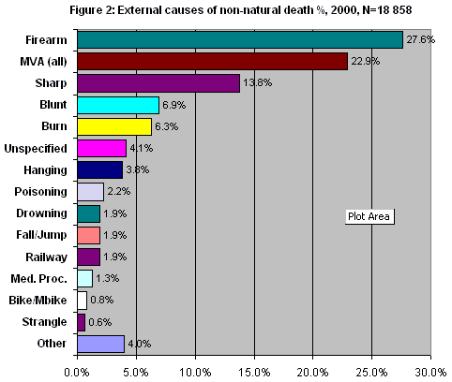

[*http://www.brandon.za.org/crimestats/South\_Africa\_Crime\_Statistics\_Sheet\_Facts\_Figures.htm*](http://www.brandon.za.org/crimestats/South_Africa_Crime_Statistics_Sheet_Facts_Figures.htm)

*(03-03-2009)*

1. Find the highest cause of unnatural death in 2000.
2. Find the number of males who died unnaturally in 2000.
3. Find the number of Asians who died unnaturally in 2000.
4. Find the number of people who died because of burning in 2000.
5. Find the number of people who were strangled to death in 2000.

# 6. Histogram

A histogram is constructed (much the same way as a bar graph) so that neighbouring bars or columns are drawn so that they touch each other

A histogram provides a visual representation of how data are distributed across a range of values.

|  |
| --- |
| **Features of a histogram**   * Vertical axis is used for the frequencies. * Horizontal axis is used for the range of the response variable. |

We use the following example to explain histograms.

The table below records examination scores for 80 students.

|  |  |
| --- | --- |
| **Range of % marks** | **Frequency** |
| 1 -10 | 2 |
| 11 – 20 | 2 |
| 21 – 30 | 4 |
| 31 – 40 | 6 |
| 41 – 50 | 7 |
| 51 – 60 | 8 |
| 61 – 70 | 15 |
| 71 – 80 | 22 |
| 81 -90 | 10 |
| 91 – 100 | 4 |
| **Total** | **80** |

The following histogram represents the information given in the frequency table above.

****Distribution of examination scores for 80 students.

|  |  |
| --- | --- |
| Maths Literacy icon_2.jpg | Learning activity 3.11 |

1. Use the above histogram to answer the following questions.
   1. How many students scored between 81 and 90%?
   2. How many students scored between 21 and 30%?
   3. What was the most popular range score in the examination?
   4. What was the highest range score in the examination?
   5. What was the range score that 15 students achieved?
   6. What were the range scores achieved by the same number of students. Give this number of students which was the same for both range scores.
   7. What percentage of the students scored between 61 and 70%?
2. Use the following histogram to answer the questions below.

###### Prevalence of overweight women by age



**Age group**

**Percentage overweight**

20-24 25-34 35-44 45-54 55-64 65-74

* 1. Which age group contains the lowest percentage of overweight women? What do you think is the reason for this?
  2. Estimate the percentage of woman in the age group 55 – 64 years that are overweight.
  3. Give the fraction of woman in the age group 35 – 44 years that are overweight.
  4. Give the percentage of woman that are not overweight in the age group 25 – 34 years.
  5. What can we infer from this graph about overweight and age group?

## Stacked bar graphs

The stacked bar graph can be used as a data analysis tool to compare the parts to the whole. The bars in a stacked bar graph are divided into categories. Each data item is represented as a segment in the stacked bar and each bar represents a total.

It can be rather difficult to analyze if too many items appear in each bar.

|  |
| --- |
| **Features of a stacked bar graph**   * Categories are indicated on the horizontal axis * The vertical axis represents the total |

The example below shows how data forms a stacked bar graph.

The data below gives the sales for three products over two years.

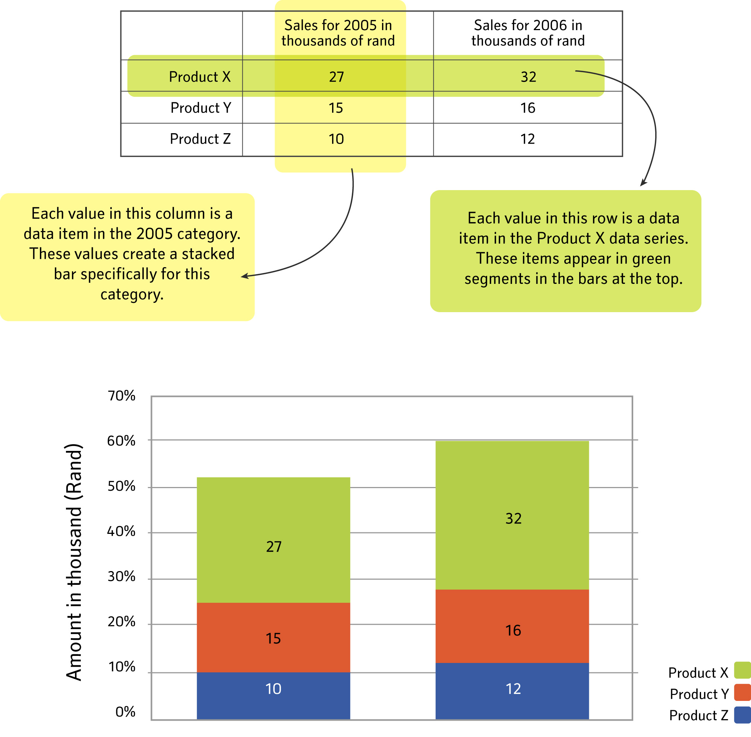

We can also draw a 100% stack bar from the data as follows.

|  |  |  |  |  |
| --- | --- | --- | --- | --- |
|  | **Sales for 2005 in thousands of rand** | **% sales for 2005** | **Sales for 2006 in thousands of rand** | **% sales for 2006** |
| Product X | 27 | 52 | 32 | 53 |
| Product Y | 15 | 29 | 16 | 27 |
| Product Z | 10 | 19 | 12 | 20 |
| **Total sales** | 52 |  | 60 |  |

*Each value in this column is a data item in the 2005 category. These values create a 100% stacked bar for this category.*

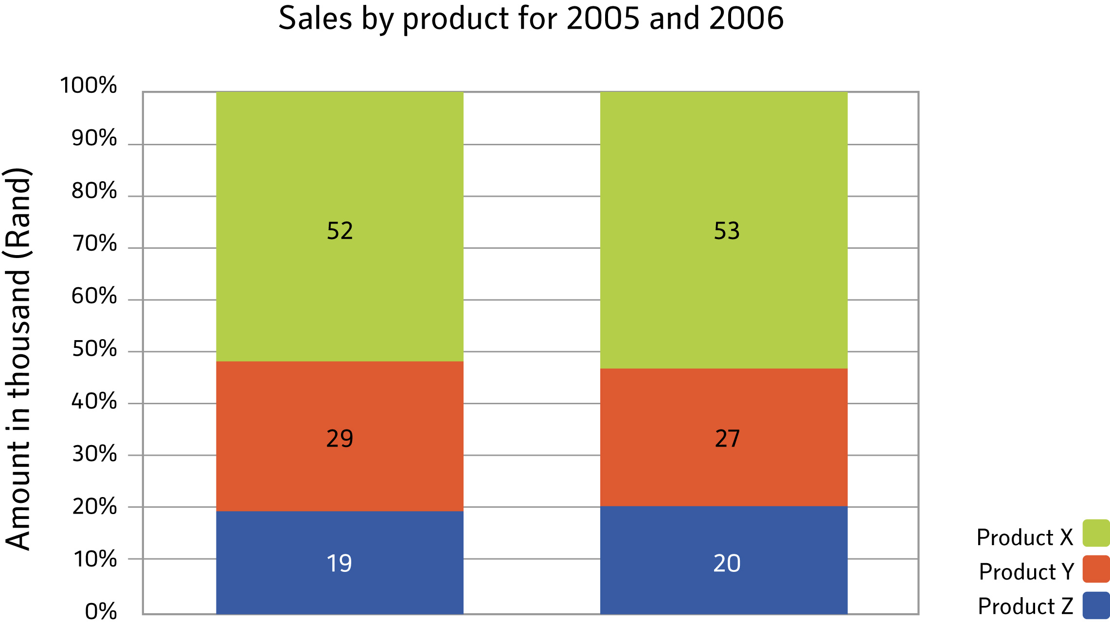

Use the above stacked bar graphs to answer the following questions:

1. Give the amount of sales for product Y in 2006.
2. Which product had the lowest sales in 2005?
3. What can we say about the amount and percentage sales of product X?
4. What can we say about the amount and percentage sales of product Y?

##### Solution:

1. R16 000.
2. Product Z.
3. Although the amount of sales for product X increased by R5 000, the percentage sales only increased by 1%.
4. Although the amount of sales for product Y increased by R1 000, the percentage sales decreased by 2%.

|  |  |
| --- | --- |
| Maths Literacy icon_1.jpg | Assessment activity 3.12 |

1. Use the following stacked bar graph to answer the questions below:

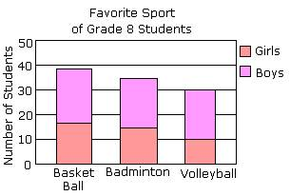

<http://www.icoachmath.com/SiteMap/StackedBarGraph.html>

*(03-03-2009)*

* 1. Estimate how many students prefer Basket Ball?
  2. How many girls prefer Volleyball?
  3. How many boys prefer Badminton?
  4. Estimate how many grade 8 students like to play sport?

1. Use the following stacked bar graph to answer the questions on the following page.

###### Percentage contributions of different kinds of economic activity to South African GDP.

****

* 1. Find the percentage contribution of “other” activities to the GDP in 1960.
  2. Estimate the percentage contribution of trade activities to the GDP in 1990.
  3. Does the graph give us any information about the amount (in rand) that each activity contributes to the GDP? Explain.
  4. The percentage contribution of trade activities to the GDP stayed the same over the years. Does this mean that the amount (in rand) of trade activities contributes to the GDP stayed the same? Explain your answer.
  5. What can we say about the percentage contribution of manufacturing activities to the GDP over the years?
  6. Which activity had the biggest increase in their contribution to the GDP from 1940 to 1990?

1. Use the following stacked bar graph to answer the questions below.

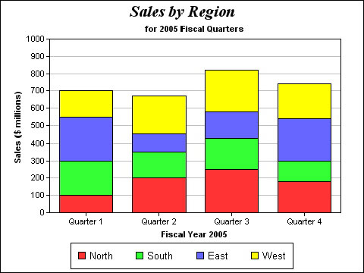

<http://www.omnis.net/images/technews/g2mstackedbargraph.jpg>

*(03-03-2009)*

* 1. Give the amount of sales in the North for the third quarter.
  2. Give the amount of sales in the East for the third quarter.
  3. Give the total amount of sales during the first quarter.
  4. Estimate the total amount of sales for 2005.
  5. Which region had the biggest decrease in sales from the first to the second quarter? With how much did it decrease?
  6. Which region(s) were the most stable in sales over the year?
  7. Find the percentage increase in sales for the North from the second to the third quarter.
  8. Estimate the percentage increase in sales from the second to the third quarter for all the regions together.

# 7. Line graphs

Line graphs compare two variables. In other words, it shows how one variable varies with respect to another variable. For example, a distance-time graph shows the distance of an object from a specific point at specific times.

Look at the following line graph that illustrates Allison’s journey.

###### Allison’s journey

80

70

60

50

40

30

20

10

13:00 14:00 15:00 16:00 17:00 18:00

**Time**

**Distance from house (*km*)**

Allison leaves home at 13:00 and drives to the supermarket, which is 60*km* away. After shopping, she continues to her aunt’s house for a cup of tea. Then she drives back home. Note that the distance changes as Allison is moving, but remains constant when she is stationary.

Use this line graph to answer the following questions:

1. At what time did Alison arrive at the supermarket?
2. How long did she spend at the supermarket?
3. How far is it from the supermarket to her aunt’s house?
4. How long did she stay at her aunt’s?
5. How long did it take her to drive home?

##### Solution:

1. She arrived at the supermarket at 14:00.
2. She spends almost an hour at the supermarket.
3. Almost 10 kilometres from the supermarket to her aunt’s house.
4. Almost an hour.
5. It took almost 1 hour and 30 minutes to drive home.

A line graph is a diagram that shows a line joining several points. A line graph has a vertical axis and a horizontal axis and each variable is measured along one of these. So, for example, if you want to graph the distance-time graph, you could measure time along the horizontal, or x-axis, and distance along the vertical, or y-axis.

|  |
| --- |
| **Features of a line graph**   * There should be a heading at the top of the graph that tells us what the graph is about. * Both the horizontal and vertical axes should be labelled so that we know what kinds of data are compared. * Choose a sensible scale to indicate the units in which the variables are measured in. |

|  |  |
| --- | --- |
| Maths Literacy icon_1.jpg | Assessment activity 3.13 |

1. The line graph below shows people in a store at various times of the day.

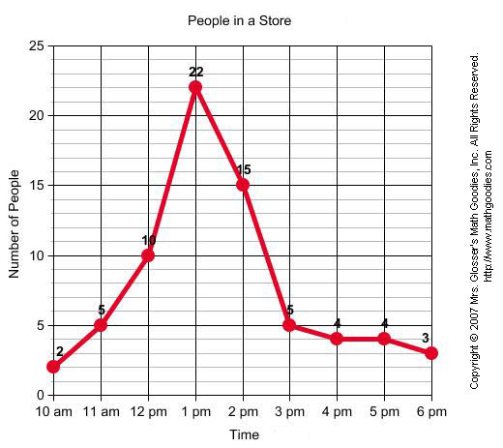

<http://www.mathgoodies.com/lessons/graphs/line.html>

*(03-03-2009)*

* 1. At what time does the store opens?
  2. How many people were in the store when it opens?
  3. How long was the store open?
  4. Give the busiest time of the day in the store. Also give the number of people in the store at that time.
  5. Estimate the number of people in the store at 12:30 pm.
  6. At what time does business begin to slow down?
  7. What was the smallest number of people in the store?

1. The following line graph shows sales figures for three products per month. The line instantly conveys how sales vary throughout the year.

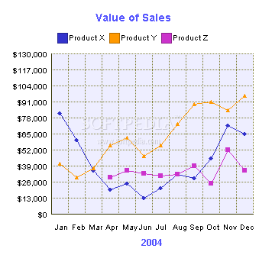

<http://webscripts.softpedia.com/screenshots/2D-3D-Line-Graph-1493.png>

*(03-03-2009)*

* 1. Give the sales for product X in May.
  2. Which product shows the biggest sales? Give the month and the amount.
  3. What were the sales for product Z in February? Explain your answer.
  4. Which product shows the most consistent sales figure?
  5. Find the increase in sales for product X from June to November.
  6. The manager informs you that we have to choose one product to sell for the next year. Write a short report to inform him on which product should we keep on selling and which products should we cancel.

1. Use the following line graph to answer the questions below.

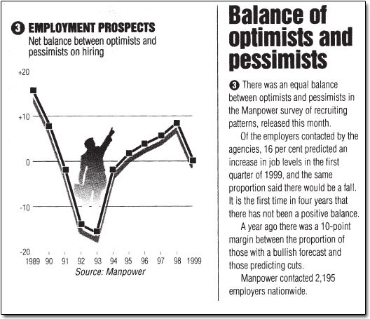

<http://openlearn.open.ac.uk/file.php/2880/LDT_3_I008i.jp>

*(03-03-2009)*

* 1. Compare the sentence “16 per cent predicted an increase in job levels in the first quarter of 1999, and the same proportion said there would be a fall” with the information on the graph. Are the two the same? Explain your answer.
  2. For how long was there a negative balance?
  3. Which year had the highest balance?
  4. How many employers were contacted in 1999 for the survey?
  5. Give the number of employers that predicted an increase in job levels during the first quarter of 1999.

|  |  |
| --- | --- |
| Maths Literacy icon_4.jpg | Group activity 3.14 |

The questions below follow from the surveys on the following web sites:

<http://www.afrihealth.com/violence/gfj2000.pdf>

<http://www.afrihealth.com/violence/gfj99.pdf>

*(03-03-2009)*

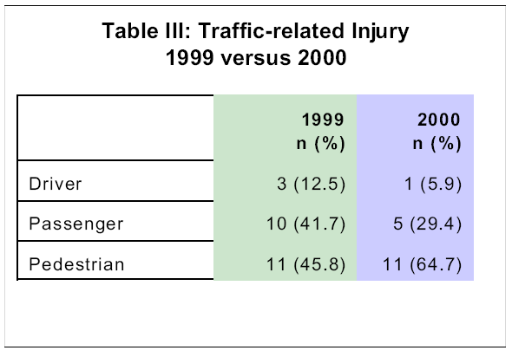

**In 2000, nearly two-thirds of the traffic related injuries involved pedestrians while one-third involved both passengers and drivers. Cars were involved in 82% of the collisions while train casualties accounted for twelve percent.**

1. How many patients were included in the study for 1999?
2. For both 1999 and 2000 only 11 traffic related injuries involved pedestrians, but the percentages are different. Explain this.
3. Give the percentage decrease in the number of traffic related injuries that involved passengers from 1999 to 2000.

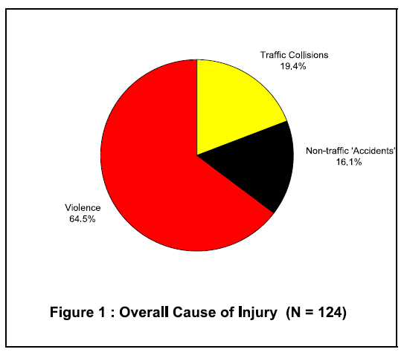

**Violence out-numbered traffic accidents as the leading cause of injury, accounting for nearly two-thirds of all injuries.**

1. Estimate the fraction of patients involved in traffic collisions.
2. Give the number of patients involved in non-traffic ‘accidents’.

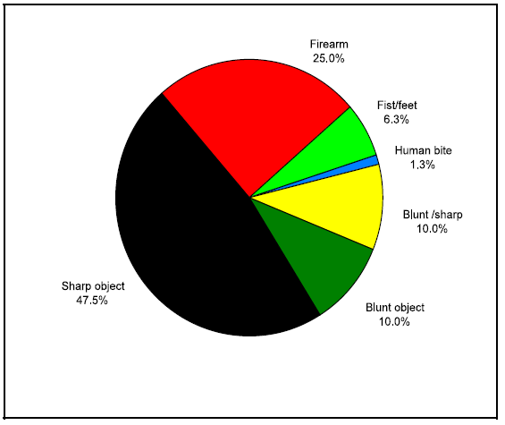

**Of the 80 patients injured as a result of violence, nearly half were due to sharp objects.**

1. Give the fraction of patients involved in firearm injuries.
2. Give the percentage of patients involved in blunt object injuries.
3. Give the number of patients involved in fist/feet injuries.

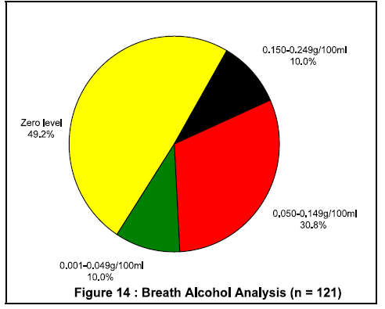

**The alcohol level of three patients was unknown. Of the remaining 121 patients, 51.2% had alcohol levels greater than zero (Figure 14).**

1. Is this statement true? Explain your answer.

**0.05g/100ml (at most) is the legal blood alcohol limit for a driver of a vehicle.**

1. Give the percentage of patients that was above this limit.

**The mean alcohol level for those with positive results was found to be (+ 0.06) g/100ml.**

1. Give the number of patients that fall in this mean alcohol level category.

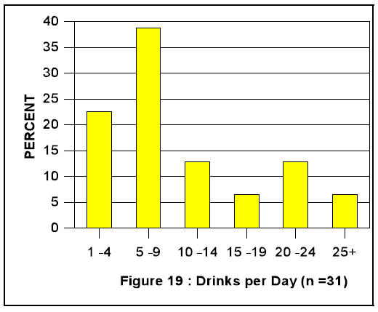

1. Estimate the number of patients that consumed about five standard drinks per day.

**Patients said that on average they consumed about five standard drinks per day.**

1. Is this statement true? Explain your answer.

**However, a disturbing 39% consumed ten or more drinks a day (Figure 19).**

1. Explain how to determine this answer.

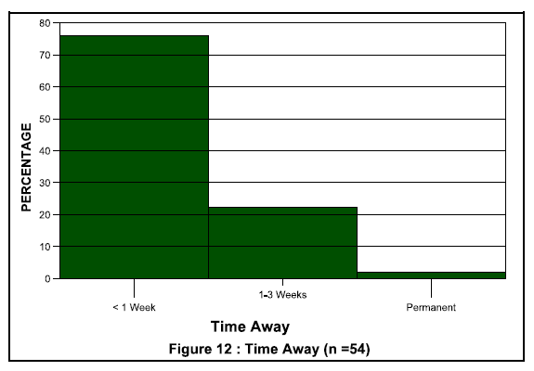

There were as many patients employed as unemployed (43.0%). Of those employed, three quarters required a week or less leave from work, while 22.2% required up to three weeks leave (Figure 12).

1. Explain how to find the number of patients there were unemployed, and give this number.
2. Estimate the number of patients that resign from their jobs.

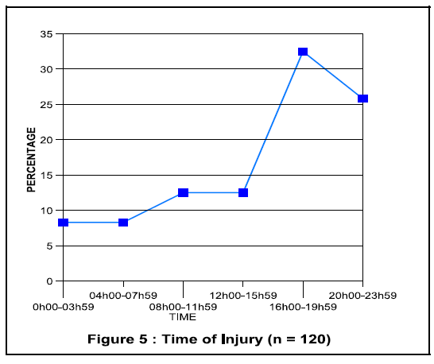

The time of injury was unknown in 4 (3.2%) of 124 cases.

For the remaining 120 cases, 32% of injuries occurred during office hours, i.e. from 08h00-17h00.

1. Estimate the number of patients that were injured between 20:00-23:59.
2. Give the number of injuries that occurred between 17:00 and 08:00.
3. What is the peak time of injuries?

|  |  |
| --- | --- |
| Maths Literacy icon_4.jpg | Group activity 3.15 |

Work in groups of three.

Visit the following website where you can draw bar, pie and line graphs:

🡪 <http://nces.ed.gov/nceskids/createAgraph/>

*(03-03-2009)*

(You can also use Excel to draw graphs.)

Draw a line graph representing the following data, by making use of the above web site.

Assume we have a demand function defined by the equation Qd = 150 – 5P.

Let the values of P (for price) range from 0 to 30. Use the horizontal axis to measure the quantity (Qd) and the vertical axis for the price (P).

Plot the data in the following table.

|  |  |
| --- | --- |
| **Qd** | **Price** |
| 0 | 30 |
| 25 | 25 |
| 50 | 20 |
| 75 | 15 |
| 100 | 10 |
| 125 | 5 |
| 150 | 0 |

A possible example is given below.

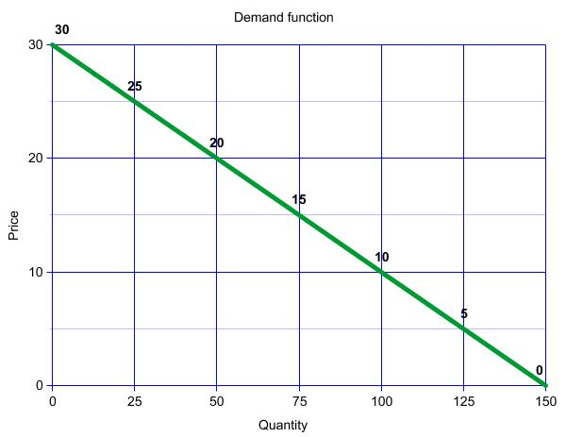

The same graph drawn as a bar graph looks as follows:

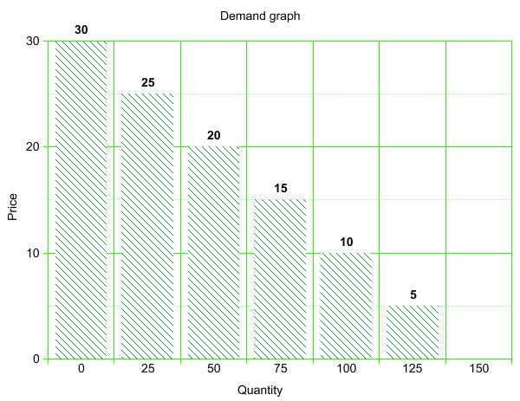

Now make use of Excel, or any other software program, to answer the following questions. Show the information on a pie, bar or line graph. Make sure your surname and student number is on the page when you hand it in.

1. Your test results for the semester were as follows:

|  |  |
| --- | --- |
| **Subject** | **Result** |
| **Chemistry** |  |
| **Mathematics** |  |
| **Physics** | 75% |
| **Statistics** |  |

* 1. Represent this information on a suitable graph of your choice.
  2. In which subject did you do best?
  3. If the physics test was out of 40, what was your mark?

1. Your income and expenditure for the month are as follows:

**Allowance from your parents: R3 000**

* Rent: R1 500
* Food: R1 000
* Entertainment: R500
* Cell phone: R300
* Received money for your Birthday: R350
  1. Construct a budget.
  2. Do you have enough money for the month? Explain.
  3. Make use of a suitable graph of your choice to show how your expenses are divided.
  4. What fraction of your expenses is for rent?
  5. What fraction of your expenses is for entertainment?

# End of section comments

In this section we saw the different representations of data in bar, pie and line graphs. We interpreted the data and made inferences. In the next section we will analyze the data further by making use of descriptive statistics to make comparisons and draw conclusions.

# Feedback

##### Answers on hidden message:

1. (c)
2. (b)
3. (b)
4. (a)

##### Answers to start up activity 3.1



* 1. R4 144
  2. R637,54



1. R23,90 It is almost the same as the R24 in the text.



* 1. 10 315 404
  2. 56



1. R10 267,67



##### Answers to learning activity 3.2

* 1. 46 888 200
  2. 46 890 000
  3. 23 million 70 thousand 3 hundred
  4. African White Coloured Indian/Asian
  5. 79,4%
  6. 83 600 more females
  7. 5%
  8. 51%
  9. 23:24
  10. 19%
  11. 0,04%
  12. 13,5



* 1. 22%
  2. 10
  3. 1
  4. 19:11

##### Answers to assessment activity 3.3

* 1. No, we do not know the number of people in the age group 7-15 years
  2. Yes, 1 428 980
  3. 448 875
  4. 1%
  5. 47 823 429 This is almost twice the amount as for the number of people older than 20 years
  6. 21% decrease. It is better because more people are now educated
  7. 12%
  8. More people are now educated
  9. People that are leaving and entering a country
  10. More White people is leaving the country and African people are entering the country
  11. Your own answer
  12. Less people were leaving the country
  13. More African people is entering the country
  14. 796 000
  15. 623 00
  16. 65% decrease
  17. Unemployed persons are those (aged 15–64 years) who:

1. Were not employed
2. Actively looked for work or tried to start a business
   1. Persons aged 15–64 years who are neither employed nor unemployed
   2. The labour force comprises all persons who are employed plus all persons who are unemployed.
   3. 12 301 000
   4. 17 million 191 thousand
   5. 113 000
   6. 12:5
   7. 6%



##### Answers to learning activity 3.4

* 1. To roll over
  2. months



* 1. Sits without support
  2. Walks while holding onto something
  3. 10-20%
  4. Botswana and Zimbabwe
  5. 8 600 000
     1. and



* + 1. Yes
    2. 21 209
  1. 1 500 000
  2. 1 166 666
  3. 250 000
  4. 1 000 000
  5. 3:



##### Answers to learning activity 3.5

1. K
   1. Christian
   2. Muslim
   3. 5%
   4. 309 600 000



* 1. 56



* 1. 18%
  2. More than 1 year



* 1. 18%
  2. 20 firms

##### Answers to Assessment activity 3.6

* 1. 20
  2. 20
  3. 126
  4. Back
  5. 1:2
  6. 4,761%
  7. 120
  8. 30-34
  9. 29 and 35-39



* 1. 26
  2. Pretoria
  3. Kimberley
  4. 769 589
  5. 5 9270,8
  6. 1 552 919



* 1. 1 407 905

##### Answers to learning activity 3.8

* 1. 100 000
  2. 200 000
  3. 25 000
  4. 1,5%
  5. 1:2
  6. Railway
  7. Motor vehicle and Homicides
  8. 30%



* 1. 70%



* 1. UK with 2,5%
  2. It is the same
  3. R24 500
  4. 525 Pound

##### Answers to Assessment activity 3.9

* 1. Black Africans dominate in KZN
  2. Almost the same for both genders
  3. 3 925 373
  4. 256 208
  5. 145 299
  6. 5 287 187
  7. 9 923 988
  8. 4%
  9. KZN, Eastern Cape, Limpopo
  10. Gauteng
  11. 175 000
  12. KZN with 1 000 000
  13. 400 000
  14. All of them
  15. Smaller person, because their alcohol levels is higher according to the graph
  16. Women, because their alcohol levels is higher according to the graph
      1. C
      2. B
  17. Pvt. House and yard
  18. Liquor outlet
  19. Pvt. House and yard
  20. 27,6%
  21. Pvt. House and yard with 19,7%
  22. Because of rounding off
  23. 3768

##### Answers to learning activity 3.10

1. Firearm
2. 15 101
3. 378
4. 1 189
5. 113

##### Answers to learning activity 3.11

* 1. 10
  2. 4
  3. 71-80
  4. 91-100
  5. 61-70
  6. 1-10 and 11-20, 2 students each
  7. 18,75%
  8. 20-24
  9. 27,5%



* 1. 80%
  2. Older woman tend to be overweight

##### Answers to Assessment activity 3.12

* 1. 40
  2. 20
  3. 15
  4. 105
  5. 20%
  6. 13%
  7. No, it gives only the %
  8. No
  9. It increased
  10. Manufacturing
  11. 250 million US$
  12. 150 million US$
  13. 700 million US$
  14. 2 950 million US$
  15. East with 150 million US$
  16. West and South
  17. 25%
  18. 16%

##### Answers to Assessment activity 3.13

* 1. 10am
  2. 2
  3. 8 hours
  4. 1pm with 22 customers
  5. 15
  6. 3pm
  7. 2
  8. $26 000
  9. Product Y with $97 500
  10. None, did not sell product yet
  11. Product Z
  12. $58 500
  13. Keep on selling product Y
  14. Yes, this will give zero as indicated on the graph
  15. 4 years
  16. 1989
  17. 2195
  18. 351

##### Answers to Group activity 3.14

1. 24
2. for 1999 and for 2000



1. 50% decrease



1. 20



1. 9,9%
2. 5
3. No it is 50,8%
4. 40,8%
5. 37
6. 38
7. Yes, this is the highest column on the graph



1. 43% also, so this is equal to 54
2. 1
3. 31
4. 82
5. Between 16:00 and19:59

##### Answers to Group activity 3.15

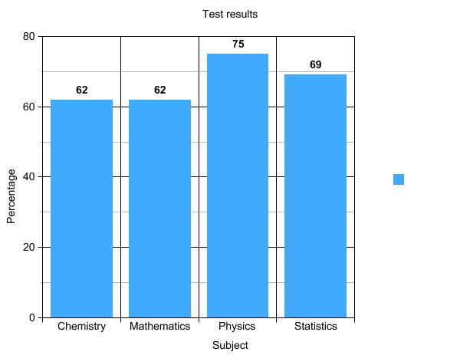

* 1. Physics
  2. 30

|  |  |  |  |
| --- | --- | --- | --- |
| **Income** |  | **Expenses** |  |
| Allowance  Birthday money | 3 000  350  R3 350 | Rent  Food  Entertainment  Cell phone | 1 500  1 000  500  300  R3 300 |

* 1. Yes, I have R50 extra

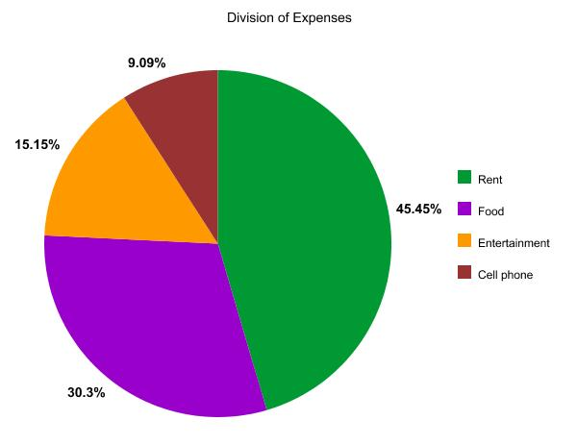



# Tracking my progress

You have reached the end of this section. Check whether you have achieved the learning outcomes for this section.

|  |  |  |
| --- | --- | --- |
| **Learning outcomes** | **✓ I feel confident** | **✓ I don’t feel confident** |
| Understand that data can be summarised in different ways |  |  |
| Interpret a set of data and representations thereof to draw conclusions |  |  |
| Effectively communicate conclusions and recommendations on the basis of various representations of data |  |  |
| Interpret tables |  |  |
| Interpret pictograms |  |  |
| Interpret pie graphs |  |  |
| Interpret vertical bar graphs |  |  |
| Interpret horizontal bar graphs |  |  |
| Interpret comparative bar graphs |  |  |
| Interpret histograms |  |  |
| Interpret stacked bar graphs |  |  |
| Interpret line graphs |  |  |
| Make use of Excel or any other computer software to draw pie, bar, line graphs and histograms |  |  |

Now answer the following questions honestly:

1. What did you like best about this section?

|  |
| --- |
|  |
|  |
|  |

1. What did you find most difficult in this section?

|  |
| --- |
|  |
|  |
|  |

1. What do you need to improve on?

|  |
| --- |
|  |
|  |
|  |

1. How will you do this?

|  |
| --- |
|  |
|  |
|  |