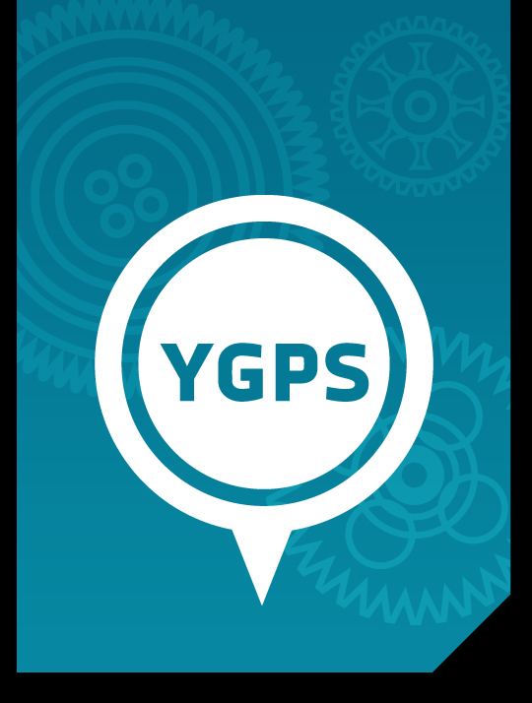

Unit Seven:

Navigating Across Boundaries

YGPS (Your Global Positioning System), Workshop Series 2010

Unit 7: Navigating Across Boundaries

1. Introduction: Welcome on Zook Island!
You have been summoned on a mission. You must navigate your way across the boundary from here to there. But you must be asking where is here and there? Allow me to introduce myself; I am Chief Zooka, leader of the inhabitants of Zook Island. I have selected you and a number of the other island inhabitants to fulfil an important mission for me. Look around you, to the left, to the right, in front and behind – these are your team mates and together you will be learning to navigate across boundaries.

Your mission: Navigate your way from Zook Island to the Island of Moob. There you will encounter a people you have never had contact with before and you will be required to work with them to better the lives of Zookians and Moobians alike. If you accept this mission you will have to undergo intensive training to prepare you for the Island of Moob. This instruction guide is your step-by-step training manual that will ensure that you and all your team members are equipped for MISSION: MOOB.

Farewell and best of luck dear Zookian. This is your leader Chief Zook thanking you for your cooperation and willingness to work on MISSION:MOOB.

Learning outcomes
The aim of this unit is to help you to:
- Know what type of boundaries you encounter in everyday life;
- Recognise the value of being able to venture beyond your own boundaries;
- Develop the ability to readily adjust in new environments by managing your own emotions and behaviour;
- Understand what respect is and demonstrate respect for others outside of your own group;
- Know how to collaborate and compromise with others in order to achieve a goal.

What do we mean by the terms ‘boundaries’ and ‘navigating’? Have a look at the definitions summarised on the following page.

Boundary  A boundary can be defined as the dividing line between two areas.  Sometimes boundaries can be easily seen. For example there is a boundary between the Free State Province and Gauteng, it is the Vaal River.  Sometimes boundaries cannot be seen such as the boundary between the Free State and the Northern Cape, but we know the boundary exists.  But whether sharp or blurry, natural or artificial, for every object there appears to be a boundary that marks it off from the rest of the world.  Events also have boundaries —the soccer game began at 3pm sharp and ended with the referee's final whistle at 4:45pm.  We as people have boundaries, places we have been, people we are willing to interact with or limitations on our talents and abilities. |  | Navigation  The word navigate is derived from the Latin words navis meaning “ship” and agere meaning “to move” or “to direct.”  Often the word navigation is used to refer to the steering of ships out in the ocean – or it can be used to describe the process of using a map to direct a driver from one place to another.  Navigation is all about moving FROM where you are TO where you want to be.
(These definitions are based on the Stanford Philosophical Dictionary, 2004.)

So, when we speak of navigating across boundaries, we are referring to directing our lives from where we are now, over physical and non-physical boundaries, to where we want to be.

Mission Moob
Chief Zooka has left a number of adventure tasks for you to complete before you leave on your mission, time is limited so we have to get cracking immediately. So, what are you waiting for? Get busy with the first training task for Mission: Moob.

Start up Activity 7.1:
What is your DQ? (Diversity Quotient)

Welcome to your first challenge in boundary breaking! Take a look at the 9 dots below. Without picking up your pencil, can you connect all these dots with only 4 lines?

Did you manage to get it right? If not, turn to the end of this section to see the answer. The truth is that it is impossible to do unless you draw outside the boundaries! On your mission it will be of utmost importance that you are able to think outside of the boundaries and be willing to work outside of the patterns that you are already familiar with.

Learning to work outside of the boundaries that you are familiar with is not only a skill that you will need for MISSION: MOOB. Soon you will find yourself at university or in the world of work and employment and you will have to be willing and able to step outside of your boundaries in order for you to achieve your goals, and for the organisation to achieve its goals. So while you are currently undergoing training for the mission to Moob Island, you are in fact being trained for life.

2. Navigating Zook Island

Investigating your boundaries
Before making the journey over to Moob Island, it is important to investigate your own boundaries and the boundaries that you encounter in everyday life. If you refer back to the definition of a boundary at the beginning of this section you will remember that boundaries come in many different forms both physical and non-physical.

Complete the following activity on your own in order to reflect on some of your physical boundaries.

Learning Activity 7.2

Fill in the following table by listing places (either in South Africa or outside of South Africa) that you have already been to; then, in the second column fill in places that you would still like to visit someday (either in South Africa or abroad). The first example has been included for you as a guideline.

Places I have visited | Places I would still like to visit
Cape Town, South Africa | Pyramids, Egypt
 | 2.
 | 3.
 | 4.
 | 5.

The places that you have already visited represent the physical boundaries of your experiences. One day when you have visited the places on your wish list, you can say that you have extended your boundaries and explored new territory. However, boundaries are not only physical, every day we encounter cultural, religious and socio-economic boundaries.

We are now going to investigate the benefits of navigating across boundaries.

Benefits of crossing boundaries
You may think that learning to navigate boundaries is not such an important skill, but the nature of the modern workplace will make it essential for you to be able to work and cope in new environments on a regular basis. Let us take a look at some of the characteristics of the modern workplace and how you will be required to break boundaries (Landy & Conte, 2004):

- In the 21st century world of work the focus is on teams rather than on the individual.
BOUNDARY BREAKER: This means that you will have to work in different teams on different projects on a regular basis.

- The modern workplace is no longer only located in one geographical location. Travelling from one side of the world to the other is only a flight away and inter-continental travel has become characteristic of most modern day organisations. The internet has also made international collaboration accessible to all.
BOUNDARY BREAKER: International collaboration will require of you to work with colleagues of many different cultures – you will need to know how to cross the boundary into their world.

- In today’s world of work, the only constant is change. Previously people stayed in one job for a very long time. This is no longer true, we change jobs on a regular basis
BOUNDARY BREAKER: Those employees who can adjust to this change and navigate themselves from the old to the new will have a greater chance of success in their careers.
- There is an increased need for networking (i.e. interacting with others to exchange information and experiences for mutual benefit).
BOUNDARY BREAKER: In order to be able to interact effectively you will need to know how to connect with all types of people – especially those who are different from you.
Although all of this may sound scary and intimidating if you learn to navigate well, you will enjoy the benefits of the modern day workplace. Some of the benefits include (Casto, 2008):
- More career opportunities.
- Freedom to choose from a variety of jobs, tasks, and assignments.
- More flexibility in how and where work is performed.
- More control over your own time.
- Greater opportunity to express yourself through your work.
- Ability to shape and reshape your life's work in accordance with your values and interests.
- Increased opportunity to develop other skills by working in various industries and environments.
How can you successfully navigate through the turbulent times of change and career uncertainty? The answer is easy, by having the right attitude about the changes twists and turns along your career path. You will still need to navigate many boundaries during your career, so you may as well get comfortable feeling uncomfortable.

Now that you can see the benefits of navigating borders, let’s begin navigating!

3. Mission: Moob Island
Good day again Zookian! This is your chief Zook checking in to see how you are progressing in your training programme. I am sure you have begun to wonder why I want to send a Mission to Moob Island. This is an excellent question to be asking and in order for it to be answered it is important for you to read the following excerpt from the Moobian, the local newspaper on Moob Island.

THE MOOBIAN  Great excitement arose all over Moob Island yesterday afternoon when an expert confirmed that a precious NoogStone had been found. Experts are of the opinion that thousands more of these NoogStones can be mined out of the soil on Moob Island.  The Minister of Finance commented yesterday, “This is potentially the greatest economic discovery for the Island yet! It is a chance for the Island to make its mark internationally!” | 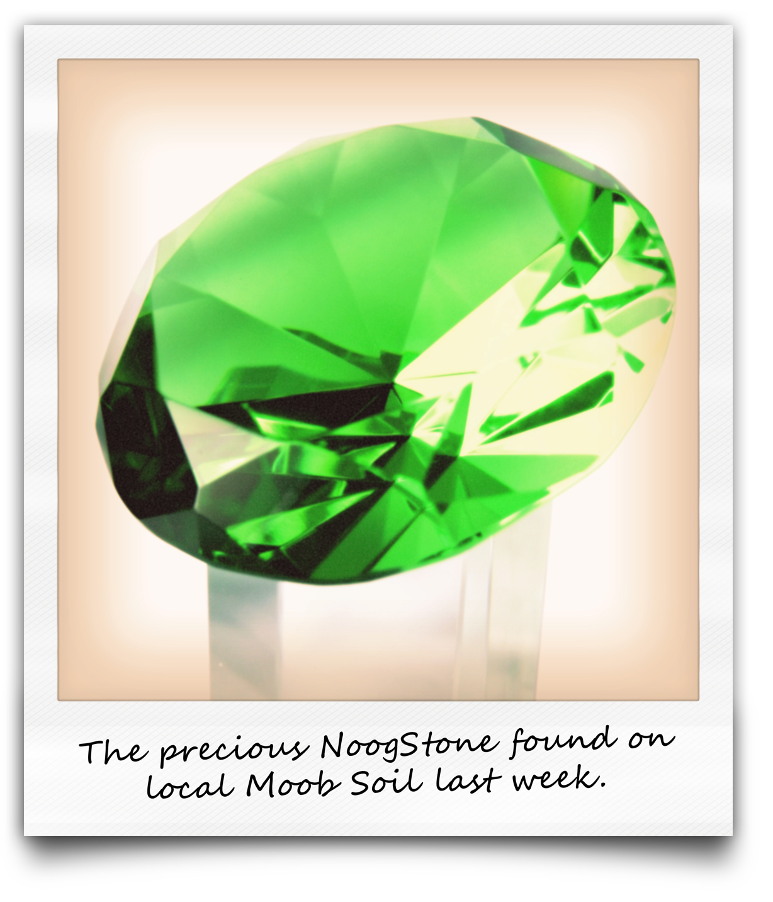

Despite this great discovery, there are a couple of problems facing the population on Moob Island. First, the people of Moob are small and not very strong at all. They will not be able to mine the NoogStones on their own; it will require the strength of someone like a Zookian to effectively mine the treasure. Second, they do not have the necessary equipment such a spades, mining gear etc. Due to the fact that Zook is well known for the mining of Xonia, our island has an abundance of mining gear and the capacity to produce more gear if need be. It is evident that the Zookian people can be of great assistance to the Moobians to help them mine the treasure. But who will the profit belong to? This is a potential opportunity for both islands to make money. Where will the NoogStones be sold? Who will transport the Zookians to Moob Island? All these questions and more will have to be answered during the training programme.

Most times, it is easier for us to work within the boundaries we know because that is where we are most comfortable. As a Zookian you understand how business is run on the island, you are familiar with the currency and can speak the language well – however, to work on Moob Island will require of you to learn a new set of rules, communicate in Moobienese and use the Mooba currency. All these adaptations are not always easy to make.

But, fear not Zook citizen, you have been chosen because of your unique talents and ability to learn how to work across boundaries.

Mutually beneficial outcomes are one of the reasons why collaboration and crossing boundaries in the workplace has become so important in the 21st century world of work. Organisations, departments, governments and individuals are realising the enhanced capacity to create innovative solutions through working across their boundaries.

Although the value of collaboration is clear, it is not always easy to work across boundaries. In order to be successful in working with other departments, organisations, countries and people; there are skills that you will need to practice. The rest of this unit focuses on learning and practising these skills.
“A ship in the harbour is safe but it’s not what ships were built for”

4. How to be a skilful navigator
Greetings Zookian! You are now about to discover the key skills for survival during MISSION: MOOB. It is essential that you are adaptable and are able to treat all fellow Moobians and Zookians with respect. But first things first – what to pack?!

Learning Activity 7.3

Take 5 minutes to make a list of the 10 things you would not be able to survive without on an unknown island.

Now that you have your own list, find two other fellow Zookians who will be going on the mission with you and complete the activity below. This group activity should take you about 15 minutes to complete.

Group Activity 7.4

Your group of 3 will ONLY be allowed to take 15 items in total with you on MISSION: MOOB. Use each of your lists to compile a new group list of the items you will be taking.

MISSION MOOB ISLAND: LIST TO PACK

Be Adaptable – coping across boundaries
Besides having your physical baggage to take with you, there is additional baggage you carry which you might not even be aware of. This baggage is referred to as personal/cultural baggage and it contains the values that are important to you and the patterns of behavior that are customary to your people. The more you know about your personal values and how they are derived from your culture, the better prepared you will be to see and understand the difference you will encounter as you cross the boundaries onto Moob Island. This baggage will affect the way you interpret the actions and the words of others, you can think of this as the sunglasses through which you see the world. Working effectively across boundaries will mean that you must be willing to remove your sunglasses and put on the sunglasses of the people you encounter in the new situation.

Chief Zooka has left the following steps for you to follow on how to adapt emotionally and behaviourally on Moob Island. For each step he has given his expert opinion and a short activity for you to complete. This should be completed on your own.

Learning Activity 7.5

Step 1: Recognise your own anxiety
When you begin to work across boundaries, whether the emotional, physical, cultural or intellectual it can be a very stressful experience. The stress arises from not knowing what to expect in these new situations, not knowing how to work with the people and not knowing what your role will be. First, be assured that this is a natural feeling that all people have to deal with when they are placed in new environments. So, when you recognise that the others who are around you are probably experiencing something similar, it helps you to feel more confident. This sense of anxiety will only last for a short while and then it will pass as you learn to cope in your new environment.

Think back to a time when you had to work with a group of people you did not know very well. Write down how you felt in this situation. How did you handle this situation? Thinking back on the situation, would you react differently the next time you are in a new group? Write down how you plan to handle having to work in a new group in the future.

Step 2: Listen, observe and keep an open mind
When you arrive on Moob Island it is important to follow these strategies:
- Listen to what the Moobians have to say. By what people say you can learn what they stand for, how things are run on their island and how you can most effectively work with them.
Can you think of a time when you wanted to share important information with someone (a friend, relative or person in authority), but they did not listen to you? Write down how it made you feel not to be heard or given the space to share your perspectives. Can you think of a time when you may have prevented others from having a chance to speak? Write this down too. Do you think they experienced the same negative emotions that you did?
- Observe. Many times people are very aware of the presence of strangers and tend not to say all the things they would have said if the new group members were not present. This is why it is very important to learn to observe and watch others carefully.
Pick one of your fellow Zookians who is currently in the room with you. Without telling them that you have chosen them, take 2-3 minutes and just observe what they are doing. Make notes of what they are doing while you are watching them, write down who they spoke to, whether or not they moved around etc. Did you learn something or notice something about this person that you were not aware of before?
- Do not to make assumptions. Remember that whilst you are on Moob Mission, you will find that the Moob people may do things differently to Zookians. Most often it is the non-verbal communication that differs from group to group. If some of the non-verbal signals on Moob Island are insulting to you as a Zookian, don't take it personally. For example, on Zook Island we always hug people when we meet them for the first time. This is not true of the Moobians, each time they meet someone new they clap their hands together. Try to think of 3 non-verbal signals/actions that are insulting or important in your culture that you know are different in other cultures. Have you ever been in the situation where your non-verbal signals were misinterpreted? Describe what happened. Have you ever misinterpreted the non-verbal communication of others? Describe the situation.

Step 3: Ask questions, seek clarification
This step relates directly to step 2. You may come across a situation where you are not understanding why the Moobians are acting the way they do. Then you should ask yourself if the behaviour you are seeing makes sense on Moob Island, even if it seems strange or wrong to you. Remember that you may have misunderstood something because you didn't have enough information. Ask questions from those you know who you think can help.

Step 4: Keep your sense of humour
It is very likely that you will make mistakes as you explore the new island. If you laugh at some of these mistakes it will help you to learn, adapt and enjoy the experience! Can you think of an unfamiliar situation where you made a mistake? How did you react? How did the other people in the group react?

Be respectful: reaching across boundaries

If you want to be effective in reaching out across the boundaries on Moob Island you will need to demonstrate genuine respect for everyone you work with. Respecting begins with taking into consideration someone else’s feelings, needs, thoughts, ideas, wishes and preferences. But respect goes further to include valuing the thoughts and feelings of others. As your chief on Zook Island, I would like draw your attention to the golden rule to remember at all times when working across boundaries: Always treat others as you would like them to treat you!

Step by Step Guide to showing respect

- When discussing important matters ask the Moobian how they feel about the matter being discussed;
- Once you have asked them to share how they are feeling, be willing to really listen to what they are saying. In order to be able to do this, you must not interrupt while they are speaking.
- Try your best to understand why they feel the way they do, and not only what they are feeling.
- Avoid telling people what they should do or how they should feel. They are entitled to their own perspective.
(Based on What is respect, 2007).

Treating people with respect makes your world a nicer place to live in; whether it's at home, at school, or out in your community. So, no matter which situation you find yourself in do your best to apply the golden rule of respect.

Before you get deployed on MISSION: MOOB it is important to practice showing respect for others. Captain Zoooka would like you to complete the following 2 activities as part of your training. Good luck Zookian!

Learning Activity 7.6

Think back to a time when you felt that you were not respected. Write a letter that you would like to give to your future children one day when they are older. In this letter describe a situation where you were not respected. Next, give them advice on how they should show respect to others and how you would like them to treat the people they come into contact with. Use the space below to complete this activity.

Dear Child
First, I want to tell you how proud I am of you and how much I love you.
I would like to share with you something that happened to me when I was growing up, a time when I felt very disrespected
This incident was not very pleasant for me and I therefore want to give you the following advice on how to treat others with respect:
As your parent, I would like you to be the type of person who treats others in the following manner:
All my love,
Your Parent

Now that you have completed this activity on your own, do the following activity in pairs.

Group Activity 7.7

Step 1:
Work in pairs and make list of different behaviours that you could do to show others that you respect them.

Here are some ideas to get you started:
• Don't insult people or make fun of them.
• Listen to others when they speak.
• Be considerate of people's likes and dislikes.
• Don't talk about people behind their backs.
• Be sensitive to other people's feelings.

Step 2:
Now join with another pair so that you are 4 students together.
Share your respect lists with each other and combine into a group list.
How many different behaviours did you manage to generate between you?

Step 3:
Now all the groups in your class should join together. Take a large piece of cardboard and together as a group create a “Respect Graffiti Wall”. Each person must get an opportunity to write their respect idea on the wall. Hang up the poster on the wall of your classroom to remind yourselves how you would like to be treated and how you should treat others!

Although you are learning these skills specifically for your trip to Moob Island, you can use these same skills for navigating all the boundaries that you have to cross in the workplace and learning environment.

5. Collaborating to achieve your goals
Welcome to the final component of your training module. In this important part of your training you are going to learn to negotiate and collaborate with the Moobian people in order to ensure that in the mission to mine NoogStones the goals of both Moobians and Zookians are met.

In your negotiations across any borders you should always be willing to compromise some of your own goals in order to allow the party with whom you are collaborating to achieve some of theirs.

For example you should avoid the situation where the Zookians get all the benefits they wanted from the mission and the Moobians get nothing, or vice-versa. This is called a win-lose situation.

When negotiating with the Moobians you should also avoid a situation where neither of the negotiators is willing to compromise at all and therefore neither gets anything they were hoping for from the mission. This is called a Lose-Lose situation.

The ideal outcome to a negotiation is when both Moobians and Zookians are willing to take each others’ needs into consideration in such a manner that they will all benefit. This is called a win-win situation.

Strategies for effective negotiation and collaboration

Strategy 1: Set the rules of the negotiation.
When you go to negotiate on Moob Island as a group you must all decide on the ground rules that will guide your behaviour at all times during the process.
- Each member in the group must agree that they are willing to work together to find a solution peacefully.
- Each person must agree that there will be no name-calling, blaming, yelling, or interrupting.
- It is important to avoid put-downs, guilt-trips, sarcasm, or negative body language.
- At all times participants should be aware that they are there to find solutions to a problem and not to fight against each other.

Strategy 2: Describe the problem.
Once you have established the rules of how the negotiation will take place, it is time to tackle the problem.

EACH person in the group must have a turn to describe the problem that must be solved from their perspective. It is very important to describe the PROBLEM and not attack the other person. An effective strategy to express how we feel without attacking someone else is to start the sentence with “I feel...” or “I believe”. By using these types of phrases we take the responsibility for expressing our perception of the problem. This is in sharp contrast to “you do this or that” which put others on the defensive and closes doors to communication.

A statement like, “You’ve left the spades and mining gear lying around again! Can’t you ever clean up after yourself?” will easily lead to conflict. Rather attempt to use I statements such as: “I am feeling annoyed because I thought we agreed you’d clean up the mining gear after using it. What happened?”

Strategy 3: Describe your ideal solution
Now that each person has had the chance to describe the situation from their perspective, it is time to allow EACH person the chance to describe what they would ideally like from a solution. When describing what you want try to focus not only on the outcome but on why you want that specific outcome. For example if the Moobian Mine Manager insists that you pay for mining equipment that was broken, he may be doing so not because he really cares about the object, but because he feels that you do not respect him. Addressing the manager’s need to feel respected may be key to resolving the conflict.

Remember the skills you learnt on how to be adaptable? Listening carefully to each other’s point of view is important if you really want to solve the problem. When people feel heard, they are more likely to work on a solution.

Strategy 4: Brainstorm solutions by focussing on common interests.
Now comes the most exciting part! Follow these steps to come up with as many potential solutions as possible.
- Decide on the issues that everyone agrees on.
- Identify the issues where people differ, remember to note why these issues are important to each person.
- List as many possible ways as you can think of to deal with the situation. During this phase do not criticize ideas or point out why some solutions won’t work. The important goal of this step is to generate as many ideas as possible.
- Allow each person in the group to offer at least one solution.

Special Note from Chief Zooka: Try to think of solutions where both Moobians and Zookians gain something. Think win-win! It is often possible to think creatively and come up with a solution that both people feel good about, where both walk away feeling that their needs have been met.

Strategy 5: Decide on a solution
After several solutions have been listed, it is time to choose one.
- It important to be as specific as possible and to attempt to address the interests of as many participants as possible.
- As Moobians and Zookians together you must explicitly state your agreement and it may even be a good idea to write it down.
- Decide upon a date when you and the team will get together again to see how the agreement is working.
- At this point you may need to go back to step 1 and renegotiate if you find the solution that you selected is not working.

The above strategies are based on the following resources (Drew, 2006; Facts for Teens, 2002.)

Assessment Activity 7.8:
Negotiation Simulation

This activity will serve as your assessment for this unit. You will be observed by a facilitator who will use a checklist to assess how many of the adaptability, respect and negotiation skills you made use of in your negotiation. The checklist the observer will be using is included below these instructions so that you have a clear idea what you will be assessed on.

You will now have an opportunity to practice all the skills that you have learnt during this module in a MISSION: MOOB negotiation simulation. Work in groups of 4-6 members.

You must pretend that you have crossed over the ocean to Moob Island and are part of the team who is working on the NoogStone Mining Project.

In your groups allow half of the participants to be Zookian negotiators and the other half to be Moobian negotiators.

Follow the instructions below.

Imagine! The time has finally arrived! You are now on Moob Island and must negotiate how the mining of the NoogStones will be handled. Take the following information and negotiate the best solution on how to run the mining project in the interest of both islands. A summary of the key points about the scenario, challenges and strengths is provided.

SCENARIO
The precious jewel NoogStone has been discovered on Moob Island. Experts believe that there are many more jewels to be found on the island which can create significant revenue for the inhabitants on the island.

CHALLENGES:
- The Moob people are very small and not strong enough to mine the NoogStone on their own.
- There has never been any mining activity on the island, and thus none of the necessary equipment is available to do the mining

STRENGTHS:
- The Moobians have a highly developed transport infrastructure including many ships which can transport the NoogStones to neighbouring islands where they can be sold.
- The ships can also be used to transport workers to Moob Island to help with the mining.
- For each NoogStone sold a family of Moobians can survive for a month.
- For each NoogStone sold a family of Zookians can survive for 2 months.

Checklist for negotiation in the NoogStone Mining Project
Participants in the negotiation demonstrated that: | NO | YES | EXCEEDED
ADAPTABILITY
They were willing to listen to each group member without interrupting
They were willing to observe the behaviours and reactions of others
They asked relevant questions when they needed clarification
They were able to use humour in tense situations
RESPECT
They would ask other participants how they felt and genuinely listened to the responses
They did not interrupt other members whilst they were speaking or sharing
They took the viewpoint of the other members into consideration when coming up with solutions
They made use of “I statements” and avoided “You statements”
There was no evidence of name calling, insults etc.
PROCESS OF COLLABORATION
The rules for the negotiation were clearly set
Each participant was given the opportunity to describe the problem from their perspective
Each participant was given the opportunity to describe their ideal solution
Solutions were brainstormed based on common interests
A solution was selected. The selected solution is an attempt at a win-win situation.

ADDITIONAL INFORMATION:
- The Zookians are strong and tall. They are a mining community and have years of experience and sufficient equipment available to help the Moobians.
- They do not have any means of sea transportation.

In your negotiations consider the following:
- How much will Zookians get paid to work in the mines?
- How much will they charge for the use of their equipment?
- How will the Zookians get transported to the island?
- Where will they live?
- How will Moob Island benefit in the long run?
- How Zook Island benefit in the long run?
- Who will be responsible for marketing and selling the NoogStones once they are mined?
- How will profits be shared?

6. Beyond Boundaries
Congratulations! You have successfully completed your mission to Moob Island. As your Chief I hope you have enjoyed this journey. Remember, no matter which environment you may find yourself in you can apply these skills.

Be adaptable!

Show respect!

Look for the win-win situation!

7. Feedback
The solution to learning activity 7.1

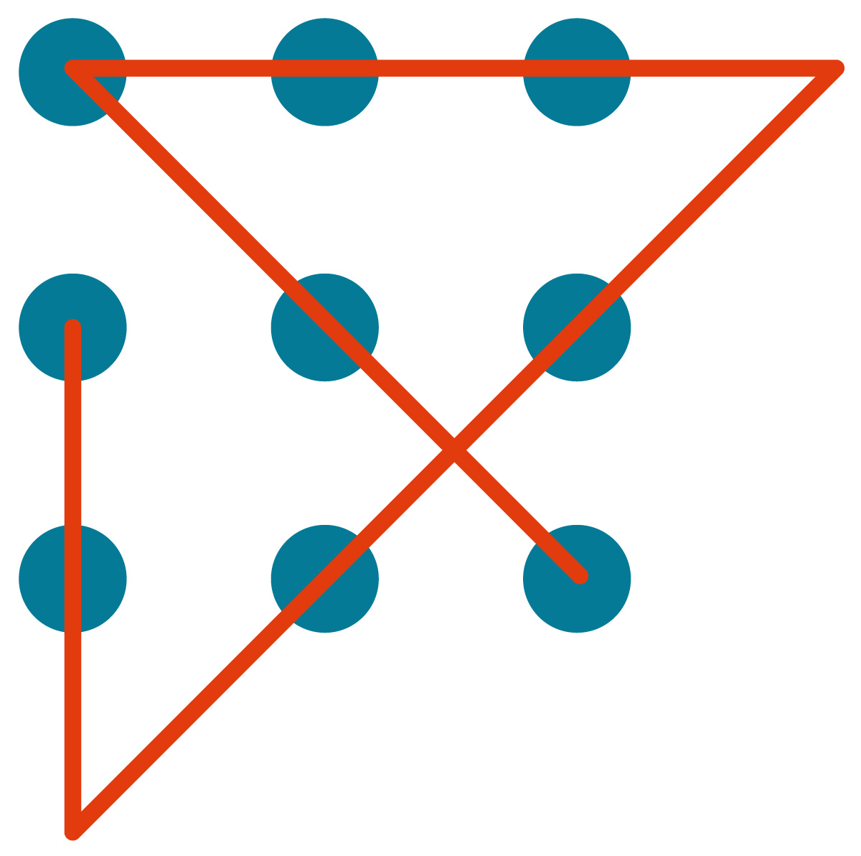

Tracking my progress
You have reached the end of this unit. Check whether you have achieved the learning outcomes for this section.

Learning outcomes | I feel confident | I still need practice
I am aware of the different types of boundaries that I will encounter in daily life
I can recognise the value that can be gained from working across boundaries to achieve common goals and objectives.
I am aware of strategies that I can use to help myself adjust to new environments emotionally and behaviourally.
I know what respect is and I am able to apply the golden rule in various situations
I have practiced negotiation skills
I am willing to compromise to find win-win solutions in group negotiations.

What did you like best about this section?

What did you find most difficult in this section?

What do you need to improve on? How will you do this?

Bibliography
Casto, M.L (2008) What Will 21st Century Career Success Look Like? Retrieved September 20, 2008, from http://www.quintcareers.com/career_success.html
Drew, N. (2006). Hope and Healing. Retrieved September 23, 2008, from http://www.learningpeace.com/pages/LP_04.htm
Facts for teens: Conflict resolution. (2002).
National Youth Violence Prevention Resource Centre. Retrieved September 25, 2008, from http://www.herkimercounty.org/content/Departments/View/11:field=services;/content/DepartmentServices/View/68:field=documents;/content/Documents/File/124.PDF
Landy, F.J., & Conte, J.M. (2004). Work in the 21st century: An introduction to Industrial and Organizational Psychology. McGraw Hill Higher Education
Stanford Philosophical Dictionary. (2004). Retrieved September 18, 2008, from http://plato.stanford.edu/entries/boundary/
What is respect? (2007). Retrieved September 21, 2008, from http://eqi.org/respect.htm#

