Harnessing OER Practices to Drive Pedagogical Improvement: The Role of Continuing Professional Development

Network of Open Orgs’ Collaborative Project:
Case studies that demonstrate the success of Open Educational Resources

Author: Paola Corti
SPARC Europe
Name of the initiative | Harnessing OER practices to drive pedagogical improvement: The role of continuing professional development
URL | https://www.nba.co.za/sites/default/files/2021-04/oer-africa-2019-research-report.pdf
Categorization of impact (access to education/ learner outcomes/ costs/ continuous professional development) | Continuous professional development (CPD)
Partners | - OER Africa  - Saide  - UNESCO Institute for Information Technologies in Education (IITE) for background research
Funding sources | William and Flora Hewlett Foundation
Years it has been operational | 2017 - 2019

Description, purpose, and aims of the initiative
OER Africa aims to support African universities to understand and harness the concept of open educational resources (OER). There are several practical constraints to achieving the widely anticipated potential of OER to create greater equity within higher education in Africa. Harnessing OER practices effectively (rather than propagating OER to replicate rote learning and top-down content transmission) depends heavily on the educational skills of participating academics. Despite this, OER Africa’s work has suggested that these skills are at much lower levels than assumed, regardless of the subject matter expertise of academics.

Consequently, in mid-2017, OER Africa commenced a series of interrelated research activities to explore in more detail the relationship between educationally effective use of OER and Continuous Professional Development (CPD) of African academics, which are brought together in a summary report. The purpose of this work was to move beyond the rhetoric of the OER community to determine what effect the OER movement has had in educational systems and how sustainable this has been.

In parallel with this reflection on the impact of OER practices, the OER Africa project team performed a literature review on CPD needs and practices in African academia, with a focus on developing competencies in teaching and learning. These two lines of enquiry provided a platform for practical work with universities, which had two priorities. First, to learn more about academic CPD needs by conducting surveys amongst academics and collating the results. Second, to develop and test a range of professional development activities and approaches that might respond to these needs. The results of these processes are summarized below.

Successes and achievements
OER Africa developed a Pedagogical Improvement Framework to define how to harness effective OER practices to improve teaching and learning at universities. The Framework (page 11-13 of the report) is a useful starting point to define what skills and competencies academics need to make educationally effective use of OER.

The team used three surveys to better understand CPD needs related to OER, focusing on teaching and learning and information and communication technology needs. The surveys are available for others to reuse. OER Africa used the survey results to design the pilot experimentation for new approaches to CPD (see Appendix One).
The six main improvement areas identified in the Framework are:
- Effective learning design for programmes/courses;
- Learning from well-designed educational resources;
- Inclusion of multiple voices/perspectives demonstrating the contested nature of knowledge;
- Knowledge construction;
- Regular, specific, and constructive feedback from educators and peers; and
- Application of knowledge and work-integrated learning.

The continuous requirement to revise curricula and develop new academic programmes relevant to the needs of the 21st century requires a system to train and retrain academics continuously. Training programmes that are conducted without support rarely result in the adoption of student-centred pedagogy at the classroom level. For CPD efforts to be effective and successful, they need to allow teachers to experience the types of instruction that they are supposed to use in their actual classes. The desktop research further revealed that institutions should provide training participants with an opportunity to practice the skills that they have learned. This opportunity would allow staff in higher education institutions to fully apply the skills they learn to achieve the desired impact.

This research confirmed that CPD for academics is key to developing OER practices in African higher education. In particular, it revealed that:
- Basic knowledge and understanding of teaching and learning practices is fundamental to building effective OER practices.
- Research itself attracts much more attention in CPD than teaching and learning, the latter being more expensive to implement and less scalable.
- Other forms of CPD can supplement these traditional, more expensive forms of CPD very effectively, as the pilot activities show.

Drawing from the above research and the Pedagogical Improvement Framework, OER Africa identified a series of CPD learning pathways that, taken together, provide the beginnings of a CPD Framework for effective OER practices to address the abovementioned points. The learning pathways are short tutorials that engage participants in authentic learning tasks, some of which are available in more than one language. They are mainly designed to support university academic staff, enabling them to improve their teaching and learning capacity using OER. The Framework offers six learning pathways on educational issues; two focused on research, which seek to connect research with teaching and learning; and one on knowledge management. They are as follows:
- Implementing open learning;
- Open content and learning design;
- Finding open content;
- Adapting open content;
- Blended learning and open content;
- Online facilitation;
- Releasing research as OER;
- Publishing using Open Access; and
- Creating an institutional knowledge management system.

Taken together, these learning pathways aim to develop effective OER practices. The learning pathways can be completed quickly without travel costs, and without requiring time away from the classroom. The benefits are clear, practical, and can be immediately applied to improve the professional work of academics.

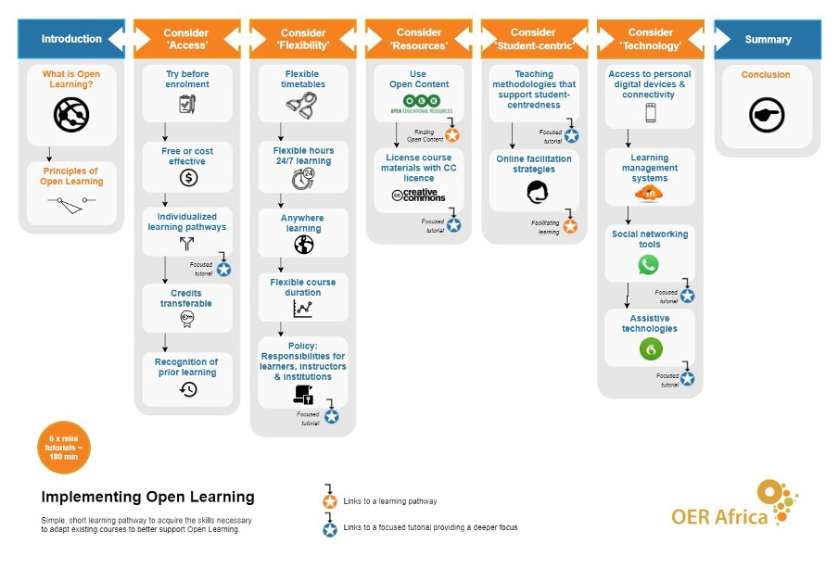
Figure 1 Learning Pathway on 'Implementing Open Learning'

Evidence of impact
The Pedagogical Improvement Framework and the learning pathways are the main results from the experiments performed in Ethiopia, Tanzania, Nigeria, and South Africa (see Appendix One of the report). CPD activities implemented in different institutions in these countries provided insights into related challenges, areas for improvement, and CPD needs. They also helped the OER Africa team adapt the suggested CPD Framework for effective OER practices. The impact of the implemented activities concerns the list of opportunities offered by CPD in the OER field and suggestions about how to face the challenges encountered, which are likely to be similar in many other contexts.

Challenges and perceived failures
Key challenges in implementing the OER CPD efforts during the pilot relate to operational issues. For example, at two universities, whilst the initial response to the collaboration was welcomed, the frequency of communication following initial meetings declined. This led to a slower pace of implementation at one university due to political unrest affecting Internet service and the need to locate a more committed person at the second university to move the pilot forward. A third university expected a larger budget. In addition, at all universities, progress tended to be very slow in the absence of visits by OER Africa support staff, raising questions about the full extent of institutional commitment to the CPD activities.

A further challenge was staff relocations. In one instance, key staff who had been trained left, and new staff members were inexperienced, resulting in some difficulty in implementing project activities. Further, university staff had competing priorities; attending OER CPD initiatives was not necessarily regarded as urgent. Whilst these were operational issues, such experiences do highlight notable challenges in rolling out CPD efforts.

In a context where many academics are not specifically trained to teach, the OER Africa survey indicated a greater focus on the content – pedagogy is regarded as a separate, additional component, often not core to the teaching and learning process. Quality assurance and evaluation are seen as a separate category, with no mention of academic staff becoming reflective practitioners who continuously evaluate what they teach (content) and how they teach (methodology). This is a challenge because self-reflection on the teaching and learning approaches, applied in the previous experiences and required to make them more effective, is key to making progress that does not depend only on the content.

Survey respondents differed on what aspects of their courses needed to change, but almost all recognised the need to make changes. In some instances, updating and/or changing content was identified in aid of making a course more contextually relevant. Given this, the issue of contextual relevance could provide a way to approach and encourage the use and adaptation of OER. In some instances, completely changing activities and assignments was deemed to be important, which indicates some academics’ willingness to redesign and iterate. Encouraging in this regard was an openness to working collaboratively. Some tensions were identified, though, especially relating to varying pedagogical orientations and skills hampering collaboration. Thus, this might be an area that could be incorporated into CPD offerings, especially in terms of what the use and reuse of OER and/or open pedagogies might mean for learning design.

Lessons learned and practices that made a difference
OER Africa and partner institutions’ gleaned the following lessons from the implementation process:
- Consider that academics tend to value research over teaching – focus on developing research capacities as a preliminary move when engaging with universities as a precursor to CPD in teaching and learning. The team identified capacity needs such as ‘packaging’ and disseminating research outputs for different audiences (and not just via journals or academic publishers).
- Focus on contextual relevance (fitness for purpose), which is critical if OER are to have any benefit as a CPD tool. Be aware of contract duration in relation to CPD and consider where participants are located to choose the best format.
- Start with staffs’ existing knowledge and skills – support building basic knowledge on online learning before addressing the OER-related part.
- Understand whether participation in CPD activities is compulsory or optional. Find ways to motivate participants to take ownership of their CPD path.
- Focus on in-depth activities rather than a wide breadth of topic areas.
- Share results of the CPD activities. Record lessons, workshops, and activities to reuse them elsewhere.
- Consider that granularity in designing CPD activities allows scaling and reuse. It also allows immediate application of what participants learned.

Resources and publications
Butcher, N. and Hoosen, S. (2019). Harnessing OER Practices to Drive Pedagogical Improvement: The Role of Continuing Professional Development. OER Africa. Available at: https://www.nba.co.za/sites/default/files/2021-04/oer-africa-2019-research-report.pdf

See:
- CPD Framework for effective OER practices (end of the main Report)
- Open Learning Policy Development Guide (Appendix Two)

Translating local insights into an international context
CPD faces similar challenges in other contexts. This includes the fact that previous knowledge and skills may need to be bolstered before starting any new learning path to align the entry-level of participants. Moreover, there may be contextual limits and issues that are external from the CPD but affect it, such as duration of contracts, technological equipment, and facilities. Another challenge is that career paths mainly build on research and not necessarily on teaching results. There is also a need for open approaches and flexible facilitation, together with careful planning and quality checks. Finally, there is a need for scalability and granular resources to address different levels of involvement, accounting for the particularities of each context. Thus, the research with institutions in the sample can be reused as a valuable starting point when considering the design and implementation of a new CPD proposal around open education and its pedagogies in other contexts.

Recommended citation
Corti, P. (2022). Harnessing OER Practices to Drive Pedagogical Improvement: The Role of Continuing Professional Development. Network of Open Orgs’ Collaborative Project: Case studies that demonstrate the success of Open Educational Resources. Available at: https://www.oerafrica.org/node/13635/materials

This work is licensed under a Creative Commons Attribution 4.0 licence
https://www.nba.co.za/sites/default/files/2021-04/oer-africa-2019-research-report.pdf

