Learning in a Digital Age (LiDA)

Network of Open Orgs’ Collaborative Project:
Case studies that demonstrate the success of Open Educational Resources

Authors: Trish Chaplin-Cheyne, Ebba Ossiannilsson, Juliane Granly, and Anaïs Malbrand
The International Council for Open and Distance Education (ICDE) OER Advocacy Committee (OERAC), and ICDE
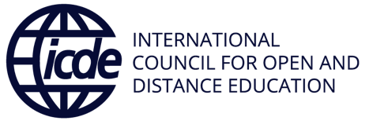
Name of the initiative | OERu: Learning in a Digital Age (LiDA)
URL | https://oeru.org/learning-in-a-digital-age/
Categorization of impact (access to education/ learner outcomes/ costs/ continuous professional development) | Access to education
Partners | - ICDE  - The United Nations Educational, Scientific and Cultural Organization (UNESCO)  - French Digital University
Funding sources | - OER Foundation: Hosting and technology support funded by general operations of the OER Foundation  - UNESCO: Contributed to initial translation and support for cultural validation  - ICDE: Project coordination
Years it has been operational | 2011 - present

Description, purpose, and aims of the initiative
March, 2021 marked the tenth anniversary of an innovative approach to provide free and open, media and information literacy education at the Open Education Resource Foundation (OERF).

The LiDA suite is made up of four micro-courses developed by the OERF that are delivered virtually, with the aim of supporting adults in developing digital and critical media literacy skills for learning online. Courses are at no cost to learners and include optional pathways to certifications, including formal academic credit towards university qualifications. In addition, courses are published and delivered using Free and Open-Source Software (FOSS), meaning any institution can reuse, remix, and replicate the course materials and delivery platforms for their own purposes.

LiDA103fr
To support the UNESCO Recommendation on OER, and in particular the third action statement, ‘encouraging inclusive and equitable quality OER’, the OERF collaborated with the ICDE, in partnership with UNESCO and the French Digital University (l’Université Numérique), to publish a French version of one of the micro-courses, ‘Open education, copyright and open licensing in a digital world (LiDA 103fr)’.

This French adaptation of LiDA 103 aligns with the ICDE Francophone Africa Project. The first French cohort, released on 17 November, 2021, is global in reach and aims to increase OER capacity by connecting national and international stakeholders, thereby increasing uptake of OER to other countries and regions, e.g. Francophone regions, particularly Sub-Saharan Africa.

Successes and achievements
To date, the LiDA suite of micro-courses have been incorporated into post-secondary qualifications across the globe and have been offered to 12,500 registered learners from over 100 countries. The micro-courses have been evaluated by an independent international panel and awarded the 2019 Commonwealth of Learning Award for Excellence in Distance Education Materials, while leadership in developing an OER-enabled, transnational micro-credentialing system was recognized by the ICDE Individual Prize of Excellence that same year.

Since July, 2019, LiDA has been offered as a self-directed elective course in three of Otago Polytechnic’s (New Zealand) undergraduate programmes. Learners can access course materials directly from the open OERu WordPress site, while a more discipline-specific assessment process has been introduced for one of the programmes via the Polytechnic’s Learning Management System. Learners may choose to interact with the open OERu tools or work within the forums in Otago Polytechnic’s Moodle instance. During 2021, the course was submitted to the New Zealand Qualifications Authority, which has evaluated the LiDA micro-credential delivered by OERu and assessed it to be equivalent to 16 credits (160 notional learning hours) at Level 5 on the New Zealand Qualifications Framework. This quality endorsement adds significant value to the LiDA micro-credential which supports both learners and employers.
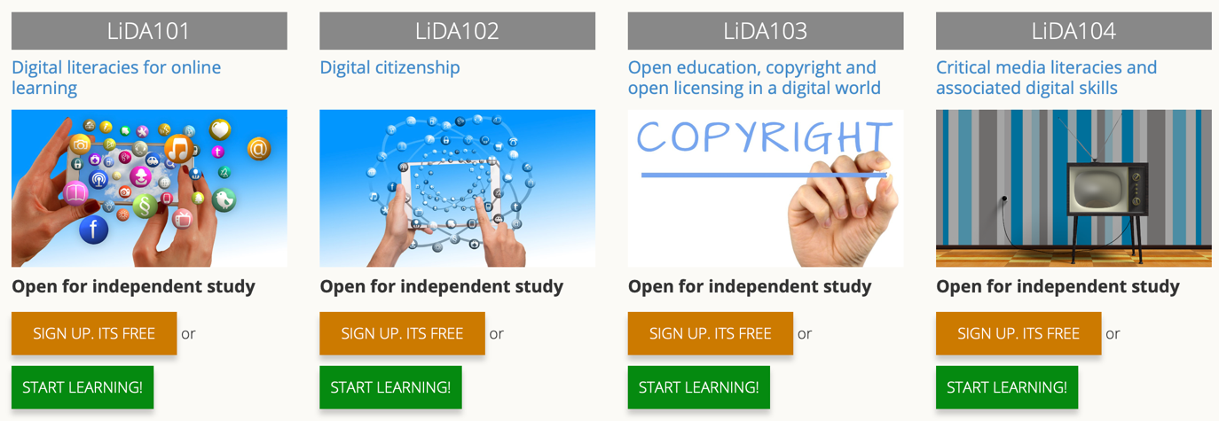
Figure 1 LiDA micro-courses on the OERu website

Evidence of impact
Noted impact has been the re-use and remixing of OER as evidenced from the following two examples. The Western Pacific University (WPU) in Papua New Guinea embeds the LiDA suite of micro-courses as a compulsory course in their Foundation Year programme. With materials published as OER using FOSS infrastructure – and as the OERu does not require learner registration to access the course materials – WPU students do not need to purchase expensive textbooks or proprietary software licences. The first cohort of students commenced their study in 2021. WPU will reuse and adapt the OERu assessments (also published under open licences) to assess their students for local credit at WPU.

North-West University (NWU) in South Africa decided to incorporate an online micro-course for the Business Management first-year course offered through the Faculty of Economic and Management Sciences. Without the need for NWU to incur any significant course design and development costs, NWU academics reviewed the OERu’s series of micro-courses and selected several learning pathways from the three OERu micro-courses to publish a new NWU version.

This remix incorporated South African video signpost examples and a NWU branded website theme for the course. Learners were required to work through the micro-course materials as self-study and to complete a quiz developed by NWU counting towards the course participation for their final grade. This customized OERu online micro-course registered 2,789 learners, with completion rates exceeding 90%. As an OERu partner, NWU also benefited from the OERF’s free hosting of this online micro-course.

Challenges and perceived failures

Notwithstanding the approval of the UNESCO OER Recommendation in 2019, the adoption of OER-enabled online courses for reuse and remix at higher education institutions remains low. This alludes to the need for ongoing advocacy and support for open education in publicly funded institutions. Organizations supporting OER adoption need to focus on crossing the chasm from ‘sharing to learn’ to ‘learning to share.’

Lessons learned and practices that made a difference
The original version of the course was developed and delivered via a wiki platform providing version control for collaborative development. Some learners were not familiar with navigating wiki-based courses, and it was difficult for novice users to onboard. Therefore, the OERF developed open scripts for publishing collections of wiki pages to a WordPress Multisite. Through numerous iterations and refinements, the OERF has established a replicable digital learning ecosystem comprising ‘best of breed’ FOSS applications for delivery of its courses.

Translating local insights into an international context
In summary, there are two lessons that are key considerations when translating content. The first lesson is that any translation initiative needs to be led by the language of adoption (ownership of the language localization), to ensure cultural validity. It was noted that to develop an English version into a multilingual context there needed to be a focus on the French localization and the local insights from the French speaking nations that would use the product. In this instance, this was Canada, Francophone Pacific Islands and Francophone Africa.

A second lesson was the bi-directional benefits created from the changes made to the delivery platform. The OERF developed new software for the French localization of the ‘Register Enrol’ WordPress plugin with capability to interface with the Mautic email plugin that manages campaigns for automatically sending course instructions. It is worth noting that investment in these software localization refinements will facilitate significantly quicker translations to other languages.

Resources and publications
- ICDE. (n.d). ICDE Francophone OER Project. Available at: https://www.icde.org/knowledge-hub/francophone-oer-project
- ICDE. (2021). Open registrations and synchronous session of the course LIDA103fr. Available at: https://www.icde.org/icde-news/lida103fr
- Mackintosh, W. (2021). Reuse and remix scenarios at OERu. OER Foundation. Available at: https://oerfoundation.org/2021/07/15/reuse-and-remix-scenarios-at-oeru/#png
- OERu. (2017). OERu process evaluation. WikiEducator. Available at: https://wikieducator.org/OERu/Planning/OERu_process_evaluationOERu. (n.d.). Learning in a digital age. https://oeru.org/learning-in-a-digital-age/
- Thibault, J. (2011). Introducing the OER university: 5 Questions with Wayne Mackintosh. Available at: https://opensource.com/education/11/3/introducing-oer-university-5-questions-wayne-mackintosh
- UNESCO. (2021). Open Education Resources. Available at: https://en.unesco.org/themes/building-knowledge-societies/oer/recommendation

Recommended citation
Chaplin-Cheyne, T., Ossiannilsson, E., Granly, J. and Malbrand, A. (2022). Learning in a Digital Age (LiDA). Network of Open Orgs’ Collaborative Project: Case studies that demonstrate the success of Open Educational Resources. Available at: https://www.oerafrica.org/node/13635/materials
This work is licensed under a Creative Commons Attribution 4.0 licence
https://oeru.org/learning-in-a-digital-age/

Mackintosh, W. (2021). Reuse and remix scenarios at OERu. OER Foundation.
See http://portal.unesco.org/en/ev.php-URL_ID=49556&URL_DO=DO_TOPIC&URL_SECTION=201.html
UNESCO. (2021). Open Education Resources (OER).
UNESCO. (2021). Open Education Resources (OER).
Mackintosh, W. (2021). Reuse and remix scenarios at OERu. Micro-credentials plus local course adoptions at Otago Polytechnic, New Zealand.
Mackintosh, W. (2021). Reuse and remix scenarios at OERu. Micro-credentials plus local course adoptions at Otago Polytechnic, New Zealand.
Mackintosh, W. (2021). Reuse and remix scenarios at OERu. Micro-credentials plus local course adoptions at Otago Polytechnic, New Zealand.
Mackintosh, W. (2021). Reuse and remix scenarios at OERu. Course reuse combined with local assessment at Western Pacific University, Papua New Guinea.
Mackintosh, W. (2021). Reuse and remix scenarios at OERu. Course reuse combined with local assessment at Western Pacific University, Papua New Guinea.
Thibault, J. (2011). Introducing the OER university: 5 Questions with Wayne Mackintosh.
ICDE. (n.d). ICDE Francophone OER Project.

