University of Cape Town
Case studies on African OER initiatives in higher education

Introduction
The University of Cape Town (UCT) is South Africa’s oldest university and one of Africa’s leading teaching and research institutions. The university has a long history of involvement in open educational resources (OER) and open educational practices (OEPs). This officially began when UCT’s Centre for Innovation in Learning and Teaching (CILT) initiated an Opening Scholarship project in 2007, which was funded by the Shuttleworth Foundation. The research focused on 12 case studies profiling open initiatives at UCT. As a result of this work, CILT received funding from the Mellon Foundation in 2008 to create a portal for sharing OER. With this funding, UCT developed its first open content directory called OpenContent, which provided a space for UCT academics to share OER.

UCT expressed its commitment to openness in April 2008 when it signed the Cape Town Declaration on Open Education. Then in November 2011, the University signed the Berlin Declaration on Open Access to Knowledge in the Sciences and Humanities. In fulfilling the philosophy of openness, it became possible to openly share knowledge at the institution when the university council adopted an Open Access Policy in March 2014.

Since then, through CILT, UCT has spearheaded several open education projects, including OER UCT and the Health OER Project. The University is a member of the Open Education Consortium, an international consortium with approximately 300 universities that make their teaching materials openly available for sharing. This case study examines four of the institution’s key OER initiatives: the OpenUCT Initiative (2011–2014); Research on Open Educational Resources for Development (ROER4D) (2021–2017); the UCT Vice Chancellor’s OER Adaptation Project (2013–2016); and Digital Open Textbooks for Development (DOT4D) (2018–2021). Each has been selected because of its focus and influence on OER advocacy, practice, and policy for Africa academics.

This case study is based on:
- Desktop research.
- Online survey responses from the project coordinator for the Vice Chancellor’s OER Adaptation Project, who was also the Principal Investigator for DOT4D, and a Coordinator of the UCT Vice Chancellor’s OER Adaptation Project.
- Online interviews with the director of the OpenUCT initiative, Prof. Laura Czerniewicz, and the principal investigator for the DOT4D project, Dr Glenda Cox. These two interviewees were also involved in other OER-related initiatives and activities at UCT.

OER initiatives at UCT

OpenUCT
Active between 2011 and 2014, the OpenUCT Initiative (OUI) was an intra-university special project hosted collaboratively by the Centre for Higher Education Development (CHED) and UCT Libraries, with a reporting line to the Deputy Vice-Chancellor (DVC) for Research and the DVC for Teaching and Learning. Funded by a grant from the Andrew Mellon Foundation, the OUI engaged with the academic community and university management to institutionalise open practices at UCT. Its aim was to institute a regulatory environment so that OER-related work could be mainstreamed at UCT. The initiative also had an advocacy objective, where it sought to bring issues of open education and open access onto the radar of the broader community.

One of the initiative’s main outputs was developing and launching the OpenUCT institutional repository in 2014. The OUI aggregated and detailed UCT’s full OER collection that was previously housed in the Open Content portal, absorbing it into the OpenUCT repository. Following OpenUCT’s launch, UCT Libraries took over the management and development of the platform, and it is now also an online academic research information service of UCT Libraries. OpenUCT houses the scholarly outputs produced at UCT, including theses and dissertations, journal articles, book chapters, technical and research reports, and OER. It was designed to align with international interoperability and metadata standards using DSpace open-source software. The repository is indexed by all major search engines.

Working with stakeholders across the university community, The OUI was instrumental in steering the development of UCT’s Open Access Policy, which was approved in 2014; particularly with regard to the policy’s innovative approach of integrating OER as an aspect of institutional activity. In addition, the initiative advanced UCT’s open data agenda by hosting a research sub-project which was part of the Open Data in Developing Countries initiative. The sub-project helped UCT to introduce open data and open science to its institutional practices.

When the initiative began, there was not an explicit intention to build a repository, but it soon became clear that this was needed, as people who were involved in open education needed a curated space to upload their outputs.

Strengths and achievements
When it came time to consider the best home for OpenUCT once OUI came to a close, there were a series of high-level discussions amongst all the stakeholders, including the director of OUI, the director of the UCT library, and UCT’s Senate Executive community. The group decided that the library should take on the role of maintaining OpenUCT, which was a significant success for OUI as the initiative was mainstreamed and therefore became sustainable.

Another way that the OUI had success in mainstreaming use of OER was through small grants of up to R10,000 for staff and students to develop or adapt teaching and learning content into OER. These grants were mainstreamed when they were incorporated into the university’s general teaching and learning grants. This work was also a precursor to UCT’s Open Textbook Award, which recognises the efforts of open textbook authors and promotes the creation and reuse of OER.

Challenges
OUI faced three key challenges. The first pertains to the cultural environment of a research-intensive university where teaching-related activities are often not prioritised. It is a cultural challenge for these to be regarded as equal objectives in such institutions.

The second is about structural drivers and rewards, including academic promotion. If teaching, resource development and OER are not specific criteria measuring success, it is hard to shift it from being a peripheral activity.

Third, it became clear how cumbersome the technical processes of licensing are for busy academics with little time or interest in the particulars of Creative Commons (CC) licensing conventions. This came to the fore as a recurring issue in several OER initiatives at the university.

Sustainability and capacity building
As the director of the OpenUCT initiative explained, a key issue with OER initiatives is that they lose momentum due to funding constraints and without ongoing champions. This was an important reason why the initiative sought to mainstream its activities. She added:

The problem with soft-funded projects [is that they] come to an end, whereas OpenUCT got institutionalised. It was mainstreamed into the library and is now part of the core library work. Most libraries only focus on research outputs, but we built a repository that includes teaching content, OER and research outputs. They foregrounded OER even more than we had when it was transferred.

OpenUCT was also mainstreamed through an Open Access Policy. The Policy is rare because it specifically mentions OER, unlike many which focus solely on Open Access to research output.

CILT also adopted a principle of openness in its own work, thus promoting Creative Commons licences as a default starting point both internally and when working with academics.

In terms of capacity building requirements, the director of OUI notes that, while Open Access is becoming more well-known particularly because of funder requirements, it appears that OER are less well known. As such, advocacy is an ongoing need, particularly with regard to the different kinds of licences. Finding OER also remains an issue.

The situation at present during the pandemic has shown that there is still a great paucity of OERs [and] of OERs that can be used instead of current proprietary resources/textbooks. Either because the process of adapting is too onerous, or they don’t exist, or because they are not good enough. Open education advocates have more work to do to raise awareness

Research on Open Educational Resources for Development (ROER4D)
Hosted by CILT, the Research for Open Educational Resources for Development (ROER4D) project was an international research project studying OER adoption. The project ran between 2013 and 2017 and was funded by Canada’s International Development Research Centre (IDRC), the United Kingdom’s (UK) Department for International Development (DFID), and the Open Society Foundation (OFS).

The core activity for ROER4D was to investigate how OER adoption could address the increasing demand for accessible, relevant, high-quality, and affordable education in the Global South. Originally, it was intended to focus on post-secondary education, but, when it launched in 2013, the scope was expanded to include basic education, teachers, and government funding. In 2014, the research agenda was expanded again to include the potential impact of OER adoption and associated OEPs.

Through its activities, ROER4D engaged 103 researchers in 18 sub-projects across 21 countries from South America, sub-Saharan Africa and Asia. These researchers were coordinated by Network Hub teams at two centres: UCT and Wawasan Open University (WOU) in Malaysia. The Network Hub served as the central project management structure for the project.

The project had two phases:
- Phase 1 – Adoption studies: The first ROER4D workshop was held in Cape Town in 2013, which gave the twelve sub-project researchers an opportunity to meet, refine their proposals, and engage in a gender awareness workshop. The researchers conducted their research from January 2014 to December 2015.
- Phase 2 – Adoption and impact studies: the UK’s DFID provided funding for the second phase of the project, which allowed for a second set of sub-projects. In 2014, the IDRC awarded the DFID funds to WOU, which would host the second cohort of six impact studies, creating a total of 18 sub-projects for ROER4D. Most of the impact studies, which were independently scoped to suit their contexts, began their research in March 2015 and concluded in February 2017.

Figure 1 is a snapshot summary of the ROER4D research projects.

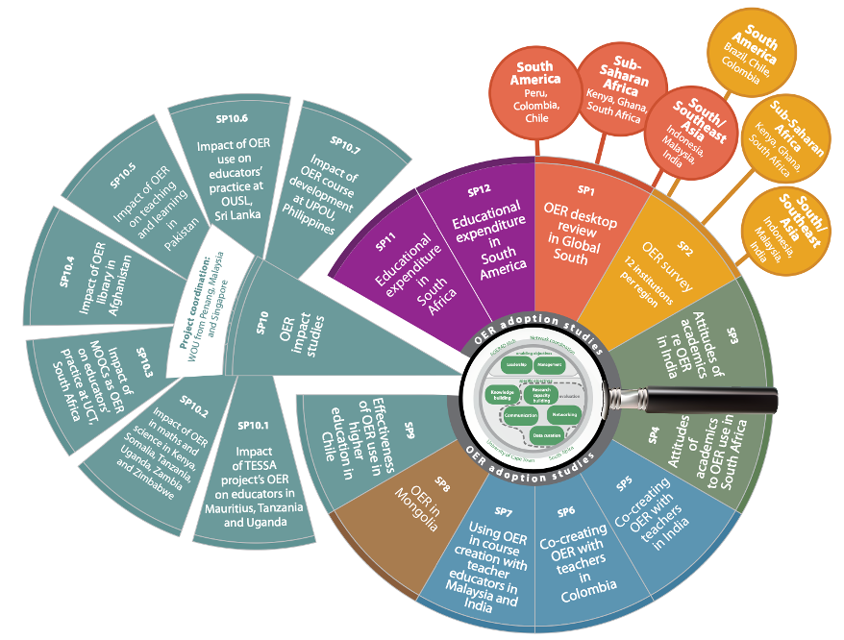
Figure 1 Snapshot summary of ROER4D adoption and impact studies (CC BY)

Strengths and achievements
ROER4D’s main research output comprised a 16-chapter edited volume, Adoption and Impact of OER in the Global South, and an associated open data collection for the six sub-project studies. The project team also produced ten journal articles, three book chapters, two monographs, five keynote addresses, ten conference papers, 75 conference presentations, 64 blogs and several teaching sessions with postgraduate students and staff.

The initiative has received acclaim for providing high-quality OER research from a Global South perspective. In 2018, it received the Open Data Award in the Open Education Consortium (OEC) Open Resources Open Resources, Tools & Practices Awards and the OEC Open Research Award in 2016. The research and researchers from the network have subsequently had broader influence, for example, assisting in writing OER policies for provincial education ministries in Sri Lanka and implementing state-sponsored OER portals for teacher professional development in three states in India. In addition to researching openness in education, the network was strategic in effectively leveraging different open practices. It experimented with open engagement in all of its work, which included highly inclusive decision-making processes and open sharing and collaboration within the network.

The project undertook four research projects on OER and OEPs in sub-Saharan Africa specifically, making a significant contribution to research on OER on the continent. These were:
- Tracking the money for Open Educational Resources in South African basic education: What we don’t know: This study sought to explore government funding allocated to educational resources in basic education in South Africa, with the aim of establishing a benchmark of public spending on educational resources to ascertain the economic benefits of using OER.
- Teacher educators and OER in East Africa: Interrogating pedagogic change: This study examined the use of OER at six teacher education institutions in Mauritius, Tanzania, and Uganda. Drawing primarily on interviews with teacher educators, the study examined how and when teacher educators engage with OER, the factors that support and constrain sustained OER engagement, and the influence of such engagement on their teaching practice.
- Factors shaping lecturers’ adoption of OER at three South African universities: This research addressed the question: Why do South African lecturers adopt – or not adopt – OER? It found that whether and how OER adoption takes place at an institution is shaped by several factors, including infrastructural access, legal permission, conceptual awareness, technical capacity, material availability, and individual or institutional volition – which are further influenced by prevailing cultural and social variables.
- OER in and as MOOCs: The team conducted an investigation into the production and rollout of four massive open online courses (MOOCs) at UCT, and on the experiences of the educators involved in their production. The study found that, despite the challenges that educators faced, they largely achieved their purposes of making MOOCs and thus manifesting legal, pedagogical, and financial dimensions of OEP.

Challenges
ROER4D encountered several challenges throughout the process of creating an empirical knowledge base about adoption and impact of OER in the Global South. The fact that researchers were from diverse linguistic, cultural, and academic backgrounds was both a benefit and a challenge. As a means of mitigating the risks associated with this, the project team implemented a real-time feedback mechanism that allowed for consistent feedback, reflection, and adaptation.

ROER4D conducted an extensive evaluation using a Utilisation-Focused Evaluation (UFE) framework, where evaluators facilitated a learning process by focusing on how key project management structures could apply evaluation findings and experiences. Due to time and resourcing constraints during the evaluation process, not all project objectives could be evaluated in an iterative fashion. For example, the team did not have time to evaluate the successes of the curation and dissemination strategy. Recognising this as a problem for the UFE’s developmental and iterative process, the evaluation advisor and project curator began a process in February 2015 to develop a list of curatorial best practices that would support the communications objective. These were later incorporated into a more comprehensive curation and dissemination strategy.

Sustainability
The UFE encouraged evaluators to facilitate a learning process by focusing on how central project management structures might apply evaluation findings and experiences. In ROER4D, an evaluation advisor worked with the UCT Network Hub to create and implement the evaluation approach. Developing Evaluation and Communication Capacity in Information Society Research (DECI-2) was another IDRC-supported project that had expertise in employing UFE in large-scale projects. DECI-2 thus provided feedback and support through strategic discussion, as well as review and commentary on key constructs, such as key evaluation questions (KEQs) and measures.

UCT VC OER Adaptation Project
Running from 2013 to 2016, the UCT VC OER Adaptation Project sought to empower students to adapt their lecturers’ learning content into OER. It was a bottom-up initiative in which five postgraduate students would search for and request lecturers’ high-quality learning materials in the Humanities, Commerce, Science, and Engineering and the Built Environment Faculties. Through a process of copyright clearance and enhancement, the students would then adapt the materials into OER, which would in turn be shared on the institutional repository, OpenUCT. The students were supported by a student coordinator, who arranged training on copyright and metadata and provided quality assurance for the materials they adapted. The initiative aimed to improve student awareness of open education and related concepts

In 2015, the project received additional funding to focus on upskilling UCT librarians on OER-related issues. CILT facilitated training workshops for UCT librarians on open education and open content. The project also used funding to continue with advocacy work by organizing events and administering small OER grants.

Strengths and achievements
The main success of this initiative was that, through its activities, it added numerous OER to the institutional repository. Small grants to lecturers allowed them to use that money to employ students to assist in the adaptation process, which the project coordinator highlighted as a significant success in promoting adaptation. This was particularly the case because, as an article by the student coordinator noted, lecturers who had previously been interested in being involved in OER production noted a lack of incentivisation and a reliance on upper-management decisions to ensure incentivisation. However, the adaptation project was innovative because it ‘took an agile alternative approach in supporting lecturers in developing their own enabling systems for OER production, specifically through employing students to reduce the time costs of OER engagement.’

The initiative was also directly responsible for training six student facilitators in copyright, Creative Commons, and OER advocacy. Five of those students were substantively involved in the project, adapting materials from nine lecturers. The student adapters were employed on a paid-on-claim basis, allowing them a degree of flexibility in their working hours, under the assumption they would work approximately five hours per week. Students were tech savvy and good at understanding and using concepts such as copyright and CC licensing, which aided the project activities, such as using those licences correctly.

Challenges
While students grasped CC licensing fairly easily overall, it would have been useful to focus more attention on helping academics to understand these elements. Post-project interviews with the contributing lecturers indicated that, while it was straightforward to negotiate licensing with lecturers, their knowledge of conventions around copyright and CC was often low or limited. This suggests that students were only responsible for partial knowledge transfer. Feedback gathered from lecturers as part of the project also revealed that, in many cases, ‘the contributing lecturers had not incorporated the completed OER in their own teaching, or in extreme cases had not even viewed the OER records on the institutional repository after the project’s completion.’ This finding, however, was consistent with disengagement by some lecturers during the adaptation process.

Moreover, while students found it relatively straightforward to undertake activities related to copyright clearance, which included sourcing open equivalents of media objects, their role as lecturer-facing intellectual property educators and open advocates was more challenging. A large number of lecturers who declined to participate in the initiative noted that they were concerned about the ‘exposure’ that the OER adaptation process would provide. This is known as the ‘sunflower effect’, where lecturers are comfortable to create and share materials for students to use, but feel exposed if they are shared more widely as it might expose them to critique.

Another key issue that the initiative faced was the transience of students. As the project coordinator notes, ‘I can’t say that the student side was a great success, the students moved in and out very quickly; they could only help for six months.’ The project team also found it challenging to identify students to participate in the initiative in every faculty, indicating that some students were very reliable while others lost interest. Compounding this issue was that it was difficult to contact some lecturers. They often only provided materials late or in part and only partially integrated the adapted OER into their courses.

In relation to project rollout, the project coordinator added that, because universities are slow to change, it was difficult to implement a project over a six-month period. Another time-related issue was that students struggled to manage the time required to solicit content and adapt the OER while balancing their course loads. When the project was concluding, students indicated that they would have preferred a more structured, production-focused model with dedicated weekly or bimonthly workshops to support their adaptation activities.

Digital Open Textbooks for Development (DOT4D)
CILT launched the 36-month DOT4D initiative in July 2018, which was funded by the IDRC. DOT4D’s overarching objective was ‘to contribute to improving inclusion in South African higher education by addressing equitable access to appropriate and relevant learning resources.’ Focusing on OER policy, practice, and research, the project had three components:
- research into open textbook,
- grants to produce open textbooks, and
- advocacy.

All these activities had a social justice imperative, and the project aimed to make an argument for the role of open textbooks in redressing injustices in higher education. To this end, DOT4D researched the ecosystem of open textbook publishing at UCT and supported policymakers and other stakeholders in developing institutional and national policy frameworks that regulate open textbook publishing and address long-term sustainability mechanisms.

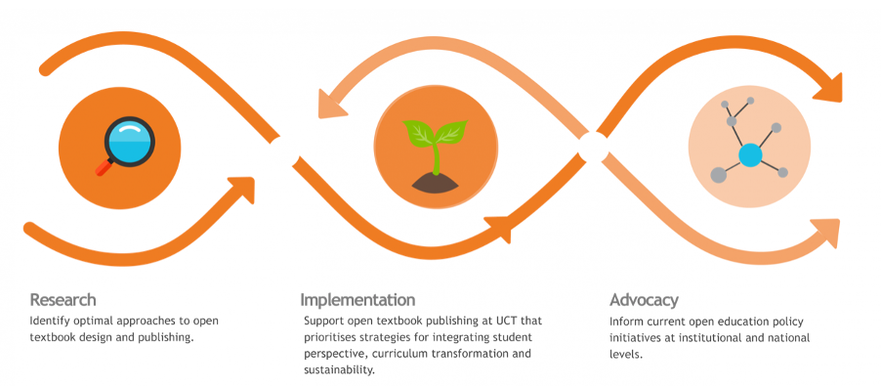
Figure 2 DOT4D Objectives (CC BY)

Following an open call to UCT academics at the start of 2019, the initiative made grants of up to ZAR80,000 available to nine open textbook initiatives at UCT. The initiatives address transformation of the curriculum, inclusion of marginalised voices, inclusion of student voices, relevance to local context, multilingualism, disability access, interdisciplinarity, and strategies for the sustainability of the proposed open textbook. Grants were open to UCT staff working in any discipline and were used for the following activities:
- supporting authoring and collaboration processes,
- sourcing additional capacity and specialist expertise in design and production processes,
- soliciting student involvement in content-generation or quality assurance processes, and
- undertaking technical work required for optimal access to and dissemination of the work.

Grant recipients were required to license materials produced with the aid of the DOT4D grant under a Creative Commons Attribution (CC BY) licence.

In addition, DOT4D worked with Creative Commons, UCT Libraries, and the Department of Health Sciences Education to develop and curate the UCT Open Content Finder. The Open Content Finder assists lecturers and students in finding affordable, appropriate teaching and learning resources that can be used during remote teaching. The directory hopes to become a community-developed list of textbooks and other OER.

Strengths and achievements
DOT4D awarded a total of nine grants. As a result of this resourcing, the grantees were able to develop seven chapters or open textbooks that have been published. The principal investigator noted that the project has created some very useful materials. She added that the research process also highlighted that there is a definite need for OER-related initiatives and people need resource assistance to initiate such activities.

The research activities that the initiative undertook provided deep insight into the benefits and pitfalls of open textbook authoring. It highlighted that open textbooks and their associated open practices provide a tool to address economic, cultural, and political injustices. Thus, they hold the potential to promote an enabling pedagogy for social justice and transformation in South African higher education. The key findings, which draw from Nancy Fraser’s trivalent lens for examining inequality (economic, cultural and political), are highlighted below.

Economic maldistribution
- Academics at UCT are aware of challenges related to the cost and utility of traditional textbooks and are experimenting with new approaches towards resource creation through open practice.
- Time is a significant cost to the academic in open textbook production.

Cultural misrecognition
- Open textbook authorship models are providing avenues to explore innovative, student-centred pedagogical approaches.
- Open textbook authors are attempting to make content more accessible in terms of relevance, format, and genre to promote greater inclusivity.
- Open textbook activity appears to be on the rise at UCT despite a range of institutional barriers.

Political misrepresentation
- Academics at UCT acknowledge that there is a legacy of gatekeeping in the selection of prescribed textbooks which serves to perpetuate political mis-framing and exclusion.
- Open textbook authors at UCT are including students in content development processes to shift power dynamics and build confidence in terms of students’ ability to contribute.

The project entailed skills development for OER creators and developers and part of the exercise was to assist authors with production and publishing skills. The principal investigator noted that there is place for developing a skillset for various publishing models that one could share with academics. However, there is a gap in the interface between materials and open publishing.

Challenges
One of the main challenges that the initiative experienced was a lack of flexibility built into the academic calendar and pressure to undertake specific activities at particular times during the year. Thus, the project ran well until the COVID-19 pandemic outbreak, but the resulting disruptions from the outbreak meant that the project team had to postpone the planned institutional and national advocacy events. One such event was aimed at the grant holders, the DVC Teaching and Learning and others interested in open materials hosted at UCT. Following a delay, the national event took place on 7 July 2021 and focused on open textbooks, where the project managers invited people interested in open education, bringing senior academics and management into conversation. Two more events were planned for the second part of 2021. Ultimately, this advocacy work is designed to enable an Open Textbook for South African Higher Education community.

Another key challenge that the initiative faced concerned academics’ time. As noted, one aspect of the project investigated models of open textbooks. Some academics who were involved in DOT4D wanted to collaborate with other academics but were unable to because of conflicting schedules or an unwillingness of some academics to be involved. The initiative struggled to get hold of two lecturers who had previously committed to developing textbooks, one of whom was having difficulty completing the work. The principal investigator added:

It’s a challenge we were disappointed to hear about, because we feel part of the power of an open textbook is that you can collaborate. People said they would love to do it but didn’t send their pieces through [to the DOT4D team].

Others decided to collaborate with students, which the principal investigator said worked well. This highlights crucial challenges around collaboration and time, noted in a recent analysis of the project:

All respondents highlighted the time required to produce and publish open textbooks as a significant cost and the most substantial barrier to open textbook creation. As one author stated: ’Honestly, the biggest problem is time. It takes time to produce a really good book and get it written and checked … there needs to be support for people to have time to just write.’

The team has sought to tackle this challenge by fostering recognition for this work through an annual Open Textbook Award.

Although there are numerous open materials being created, it is difficult to track how they are used. This is a future area that could provide empirical evidence in favour of using and developing open materials. It might involve structuring analytics better so there are more sophisticated analytics on a particular resource, which could track where a resource is being used. This can be supplemented by a qualitative study analysing students’ use of OER.

Sustainability and capacity building
At the time of publication, the initiative was still engaged in the advocacy phase, which had experienced delays due to the COVID-19 pandemic. The team is now in a DOT4D-Reach phase, as funding was secured from UCT until the end of January 2022.

The team provided training for project participants on understanding copyright and CC licences but noted that it would be useful to have greater efforts to help academics understand these concepts and their implications. There were several queries around reading and external sites as well as video fair use. This suggests that, although people might be aware of CC licensing conventions, there is still a need for communicating the details about concepts such as fair use.

Academics consistently approach the DOT4D team for assistance in their open textbook work. Moving forward, the principal investigator notes that there is a lot of opportunity for the proliferation of open textbooks and OEPs, but there also needs to be more advocacy regarding the benefits of OER and OEPs at UCT and beyond. Although UCT has launched several open projects over the years, most staff have not yet become engaged in curating and using open materials.

In terms of requirements for OER-related capacity building, the principal investigator indicated several areas. This included upskilling academics to find, create and use OER effectively. Related to that is building capacity around copyright and CC licensing as people are not aware about the implications of different licences. There is also a need to build students’ awareness at all institutions, which will hopefully put pressure on staff to create OER.

The principal investigator noted that longitudinal support would be useful in ensuring the sustainability of project activities. Different layers of support would be useful in achieving the project team’s objectives. For example, support from senior institutional management, peer recognition, financial support, and assistance with design, copyright, and publishing advice would be of value.

Lessons learnt
UCT’s extensive OER-related projects have provided invaluable insights into the use, development, and advocacy of OER. Key lessons across the initiatives outlined above are explored below.

Formative evaluation
Evaluation frameworks can play a significant role in effective project iteration. The UFE that ROER4D used allowed the UCT Network Hub to be responsive to researchers’ needs by receiving regular feedback and responding to it in an agile manner. Evaluation occurred over several phases of the project, which enabled the UCT Network Hub to use the data and insights from the evaluation to shape their actions. This iterative process was valuable in that it enabled the team to adapt as the project unfolded.

In addition, the project team concluded the following from the ROER4D activities:
- It is important to develop clear and measurable communications objectives and outcomes, and to be amenable to reviewing and amending communications activities based on feedback. This helped the team develop an agile and iterative communications mindset.
- The UFE model helped the team to monitor its activities and to understand, at various stages of the project, what research capacity the researchers had, and how they could be enhanced.
- In both internal and external evaluation, never underestimate the importance of iterative engagement. More engagement can result in a better understanding of the project and what matters to the evaluation users.
- Apply what you learn about what is ultimately useful (and not useful) by facilitating use of the evaluation findings and further refining the evaluation focus.

Sustainability through mainstreaming
UCT has experienced success in mainstreaming OER at the institution. As part of entrenching OpenUCT at the institution, the OUI hosted several events and used existing forums to promote the platform. In addition, it linked the initiative to existing committees and structures. The OUI team also partnered with the research office to link OpenUCT with their existing seminar series. As the director noted, ‘it works better if you link it to a discourse and language and set of interests that people already have…If you do the advocacy work, people will come round to agreeing’. She added that some academics were about to retire and due to the advocacy work, had a lifetime’s worth of teaching resources which they were happy to share. However, even though the materials were made available, the team still required resources to turn the materials into OER. This included a need for curators and writers, together with subject matter experts in some cases, and maintenance costs, such as library staff’s time to sustain the platform.

The need for sufficient resource support came to the fore as a key requirement. Regarding lessons learnt from the UCT VC OER Adaptation Project, the project coordinator noted that it would have been useful to have support in the form of resources to roll the project out more effectively. She added that actively advocating for the use of OER can be a highly effective way of involving a broader range of people: ‘people who were about to retire were really keen [to participate] and had a lifetime’s worth of teaching resources; they were in favour of sharing them’.

The pandemic was also an opportunity for OER to gain traction. Students and academics at UCT were desperate for resources, which enabled a lot of sharing and collaboration. For example, CILT produced several resources about going online, which were all CC licensed.

The pandemic and initiatives such as DOT4D also highlighted that open textbooks provide a tool to address economic, cultural, and political injustices. They therefore hold potential to promote an enabling pedagogy for social justice and transformation in South African higher education.

Metrics, rewards, and incentives
There remains a need for further advocacy efforts at institutions like UCT to sustain and even grow a focus on producing openly licensed teaching and learning materials. The director of OUI added that the rankings culture in South Africa is what drives research intensive units in South African universities. She suggested that, if the university community were to change the criteria for the University World Rankings, placing greater emphasis on OER output, it might change peoples’ behaviour: ‘it’s part of a much broader discourse of higher education at the moment, which is marketized and commoditized’. As a result, open education practices are regarded as non-conformist in some circles.

The research highlighted a need for rewarding the open education culture at universities, without which it would remain at the periphery of institutions. This might include incorporating OER into academics’ key performance indicators, absorbing OEPs into existing committees and structures, and amending criteria for the University World Rankings by placing greater emphasis on OER outputs to incentivise lecturers to use OER. Initiatives such as DOT4D and the VC’s OER Adaptation Project provide evidence that providing incentives such as grants and awards can change behaviour and encourage OER development.

OER as an opportunity for innovation
OER itself:

Is just a resource, as good or bad as any resource. The process of creating or adapting the resource is the catalyst for thinking about pedagogical learning design, curriculum, pacing, etc. This is hugely beneficial.

For OEPs in general however, it is more complex. The real challenge is to change the regulatory and cultural environment, which is crucial to overcome the damage that the privatised, marketized, and individualistic higher education paradigm is causing, according to the director of OUI.

Another key takeaway can be gleaned from the role that students have played in OER development and advocacy. The initiatives above demonstrate that, although their time at the university was limited, students were tech savvy and good at understanding and using concepts such as copyright and CC licensing. This is a promising finding about the role that students can play in supporting OER-related activities, particularly within the context of academics’ time constraints.

Conclusion
The case studies above demonstrate how a small group at UCT has developed strong internal partnerships and has consistently raised funding both within and external to the university in order to research, support and promote OER at the institution. There has been a source of support for academics interested in making their teaching resources legally freely available. In addition to the multimodal OERs themselves, these initiatives have also produced guidelines, policy briefs, and research outputs while contributing to institutional policy processes. In this way, UCT has acted as a site for the promotion and growth of the open education movement in South African higher education.

As with other case studies in this series, the issue of ensuring the sustainability of OER activities came through strongly throughout this research. At UCT, there have been at least three cases of mainstreaming: the development and housing of the open access/OER repository in the university library, the incorporation of OER grants into general teaching grants and an award for publishing an excellent open textbook.

The work undertaken at UCT echoed that from elsewhere regarding the need for comprehensive analytics to track how and where open materials are being used. Advancements in analytics enable more thorough tracking of how materials are being used. In turn, this would allow for more targeted interventions in OER advocacy. Key considerations for this, however, would need to include data protection legislation and policies at institutions and at the national level.

While the last two decades have seen widespread support for open access research, equivalent commitment to opening teaching resources through OER has been less common. The cases provided here from UCT are indicative of what determination helped by enabling factors can achieve.

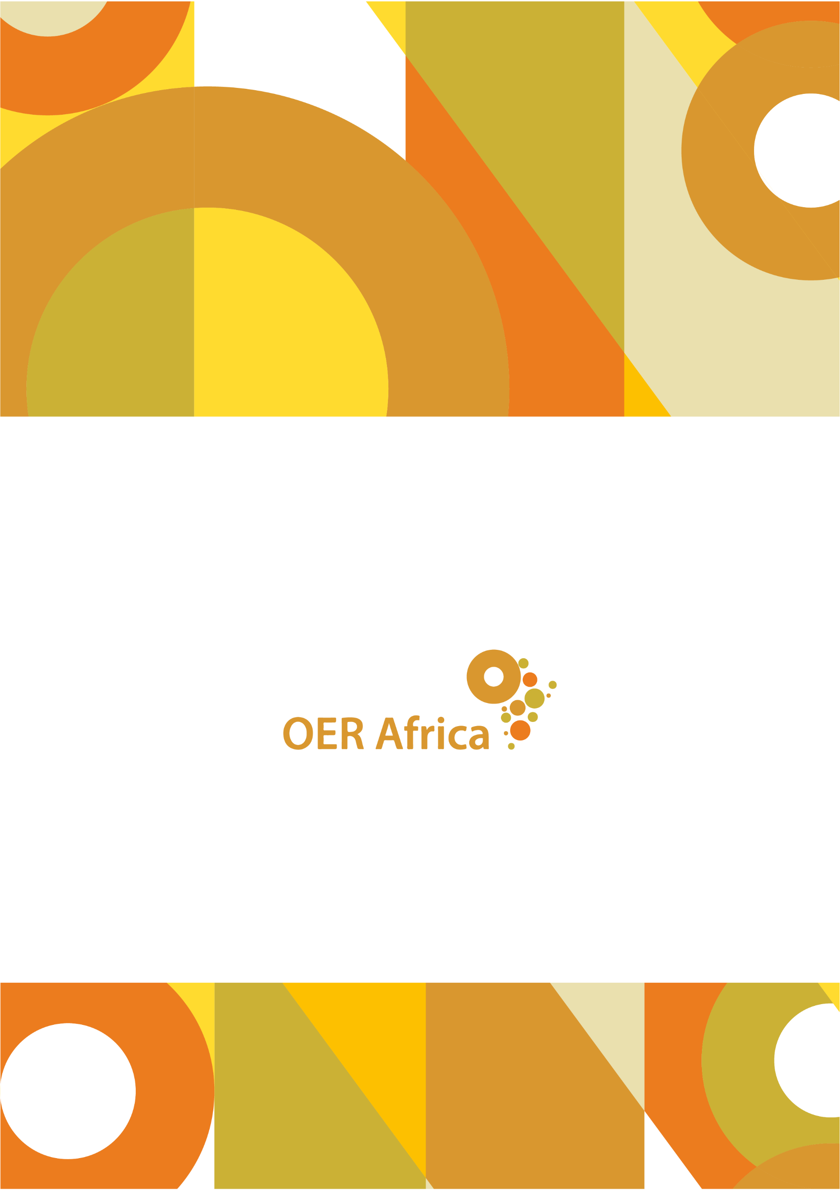
Unless otherwise stated, this work is licensed under a Creative Commons Attribution 4.0 licence

www.oerafrica.org

Open Educational Practice (OEP) encompasses teaching techniques and academic practices that draw on open technologies, pedagogical approaches and OER to facilitate collaborative and flexible learning.
OpenUCT. (2020). About Institutional Repository at UCT (OpenUCT). UCT. Retrieved from http://www.openaccess.lib.uct.ac.za/oa/about-open-uct
Centre for Innovation in Learning and Teaching (CILT), UCT. (2020). Open Education at UCT. CILT. Retrieved from http://www.cilt.uct.ac.za/open-education-uct
CILT. (2020). OpenUCT. Retrieved from http://www.cilt.uct.ac.za/cilt/openuct
CILT. (2020). OpenUCT. Retrieved from http://www.cilt.uct.ac.za/cilt/openuct
OpenUCT. (2020). About Institutional Repository at UCT (OpenUCT). UCT. Retrieved from http://www.openaccess.lib.uct.ac.za/oa/about-open-uct
CILT. (2020). OpenUCT. Retrieved from http://www.cilt.uct.ac.za/cilt/openuct
Interview with Prof. Laura Czerniewicz, Director of OUI, 10 July 2020
Interview with Prof. Laura Czerniewicz, 10 July 2020
Email exchange with Prof. Laura Czerniewicz, Director of OUI, July 2020
Hodgkinson-Williams, C. and Arinto, P.B. (eds). (2017). Adoption and impact of OER in the Global South. Cape Town & Ottawa: African Minds, International Development Research Centre & Research on Open Educational resources. Retrieved from http://www.africanminds.co.za/wp-content/uploads/2017/08/171204-AM-ROER4D-combined-Web.pdf
ROER4D. (2020). Project Activity Toolkit. ROER4D. Retrieved from http://roer4d.org/project-activity-toolkit
Arinto, P.B., Hodgkinson-Williams, C., King, T., Cartmill, T. and Willmers, M. Chapter 1 – Research on Open Educational Resources for Development in the Global South: Project landscape in Adoption and Impact of OER in the Global South. Retrieved from https://open.uct.ac.za/bitstream/handle/11427/26435/ROER4D-ch1-final.pdf?sequence=7
Hodgkinson-Williams, C. and Arinto, P.B. (eds). (2017). Adoption and impact of OER in the Global South. Cape Town & Ottawa: African Minds, International Development Research Centre & Research on Open Educational resources. Retrieved from http://www.africanminds.co.za/wp-content/uploads/2017/08/171204-AM-ROER4D-combined-Web.pdf
Hodgkinson-Williams, C. and Arinto, P.B. (eds). (2017). Adoption and impact of OER in the Global South. Cape Town & Ottawa: African Minds, International Development Research Centre & Research on Open Educational resources. Retrieved from http://www.africanminds.co.za/wp-content/uploads/2017/08/171204-AM-ROER4D-combined-Web.pdf
Hodgkinson-Williams, C. and Arinto, P.B. (eds). (2017). Adoption and impact of OER in the Global South. Cape Town & Ottawa: African Minds, International Development Research Centre & Research on Open Educational resources. Retrieved from http://www.africanminds.co.za/wp-content/uploads/2017/08/171204-AM-ROER4D-combined-Web.pdf
Hodgkinson-Williams, C. and Arinto, P.B. (eds). (2017). Adoption and impact of OER in the Global South. Cape Town & Ottawa: African Minds, International Development Research Centre & Research on Open Educational resources. Retrieved from http://www.africanminds.co.za/wp-content/uploads/2017/08/171204-AM-ROER4D-combined-Web.pdf
Goodier, S. (2018). ROER4D project activity toolkit: Evaluation. Cape Town: Research on Open Educational Resources for Development. Retrieved from https://zivahub.uct.ac.za/articles/online_resource/ROER4D_Project_Activity_Toolkit_-_Evaluation/10006760
Goodier, S. (2018). ROER4D project activity toolkit: Evaluation. Cape Town: Research on Open Educational Resources for Development. Retrieved from https://zivahub.uct.ac.za/articles/online_resource/ROER4D_Project_Activity_Toolkit_-_Evaluation/10006760
Goodier, S. (2018). ROER4D Project Activity Toolkit: Evaluation. Zenodo. Retrieved from https://zenodo.org/record/1221325#.XvsDHC2B0Wo
King, T.W. (2017). Postgraduate students as OER capacitators. Open Praxis, vol. 9 issue 2. Retrieved from https://openpraxis.org/index.php/OpenPraxis/article/view/566/315
King, T.W. (2017). Postgraduate students as OER capacitators. Open Praxis, vol. 9 issue 2. Retrieved from https://openpraxis.org/index.php/OpenPraxis/article/view/566/315
King, T.W. (2017). Postgraduate students as OER capacitators. Open Praxis, vol. 9 issue 2. Retrieved from https://openpraxis.org/index.php/OpenPraxis/article/view/566/315
King, T.W. (2017). Postgraduate students as OER capacitators. Open Praxis, vol. 9 issue 2. Retrieved from https://openpraxis.org/index.php/OpenPraxis/article/view/566/315
King, T.W. (2017). Postgraduate students as OER capacitators. Open Praxis, vol. 9 issue 2. Retrieved from https://openpraxis.org/index.php/OpenPraxis/article/view/566/315
Correspondence with Dr Glenda Cox, DOT4D Project Coordinator, 27 August 2021
Interview with Dr Glenda Cox, DOT4D Project Coordinator, 20 May 2020
King, T.W. (2017). Postgraduate students as OER capacitators. Open Praxis, vol. 9 issue 2. Retrieved from https://openpraxis.org/index.php/OpenPraxis/article/view/566/315
The project was initially 30 months, but received a no-cost extension.
DOT4D. (2020). About. Retrieved from http://www.dot4d.uct.ac.za/about-32
DOT4D. (2020). About. Retrieved from http://www.dot4d.uct.ac.za/about-32
Taken verbatim from DOT4D. (2020). Implementation. Retrieved from http://www.dot4d.uct.ac.za/dot4d-grants
DOT4D. (2020). Boosting OER Discoverability: The UCT Open Content Finder. Retrieved from http://www.dot4d.uct.ac.za/news/launch-uct-open-content-finder
Cox, G., Masuku, B. and Willmers, M. (2020). Open Textbooks and Social Justice: Open Educational Practices to Address Economic, Cultural and Political Injustice at the University of Cape Town. Journal of Interactive Media in Education, 2020(1), p.2.
Taken verbatim from Cox, G., Masuku, B. and Willmers, M. (2020). Open Textbooks and Social Justice: Open Educational Practices to Address Economic, Cultural and Political Injustice at the University of Cape Town. Journal of Interactive Media in Education, 2020(1), p.2.
Interview with the principal investigator of DOT4D, Dr Glenda Cox, 20 May 2020
Cox, G., Masuku, B. and Willmers, M. (2020). Open Textbooks and Social Justice: Open Educational Practices to Address Economic, Cultural and Political Injustice at the University of Cape Town. Journal of Interactive Media in Education. Retrieved from https://jime.open.ac.uk/articles/10.5334/jime.556/
Goodier, S. (2018). ROER4D project activity toolkit: Evaluation. Cape Town: Research on Open Educational Resources for Development. Retrieved from https://zivahub.uct.ac.za/articles/online_resource/ROER4D_Project_Activity_Toolkit_-_Evaluation/10006760
Goodier, S. (2018). ROER4D project activity toolkit: Evaluation. Cape Town: Research on Open Educational Resources for Development. Retrieved from https://zivahub.uct.ac.za/articles/online_resource/ROER4D_Project_Activity_Toolkit_-_Evaluation/10006760
Interview with Prof Laura Czerniewicz, Director of OUI, 10 July 2020
Interview with Dr Glenda Cox, DOT4D Project Coordinator, 20 May 2020
Interview with Prof Laura Czerniewicz, Director of OUI, 10 July 2020
Interview with Prof Laura Czerniewicz, Director of OUI, 10 July 2020

