Open Education Influencers
Case studies on African OER initiatives in higher education

Introduction
Figure 1 Image courtesy of OEI's homepage (CC BY)
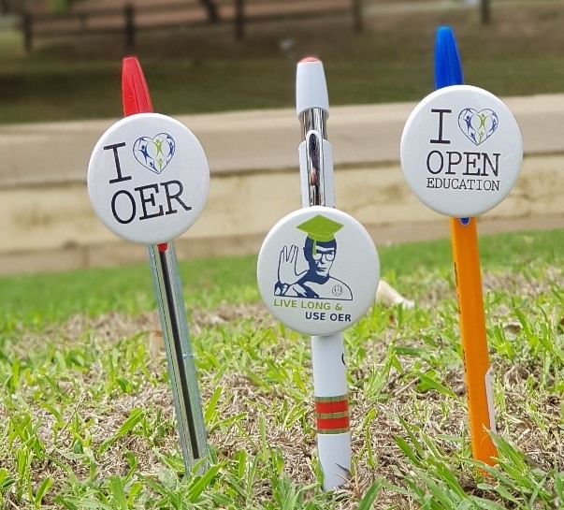
Open Education Influencers (OEIs), or #OpenEdInfluencers, is an initiative based at Nelson Mandela University (NMU) in Port Elizabeth, South Africa. The initiative has been operational in an informal capacity since 2015 but has been officially operational in its current form since 2018. Led by Gino Fransman from NMU, it seeks to influence decision-makers to adopt open educational resources (OER) through advocacy and facilitation, while aiming to affect decision-making and practice through activities to publicise and entrench the use of open education praxis.

A core part of the initiative are OEIs, who are ambassadors for the use of open textbooks at NMU. They target all levels in the university – undergraduate, post-graduate and teacher education – across all faculties, advocating for the use of open materials and increasing awareness about the use of OER.

In 2018, the initiative launched an effort to increase awareness, access, adoption, and creation of openly licensed materials at NMU. The university has actively supported this initiative. In 2018, it appointed and trained three NMU students to become OEIs and assist with OER advocacy. In 2019 and 2020, it shifted student support under the umbrella of the Learning and Teaching Collaborative for Success (LT Collab) at NMU. Initiative participants include the following:
- project lead,
- project mentor,
- hub coordinator,
- project collaborators,
- OpenEdInfluencers at NMU, Open University, United Kingdom (OUUK), and University of Massachusetts Amherst (UMass),
- Deputy Vice Chancellor: Learning and Teaching at NMU,
- Dean: Learning and Teaching (LT Collab),
- graphic design and LXD at NMUdirectors of the LT Collab linked to staff and student development and success, and
- web support.

The initiative has the following project partners who fulfil various roles, namely:
- Siyaphumelela Programme (an initiative of Saide) and the Kresge Foundation
  - Provided access to a three-year cycle of project funding.
- University of Massachusetts Amherst, OUUK, Global OER Graduate Network, and Open Education for a Better World (OE4BW)
  - Collaborated on and co-created the Becoming an OEI (BOEI) online empowerment course during lockdown 2020.
- University Capacity Development Grant
  - Provided access to funding for the first cohort of OEIs, as well as funding to travel to international conferences like Open Education Global (OE Global) and Open Education for a Better World.
- ProductionHauss (the OEIs’ media partner in Port Elizabeth)
- Supported the creation of a series of advocacy media resources, and supported the development of media creation skills for OEI team members.

Description of the initiative
The OEI project has created awareness and promoted OER use at NMU, either as a supplement or as the primary source of content in various modules. This includes the following activities:
- OEIs advocate for the use of open textbooks across purpose, faculties, and schools. Advocacy includes:
  - Empowering the advocates themselves to develop an in-depth understanding of open educational practices and the resources that would be useful to students and staff.
  - Enabling continuous professional development (CPD) by assisting educators with finding openly licensed materials to supplement teaching and learning. OEI shared supplemental resources with the lecturers. Although some were apprehensive to include these resources in their courses, a few lecturers have been responsive and have incorporated these resources in their teaching.
  - Developing the Becoming an #OpenEdInfluencer (BOEI) Course. The BOEI course, outlined below, is a practical online course that supports influencers of and for open education. In 2021, BOEI was added to the UNESCO OE4BW empowerment toolkit for new project authors. The aim of this was to ensure that project authors develop a firm grasp of open education principles through the course. This will continue into 2022.
  - Collaborating on a children’s book about open principles called ‘Together’ in 2021 with the Global OER Graduate Network picture book team. The book received OE Global’s 2021 Open Innovation Award and the 2021 UNESCO OER Implementation Award for Excellence.
  - Hosting the #OpenEdColloquium21, a webinar that sought to explore open educational practices.
- OEIs have also been involved in several national and international conferences. This includes presenting on the initiative at the UNESCO OE4BW Programme: A Course for Practitioners in Slovenia and the Open Education Consortium’s OE Global 2019 conference in Italy, as well as a similar virtual event during lockdown in 2020. The project lead was awarded the 2021 OE Global Emerging Leader Award. In addition, one of the OEIs was part of a keynote panel for the Open Education Conference in 2021. Moreover, the OEI project also enabled the inclusion of another NMU open project, featuring the law clinic director and a multilingual glossary of legal terms, to support various communities to engage legal support in South Africa.
- Conducting research on student experiences with textbook access and usage of OER. Through their research, the OEIs found that at least a third of students were not purchasing textbooks for their courses, primarily because they were too expensive, while another third were only purchasing certain textbooks. Several students were digitising copies of textbooks and distributing them to peers. The research demonstrated that an easily accessible electronic artefact would be a valuable resource to suggest to students. The research also showed that students queried the process of academics prescribing their own publications for classes that they taught. The initiative hopes that the research will provide insight into the value of open education inclusion into current recurriculation efforts, and ultimately result in including open education practices in a curriculum development policy that would provide all students with access to OER. The Open Access Policy, led by the NMU library, was adopted in November 2020.
- OEIs hold various workshops and information sessions regarding the value of OER in current academic environments. The OEIs have facilitated several workshops for students and staff about OER, open textbooks, and finding resources to infuse into their academic projects. Though there has been minimal feedback on the impact, OEIs have received and responded to requests for additional workshops both nationally and internationally. In 2022, the OEIs will present workshops on student advocacy and empowering student voices via the BOEI course to the Siyaphumelela University Network of 27 South African universities. They will also conduct workshops on how to create and support the creation of open textbooks for the same network.
- The initiative encourages researchers at NMU to contribute to the open education movement, providing access to valuable, relevant, Africanised content to enrich students’ learning experiences. Activities include promoting the Global OER Graduate Network and conducting community-based research on OER practices.
- A community development facing output was supported and funded via Siyaphumelela, titled Peacebuilding Within High-Risk Communities in SA, in association with PeaceJam, an NGO where Nobel Peace Prize winners engage communities. The course is complete and freely available on the NMU Open LMS.

The project lead believes that the OEI initiative aligns with the ‘humanising pedagogy’ approach to teaching and learning practice at NMU and responds to student calls, through the #FeesMustFall protests, for affordable, quality, decolonised education. As part of this, the initiative helped to introduce the Open Textbook Fellowship, which was piloted in 2021 and will be introduced in 2022. By supporting the development of high quality, free and locally contextualized content at NMU, the fellowship aims to:
- Position NMU and the OEI initiative as enablers of student success through the provision of cost-saving teaching and learning resources in higher education.
- Enhance student access to learning resources that are developed for their requirements.
- Be easily adaptable with legally sharable content that supports high quality engagements.

OEIs are responsible for co-curating content under the fellowship and activities will include adapting the BOEI course into a micro-learning nugget of approximately three notional hours.

The initiative focuses on several aspects of OER, including policy, practice, research, advocacy; licensing, sharing, use and creation. Other related topics include student development, work experience, social justice, equitable access and collaboration.

Through its project activities, the initiative seeks to build several types of skills for OER creators and users, such as students, staff and collaborators. These skills include:
- collaborative skills,
- research skills (surveys, research briefs, proposal writing, social media platform and creation, video & media production – scripting, producing, collaborating online, recording, group/peer reviewing),
- policy development skills,
- media production,
- remote facilitation and public speaking,
- use of online tools such as Zoom, Microsoft TEAMS, and the Google suite,
- open licencing,
- course development,
- reflection writing, and
- project management.

In an effort to develop OER-related skills, the initiative created the BOEI Course, which is a practical, fully online course that supports influencers of and for open education. The BOEI course design project, which falls under the umbrella of the OEI initiative, is included in the UNESCO OE4BW Programme. The course empowers users to gain insights, skills and experiences in open principles, such as OER, open licensing, open textbooks and advocacy. The course consists of six modules, namely, Open (a shortened, remixed edition of the Commonwealth of Learning’s ‘Understanding OER’ course); Ubuntu; Advocacy; Facilitation; Influencing; and The Sustainable Development Goals. Each module develops a specific set of skills in OER users and creators. These are outlined in Table 1 below.

Table 1 Skills developed in the BOEI course
Module | Skills to be developed during the module
Open | - Understanding copyright  - Finding OER  - Developing, remixing and/or sharing OER  - Advocating for Open  - Collaborating on OER projects
Ubuntu | - Engaging with alternative world views  - Collaboration  - Identifying opportunities to enable change
Advocacy | - Problem identification  - Problem analysis  - Problem solving  - Critical reading and information gathering  - Assertiveness
Facilitation | - Skills and attributes associated with a facilitator  - Facilitation techniques  - Active listening skills  - Conflict management skills  - Planning and time management skills
Influencing | - Decision making  - Enabling change  - Building connection  - Persuasive communication skills  - Powerful communication skills
Sustainable development goals | - Individual activism  - Creating pressure for action  - Identifying different ways of doing  - Advocating for change

The aim of the BOEI course is to support individuals and groups to act as OEIs in their own right. It therefore seeks to assist them in influencing key decision-makers through advocacy and facilitation.

The course is being created on the Moodle Learning Management System (LMS) and carries a CC-BY-SA licence. To find an online space to host BOEI and allow registrations for the course, the project team decided to use the UMass Open website. Subsequently, the OEI team has facilitated a process in which NMU installs the instance of Moodle to encourage open campuses. Thus, school leavers who are prospective students at NMU could gain access to BOEI. In December 2020, the Engage platform was established as the Open Moodle instance for NMU to provide services related to open education, research, collaboration, and community projects. The project lead observed that an increasing number of staff and students are taking the course by request and that they were collecting statistics on this at the time of writing.

In 2021, ‘How 2 buddies’ at NMU were required to complete the BOEI course and were paid to do so as one of their key activities. Some did not complete it, citing challenges in engaging online as one of the key reasons for this. However, positive feedback included students explaining that they did not know about open education previously, while others asked critical questions such as why open education principles were not more widespread in the university. In 2022, the decision to focus on more direct engagement with students meant that BOEI was not implemented for the new cohort of How 2 buddies.

Strengths and achievements
One of the OEI initiative’s greatest strengths has been its commitment to extending its network. As noted, it has participated in several forums, including the UNESCO OE4BW in 2019. Following this, the initiative shared its progress at OE4BW 2020, highlighting collaborations and work both for OE4BW and in adapting several OER. Collaborators have included UMass Amherst, the University of Cape Town, the Open University UK, OEGlobal, North West University, and Global OER Graduate Network, with input and guidance from several experts in open education both in South Africa and globally.

As the OEI initiative is fairly new, its full impact is yet to be measured. This is one of the key activities for 2022 where the project is setting up a user survey for all BOEI course participants, and conducting a needs analysis on what participants would like the course to include in future iterations. However, there are markers of impact in the initiative’s activities. For example, it has been responsible for embedding OER in four permanent staff members’ work.

In NMU’s organizational replanning processes, the project lead has advocated for one of the key performance indicators (KPIs) for staff to include reference to using OER. Moreover, all new contract staff in the LT Collab’s Academic Literacy Writing Programme are required to complete the BOEI course, providing a focus on OER-related CPD that is intended to assist staff with teaching and learning.

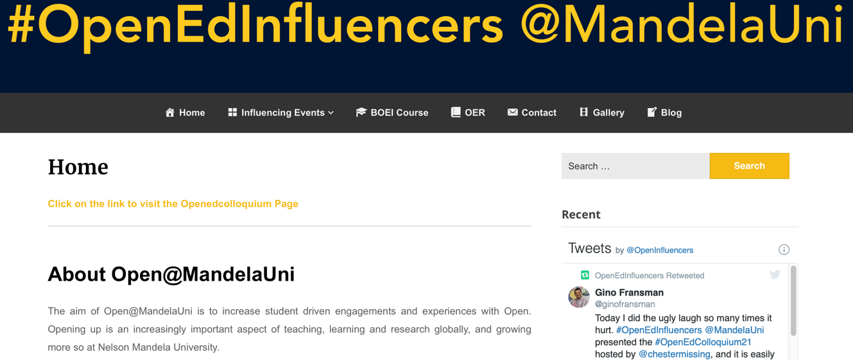
Figure 2 The OEI initiative's website (CC BY)

Challenges
The OEI initiative has experienced several challenges, which relate to a need to embed open education in NMU’s institutional practices more decisively, while creating an environment that is conducive to sharing intellectual property and that supports open educational practices through resource provision. These challenges are outlined below.

Funding streams are limited. The OEI initiative has needed to be innovative in developing funding streams for its activities, which has further motivated its advocacy efforts. This includes being innovative about showcasing ‘open’ within existing roles at the university and creating activities to expose and induct staff and students into the domain. This began with efforts to increase awareness, then moved on to channelling funds to strategic objectives to increase the scope of efforts in openness at NMU.

Staff capacity is limited. The ratio of the OEI team to institution staff made large-scale activity a challenge. However, funding for writing respondents (the student support staff assisting with academic writing, based in the LT Collab) included having them trained to share OER in their student support activities. Siyaphumelela funding support allowed the initiative to appoint a cohort of OEIs to facilitate additional advocacy efforts.

Transience of OEIs. There is a high turnover of student staff as they leave the university to pursue careers outside of academia. However, this provides an opportunity as OEIs would presumably disseminate their knowledge about OER in their respective careers. OER also offered opportunities for workplace skills development, tying this in with the growing open movement at the institution. As one element of this, the team developed the BOEI course to enable better empowerment opportunities for OEIs. The course can also be used as a tool to induct newcomers and practitioners more efficiently.

A national network of open practitioners does not exist in South Africa as yet, but is likely active in various silos such as Creative Commons South Africa and initiatives at other institutions. Participants at the OpenEdColloquium tabled a proposal to initiate a South African network for open practitioners. The idea is being discussed with Creative Commons South Africa.

OER are sometimes viewed as direct competition to published textbooks. OEIs experienced a fair amount of resistance from publishers and vendors on campus in their efforts to assist academics to find ‘textbook equivalents’ that were openly licensed. When the initiative approached academics with an offer to find OER to either supplement or replace textbooks in their courses, they found that academics were often reluctant or unresponsive. OEIs then reframed these efforts as learning and teaching support resources and have subsequently engaged with four academics to find appropriate OER.

Sustainability
The project lead explains that advocacy efforts currently occur on the same level at the institution, but that it would assist the initiative if it received top-down support in which the academic leadership (Heads of Department; Deans of School and the Deanery) encouraged the academic sector to explore OER. He adds that leaders and key stakeholders within higher education institutions need to advocate for OER use instead of advocates mainly being people who occupy similar spaces.

The project lead further notes that OER need to be embedded into the architecture of institutions through policy mechanisms and effective implementation. In this regard, there should be a strategic directive or guidance for OER use and creation. He adds:

It says in our mission we are moving towards a digital campus where materials are accessible – it doesn’t mean that everything needs to be open, but make some materials open.

The initiative would also benefit from a digital bootcamp for OER users. As the project lead explains, the challenge is that people have different knowledge bases of digital skills. For OER users to harness the opportunities that OER offer, they need to have an understanding of ‘open’ and its potential, as well as the associated digital skills.

The OEIs are situated in the newly configured student support arm of the institution, within the academic literacy writing unit in the LT Collab. Being linked to an established segment of the university means that the initiative can draw on resources and networks from that segment, which contributes to its sustainability.

In addition, the project lead is empowering others to take on similar OER initiatives so that the OEIs’ fundamental mission is dispersed. To do this, the initiative is keeping detailed records of their intentions and aims, the purpose being to share this information with others for replication at other institutions. The initiative also motivates people to attend events hosted by organizations and individuals who have a good understanding of Open principles.

In considering the main areas where capacity building is still required to enable more effective implementation of OER practices, the project lead provides several suggestions, outlined below:
- Support OER orientation for new staff: Introduce new staff to OER during the orientation process and provide them opportunities to contribute fresh ideas about how to integrate open educational practices into the university. In parallel, ensure that the institution supports those ideas through skills development, such as providing training on understanding OER licenses and how to apply those licenses.
- Integrate OER into the institutional structure: Create a motivator or directive for a certain amount of openly licenced content. This includes incorporating OER into staff KPIs and building a reward system that contributes to institutional open educational practices.
- Demystify the OER content searching process: Use workshops and pre-recorded webinars for new and current staff to inform them on how to find openly licensed content. Connect these activities to a larger ideal of open praxis and provide a strong rationale for doing so.
- Turn the application of the licenses into a practical process: Steer clear from a purely theoretical narrative on open licencing and focus instead on integrating theory with practice. For example, demonstrate how to repurpose and apply a new license to OER or show users how to share OER effectively.

Lessons learnt
A key lesson of the OEI initiative has been recognising that, although OER are free to use and adapt, there are still costs associated with developing and advocating for OER and perpetuating open practices. As the OEI project lead notes:

Open is speaking about free access to resources, but it does not mean that speaking about it is free. Open still costs money. Money is one of the contributors to opening up. There is a financial implication.

There is also an imperative for change in approaches to knowledge, where it is becoming increasingly important for academia to move away from the idea of the academic as the gatekeeper of knowledge. In this way, promoting OER through an initiative such as this one is a commitment to transformation. In aid of this, it is important to support OER advocacy efforts and to keep in mind that advocacy efforts can have a negative impact as well as a positive impact.

The project lead adds that it tends to be more effective to use OER in support of something, when it is relevant to peoples’ KPIs. He suggests linking open educational practices to KPIs so that they hold more weight: ‘you need leverage, which in this case is stature and standing in the wider community.’

Conclusion
The OEI initiative takes a bottom-up approach to OER advocacy. It aims to empower those who are passionate about OER to influence key decision-makers and stakeholders in the academic space. The initiative has sought to highlight OER activities that peers in the country are engaged in. Although the reaction has generally been positive, it is not yet possible to quantify the initiative’s impact. The initiative does however plan to conduct an impact assessment as it matures. The project lead notes that there are different levels of impact that the initiative wants to explore, i.e. there is a significant difference between exploring OER, engaging with them and adopting them. He adds:

People are speaking about the initiative; attendance shows that people are listening, and people want to hear more. There are quite a lot of repeat attendees [at the workshops]. There needs to be a more directed focus on opening up in higher education. It needs to be explicitly stated by leadership [including Higher Education South Africa and the Department of Higher Education and Training). Localized activities need to be supported nationally.

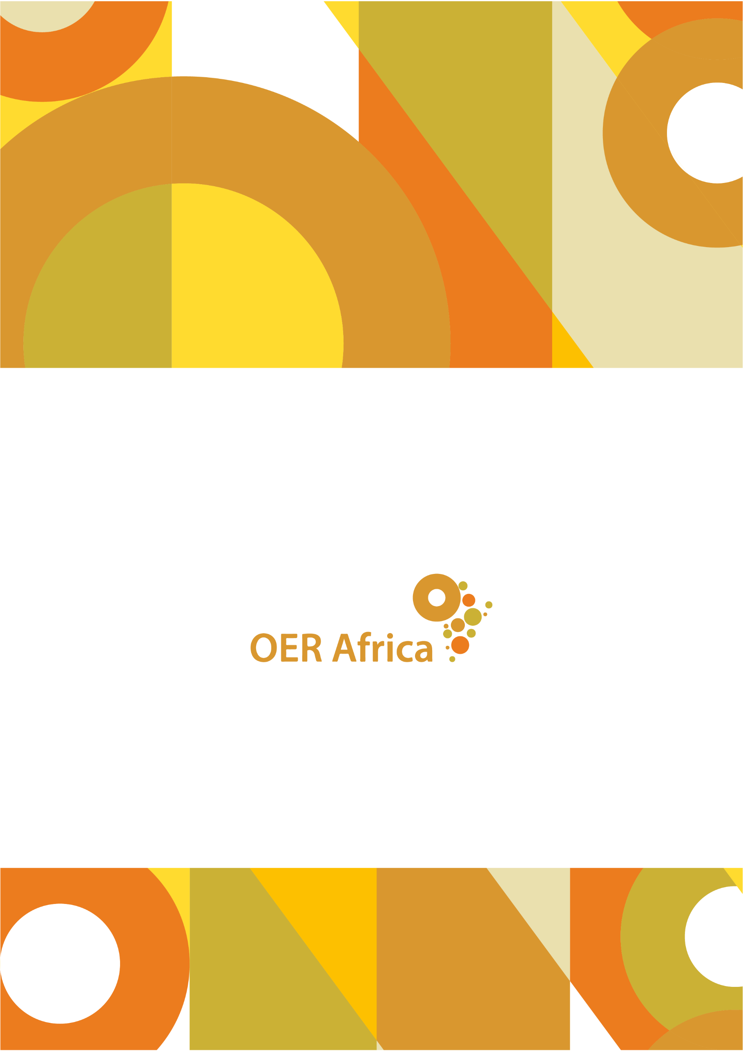
Unless otherwise stated, this work is licensed under a Creative Commons Attribution 4.0 licence

www.oerafrica.org

Survey response from Gino Fransman (Project Lead), 17 July 2020
Open Education Influencers. (2020). BOEI course. Retrieved from http://openedinfluencers.mandela.ac.za/courses/
See https://www.youtube.com/watch?v=PkI9Nhb3N7s
See https://www.youtube.com/watch?v=NHh0F22GoGA&t=948s
Nelson Mandela University. (2019). NMU Motivation to be a partner Institution in the Future Siyaphumelela Network
Nelson Mandela University. (2019). NMU Motivation to be a partner Institution in the Future Siyaphumelela Network
Interview with Gino Fransman (Project Lead), 5 April 2022
Nelson Mandela University. (2020). The BOEI Course. Retrieved from http://openedinfluencers.mandela.ac.za/courses/
Survey response from Gino Fransman (Project Lead), 17 July 2020
A platform for research, open education, collaboration, and community projects. The authentication/login method could be via Google. As such, this instance of Moodle can be used to support prospective applicants (unregistered students). Courses could be created here to start the orientation to university (online orientation i.e. before registration has happened) and access to digital literacy can start as soon as a student applies to university.
Undergraduate and postgraduate student leaders at NMU who support new entrants into the university from first year onwards
Fransman, G. (2019). Becoming an Open Education Influencer BOEI NMU at OE4BW 2019. Accessed from: https://www.slideshare.net/ginofransman/becoming-an-open-education-influencer-boei-nmu-at-oeoe4bw-2019-gino-fransman
Survey response from Gino Fransman (Project Lead), 17 July 2020
Interview with Gino Fransman (Project Lead), 20 October 2020
Interview with Gino Fransman (Project Lead), 20 October 2020
Interview with Gino Fransman (Project Lead), 20 October 2020
Interview with Gino Fransman (Project Lead), 20 October 2020
Interview with Gino Fransman (Project Lead), 20 October 2020

