Open Educational Resource Term Bank
Case studies on African OER initiatives in higher education

Introduction
Open Educational Resource Term Bank (OERTB) was an initiative by the University of Pretoria (UP), the University of Cape Town (UCT), and the South African Department of Higher Education (DHET). It aimed to establish an online, multilingual term bank, specifically aimed at South African university students. The initiative ran between 2014 and 2017, servicing all eleven official South African languages in various subject areas. Today, students are still able to use OERTB to access key subject-specific terms and definitions in one of those languages.

The rationale behind the project was that research has shown that students learn better in their mother tongue. As a result, first year students often need academic support because they are unable to attend school in their mother tongue. For students to complete their studies successfully within three or four years, learning about concepts in their mother tongue creates a strong foundation for them, helping them grasp fundamental concepts more easily. As an article on the UP website notes:

The underlying assumption is that giving these students access to an internet-based terminology data bank, which contains not only term equivalents for key concepts in the African languages, but also additional conceptual information and guidance on usage of terms, should aid in the conceptualisation of subject content.

Funded by the South African Government’s Department of Higher Education and Training, project participants included three senior academics from the two universities as joint project leaders, a term bank manager, editors, as well as external translators and language practitioners. In addition, subject matter experts (SMEs) were an important part of the process. Language practitioners and SMEs worked together to create definitions and add or remove terms. They provided translation and contextualisation services in subject areas. Some SMEs were lecturers for first years (both retired and still working). In addition, the website was developed by TshwaneDJe and implemented using the tlTerm terminology software and TLex online platform developed by David Joffe and Malcolm MacLeod.

This case study is based on desktop research, an online survey response from one of the project managers, and an online interview with the term bank manager for OERTB.

Description of the initiative
The project was divided into three phases, which ran between 2014 and 2016. In the first phase (2014), the project team conceptualised the design and management of the OERTB, then held a multilingual roundtable and workshop for representatives of different universities to gain support for the selected open-source software and the design of the OERTB. The team also used this opportunity to present examples of terminology resources at universities that had already conducted such work. In the second phase (2015), the team developed OERTB, uploading existing terminologies. The team also designed the database, the management system, and the user interface. In the third phase (2016), the team identified possible gaps in the OERTB and the team continued with their work from the second phase.

In the second and third phases, a core activity of the initiative was to extract key terms in specific disciplines and translate them. The coordinating team started the process of semi-automatic term extraction by using sources from a subject field that included academic writing, examination papers, and encyclopaedic information. They used these resources to create a corpus. The team then uploaded these resources to a software platform called Sketch Engine, which extracted the most frequently used terms out of the corpus. SMEs reviewed these lists and, where necessary, added terms that were not extracted or removed terms that were not relevant. Once they had finalised the list, the team sent it for translation.

Some faculties from the two universities provided lists of key terms while others already had translated lists but needed those terms to be translated into other languages or to be checked for validity. After receiving terminology lists from university departments, the coordinators found suitable SMEs to prepare definitions for the terms where necessary. They had the terms and definitions translated into at least two African languages, following which they engaged in quality assurance activities. Quality assurance activities included reviewing all terms and definitions for translation and ensuring that punctuation marks were used correctly. For example, nouns, adjectives, verbs, and definitions needed to start with a lowercase character while proper nouns needed to start with an uppercase character. Quality assurance also included having mother tongue speakers check translated work. Once the quality assurance process was completed, the terms and definitions were uploaded into OERTB.

Other activities included:
- Maintaining audit lists of terms for verification; they had to be updated regularly to keep up to date with the terminology of the subject fields.
- Identifying terminological gaps in subject fields.
- Building subject-specific corpora in identified subject fields in English.
- Defining concepts and adding other terminological data by subject field experts.
- Translating terminological data into the other ten official languages of South Africa.
- Entering the data into the database.
- Incorporating feedback.
- Researching strategies on how to use terminology products that are available online in learning environments and to measure the effectiveness thereof.

The initiative focused broadly on having commonly used subject-specific terms accessible to students. It helped to develop the language skills of OERTB users (students), particularly as the OERTB is a support tool for students who learn and are taught through a medium that is not their first language.

Strengths and achievements
OERTB received positive feedback from students who used the term lists. Anecdotal evidence suggests that students found the term bank to be an effective learning tool. The project manager at UCT also used the term bank in his workshops.

In addition, one of the main strengths of the initiative was the enthusiasm from many of the academics who wrote the definitions and terms. The initiative’s use of semi-automatic extraction of terms and definitions was highly effective. The team sent terms to SMEs, who wrote definitions when it was not possible to find suitable definitions in a given corpus. The SMEs showed great enthusiasm and support for the project, with the term bank manager noting that they ‘grasped the necessity to help students in their mother tongue’.

The project team also gave potential collaborators different options under which they could license their work and made provision to give them credit next to each entry they provided for the initiative.

Challenges
Despite the overall enthusiasm that SMEs displayed, a challenge that the project team experienced was getting buy-in from institutions to contribute terminological data to the project. Other universities were reluctant to send their lists for use in the initiative. To overcome this challenge, OERTB held a workshop with potential collaborators, where they explained the process and the big picture.

We had a bit of success where one or two institutions shared data with us. We also followed up regularly – emailing (and) meeting them at conferences.

Some translators also presented a challenge, as they were part-time and had competing priorities, meaning that the work for OERTB was not always prioritised. In addition, it proved difficult to find suitably qualified SMEs with capacity to write definitions and do specialised translation work. Although these were paid positions, time was an issue for SMEs. A connected challenge was that not all translators are SMEs in specific fields and there is a shortage of SMEs in all African languages. For example, it is difficult to find Sepedi translators in medicine.

Another challenge was ensuring the standardisation of terms. The term bank manager highlighted reluctance of external participants who were working on separate terminology projects to share their terminology because of how they view intellectual property. This became evident at the workshops that the initiative held.

Getting individuals to share their work is a big problem, resources are wasted on everyone’s own small project, other small subject fields are lagging behind. Maybe because of the contracts they have with their institutions? It needs more research, and one needs to find out why individuals are reluctant to share their data.

As noted, the team addressed this issue by offering different licences and inserting a field in the term bank to give recognition to the author.

Other challenges included the quality and comprehensiveness of glossaries received as input from lecturers and other institutions. Due to capacity constraints, quality assurance of incoming translations was sometimes difficult. To overcome these issues, the team developed processes to carry out limited in-house editing and quality assurance.

Sustainability
OERTB prioritised sustainability of the platform while the initiative was still running. When the project ended, the team put funding aside to host the project for three years.

The South African Centre for Digital Language Resources (SADiLaR) approached the OERTB team to express interest in providing funding and hosting for OERTB. Funded by the South African Department of Science and Innovation, SADiLaR aims to create a repository of resources for South African languages. If the OERTB team and SADiLaR reach an agreement, the link to the OERTB will be provided on the SADiLaR website. They will also have access to OERTB’s usage data. Negotiations are still underway for SADiLaR to host OERTB. This will ensure continued access for potential users and enable updating of content. Raw data from the initiative will also be donated to SADiLaR. The data will then be made available via an online platform for further use and research.

The term bank manager for the project indicates that the greatest impact that OERTB has had is developing African languages and making people aware that they need to be developed and why this is necessary. OERTB has also made an impact on students. The term bank manager stresses, however, that it would have been useful if the project could have continued for a few more years to provide more concrete research on impact.

In terms of capacity building requirements, the term bank manager notes that additional time, funding, and collaboration between institutions would have assisted implementation. In addition to this, there should be greater access and availability of open source information:

One should not need to pay for the terminology, though I know private institutions need to fund themselves. Terminology should be free to everyone, especially the African languages as we don’t have subject specialists for every language.

The OERTB team prioritised using subject field specialists. However standardising terms is a long process that often takes years, and the OERTB team did not have time or funding to undertake this task. Instead, they used reliable resources to do the term extraction and used translators who worked for the Department of Arts and Culture and University of South Africa (UNISA). Because UNISA also had translation projects, the OERTB team used the translators who worked on those projects.

Lessons learnt
There is a great deal of terminology research and development that needs to be undertaken for African languages and more funding is required for initiatives that focus on this. OERTB indicates that greater exposure for its institution would be useful. For example, the team had wanted to put the link for OERTB on Blackboard – a learner management system – but there was not enough time to complete the phase for exposure and marketing of the platform.

Exposure is a critical part that needs attention – more workshops, campaigns, making people more aware of the term bank… More awareness campaigns should have been organized in the first year.

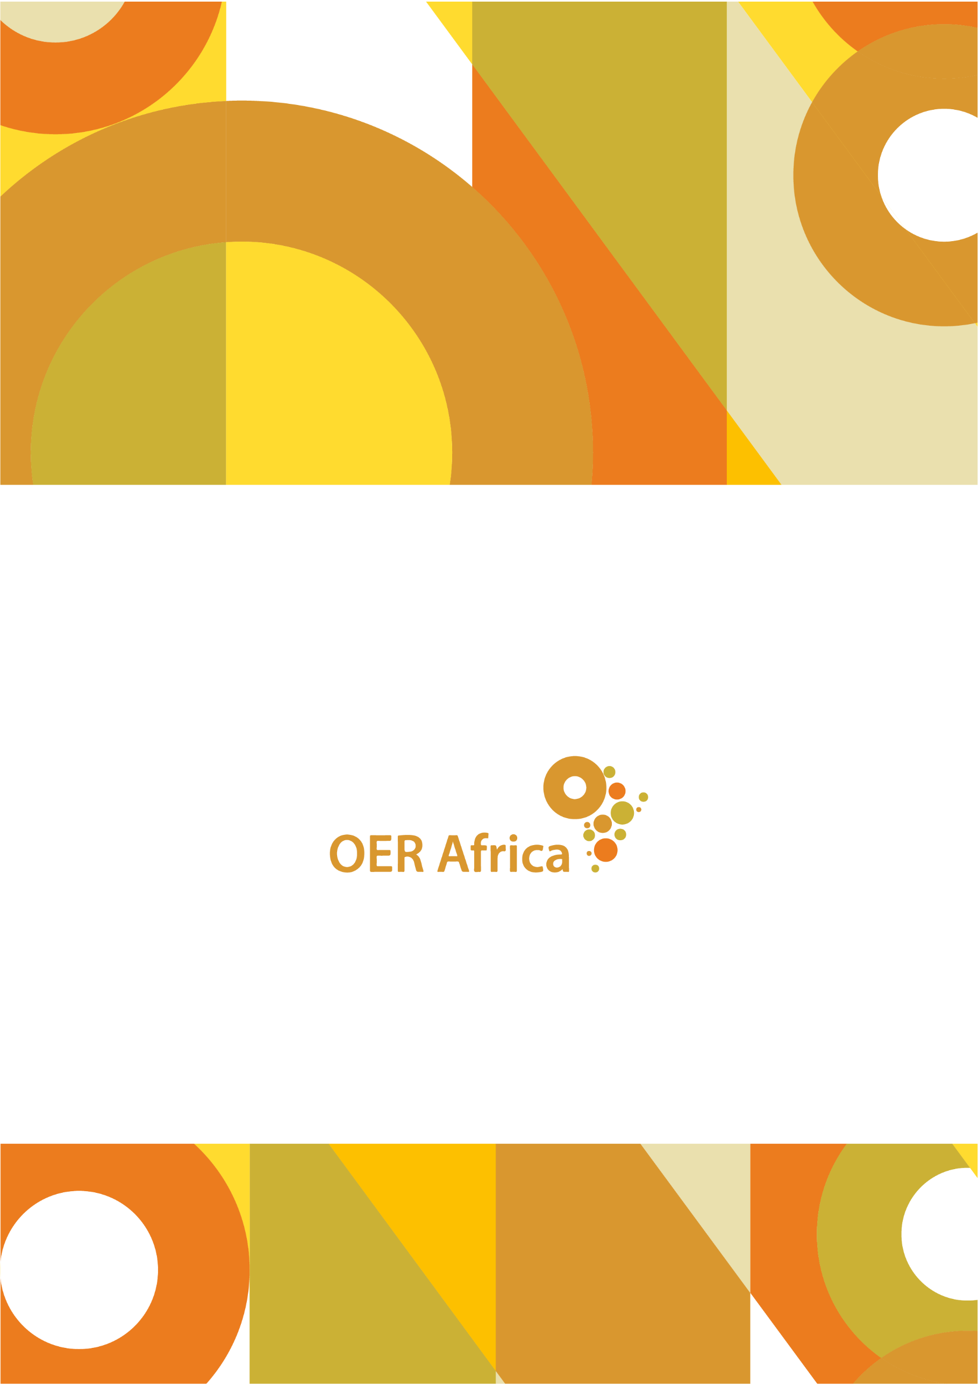
Unless otherwise stated, this work is licensed under a Creative Commons Attribution 4.0 licence

www.oerafrica.org

Subject areas are: Academic vocabulary; Accounting; Anthropology; Augmentative and Alternative Communication; Building Science; Chemistry; Communication Pathology; Criminology; Economics; Family Medicine; Literature; Mathematics; Philosophy; Political Science; Psychology; and Sociology.
Open Education Resource Term Bank. (2020). About. Retrieved from http://oertb.tlterm.com/about/
Open Education Resource Term Bank. (2020). About. Retrieved from http://oertb.tlterm.com/about/
Tshwaane, B. (nd). University of Pretoria. Partnerships and Collaborations: African Languages. Retrieved from https://www.up.ac.za/african-languages/article/17948/partnerships-and-collaborations
Open Education Resource Term Bank. (2018). Narrative Report.
Taljard, E. (2018). Open Educational Resource Term Bank. University of Pretoria. Retrieved from https://www.up.ac.za/african-languages/news/post_2728581-open-educational-resource-term-bank-pg2
Conradie, R. (2014). University of Pretoria. Huge teaching development grant for UP. Retrieved from https://www.up.ac.za/news/post_1949179-huge-teaching-development-grant-for-up
Open Education Resource Term Bank. (2018). Narrative Report.
Open Education Resource Term Bank. (2020). About. Retrieved from http://oertb.tlterm.com/about/
Interview with the term bank manager, 22 April 2020.
Interview with the term bank manager, 22 April 2020.
Interview with the term bank manager, 22 April 2020.
Interview with the term bank manager, 22 April 2020.
Open Education Resource Term Bank. (2018). Narrative Report.
Open Education Resource Term Bank. (2018). Narrative Report.
Interview with the term bank manager, 22 April 2020.
Interview with the term bank manager, 22 April 2020.

