**Advanced Diploma**

**Technical and Vocational Teaching**

**Reflective Practice**

Department of Higher Education and Training



**Department of Higher Education and Training**

Advanced Diploma: Technical and Vocational Teaching

Module: Reflective Practice

Author: Bobbie Louton

© Department of Higher Education and Training 2020

Department of Higher Education and Training

123 Francis Baard Street

Pretoria

0001

Website: [www.dhet.gov.za](http://www.dhet.gov.za)

This Module of the Advanced Diploma: Technical and Vocational Teaching (Adv. Dip TVT) was produced with the financial support of the European Union. Its contents are the sole responsibility of the Department of Higher Education and Training, and do not necessarily reflect the views of the European Union.



Creative Commons LicenseThis work is licensed under a Creative Commons Attribution 4.0 International License.

# Contents

Contents i

Acknowledgements ii

Acronyms and Abbreviations iii

Module overview 1

Purpose……… 1

Outcomes….. 1

Structure……. 1

Unit 1: What is reflection and how is it powerful? 5

Introduction… 5

Unit 1 outcomes 5

Understanding and recognising reflection in everyday life 7

Reflection as a key role of the TVET lecturer 11

Tools of the trade: Recording reflections 21

Unit 2: Models and tools that harness the power of reflection 31

Introduction… 31

Unit 2 outcomes 31

Key concepts for effective reflection: Objectivity, critical thinking and social learning 31

Cyclical models that facilitate reflection 34

Tools that aid deeper reflection 47

Transformation: Going for more than improvement 56

Unit 3: Using reflection and enquiry to plan and design teaching and learning 65

Introduction… 65

Unit 3 outcomes 65

Environmental scan and situational analysis as tools in a reflective cycle 66

Situational analysis 75

The role of reflection and enquiry in student learning 82

Enquiry-based learning (EBL) 86

Unit 4: Clarifying your purpose as a TVET lecturer and assembling the reflective tools you will need 99

Introduction… 99

Unit 4 outcomes 99

Clarify your goals and values 99

Assess your current reality and plan your way forward 104

Articulate your teaching philosophy 107

Put together a toolkit for reflective practice 112

Summative Assessment: Building up a toolkit of reflective tools 113

Conclusion 119

References 121

Appendices 125

Appendix 1: Reading for Activity 2 125

Appendix 2: Resource for Activity 8 129

Appendix 3: Models for Lecturer Assessment forms for Activity 22 131

# Acknowledgements

The Open Learning Directorate of the Department of Higher Education and Training would like to acknowledge:

The European Union for funding the Capacity Building for TVET College Lecturers through Open Learning Programme (Sub-Programme 2 of the Teaching and Learning Development Sector Support Programme). The production of open learning courses for the Advanced Diploma in Technical and Vocational Teaching (Adv Dip TVT) is a project of that programme.

The following universities, for making lecturing staff available to contribute to the project as subject matter experts, writers or critical reviewers:

* Cape Peninsula University of Technology
* Central University of Technology
* Durban University of Technology
* Nelson Mandela University
* Tshwane University of Technology
* University of Fort Hare
* University of the Free State
* University of Johannesburg
* University of Pretoria
* University of KwaZulu Natal
* Vaal University of Technology
* University of the Witwatersrand

The Technical and Vocational Education and Training (TVET) Branch of the Department of Higher Education and Training for providing information whenever it was requested.

The following TVET Colleges for making lecturing staff available to contribute to the project as subject matter experts, writers or critical reviewers:

* False Bay TVET College
* Majuba TVET College
* South-West Gauteng TVET College
* West Coast TVET College, and
* Motheo TVET College for developmental testing of materials.

The University of the Free State South Campus for overall project management, and the Ideas Lab on the South Campus for producing multi-media materials, resources and the e-learning (SCORM) versions of the courses, as well as uploading the materials on the National Open Learning System (NOLS).

The South African Institute for Distance Education (Saide) for their expertise in co-ordinating production and in ensuring that the developed material is made available for use as Open Education Resources (OER), thereby contributing to the implementation of open learning in post-school education and training (PSET).

# Acronyms and Abbreviations

|  |  |
| --- | --- |
| AdvDipTVT | Advanced Diploma: Technical and Vocational Teaching |
| DHET | Department of Higher Education and Training |
| CoP | Community of Practice |
| TVET | Technical and Vocational Education and Training |
| PESTEL | Political, Economic, Social, Technological, Environmental, Legal |
| SETA | Sector Education and Training Authority |
| SWOT | Strengths, Weaknesses, Opportunities, Threats |
| SOAR | Strengths, Opportunities, Aspirations and Results |
| EBL | Enquiry-based learning |
| TELSTAR | Tune in – Explore – Look – Sort –Test – Act – Reflect |
| TOWS | Threats, Opportunities, Weaknesses, Strengths |

Programme introduction

The Advanced Diploma in Technical and Vocational Teaching (Adv Dip TVT) programme seeks to provide a structured professional learning pathway for current and aspirant technical and vocational lecturers/teachers. The Diploma will equip them with the knowledge and competences to implement and manage teaching and learning in their TVET colleges effectively and in alignment with national goals.

This module is one of a set of modules that contribute to the Advanced Diploma programme. The overall purpose of the Advanced Diploma is to engage lecturers working in the TVET sector in conversations about what it means to be a quality teacher in a TVET college. Each Module in the programme explores this from a different angle, but for every module the foundational concept is about the type of teacher you want to be. We all know that the relationship between teaching and learning is interrelated. So in order to understand the type of teacher you want to be you will need to engage with what learning means in a TVET context.

We often think about vocational and technical or craft knowledge as different from theoretical knowledge. However, there is increasing recognition of the power of vocational and theoretical knowledge coming together to develop the skilled craftsperson whether it is in plumbing, baking, even mathematics and physics. This integration of theory and vocational knowledge is equally important in teaching as well. Teachers are constantly needing to make informed decisions and judgements as they make a selection of what to teach and how best to teach the specific content, concept or skill. This leads to a question about how different forms of knowledge and skill are brought together and balanced in the curriculum and in teaching and learning.

Approach to learning

To answer the question above in this diploma programme, a framework has been developed which is referred to as *know how*, *know it* and *know that*, or the HIT framework. This framework is introduced, referred to and deepened in different ways all the way through the programme.

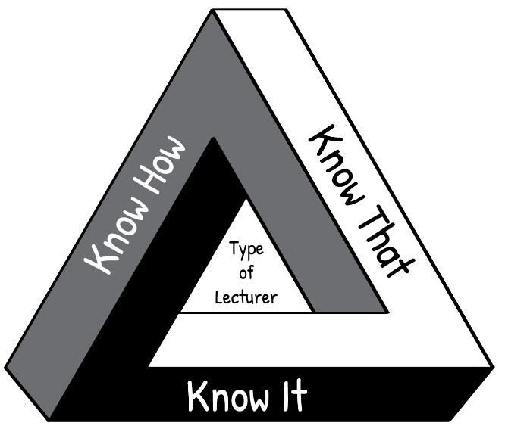

**“Know How”** is *procedural knowledge*, “in our bodies” or *embodied knowledge*.

For example, following a bread recipe.

“**Know It**” is *recognition*, the knowledge of what counts as good; wisdom; technical and theoretical judgments.

For example, is this sourdough good quality bread?

**“Know That”** is *propositional knowledge* or

*theoretical knowledge*, the knowledge of how and why, *cognitive knowledge*.

For example, the science of bread baking.

**Figure 1: The HIT framework**

Think about your own craft of teaching. The kind of teacher you want to be, is one who knows how (the techniques of teaching), knows that (the science and theory behind teaching AND learning) and knows it (knowing and reflecting on what makes a quality teacher). Such a teacher enables students to actively engage with their learning and to develop their full potential.

If you are interested, click on the link provided to watch a short [video](https://youtu.be/9GD-DgNLaxw) in which Wayne Hugo discusses the “HIT model” of TVET knowledge and learning.

Relating theory to practice

In this module new concepts are often introduced by developing them from a practical situation with which you are probably familiar. This process, which moves from your experience towards a more abstract level of theory is known as inductive learning. It makes learning easier and is very different from deductive learning, which starts by presenting abstract theories and principles, then requires you to “deduce” practical conclusions and concrete examples. You are encouraged to relate the ideas you learn from the Adv Dip programme to your own context and to try to think theoretically about your practice. In other words, to think about the rationale for your practice.

Reflective practice and the use of a learning journal

One of the Adv Dip TVT modules is called Reflective Practice, and covers the concept of reflection in the life of a TVET lecturer. Of particular importance is unit 2, which describes various models which facilitate reflection. The simplest reflective model that is discussed in this unit, is that of Terry Borton (1970). It consists of three steps as follows:

**Figure 2: Reflective model**Redrawn: Borton, 1970

The three questions to prompt reflection leading to action:

1. What?

**What** happened? In this step you remember or describe the situation or event you have experienced.

1. So what?

**So,** if that happened**, what** does this show you or teach me?In this step you explore what new insights or knowledge the situation gives you.

1. Now what?

**Now** that I have learnt something new by reflecting on the situation, **what** should I do about it? In this step you think about what to do with the new awareness you have gained – i.e. how to make use of it to act more effectively in future situations.

Throughout the Adv Dip TVT programme, you are encouraged to use a model to reflect on your practices at work in the college so that you can improve how teaching and learning takes place. We have embedded reflective practice throughout the programme, and at the end of most units in the modules you will find a reflective activity to complete. The reflective activity will enable you to make the most of what you have learnt throughout the unit, as well as assisting you to apply your learning in your workplace. Throughout the Advanced Diploma modules, we encourage you to use a learning journal. Keep a file (paper- based or electronic). You will use it to write notes and reflections and complete activities. Start your learning journal at the beginning of the programme, and keep it regularly updated throughout.

Active learning

Most learning theorists tell us that new understandings and learning depend on, and arise out of action. All the modules in the Adv Dip TVT programme include activities. Your learning will be more fruitful if you engage systematically with the activities. If you do not do the activities, you will miss out on the most important part of the programme learning pathway.

Thinking activities

At various points in the module you are asked to *stop and think* and to take some time to reflect on a particular issue. These *thought pauses* are designed to help you consolidate your understanding of a specific point *before* tackling the next section of the module. One of the habits many of us develop through a rote kind of learning is to rush through things. Work though each module slowly and thoughtfully. Read and think. This is how we develop a depth of understanding and become able to use the ideas we learn. Try to link the issues raised in each thought pause with what you have read, with what you have already learnt about learning, with your own previous experience, and so on. Think about the questions or problems raised in the module. Jot down your ideas in your learning journal so that you can be reminded of them at a later stage.

Linkages across modules

As you work through this and other modules, you will notice that topics or issues raised in one module may cross refer to the same issue or topic in another module, possibly in more detail. So for example, while there is an entire module dedicated to the investigation of *curriculum,* key issues related to curriculum will also be highlighted and discussed in the modules dealing with pedagogy, psychology in TVET as well as in the assessment module.

Access to readings

There are links to readings throughout the activities. We have tried as far as possible to provide links to Open Educational Resources (OER). In cases where this was not possible you will be directed in the activity to access these through your university library. The website link is shown in the reference list.

Assessment

The activities contained in this module and the Adv Dip TVT programme as a whole, promote a continuous and formative assessment process. This approach is intended to support your ability to relate ideas to practice and to contribute to your development as you work through the various modules of the programme.

You will also notice that each module includes a summative assessment task with the assessment criteria set out in an accompanying rubric. This summative assessment task is a model only, intended to illustrate the kind of assessment tasks that may be set by the university providing this programme.

# Module overview

Reflective practice is a powerful approach that promotes the development of expertise, professional judgement and wisdom in teaching, industry and personal life. In the complex and rapidly changing context of technical and vocational education, it is essential that Technical and Vocational Education and Training (TVET) lecturers have a well-equipped toolkit of reflective practices and models which they use both formally and informally, and individually and in their communities of practice. As a high priority of the Department of Higher Education and Training (DHET), developing a reflective practice is a key component of the Advanced Diploma in Technical and Vocational Teaching (AdvDipTVT).

## Purpose

The module is designed to assist both those who are new to reflective practice and those who work with it regularly to develop a toolkit of reflective practices. Such practices are grounded in sound theoretical approaches, are adapted to suit their individual contexts and preferences, have been tried and tested during the module and yield effective results. To this end, the module aims to foster the following knowledge, skills, values and attitudes:

**Knowledge:** Develop an understanding of reflective and enquiry-based theories, models, practices and tools; develop understanding of the value of reflective practice to teaching and workplace practices.

**Skills:** Become familiar with using a range of tools for reflection, enquiry, situational analysis and self-assessment and integrate these as a toolkit for lifelong learning; learn how to theorise from one context and apply theory to another context, using reflective practices.

**Values:** Hold a view of the learner as being at the centre of the pedagogical experience, with the lecturer taking responsibility to ensure learning; develop an appreciation for the construction of knowledge with peers and students; foster a positive sense of being inducted into an identity as a lifelong reflective practitioner.

**Attitudes:** Be willing to modify practice, and to face errors and weaknesses and share these with colleagues; acknowledge that learning is ongoing and be prepared to learn from students and colleagues; want to continue to learn and grow in teaching practice and other areas throughout one’s life.

## Outcomes

When you have completed this module, you should be able to demonstrate:

1. An understanding of the role and value of reflection in teaching and learning processes and in ongoing professional development.
2. An ability to observe and reflect critically on your own thoughts, actions and feelings and use this self-assessment to modify your teaching practice.
3. An ability to select, modify and combine reflective and enquiry-based practices and tools to suit different situations.
4. An ability to integrate reflective and enquiry-based practices into your planning, implementation and evaluation of teaching and learning processes.

## Structure

In **Unit 1** you will explore the role which reflection plays in everyday life, in your industry and in the TVET space to enable a person to learn from experiences and use these lessons to act with greater skill and understanding. You will explore different ways to document your reflections and will begin to develop a reflecting journaling style that suits you.

In **Unit 2** you will explore a range of different theoretical approaches to and models for reflection and enquiry. You will experiment with these to find which are most useful to you as tools in your reflective practice and which may be useful to your students.

In **Unit 3** you will look at bringing reflection into your teaching by using it to plan your teaching sessions and engaging your students in reflection. You will explore and experiment with tools including situational analysis, environmental scanning and writing a reflective report, and will develop a statement of your teaching philosophy.

In **Unit 4** you will refine the personalised set of reflective tools you have developed throughout the module and use these together as a toolkit for lifelong learning.

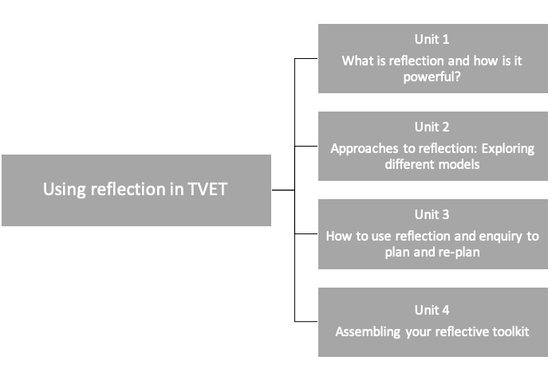

**Figure 1: Module structure**

Credits and learning time

This module carries 6 credits. This is equivalent to 60 notional learning hours. It is anticipated that you will take approximately 60 hours to complete the module successfully. The 60 hours will include contact time with your Higher Education Institution (HEI), reading time, research time and time required to write assignments. It is also expected that at least half of your learning time will be spent completing practice-based activities in your TVET College. This will involve your individual work on the activity, and may also require you to discuss these college-focused activities with your colleagues. Each activity in this module indicates the suggested time for completion.

# Unit 1: What is reflection and how is it powerful?

## 

## Introduction

As educators, we know that it is important to help students build new knowledge from what they already know – what is called their prior knowledge. This module starts by helping you collect what you already know about reflection. At first, the concept of reflection may feel unfamiliar. But as you engage with the unit, you may discover that you already know more than you had realised. Mapping out your prior knowledge will give you a foundation on which to build new knowledge. If you already use reflection often in your teaching and life, this unit will give you the chance to deepen and extend the way you use it.

As we explore the idea of reflection, we will stretch it in different directions, like a piece of chewing gum or Prestik, to see how it works in different contexts. We will start with how it works in everyday life and then look at how it works in industry, in teaching and learning and in the work of a TVET lecturer. We will look at how reflection gives a person greater power to make good decisions, solve problems and constantly improve their work.

The activities in this unit will give you opportunities to experiment with reflection in different ways. Many of the activities are used again later in the module, so it is important that you complete them. By the end of each unit you will have created a number of products that represent your learning. These are referred to as *artefacts*. You will share your artefacts with your learning community in this course. You will also have the chance to explore the artefacts created by your peers. This will help you to develop a deeper and broader understanding of what you have learnt in the unit.

You will use a reflective learning journal throughout this module. You will write notes and reflections, complete activities and create artefacts in your journal. For your learning journal, you will need an A4 notebook with at least 100 pages. Because you will need to draw some diagrams and sketches, a notebook with lined pages on one side and blank pages on the other is useful. Otherwise, you can paste a blank sheet of paper into a lined book whenever you need to draw something.

## 

## Unit 1 outcomes

By the end of this unit, you should be able to:

1. Discuss the process of reflection, how it manifests itself in different walks of life and how it can benefit professional practice.
2. Discuss the value of reflection in developing, updating and upgrading your expertise as an educator and as a technical practitioner.
3. Evaluate journaling options and design and implement an experimental/experiential reflective journaling practice.

.

## Understanding and recognising reflection in everyday life

In our daily lives the words ‘reflect’ or ‘reflection’ refer to a picture of something bouncing off something else and coming back to its source. When you look in the mirror or into the water of a pond, it is a picture of yourself that is reflected back to you. Your reflection allows you, in a way, to step outside of yourself and observe yourself as if you were a second person: you are looking at you. This allows you to study yourself closely. When you do this, you can discover things you did not know about yourself.



**Figure 2: Reflection is stepping outside of yourself to look at yourself.**[Source](https://pxhere.com/en/photo/1419056)

In the morning before you leave for work you might stop in front of the mirror to look at your reflection. You might discover that you spilled tea on your white shirt and decide to change it before you give a presentation to your department. Or you might find that your glasses, which you have looked for all morning, are on top of your head. That moment of reflection in front of the mirror can help you discover some things about yourself, giving you the power to take an action that will allow you to have a more successful day.

In addition to the mirror, we have other tools that ‘reflect’ us back to ourselves. Photographs do this. Videos can show us how we look and move. If you are a professional athlete or dancer, you may repeatedly watch a video of your performance, to pinpoint where you need to change your actions. Studying your own performance is a key tool in improving it.

We also have the ability to see pictures in our minds, without looking at a photo, video or mirror. Do you sometimes ‘replay’ in your memory something that happened, looking at every detail carefully and slowly, even though it is no longer there? If it was a situation that left you feeling unhappy, you might notice something new as you reflect on it. This may help you understand why it turned out badly and find another way to approach the situation in future. You might notice, for the first time, connections between things. This may help you to realise something important, which will enable you to succeed another time.

We can also reflect on things without seeing pictures in our minds. We can think deeply about a book we have read or a conversation we have heard, or we can explore an uncomfortable feeling. As we dig deeper, we are sometimes able to ‘mine’ our thoughts for useful treasures – new and helpful understandings. As we reflect on the contents of a book, we might realise that it contains an important lesson for our own life. As we recall a telephone conversation with an old friend, we might realise that she was asking for our help, although she never said this directly. As we explore a hurtful experience, we might realise that sometimes we also act hurtfully towards others.

At its most basic level, reflection is simply stepping outside of what is happening – or what happened – to pay careful attention to what is going on before we react to it. By carefully noticing what we are seeing, hearing and feeling, we can gather new information we might have missed. We can then explore this new information and try to make sense of it. Why did it happen this way? Am I handling this in the best way I could? Or am I just reacting in the same way I always have? Is there something I want to do, or do differently, as a result of the new things I can see? Creating a small gap between our experience and our actions thus places us in a more ‘intelligent’ position to decide how to make our next move. Over time, reflection helps us ‘improve our game’ in every area of our lives.

Reflection can be individual or social, private or public, formal or informal. It can take place in every possible part of life and take many forms.

Many people find that they reflect informally when they are alone. Have you ever noticed that you suddenly realise something about a situation while you are doing something else – for example, having a bath, washing the dishes, or going for a run? When we have some quiet time alone, our minds often start doing their own informal reflection. If our lives are constantly busy and full of people and technology, this may never happen. Sometimes, you may find when you go to bed at night your mind floods with thoughts and you can’t get to sleep. There may be important things you are trying to understand, which are below the surface. Sometimes, we don’t need to think more thoughts but rather need to quieten our busy minds, so that deeper realisations can rise to the surface.

Some people feel a strong need for reflection and look for quiet time alone to do it. They might wake up early to pray or meditate. They might go for a long walk, or lie in a field and look at the clouds, or gaze at the stars at night. Some people like to write their thoughts in a journal or express what they are reflecting on in a song or a poem. Many people who create art or music find that important reflection happens while they do it.

Some people prefer to reflect with others. You might have a best friend you chat to when something is bothering you who always helps you to see the situation more clearly and helps you to make a better decision. You might know people who like to tell stories about their experiences and, as they do so, they draw out new understandings.

Some people make their personal or social reflections public. They might post reflections on Twitter or Facebook or on a blog. Others may respond with their own reflections, using the first person’s ideas to deepen their awareness. Others may incorporate their reflections into performance.

Some traditions use communal reflection as a central practice. Reflective practices are a formal part of different religious and spiritual traditions that have their roots deep in the past. Different forms of meditation and prayer involve reflection. People in a religious community might share problems or issues in their lives and reflect together on how their common spiritual principles relate to and may address the problems. Self-help groups like Alcoholics Anonymous have been helpful to people with addictions. Their approach relies strongly on reflecting alone and with others. Counsellors or psychologists often use reflection to help a person understand the causes and effects of their problems and identify more successful ways to manage their lives.

### Activity 1: Exploring reflection in my everyday life

Suggested time: 15 minutes

Think about the following questions and write your thoughts in your learning journal.

1. Think of your family and friends. Who are the people who are the most reflective? How do they reflect? How have you experienced their reflective practices? (For example, do you find them irritating, threatening, interesting, admirable?)
2. Do you think you are a very reflective person or not? Can you identify any factors in your life that have contributed to this? Have the people you thought of in question 1 played a role in this? If you do reflect, what forms does your practice take?
3. What formal reflective activities take place in your life, your family or your community? Think about the areas of religion and spirituality, sport, relationships, social media and the arts (for example, art, writing, music, dance, poetry).

Discussion of the activity

Did this activity help you to become more aware of reflection in your life? Did it help you become more aware of your current feelings about reflection? As you begin to look at your life through the ‘lens’ of reflection, you may notice that you have ways of reflecting informally or formally that you had not thought about. You may also realise that you have a positive or negative attitude towards reflection.

Reflection is a process that helps us achieve success and gain wisdom. You have probably known people who seem to repeat the same mistakes. Many people feel that in some area of their life they don’t seem to make progress no matter how much effort they put in. In such situations, reflection helps us see things that we were not aware of before. This enables us to learn from our experiences and not repeat the same mistakes. We can move closer to achieving our goals.

Instead of our lives going in a circle that takes us through the same problems with the same outcomes again and again, reflection enables us to use each experience to increase our understanding. When we face the same situation again, we are no longer on the same level as we were the last time. We see the situation differently and we have different knowledge and skills. As a result, we handle it differently and get a different result. This feeds into our learning, and the next time we encounter a similar situation we engage with it from an even higher level of wisdom.

Through reflection, your learning spirals upwards, illustrated in Figure 3 (at the Vatican Museum). The figure illustrates the way that reflection enables us to move to higher levels of insight as we move through the cycles of life rather than repeating the same experiences and mistakes. As your life moves forward, you can ‘look down’ on your previous experiences and see how you used to handle them and how much you have learnt and grown.



**Figure 3: A spiral staircase**[Source](https://pxhere.com/en/photo/663517)

If we choose to learn from life, reflection is a key tool we can use. The following scenario illustrates this.

**Scenario: Three losing soccer teams**

Soccer Team A loses their third game in a row. The coach gathers the team together after the game and tells them, “You are a useless bunch of losers! I have poured my sweat and tears into you lot and this is all you have to show for it! You make me ashamed! Go home and don’t show your faces until the next practice. I expect a complete turnaround by the next game!”

Team B also loses their third game in a row. The coach gathers the team together after the game and tells them, “Don’t feel bad, guys! You are the best! This is just a run of bad luck. The players on the other teams have been cheating left, right and centre! But next game you are all going to show them who you really are! They will eat your dust. Now, let’s all go out for a drink and put what happened today behind us.”

Team C also loses their third game in a row. The coach gathers the team together after the game and tells them, “I can see you all played your hearts out today, and I’m proud of you for that. But we need to look carefully at what’s going on and make some changes. Let’s spend a few minutes thinking about what happened while it’s fresh in our minds. What went according to plan; what didn’t? Did you notice any patterns: things that seem to be happening over and over? Can you identify any challenges that we haven’t prepared ourselves for? What key advantages do we have that we can capitalise on? Tomorrow we’ll go over the video of today’s game carefully and discuss these things further. Then we’ll come up with a strategy.”

### Stop and think

|  |
| --- |
| Think about the following questions and write your responses in your learning journal.   1. What outcome do you expect for each of these teams if the coach continues to use this strategy? 2. Which coach’s approach is reflective? How might it result in greater success than the other approaches? 3. Does this coaching role remind you of any experiences you have had in industry or lecturing? |

Reflection helps us to see our performance more clearly and accurately so that we can adjust and improve it.

It also helps us to become more aware of any attitudes or beliefs we have that may be impacting ourselves or others negatively. From the time we are born, each of us starts learning knowledge, skills, values and attitudes about life from our families and communities. Much of what we learn includes valuable lessons passed down by those who came before us, but it may also include negative or incorrect beliefs or attitudes. For example, the belief that our family or group is better than another, because of wealth, religion, race, gender or any other characteristic, can be passed down to us. Because we learn our beliefs and attitudes from people we trust from a young age, we often do not question them. This can result in us thinking about other people in an unfair or untrue way without even realising it.

In the example of the soccer team, as the coach reflects with the team, they may discover that there are beliefs or attitudes that are negatively impacting their performance. They may feel intimidated by or inferior to players in other teams because of the cultural group they come from. Or perhaps they do not work well together as a team, because of negative values or attitudes about race, religion, or family background.

## Reflection as a key role of the TVET lecturer

We have looked at how reflective practice brings new learning, enabling us to mature and become more insightful in our responses. This, in turns, helps us to achieve greater success and satisfaction in different areas of our lives.

Now, let us look at the importance of reflective practice in our professional life, and in the work of a TVET lecturer.

### The role of reflection in professional life

As we saw earlier, reflective practice has been important to humans throughout history. Research over the past 100 years has developed theories and models around reflective practice. We will explore these in Units 2 and 3 of this module.

John Dewey brought the idea of using reflection in the work context in the early 1900s. Dewey was an American philosopher, educator and psychologist. Many of his ideas have shaped modern education. He introduced the term ‘reflective practice,’ defining it as “the active, persistent and careful consideration of any belief or supposed form of knowledge in the light of the grounds that support it” (Dewey, 1910, p.6).

Donald Schön (1983) built on Dewey’s work in the 1980s. He highlighted the difference between reflecting *during* action and reflecting *after* action. Sometimes it is only possible to ‘step outside’ of a situation and reflect deeply on it after an experience has happened. However, in many situations we need to respond insightfully to what is happening in the present, *during* an event. In both teaching and industry we need skills to reflect while we are working with practical challenges, to make sure that the action we take lines up with theory or other requirements. This requires reflection *during* action. In this module, the ‘stop and think’ exercises are a type of reflection in action.

In a variety of modern occupations, reflection is increasingly valued as key to becoming more effective and proficient. Many higher education programmes require that students develop their reflective skills.

Some people who have learnt their trade by working at the side of experts may feel that this ‘apprenticeship’ approach prepares them adequately for the world of work. While this approach has many benefits, it is based on how things were done in the past. In a rapidly changing world, we need to be prepared for new realities. The education we received as young people – or which our students receive from us – may not be adequate a few years later, as industries and the nature of work change. As technology has developed, knowledge has grown very quickly. In fact, one study calculated that in 1900 knowledge was doubling every 100 years, by 1980 it was doubling about every year; and by 2020 it would be doubling every 12 hours (Rosenberg, 2017). This rate of change is almost impossible to grasp, but it is clearly not enough just to teach students how to ‘do the job’ as it is currently done.

As a TVET lecturer, you have one foot in industry and one foot in education. You will need to work effectively with the demands of both environments as they change. This means that you will need to continually reflect on what skills or knowledge your students will need going forward and how to adapt your teaching to address this.

In addition, you will need to teach your students how to teach themselves – how to find and learn the knowledge and skills they need as they go through life so that they will not only survive but be leaders and innovators in the changing world. This means you need to continually reflect on how you yourself learn, so that you can impart effective practices to your students.

In our current world, both lecturer and student need to commit to lifelong learning, in order to become increasingly effective – instead of increasingly outdated – in the changing world.

Before we explore further how reflection applies to your role as a TVET lecturer, do Activity 2. This activity is designed to help you identify your existing beliefs about what a TVET lecturer’s roles are. This will serve as a baseline: as you progress through the module you will come back to it to check how your ideas have developed or changed.

### Activity 2: Define the characteristics and competences of the expert TVET lecturer

Suggested time: 90 minutes

The aim of this activity is for you to identify what you consider to be the characteristics and competences of an expert TVET lecturer and to integrate these with the competences required by the DHET. You will first try to identify your conscious as well as your unconscious beliefs about being a TVET lecturer. Then you will look at three policy documents to see where your concept of an expert TVET lecturer needs to be more fully developed.

This activity will serve as a baseline for the statement of teaching philosophy you will develop in Unit 3.

1. To help you begin thinking creatively, let us start with something playful:

Think of one of your favourite performers – for example, a singer, actor or soccer player. Now imagine that you get a call from that person’s manager, saying they have booked their star to appear at two different events next Saturday. The manager asks if you would please step in and be that person’s double at one of the events. No one must find out you are not the real star. The manager sends you a life-size poster of the star and a video of them in action to help you prepare.

You start out by placing the poster next to you in front of a big mirror. In your mind’s eye carefully look at every aspect of the image of the star performer and compare yourself to them. What does their hair look like? How can you get your hair to look like that? How do they smile? Can you imitate their smile convincingly? Do you need to lose some weight? Gain some weight? What kind of clothes do they wear?

Convincing people that you are the star will take a lot more than looking like them. You will need to learn to imitate their voice and the way they move. What will you need to do to bring your skills to the level of the star’s?

Because this is an imagined situation, there is no problem; you can do it. The big day arrives and you pull it off beautifully – in fact, the crowds say it was the star’s best performance yet!

1. Now let us take this idea across to the TVET context.

Imagine that there is a ‘superstar’ TVET lecturer standing next to you in front of the mirror – someone who is a shining example of what a TVET lecturer could and should be, and whom you aspire to be like. This imaginary person may be a combination of:

* the best teachers and lecturers who have taught you throughout your life;
* master practitioners who have mentored you in the workplace;
* family members or friends who inspire and motivate you; and
* your own aims and goals for yourself.

Now look at this person closely. Their physical traits are not important – but look at how they talk, move around the classroom or other venue, or engage with students. What different roles do they take on in the classroom, practice spaces, industry, institution, among their colleagues – and maybe even beyond –that you consider important, powerful and effective? What teaching strategies do they use? How do they deal with challenges? Think about the values and principles mentioned in this unit as well.

Draw the following table in your learning journal. Use a full page, or more. In the left-hand column, write a list of short descriptions, as you think about what makes this TVET lecturer so excellent.

| **The ideal TVET lecturer** | **Me as a TVET lecturer now** |
| --- | --- |
| * Has a good theoretical understanding of topics … can explain why a certain approach is best * Is skilled in practical areas * Knows a variety of teaching approaches and is skilful at choosing/using them * Solves problems creatively * Has a positive relationship with students ... is approachable and isn’t threatened by questions or ideas * Shares ideas and discusses problems with colleagues * Keeps up with changes in industry and education | (Leave this side blank until step 4). |

Now add another layer to this picture. What is required of you as a TVET lecturer by DHET? Read the following extract:

### Minimum competences required of professionally qualified TVET lecturers

|  |
| --- |
| 1. Professionally qualified lecturers must have a sound knowledge base in terms of their own subject specialisation. They must know how to teach the subject, how to select, sequence and pace content in accordance with both subject and learner needs, and how to integrate teaching of knowledge, practice and affective attributes.  2. Professionally qualified lecturers must have a sound understanding of the TVET context in South Africa, including the policy environment and contextual realities, and must be able to adjust their practice to take this into account.  3. Professionally qualified lecturers must know who their learners are, including understanding their diversity in terms of socio-economic background, age, culture, life and work experience, learning styles and aspirations, and special education needs, and they must use this knowledge to adjust teaching and learning approaches to accommodate learner diversity.  4. Professionally qualified lecturers must possess advanced speaking, reading and writing skills in order to be able to communicate effectively in the language of learning and teaching.  5. Professionally qualified lecturers must be able to manage teaching and learning environments effectively to enhance learning.  6. Professionally qualified lecturers must be able to assess learners in varied and reliable ways, and to use the results of assessment both to improve learners’ learning through a variety of types of feedback, and to improve their own practice.  7. Professionally qualified lecturers must be ICT literate. This means being personally competent users of ICTs, as well as being able to integrate ICTs in an effective manner in teaching and learning.  8. Professionally qualified lecturers must be knowledgeable about the demands that will be made on their learners in the workplace, and able to use the subject they are teaching to help equip their learners to meet these demands.  9. Professionally qualified lecturers must have a positive work ethic, display appropriate values and conduct themselves in a manner that befits, enhances and develops the vocational teaching profession.  10. Professionally qualified lecturers must be able to reflect critically, in theoretically informed ways and in conjunction with their professional community of colleagues, on their own practice, in order constantly to improve it and adapt it to evolving circumstances.  Source: South Africa (2013). Policy on professional qualifications for lecturers in Technical and Vocational Education and Training, Government Gazette, Vol. 576, No. 36554, 11 June. |

Also read the Exit Level Outcomes for the Advanced Diploma in TVET (Blom, 2016) which is Appendix 1.

As you read, note that both documents state that a TVET lecturer must practise reflection. Which competences in the documents rely on, or benefit from, reflective practice? See if you can identify these.

Now compare the competences listed in the documents with your list of characteristics in the left-hand column of your table. Are any competences not on your list? If so, add these. Reflect for a moment: Why didn’t I think of these when I made my list? Was it because I didn’t know that a TVET lecturer must have these competences? Or don’t I regard them as being important? If the latter, why does DHET require them?

In step 2, you created a detailed list of the characteristics and competences of an expert (‘star’) TVET lecturer who is standing alongside you and reflected in an imaginary mirror. Now, move across to your own reflection in the mirror: the TVET lecturer you are today.

How do you compare to the expert next to you? Are there areas where you feel you are operating as an expert? How do you think your students and colleagues experience you as a TVET lecturer? Are there areas where you are still developing your knowledge or skill?

Use the list in the left-hand column as a rubric to assess yourself. Note down your observations and reflections in the right-hand column.

Now circle characteristics or competences that you think are important for you to work on, so that you will become that lecturer next to you in the mirror. This time, you are not pretending to be a performer you will never be. You are aiming to be yourself as a mature, well-balanced expert. This is a goal you can achieve if you continue to learn and develop.

You may add to this table at any time if you think of more competences that are important. You will use this list again later in the module.

### Discussion of the activity

As a TVET lecturer you have one foot in the more theoretical world of education and the other foot in the more practical world of the technical skills you are teaching. In addition, you are responsible for preparing your students for the world of work. In fact, you have to work with a large number of factors and each has its own challenges. These include:

* The expectations and demands of industry;
* Changes and technological advancements in your field, discipline or industry;
* Curriculum requirements;
* Practical skill requirements;
* Constraints of your college (such as inadequate resources for simulating training, too much separation between theory and practice, not enough contact with industry, your workload and time constraints); and
* Challenges presented or faced by your students (for example: lack of basic knowledge, lack of access to industry in rural areas, no access to internet).

To deal skilfully with these challenges you need to continually develop, update and upgrade your expertise as an educator and as a technical practitioner. Formal training – such as the AdvDipTVT – may play an important role in this process at different points in your life. But on a day-to-day basis, much of your learning throughout your life will happen more informally and will be directed by you. *You* will decide whether to learn from your experiences, colleagues, new research or online communities. Reflection is the ‘engine’ that will motivate and guide you through this. It will enable you to gain new insights, learnings and expertise.

### Stop and think

|  |
| --- |
| Can you think of other things you have to balance and integrate in your role as TVET lecturer? Write any ideas you have in your learning journal. |

### TVET lecturer as reflective practitioner

Earlier we looked at the some of the ways in which reflection can benefit us in everyday life. We saw that reflection helps us to see our actions more clearly so that we can pinpoint what is working well and what is not. This allows us to make changes to increase our success. We also saw that reflection helps to make us aware of underlying values or attitudes that can keep us from growing or performing well. Reflection offers these same benefits in the context of teaching, in professional life.

As you learn from your experience in the classroom, in industry, or from new research, you need to incorporate this into your teaching so that you become a more expert lecturer. Reflection will help you to see how to combine new theoretical ideas with knowledge you have gained from experience and use this to improve your practice.

Reflection also helps you to make tacit knowledge explicit (obvious or clear). Tacit knowledge is knowledge that you have learnt without a theoretical basis. It is often difficult to articulate the ‘how’ or ‘why’ of tacit knowledge, although you might use it very skilfully. Riding a bike is a good example. If someone asks you how to ride a bike, it is not easy to explain. If someone asks you why you are able to ride a bike, it is not easy to give an explanation without using the terms ‘practice’ and ‘experience.’ There is theoretical knowledge that explains it, but, without having this knowledge, you can still ride your bike well.

The same can apply to some of the practical knowledge you teach. You might know that something works, but you don’t know exactly why. Sometimes you might not be completely sure why you made a decision or took an action, except that it ‘feels right’. You may be drawing on sound professional judgement or wisdom, but you cannot consciously identify it. This means you also cannot be sure that some of your assumptions are wrong or your knowledge is outdated. If you have learnt important knowledge and skills as tacit knowledge from your mentors, it is important to be able to understand these more fully so that you can teach the theoretical principles to your students. This puts you – and them – in a position to ‘own’ and manipulate this knowledge. Then you can adapt it expertly to different contexts – and to the changing environment.

The following scenario provides an example of this.

**Scenario: Making a strong wood joint**

Mr Pillay has been teaching his carpentry students how to design and make a shelving unit. He explains that they must measure and cut all the boards, then assemble them, applying wood glue to the joints, and then varnish the unit. He tells them ‘what’ to do and ‘how’ to do it, but he doesn’t explain ‘why’. This is how he was taught when he was young, and he believes it is important for his students to imitate meticulously as part of the discipline of the trade. He has no time for them constantly asking questions or making suggestions.

Kiyara and Thami were both present the day Declan demonstrated the process, but they were both sick the next day, when their classmates began working on their own shelving units. The following day, when they returned, they were behind schedule and were under pressure to finish. By the time the others left the workshop at the end of the day they had only finished measuring, cutting and sanding their boards, while the others had assembled and glued the units, and then varnished them.

“Thami,” Kiyara said, “if we assemble and glue them tonight, we’ll have to varnish them tomorrow morning and they won’t be dry by the time we have class. Why don’t we varnish all the boards and let them dry overnight. Then we can come in early and quickly assemble and glue them. By the time we have Mr Pillay’s class, the glue will be dry and they’ll be finished.”

“That’s a brilliant idea, Kiyara,” Thami said, “but Mr Pillay will kill us if we don’t do it exactly the way he showed us.”

“He’s not here; he’ll never know,” Kiyara pointed out.

“True,” said Thami. “Ok, let’s go for it.”

They varnished all the boards, and in the morning applied glue to the joints and assembled them.

When it was time for class their units were finished and ready for marking, just like everyone else’s.

Mr Pillay inspected each unit. He checked that the shelves were level and the joints were square. He smiled with satisfaction as each unit passed the test. Kiyara and Thami looked at each other and breathed a sigh of relief. Their plan had worked!

Then the students were asked to load their shelving units onto a truck to be moved to another building. As the students lifted Kiyara’s unit, the shelf they were holding came loose in their hands. They dropped the unit and two other boards came loose.

Mr Pillay turned and stared at the unit in horror. “What is going on here!” he shouted. “Not in all of my 30 years of teaching have I seen this happen! What did you do?” Kiyara guiltily explained that she had varnished the boards first to save time. Mr Pillay nearly exploded with anger.

“But Mr Pillay,” Thami intervened, “we were actually just trying to use our heads to make up the time we’d missed. Why did it make a difference that we varnished before we glued? It really was a lot faster.”

Now Mr Pillay looked guilty. He had no idea why. He had never thought about doing it differently.

“It’s not your business to ask questions!” he shouted. “If you want to be a good carpenter, you need to be disciplined and do things as you are taught.” But he felt completely shaken that he was unable to explain why the joints had been weaker on Kiyara’s unit. That evening he chatted about it with his father and uncle, who had taught him the trade. As they thought about it, they realised that the water-based wood glue was able to saturate the wood fibre when it was unvarnished. Once the joint was assembled and the glue dried, the bond was far deeper than it would have been if glue was applied to the impermeable surface of a varnished board. Once they articulated this, they realised that they had already understood these principles, they’d just never thought about them consciously in the context of gluing a joint.

“That’s too bad,” thought Mr Pillay. “If I had taught all my students why they should apply glue before varnish it would have made them better able to try new designs successfully. Maybe these impolite young students who ask ‘why’ all the time have something to teach me. I think from now on I should try to include a little more ‘why’ in my teaching.”

In this scenario, Mr Pillay discovered that his tacit knowledge was important and reliable – even though he had not known why. But when knowledge is tacit, it could also be the case that in a slightly different situation the knowledge is not appropriate or relevant, and the person who holds the knowledge may not know it. This makes the person less flexible in the context of change.

### Stop and think

|  |
| --- |
| Think about the following questions about the scenario involving Mr Pillay and his students and write your thoughts down in your learning journal.   1. Can you think of any experience you have had in which something similar happened, either as a student or as a lecturer? What did you take away from that experience? Did it in any way influence the way you acted in the future? 2. Do you think you teach everything the same way every time you teach a course? Why or why not? 3. Do you feel you let your students’ experiences and ideas influence you? If so, in what ways? 4. How do you feel and how do you respond if a student asks you a question you cannot answer? |

### The primary and interfacing roles of the TVET lecturer

Figure 4 shows a simple way to model the roles of a TVET lecturer. As a TVET lecturer you need to be (1) an expert educator working consciously with content, the curriculum and your students’ developing theoretical knowledge. You also need to be competent as (2) a technical practitioner working with theoretical and tacit knowledge as it is applied in practice. In order to be able to analyse the needs of your students, the curriculum, your institution, your physical space and resources, your technical field and your related industry, you also need to be (3) a reflective or critical practitioner. These roles overlap, as shown by the areas A, B and C on the diagram. The area labelled ‘A’ shows the area of overlap between the roles of educator and technical practitioner. There are knowledge, skills, attitudes and values that are shared between both roles – but there may be some that are not, and do not fall in the ‘shared’ zone. Area ‘B’ shows how your reflective capacities are used in your role as an educator, and area ‘C’ shows how they are used in your role as a technical practitioner. As you work effectively between these zones, your knowledge and skills become more and more integrated. This builds up your professional judgement or wisdom (shown by the star in the centre, where the three areas overlap with each other).

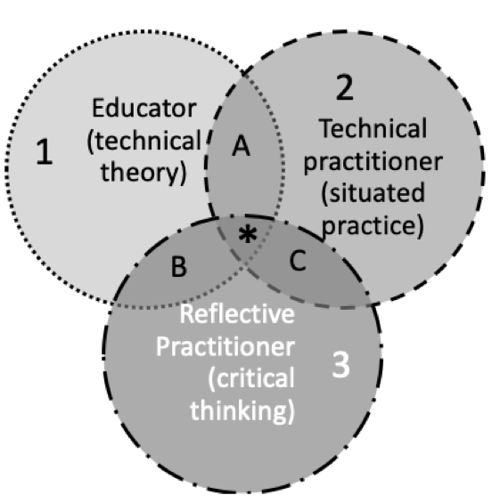

**Figure 4: The three primary and interfacing roles of the TVET lecturer, grounded in personal identity**

Remember the spiral staircase in Figure 3, which was used to show how reflection enables a person to learn from experience, so that when a similar situation arises in the future the person has greater awareness, skill and intelligence?

Let us combine the model in Figure 4 with the idea of a spiral staircase that is going higher and higher. An Archimedes screw is a device that turns a spiral inside a casing to raise water from a lower level to a higher level, as shown in Figure 5. Imagine that the spiralling screw shown in the model in Figure 4 represents time and has three blades that represent the roles of: (1) educator, (2) technical practitioner and (3) reflective practitioner. As time ‘turns’, you gain more experience (represented by the water in the reservoir). As you reflect on your experience you move to higher levels of awareness in your roles. This results in an increasing ‘output’ of professional judgement and wisdom in your work—represented by the water that comes out on the higher level.

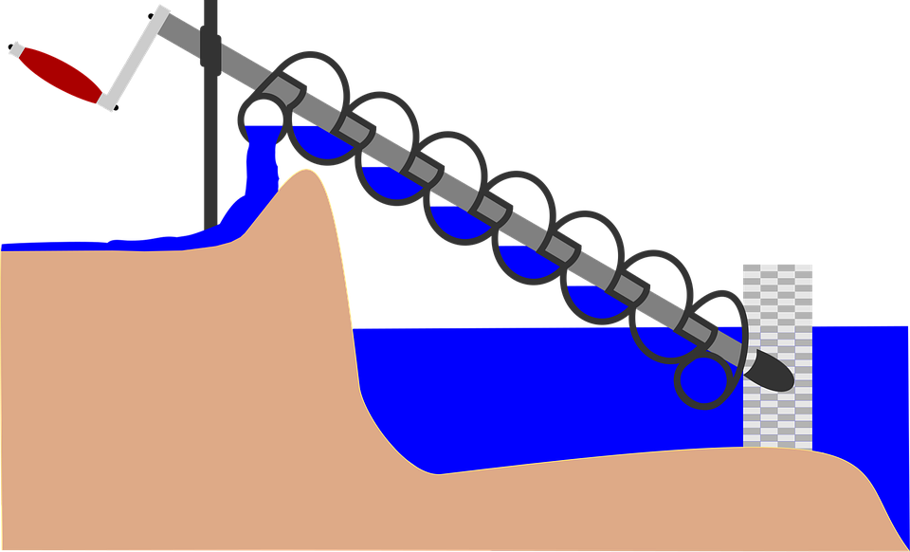

**Figure 5: Computer-aided design drawing of an Archimedes screw lifting water from a lower level to a higher level.**([Source](https://pixabay.com/vectors/physics-archimedes--screw-4776440/))

### Stop and think

|  |
| --- |
| 1. Do the models in Figures 4 and 5 help to make the ideas around your roles as a TVET lecturer clearer? Or do they make the content more difficult to understand? The first model (Figure 4) is abstract and the second (Figure 5) relates to an engineering principle. Is there something from your teaching context that could model these concepts more effectively to you? If so, feel free to experiment with your ideas by sketching them in your learning journal.  2. Taking this reflection a step further, how do your students respond when you use a model to explain a concept to them? Do some find the model helps and others find it complicates things further or muddles their understanding? Could it be helpful to model concepts in a range of different ways to help your students grasp them? Maybe you already do this in your teaching. Can you think of some examples? |

### 

### Values and principles linked to reflection

For reflection to be effective, a person needs to be willing to look honestly at themselves, believe that there are new things to learn in life, and believe that they can change and grow while learning the new things.

These principles are equally important for reflection in your practice as a TVET lecturer. In the professional space – and particularly in education – there are a number of related educational principles that should inform your teaching as a TVET lecturer, and that also link strongly to reflection. It is also important that you help your students to develop and adopt these principles for themselves.

Below is a short description of these core educational principles, so that you can begin to think about them. They will be explored in depth as the module continues.

* **Lifelong learning.** This is an understanding that we continue to grow and learn – professionally and personally – throughout our lives. Lifelong learning involves taking responsibility for our own growth and development and being motivated to pursue new learning. While we may become experts, we understand that we can always gain new insights and improve our skills and effectiveness. There is always new and innovative knowledge developing in our field.
* **Student-centred (or learner-centred) pedagogy.** This way of teaching is based on the understanding that both students and teachers work together to create knowledge. The teacher is not ‘full’ and the student is not ‘empty’. Students learn from each other and teachers learn from students, in addition to students learning from teachers. It is not effective or appropriate for a teacher to dispense knowledge to a student in the same way, time after time, with no engagement with the student’s experience or perspective. Student-centred teaching requires reflection.
* **Growth mindset.** In the past, intelligence was believed to be something a person was born with that could not be changed. However, research shows that when teachers and students believe that they control their ability to learn and improve, their intelligence increases. Using a growth mindset involves reflecting, self-assessing and using feedback to learn more, and more effectively.
* **Critical thinking.** This involves questioning, comparing or judging knowledge or ideas. This very important skill enables a student or teacher to innovate and contribute to their profession or trade. Teaching critical thinking to students is both challenging and essential.

### Stop and think

|  |
| --- |
| 1. Which of the principles above are you already familiar with? Do you already incorporate them in your teaching or personal life?  2. Which principles are new to you? Are they already on your list of competences for a TVET lecturer? If not, add them in. |

It is a good idea to write notes about your thoughts on these ideas in your learning journal, as you can refer to them later. If you are unclear about a concept, or find something particularly interesting, do some research online or in a library to develop your understanding more fully.

### 

### Activity 3: Investigating the relationships between your roles as a TVET lecturer

Suggested time: 45 minutes

In this activity you will use your prior learning and new learning from this module to map your various roles as a TVET lecturer.

Review the previous two sections of this module, ‘TVET lecturer as reflective practitioner’ and ‘Values and principles linked to reflection’.

1. Going back to the table you created in Activity 2, see if there are any characteristics or competences that you identified in these sections that you want to add to your table.
2. Draw the diagram in Figure 4 in your learning journal. Make it big enough to fill the page.
3. Now map the characteristics or competences from the left-hand column of your table in Activity 2 onto the diagram in your learning journal. Think about which of the three roles the characteristic or competence fits into. Does it overlap with another role? (If there is not enough space to write in the circles, write outside them and draw arrows to indicate which circle the characteristic belongs in.)
4. Think about any new connections or realisations you had about your roles as a TVET lecturer while doing this activity. Note these down below your model or on the next page.

### Discussion of the activity

Using reflection and critical thinking, you have now added several layers of knowledge to the prior knowledge you brought to this module about your roles as a TVET lecturer. You have incorporated the requirements of the Department of Higher Education and Training, and analysed which characteristics and competences relate to which of your roles as a TVET lecturer. As you go forward with the module, continue to think about this relationship and add to your lists or diagram, or write down thoughts you have in your learning journal.

## Tools of the trade: Recording reflections

For effective reflection as a TVET lecturer, it is useful to develop a set of tools that you can apply in different situations. Throughout this module you will experiment with different types of tools. You can decide which work best for you, and shape them to fit your needs and personality. If you already use reflective tools, you may find some new ideas to try out. You can also share the tools you use and the reflection experiences you have had with your peers in your learning community, so that they can benefit.

One of the most important tools you will need is a way to record your reflections. While you may find that some of your best reflection happens informally, if you don’t record your thoughts you may not follow them through to the point of taking new action. You also need to be able to look back on your reflections so that you can identify patterns and gain insights from these.

It is also essential to set time aside regularly for more formal reflection. If you don’t do this, there will probably be periods in your life when you are especially busy and you won’t find time to reflect at all. And these are often when reflection could be most helpful.

### Using a journal for reflection

Traditionally, reflective journaling has been used in different ways in different trades. Some trades use a logbook or trade journal. Artists and writers often keep journals with them, in which they write down experiences and ideas or draw images of things they see, which inspire them to think creatively. Educators and other professionals around the world find that using a journal for reflection helps them become better at what they do. Many have found their reflective journaling practice to be a very enjoyable and important part of their lives.

**Scenario: Keeping a journal**

Washington Munhunga is a master cabinetmaker and a TVET lecturer. In Zimbabwe, where he trained, he is called a ‘worker intellectual’. He keeps a journal with him all day in which he records detailed notes and sketches of ideas. He first takes photos at the site where he will be constructing cabinets. Then he reflects on these and makes sketches as he thinks about the different materials and design options he could use. As he reflects, he begins to have ideas for solutions. At home, he has a shelf full of the journals he has filled over the years. When he is working on a new job he often looks through his old journals to reflect on how he has solved similar situations in the past. At the end of each project, he looks back on his notes for that project and asks himself, “If I were to do this over, what would I do differently?”

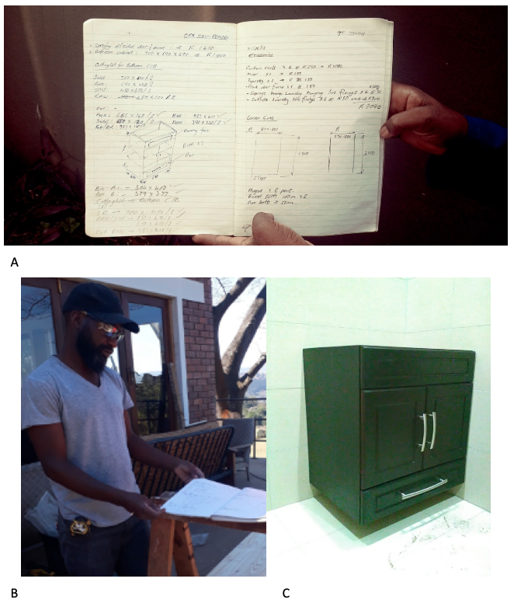

**Figure 6: (A) Pages from Washington Munhunga’s journal; (B) Munhunga displays his journal, which he keeps with him on the job; (C) finished cabinet**

### Stop and think

|  |
| --- |
| 1. Is there any formal way in which reflection is recorded in your industry? Was there in the past?  2. If you are not sure, ask some of the practitioners in your industry about their experience. Have they developed their own way in which to record their reflections on their work? |

### Ways to journal your reflections

One of the goals of this module is to help you develop a way to journal your reflections that you find easy and enjoyable, so that you will want to continue using it in your work. In this module, you will use your learning journal for reflection as well as for taking notes, completing activities, and creating artefacts. You may add ideas, drawings and reflections to it at any time. You could use pens or paint, stick in pictures or objects, or do anything else that makes it meaningful to you. If you find yourself reflecting at a time when you are not able to write in your journal, you can record your thoughts verbally, using the voice recorder on your cell phone. Later, you can listen to the recording and write your ideas down in your journal. You could also video yourself if you found this helpful.

### Journaling styles

People often journal as if they are writing a letter to themselves. Sometimes this is a very useful approach because you can let all your thoughts flow without worrying about how to organise your ideas. This free flow of ideas can allow you to clarify what you are thinking.

However, this approach can also be time consuming. You could also journal by recording your ideas onto your phone, as you reflect. This allows you to reflect while you are walking, riding in a car, or when your journal is not with you. But long audio messages are difficult to search and sort later, when you want to find the important points or look for patterns and themes.

People who journal regularly have developed different ways to capture key thoughts quickly, in the moment. They then take time later to explore their thoughts more deeply. We will look at two ideas that can be used separately or in combination: mind mapping and sketchnoting. And you can, of course, develop them in any way that you find interesting and useful for your own journaling practice.

**Mind maps**

You may be familiar with using a mind map as a tool to highlight key ideas and the relationships between them. A mind map is a drawing where the main idea is placed in the middle and secondary ideas that lead from the main idea are arranged around it, connected to it with lines. Sub-ideas can be arranged around the secondary ideas, and so forth.

In mind mapping, we create notes in such a way that our brain is loving it. The brain doesn’t operate in a linear fashion. It jumps from concept to concept, from idea to idea, from association to association. (How to mind map, n.d.)

Mind mapping can be a useful tool for reflection. Figure 7 shows a basic mind map of this unit.

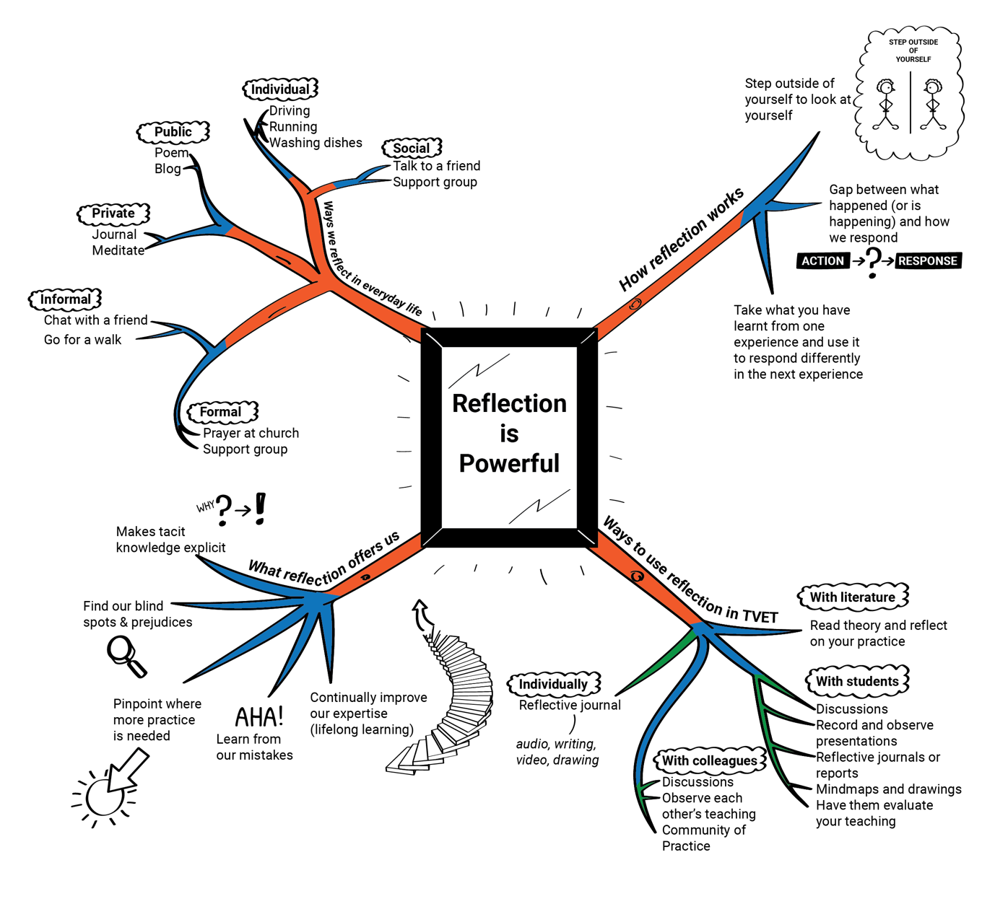

**Figure 7: Mind map of key ideas in this unit**

Tony Buzan developed the mind mapping technique. If you search for his name on the internet, you can find hundreds of examples and videos about mind mapping to help you develop your ability to use this technique.

**Sketchnotes**

Sketchnoting has become popular for notetaking and reflection. It is similar to mind mapping because it shows key ideas and how they relate to each other. It also invites you to use colours, shapes, lettering styles and pictures to both capture and facilitate reflection. Sketchnoting encourages creativity, which makes it more personal and enjoyable for many people than writing.

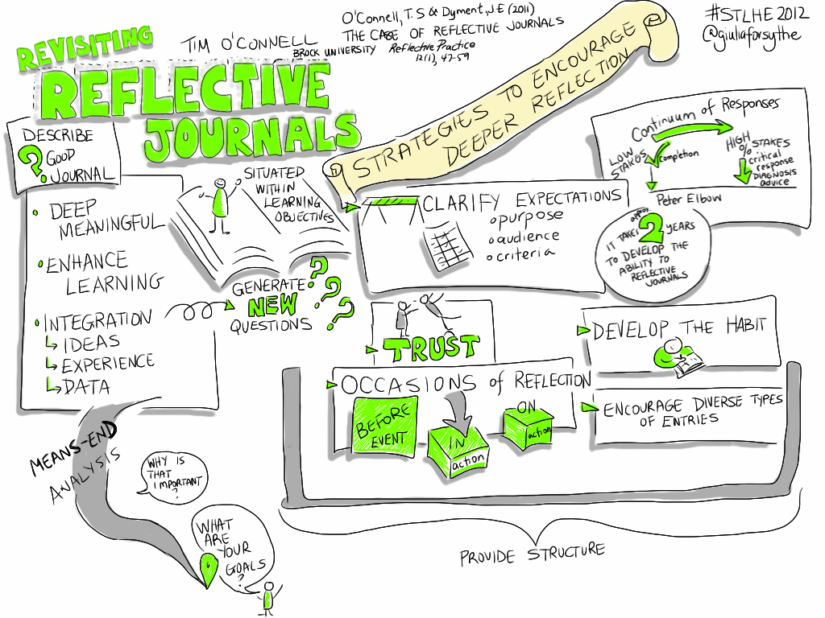

**Figure 8: A reflective sketchnote**

[Source](https://www.flickr.com/photos/gforsythe/7415765422/in/photolist-vg6AiM-ciiJGw-EE76jX-q84wbE-eYMkwn)

### Activity 4: Sketchnoting blog readings

Suggested time: 30 minutes

Aim: To learn more about sketchnoting, by reading a blog excerpt.

Read the following excerpt from the blog article ‘The beauty comes in the reflection’ by the educator Tisha Richmond (2018). Reproduced with permission of the author.

|  |
| --- |
| One of my favorite ways to document my learning during a conference is to sketchnote the sessions and keynotes with visual images and text. It’s something that I truly look forward to. This past week I went to the Spring CUE conference in Palm Springs, CA and once again, I thoroughly enjoyed sketching the keynotes and sessions I attended. I have found I am able to focus better, make deeper connections to the ideas, and retain the information longer when I allow my thoughts to fill the page with images and text. However, as one of the last sessions was coming to a close, I looked at my sketch and realized something. Though, my page was filled with images and text, there was very little color or detail. That’s because it wasn’t complete. My favorite part of sketchnoting comes after the session....the beauty comes in the reflection.   At times I am able to reflect immediately after the learning and other times it happens later as I fly home or decompress from the experience in my pajama’s in the living room. It doesn’t matter when it occurs, but it always does. This past week, as I settled into the airport after going through security I pulled out my ipad pro and opened up Paper53 to look at my sketchnotes from the week. With each quote I read and image I saw, the memories from each session came flooding back and I began to process. I rewrote some of my text, added in images, wrapped some of my thoughts in containers and bubbles, and colored. As a person who recharges in solitude, the act of coloring and creating is therapeutic for me. It brings me back to being a kid sprawled out on my bedroom floor with my big box of crayons and a coloring book. Coloring between the lines and adding my own unique details to the page, allowed me to process the day. It gave me time to untangle all of my complicated thoughts and ideas and organize them into manageable chunks. This is exactly what happens when I reflect on my sketches. I am able to take the new ideas and content, connect it to prior knowledge, and sort it out into manageable chunks of information that are meaningful and actionable. I also find that taking the time to make my sketches visually appealing, brings me joy. Like a photograph, it captures a memorable moment in time that I want to revisit.  When I teach sketchnoting to my students I also share the importance of the reflection time. I tell them to not worry so much about adding color and detail when they are documenting their learning. If it helps them focus, do it. However, if it distracts them from making connections and focusing on what they are learning, wait until after. I always try to carve out a minimum of 10 minutes for students to process what they sketch, add details, color, and ask questions of those around them to fill in missing information or make sense of what they recorded in their notes. I have found that my students really appreciate this time. Just as I do, they find this time of reflection to be valuable for connecting and sorting their new ideas and organizing them into chunks that are meaningful and actionable. For some students, they want to complete their sketches at home in solitude….I allow this too.   Sometimes I think people feel that if they can’t draw images, text, color, and make it beautiful before the learning is over, sketchnoting isn’t for them. I thought this too at first. However, I know now that this just isn’t how I process. I need time to reflect, sort, organize, and color. My sketchnotes have evolved over time as I’ve developed my own style and flow. The more I sketch, the more I love it and appreciate how valuable it is to my learning. I also find it's a way for me to give back to those who have shared their heart and passion as well as share to those who were unable to take part in the experience.  Excerpt from the article ‘The beauty comes in the reflection’ by Tisha Richmond posted on 19 March 2018 on her blog Make Learning Magical at www.tisharichmond.com  The full article can be found at https://www.tisharichmond.com/blog/the-beauty-comes-in-the-reflection |

As you read, take notes in your learning journal. Note ideas that you think are important, interesting or might be useful to you or your students. Note down ideas you would like to try during reflective activities in this module.

Discussion of the activity

Does sketchnoting sound fun to you? Or difficult? Many of the people who teach sketchnoting emphasise that you do not need to be an artistic person to find this method useful. Just use whatever shapes, symbols or lines make sense to you. If you are not a person who often reflects informally, you may find, as you start playing with pen and paper and thinking about a situation, that new ideas begin to flow.

As you have seen, styles of journaling that include words, pictures, symbols and colours give you creative and individualised options for capturing your reflections. Give yourself the opportunity to go outside your comfort zone in this module. As you explore different ideas you will discover what forms of reflective journaling are most enjoyable and useful to you.

### Paper or virtual journaling

Using a paper notebook such as your learning journal might be the easiest way for you to keep a reflective journal throughout your career, because you can keep it with you and use it in the classroom, at home, or while travelling. You can also keep all of your past journals on hand and easily flip through them when you want to refer back. While a paper notebook does not allow you to add voice recordings, photos or videos, you can draw sketches and stick in pictures from magazines, for inspiration. You could also print and add photos of your classroom, workshop or industry experiences.

Keeping a journal on your phone, tablet or computer has some advantages over using paper. You can add photos, videos or audio to your journal. You can easily delete, change or move something and you can come back and add more detail later. You can sort, file or rename your entries and do a word search more easily than with a paper notebook. You can share your reflections via email, Facebook, WhatsApp, Twitter or other platforms. Some apps can also sync your notes between devices, so that you can access them on both your phone and computer. Some also remind you to journal every day!

If you want to journal on a computer or mobile phone, but you do not have reliable internet access, there are several options.

Microsoft Word can be used for journaling, although it has fewer options than some applications. Use the Headers on the Styles tab to label your reflections by date or topic. You can view all your headings on the Navigation pane (to see this, tick it on the View tab). Drag headings on the Navigation pane to rearrange sections. You can find all the times a word is mentioned by typing it into the search bar on the Navigation pane. Then you can generate a Table of Contents (under References) to see an index of all your dates and topics. If you would like to link to images, videos or files on your computer or device, create a hyperlink (on the Insert tab) to the location. Share your documents with others by email or by uploading them to Google Drive.

The following suggestions are additional resources, which you can refer to:

|  |
| --- |
| [Microsoft OneNote](https://www.onenote.com/) may already be on your computer and gives you many more options than Word. It allows you to create sections, pages and sub-pages. You can add videos, images, audio clips, screen shots and drawings. You can also sync between devices and share with other users.  Some digital journaling options are only available when you are connected to the internet. [Evernote](https://evernote.com/) is similar to OneNote. [Google Keep](https://keep.google.com/u/0/) is a notetaking service that you can use through your Google account on a computer or mobile phone. It has fewer features than Evernote or OneNote but lets you colour-code text, audio and image notes to help you organise and search them.  Blogs are another way to keep a reflective journal where you can easily add photos, audio or videos. You can choose to keep a blog post private or you can share it with the world. You can set up a blog for free on sites like [Tumblr](https://www.tumblr.com/) (www.tumblr.com) and [Medium](https://medium.com/) ([www.medium.com](http://www.medium.com)). These are very easy to use from a computer, phone or other electronic device. Tumblr works with social media so you can share and discuss your reflections with others. The website [Start Blogging Online](https://startbloggingonline.com/) offers a step-by-step tutorial on how to start a blog, a free blogging course and lots of resources to help you design a blog. |

### 

### Stop and think

|  |
| --- |
| 1. Which of these options appeals to you?  2. Which option you think would be easiest for you to use daily? |

While this course will give you time and space to experiment with new ideas, do not let the challenge of learning new technologies get in the way of reflective journaling. If you would like to try something but do not have the technical expertise to set it up, ask a friend, colleague or one of your students to help you. If, on the other hand, you find navigating new apps and technologies easy, share what you have found with your learning community to help others on their way. Whatever you use, it must work for you, otherwise you will not feel motivated to continue with it.

### 

### Activity 5: Using sketchnoting to reflect on the unit

Suggested time: 2 hours

In this activity you will use sketchnoting to review and reflect on what you have learnt during this unit. Then you will share your sketchnote with your learning community and provide feedback to each other.

The purpose of this activity is to give you an opportunity to experiment with reflection and ways of documenting reflection and to see if your peers’ ideas can benefit you. This type of activity may be new – and uncomfortable – to you and others in your learning community, but there are no ‘right’ or ‘wrong’ answers and the goal is to be creative as you develop tools for reflection that work well for you, personally.

Watch this [video](https://youtu.be/xPqMDtfJRZ4) on sketchnoting. Please note: it has no sound but explains how to sketchnote quite effectively.

Then:

* + - 1. Review the following from Unit 1:
* the unit outcomes;
* the material presented in this unit; and
* your notes in your learning journal.

As you go, use a notation system to mark the text as you reflect on the following questions. For example, you could use the symbols below to mark the text:

* What is a new concept that I have learnt?

? What is something I still don’t fully understand or that I want to think more about or ask my learning community about?

! What new ideas have I had for my teaching, industry or personal life?

>> What action could I take?

Now go through the material again and start a clean page in your learning journal. Aim to keep to the one page for this activity. (There is no reason to limit the length in your day-to-day use of this practice.)

Structure your journal entry in whatever way makes sense to you. You might list each main idea and then nest some details, a question and idea under it. Or you may list concepts, questions, ideas and actions separately.

Your journal might look something like this:

|  |
| --- |
| Unit 1: What is reflection and how is it powerful?  **\*** Reflection is something that I already do but I never thought about it   * I think I tend to reflect early in the morning when I’m making tea before anyone else wakes up. * I think I reflect on my goals and progress but I avoid exploring my feelings. I wonder why that is?   **\*** Growth mindset   * Intelligence is not fixed … you can develop it! I did not know this! * If I could use this approach in my teaching, I might be able to help some of my students who struggle.   **!** I just realised that I’ve been feeling really good about using all the same material from the year before.  I thought I was very ‘organised’. But I need to use that as a base and find new examples from industry … and also look for things which specifically address the needs and interests of my individual students each year.  **!**  Interesting … Some people sketchnote on their device.  **>>** I want to read up on the internet about which programmes work well for this … or if there is a blog platform which has the capacity for you to do sketchnoting right there.  **?** I don’t understand the description of how to use Word to journal …  **>>** I’ll see if technical support at my college can show me. |

1. Now for the creative part. Take a blank sheet of paper and create a sketchnote, based on your journal entry, using the sketchnote ideas in this unit. You can use the mind map in Figure 7 as a starting point if you wish. You can also google ‘sketchnote images’ on the internet to see more examples that might give you more ideas.
2. Use this creative activity to reflect further on the material in this unit. Pay attention to feelings you have as you add colour and shapes. These may indicate thoughts that could be valuable to uncover. Do you feel excited, bored, overwhelmed, inspired, threatened? Include these feelings in your sketchnote if you feel comfortable with that. Send an image of your sketchnote to your learning community for this course.
3. When you receive the images from your peers, look at them carefully and compare them with yours. Are there any new ideas you would like to incorporate in the way you document reflection? If you send feedback to your peers on their work, make sure it is positive: a creative activity like this can feel unfamiliar and a bit threatening to many people.

Discussion of the activity

In this activity you have reviewed the unit using different approaches. First, you scanned through the unit and your notes, using whatever review approach you usually use. Second, you made a sketchnote of your learning. Third, you reviewed the sketchnotes of your peers and incorporated new ideas from these into your own. In this process you have related new knowledge to your existing (prior) knowledge. You have also used the notes you have made, which included your ideas and reflections as a source of knowledge, in addition to what was provided in the unit.

As you worked with the ideas in this unit in these different ways, you will have had new realisations and insights that didn’t occur to you when you first read the unit. You may have become newly aware that you reflect in your daily life or in your work context. You may have discovered ways that reflection can be useful. You may also have discovered that you had a particular attitude to reflection and that this has changed in some way. You may have had ideas about how you could use reflection to improve your teaching, or how you could use reflection with your students to enhance your and their learning.

Can you identify where you found yourself understanding something in a new way, or having an idea about how something could be useful? Did you find that the creative aspects of this activity – for example, where you experimented with colour, shape and design – allowed you to ‘dig more deeply’ than usual? Some people have found that it can take several months of practice with new ideas like sketchnoting before they become enjoyable and meaningful. How did you experience looking at your peers’ sketchnotes? Did you find it exciting or interesting to see how people represented their ideas, and the varied learnings that emerged for different people from the same text?

You have completed Unit 1. The next unit explores models for reflection that may be useful to you in your teaching.

# Unit 2: Models and tools that harness the power of reflection

## Introduction

In Unit 1 you learnt about reflection as a process that enables us to learn from our experiences, whether in our personal or professional lives. After we complete our formal studies, we continue to learn and develop in our careers and lives, but most of this learning will be directed by ourselves. If we don’t reflect, we are likely to repeat the same mistakes, or do things the same way time after time, without taking advantage of opportunities to gather new knowledge and skills from the experiences we have along the way.

Reflection helps us to become more conscious, or aware, of what we are doing that is working and is not working. This awareness is extremely helpful to us as educators because it helps us to pass on our lifelong learning to students in ways that will benefit them. If our knowledge is tacit – we do something automatically or just ‘feel’ what the right thing is to do in a situation, without being able to explain why it should be done that way – it is difficult for us to impart the knowledge effectively to students. Through reflection we can explore and understand more consciously the things we ‘feel’ to be right or wrong, enabling us to explain and demonstrate our knowledge to our students and others.

When we reflect, we create new knowledge from our experiences and previous knowledge. We may realise something about an aspect of our discipline or teaching that no one has ever taught us. Educational theorists call this process *constructing*knowledge. When we construct new knowledge, we are also contributing something new to our discipline. As we gain a new understanding of something and work out how that can be applied to other situations, we become theorists ourselves and help to take our own discipline forward.

In Unit 1 we explored some of the ways we may already reflect naturally and informally, without really thinking about it. Some of us will tend to reflect more than others, and some of us will use more effective strategies for reflection than others. Since the early 1900s, when John Dewey highlighted the importance of reflection in professional life, many theorists have tried to identify how reflection happens and what the most effective approach is to reflection. In this unit you will have the opportunity to explore and try different models and approaches that have been developed. You can use, combine and adapt these as you experiment with developing a reflective practice that works well for you.

## Unit 2 outcomes

By the end of this unit, you should be able to:

1. Explain how to use a reflective cycle across different models.
2. Explain how critical thinking and social learning can help you to develop a more complete and objective understanding of a situation through reflection.
3. Describe how to use the perspectives of your students, peers and theory to reflect on aspects of yourself that you might not be able to see by yourself.
4. Explain what is meant by ‘transformative learning’.
5. Reflect, via a journaling, sketchnoting, blogging or other practice, with greater awareness and depth.

## Key concepts for effective reflection: Objectivity, critical thinking and social learning

Before we look at the different ways in which theorists propose that we go about doing reflection, let us look at some key theoretical concepts. We will look briefly at three key concepts that can shape the way we do reflection: objectivity, critical thinking and social learning. You already began to explore these concepts during Unit 1. You will use them to understand and analyse models for reflection and to build an effective reflective practice for yourself.

To work well with any situation, we need to have as complete and fair an understanding of it as possible. But while we might all agree about this in principle, we often think our own view of things is right and best and we prefer to act on that basis. But this limited way of working prevents us from learning from situations. The scenario in Activity 6 illustrates this.

### Activity 6: The benefit of seeing things objectively

Suggested time: 15 minutes

1. Read the following scenario.

2. What could you do in this situation? In your learning journal, write down what you would be able to do to resolve the situation, using the broader picture the drone has given you.

**Scenario: Traffic jam**

You are a traffic officer standing in a downtown intersection at 8 a.m. There is a terrible traffic jam and no one can move in any direction. Angry drivers are shouting rude things at you. Each one is coming from their own limited and personal position: they need to get to work, they did not create this problem, and they see everyone else as being in their way. They are unable to see that everyone else is in a similar situation and sees *them* as being the problem; just as they see *others* as being the problem.

Standing there on the street you, too, have a limited perspective. You can see that there is problem, but to find solutions you will need to see the bigger picture.

What would really help is if you could fly up into the sky and get a bird’s eye view of the situation. If you could look down at what is happening from further away, then you could see everyone’s experience and work out what to do.

Fortunately, the traffic department has a drone equipped with a camera that can feed a video to your phone. As the drone climbs higher, it takes in more information about what is happening on the ground, and you are able to get a more complete view of the problem. Now you can see that a car has broken down in the middle lane two blocks away, and a delivery van has parked illegally in the street three blocks in the other direction, preventing anyone from passing. There is also a traffic policeman at the junction. Figure 9 gives a view of the situation.

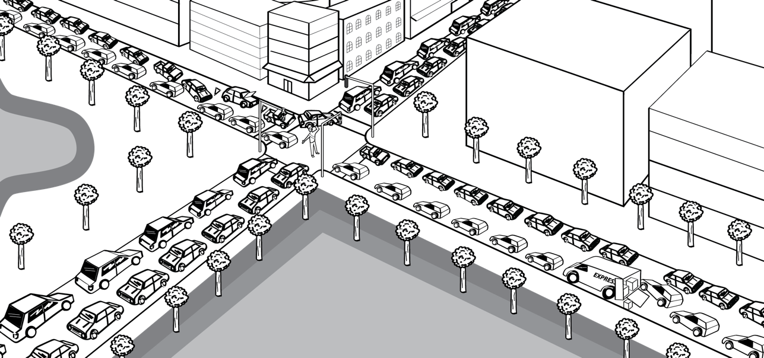

**Figure 9: View of downtown traffic from a drone’s camera**

Discussion of the activity

Using this bird’s eye view, you radio your department and tell them that more traffic officers are needed to clear the breakdown, tow the van and direct traffic where the light is out. In a short time, the traffic jam is unblocked, and everyone goes on their way. The ‘big picture’ provided by the drone gives you information that is far more accurate and complete than any one person’s personal view could in the situation.

One of the main obstacles to changing what we do in response to a situation is that we tend to see things first – and sometimes *only* – from our own position in the situation. We also tend to put our own needs and interests first, without considering how this will impact others or what their needs might be (as many of the drivers in the traffic jam scenario did). Even when we want to be fair and professional – *objective* – our emotions and personal wants and needs affect how we see a situation, other people and ourselves. Our view is *subjective*; it is shaped and coloured by all sorts of things in our personalities, experiences and beliefs. We might feel strongly that our view of a situation is the only correct one – but other people in the situation will each have their own subjective experience and view of the situation as well. As a result, each person experiencing a difficult situation may find it far easier to blame other people or institutions than to look at how they might have contributed to the problem, or to admit that they did not respond to something well.

One of the reasons reflection is powerful is that, as we step away from a situation and look back at it from some distance, we begin to see the bigger picture, in which our own subjective experience is only a small part. We may begin to see that behind another person’s frustrating behaviour are factors that they cannot control, and that our own point of view is not completely fair. We develop a bigger, more objective understanding of the situation, with the result that our actions can be more intelligent and we can see more opportunities for solutions.

We also develop more *empathy*for others.(Empathy means understanding and ‘feeling’ another person’s position or experience in a situation and is also discussed in the AdvDipTVT module on collaboration.) Once we allow ourselves to develop empathy our conflict with and defensive reactions toward another person may naturally fall away without us even thinking about it, because we will begin to value their concerns, as well as our own. This often results in a more cooperative response from those around us, as they feel that we understand them and are concerned about them, rather than working in opposition to them.

By reflecting with others or asking others for feedback on your actions or words, you build understanding and cooperation with them. You also benefit from learning what they can see about you, which you may not be able to see. When you look in the mirror, a coffee stain on your shirt may be obvious, and you will probably want to change your shirt. However, it may not be so easy to see that one of your attitudes is causing difficulty for your colleagues, or one of your habits is undermining the learning of your students. Because this sort of information makes us feel uncomfortable, we often avoid seeing it reflected back at us. When we reflect on a situation on our own we may have some ‘blind spots’ or ‘unknown territory’ within ourselves that we avoid, consciously or unconsciously. This may limit the effectiveness of our reflection and hold us back from learning from our experience and continually improving our practice. *Social learning* – learning with and from others – helps us uncover things we may struggle to see or learn on our own.

As we learn to see the situations around us – and ourselves – from different points of view, we develop our ability to *think critically*: instead of just accepting things as they are, unquestioningly, we look at them more carefully. We do not always do things in a particular way, just because ‘this is the way they’ve always been done’. Instead, we ask ourselves whether it make sense to do it like that, or if there could be a better way to do something. We investigate our assumptions and blind spots to get greater insight and clarity.

Let us look at how different approaches to reflection can help us gain greater *objectivity*, see things more *critically*, and gain the benefits of *social learning*.

## Cyclical models that facilitate reflection

In this section, we will explore some reflective cycle models that theorists have developed to help make reflection an effective learning tool (see Figure 10). The purpose of this section is not for you to memorise a lot of different models, but for you to be exposed to different approaches to reflection. There is no ‘correct’ or ‘best’ model, instead, the models emphasise different insights into reflection. By exploring these, you will become more aware of what you want to incorporate into your reflective practice. As you experiment with the different models, think about which aspects or approaches feel most natural to you and would be most effective for the type of lecturing you do and for your field of expertise.

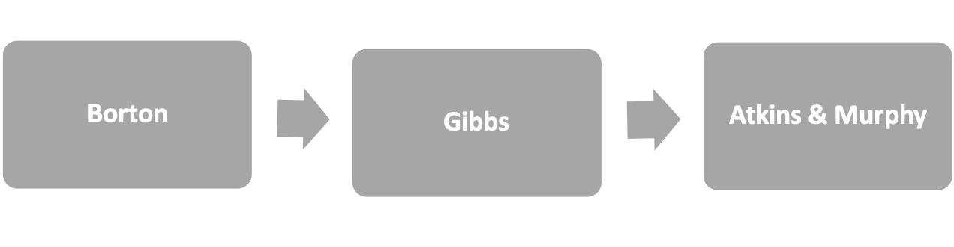

**Figure 10: Reflective cycle models**

As we saw in Unit 1, reflection is basically an ongoing cycle of thinking about an experience, extracting new learning from it, and using this new learning the next time. When you use the new learning the next time, it becomes a new experience, which you then reflect on – starting a new loop of the cycle. However, you are not just going around and around like a car on a race track, but up and up like a spiral stair case (see Figure 3) or like a car driving from a lower level to higher levels in a parking garage. Each time you go around, you carry more knowledge and skill with you, like an Archimedes screw lifting more and more water with each turn (see Figure 5). Let us break this cycle into simple basic steps:

Step 1: THINK CAREFULLY about what happened in a situation, in order to:

Step 2: GAIN NEW UNDERSTANDING of yourself, the situation or others, which will allow you to:

Step 3: TAKE NEW ACTION to ensure greater success or effectiveness in the future.

Step 4 becomes Step 1 of the next cycle: THINK CAREFULLY about what happened ….

And so on.

This cycle can be represented simply in whatever way makes sense to you. We show an example in Figure 11.

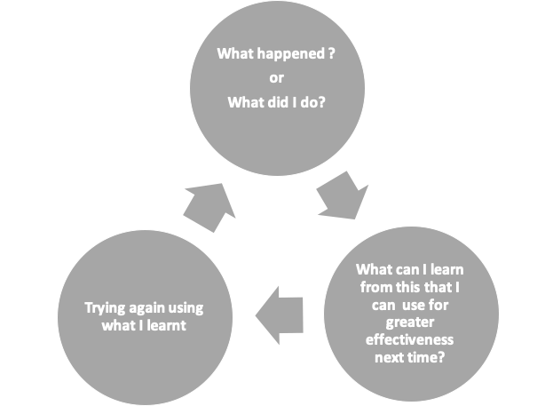

**Figure 11: Steps in a simple reflective cycle**

### Borton’s reflective questions

In 1970 Terry Borton, an American schoolteacher, proposed a simple series of questions that an educator could use as a cycle of learning through reflection. His framework uses three questions to prompt reflection leading to action:

1. WHAT?

*What*happened? In this step you remember or describe the situation or event you have experienced.

1. SO WHAT?

*So*,if that happened**,** *what* does this show you or teach me?In this step you explore what new insights or knowledge the situation gives you.

1. NOW WHAT?

*Now* that I have learnt something new by reflecting on the situation, *what* should I do about it? In this step you think about what to do with the new awareness you have gained. How can you make use of it to act more effectively in future situations?

Here are the questions represented in a reflective cycle (Figure 12) below.

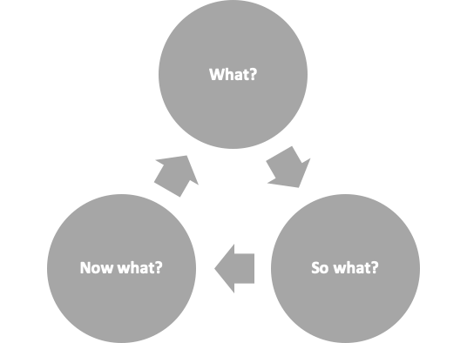

**Figure 12: Using Borton’s (1970) reflective questions as a cycle**

This model is simple, which makes it easy to remember the steps while you are reflecting on a situation, either in the middle of the situation (reflection*in* action) or later (reflection *after*action). This makes it a good starting point when you begin to practice reflection. It also provides a simple guide to use as you develop a deeper and more personalised reflective practice.

The questions do not force you to think critically as you reflect, as some other models do, and so you could use this model and not dig deeply enough for your reflection to help you very much. But this model also doesn’t prevent you from reflecting critically. Once you have become used to reflecting critically, using other models, you could use the simple steps of this model but make sure that you reflect critically as you move through it.

### Rolfe et al’s questions for critical reflection

Borton’s model has been used and adapted by different theorists in education, as well as other fields. Rolfe, Freshwater and Jasper (2001) expanded Borton’s three questions to create a framework for reflective practice for the nursing and helping professions. While Borton’s model does not require a person to think beyond the external events in a situation, Rolfe and his colleagues deepened the reflection to include the thoughts, feelings and attitudes one experiences in a situation and evaluate what was positive or negative about what happened and why it happened that way. In other words, they require the reflection to involve critical thinking about the situation.

**Table 1: Model for critical reflection**



Source: Adapted from Rolfe, Freshwater and Jasper, 2001.

### Activity 7: A reflective cycle in action

Suggested time: 60 minutes

Let us try out how a reflection might work using Rolfe et al.’s questions to guide us. In this activity, you will work through a scenario, discussing it in stages with your peers and writing your responses in your reflective learning journal.

**Scenario: Miranda’s class**

Miranda is an Early Childhood Development lecturer. She is teaching her students about using children’s literature to help Grade R learners develop early literacy skills. The following situation happened in her class which she has described in her reflective journal using Step 1: What?

|  |
| --- |
| **Step 1: What?**  I brought in several boxes of children’s books and arranged them on tables. I had spent the weekend collecting them from various sources. Some of them were really beautiful books. I told the students to browse through the books and take note of how words and pictures are used together, how word size and shape, colour and texture are used to tell a story visually. I was excited, hoping the books would inspire and motivate them about the topic.  Basambilu is a student who always looks bored or angry, I’m not sure which. She sits there and stares with an unhappy face and never offers responses when I ask questions. I saw her look at a few books, then slam one down on a table. She went and sat down, turned her chair to the wall and started looking at her phone. I was standing at my desk observing everyone. I called out to her, “Basambilu, you can’t possibly have finished looking at the books. Please come back and finish the activity with the others.” She completely ignored me! I felt my heart rate go up and my neck got hot. I raised my voice. “Basambilu, I need your cooperation please! Is there a problem?” All the students looked up and went silent. Basambilu turned to face me and stared at me. “Yes, there is a problem!” she said. “These books are ridiculous. Every single one is in English. And they’re all about some fairy tale in Europe or little white children having holidays by the sea with their mummies and daddies. Do you actually think this is appropriate for the children we teach? We should be using resources in their home language. And we should have lots of books showing children like them with lives like theirs that they can relate to, as well as other things! The kids in my village live 30 km from the sea but none of them have ever been on holiday there, I can promise you! Why are you giving us this stupid colonial and apartheid garbage and expecting us to use that with our learners?! This is not transformation! What about our stories? Do you think they’re no good? Where are the books by Sindiwe Magona and Gcina Mhlope and all our other amazing South African writers? Or don’t you even know about them?”  My heart was pounding and I felt my hands trembling. I couldn’t allow a student speak to me so defiantly! I needed to show my authority. I said, “Basambilu, I will not allow that kind of disrespect in my class. Please leave the class and wait for me by my office. We’ll discuss this after class.” She stared at me for a long moment, then picked up her things and left. For the rest of the class I couldn’t really concentrate. I kept telling myself I had done the right thing, but my stomach was churning. The other students, who had been chatting excitedly about the books before this happened, were quiet. They kept whispering to each other and glancing at me. I don’t think they really paid any attention to the books after that and our discussion was very superficial. After class I braced myself to talk to Basambilu. But she had gone.  I feel completely shocked about what happened. All my hard work to collect wonderful books to share with the students, and she practically spat on them! How dare she?!  I feel like the interaction spoiled the rest of the lesson, but I couldn’t see what else to do. When a student challenges your authority, you have to stand your ground. |

1. Look at the questions for Step 1 in Table 1 based on Rolfe et al.’s (2001) framework for Borton’s questions. Check Miranda’s journal entry against these questions. Do you think she has covered all of them? Discuss your thoughts with your peers. Then write down your answer in your learning journal.
2. Trying to put yourself in Miranda’s shoes (imagine you are her), write a Step 2 entry in your journal. What sense would you make of what happened? Make sure you cover all the questions. Read your entry to your peers and listen to theirs.
3. Now read what Miranda wrote for Step 2.

|  |
| --- |
| **Step 2: So what?**  I need to think about this with a cool head. I feel so angry with Basambilu. It’s true learners should have more home language books related to their lives. It’s hard to admit it, but I’ve never really thought about that. My students come from all different home language backgrounds and the course is taught in English. It never occurred to me that I should actively look for books in other languages. I think she’s right: there aren’t even black children in the books I chose! I support transformation and decolonisation and I know that if it’s going to happen, I must make it happen in my class. How can I have never realised that? Maybe, coming from a Coloured family, I never questioned the fact that all the children in the books I read were white because I loved those books so much. That was what we had, and I never thought about what effect that had on me or how it would be different if the stories were more diverse. Also … I’m from an English-speaking family, and I never thought about how frustrating it must be to only have access to English children’s books if your family speaks a different language. Wow, I’ve had a huge blind spot! Basambilu has really woken me up to something. I really handled that wrongly … and now I’m so embarrassed! |

1. Check Miranda’s journal entry against the ‘So what’ questions in the table. Do you think she has covered them all?
2. Discuss with your peers any differences between everyone’s responses and Miranda’s. Do any of your peers’ responses make you see the situation differently, or realise something new?
3. What would you do next if you were in Miranda’s situation? Write a Step 3 entry in your learning journal. Read your entry to your peers and listen to them reading their entries.
4. Now read Step 3 of Miranda’s reflection.

|  |
| --- |
| **Step 3: Now what?**  I need to admit to Basambilu and to the class that her points were valid. This is not going to be easy. I hope I will earn their respect and be a good example of admitting when you are wrong, learning from students, growing and changing. I also have to make changes in my teaching: I been teaching this course without decolonising it. I need to explain to the students that they need to work with the context where they teach and show them how to do that. I also need to make sure I am not overlooking the same issue in other parts of the course or other courses that I’m teaching. I should raise this issue at our next subject group meeting. This was an important wake-up call for me and others might need the same wake-up call. |

8. How did your Step 3 compare with Miranda’s and those of your peers? Do their responses help you see anything new, which you would like to add to your Step 3? You can do so.

Discussion of the activity

Do you think that you (and Miranda) were able to get more useful learning out of the situation by going through the reflective cycle, using Rolfe et al.’s questions, than you would have otherwise? Having the discipline of specific steps and questions can help to push us beyond what is initially visible and gain additional insights.

Did you find that your peers (and Miranda) saw things you didn’t see on your own; or that you saw things they had not seen? Reflecting with colleagues, or asking others for their perspective on a situation, can often broaden and deepen your reflection.

### Gibbs’ six steps

Graham Gibbs, a sociologist and psychologist, developed a model for reflection that he published in 1988 in his book *Learning by doing*. The Gibbs reflective cycle breaks reflection down into six steps, as shown in Figure 13.

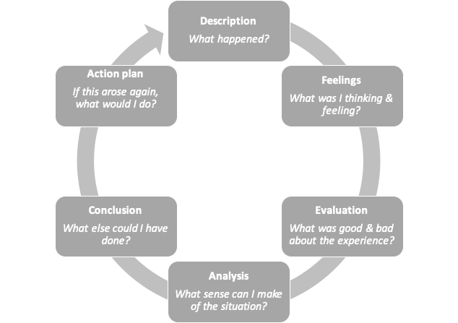

**Figure 13: Reflective cycle**

Source: Redrawn: Gibbs (in Finlay, 2008)

Can you see how steps 1, 2 and 3 correspond to the first step in the models by Borton and Rolfe et al: the ‘what’ question? These steps help to map out the situation or experience. While breaking this down into three steps might seem to make it more complicated, it might also make it easier by providing more support and guidance as you work through the ‘what’ of each question. Let us look at these first two steps in detail.

**Gibbs’ Step 1: Describe what happened**

In this step, you aim to get a clear and full picture of what happened, without thinking about how you or others thought or felt about it or why it happened like that. Do not make judgements yet or try to draw conclusions; simply describe. Ask yourself questions like:

* What happened?
* What had you planned or intended to happen?
* When and where did it happen?
* Who else was there and why were they there?
* What did you do?
* What did other people do?
* What was the result of these actions?

**Gibbs’ Step 2: What did I think and feel?**

Now identify what you thought and felt during the experience. You do not need to go into a lot of detail, or to evaluate or judge your thoughts and feelings. The purpose is just to identify what you thought and felt, so that you become aware of these aspects of the situation. You could also explore your thoughts about what other people were thinking and feeling.

My feelings:

* What was I feeling*before* the situation happened?
* What did I feel *while* the situation was happening?
* What feelings am I experiencing about the situation *now* (*after* the situation)?

My thoughts:

* What thoughts went through my mind *while* the situation was happening?
* What do Ithink about the situation *now*?

Now explore what you think other people were and are thinking or feeling about the situation:

* What do I think other people were *feeling* *during* the situation?
* What might the other people who were there be *feeling**now*?
* What do I think other people were*thinking during* the situation?
* What might the other people who were there be thinking now?

Note that these questions encourage you to try to imagine what others were thinking or feeling, based on their words, actions, expressions and your own observations. This is very useful, but these questions do not push you to actually seek out others to ask them what they thought or felt or to reflect together with them on the situation.

Without actually asking people about their thoughts and feelings, there is always the danger that we will interpret their words, actions and body language in a way that suits our ‘story’ about the situation or agrees with the view we already have of them. This could be wrong or unfair. In order to experience empathy for others – where we start seeing the situation through their eyes – we need to be willing for them also to be ‘right’. We need to admit that there can be more than one valid experience or viewpoint in a situation. As we will see later, it is always good to ask other people what they felt and thought in a situation, to make sure we have not read their body language incorrectly.

Some people get overwhelmed by their feelings and struggle to separate what happened (objectively) from the flood of subjective feelings they have about the situation. It is especially difficult for them to be objective about what is happening. Other people feel uncomfortable exploring their feelings and tend to ignore them or even be unaware of them. They miss the important information that feelings can provide by alerting you to a situation where you need to stop, understand what is happening and think about your responses. In other words, noticing your emotions start to rise in a situation – whether you are feeling angry, disrespected, frustrated, or anxious – can be a very important signal that you need to reflect about the situation (sometimes stopping right then to reflect in action) and perhaps choose a better course forward, instead of continuing as you are.

If you struggle to identify your feelings, the physical sensations you are experiencing may provide clues to your emotions. Try to tune into these sensations. Paying attention to other people’s body language may also help you to identify the emotions they are experiencing.

The following activity will help you engage with this more deeply and may help you ‘mine’ more from the scenario with Miranda and Basambilu than you did during your first reflection. (We will continue with Steps 3 to 6 of Gibbs’ model after the activity.)

### Activity 8: Identifying emotions

Suggested time: 30 minutes

1. Turn to the table in Appendix 2. You will see a list of basic emotions with common physical sensations or behaviours that often go with each emotion. Different people may experience different sensations or show a different behaviour for the same emotion, but in general you will notice patterns of similar sensations or behaviours.
2. As you read through the table, think about whether the physical sensation or behaviour described is something that you think you experience along with that emotion. Can you think of a time you experienced it? Have you seen someone else acting this way when they experienced this emotion? If you can think of another sensation or behaviour which can go along with an emotion, add it to the blank space at the end of each section.

You can see that the category ‘anger’ has a lot of physical descriptors listed. There are many different emotions that result in anger, such as feeling disrespected, threatened or humiliated.

Shame can be a very ‘invisible’ emotion. This is because one of the characteristics of shame is that we tend to feel more ashamed if anyone finds out that we feel ashamed. This means that we tend to try to cover up any physical evidence of feeling ashamed. You will need to observe carefully to ensure that you don’t interact with your students in ways that can cause them to experience shame.

3. Go back to the scenario about Miranda and her student Basambilu and read her Step 1 reflection again. Then review the questions in Step 2 of Gibbs’ model. Respond to the following questions in your learning journal:

1. What emotions does Miranda experience that she identifies (names)? What physical sensations does she identify that might be clues to her emotions? What emotions do you think they indicate?
2. Which of Basambilu’s physical behaviours does Miranda use as clues to the student’s emotions or attitudes? Do you think she is reading Basambilu’s body language correctly? Did you read it differently?
3. What body language does the rest of the class show as the scenario unfolds? Does Miranda interpret this body language? Was your interpretation different?
4. If Miranda had used Gibbs’ Step 2 questions, how could these have deepened her reflection on what happened?
5. What could you do to ensure that you accurately and fairly understand another person’s experience of a situation? How could you get yourself to let go of the need for your own thoughts and feelings to be the ‘right’ ones in a situation – especially if the situation has involved a conflict of views or unpleasant emotions for you personally?
6. Discuss your responses to these questions with your peers. Do they perceive anything differently? Does their perspective enrich your own viewpoint?

Discussion of the activity

Miranda identifies her own emotions such as feeling excited about the books and shocked afterwards. She also notes a number of physical sensations, but does not link them to feelings: heart pounding and hands trembling (feeling her authority is being threatened); being unable to concentrate and her stomach churning (feeling anxious); or bracing herself (feeling anxious).

She identifies and interprets Basambilu’s body language by saying that she ‘stares with an unhappy face and never offers responses when I ask questions’ and that she thinks this means Basambilu is either bored or angry. Miranda describes a number of Basambilu’s actions without attempting to interpret what the student was feeling, but she uses words that show her negative view of Basambilu: ‘slamming’ the book down; ‘she ignored me’; she ‘stared at me for a long moment’.

While Miranda is in the situation she reads all of this as a challenge to her authority in the classroom, but she does not ask herself what Basambilu might be feeling or thinking, or why. After the situation is over, Miranda reinterprets Basambilu’s angry, hostile and challenging *actions* based on the *thoughts* Basambilu expressed. Miranda comes to see these actions as not challenging her authority but rather challenging a choice she had made in her teaching, which supported a colonial perspective on education.

|  |
| --- |
| Learning more about how to ‘read’ body language can help you learn more from situations as you reflect in action and after action and as you plan future action.  The following resource can help you develop your understanding of body language and your ability to interpret your own physical sensations and other people’s body language:  **Body Language II: Reading People**  This booklet provides information on how facial expressions, gestures, postures and eye behaviour are used to communicate, as well as tone of voice, touch, the use of space and the use of time. It suggests keeping a body language journal for a week to help you become more aware of how body language is used.  You can access the resource [here](https://www.socialstudies.com/pdf/LSC142DVG.pdf).  You can find information on a range of body language issues, such as cultural differences, office dynamics, eye contact, use of space, or defensive and aggressive body language by typing “body language” into a search engine. |

Now that we have explored a deeper engagement with emotion in the reflective cycle, let us move on to the other steps of Gibbs’ model.

**Gibbs’ Step 3: Evaluate the experience**

Once you have put what happened clearly before you and explored what you thought/think and felt/feel about it, you can evaluate what happened. For this to work you must be very honest with yourself: if you were unfair, unprofessional or unprepared, for example, it will be very tempting to feel defensive and blame others. Be willing to look at both positive and negative aspects of what was said or done by both you and others. The following questions can help you to do this:

* What was *positive or successful* in the experience?
* Why did it have this outcome?
* How did I contribute to this?
* How did others contribute?

Then:

* What was *negative or unsuccessful* in the situation?
* Why did it have this outcome?
* How did I contribute to this?
* How did others contribute?

Now that you have mapped out the situation, the final three steps of Gibbs’ model help you to make sense of what happened, learn from it, and apply why you have learnt to future situations.

See how steps 4 and 5 correspond to Bolton’s cue question ‘so what?’ and Step 6 to ‘now what?’.

**Gibbs’ Step 4: Analyse the situation**

Having laid out the situation in steps 1, 2 and 3, try to make sense of what happened.

* What understandings can I ‘extract’ from the situation?
* What was *really* going on?
* How does this relate to theory, or other experiences?
* Did different people have different experiences of it, and why was this the case?

**Gibbs’ Step 5: Conclusions**

Now take a step away from the situation and summarise what you have learnt. Identify what alternatives you have that could give you better outcomes the next time. Some of the questions that can help are:

* What did I learn from this situation?
* What could I have done differently that could have resulted in a better outcome?
* What skills do I need to develop so that I can handle a situation like this better?
* What will I do differently if the event, situation or activity were to happen again in the future?

**Gibbs Step 6: Action plan**

In Step 5 you identified what you would like to do differently in a future identical or similar situation; now make a plan for how you will ‘help’ yourself to do this, to make sure that it happens. Do you need to set things up differently? Get resources on board? Make a schedule? Meet with someone?

Helpful questions:

* What will I do differently next time?
* How will I develop the required skills I need?
* How can I make sure that I follow through with this plan?

### Stop and think

|  |
| --- |
| 1. Would steps 3 to 6 of Gibbs’ model have deepened Miranda’s reflection?  2. What plans might Miranda have made about how to respond in a similar situation in the future?  In a future situation, Miranda could try to find a way to withdraw from the interaction for a moment to reflect in action about the situation before reacting, possibly saving herself some embarrassment. She could even draw the students into a reflective discussion about Basambilu’s comments, encouraging them to listen and learn together. However, Miranda’s own need to feel in control and her fear that Basambilu was threatening this, was a big factor contributing to the situation, and she would need to address this before being confident and secure enough to welcome criticism from her students and inviting discussion on a difficult issue.  Remember, in a cycle your last step is the first step of the next cycle. A similar situation will now be different, because you will use what you have learnt from your experience to try something new. Imagine you are Miranda. In your learning journal, describe what happened in a similar situation, when you acted after reflection. |

### 

### Atkins and Murphy’s cycle challenges assumptions

Gibbs’ reflective cycle is quite clear and easy to understand. It may help you to become more aware that you would have been otherwise. As you use it more, you will probably begin to notice things as they happen and develop a more balanced judgement. However, it doesn’t push you to go more deeply into the underlying issues and explore your assumptions. While Gibbs’ reflective model breaks down reflection into smaller steps, and helps to ensure you explore both thoughts and feelings, it does not require deep analysis or critical reflection. Again, however, there is nothing to stop you from reflecting critically, as you use Gibbs’ model.

Atkins and Murphy (1993) proposed another version of the reflective cycle to encourage critical reflection on assumptions.

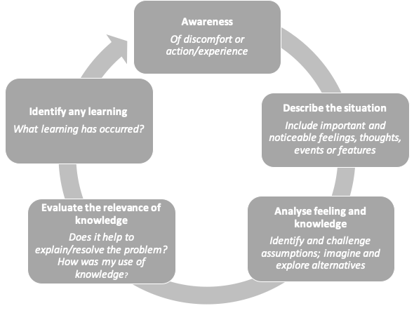

**Figure 14: Reflective model**Source: Redrawn: Atkins and Murphy’s 1993, p. 1191

Both Gibbs’ and Atkins and Murphy’s models have a stage where you describe what happened. However, while this is the first stage in Gibbs’ model, Atkins and Murphy start the reflection cycle with a ‘trigger’ – an awareness of an uncomfortable feeling (or of an experience or action). (This is what happened in the scenario with Miranda and Basambilu.)

While both models emphasise exploring thoughts and feelings, for Gibbs this happens after describing what happened in the situation, while for Atkins and Murphy being aware of and exploring thoughts and feelings take place early in the cycle. Atkins and Murphy’s model thus acknowledges the important role that feelings (emotions) can play in flagging a situation where reflection is needed. Being aware of your feelings may save you from continuing with an action, resulting in a negative outcome.

Both models include analysing, evaluating and identifying what could be done differently, but there are differences in the way they handle this. In Gibbs’ model, you evaluate what was good or bad about the experience (Step 3) then analyse what you think was really going on in the situation and try to make sense of it (Step 4).

In Atkins and Murphy’s model, after becoming aware of and describing feelings/ action/ experience (first and second parts of the cycle), you analyse what you felt and what you know about the situation (third part of the cycle). You dig more deeply into this, trying to identify and challenge your own assumptions in the situation – whereas Gibbs does not push you to work at this level. Important learning might happen when probing these spaces, which may remain hidden to you when using Gibbs’ model.

Having tried to broaden your awareness of your own role in the situation, you try to imagine and explore alternative ways you could handle a situation like that in the future (still third part of the cycle). This corresponds to ‘now what’ and Gibbs’ Step 6, where you plan what you would do next time, but does not necessarily take it to the level of planning. Atkins and Murphy’s cycle ends with identifying what learning has occurred – which is not done as consciously or explicitly in Gibbs’ model.

**Table 2: Comparison between Gibbs’ and Atkins and Murphy’s models**

|  |  |
| --- | --- |
| **Gibbs’ Reflective Cycle** | **Atkins and Murphy’s Reflective Cycle** |
| **WHAT?** | |
|  | **1: Awareness:** Of discomfort or action/experience |
| **1: Description:** What happened?  **2: Feelings:** What was I thinking and feeling? | **2: Description:** What happened? What did I think and feel? |
| **SO WHAT?** | |
| **3: Evaluation:** What was good and bad about the experience?  **4: Analysis:** What sense can I make of the situation? | **3: Analyse feeling and knowledge**: Identify and challenge assumptions – imagine and explore alternatives  **4: Evaluate the relevance of knowledge:** Does this help to explain/resolve the problem?  **5: Identify any learning:** What learning has occurred? |
| **NOW WHAT?** | |
| **5: Conclusion:** What other ideas/approaches could have been used that could have had a better result?  **6: Action plan:** What will I do next time? | (6) How could I use this knowledge? |

### Activity 9: Using a reflective model

Suggested time: 30 minutes

1. Choose an experience you have had with your students or colleagues that you would like to reflect on.
2. Choose *either* Gibbs’ model *or* Atkins and Murphy’s model and work through the steps.
3. You can record your reflection in any format you would like (for example, audio recording, sketchnoting, journaling or blogging), but ensure that you do record it.

We have explored several models that approach reflection as a step-by-step process ending at a new situation where learning is used to handle the situation differently. Borton’s model can be used as a quick-and-easy memory device to help us use our reflective tools when we are in a situation where we do not have the more detailed models at hand. Rolfe et al.’s model introduced critical thinking. Gibbs’ model helps us to consider what we thinkothers might be thinking and feeling, and Atkins and Murphy’s model helps us to challenge our own assumptions.

Let us now explore some theoretical models and tools that can help us to reflect more deeply and to use others’ perspectives to deepen and broaden our understanding.

## Tools that aid deeper reflection

There are many different tools that are designed to aid reflection. Here we look at three that you can incorporate into your reflective practice (Figure 15). The *Johari window* helps you identify different levels of awareness that you have about different things and how you can increase your awareness. *Brookfield’s lenses* use the perspectives of your colleagues, your students, and the literature, in addition to your own experience to increase your awareness of your teaching. *Everyday practice* looks at the cognitive (intelligence and reasoning), psychomotor (cognitive processes associated with physical movement), conative (effort) and affective (relationships) aspects of what happens in the classroom to deepen reflection. You can use these tools on their own or combine them, or you can borrow elements from them to incorporate into your reflective practice.

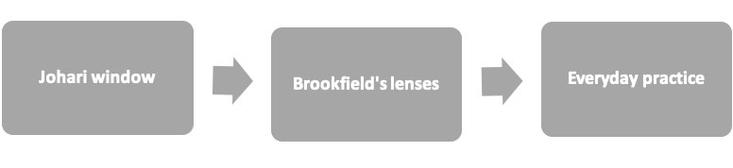

**Figure 15: Tools to aid reflection**

### The Johari window model

The Johari window (Figure 16) is a model that helps us find and explore areas of ourselves that we are not aware of. The tool was first developed by psychologists Joseph Luft and Harry Ingham in 1955 (the name of the model comes from the first parts of both of their first names: Jo-Har, [Wikipedia](https://en.wikipedia.org/wiki/Johari_window)). It is often used in business and organisational contexts.

The model has four quadrants (sections) or ‘window-panes’. Each window pane represents an area of oneself. The two panes on the left are areas of yourself that you know about, the two panes on the right are areas within yourself that you do not know about. The two panes on the top are areas that others know about; the two panes on the bottom are areas that others do not know about.

|  |  |  |
| --- | --- | --- |
|  | **KNOWN TO SELF** | **NOT KNOWN TO SELF** |
| **KNOWN TO OTHERS** | | **Open area**  (you know,  others know) | **Blind spot**  (Others know,  you don’t know) |
| **NOT KNOWN TO OTHERS** | | **Hidden area**  (You know,  others don’t know) | **Unknown area**  (You don’t know,  others don’t know) |

**Figure 16: The Johari window model**Redrawn: [Source](https://commons.wikimedia.org/wiki/File:Johari_Window.PNG)

Let us look at each of these areas in more detail.

**Open area**

The ‘open area’ is information about you that you and others know. This can include your knowledge, behaviours, habits, skills, experiences, attitudes, views, feelings, personality traits, and so on. In the work context, the longer you work with people the more you will usually share with them and this open area will grow. When both you and others know things about you, they can give you helpful feedback about how you handle things.

**Hidden area**

If you are working alone, rather than in a team, your colleagues might not know much about you. This ‘hidden area’ limits their ability to give you useful feedback. Some people actively withhold information or hide aspects of their professional lives from their colleagues. They might lack confidence and feel afraid they will be criticised if others see their limitations. Or they may know they are not doing their work diligently and do not want others to find this out. Or they could even be violating the institution’s policy or professional code of ethics and want to keep this a secret. For example, they could be involved in an inappropriate relationship with a student or be using the institution’s resources for their personal benefit.

It is important to be transparent in your professional life, inviting those you work with to watch you teach or work and sharing difficulties and successes alike. You have every right to not share information about your personal life with your colleagues and students. However, if you are open about your personal life (to some extent) those around you will have a better understanding of who you. This will make them more able to support you and will also help them to develop their trust in you. For example, telling your students stories about your children from time to time or about your own experiences as a student can help your students realise that you are a full human being who is capable of feeling concern and of understanding them as full human beings as well. A high level of trust in the classroom is beneficial to learning. For example, it might make a student more likely to reveal something about their personal life, which may be interfering with their learning. Similarly, if your colleagues know you have a family member who is dying, for example, they will be more understanding if you don’t seem as friendly as usual, or they may offer to help carry some of your load temporarily. If you keep these aspects hidden, they may be more likely to misinterpret your body language and behaviour and judge you unfairly.

**Blind spot**

The ‘blind spot’ is the area where others know things about you that you do not know about yourself. At first, it may seem that this is not possible. But think about the teachers you had when you were a learner or student. Can you remember mannerisms, habits or weaknesses that were glaringly obvious to you and your classmates, but that they seemed to be unaware of? People who do not reflect on their words and actions and assume that they are always right and that everyone agrees with them can have large blind spots. Leaders who surround themselves with people who tell them what they want to hear and are afraid to challenge or criticise them can end up with blind spots that keep growing. There is a danger of this happening in the classroom, as well, where you have greater power than your students and they may feel afraid to challenge you or point out an error or weakness.

To reduce our blind spots, we need to reflect on our own actions. We also need to invite honest feedback from colleagues and students and receive this feedback graciously. Because, as lecturers, we have more power than students do in the college, we need to ensure that students feel safe and protected if they express criticism of us. This could be achieved by building up a trusting environment, using humour and owning your weaknesses and mistakes, and encouraging an environment of experimentation where errors are a seen as a useful part of the learning process (growth mindset). When students find the courage to give you feedback and you receive it with gratitude, it will increase the atmosphere of trust and reduce your blind spots.

**Unknown area**

Not all your attitudes, behaviour, emotions, feelings, skills and views are within your conscious awareness, but they affect the way you act and teach, and others are impacted by them. Our colleagues, students, clients, patients, customers, guests, and so on all have an ‘unknown area’.

You should aim to bring as much as possible that is related to your professional life out of the unknown area into the open area. Through reflection and feedback from others you can come to know yourself well and have no major hidden areas or blind spots. You can also reduce the hidden area by sharing your thoughts, experiences and failures and successes with your colleagues and, to some extent students, patients, or others with whom you have an ongoing relationship built on trust. This fits with growth mentality, where you see the exploration of weaknesses, mistakes or failures as a natural and positive path to improvement, rather than generating shame, humiliation, fear of disapproval or disrespect.

### Stop and think

|  |
| --- |
| Think back to the scenario with Miranda and Basambilu. Which parts of Miranda were in the hidden or unknown area and were brought into the open area through reflecting on the experience? Note your thoughts in your learning journal.  Brookfield’s lenses are another tool which can help us identify what is in our blind spot or unknown area and bring it into the open where we can work with it more effectively. |

### Brookfield’s lenses

Stephen Brookfield (1995) proposes that for reflection to increase our awareness of our teaching as much as possible we should include as many different perspectives as possible. His model provides four lenses or points of view that educators can use to broaden their critical reflection (Figure 17).

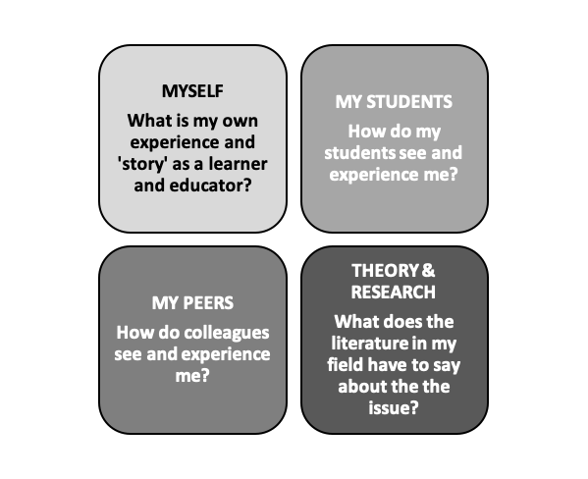

**Figure 17: Brookfield’s four lenses**

Source: Redrawn: Brookfield, 1995.

Each of these four lenses can give us quite a different picture of who we are and what we do:

The ‘*myself’* lens (called the ‘autobiographical’ lens by Brookfield) involves looking at one’s teaching through one’s own experience or ‘story’ as both a teacher and learner (Brown, 2017). By relating our current situation to past situations, using our emotions and observations, we may be able to identify patterns or achieve insights. We may be to see where our teaching needs adjustment or strengthening. We may realise that we are reacting to current situations based on past issues or personal hurts that are not relevant to the present context. Reading past reflective journals may help with this. We may be able, on our own, to uncover and transform some of our assumptions and beliefs about how people learn or other aspects of our teaching. But, as we saw with the Johari window model, if we use a reflective cycle that only involves looking at our own perspective of who we are (the MYSELF lens), we are unlikely to reveal things in the ‘blind’ or ‘unknown’ parts of ourselves. The other three lenses identified by Brookfield may provide us with important insights.

The *‘my students’*lens involves seeing your behaviour (words, actions, interactions, body language) through the eyes of your students. You may see new things by trying to imagine how the situation looked and felt from their perspective. However, it is also important to find out directly from them how they experienced the situation, as you could be wrong about what you think they felt and thought. You can do this by holding reflective discussions in class. However, you will need to establish an atmosphere of trust, where you show them convincingly that you will not react negatively to criticism in a way that could hurt them. You could ask them to write their reflections and submit these anonymously (without an identifying name). Alternatively, you could ask them to reflect in groups and have a representative report back on all points made, so that individual identities are protected.

The *‘my peers’* lens involves looking at your teaching from your colleagues’ perspective. It may feel uncomfortable to ask your peers to watch you teach or ask for their input on an issue you are encountering. You may feel that, if you reveal problems or weaknesses, they will question your competence or think you are inferior. However, by opening up aspects of your teaching to colleagues whom you think may be willing to help (bringing hidden parts of your teaching into the open area, to this to the Johari model), you may find that they have similar struggles. They may offer suggestions that have helped them. You may find that they are already aware of the issue by observing your behaviour, or that your students have discussed it with them, but that they did not feel they could open the topic with you until you did. (In other words, you may find that while you thought it was in the *hidden* area where they couldn’t see it, it was actually in the *blind* area, where they knew things about you that you didn’t know they knew, or possibly were aware of things you were not aware of). Your willingness to discuss a problem with them may make them feel more comfortable to come to you with a problem of their own. This may help to create a more supportive atmosphere among your colleagues, as well as enable common problems to be identified and addressed, encourage group reflection about professional concerns, and result in greater social learning.

The *‘theory and research’* lens involves drawing from the perspectives that theoretical literature and scholarship have to offer on the issues that that you are reflecting on. By exploring the literature, you may find theories and models that help you to understand your situation better, and that provide options for handling it more effectively. Again, by cultivating an atmosphere in which you discuss issues professionally with colleagues, you can benefit from others’ theoretical knowledge and explorations into literature, as well as share your own.

### Activity 10: Using Brookfield’s lenses to deepen reflection

Suggested time: 60 minutes

Think back to the scenario with Miranda and Basambilu. Discuss the following questions with your peers. Then make notes in response to each question in your learning journal:

1. What might Miranda gain by asking her students (Basambilu, as well as other students) and colleagues for their perspectives on the situation?
2. If you had been a student in Miranda’s class and she had asked what you thought and felt in the situation and after it, what would you have said? Would you have felt afraid to answer her honestly in case it might affect your marks?
3. If you were Miranda’s colleague and she had asked for your point of view, what would you have said? Are there relevant lessons from your own life or teaching experiences that you could share with her?
4. What might theoretical literaturebe able to offer her on the situation? Would you, as a colleague, be able to point her to relevant and helpful literature?
5. Now apply the three new lenses provided in Brookfield’s model to your own teaching practice. Write your responses to the following questions under these headings in your learning journal: a) Using my students’ perspectives to enhance my teaching:

* Do I currently have any ways in which I enable students to give me feedback on my teaching or my courses in general, or in specific situations? Can I think of specific examples?
* Do my students feel I will accept their feedback with appreciation or are they afraid I will feel attacked or offended, and that I might retaliate?
* What other approaches could I use that would help me find out what my students think and feel about things that might be sensitive?
* What obstacles do I face to getting honest perspectives from my students (including, possibly, my own attitudes, beliefs or assumptions)? How could I overcome these?

Using my colleagues’ perspectives to enhance my teaching:

* Are there currently ways in which I get feedback from my colleagues about my teaching in general or about specific situations? Can I think of examples?
* Do I seek their feedback or does this happen through some formal process in the college? How can I seek out more specific feedback that could be useful?
* Which colleagues do I trust enough to discuss a difficult situation with (and perhaps expose some of my weaknesses)?
* What obstacles do I face to getting honest perspectives from my colleagues (including, possibly, my own attitudes, beliefs or assumptions)? How could I overcome these?

Using theoretical knowledge to enhance my teaching:

* Do I ever look to theoretical knowledge to help me with teaching challenges? Why or why not?
* Where do I usually go to find theoretical input on questions that I am exploring (for example, experts, internet, library)?
* What obstacles do I face to getting theoretical input into my teaching (including, possibly, my own attitudes, beliefs or assumptions)? How could I overcome these?

1. Discuss your responses to question 5 with your peers.

Discussion of the activity

In this activity you have explored how seeking out perspectives in addition to your own – those of your students, colleagues and scholarly literature – can enrich your reflection and thus your ability to improve your teaching practice.

Theories and models are not cast in stone: you can borrow from them, combine them, build on them, or create something that you think is more complete or effective. If we incorporate the Johari window model (Figure 16) as a more complex breakdown of ‘myself’, we can see how the Brookfield lenses help to continually expand our ability to see things clearly and objectively. Engagement with students, colleagues and theoretical literature continually moves things from the blind, hidden or unknown areas of yourself into the open area, where you have self-awareness and the power to make choices and act.

Let us relate the Johari window model and the Brookfield lens model to a reflective cycle by incorporating them into the second step of the cycle (see Figure 18).

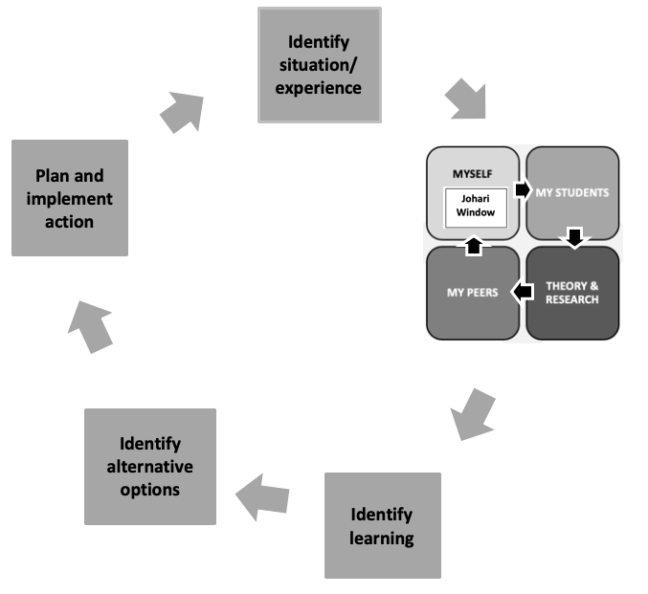

**Figure 18: Brookfield’s lenses can be used in the second stage of a reflective cycle and the Johari window model can be used to deepen reflection while using the ‘myself’ lens.**

### Everyday practice



**Figure 19: Erik Blair**

[Source](https://www.uwl.ac.uk/about-us/how-university-works/our-academic-schools/expert-academy/who-we-are/dr-erik-blair): Reproduced with permission of E. Blair (pers. comm.)

Erik Blair, a senior lecturer in Higher Education Research and Practice at the University of West London in the United Kingdom, has developed a model that he calls ‘everyday reflective practice’. He describes this in his blog (Blair, 2017):

In teaching and in research I tend to ask two questions: “What?” and “So what?” The first of these seeks to discover what is happening, while the second looks for possible impact. I have found the beauty of these questions is their simplicity and portability. After a heated meeting I can walk away asking myself, “What happened there?” and “What am I going to do about it?” After reading a journal article I can think to myself, “What are the key messages?” and “How do these translate to my world?” And, after a successful class, I can reflect on what made it successful and how I can maximise this in future. (Likewise, I can reflect upon a class that was not so successful). So, for me, the start of everyday reflective practice involves asking myself these two questions.

From this simple beginning I then reflect on four specific areas drawn from the work of Benjamin Bloom and his colleagues: the cognitive domain; the psychomotor domain; the affective domain, and the conative domain (see Blair, 2011; Blair & Deacon, 2015). In other words, I reflect on the content of the session and how well it was taught and learnt; I reflect upon my movement through the teaching environment and the body language of my students; I reflect on the relationships I have with my students and their interaction in the classroom; and lastly, I reflect upon the effort that I put into my teaching and the effort that I feel they put into their learning.

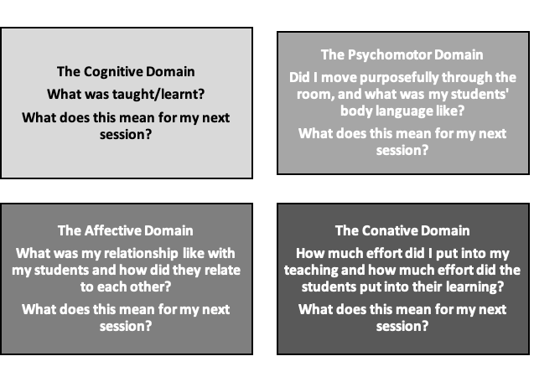

**Figure 20: Reflecting against four educational domains**

Source: Blair, 2017

Blair’s approach has quite a different focus from the other models we have looked at. Rather than focusing on thoughts and feelings, he focuses on content and skills that were taught or learnt, the use of one’s body and the physical space in the teaching and learning encounter, the effort invested in teaching and learning and the quality of interactions. He does this by looking at his own actions, effort and interactions and evaluating what the students have done.

The model does not indicate that students were asked for their input. This could have the weakness discussed in the section on Atkins and Murphy’s model: one might imagine students’ experiences of a situation to be what you want them to be, instead of checking with them how they actually experienced it. These judgements could, therefore, be quite subjective. To gain a wider perspective, you could incorporate Brookfield’s lenses. It may also be useful to define what ‘body language’ and ‘effort’ mean in the context, and to provide more specific detail for the question: ‘What was my relationship like with my students and how did they relate to each other?’.

### Stop and think

|  |
| --- |
| Use the scenario with Miranda and Basambilu to work through the four domains in Blair’s model.   1. How do these domains help to highlight aspects of the situation that might have been missed otherwise? 2. How could these insights be used to improve things another time? |

Write your reflections in your learning journal.

## Transformation: Going for more than improvement

Jack Mezirow, a sociologist and Professor of Adult and Continuing Education, in 1975 introduced the concept of transformational learning(also called transformative learning) (Reflective practice, 2020). Transformational learning happens when we become aware that assumptions, beliefs or attitudes we have held are not true or relevant. This can result in a deep and permanent change in the way we see a situation or the world around us.

Our beliefs and assumptions can be very deeply rooted inside of us, part of our identity. It can be difficult or painful if someone or something challenges them; it may even be difficult or painful for us to admit to ourselves that we hold some beliefs and assumptions.

An example could be something that is ‘politically incorrect’ – something that society strongly disapproves of at present but might not have in the past. For example, nearly all governments and organisations today reject racism, sexism, and treating minorities differently (unfairly) than everyone else. But many individuals still harbour sexist, racist or other discriminatory beliefs within themselves. They may not admit it to others, or to even themselves. But in some situations, their actions may be based on their underlying beliefs, producing ‘evidence’ of how they really think.

Many of our beliefs and assumptions are formed early in our lives and may be taught to us by the people we love and trust most – our parents or grandparents, or spiritual leaders, for example. Others are ‘wired’ into us by repeated experiences – for example, how we were treated as children at school day after day, or how we saw minorities repeatedly treated by members of our community.

As educators, we may have assumptions and beliefs about how teachers and students should be, which are based on experiences we had ourselves. These assumptions and beliefs may be wrong, but we have never questioned them or considered another view. We may even go along with professional values and ethics that are different to our personal views and not even realise that there is a conflict between the two. In an emotional situation or crisis, our deep-seated, ‘real’ beliefs or attitudes may come to light.

When someone acts against our deep-seated beliefs, we may feel angry or disrespected and assume that they are in the wrong. We may not stop to question what assumption we are using to judge their action by and whether we, as educated adults, sincerely believe that assumption to be true. Digging out and critically examining old assumptions, beliefs and thought patterns that are harmful to ourselves and our students enables us to experience the deepest and most profound level of change and growth. It can turn our perceptions, actions and reactions ‘inside out’; in other words, transform us.

Questioning and unpacking our beliefs and assumptions can be a disturbing, frightening and painful process, because it can feel like we are cracking into pieces, or even that our core self is being destroyed. But if we are committed to seeing things accurately and not allowing wrong or destructive beliefs or ideas to influence our actions, we can learn to tolerate the discomfort of going through the process.

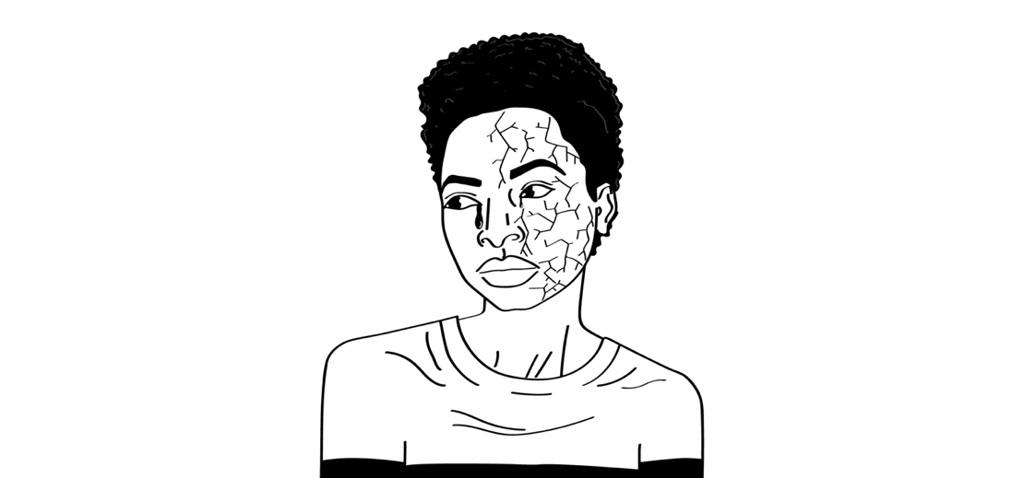

**Figure 21: As we question beliefs and assumptions we have always trusted, transformative learning can take us through a difficult process, where we feel we are shattering or being destroyed.**

Redrawn: [Source](https://www.pexels.com/photo/the-transformation-1669547/)

Transformative learning happens when deeply held beliefs or attitudes are challenged and you begin to realise they are not accurate or true. It can be very unsettling or even terrifying. You may feel like the person you know yourself to be is cracking, shattering or crumbling. You may feel like you are going to fall apart, and that you will not be able to put yourself back together.

### Stop and think

|  |
| --- |
| 1. Have you ever had an experience like this? 2. Do you think the image in Figure 21 fits with that experience? If not, how would you depict what you have felt? |

When we come out the other side of the transformative learning process, it can feel liberating and exhilarating. Instead of losing part of ourselves, as we may have feared during the process, our minds have expanded, and our thoughts and feelings are clearer and truer. Our perspective has changed and as a result our behaviour will change without us even thinking about it. We may experience this as intellectual and emotional growth. The image in Figure 22 also depicts a person ‘cracking open’, allowing new awareness and growth to emerge.



**Figure 22: Cracking open**

[Source](https://www.needpix.com/photo/download/334756/awakening-emergence-transcendence-liberation-emerging-awake-self-discovery-consciousness-enlightenment)

### Stop and think

|  |
| --- |
| 1. Consider the images in figures 21 and 22. 2. Which image makes you feel more uncomfortable, or more excited, about the idea of transformative learning? |

Robert Boyd, who developed a theory of transformative education, describes transformation as “fundamental change in one’s personality involving [together] the resolution of a personal dilemma and the expansion of consciousness resulting in greater personality integration” (Boyd & Myers, 1988).

This sense of our self-awareness expanding so that our understanding and actions become clearer or better can be very rewarding – for those who get used to it, deep reflection has intrinsic rewards.

### Stop and think

|  |
| --- |
| 1. Think back to the scenario with Miranda and Basambilu. Can you see how the ‘shocking’ experience that Miranda had with Basambilu, followed by reflection, resulted in a transformation of her perspective that had not happened through day-to-day learning and professional growth? While this was traumatic, Miranda also found it a liberating experience. She was able to see and bring more of her unknown self into line with what she really believed and cared about. 2. Can you see how the transformative experience relates to becoming more objective? When we are less trapped in our personal story and more willing to see things from all perspectives, incorporating different ‘sides’ of the story into our view, we gain a more complete, true picture than we had before. |

Once we have experienced transformative learning a few times, we may learn to trust the process, knowing that it can bring us very great rewards. During reflection, we may be willing to dig deeply into the ‘scary places’ on our own, or with others whom we trust. However, many people remain afraid of looking very far into the ‘shadows’ within themselves and they stay in a ‘safer’ zone during reflection, digging more shallowly and making small improvements.

Mezirow noted that a “disorienting dilemma” such as a crisis or major change in life could trigger transformational learning in a person who might not be open to it otherwise (Simsek; quoted in Seel, 2012). In such a situation, we may become aware that beliefs we held were not true, that what is really important to us is different from what we believed we cared about, that our abilities are different from we had thought, or that other people are different from what we had seen. The tidy systems we had constructed for understanding ourselves and the world around us are torn open and we have to let some things go, while we gain other things, which then become part of our new sense of ourselves or of the world around us.

### Stop and think

|  |
| --- |
| 1. Can you think of crises or changes which have triggered transformational learning in your life or the life of someone close to you?   In your personal life, this could be a death, or divorce, or betrayal, for example. A person may believe that they could not survive without their spouse, and after their spouse’s unexpected death they go through a painful but liberating process of discovering that they are more capable than they thought and that they can live a full and rich life on their own.  On a professional level, it could be an experience such as being fired unfairly, accused of a serious crime or violation, or discovering someone you trusted has committed a serious violation. This could permanently change the way you see yourself and behave as a professional. |

Note your reflections in your learning journal.

In terms of a model, or process, to facilitate transformational learning, Mezirow offers the following transformative learning structure:

1. Critical reflection on one’s assumptions;
2. Discourse: communication with others to validate insights from the critical reflection; and
3. Action.

Notice how, in Mezirow’s structure, the use of social learning by getting perspectives from others is important for transformation to happen. It is vital to engage with others directly as part of reflection – not just rely on our own reading of what others think and feel.

### Stop and think

|  |
| --- |
| Mezirow’s structure can easily be modelled as a reflective cycle, adding the *experience* as the first step.   1. Can you think of transformative learning experiences you have had? 2. What triggered them? 3. How did they change you? 4. What kept you from seeing or understanding these things before the transformative experience? Can you identify attitudes or beliefs? Where did they come from? Why had they not been challenged or ‘ruptured’ before? 5. Do you think it would have been possible for you to trigger these important insights yourself through reflecting in a very honest way, maybe with others who would have helped you to see the things you couldn’t see? |

Note your reflections in your learning journal.

While Mezirow focused on rational (logical) critical reflection as the way in which transformational learning happens, other theorists have noted that transformative learning may be more of an emotional or intuitive process for some people.

Simsek (quoted in Seel, 2012, p. 3341) writes:

While the learning process is certainly rational on some levels, it is also a profound experience that can be described as a spiritual or emotional transformation as well. The experience of undoing racist, sexist, and other oppressive attitudes can be painful and emotional, as these attitudes have often been developed as ways to cope with and make sense of the world. This type of learning requires taking risks, and a willingness to be vulnerable and have one’s attitudes and assumptions challenged.

If people often avoid transformative learning because it feels threatening and destabilising, and it usually happens to us when life forces it on us, how can we facilitate transformative learning for our students? Let us look at a scenario where a TVET lecturer was forced – through a crisis situation – to think about this question, and how she reflected on a transformative learning experience in her own life as way to gain insight into how to trigger transformative learning for her students.

### Activity 11: Creating discomfort to facilitate transformation

Suggested time: 1.5 hours

In this activity you will read a scenario involving transformative learning, discuss with your peers the questions that follow, and write your responses to the questions in your learning journal.

Read the following scenario.

**Scenario: Crisis situation**

Makhosi Ntuli is a lecturer in hospitality and catering services and is teaching a catering course to her N4 students. They have served a meal to a group of lecturers visiting from a TVET college in Sweden. One of her students has made a terrible mistake with one of the lecturer’s dietary restrictions, with devastating results. Ms Ntuli is afraid she could lose her job. Here is the first part of the reflection she wrote in her reflective learning journal:

|  |
| --- |
| 12 March  **What happened? (Awareness of discomfort)**  Tonight we prepared dinner for the college’s visitors from Sweden. One of the visitors has an allergy to nuts. Sindisiwe was his waiter. He asked Sindisiwe if there were any nuts in the meal and she said no. However, the chefs had made a peanut sauce which was drizzled over the vegetables. The man’s face swelled up and he had to be rushed to hospital. He is being flown back to Sweden as soon as he is able to travel. The Deputy Principal of Education and Training has asked me to come to his office first thing in the morning to discuss what happened. I’m so nervous! The guy could have died and I was ultimately responsible for the food! How could this have happened?! I suppose they have reason to fire me if they want to.  **So what? (analysis/evaluation)**  We spent a good amount of time at the beginning of the semester going over food allergies. They wrote a test on it. They all know it can be life threatening and you have to check for even small traces in the ingredients or the allergies listings. And I taught them the rule of thumb over and over: If you aren’t 100% sure, don’t take any chances. When I asked Sindiswe why she didn’t check she said she thought it was only if it was a piece that was big enough to see, and she knew there wasn’t. But I taught them that the smallest traces, too small to see, can make people sick! Why didn’t this stick with her?  Thinking about this brings to mind an experience I had as a student. We had to prepare a meal for students visiting from India. We had been taught about different diets – for example halaal, kosher, vegetarian and vegan. I remember the lecturer saying people take these very seriously, and I thought it was quite silly. Why does it really matter so much how the animal was killed, or if there is a tiny bit of meat in your stew, if it doesn’t make you sick? I remember thinking that people who thought like that were really too uptight. I had a customer who said he was Hindu and he asked for an option with no meat. I brought the dishes and they started eating. When I came back to check on them I noticed that he was eating the wrong one – with some shredded beef in it. Oh no, I thought, I realised I put the wrong plate in front of him. Anyway, he didn’t seem to be minding, so I thought it was best to not say anything. Then his colleague asked him, ‘what is that stringy stuff in your soup? It looks like beef.” Someone else at the table said, yes, that’s beef, I ordered the same thing. The guy nearly fainted. He jumped up and ran to the toilet. I followed him, trying to apologise. In the toilet he vomited and vomited. His colleague who was also Hindu told me they had actually never seen meat before because all of their families and neighbours are completely vegetarian, so they had not even recognised the beef. The student was supposed to speak as a representative of his college that night but he had to excuse himself and go lie down at his hotel. I was so shocked. I had never realised that what you eat could affect a person so deeply. I was severely reprimanded by my lecturer and made to apologise to the team. But it wasn’t even needed. It shook me to my core to see how badly I had affected that guy by my carelessness. Imagine if it had been something that made him deathly ill? I have never, ever made a similar mistake again and I never will. People have the right to decide what they feel they cannot or should not eat and in hospitality it is our role to make sure that is respected at all times. |

Before reading further, stop and imagine that you are Ms Ntuli and this has really happened to you. In discussion with your peers, continue the reflection through the stages of drawing out new learning and making a plan. Write your responses to the questions in your learning journal.

1. **Identify learning:** What new insights or understandings could Ms Ntuli draw from her own transformative experience?
2. **Conclusions:** What could Ms Ntuli do differently? What would transform her students’ attitudes and beliefs about people’s dietary choices or limits? What would go beyond simply acquiring new information, enabling students to take apart their existing assumptions and reconstruct them? What would give students a strong commitment to understanding and respecting their customer’s dietary restrictions?
3. **Action plan that facilitates transformation:** How could Ms Ntuli construct a transformative learning experience for students, based on her conclusions?

Now let us see how Ms Ntuli’s reflection progressed:

|  |
| --- |
| **Identify learning:** I realise that it is not enough to lecture people on serious issues like allergies. They may not fully understand, and they may not remember later. Information is not enough. They need an experience that makes them aware of attitudes or assumptions they have that need to change, and that motivates them to engage and change.  **Conclusion:** What could I do differently? What could I do that could facilitate transforming their underlying views? I don’t want to just put more information into their heads but leave their views intact. I need to simulate a situation that will shock them, but without putting them in danger, or humiliating or degrading them.  **Action plan for transformative learning:** I have an idea. I will have the second-year students make ice-cream and chocolate sauce and serve it to the first-year students, to give their feedback on the taste. But I will really use frozen mashed potatoes with vinegar and make a thick brown gravy with soy sauce. |

Discuss the following questions with your peers, then write your thoughts down in your learning journal.

1. What do you think of Ms Ntuli’s conclusions and plan? How is this different from your own?
2. Imagine you are Ms Ntuli’s colleague. What advice would you give her if she were reflecting with you on this experience?

Now, let us read on to see what happened after Ms Ntuli implemented her reflection-based plan (the final stage of that reflective cycle and the first stages of the next cycle):

|  |
| --- |
| 14 March  **ACTION (end of cycle) / WHAT HAPPENED? (beginning of next cycle):**  I had the second-years make the ‘ice-cream and chocolate sauce’ and serve it to the first-years in style. They served me first (some real ice cream and chocolate sauce) and I made a big show of tasting it carefully, telling them it was delicious and giving them feedback on improving the texture. Then they served the first-years. I watched the first years take a bite. Their reactions were intense! Absolute horror on their faces. Most of them jumped out of their chairs. They spat it out in their bowls, some even spat on the floor. As they looked around at each other they realised they had been tricked. I sat them down and told them what I’d done. From that I told them my story about serving the Hindu student meat, and facilitated a discussion about what had happened to the Swedish guest.  One student said, “I’m beginning to see that what we put in our bodies is very personal and whether it’s beliefs or health issues we have to take it very seriously – even if we don’t understand it. Another student said, “As people who prepare food for others we need to deeply respect that they are the only ones who can and should decide what to eat, and we need to be completely knowledgeable about the food we prepare”. Another student said, “I will NEVER forget the fake ice-cream and chocolate sauce!” and a lot of the other students agreed. I think the lesson has been learnt!  **EVALUATION/ ANALYSIS:**  I think my intervention was successful. The experience jolted them at a physical and emotional level and this triggered a transformative learning experience, which would not have happened, no matter how much I could have tried to drill into their heads the importance of carefully following people’s dietary restrictions.  **CONCLUSION**: I should do the same intervention every time I teach this course. But in future I’ll do it just before introducing the subject. They will then be very alert, I think, as we discuss different food allergies and dietary restrictions. I might need to think of a few other dishes to prepare that will achieve the same effect, as the story of the fake ice cream will probably get passed around and next year’s students may realise what is happening before they taste the ice cream. |

1. Consider the following questions:
2. Is there an area of learning in my teaching context where my students need to experience transformational learning?
3. What are the underlying attitudes, assumptions, or beliefs that they hold that need to be challenged, for them to develop the more accurate or complete understandings they will need as professionals?
4. How could I facilitate this?
5. Write down your ideas in your learning journal. Share your responses and your plan with your peers.
6. If you have an opportunity to implement your new action during this module, do so, and complete a reflective cycle on what happened. Share this with your fellow students if possible.

Record in your learning journal any insights or ideas you have while your fellow students share their ideas and experiences. You might like to try sketchnoting while they are sharing, if it is in a large group context.

Discussion of the activity

Transformative learning is powerful, because it suddenly breaks us out of assumptions or attitudes we may have held for a long time, often without even being aware of them. These beliefs or attitudes can be very deep-seated, and so simply teaching the ‘correct’ values or attitudes often does not change the way a person thinks and feels.

As valuable as transformative learning is, it can be very uncomfortable. As educators, we need to maintain a willingness to explore what we ourselves can learn from uncomfortable experiences, rather than just reacting to them, and also gently guide our students through transformative experiences so that they reap the rewards from them.

In this unit we have explored a range of reflective models and approaches. Each provides a different lens or tool that can help you to see more than you might otherwise have in a situation and to use these new insights to improve your teaching practice.

The purpose is ultimately to make sense of new experiences and knowledge, and to use tthis – rather than simply moving through life with a fixed perspective. *Sensemaking*(a term that was introduced by Karl Weick) is increasingly valued as a key ‘21st century skill’ – something that everyone needs in our rapidly changing and unpredictable world, in order to cope and succeede.

The more that you, as a professional, take responsibility for engaging with change and the unknown and, together with other colleagues, making sense of it, the better you will be able to work with the realities of the TVET context and prepare your students for the uncertainties of the future. Harold Jarche (2014) promotes what he calls Personal Knowledge Mastery, where professionals take responsibility for driving their own personal development through an onging process of seeking, sensing and sharing. *Seeking* involves continually looking for what’s new and staying up to date. *Sensing*involves making sense of the new things we learn as they apply to our own context, and experimenting with them. *Sharing* involves exchanging the new things we learn and discussing our ideas and experiences with colleagues. Building a network of colleagues that supports each other with professional growth and problem-solving can be very beneficial so that all can share what they find, rather than each person doing all the seeking on their own. This kind of a network is often called a Community of Practice (CoP). You will learn more about CoPs in your module on collaboration.

As you continue your journey of professional development and lifelong learning we encourage you to regularly explore and expose yourself to new ideas and models that have been developed, in addition to those that we have discussed here.

# Unit 3: Using reflection and enquiry to plan and design teaching and learning

## Introduction

In the previous units in this module we looked at how to use reflection during an experience (reflection *in* action) or after an experience (reflection *after* action) to gain new learning from the experience. This is a primary way that professionals can continue to drive their own learning forward, throughout their careers. In this unit we look at how to focus the reflective cycle as an enquiry to help you plan at several levels and to help you design effective teaching and learning experiences in your courses.

To ‘enquire’ means to ask a question and seek answers, to better understand something. You have seen that most of the reflective models we have looked at involve asking a lot of questions:

* What happened?
* What did I/others think/feel/do?
* What does this mean?
* What can I learn from it?
* How can I use what I have learnt to act more effectively in the next situation?
* When I used my new learning, what happened? Was I more effective?

All these questions are forms of enquiring – probing – into the situation to discover more. When you have something specific you would like to find out, you can reflect on what you want to know and how to construct your investigation *before*you implement the action. Cowan (2006) calls this reflection *for* action.

Using a reflective cycle to conduct an enquiry can be a powerful way to investigate the broader picture around your TVET programme or course, or specific aspects of them, so that you are able to plan effectively for action. In this unit you will learn how to conduct an environmental scan and a situational analysis as a means of carrying out an enquiry.

In earlier units we explored how reflection is a powerful tool that enables you, as a lecturer, to learn from your experience and continually increase your expertise. In this unit we will also explore how you can use reflective concepts and models powerfully to guide teaching and learning in the classroom. As your students become increasingly familiar with reflection and enquiry in your courses, you will also be able to help them develop a reflective practice which will become their own lifelong learning tool throughout their careers.

## Unit 3 outcomes

By the end of this unit, you should be able to:

* + - 1. Discuss the relationship between enquiry, experiential learning and reflective practice.
      2. Design an environmental scan and situational analysis as a form of enquiry and reflection to inform planning for a TVET department, programme or course.
      3. Discuss the importance of experiential learning and enquiry-based learning in TVET teaching and learning.
      4. Engage your students in different forms of reflective practice and enquiry through experiential teaching and learning approaches and in the workplace.

## Environmental scan and situational analysis as tools in a reflective cycle

An *environmental scan* is a process of gathering information about factors both inside and outside of a situation or institution, which have an impact on it. This information is then used to analyse the situation (*situational analysis*): how do the factors impact the situation and relate to each other, and what responses or actions would be most effective going forward? If we relate these back to Borton’s (1970) very simple three-stage reflective cycle, which we discussed in Unit 2, they fit in as shown in Figure 23.

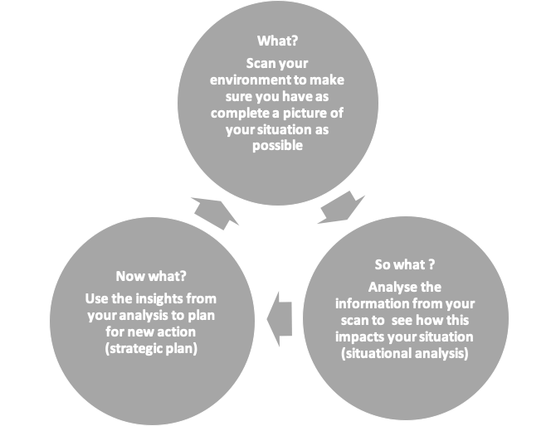

**Figure 23: Steps of an environmental scan related to Borton’s (1970) three-stage reflective cycle**

Many businesses or organisations do environmental scans or situational analyses regularly to make sure they recognise and address all the issues that impact them, and to try to anticipate how things are likely to develop in their environment in the future, so that they can plan for them. Du Toit (2016) surveyed South African businesses and found that 30% had a formal environmental scanning department. They collected information directly from customers, sales staff and suppliers for their environmental scans.

Systematically reflecting on the bigger picture and the anticipated future, in order to plan, is equally important in the context of a TVET programme. Mwaka (2013) writes:

Educational institutions ... need to respond appropriately to changes in their environment if they are to remain relevant, viable and valuable entities. This underscores the need for environmental scanning, a process through which educational institutions identify the needs, changes, and challenges characteristic of the environment ... This enables an institution to develop contingency plans and actions which reduce the response time needed to address an environmental opportunity or threat ... A university interacts considerably with other institutions that are consumers of its graduates. From a Systems Approach, the university cannot ignore factors within these other institutions and be able to process outputs acceptable to the institutions. It therefore has to guard an attitude of active watchfulness on what changes are taking place in the other institutions in order to respond to their needs ... It makes sense for the above institutions to keep a close watch on their environments and adapt to any changes if their graduates are going to be acceptable in the job market.

In TVET, environmental scanning is important at the national level, where the DHET scans and analyses the changing environment so that it can plan appropriately for TVET. It is also important at the level of the individual TVET college, which will have its own set of factors that affect it. TVET colleges are required by law to develop a strategic plan, informed by a situational analysis, and submit it to the Minister of Higher Education, Science and Technology (Nkangala TVET College, 2019).

On the level of a TVET programme or a single course you are teaching, you and your colleagues can use environmental scanning and situational analysis to assess the many factors influencing teaching and learning and to identify the needs that you should take into consideration. Environmental scanning and situational analysis can also be a useful part of your students’ skillset as they go out into a rapidly changing world, where the sector or industry they enter will be affected by local, national and international factors.

### Bringing things into the open

An environmental scan looks at key factors in your external and internal environments. What you consider external or ‘outside’ and what is internal or ‘inside’ for the scan depends on where you are positioned in the system and what kind of information you want. So, if you are doing a scan at the level of DHET, everything outside of DHET is external, and everything inside and directly related to DHET is internal. If you are participating in an environmental scan that your college is doing, then everything outside of the college is external, while everything inside and directly related to the college is internal. However, if you are interested in looking at just your department, programme or a specific course, then everything outside of that would be external. A simple way to divide it is to consider external as the things you cannot control or impact directly, and internal as the things you can impact or control directly.

The purpose of doing a scan is to detect things that you don’t already see. Just like in medical care, if you have a problem inside your body, you might be sent for scan (an ultrasound, a CT scan or an MRI), which can reveal things that are not visible to the eye. An effective environmental helps you find your blind spots – the factors or issues you are not already aware of or considering in your planning. Theorists have tried to identify the factors that need to be considered in an environmental scan to make sure we do not miss anything important.

### Stop and think

|  |
| --- |
| 1. Compare the purpose of an environmental scan with the Johari window in Figure 16, Unit 2. 2. Can you see how an environmental scan helps to bring things in your ‘unknown area’, ‘hidden area’ or ‘blind spot’ into your open area – whether as an institution or an individual – so that you can work with them more effectively? |

### External environment

In an environmental scan, some of the factors that might need to be considered in the external environment are as follows:

* Political environment;
* Policy;
* Legal environment;
* The economy;
* Education (What educational background do students and staff have?);
* Industry;
* Change in technology;
* The natural environment (resources and issues such as global warming);
* Social aspects (the communities where students come from, the context of the college, and broader society); and
* Ethics (views about whether something has a positive or negative impact for society or the environment).

Factors like the economy and industry may have global, national and local aspects that need to be considered. Their current situation needs to be considered, but also how they are predicted to be in the future. In other words, it is important to identify changes or trends that are likely to happen in the future, so that you can plan for them.

To help people remember which external factors to scan for, a number of acronyms have come into use that reflect the different factors selected for different contexts. PESTEL (or PESTLE) is one grouping which is used often. PESTEL is an acronym for:

**P** olitical

**E** conomic

**S** ocial

**T** echnological

**E** nvironmental

**L** egal

Other versions include STEEPLE (**S**ocial/Demographic, **T**echnological, **E**conomic, **E**nvironmental, **P**olitical, **L**egal, **E**thical) and PESTLIED (**P**olitical, **E**conomic, **S**ocial, **T**echnological, **L**egal, **I**nternational, **E**nvironmental, **D**emographic).

### 

### Stop and think

|  |
| --- |
| 1. How would you want to customise the factors you focus on if you conducted an external scan in the context of a TVET college programme? Consider the list below:   * Political (history and current) * Policy (and law) * Industry (or industries, current and future) * Environmental (natural and built) * Economy (and funding) * Education (students and staff) * Social (community needs, issues) * Technological (availability and change)   2. Can you think of any factors missing from this list that have an impact on your TVET programme? Or are any factors on this list not relevant?  3. Compile your own set of factors that you think are most important for your context. Play around with the order to develop an acronym, if you find that helpful. (The factors in the list above could be arranged as ‘SITE PEEP’, for example). Remember, to be able to see a bigger picture, you need to break out of your assumptions and what you think is important. So, before you drop something from your list, first reflect on why you would exclude it. |

Let us look at some questions you might use to probe these aspects of your external environment for information and insights.

* **Political environment**
* What *past* political realities continue to impact on the college or programme today and in what ways? (For example, aspects of apartheid, such as migratory labour, poor funding and infrastructure, poverty in the local community, interparty conflict)
* What *current* political realities – internationally, nationally, provincially or locally – have an impact on the college, and in what ways?
* **Policy environment**
* What are the key policies and programmes of DHET and other departments of government (such as Science and Technology, Agriculture or Health) that affect TVET, or a particular programme?
* **Industry**

(Your college would need to look at all industries it trains students for; if you were doing an environmental scan as a department or individual you could focus on your specific industry).

* What is happening now in your industry internationally, nationally and locally? What can be expected to change or develop in the future (such as new technology, changes in demand)?
* What is happening in other industries that could impact your industry (such as climate change or technology breakthroughs, which could create or reduce jobs in your industry)?
* Whatis the presence of your industry locally?
* Are communities of practice in this industry (local or online) available to staff in your programme? (Communities of practice are groups of people doing the same kind of work who intentionally discuss problems, share ideas and develop solutions together, either through a formal structure set up for this purpose or informally. This is discussed in more depth in another module.)
* **Environment (natural/built)**
* Are there any environmental issues that impact your college? (For example, climate change affects agriculture.)
* Are there new regulations or technologies related to climate change and sustainability that affect your college or industry?
* **Economy**
* How do the international, national and local economy affect the college and your target industry?
* In your target industry, what employment and income opportunities are there in the community and in the country?
* What needs or gaps could your college or programme address?
* **Education**
* What are the quality and characteristics of the primary education system that is feeding students into the college?
* What are the quality and characteristics of the tertiary education system that is feeding staff into the college?
* What educational programmes could the college partner with, to support students or staff?
* **Social**
* What are the cultural and language characteristics of the surrounding community?
* Is the context rural or urban?
* What are the main issues affecting this community (such as poverty, HIV/Aids, climate change, political conflict or crime)?
* What is the state of infrastructure that affects TVET (such as transport to the college)?
* **Technology**
* Are there new technologies that could provide opportunities or create threats to your programme or affect your industry?

### Activity 12a: Conduct an environmental scan of your external environment

****Suggested time: 3 hours****

(This activity has two parts and includes an external and internal environmental scan.)

In this activity you will conduct a simple scan of your external environment with a partner. You can choose whether to do it at the level of the college or of your department or programme. (Doing it at the level of your department or programme might be most useful to you and your partner if you are both in the same one.)

1. In discussion with your partner, write down a list in your learning journal of all the factors outside of your TVET college which affect your TVET programme. You should include those we have just discussed (political, policy, industry, environment, economy, education, social and technological) but you may add others that you think are relevant.
2. Read the extract from the strategic planning document by Ekurhuleni East TVET College reporting on its ‘performance environment’ in Appendix 6. This is a TVET college positioned in one of the most productive areas of the country, in terms of industry. As you read, think about how this college’s context is similar or different to yours. Discuss with your partner whether this comparison can help you think of any other factors you should add to your list for your external scan. If so, add them to your list.

|  |
| --- |
| Ekurhuleni is a Tsonga word meaning ‘place of peace (Ekurhuleni Metropolitan Municipality Integrated Development Plan (EMM IDP) 2015-16). City of Ekurhuleni Metropolitan Municipality covers an extensive area of about 1 975 Km2. EMM comprised of nine towns of Alberton, Benoni, Boksburg, Brakpan, Edenvale, Germiston, Kempton Park, Nigel and Springs. Included in these towns are 17 townships (EMM IDP) 2015-16).  Geographically, Ekurhuleni is uniquely situated. It borders the eastern part of Johannesburg and the southern part of Tshwane. The city spreads over 15.6% of Gauteng’s land mass. It is the fourth largest municipality out of all metropolitan areas that currently exist in South Africa. Ekurhuleni has three big towns and they are: Kempton Park, Benoni and Springs. The climatic conditions and irrigation systems in the EMM make the land conducive for commercial farming.  The economy in the region is larger and more diverse than that of many small countries in Africa. It accounts for nearly a quarter of Gauteng's economy, which in turn contributes over a third of the national Gross Domestic Product. Many of the factories for production of goods and commodities are located in Ekurhuleni, often referred to as ‘Africa's Workshop'.  The network of roads, airports, rail lines, telephones, electricity grids and telecommunications found in Ekurhuleni resembles that of Europe and America. It can be regarded as the transportation hub of the country. It is home to OR Tambo International Airport; South Africa's largest railway hub; a number of South Africa's modern freeways and expressways; the Maputo Corridor Development; direct rail, road and air links connecting Ekurhuleni to Durban; the Blue IQ projects, with linkages to the City Deep Container terminal; the planned Gautrain rapid rail link to Johannesburg and Pretoria; and the OR Tambo International Airport Industrial Development Zone (IDZ).  Main Economic Sectors: Manufacturing (23%), finance and business services (22%), community services (19%), trade (15%), transport (11%), construction (5%), electricity (3%), mining (2%) Key industries such as aerospace, agribusiness, manufacturing and logistics; Rail Cluster Development – based on the existing rail industry, including the new Rolling Stock Programme by PRASA through the Gibela Consortium; production of the new passenger trains in Nigel is expected to carry up to 70% in local content. The metro also boasts of a big commercial Vehicle Cluster.  The cluster is based on existing commercial vehicles and bus manufacturing industry. The current BRT Roll-Out Programme has provided an opportunity for inward investment, local bus and related components manufacturing for local procurement by the bus manufacturers.  Ekurhuleni East TVET College (EEC) is located in five towns of Ekurhuleni Metropolitan Municipality (EMM). These are: Springs, Kwa-Thema, Daveyton, Benoni and Brakpan. There are however six college sites that are spreading across the five towns. These sites comprise of five campuses offering mainly NCV and Report 191 programmes while the sixth one is a centre of specialisation. The campuses offering NCV and Report 191 programmes comprise of Benoni Campus, Brakpan Campus, Daveyton Campus, Kwa-Thema Campus as well as Springs Campus.  One and the only centre of Specialisation which was established in 2015 is called Artisan & Skills Development Centre which is situated in the industrial area of Springs town as well. The strength of the College is embodied in its location in the EMM. Ekurhuleni has a total surface area of 1975km² that accommodates a population of 3 178 470 million (Source: Census 2011). This means that the College has a large catchment area to draw potential students.  The strength of the College is also its access to manufacturing-based industries. This has enabled it to increase the partnership base. The City of Ekurhuleni’s economy and strength lies in the comparative advantage of the manufacturing sector that is higher than in other areas.  The College has partnerships with the local paper factories, SAPPI, Kimberly Clark and Mondi in offering NCV Process Plant Operations; three foundry trades (Melting, Moulding and Patternmaking) are offered in partnership with local foundries, SAIF, CSIR and NFTN. A partnership with EOH in placing students and offering soft skills as well business and IT programmes is in place. Merseta is the lead-Seta of the College and all programmes in the Mechanical Engineering are accredited and the Seta representative assists the College with accreditation with other Seta’s such as MICT SETA, Services Seta, FP+M Seta, E+W Seta, etc.  The W&R Seta also signed and MOU with the College to open a Seta Office at the College. The College has established a centre of excellence in air-conditioning, refrigeration, and ventilation in partnership with SAMSUNG and Merseta. In addition, trade test centres have been established for:  Hairdressing; Melting, Moulding and Patternmaking.  The College will further be establishing trade test centres for the following trades:  Fitting and Machining, Toolmaking, Electrical, Civil trades and Air conditioning and Refrigeration  Extract from an analysis of the ‘performance environment’ of Ekurhuleni East TVET College conducted in 2016  From: Ekurhuleni East (2016) (Ekurhuleni East TVET College). Ekurhuleni East TVET College Strategic Plan 2017. Department of Higher Education and Training: South Africa http://www.eec.edu.za/Corparate/EEC%20TVET%20College%20Strategic%20Plan%202017.pdf Department of Higher Education and Training: South Africa |

1. Working together with your partner, answer the bulleted list of questions above, and any other questions you think are important. Use the knowledge you already have and collect additional information from colleagues, your college administration office, your college website, the internet or the municipality. An environmental scan could contain hundreds of pages of information, so for this activity just go into as much detail as you can, spending about an hour and a half collecting useful, new information. Write your responses in your learning journals.

(Note: If you later conduct or participate in an environmental scan at the level of your programme or college, you can get statistics from StatsSA (<http://www.statssa.gov.za>) and from DHET and other government departments. Some additional studies may need to be undertaken to get information that has not already been collected by the college or government.)

1. Reflect with your partner on the following questions:

* Have we written anything down that we did not consider carefully before? If so, why might that be?
* Is there anything else that we should add?

You have collected information across a range of external factors which you can analyse to determine how it might impact your ability to reach your aims. You can now do the same for internal factors in your environment.

### Internal environment

When you scan the internal environment of a college, department or programme, ensure that you look for relevant factors. You may find that some of the internal factors link to external factors. For example, if the primary education system is weak or the community is poor (in the external environment) then some of the challenges that students face (in the internal environment) are likely to originate from these factors.

You will want to consider the characteristics of your college or department, programme, staff and students, making sure you consider requirements, resources and limitations. Let us look at some of the questions you might want to ask:

* **College (and department) level**
* What is its history and reputation in the community?
* What are its mission, vision and goals?
* How are leadership and management structured? Are they effective?
* What are its policies, programmes and areas of focus?
* What are the specific issues it faces?
* What resources (financial and other), facilities and equipment (including technology) does it have (in general and specific to your area)?
* What partnerships or relationships with industry does it have?
* What support does it provide to students (such as tutoring, literacy and numeracy, accommodation or financial aid)?
* What support does it provide for staff to continue learning through professional development workshops and continuing education courses (such as the course you are taking right now)?
* What programmes or initiatives are available that you or your department could tap into, which could support you in meeting your goals or fulfilling your vision?
* **Programme level**
  + What college policies do you need to follow?
  + What is the curriculum for your programme?
  + What are the time allocations for class sessions, practical sessions and workplace experience?
  + What requirements must students meet?
  + What spaces do you have available or lack (such as a classroom, a workshop, a laboratory)?
  + What equipment and materials (include technical equipment, machinery and supplies) do you have available or lack, to meet your programme goals?
* **Staff level**
  + What training and experience do the staff in your programme have in your target industry?
  + What training and experience do the staff in your programme have in education or TVET?
  + What are the needs of staff?
  + What are the attitudes, values and beliefs of staff (for example, towards education, industry, students, the college or the programme)?
  + How professional are staff? For example, do they discuss theory and research related to their teaching? Do they engage in ongoing professional development, either through the college, or on their own? Do staff take the initiative to keep themselves current in their industry and keep developing themselves professionally?
  + What is the relationship among staff? For example, do they collaborate on teaching, discuss problems together and support each other’s development, or are they distrustful of each other and keep to themselves?
* **Characteristics of students**
  + What backgrounds (such as cultural, language, socioeconomic or religious) do students come from?
  + What is their breakdown by gender (male/female) in the college and in your programme?
  + What percentage are from the local community? What percentage are boarders?
  + What are their interests and career goals – both short and long term?
  + What are their attitudes, values and expectations with regard to their programme?
  + What skill and knowledge do they have (related both to their basic education and life experience)? Do they have adequate competences in literacy, numeracy and information technology to enter your programmes?
  + What challenges do they face (such as finances, language of learning)?
  + What support do they need?

You could alternatively structure these questions according to themes, such as requirements, resources, attitudes, technology, and so on, if you prefer.

### Activity 12b: Scanning the internal environment of your TVET college or programme

Suggested time 2 hours

Now continue your environmental scan by working through the internal factors in your situation with your partner.

1. Go through the sets of questions above. Add any other factors or questions that come to mind as you go. As with the external scan, it will benefit your scan to consult your colleagues, students and programme administrative staff.
2. After you have collected this information, reflect with your partner:

* Is there anything that we have written down that we have not considered carefully before? If so, why might that be?
* Is there anything else that we should add?

1. Now that you have worked through a full environmental scan, make a diagram in your learning journal to capture the external and internal factors that you think are important. Share and discuss your diagram with your peers. Make notes (or a sketchnote or mind map) in your reflective journal of other ideas or insights that come to mind as you listen to your peers present their diagrams.

Discussion of the activity

You can use your environmental scan to inform your planning for the year or semester. Next time you repeat it, you can think about what has changed and what is new. Over time, your scans will help you to become more aware of trends that are developing and adjust your programme and teaching accordingly.

Have you noticed that the different parts of an environmental scan are similar to Brookfield’s lenses (Figure 17, Unit 2)? Each gives a different perspective on the same situation, giving you a more complete picture. Getting the perspectives of your colleagues, students, community, clients (in industry) and external research as you do your scan is also important to help you uncover your blind spots.

You could adapt Brookfield’s model as shown in Figure 24.

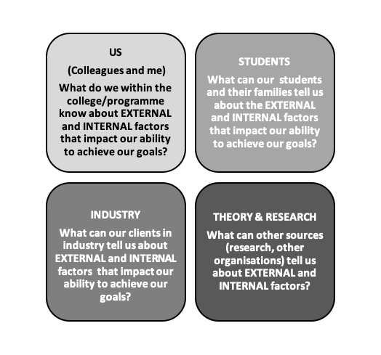

**Figure 24: Adaptation of Brookfield’s (1995) lenses to illustrate environmental scan**

## Situational analysis

Now that you have collected information by scanning your environment, the next step is to analyse it by looking at how the factors you identified in the external and internal environments might affect your programme (or your business or organisation). Just as tools such as PESTEL have been developed to help you do a thorough environmental scan, a number of tools have been developed to help you analyse the information you collect in a way that you can use effectively. Let us look at two of the most commonly used methods: SWOT analysis and SOAR analysis.

### 

### SWOT analysis

A ‘SWOT analysis’ (Figure 25) is a tool that was developed by Albert Humphrey in the 1960s and 70s. It is used widely in business and industry as well as in government and education. SWOT is an acronym that stands for **S**trengths, **W**eaknesses, **O**pportunities and **T**hreats. Strengths and weaknesses relate to factors within the organisation, college or department, while opportunities and threats relate to external factors. Strengths and opportunities are factors that could help the organisation, college or department achieve its goals, now or in the future. Weaknesses and threats are factors that could make it difficult for the organisation, college or department to reach its goals.

|  |  |  |
| --- | --- | --- |
| SWOT ANALYSIS | | |
|  | Helpful to achieving the goal | Harmful to achieving the goal |
| Internal factors | Strengths | Weaknesses |
| External factors | Opportunities | Threats |

**Figure 25: SWOT analysis**

Table 3 shows a SWOT analysis done by Ekurhuleni East TVET College (Ekurhuleni East, 2016). As you read through each quadrant, think about how Ekurhuleni’s situation compares to your own. Do you share a strength? Or does a strength they have listed bring to mind a weakness at your college which you hadn’t thought of?

**Table 3: SWOT analysis conducted by Ekurhuleni East TVET College**

|  |  |
| --- | --- |
| **Strengths** | **Weaknesses** |
| * The campuses are situated in feeder areas (schools) and easily accessible by any means of public transport * Qualified staff * Excellent physical resources * The college is ISO 9001 quality assured * Funding from government for institutional support and bursaries for students * Urbanisation * Partnerships between college and industry * Responsiveness to the needs of individual citizens, employers in both public and private sectors * Culture of teaching and learning * Achievement of strategic targets * Leadership and management a functional structure * Quality and reputation * Good systems, policies and processes * Governance – college council constituted * Financial backing from SETAs | * Limited access to internet for students * Mode of delivery restricted (full time/part time) * CAMI programme for remedial and accelerated learning ineffectively used * No Wi-Fi for student mobile technology users * Limited Green Management practice * Union activities * Skills and qualifications of staff * Weak implementation of systems and processes * Lack of academic technological support * Poor monitoring, control and evaluation measures * Lack of proper induction for new staff * Ineffective communication and decisions * Honouring of reporting lines * Job descriptions and job specifications * Performance management * Employee wellness service * Infrastructure maintenance * Attraction and retention of qualified staff especially suitably qualified lecturers |

|  |  |
| --- | --- |
| **Opportunities** | **Threats** |
| * Extended partnerships with industry, government and SETAs * Offer new skills programmes * High level of unemployment * New programmes, e.g. renewable energy and green skills * Use of technology (eLearning) * Adult learning * Job creation * New product development * Community participation * SETA assistance with placement of students * International exposure – students taking part in the World Skills Competition | * Speed of technological change; slow response of the college * Competitors: private colleges * Dropout rate of students, including students not returning if they fail examinations * Political cyclical environment * Unavailability or late production of textbooks * Student unrest * GDE schools and the quality of learners entering the college sector * Industry training centres * Current programmes not in line with industry requirements and government initiatives * Socioeconomics: affordability of the colleges, products and services * Dependency on government funding |
| Source: Ekurhuleni East TVET College 2016 | |

The United Nations Agency, UNICEF has developed a toolkit to guide organisations when they use PESTEL or SWOT (Mullerbeck, 2015). They recommend that, when doing a SWOT analysis, instead of starting with S and W (internal strengths and weaknesses) you swop the order around and start with the external factors (threats and opportunities) first (Figure 26).

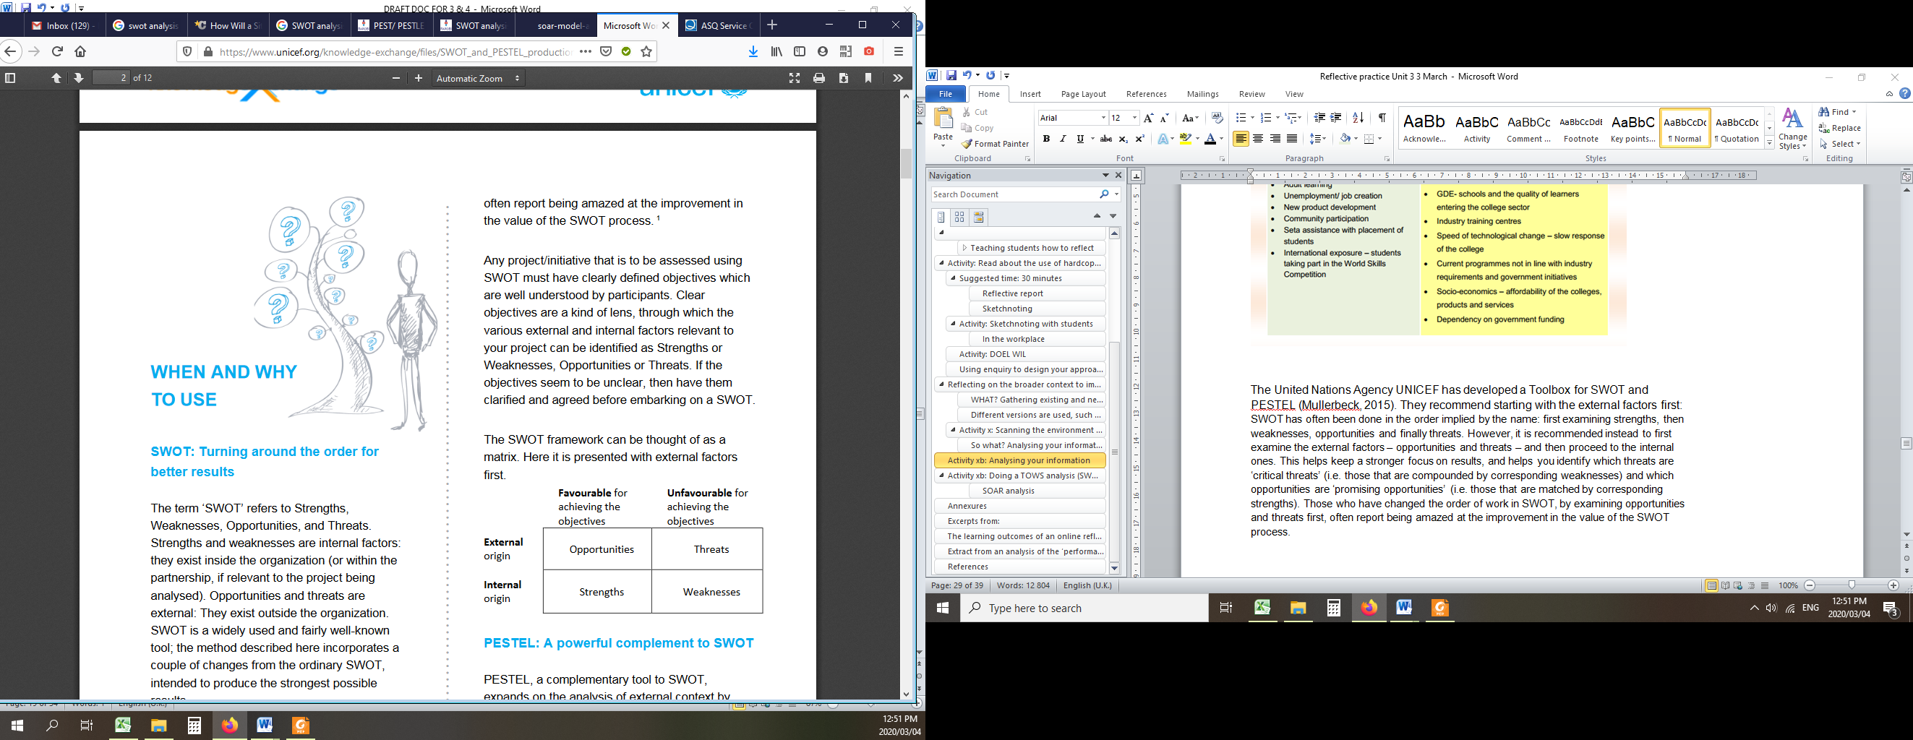

**Figure 26: Adapted SWOT model**

The adapted SWOT model creates a stronger focus on results, and helps identify which threats are ‘critical’ (those that are compounded by corresponding weaknesses) and which opportunities are ‘promising’ (those that are matched by corresponding strengths). Those who have changed the order of work in SWOT, by examining opportunities and threats first, often report being amazed at the improvement in the value of the SWOT process.

UNICEF also advises that:

[a]ny project/initiative that is to be assessed using SWOT must have clearly defined objectives which are well understood by participants. Clear objectives are a kind of lens through which the various external and internal factors relevant to your project can be identified as Strengths or Weaknesses, Opportunities or Threats. If the objectives seem to be unclear, then have them clarified and agreed [upon] before embarking on a SWOT. (Mullerbeck, 2015, p.2)

Let us follow UNICEF’s advice and do a ‘TOWS’ (SWOT reversed) analysis of your data. The TOWS analysis matches up the external environment threats and opportunities with your internal environment weaknesses and strengths. Since you did your external scan first, it is easy to start with the threats and opportunities which relate to the external factors.

### Activity 13: Doing a TOWS analysis (SWOT reversed)

Suggested time: 45 minutes

1. Take two loose sheets of paper and divide each in half, so that you have four areas. This will allow you to lie them next to your environmental scan while you work. You can add them to your journal afterwards.
2. Name the first two areas ‘Opportunities’ and ‘Threats’ and the other two ‘Strengths’ and ‘Weaknesses’.
3. Go through your environmental scan of external factors, identify where something is an opportunity or threat and place it in the appropriate column. If you think of new opportunities or threats as you do this, add them. Do not worry about whether something is ‘important enough’ to include.
4. Now turn your attention to your environmental scan of internal factors, and brainstorm all the Weaknesses and Strengths you can think of.
5. Now go through your four lists (Threats, Opportunities, Strengths and Weaknesses) and rank the items by judging their impact on your programme being able to meet its goals. You can rank them simply by giving marking very important things with two stars (**), things that are quite important with one star (*), and things that are not important or relevant with a zero (0).
6. Now reflect on whether there are connections between the things you have ranked as ‘very important’ on the four lists. For example, is an external threat made more serious by an internal weakness? Or does an external opportunity offer the chance to build on a strength?

Make notes about these connections (relationships) in your learning journal.

1. Compare and discuss your TOWS with the same partner you worked with on Activity 12. Make any changes you think are beneficial, based on your discussion with your partner.

Discussion of the activity

You have spent some time reflecting critically on the way factors in your external and internal environment can present obstacles or opportunities to the achievement of goals and aims. This is something you can revisit, update and build on as you plan and re-plan aspects of your course or programme.

### 

### SOAR analysis

An alternative approach to the SWOT (or TOWS) analysis is the SOAR analysis developed by Jacqueline Stavros and Gina Hinrichs (2009). SOAR stands for Strengths, Opportunities, Aspirations and Results. The SOAR model (Figure 27) focuses on the following questions (Aziz et al., 2019):

1. What is our biggest **strength**?

2. What is our best chance (**opportunity**)?

3. What is the future of our choice (**aspirations**)?

4. What are the measurable **results** that will tell us that we have reached a vision of the future?

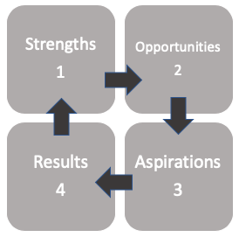

**Figure 27: The steps of a SOAR analysis**

A previous SOAR analysis can serve as a basis of comparison and reflection after action, for example on a semester or annual basis. The SOAR approach does not examine weaknesses or threats to the organisation, because these can make people feel overwhelmed and negative, and positive change can begin to seem impossible. Focusing on the negative can also lead to expensive plans to try to fix problems, which do not always work. Focusing on building on existing strengths, however, helps an organisation start with what is working well and use it as an engine for improvement.

SOAR is based on ‘appreciative inquiry’, which is explained by Hammond (2013) as follows:

Appreciative Inquiry is a complex philosophy that engages the entire system in an inquiry about what works. The inquiry discovers data that is then analyzed for common themes. The group articulates the themes and dreams of ‘what could be’ and ‘what will be.’ What will be is the future envisioned through an analysis of the past. The entire system maintains the best of the past by discovering what it is and stretching it into future possibilities.

This approach can be particularly useful in organisations that have become overwhelmed by a constant demand for change, because it works on the assumption that whatever you want more of already exists in all organisations (Thin Book, 2020). This can be quite applicable to the TVET environment, where the challenges colleges face, combined by frequent introduction of new policies and initiatives by government resulting in new workload requirements, can leave staff feeling they have no energy to try any new ideas of their own. Instead of focusing on a problem and trying to fix it, appreciative inquiry searches for solutions that already exist and tries to amplify (increase) what is already working.

The SOAR and SWOT models can be compared as follows:

**Table 4: Comparison of SWOT and SOAR models**

| **SWOT analysis** | **SOAR approach** |
| --- | --- |
| Analysis oriented  Weakness and threat focused  Competition focused: Just be better!  Incremental improvement  Top-down  Focus on analysis for planning  Energy depleting: There are so many weaknesses and threats!  Attention to gaps | Action oriented  Strength and opportunity focused  Possibility focused: Be the best!  Innovation and breakthroughs  Engagement of all levels  Focus on planning for implementation  Energy creating: We are good and we can become great!  Attention to results |
| Sources: Adapted from Khavarian-Garmsir & Zare and Stavros & Hinrichs in Aziz et al., 2019 | |

Aziz et al. (2019) argue that this approach increases involvement in strategic planning at all levels of the organisation and stimulates creativity and energy in response to the realities revealed in the environmental scan. Students and other stakeholders – even partners in industry – can participate in a SOAR exercise together with college staff.

### Stop and think

|  |
| --- |
| 1. What do you think about the logic behind the SOAR approach? 2. Do you think a more positive approach will yield better results? 3. Do you think that not looking closely at weaknesses or threats is dangerous? |

Let us look at some questions you might use to carry out a SOAR analysis in a college.

**STRENGTHS**

**These are things you have, or can do, which you can build on.**

* What are we most proud of as a college programme and/or what are our greatest accomplishments in the past two years?
* In what areas are we providing the best education available at a college or specialisation level?
* How do these reflect our greatest strength?
* What makes us unique?
* How do we use our strengths to get results?
* How do our strengths fit with the realities of our target industries/economy?
* What do we do or provide that is world class for our customers, our industry, and other potential stakeholders?

**OPPORTUNITIES**

**These are circumstances that you can use to your advantage, to increase the possibility of achieving your vision and goals.**

* How do we make sense of opportunities provided by the external forces and trends?
* What are the top three opportunities on which we should focus our efforts?
* How can we best meet the needs of our stakeholders, including students, industry, and community?
* What needs and wants of our stakeholders (students, industry, community) are we currently not fulfilling and how could we fulfil them?
* How can we reframe the challenges and threats we face to find the opportunities they hold?
* What new skills do we need to move forward?
* Are there gaps in the market that we could fill?
* What partnerships would lead to greater success?
* What changes and trends in the market align with our strengths?

**ASPIRATIONS**

This expresses your vision for what you want to be (as a programme or college) and what you want to achieve in the future. This is about using your strengths to challenge your current situation and grow (in terms of quality, professionalism, competitiveness with other programmes, responsiveness to industry and markets).

* When we explore our values and aspirations, what are we deeply passionate about?
* Reflecting on conversations about strengths and opportunities, who are we and what do we want to become and achieve in the future?
* What positive impact would we like to make on our students, communities and target industries?
* What strategic initiatives, actions, or resources could help us achieve our aspirations? What does this mean for our projects and programmes? What changes should we make in the way things are done?

**RESULTS**

This is about deciding on outcomes that can help you track your progress towards achieving your goals and aspirations.

* How can we translate our vision of success into outcomes we can track and measure?
* What measurements will tell us we are on the right track to achieve success?
* How will we know when we have achieved our goals?
* How can we acknowledge or reward those who work hard to achieve these goals?

### Activity 14: Doing a SOAR analysis

Suggested time: 1 hour

1. Now go back to your environmental scan and use it to do a SOAR analysis. Drawing from the environmental scan, answer the questions preceding this activity.
2. Share your SOAR analysis with the same partner from activities 12. Reflect together on the following questions.
   * How was doing a SOAR analysis different from doing the SWOT analysis?
   * Do you think the information it yielded was less useful, equally useful or more useful?

* Did you experience the SOAR analysis as a more positive and creative process?

### Discussion of the activity

You could also do a SWOT or SOAR analysis for an individual course or class. Think about external factors as those beyond your control and internal factors as those you have some authority and power over as a lecturer. You might want to consider the external factors listed in earlier in this unit, and internal factors such as:

* Resources:
* Classroom, workshop and other places
* Technology
* Materials
* Partnerships/links with workplace/industry
* Lecturer (you)
* Industry experience
* Teaching experience
* Course requirements to meet
* Attitudes and values
* Teaching approaches
* Relationship with students
* Students:
* Prior knowledge
* Ideas and interests
* Career goals
* Students’ strengths, successes, issues and needs
* Links to industry
* Links to theory

Once you have completed your SWOT or SOAR, you are in a position to plan for action. How will you implement what you have learnt in your programme, or your next course, or your next teaching and learning session? Once you have implemented it, you have completed the cycle. After the semester, or year, you can do another cycle of enquiry (environmental scan) and analysis (reflection to draw out insights).

Enquiry, environmental scanning and situational analysis are all tools that you can use with your students during teaching and learning. Giving them an opportunity to learn how to use these tools during a course can help them develop the critical thinking skills they will need in order to make good decisions, evaluate their own performance and be at the forefront of change in their industry.

## The role of reflection and enquiry in student learning

We have explored reflection and enquiry as tools you can use as a TVET lecturer for your own professional growth and planning. You can also use these tools to structure your teaching and learning sessions in ways that will help students learn more deeply and broadly. By guiding them through activities where they learn through enquiry and direct experience, followed by reflection, you can give them the opportunity to *discover* the important concepts you want to teach them. This is far more powerful than having them listen passively to a lecture. They will also become more skilled at learning from their own experiences, rather than only from formal instruction. This vital skill can empower them to direct and manage their own professional learning throughout their lives.

### Experiential learning in the classroom

Experiential learning is based on the same reflective practice cycles you have become familiar with in this module. The difference between using experiential learning to facilitate your own learning and using it to teach your students, is that in the latter case *you* determine the purpose and goal of the learning experience and facilitate it for them. You create an experience for them or give them a problem to solve or a question to seek an answer for. The students observe and reflect on the experience, conceptualise or theorise (come up with understandings based on their own thoughts, peers’ ideas, theories or ideas they have researched) and then experiment to test whether and how these work.

David Kolb (2014) developed the first model for experiential learning (Figure 28).

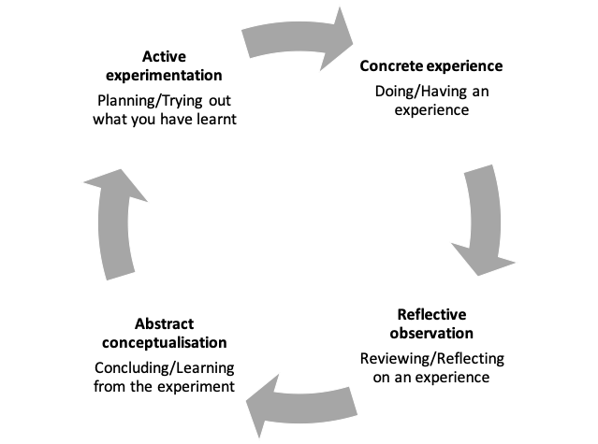

**Figure 28: Kolb’s experiential learning model**

Source: Redrawn: Kolb, 2014, p. 51

In TVET, it is clear that many aspects of technical and vocational knowledge and skills can only be learnt – or can be learnt best – through doing. However, experiential learning theorists argue that learning through doing is a more effective type of pedagogy (teaching approach) than a lecturing-listening approach in *any* teaching context. Theorists encourage a shift to learning from experience as a way of teaching non-technical subjects at schools and universities as well as for technical education.

While technical education may be based in practical experience, it may be focused on the development of manual skills and production of products, rather than on developing the student’s capacity to enquire and reflect. In many cases, student do not learn to conceptualise a problem or challenge, reflect on it, explore available knowledge, develop creative solutions and experiment to determine which concepts work or which theories prove correct (Kožuchová & Jiří, 2016). In experiential learning, the studentis at the centre of the learning experience – not the teacher, the content, or the end product, as in many traditional classroom-based learning approaches.

Many students in South Africa experienced traditional rote learning in their primary education, where the exploration and experimentation necessary to develop critical thinking and problem-solving abilities were almost absent. In fact, learners who do not remain passive in a traditional classroom are often punished.

It is extremely important that in TVET we give students the opportunity to learn actively through their own experimentation and initiative, and to construct their own knowledge as they discover concepts for themselves. Otherwise, they may develop technical skills and theoretical knowledge but lack the competence to innovate and think critically. You will learn more about constructivism as a theoretical approach to teaching and learning in the modules on pedagogy and psychology of education in this programme.

Markus Boehner (2017) writes that, in order to develop the competence of TVET students effectively, learning needs to happen through practical experience, where theory is part of the learning (not separated from it). Periods of reflection should be included, so that students can construct new meaning from their experiences.

Any teaching and learning session in TVET should be based on practical experience, and allow for reflective intermissions and phases to become aware of knowledge background and knowledge components, embedded in practical working and doing ... The artificial separation of theory lessons and practice-based teaching in workshops (practicals) should be eradicated in TVET. Any teaching and learning process should be practice-based or practice-related and interweave knowledge background and skills to be acquired. That will make reflection phases indispensable in between and at the end of any TVET session taking place. (Boehner, 2017, p. 12-13)

Boehner provides a model (Figure 29) for a competence-based TVET teaching and learning session. He indicates that this should form the basis of all teaching and learning sessions, whether a theory class or a practical session. Phases may be repeated throughout a session, and a session may stretch over several days. In his model the session ends with a dedicated period for reflection and integration of new learning.

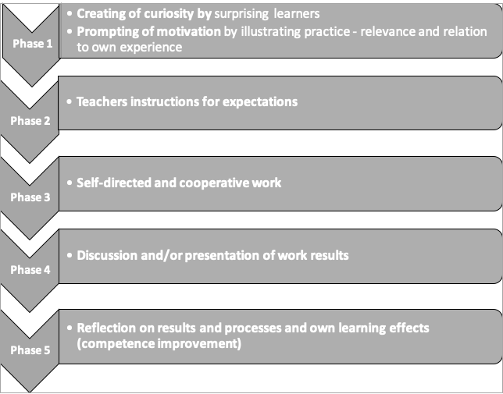

**Figure 29: Boehner’s teaching session**Source: Redrawn: Boehner (2017, p. 15)

Phase 2, which is teacher centred, should be the shortest, and Phase 3 should take up the bulk of the time. Phase 5, the final phase, is dedicated to reflection. Boehner (2017, p. 17) explains that:

... educational research has clearly found out that students always need to reflect on their learning process and outcome. Firstly, this is to make them aware of what they have done and achieved, and secondly, to look for improvements and to self-evaluate. Ultimately, the reflection phase supports long-term retention and fosters competence development in terms of self-awareness what one can actually do and what the individual still has to work on. Reflection can be done with all learners, in groups, pairs or written style, depending on trust, confidentiality, time available and purpose.

Figure 30 shows the model mapped out as an experiential learning cycle:

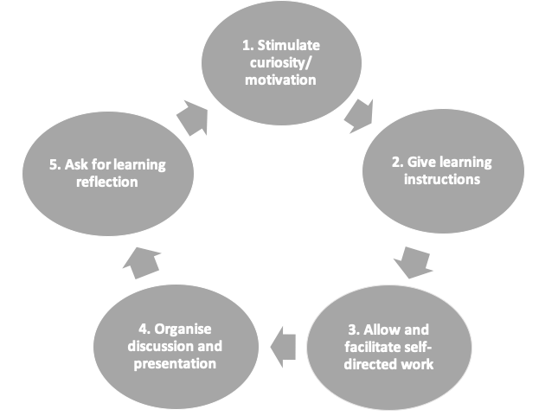

**Figure 30: Boehner’s model mapped as a reflective cycle in the phases of a TVET teaching and learning session**

Source: Adapted from Boehner, 2017, p. 17

### 

### Activity 15: Sketchnoting on experiential learning

Suggested time: 15 minutes

Let us explore how sketchnoting can be used to deepen learning at each stage of Kolb’s learning cycle (Figure 30). Watch Niell’s tutorial [video](https://www.youtube.com/watch?v=iMGTr5i8fAw) (5:57). As you watch, pay attention to how Niell uses sketchnoting. Pause the video and copy down icons or jot down ideas that you would like to use in your own sketchnoting. According to Niell, “The best way to learn is by doing (and then layer sketchnotes on top).”

Discussion of the activity

Throughout this module you have worked with visual representations of concepts in the form of models and diagrams, as well as experimented with ways to represent your own learning through sketchnoting and mind mapping. As you become familiar with these tools for helping you construct your own knowledge and deepen your understanding, you can begin to incorporate them into activities you do with your students, so they can begin to master these tools as well.

Several different theoretical approaches and models have been developed that you can use to facilitate experiential learning for your students. With *enquiry-based learning* (EBL) students are given a question or topic to investigate through a process of exploration, reflection and testing, while the lecturer facilitates this process, providing as much support as needed at the different stages (rather than lecturing). *Problem-based learning* presents students with a real work problem scenario which might involve a number of subjects or topics, rather than fitting into a single one. *Project-based learning* can be similar to enquiry-based learning or problem-based learning but poses a question or problem that requires students to produce an artefact or product (Ismail, 2013). All these approaches rely on reflection to drive learning. Let us look more closely at enquiry-based learning (EBL).

*(Note that in the United States the word ‘enquiry’ is spelled ‘inquiry’ and enquiry-based learning is thus referred to as IBL, instead of EBL as it is in South Africa, the United Kingdom, and other countries. If you research enquiry-based learning further on your own it would be useful to search using the terms ‘enquiry-based learning’, ‘inquiry-based learning’, EBL and IBL to ensure that you don’t miss some useful resources.)*

## Enquiry-based learning (EBL)

Enquiry-based learning (EBL) refers to a group of approaches that use an enquiry to drive someone through the experiential learning cycle. Rather than feeding students information, the lecturer poses a question, or asks the students to think of a question, and provides support as they progress through the learning cycle, eventually discovering the information (that otherwise would have been taught) for themselves.

You can probably remember times when you discovered something for yourself – whether it was something new, or something you had never really understood – and suddenly ‘the light came on’. Discovery comes with feelings of excitement, pride and happiness, which are often *not*the feelings that students have while listening to a lecture in class. By actively learning through their own discovery process and experiencing the emotions that accompany this, they will learn more deeply and have a greater sense of ownership of what they have learnt.

Enquiry-based learning is grounded in reflection. But while the reflective cycle typically starts during or after an event with the question, ‘What happened?’, enquiry starts with a question before the action that sets up and drives the event. The question may be, ‘What will happen if I do ... ?’. In the same way, the last stage of a reflective cycle sets up an enquiry that triggers the next action. For example, if during reflection you realise that you paced a session too quickly and some of your students got left behind, you might decide that in the next session you will slow things down. Your reflective cycle would end by framing an enquiry for the next session: Will slowing things down result in all my students learning effectively?

You can see that the enquiry will require reflection, because during and after the session you will need to check what is happening against your enquiry question, to see whether slowing things down is resulting in more learning. Then you will feed your results into the next enquiry, and so on.

You may have noticed by now that enquiry is very similar to the scientific method, where you formulate a hypothesis to be tested, for example: If I slow down the pace then my students will learn more effectively. Then you test it, look at the results, draw conclusions, and maybe make adjustments to your hypothesis or draft a new hypothesis and test again.

As students become more familiar with enquiry, the lecturer can gradually provide less support, until experienced students are able to formulate questions themselves to drive their learning forward.

The TELSTAR model is one tool that can be used to integrate enquiry-based learning into the classroom (Table 5). TELSTAR is an acronym for the steps of the model: Tune in – Explore – Look – Sort –Test – Act – Reflect. Questions that can be used to focus students at each step are shown on the left. Questions that can be used to ensure that the step is done thoroughly are shown on the right. Reflection is the final step of the enquiry process, but it is also embedded into each step through the control questions. Reflection at the end of the step might show that the student should go back to an earlier step to ensure that learning is consolidated.

As students work through the model, they become increasingly aware of the steps and processes involved in their learning (Catholic Education Services, n.d.). As with reflective practice, it is important that the student be aware of the stages of the cycle they are working through so that enquiry becomes a conscious habit.

**Table 5: TELSTAR model of enquiry**

|  |  |  |  |
| --- | --- | --- | --- |
| **Student focus questions** |  | **Enquiry steps** | **Control check / reflection** |
| What is the topic/issue? Why should we study the topic/issue? | T | TUNE IN | How does this affect me?  What concepts are included?  What is the key question?  REFLECT: Should I change the questions? |
| What do I know/ feel about this topic?  What are other people’s views?  What questions do I have? | E | EXPLORE  (to prepare for learning) | Explore (1) prior knowledge, values, viewpoints, (2) questions, methods, skills, outcomes.  REFLECT: Should I change the questions? |
| What do we want to find out? How will we gather the information? What skills/ resources/ strategies do we need? | L | LOOK | Look for and organise information.  Do I need to learn some new skills? (REFLECT)  Has enough information been collected? (REFLECT) |
| How might we sort our information? What thinking skills/ strategies do I need? What connections can we make? | S | SORT | Sort the information using thinking skills.  What concepts/ values are involved?  Is it accurate, biased, relevant, worth using? (REFLECT) |
| What conclusions can we draw?  What evidence supports them?  What might we do with our findings? | T | TEST | Does this answer the key question sufficiently? (REFLECT)  What are the implications of our findings?  How can we decide? What values will we base decisions on? |
| What actions could we take as a result of our findings? | A | ACT | Do I understand the range of actions that could be taken? (REFLECT)  Are they practical? (REFLECT) |
| What have we learnt, and how do we feel about the topic now? | R | REFLECT | How have my skills improved?  How could the enquiry have been improved? |

Source: Adapted from: Catholic Education Services, n.d.

As a lecturer you can use the TELSTAR model as a frame to deepen reflection for both you and your students. If you are aiming for transformative learning, as in the example of Ms Ntuli who aimed to transform the attitudes of students toward dietary restrictions, in the final ‘Reflect’ step you could ask: How have my students’ attitudes, beliefs and assumptions changed? You could ask your students to reflect on the same question.

### Activity 16: Transform a lecture into an experiential learning session

Suggested time: 30 minutes

Choose one of the ideas you had for transforming a lecture into an experiential learning session in the previous activity and choose one of the experiential learning models we have looked at in this section (Kolb, Boehner or TELSTAR).

1. Copy the model into your reflective journal, noting what you will do at each stage. You can use the examples for sketchnoting in Doug Niell’s [video](https://www.youtube.com/watch?v=iMGTr5i8fAw), which you watched in Activity 15, or you can use your own ideas.
2. Share your sketchnote or plan with your peers. Note down ideas you get from your peers’ sketchnotes and plans in your reflective journal.

Discussion of the activity

You have experimented with adapting a lecture into an experiential learning session and gathered some new ideas from your peers. If you have the opportunity, implement this lesson in the classroom and reflect on how it went in your learning journal. You can experiment with adapting other lectures to a more experiential learning approach, using the models and ideas in this unit and those that your peers share.

### Tools for facilitating students’ reflection

The TELSTAR enquiry-based learning model shows that reflection can be incorporated into teaching and learning experiences in different ways: as a specific step of an experiential learning cycle or enquiry, or as part of each step.

Once you are thinking from the perspective that reflection helps to deepen your students’ learning, you have a flexible range of options for how to use it – from asking students a question that will get them thinking more deeply when they get stuck during experimentation, to having them work formally through a reflective cycle that involves several distinct steps. Your students will benefit from experiencing different kinds of reflective opportunities that push them into areas they are not used to thinking about – from open-ended activities where they are free to explore reflection in any way they want, to structured activities where they have to discipline themselves to work through specific stages.

While young children are naturally curious and are known for asking ‘why?’ about everything, this natural desire to enquire and experiment can get shut down by many years of rote learning in the school system. In fact, in traditional education learners may be punished for challenging assumptions or thinking critically about what the teacher is teaching. Independent or critical thinking is seen as disrespectful, rather than being understood as an important and wonderful ability to encourage and develop.

By the time students reach the TVET college, they may no longer be used to thinking independently and may expect to be ‘spoon fed’ everything they are supposed to learn. They may believe that nothing interesting ever takes place in the classroom, which is one reason why Boehner’s model for a lesson starts with surprising your students in order to stimulate their curiosity.

To begin with, your students may find it strange and uncomfortable when you ask them to reflect or to come up with their own questions. Because of this they may need more ‘scaffolding’ when they first start learning to reflect. Scaffolding is giving just enough support to help students succeed, while still challenging and stretching their thinking skills. For example, first model the process of reflection in front of them by going through a reflective activity yourself; then work through a few reflective exercises together with them; then give them small, structured reflective activities or open activities. In this way, you can gradually decrease the support until they are comfortable doing reflection independently.

When you are giving students an enquiry-based activity, you can at first give them the questions they must investigate; then brainstorm with the class what questions should be investigated; and finally, when they have learnt how to think about what questions would drive an enquiry successfully, let each student or group come up with their own questions – leading them back to their own natural curiosity and initiative to find out more about the world (which is what learning really is, after all!).

Let us look at a few tools you can use to structure reflection in different ways for your students. Your aim is to help them develop their capacity to reflect in their personal lives, in their formal learning in their TVET programme, or in their professional lives in the workplace. Remember, any tool that you yourself use for personal or professional reflection is a tool you can teach your students.

Asking your students to keep a *reflective learning journal* throughout your course, with some structured questions to answer, can help them build their capacity to reflect, and at the same time they can use it to deepen their learning. Showing them how to *sketchnote* and giving them freedom to sketchnote during teaching and learning sessions can provide them with an unstructured opportunity to reconnect with their own creative thoughts about what they are learning.

*Environmental scanning* and *situational analysis* are tools you can use in the context of a class project or a workplace placement, to expand what students can see in a situation and help them learn how to use reflection to see the consequences of actions and plan for the future. *Reflective reports* are a more formal tool which takes them through a structured process, forcing them to think more deeply about the areas where they might normally hurry past, ignoring a blind spot.

Let us look at the following tools briefly, in turn: Environmental scanning and situational analysis, reflective learning journal, sketchnoting and reflective report.

### Reflective learning journal

You have used a reflective learning journal throughout this course, and possibly in other courses or contexts in your life as well. Having students keep a reflective journal can be a very good way to get them to start using reflection in their formal learning and, later, as part of their lifelong learning.

Using reflective journaling with your students is something you may want to experiment with – and reflect on yourself. During and after a semester, ask yourself which questions that you gave your students seemed to stimulate the most valuable reflection. As you become more experienced in guiding their reflection, you will be able to make this an increasingly meaningful activity for them.

You may find that initially students try to write what they think you want to hear. You can read out a wide range of very different examples from their journals to the class, to show them that exploring all aspects of an experience and connecting these to prior knowledge is valuable – there is no ‘correct’ answer in a reflective exercise. Over time, you can make a collection of interesting examples to share with students, but you need to ensure that the examples are anonymous or that you have students’ permission to use them.

In the past, in many trades it was common to keep a trade journal. By keeping notes about situations and patterns in their industry, a person begins to identify patterns within their own thinking and behaviour. Even in the context of industry, noting that we are experiencing an emotional response can be an important flag that we might benefit from looking at something more closely. Our personal and professional ‘sides’ work together and need to be in balance. You can extend the use of the reflective journal to your students’ workplace assignments. This will help them begin to grow accustomed to reflecting on their professional lives and experiences in the workplace.

Susan Doel (2009), who teaches at the School of Chemical Engineering at the University of Queensland in Australia, describes how students who took a professional development course were taught to use reflective practice by keeping a professional development log during their industry internships. Her paper provides a useful case study for us to explore how incorporating reflection formally into students’ workplace practice can benefit both students and lecturer.

Doel (2009) explains that reflective practice does not usually come naturally to the students at first. They must be encouraged and taught *how*, not instructed to reflect and left to work out what that means. Many students might think that reflection is simply a description of what happened. Doel further explains how reflection is introduced to the students as a key skill that they will need to develop and use throughout their careers, in order to help them see its relevance and importance:

In order to gain student commitment to the concept, it has to be introduced in terms that they can understand and accept. Therefore, it is referenced to their eventual careers as professional engineers. The course handbook reads:

Throughout your career, others will monitor your performance in whatever role you have and reward you accordingly. In order to become a Chartered Professional Engineer, that is an independent professional, you have to demonstrate your competence by critically reflecting on your work, extracting the lessons you have learned and communicating this understanding to senior members of the profession. You will also have to undertake such reflection as a central element of job interviews and annual workplace appraisals. It is a mark of a successful professional that they know what they are good at doing and where they need to improve their performance. This critical self‐knowledge is the foundation for navigating your major career moves. (Doel 2009, p. 165)

Each student is required to keep a professional development log and submit an entry electronically every week. Feedback is given to each student within 48 hours so that they have time to review the feedback before they write their next entry (Doel, 2009, p. 166):

Students are asked to identify critical learning events that have happened each week in terms of their professional development. They are asked to consider those ‘Ah Ha!’ moments when things have clicked into place. They then analyze the most significant of these events using a standard analysis template.

The analysis template involves four stages in a reflective cycle, explained by Doel (2009, p. 166-8) and summarised as follows:

**Situation: What actually happened?**

In this stage, students are asked to simply state the facts of the incident without  
interpretation. Students are asked to be concise, but to write as much as they feel they need to. Incidents will vary in complexity and depth. Students are told that while perfect prose is not required, entries written in note form must be well constructed and readable.

**[E]ffect: What was its impact on you personally?**

In this stage, students have to set out the personal [e]ffect the situation had on them ... they are advised to initially begin ‘I felt ...’ as it helps them to focus on recording feelings and not digress into learning or further description of the event. Students initially find this phase difficult in terms of isolating their feelings for this part of the analysis.

**Interpretation: What did you learn from the experience?**

This phase is usually easier for students once they have worked through the first two. Students are asked to explain in what ways the new learning either confirms or contradicts their prior knowledge, theories, or understandings about the practice of engineering, in particular the knowledge they have gained at university. All our actions stem from learnt behaviour, so if students can also identify why they acted in a certain way, it will help them interpret their actions and modify them to suit the new environment.

**Decision: What did you decide to do so as to become a better engineer?**

This phase is usually the one that students struggle with the most in terms of arriving at a usable decision. Students are asked to describe how the learning that has taken place will become part of their regular professional arsenal and be routinely applied in a wider range of circumstances, not just those similar to the particular event. In order to be effective, decisions must be specific, realistic, and ideally with some time frame indicated. Decisions such as ‘I will do better next time’ are not helpful to the individual and show that the student has not really thought through how the incident will affect their professional life in the future. Similarly, a decision that would involve their whole time to implement is not workable, so students need to realize that this element of the analysis may only be very small. A small decision acted on is worth much more than an idealistic life‐plan that is never used.

### Stop and think

|  |
| --- |
| Can you see how these steps relate to the reflective stages you have used throughout this module? |

### Activity 17: Analyse professional development logs

Suggested time: 20 minutes

The following analyses were written by four of Doel’s students (2009, p. 166-8). Read each analysis then answer the questions that follow in your learning journal.

|  |
| --- |
| ***Student A***  **What happened?**  [I] was supervising a group of 30 operators with one other supervisor. I had a number of groups moving cars from one area to another. Got into a situation where two groups were moving the same cars back and forward for just over an hour until they realized and made myself aware. After investigating I found that the other supervisor organized his group to move cars from the area my group were parking them as he thought they were a part of his area. This was because I did not communicate to him what I was doing.  **Effect:**  I felt frustrated that for over an hour two groups accomplished no valuable work due to a lack of communication. I was disappointed as I did not pick up on the mistake earlier.  **Interpretation:**  I learnt that communication between management and supervision is vital to successfully and efficiently complete a job. I have witnessed through experience the effect of poor communication at work and university. Lessons taught through studies at university have been designed to teach techniques of good communication. I will need to use these techniques and develop them throughout my career.  **Decision:**  I will be supervising similar jobs throughout next week. I will ensure I communicate with other supervisors and management using techniques I have learnt, for example, regular coordination meetings, phone calls when changes are made, or email if the required people cannot be contacted. I will review the techniques I use at the end of the week and continue to refine and develop my communication skills. |

|  |
| --- |
| ***Student B***  **What happened?**  I received a task handover for a departing colleague, but didn’t look at it. This was because, as per normal, I felt rushed and like I didn’t have time. When I finally got around to looking at the task handover plan, I had several questions for the departed colleague. However, I couldn’t talk to him as he was on holiday. Hence, the required tasks were much more difficult and time consuming.  **Effect:**  I felt frustrated because I knew that a few simple answers would clear up my questions. I realized that I should have looked at the task list at the time, and so I was annoyed with myself.  **Interpretation:**  I learnt that even if things are hectic, it is necessary to determine if it would be more efficient to have a quick look at certain tasks/documents in order to save time later.  **Decision:**  It’s not practical to look at everything as soon as you receive it. However, I resolved to scan my email every morning, even during busy times. When I see something that is important, I will make a conscious decision to either leave it, or have a quick look and follow it up. |

|  |
| --- |
| ***Student C***  **What happened?**  On Wednesday, the supervisor for one of the areas in Body Build was absent. I was asked to fill in the position for the day. Due to my current workload I could not take on the task. I explained this to the manager and told him ‘No’. He was able to find someone else and spread the load.  **Effect:**  By saying ‘no’ I felt like I had let the team down. I was relieved when the manager accepted my comment and agreed.  **Interpretation:**  I often find it hard to say ‘no’ to work takes but have learnt it is sometimes necessarily to do so. Saying ‘no’ is a form of prioritizing work, as learnt from Uni. Good communications skills help make the decision easy.  **Decision:**  Being asked to do additional tasks is common in the workplace. I need to continuously prioritize my tasks even if that means saying ‘no’ However, saying no has to be done appropriately and with good explanation. I will continue to review and reflect on the decisions I make when dealing with tasks. Particularly how to say ‘no’. |
| **What happened?**  Part of my job is to calculate the CO2 emissions of various buildings. This is done via spreadsheets and computer models. As my experience grows, I’m tempted to add complexity to continually improve accuracy and keep things interesting. I’ve been gradually increasing modeling complexity until last week. I realized such complexity is really not necessary and is really time‐consuming. Instead of adding complexity, I quickly completed the model and spent some additional time on communicating the information to the client via a better report.  **Effect:**  I felt this was a small victory against my natural tendency to greatly over‐complexity things. This felt good, because previously I have – against my better judgment – continuing to obsess over the detail. It was somewhat empowering to put into action something previously planned via the PDLs.  **Interpretation:**  I learnt that I can overcome habits and temptations to become more productive. In this situation, this conformed my thinking that often the fine detail is meaningless. Rather, I saw that the communication aspect was equally important. With regards to university, this is usually not the case. That is, at university the detail is – rightly – important. I learnt that this balance, between content and presentation, sways in the direction of presentation in private industry. **Decision:**  This was a positive experience. I should, very simply, try to repeat it. Previously I mentioned various task lists, planning methods, etc. which have enabled me to determine whether I should delve into the detail of a particular task. In this case, to continue this learning event, I’ll continue to use these methods and follow their advice. This is somewhat hard to enforce because it’s really just my choice at the time. However, one good way is to remember the positive outcome of this event, and to focus on the outcomes, not process. |

1. Which of the students concluded that their own behaviour had caused a problem for them? Did this realisation result in a positive or negative outcome for them?
2. Do you think they would have been as likely to realise the impact of their behaviour, take responsibility for it, and think of ways to change it, if they had not taken the time to reflect?
3. These examples come from a context where students have a different educational, cultural and social background than TVET students in South Africa. If you gave your students the same reflective task to do, what kind of responses do you think they would produce? Do you think they would be willing to admit their weaknesses or error to the same extent these students did? Why or why not? What support might they need, to benefit from professional development logs, and how could you provide this?

Discussion of the activity

By including reflective practice in the activities that you design for your students, you can help to deepen their learning during their courses. This can also help them to develop their reflective capacity, and to use reflection as a tool for lifelong learning. Support and structure may be needed at the beginning to help them have the confidence to get started.

### Sketchnoting

You can introduce your students to sketchnoting using the same resources that were used to introduce you to it in this module. You can also show them examples of your own sketchnotes. You may find that some have a positive response to the idea of sketchnoting, while others feel threatened by having to produce something creative.

### Stop and think

|  |
| --- |
| 1. Can you remember how you felt about sketchnoting when it was introduced in Unit 1 of this module? Did you find it scary? Exciting? Intimidating? Horrible?  2. What do you think the reasons were for this?  3. Do you think your experience with rote learning at school made it more difficult to take an active and creative role in learning?  3. Do you feel differently or the same now? |

You can invite your students to use sketchnoting in their reflective journaling exercises. But you can also encourage them to sketchnote throughout teaching and learning sessions, whenever they like – when you are presenting theoretical information, or when they are busy with a practical activity and want to make note of an idea they had or a situation they encountered. This idea ‘breaks the rule’ of the traditional classroom – where children are often punished for ‘drawing’ or writing their own notes in class.

Some of your TVET students may have chosen a technical path because they had a negative experience with academic learning at school. (Perhaps this was the case for you, too!) In their TVET programme, they may be eager to learn the technical part of the trade but dislike the more academic side of it: textbooks, lectures, tests and assignments.

By opening up the door of self-expression during formal learning time to the students, you signal to them that they have an active role in constructing knowledge as they engage with new ideas. They are the drivers of the process; you are facilitating it. For some, this might be empowering and liberating, as they experience having more room to be themselves in the classroom. You could invite them to share their sketchnotes during the last few minutes of a class. They may have made connections or representations that bring new insights to their peers – and to you.

### 

### Activity 18: Sketchnoting with students

Suggested time: 30 minutes

Rachel Smith is the Director of Digital Facilitation Services for The Grove Consultants International in San Francisco in the United States. In a TEDx talk, she speaks about how she discovered that, when she let her hand and pencil move during a lecture she found that she was able to learn better – even if what she was drawing was not related to what the lecturer was saying!

Watch this [video](https://www.youtube.com/watch?v=3tJPeumHNLY) by Rachel Smith on drawing in class.

Now respond to the following questions in your reflective journal:

1. Try to identify the thoughts and feelings that you experienced while watching the video. Were they positive or negative, or both?
2. Write each feeling or thought down and think about where it comes from. Does it relate to your experiences as a learner at school? What were they? Does it relate to assumptions, beliefs or values you hold about learning, the role of teachers, or students?
3. Explore these feelings and thoughts carefully as a way of exposing some of your beliefs or attitudes about teaching and learning that may be hidden or unknown to you. Write down any connections you make or insights that come to you.

Discussion of the activity

Your reflection during this activity helps you to become more conscious of conclusions you have drawn, based on your own experiences as a learner or student, which may need to be questioned or reconsidered. This may enable you to try some approaches you would not have before.

You might want to share this video with your students when you introduce them to sketchnoting. Following the video, you could engage them in a reflection about their experiences around writing and drawing at school. Or you could stop the video at different points to discuss together what Smith has said. You could guide students through a group discussion, using reflective questions such as those you answered in Activity 20, and then give them an opportunity to try sketchnoting about what they are thinking and feeling after the discussion. You could invite those who would like to share their sketchnotes with the class.

Encourage your students to incorporate sketchnoting into their reflecting journaling outside of class and in the workplace as well. As they engage with technical, physical and visual experiences, this may become a natural way for them to begin to use reflection to create and innovate, as they see opportunities to solve problems or get ideas for new concepts.

### Environmental scan and situational analysis of industry and the workplace

You can introduce the tools and questions above to your students by having them scan and analyse their target industries or the business where they are doing a workplace placement.

Depending on the nature of your TVET programme, you might want to add or remove factors to ensure you are targeting the factors that impact on your particular context. Having your students do a SWOT or SOAR analysis of a situation or aspect of their industry could be a valuable way to help them see aspects they had not considered before.

### Reflective report

A reflective report is similar to a traditional written class assignment, but the person who is writing the report is encouraged to highlight their own actions, emotions and opinions. They should identify their own role in the process and activities that happened, and evaluate their learning and progress. They should also link their personal experience and learning to theoretical knowledge, if possible.

A reflective report provides a way of stepping back and looking at a learning process from the beginning to end and ‘pulling together’ the threads of learning to help integrate the learning that has happened along the way. The report could be done after a practical project has been completed, after an enquiry-based activity or as a way to wrap up an activity that involved a situational analysis. It could be done at the end of a work placement, or at the end of a period of keeping a trade journal.

Provide your students with a set of questions to frame their reflective report. For example:

WHAT?

1. Summarise the purpose of the activity that is being reported on. *Sample questions*:

* + - What were the goals of your project?
    - What question were you investigating?
    - Describe the activity that you engaged in (such as workplace placement).

2. Describe the plan you followed and justify it. *Sample questions*:

* + - How did you attempt to achieve these goals and why did you choose this way?
    - How did you design your enquiry and why?

3. Describe what happened. *Sample questions*:

* + - How did the project/plan/activity unfold?
    - Where did things go as planned?
    - Where did things not go as planned?
    - What did you do as things happened? Why?
    - Did anything unexpected enter the situation?
    - What did you think and feel along the way?
    - What did others think and feel along the way?
    - What was the outcome, or what results did you get?

SO WHAT?

*Sample questions*:

* What did you learn from this?
* How does this relate to your past experiences?
* How does this relate to what you already know and the theoretical knowledge you have?
* What did you learn about yourself (strengths, weaknesses, beliefs, attitudes, values that were hidden to you)?

NOW WHAT?

* What will you do differently next time you are in this situation, or in your next enquiry?
* What will you do in response to what you have learnt about yourself (for example, change in attitude, develop a particular skill)?

The reflective report can be a useful tool for you as a lecturer as well, to evaluate a teaching and learning session. As you experiment with reflective reports, you could narrow them down to the questions you find most useful. You could create a one-page template for yourself and make several photocopies to keep in a binder. Then you can quickly fill one out after a lesson. Looking back on your reflective reports after teaching a course could bring you even more insights into trends in your teaching and learning.

Here is a sample template for a reflective report on a teaching and learning session, adding to and adapting the questions above:

|  |  |
| --- | --- |
| Course: | Date: |
| Brief description of session content/activity:  Learning objectives:  Pedagogical choices: e.g. EBL activity / SWOT / practical project | |
| **WHAT?**   * How did I plan the session in order to achieve my objectives? * What went as planned in the session? * What did not go as planned? * Did anything unexpected enter the situation? * When things did not go as planned, was it useful/positive/negative? * How did I respond when things did not go as planned? Why did I respond this way? * What did I think and feel as things happened? * What do I think the students thought and felt as things happened? * Were the objectives of the session achieved? * What worked well for me? For my students? * What did not work well?   **SO WHAT?**   * What can I learn from this? * What issues or clues can I pick up from this which I didn’t see before? (things in my hidden or unknown areas) * How does this relate to past experiences I’ve had? * How does this relate to what I already know and the theoretical knowledge I have? * What did I learn about myself (strengths, weaknesses, beliefs, attitudes, values that were hidden to me)?   **NOW WHAT?**   * What will I do differently next time? * How could I prepare more effectively? * How could I respond more effectively when things do not go as planned? (e.g. be more open to letting things unfold, be more proactive about getting things back on track) * How could I manage the physical space/position myself more effectively? * What pedagogical/assessment/etc choices might be more effective? * What will I do in response to what I have learnt about myself (e.g. change my attitude, develop a particular skill)? | |

### Activity 19: Do a reflective report on a teaching and learning session

Suggested time: 45 minutes

Make a plan to use a reflective report in one of your next teaching and learning sessions. You could choose to either do a reflective report yourself or incorporate it as an activity for your students to do.

Make notes in your learning journal about how you found the use of a reflective report and how you might use and adapt it in the future.

Where feasible, share your reflective report with a small group of peers. Note any ideas you get from their reports in your reflective journal.

Discussion of the activity

By regularly incorporating reflective reporting into your teaching you can develop your skill, and the skills of your students, to recognise new insights and knowledge that can be gained from each learning experience. You and your students can use these immediately to improve your next actions.

In this unit, you have explored how the principles of reflection and enquiry can be used proactively for planning and for designing learning experiences that enhance your students’ learning. You have explored how to use environmental scanning and situational analysis, both at the programme level and at the level of an individual course or lesson. You have looked at ways to engage your students with reflection, both in formal learning and in the workplace. You have helped them to deepen their learning and to recognise reflection as an important tool to use throughout their professional lives.

In the next (and final) unit of this module, we will draw together all the ideas, theories and tools we have explored in this module to help you consolidate your learning. You will have the opportunity to adapt these into a personal ‘toolkit’ for yourself. You will also use the new tools you have gained to clarify your own vision and goals for yourself as a TVET lecturer.

# Unit 4: Clarifying your purpose as a TVET lecturer and assembling the reflective tools you will need

## Introduction

The purpose of this final unit is to help you pull together everything you have learnt in this module and integrate it into your work as a TVET lecturer in ways that will be most useful to you.

Building on the work you did in Unit 1, you will clarify your goals and values and use the Johari window and Brookfield’s lenses to conduct an assessment of where you are today as a TVET lecturer, in relation to where you would like to be. After using your environmental scan and SWOT and SOAR analyses to inform you as you draft a plan to achieve your goals and enact your values, you will develop a statement of your teaching philosophy to guide you going forward.

Finally, you will review each of the tools and models you’ve explored in this module and evaluate how they can help you in achieving your aims as a TVET lecturer. By the end of the module, you will have a personalised toolkit of reflective tools that you can use to: continue to learn and grow professionally; plan and design your programmes and courses; engage students in enquiry and reflection to deepen their learning; and empower students to continue to learn from their experience throughout their careers.

## Unit 4 outcomes

By the end of this unit, you should be able to:

1. Discuss your goals, beliefs, values and approach to teaching as a TVET lecturer clearly and specifically.
2. Apply reflective tools to learn from your daily teaching and learning practice to improve your professional expertise.
3. Engage your students in using reflection and enquiry to learn from their daily technical practice to improve their professional expertise.
4. Compare, select and modify reflective tools to guide your planning and design of your TVET programme and courses.
5. Compare, select and modify reflective tools to use to teach your students to use reflection and enquiry for analysis, prediction, planning and design in the context of their trade or industry.

## Clarify your goals and values

As a TVET lecturer, you are trying to achieve various things on different levels. As an individual, you have personal goals for your life and career. As a lecturer your task is to fulfil the goals, vision and many requirements set out by DHET, your college, and your particular programme. You also need to consider the specific needs and goals of your students, the various workplaces that your college has partnerships with, as well as a range of other stakeholders, such as the community or society at large that needs the goods and services produced in your occupational sphere. You have probably thought deeply about some of these things before, but others you may not have given specific attention to.

Having a clearly articulated vision based on clear goals and values helps us to navigate through the many requirements, instructions, recommendations, tasks, and challenges we are asked to deal with and make sure we don’t get side-tracked and end up spending most of our time on less important things. In addition, however much an institution tells us what we should be doing, we tend to give our best effort to the things that we personally believe in and feel are important. We thus need to be conscious of what values and goals are really ‘driving’ us and make sure these are in line with the responsibilities we have been given.

In Activity 2 (in Unit 1) you envisioned the expert TVET lecturer you would like to become and made a list of the characteristics you ‘saw’ as you looked at that TVET lecturer in the ‘mirror’ of your mind. You then evaluated yourself against that list. This provides a good foundation to build on, to clarify your goals and values at a personal level, the level of being an educator working in the TVET sector, and the level of the needs and aspirations of your clients.

**Your personal goals.** Firstly, you have your own goals for your life and your career, both for the short term and for the long term. In the short term, you may be concerned mostly with having a secure income and a work environment that provides dignity. In the long term, you may want more than that out of your career. You may want your work to give you a deeper sense of fulfilment and meaning. For you, this might come from feeling that you have equipped your students to make a good contribution to their industry. You may also feel that you have contributed to your industry by sending out qualified students. Or you might hope to be promoted to a senior position, where you have influence over the way the college and its programmes operate.

**Your college/education sector.** Secondly, you are a TVET lecturer in a specific context that involves the programme you teach within the college, and the higher education sector within South Africa. This context defines the long- and short-term goals that, as a TVET lecturer, you have a role to fulfil.

**Your stakeholders.** Thirdly, your own goals and vision need to address the needs and goals of your stakeholders, or ‘clients’. A TVET college exists to meet the needs of several stakeholders: the students, the industries it relates to and the greater community or society.

The needs and goals of your **students** are your first concern. A TVET college – and thus the position of TVET lecturer – exists first and foremost to enable those who enrol to meet their professional goals. Your students’ goals and visions are likely to be similar to your own in many ways: in the short term, to have a secure income in an environment that affords dignity; in the long term, to have a fulfilling and meaningful career. It is important to recognise that their goals and visions might also be different from yours. Your goals and vision as a TVET lecturer need to include preparing students with the knowledge, skills, values and attitudes that will enable them to successfully meet their goals.

The **industry** that relates to your programme also has short- and long-term needs and goals to consider when you establish your own goals and vision. In the short term, your industry needs entry level employees who can do the job properly. In the long term, however, your industry needs experts who can lead, collaborate, problem-solve and innovate; who can look ahead and predict change and prepare the industry for it; and who can deal skilfully with all aspects of running a business. Your goals should include not only preparing students to be able to do a job correctly, but helping your students develop this broader set of critical thinking, creative, teamwork and leadership skills.

The broader community, or **society**, also has needs and goals to consider in setting your own goals and vision. In the short term, society needs services performed competently and products made to a good standard. In the longer term, society needs people with technical expertise to invent or develop products, processes or services that address bigger problems, such as global warming, crime or water shortages. Again, your own goals and vision as a TVET lecturer need to include developing your students to become professionals who have the capacity to solve the bigger problems of our world.

The idea that you need to identify the different short- and long-term needs and goals of your different stakeholders is represented in Table 6. Some of these needs and goals are shared across several or all TVET fields, while others are specific to your field. You will use this table in Activity 20.

**Table 6: Identifying the short- and long-term needs and goals of different stakeholders**

|  |  |  |
| --- | --- | --- |
| **Needs, goals, vision** | | |
| **Your context** | **Short-term needs, vision, goals** | **Long-term needs, vision, goals** |
| **Yourself** | ? | ? |
| **Your college** | ? | ? |
| **Your students** | ? | ? |
| **Your industry** | ? | ? |
| **Your community** | ? | ? |

In many cases, the needs, goals and vision at these different levels will support each other. But there could be places where they are in conflict. It is important to recognise if your goals support your students’ goals or undermines them, or if industry’s goals support society’s goals or undermines them, so that you can work with awareness to resolve this conflict.

### Activity 20: Clarifying your goals and vision as a TVET lecturer

****Suggested time: 60 minutes****

Now explore how your goals and vision as a TVET lecturer related to your specific context. Use the following sources to aid you:

* The list of characteristics and competences of an ideal TVET lecturer you created in Unit 1;
* The environmental scan you conducted in Unit 3.

1. In your reflective journal, answer the following questions as thoroughly as you can. Write only on the left-hand pages as you will use the right-hand pages in Activity 22.

* What are *my* immediate (short-term) career goals? What are my long-term career goals and vision?
* What are the short- and long-term vision, mission and goals of *DHET, my college and my programme*, which I am responsible for enacting or achieving as a lecturer?
* What are the short-term needs and goals of my *students* (both as students and as graduates)? What are their long-term goals and visions for their careers and their lives? How can I, as their lecturer, best help them to develop the knowledge, skills, attitudes and values that will equip them to be able to achieve their goals?
* What are the current visions, goals and needs of my *industry*? What vision, needs or goals can I predict my industry having into the future? (both as students and as graduates)? How can I equip my students to become professionals who can meet these needs and fulfil these goals and vision?
* What are the current needs of the *community or society* that relate to my industry? What needs, goals or visions does society have long term, which my industry can address? How can I equip my students to become professionals who can meet these needs and fulfil these goals and visions?
* Where can I find agreement between the goals and visions at these different levels? Can I find any instances where they are in conflict? What is the result of this conflict (does one part win, for example)?

1. Now draw Table 6 in your reflective journal and list the needs and goals you have identified in this activity in the table. This provides a summary view of the work you have done in this activity.

Discussion of the activity

By considering the visions, goals and needs of your stakeholders in a systematic way, you create a more complete picture of what your role as a TVET lecturer is about. This helps you guard against focusing narrowly on a few needs or goals that are most obvious or interesting to you, while missing out on things in your blind spot.

Now let us consider our values. We all hold values, beliefs and attitudes that we have learnt from our families, experiences, culture, religion and other factors in our lives. Often these are much ‘closer to our hearts’ than the knowledge we have learnt; we feel more strongly about them and are more attached to them than we are to new ‘information’. If there is a conflict between a belief and a fact, the belief may win, even though we know it is not factually true. We are attached to the way we see and feel about things, and when we gain new knowledge we may not be willing to let go of our previous way of seeing it. Beliefs that result in racism, sexism, xenophobia, or risky personal behaviour (with drugs, alcohol or sex, for example) often involve people acting on thoughts or feelings that they are attached to, even though they have been exposed to evidence proving that their beliefs are wrong.

In the context of education, this can happen too. Even if we are exposed to well-researched information and theoretical models about teaching and learning, we may still find ourselves attached to the ideas and approaches that we experienced as learners or students. That attachment remains strong even though we may have found the beliefs and approaches ineffective, frustrating or damaging when we were on the receiving end of them.

While we may act as though we agree with current research or our college’s values, when we are talking to colleagues or writing a report, on a deeper level we may still hold onto incorrect or harmful beliefs about education or students. We may not be consciously aware that we are doing this. For this reason, it is important to examine our values and try to find where there may be a conflict between the values the department or college expects us to uphold and what we say (or think) we believe, on the one hand, and what our values really are, on the other hand.

### Activity 21: Clarify your professional values

****Suggested time: 20 minutes****

Because values or beliefs often have strong emotional attachment for us, it can be easier to ‘feel’ them than to think about them rationally. You might agree completely with one set of beliefs on a rational level but be driven to act from an opposite set, emotionally.

In this activity you will have the opportunity to read and respond to a set of statements of belief. The statements are grouped into three themes: your values regarding your role as a TVET lecture; your values regarding your students; and your approach to teaching and learning.

As you read each statement, ask yourself how you really feel about it. You may find that when you read a statement it is clear that you ‘should’ agree with it – in other words, your colleagues or your college would expect you to – but that, if you are honest with yourself, you actually don’t ‘feel’ what the statement describes. No one else will see your responses, so do not try to give the answer which you think others will approve of, but rather try to be honest with *yourself*.

If you feel the statement accurately represents what you believe, put a ‘Y’ in the box (for YES);

If you feel uncomfortable or disagree with the statement, put an ‘N’ in the box (for NO).

**My values regarding my role as a TVET lecturer**

1. Y / N I want to continually increase my level of practical expertise in this technical subject throughout my career.
2. Y / N I want to continually deepen my theoretical knowledge on this technical subject throughout my career.
3. Y / N I want to continually develop my skill as a lecturer throughout my career.
4. Y / N I love teaching this technical subject.
5. Y / N I want to continually learn new things from research and the industry.
6. Y / N I feel that my role preparing students to enter this industry is important. (If you answer yes, note your key reason here).

**My values regarding my students**

1. Y / N I need to know my students’ background, interests, skills and goals and work with these.
2. Y / N All of my students are equal to each other and to me – regardless of gender, cultural, socioeconomic, political background or anything else.
3. Y / N I need to understand the barriers or challenges each of my students faces and work with these.
4. Y / N I feel happy when my students ask questions or share comments and ideas.
5. Y / N I feel the knowledge and skills my students already have before they start my programme or course are very important; I work with that as my starting place when I teach.
6. Y / N I find it exciting to learn new things myself during the different activities I do with my students.

**My approach to teaching and learning**

1. Y / N I believe my students need to learn theory primarily in the context of practical experiences, rather than through lectures.
2. Y / N I think it is important to continually make connections for my students between what I am teaching and industry/the workplace.
3. Y / N I feel it is very important that I keep up with new technologies, or any other recent developments in my industry, and familiarise my students with these before they enter the workplace.
4. Y / N It is really important that my students have the opportunity to learn things by discovering them for themselves; I do not believe in spoon feeding them information.
5. Y / N I want my students to develop the ability to think about things in a critical way and reflect on what we do in class so that they can learn from their experiences.
6. Y / N I like to move around the classroom and interact with each of my students when I teach.

Did you find that there were some statements for which you felt you ‘should’ say ‘yes’, but you really did not feel that way? It is important that you identify these areas so you can be aware of them.

Now make a list under the heading ‘My Values’ on a left-hand page of your reflective your journal. Write down all the statements you said ‘yes’ to. Leave about five lines after each statement so that you have space to write comments on your current position in the next activity. If you prefer, you can change the wording to reflect your own way of speaking or more accurately describe your value.

Go through the list of descriptors of an ideal TVET lecturer that you made in Activity 2 (Unit 1). Did you list any other important values there that were not mentioned in this self-assessment? If so, add them to your list. Were there several values in the self-assessment that you had already identified in your list?

Look at the questions to which you answered ‘no’. Reflect on the reasons you disagreed with these statements. Are you surprised to find you disagreed, or were you already aware of how you felt about this?

Discussion of the activity

By exploring how you feel you may have become aware of differences between the beliefs you think you *should* hold and what you *really* believe. This can be uncomfortable, but it is part of the process of bringing things from the ‘unknown’ part of yourself into the ‘open’ area, where you are aware of them. You can then consider where they come from and observe how they impact your behaviour, putting you in a stronger position to make changes if you need to.

## Assess your current reality and plan your way forward

Now that you have clarified what your goals and values are as a TVET teacher, you can move on to the next stage of this enquiry: work out where things are at present, in terms of your own development, competences and performance. From this you can determine what the gap is between what you want to be and achieve (your goals and values) and what you are achieving now. Then you can look at what to do to close the gap.

To do this, the Johari window and Brookfield’s lenses from Unit 2 are useful tools.

Remember, the Johari window model helps you think about how to uncover aspects of how you are thinking or operating that you are not aware of but others might be (blind spot), or things neither you nor others know (unknown area), and bring these into the open area. Brookfield’s lenses use the perspectives of yourself, your students, your peers and theory to help reveal more – bringing what is hidden, blind or unknown into the open.

It is important to get regular feedback on your teaching from both your students and your colleagues, and perhaps you already do this. Because this process can be a little bit uncomfortable for everyone, it is helpful to make sure people see it as valuable and positive. One way is to make it a two-way process so that there is more give-and-take, rather than everyone feeling they are just evaluating you. Explain to your colleagues that you are doing an assessment of yourself for this course and you would appreciate it if they would be willing to assess you, and then suggest that, if they are interested, they could assess each other. In this way, both you and your colleagues would benefit from thinking critically about each other’s teaching, drawing insights that could help you.

Similarly, with your students, you could structure a self-assessment or peer assessment of the course. It would provide a good opportunity to teach them how to do a SWOT analysis. You could demonstrate doing a SWOT analysis by assessing yourself in front of them. First, draw a table on the board (or use a projector) and note your strengths and weaknesses. Then invite the students to list their assessments of your strengths and weaknesses on a form, which they submit anonymously. Summarise their feedback, present it back to them and comment on how you plan to use it to improve your teaching.

You could also involve students in developing their own questions for self- or peer assessment. You could have their peers assess them while demonstrating a practical skill. If you can succeed in making this non-threatening for them, then you will have modelled a commitment to lifelong learning and mental growth. You will have shown how discovering a weakness or gap is not threatening or embarrassing, but an essential part of growing: discovering something you did not see before means you are sharper and better than you were.

One of the simplest ways to get feedback from peers and students is to set up a questionnaire of positive statements, similar to the self-assessment you completed in the previous exercise. The advantage of this method is that it is easy for you to score, as there are only two choices. It also holds up a model of important goals and values to your colleagues and your students. This helps them to know your expectations and may inspire them to adopt aspects of your goals and vision. It will also help you to try to live up to these goals and values in the classroom, since you have made them explicit.

The potential disadvantage of this method is that colleagues or students will recognise that the desirable answer to such positive statements is ‘yes’. This may result in them feeling some pressure to choose ‘yes’, even if this is not an honest reflection of their experience. You can try to counteract this by emphasising that you really want honest feedback and that you will not know whose answers you are reading. But you could also structure t differently to avoid this. For example, you could frame each item as an open-ended question, such as: What is your lecturer’s level of practical expertise in this subject? This will give you longer answers and a wide variety of different responses which you will have to sort through. That can be very valuable, but it can take time.

Alternatively, you could give them a ranking system for each question, such as: How often does your teacher connect the things you learn to the workplace? The ranking order could be: always, very often, often, infrequently, never. This will also give you a more complex set of responses than a simple ‘yes/no’ option, but they will be easier to sort.

For Activity 22, we will use a simple True/False (yes/no) survey to collect information from you, your students and your colleagues. This will give us three of the four perspectives in Brookfield’s lenses. We will use the research you conducted for the environmental survey for the fourth perspective. The statements on the survey are based in research of best practice in teaching (which is why, ideally, they are all answered ‘yes’, and it is not just a matter of opinion and individual personality).

The survey is also aligned to the values self-assessment you did. This will enable you to compare the picture the survey gives you of ***how things are*** with the picture the self-assessment gives us of *how you* ***would like things to be***.

### Activity 22: Collecting feedback on yourself from different sources

****Suggested time: 2 hours****

In Appendix 3 you will find three surveys – one for yourself, one to give to your colleagues and one to give to your students. You will see that the questions correspond on all of them and that they also correspond to the values self-assessment you did. If you disagreed with statements on the values self-assessment, or you would like to add statements to the survey, you are free to modify it as you see fit. However even if you disagree with a statement, you might be interested to see what your colleagues’ and students’ perspectives are on it.

If you think it would be helpful, you could video or audio record one session of your teaching and have all of your respondents (including yourself) watch it and then respond to the questions that relate to your teaching style. While a video recording allows you to observe your interaction with students and your use of space in the classroom, audio recording may be easier to do and would still give you valuable information. It also keeps your students’ identities confidential if that is a concern. Recording a session for your colleagues to view later might help you to behave more naturally than you would if your colleagues were present in your classroom while assessing you. If your goal is to get feedback on how you normally teach, try not to change your behaviour from your usual style, to get ‘yes’ answers to the questions.

For other questions, your colleagues will need to reflect on what they know of you or chat to your students.

1. Give survey C in Appendix 8 to at least two colleagues and give survey B to students. Ask them to complete the surveys within three days and return them to you. Tell them they can add additional comments under each question if they would like to clarify their responses.

2. Arrange a session for your colleagues to observe you if they have not done so recently or give them a video or audio recorded session.

3. Complete the self-assessment survey (A) yourself.

4. When you get the surveys back from your students, score each question by counting up how many ‘yes’ responses you got for that question and divide it by the total number of surveys to get the percentage of responses that indicated ‘yes’. Take note of questions where there was a strong agreement on ‘no’ (over 30%) or a strong agreement on ‘yes’ (over 70%).

For example: There are 32 students who answered the survey. On question 5, 28 students answered ‘yes’. Divide 28 by 32. This gives you 88%. This shows that your students strongly agree that this statement is true. On question 7, however, 16 students answered ‘yes’. Divide 16 by 32. This shows that half (50%) of students agreed with the statement and half disagreed. Look more carefully at the students’ comments to investigate this. If students with a certain profile (for example, male, sharing your cultural or political background) responded ‘yes’, while others (for example, female, with a different cultural background) responded ‘no’, it may reveal that you are not treating your students as equally as you think you are.

Then count up the number of questions that scored 51% or higher (where the majority chose ‘yes’) and compare this number with 18 (the total number of questions). If only two questions were answered ‘yes’ by more than half of your students, you are generally not seen as having most of the characteristics on the survey. You could choose to focus on the ones where you got the lowest score and reflect on why that might be. You might choose to ask your students for more specific feedback on these specific questions if they did not identify their reasons in the comments.

5. For the small number of surveys from your colleagues, take note of whether they agree, and if they agreed that it was true (‘yes’) or false (‘no’).

6. Now go through the comments carefully. Do they provide new insights? Do you feel they are accurate? Do any of them feel hurtful or embarrassing? If so, are you able to reflect further and judge whether either the comment was not accurate, or whether they help you see something that is true but maybe was not easy for you to see or admit to on your own.

7. Reflect on all this data for a while and identify patterns or insights you can gain from it.

8. For each question, write a short summary of common themes, insights and your responses and note the percentage score from your students and whether this agrees with your own response on the survey and that of your colleagues.

9. Now go back to the value statements that you wrote on the left-hand pages in Activity 21. On the right-hand page across from each statement, write the most accurate and honest description you can of where you are now, in relation to this value.

You now have a clearer picture of your goals (Activity 20) and values (Activity 21), and you have a measure of the extent to which you are enacting your values (Activity 22).

The final step is to plan (reflection for action) what you need to do, or do differently, to close the gap between where you are and where you envision yourself being. This includes looking at some of the obstacles and challenges that might make it more difficult to achieve your goals.

### Activity 23: Planning for action

****Suggested time: 30 minutes****

Go back to the environmental, SWOT and SOAR analyses that you conducted in Unit 3.

1. Review the goals and values you have clarified and the self-assessment you have done. Which factors – external and internal to your role as a TVET lecturer – impact your ability to fulfil your goals and enact your values? Look at weaknesses within yourself and threats that exist in your external environment (everything beyond your personal scope as a TVET lecturer). Summarise or list these in your reflective journal.
2. What strengths do you have and what opportunities exist in your external environment that could help you to develop yourself and your teaching practice, from where you are now to where you want to be?
3. Write up an action plan for utilising your strengths and opportunities to make changes that will help you reach your goals and enact your vision.

## Articulate your teaching philosophy

In this unit, you have done a lot of work reflecting on yourself and your role as a TVET lecturer. Now that you have clarified your goals and values and the realities of your context, and considered where you stand in relation to them as a TVET teacher, you are in a good position to articulate your philosophy of teaching in a strong and clear statement.

In many countries today, lecturers are required to submit a statement of teaching philosophy with their CV when they apply for a post or a promotion. The college or university wants to see what principles they teach by – what beliefs and values underpin their planning and responses. A statement of teaching philosophy is intended to paint a picture of your beliefs and values about education and your goals for teaching, and how you enact these in the classroom. This is useful for others to know, but it is also useful for you to have a detailed picture, so that you can use it to check if you are achieving your goals or not.

A philosophy of teaching statement can take different forms. On their website, Vanderbilt University (2020) writes:

A Teaching Statement is a purposeful and reflective essay about the author’s teaching beliefs and practices. It is an individual narrative that includes not only one’s beliefs about the teaching and learning process, but also concrete examples of the ways in which he or she enacts these beliefs in the classroom. At its best, a Teaching Statement gives a clear and unique portrait of the author as a teacher, avoiding generic or empty philosophical statements about teaching.

While this quote describes constructing your philosophy of teaching as a reflective essay, you could also write it as a ‘declaration’ – a series of clear, powerful statements. You could represent your teaching philosophy through a sketchnote, a collage of words or pictures or even a sculpture. For example, you could make a visual collage that shows people who inspire you and includes a word that expresses the quality they have and that you aim to develop. (An example of a collage might be a picture of your favourite sports player, labelled ‘enthusiasm’; a picture of something that does really well in your trade, labelled ‘excellence’; and a picture of your young child, labelled ‘always learning’.)

Visual representations might speak more powerfully to some but less powerfully to others. However, if you display your visual statement of teaching philosophy in your classroom or office, you may find that it catches your eye more than a written statement would, and reminds you of your goals and values. It may also interest your students and colleagues, giving you an opportunity to explain your statement and engage them about what you believe and want to achieve.

In this module, where we have worked with both writing and images for reflection, you will develop a one-page teaching statement, and also a one-page visual representation of the key ideas in your teaching statement.

Look at some extracts taken from a teaching statement before you write your own.

Fan Long teaches computer science at the Massachusetts Institute of Technology (MIT) in the United States. In his introduction to his teaching statement Long (2016) writes:

... As a growing and ever-changing field, I believe teaching in computer science is not only about transmitting knowledge to students but also about inspiring the students to inquire and learn independently. It is a process of collective improvement for both the students and the teacher.

In his section on teaching methodology Long (2016) writes:

... I believe that a central goal of teaching a subject is to nurture the ability of students to inquire and learn the subject themselves. Achieving this goal is particularly important in computer science, because computer science is one of the most rapidly changing fields. Many programming languages and software techniques that we are using today did not exist twenty years ago and most likely will be obsolete or superseded twenty years from now. Nevertheless, the ability to learn can serve a lifetime. From my personal experience, I learnt all of Java, Python, C#, and Objective C programming skills by myself from online tutorials and empirical projects. I believe the success of a career in computer science largely depends on one’s ability to keep up with the rapid innovations happening every day in the field. To realize this goal, I will design courses that encourage and nurture ‘knowledge exploration’ for students rather than ‘knowledge transmission’. From my past teaching experience, interactive components such as open-ended problem sets and large projects serve this purpose better than traditional lectures and quizzes. I am a strong proponent of using large open-ended team projects for teaching computer science subjects. There are at least three major benefits. First, working on a large project encourages active learning. When I worked as a TA for the MIT compiler course 6.035, many students told me that they learnt more from finishing the large compiler project than from listening to the lectures. Secondly, there is always a gap between the theory and the practice. There is no better way to close this gap than actually to implement the learned theory. Lastly, doing projects is a more attractive way for students to learn. It gives the students the satisfying feeling that they invented and created something on their own. To ensure the success of a large project assignment, the project should be broken into many step-by-step incremental milestones so that a steady learning curve can be achieved and the course staff can monitor the progress of each team ... More importantly, assistance and guidance from the course staff should be accessible for every student along the way so that students do not stray too far during the ‘knowledge exploration’ process.

In his section on how he supports students Long (2016) writes:

One important challenge of advising is to establish an effective communication pattern with the students. For example, having regular weekly meetings might be effective for some students but unproductive for others. Another important challenge is to decide how much I should get myself involved into the technical details of student projects. When advising a student, I prefer to play a guiding role from the start and actively help the student to determine high level technical directions. Once the project is on the right track, I switch to a consultant role and allow the student to take responsibilities of making all technical decisions. The goal is to nurture the ability of the students to productively and independently do research on their own.

### Stop and think

|  |
| --- |
| 1. Identify Long’s views and values regarding:  * The most effective approach to teaching and learning (lecturing or facilitating enquiry and exploration); * Students and lecturers learning together (collaborative learning); * The role of the lecturer; * The relationship between the lecturer and student; * Providing support or encouraging independence; and * Equipping students to deal with change.  1. Note whether these values are shared by other educators in our next examples. |

The following extract is from a teaching statement by a graduate student in mechanical engineering. Notice how he focuses on his engagement with his discipline:

Parallel to the idea of discovering new things as an engineer is the idea of discovering new minds and cultures. Similarly, learning analytical and evaluation skills as an engineer parallels learning to understand and/or tolerate other points of view ... In my classes I try to expose the students to different situations to help them gain these skills, including interacting with classmates with different backgrounds (race, ethnicity, gender, technical knowledge...), taking different roles when working in teams (leader, note taker, report writer, etc.), and taking different roles when working individually (presenter or evaluator). By doing so, I hope to provide the students the opportunity to learn not only the theory of mechanical engineering and problem-solving skills, but also to realize that around them there is much to learn as well. (O’Neal et al., 2007)

The final example is from a teaching statement by Tiani Walters (n.d), a fourth-year teaching student in Australia. While she is working in the primary education context, her statement speaks quite clearly to values and goals discussed in this module:

I am passionate about students exploring the world through creativity. Creativity is more than a hands-on experience, but a way of thinking. In my classroom, all children have an opportunity to be dreamers, imaginers and visionaries. They will be encouraged to be inventors, pioneers, innovators and investigators. I will be a creative teacher not only in a practical way but my students will be inspired to think outside the box in all areas of schooling. I understand that it’s like clothing when educating and teaching children, one size does not fit all. All students learn in different ways. Some students actively build and construct meaning wherever they may go and from whatever they may experience. They learn best when they are active participants in a collaborative setting. Most children are problem solvers and problem posers.

Students are most motivated when they involved in self-guided learning. This is most effective when they are questioning and investigating the world around them. I endeavor to do this by providing open-ended tasks and an inquiry-based approach in my teaching. Through these learning experiences, students are becoming critical and reflective thinkers. They are also developing their meta-cognition, which is a fundamental skill that stimulates a higher order thinking, self-monitoring and self-motivation. Combining all these elements students have a decent opportunity to explore what it means to be an actively engaged and informed citizen.

Children learn best where they feel physically and emotionally relaxed. It is crucial that all children feel encouraged, loved and safe in the environments I am responsible for. All children can find a sense of belonging within my classroom where their diversity is praised and celebrated. I want be a trustworthy teacher that will exemplify cohesion within the classroom relationships so effective learning can happen.

### Stop and think

|  |
| --- |
| 1. How does Tiani see her role in creating a classroom environment that is conducive to learning? 2. What are her beliefs about diversity? Were these shared by any of the other educators in these three examples? |

These extracts show that a teaching statement can – and should – be very personal. It should express who you are as an individual and engage practically with your context: your students, your subject and your trade.

### Activity 24: Developing a philosophy of teaching statement

****Suggested time: 60 minutes****

The activities you have done in this unit have prepared you to write your own teaching statement. Use the following guidelines to write your statement.

1. Try to cover all the areas in the template. Use the questions to help you think more broadly and deeply. You may address the topics in any order and combine ideas as you wish. You may also add other ideas you think are important. Aim for one page in length.
2. Draw on your self-assessment in Activity 2 and the goals, values and vision that you have clarified in this unit.
3. Include the challenges and opportunities that come with your context and the approaches to working with them that you have identified in this unit.
4. Be original, creative and true to yourself. When you read this statement again in the future, it should inspire and remind you of how important and powerful your role as a TVET teacher can be.

|  |
| --- |
| **TEACHING STATEMENT (TEMPLATE)** |
| **Your approach to learning and teaching**  What do you believe about learning? What theoretical ideas do you try to embody? How is this shown in the way you teach? What methods do you use? (Give examples) |
| **Your students**  How do you see your students? How do their individual backgrounds, interests and needs make a difference in how you teach? |
| **Your field**  What is important about your field/industry and how do you engage with this in your teaching? |
| **You as a unique educator**  Why is teaching important to you? How do your own personality and talents contribute to the way you teach? What do you do in your teaching that you are proud of? (Examples) |
| **Your roles**  How do you see your role in meeting the needs or facilitating the short- and long-term goals of your students, college, industry and community/society? |
| **Your relationships**  What kind of relationship do you aim to have with your students? And your colleagues? |
| **Your career**  What is your vision, or what are you aiming for, in your career? How do you plan to keep learning and growing professionally? |

After you have written your statement, circulate it to your peers. When you read their statements, consider if there is anything you would like to add to or change about yours. Some teaching statements also include a section that summarises the writer’s achievements – like a brief CV, written in a paragraph. You are welcome to add this if, you would like to.

Discussion of the activity

The process of writing a philosophy of teaching statement helps you to think deeply about what you believe and who you want to be as an educator. But the end product can also be a useful reminder of what you are aiming for, or a tool you can use to reflect on whether you are acting according to your values and getting closer to your goals.

You may want to make a visual representation of your teaching statement as well. You could do this as a mind map, a sketchnote, a drawing or a sculpture. Some people have made a word art portrait, where they make a sketch of themselves and write words that describe them into the sketch. A similar idea is to make a micrography portrait, where you cut words out of text and arrange them to form a picture. If you search for ‘word art portrait’ or ‘micrography portrait’ on the internet you will find hundreds of interesting examples. Figures 31 shows a word cloud. You can arrange the key phrases from your own teaching philosophy statement in any way you like.

Displaying your written or graphic teaching statement in your classroom or office would remind you frequently of your philosophy and would also communicate it to your students and colleagues. You may also like to keep a copy in the front of your reflective learning journal.

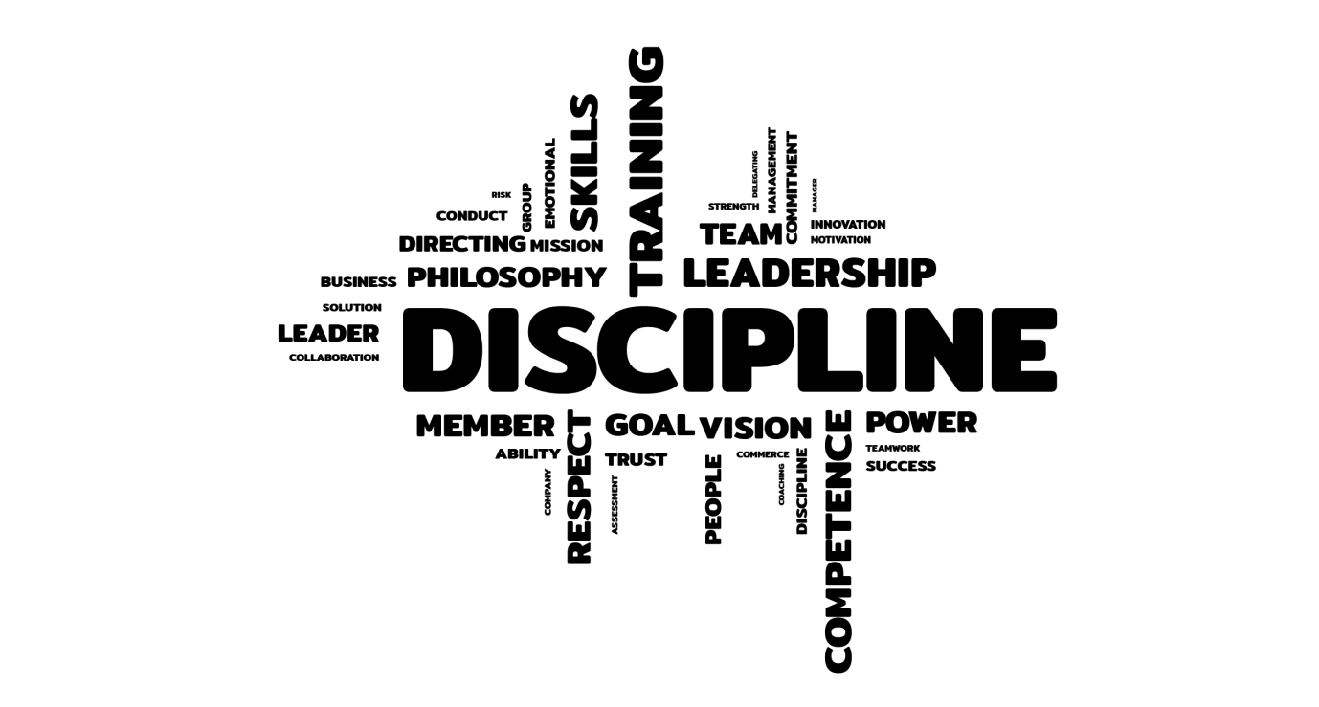

**Figure 31: Word cloud description**(Redrawn: [Source](https://stock.adobe.com/79775910?as_campaign=TinEye&as_content=tineye_match&epi1=79775910&tduid=bfee0c172b611f22e895765032d93aa8&as_channel=affiliate&as_campclass=redirect&as_source=arvato))

## Put together a toolkit for reflective practice

In your industry or field, you may have tools that are specific to your trade (‘tools of the trade’). Tools can be physical – like a hammer, a plumbing rod, a carving knife, or a hair dryer. Others can be conceptual – like a protocol for healthcare, a theory for early childhood development, or a system for organic farming. And tools can be virtual – like Computer Aided Design (CAD), a phone app for recording information or other programmes. You might have a toolkit that holds your most used tools or different toolkits for different aspects of your trade. You probably have some favourites that you rely on. Your set of favourite tools might be slightly different from another person’s in your trade, although there will probably be quite a bit of overlap. Some examples of physical tools are shown in Figure 32.



**Figure 32: Toolkits**

Sources: [Hair](https://www.publicdomainpictures.net/en/view-image.php?image=36275&picture=hair-tools-and-accessories); [Building](https://www.publicdomainpictures.net/en/view-image.php?image=320844&picture=tools-clipart); [Kitchen](https://svgsilh.com/image/2640067.html)

Throughout this module you have explored a variety of reflective models and tools and experimented with using them for different purposes. Let us review each tool and evaluate which ones best help you as a reflective practitioner, and how to create a personalised reflective toolkit to aid you and your students throughout your journeys of lifelong learning.

# Summative Assessment: Building up a toolkit of reflective tools

****Suggested time: 90 minutes****

This activity guides you through a review of the models and tools you have explored in this module, and helps you make some decisions about how you might use them for reflection as a TVET lecturer. Read the description of the activity, and then answer the questions that follow.

In your reflective learning journal, turn to the next two blank pages opposite each other. Draw a toolkit (or toolbox) on the left-hand page, with boxes where you will identify each tool and how you plan to use it. You can use the example in Figure 33 as a guide, or have some fun designing it in a way that ‘speaks’ to your industry. Allocate half the toolbox for tools you will use for your own learning and half for tools you will use with your students. Use the whole page, so that you have enough space. For example, while Figure 35 shows two rows in each section, you could make four rows in each.

As you think about each tool and how you might want to adapt it to be most useful to you, it might be helpful to play around with your ideas visually. Use your right-hand page for notes, sketchnotes, mind maps or other helpful representations of your ideas. In some cases, you may want to write down detailed notes for your ideas about how you will use a tool.

Once you have decided on a tool and how you will use it, record it in your toolkit/toolbox on the left-hand page.

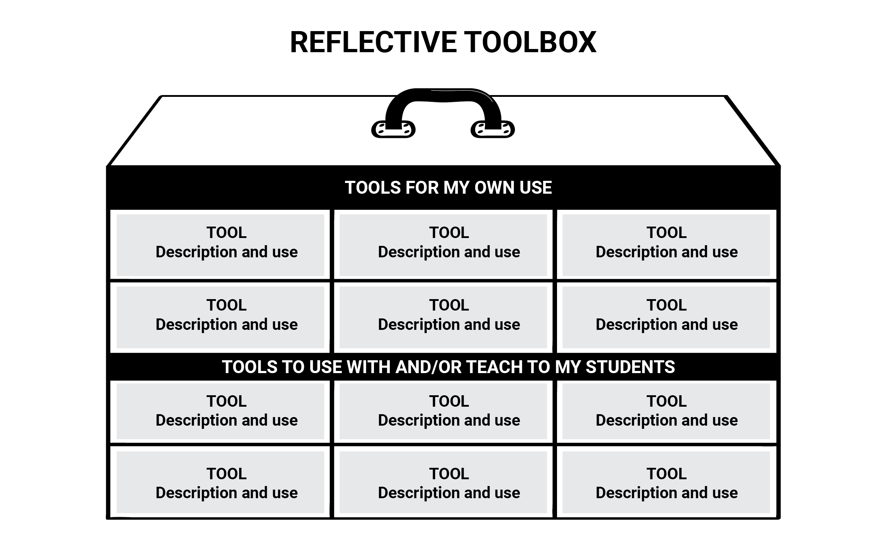

**Figure 33: Example of a ‘toolbox’ to visually organise the reflective tools you plan to use**

As you review each of the key reflective tools, models or ideas, ask yourself these questions:

For yourself:

* Could this help me to learn from my daily teaching experience and grow professionally? What would be the most effective way/s to use it?
* Could this help me to improve the way I plan and design my programme, course or lessons? What would be the most effective way/s to use it?

For your students:

* Could this help my students to learn through their own experiences and actions in my course? What would be the most effective way/s to use it?
* Could this help my students to learn directly from their own experiences and actions in their careers? How could I most effectively teach them to use this?
* Could this be useful to my students for planning and designing they might need to do in their jobs/careers? How could I most effectively teach them to use this?

Rubric

Your toolkit and descriptive notes will be assessed against the following criteria:

|  | **Task** | **Excellent** | **Good** | **Needs development** | **Inadequate** |
| --- | --- | --- | --- | --- | --- |
| **Tools for your own use** | | | | | |
| 1. | **Tools for learning from your daily teaching and growing professionally** | You have selected, adapted or designed a range of tools and you have indicated clearly how you will use them in in your TVET context. | You have selected, adapted or designed some tools and have indicated how you intend to use them in your TVET context. | You have selected at least one tool but have not considered other tools that may be useful or you have not explained clearly enough how you will use the tool/s in your TVET context. | You have not selected, adapted or designed at least one tool or have not indicated how you will use the tool/s in your TVET context. |
| 2. | **Tools for improving your planning and designing programme, course and lessons** | You have selected, adapted or designed a range of tools and you have indicated clearly how you will use them in in your TVET context. | You have selected, adapted or designed some tools and have indicated how you intend to use them in your TVET context. | You have selected at least one tool but have not considered other tools that may be useful or you have not explained clearly enough how you will use the tool/s in your TVET context. | You have not selected, adapted or designed at least one tool or have not indicated how you will use the tool/s in your TVET context. |
| **Tools to use with and/or to teach to your students** | | | | | |
| 3. | **Tools to facilitate students learning through their own experiences and actions during your courses** | You have selected, adapted or designed a range of tools and you have indicated clearly how you will use them in in your TVET context. | You have selected, adapted or designed some tools and have indicated how you intend to use them in your TVET context. | You have selected at least one tool but have not considered other tools that may be useful or you have not explained clearly enough how you will use the tool/s in your TVET context. | You have not selected, adapted or designed at least one tool or have not indicated how you will use the tool/s in your TVET context. |
| 4. | **Tools to teach to students to facilitate their learning directly from their own experiences in their careers and to aid them in planning and design in their careers** | You have selected, adapted or designed a range of tools and you have indicated clearly how you will use them in in your TVET context. | You have selected, adapted or designed some tools and have indicated how you intend to use them in your TVET context. | You have selected at least one tool but have not considered other tools that may be useful or you have not explained clearly enough how you will use the tool/s in your TVET context. | You have not selected, adapted or designed at least one tool or have not indicated how you will use the tool/s in your TVET context. |

Now review the following tools you have worked with in this module. You may want to look back through the module and your reflective journal to remind yourself of your key ideas and thoughts.

* + - 1. **Reflective journal, blog or report**

In Unit 1, we looked at different ways that a person could journal:

* using a regular notebook;
* mind mapping;
* sketchnoting;
* using voice notes;
* recording video; and
* online journals and blogs.

In Unit 3, we looked at using these tools with your students as part of enquiry-based learning or a trade journal for workplace-based learning:

* a reflective learning journal;
* professional development log; and
* reflective report.

**Which of these could** benefit you or your students? Should they be adapted in any way? Add the tools you choose to the toolkit. Add any additional notes/diagrams on the right-hand page.

* + - 1. **Reflective and experiential learning cycles and lenses**

In Unit 2, you explored four reflective cycles:

* *Borton’s (1970) simple cycle:* What? So what? Now what?
* *Rolfe et al.’s (2001) framework* to aid critical reflection
* *Gibbs’ (1988) reflective cycle*
* *Atkins and Murphy’s (1993) reflective cycle* (starting with awareness of discomfort)

You experimented with combining aspects of these cycles to best suit your situation.

You also learnt about other models that can aide reflection:

* The *Johari window*, which helps you think about blind, hidden and unknown areas within yourself and how you can bring them out into the open;
* *Brookfield’s lenses*, where you use your own experience, your students’ experience of you, your peers’ experience of you and the perspective of theory and research to help you gain more insight into yourself (linking well with the Johari model, as these additional perspectives help to bring blind, hidden or unknown things into the open); and
* *Blair’s ‘everyday practice’ approach*, which focuses on content, the use of one’s body and physical space in the classroom, the effort put into teaching and learning and the relationship with and between students.

You experimented with integrating these into a reflective cycle.

You also learnt about intentionally creating discomfort in your students, to spark a more *transformative* learning experience.

In Unit 3 you learnt about using reflection in the context of experiential and enquiry-based learning in the classroom or workplace using:

* *Kolb’s experiential learning cycle*;
* *Boehner’s teaching and learning session design cycle*; and
* *TELSTAR model of enquiry*.

**Which of these could** benefit you or your students? Should they be adapted in any way? Add the tools you choose to the toolbox. Add any additional notes/diagrams on the right-hand page.

* + - 1. **Environmental scan and situational analysis**

In Unit 3 you learnt how to conduct an environmental scan to gather information about your situation and how to do an analysis of the situation, to enable you to plan for actions or changes you will implement. For an *environmental scan* you identified external factors (such as *PESTEL*), and internal factors that included things such as goals and choice or use of resources. You learnt how to analyse this information using a *SWOT/TOWS analysis* (considering threats, opportunities, weaknesses and strengths) or a *SOAR analysis* (strengths, opportunities, aspirations and results).

An environmental scan and situational analysis can be used at any level: for example, in the context of TVET, at the level of your college, programme, course, or as part of a specific project or enquiry-based learning activity. They can be used at an individual level for self-reflection. They can be useful for your students as a tool for analysing, predicting and planning for factors and change in their trade environment.

**Which of these could** benefit you or your students? Should they be adapted in any way? Add the tools you choose to the toolkit. Add any additional notes/diagrams on the right-hand page.

Now step back and look at your reflective toolkit. Is there anything missing, or anything you would like to change? You can also add in other models and pedagogical approaches that were not discussed in this module, if you think that would be useful.

When you are happy with your toolkit, share it with your peers. If you have diagrams, sketches or notes on the right-hand page that might interest them, share those as well. Look carefully at theirs. Are there any ideas that you might like to incorporate into your toolkit? If so, add them.

### Discussion of activity

As you use the tools you have chosen or developed, you will no doubt continue to ‘sharpen’ them so that they are increasingly effective, using new insights you gain. And you will no doubt add new tools, models and theories that you discover and that your colleagues share with you.

In this unit, you have clarified your goals and values as a TVET lecturer, examined where you are currently and the realities you have to work with, and thought about how you will achieve these goals and enact these values, given these conditions. You have developed a statement of teaching philosophy that will help you to measure your daily actions against your goals and values. And you have developed a reflective toolkit to help you and your students learn from your actions, experiences and environment, so that you can plan, design, predict and continue to grow professionally throughout your careers.

# Conclusion

This brings us to the end of this module. We have explored a wide range of reflective purposes, practices and tools that you can use to aid your own development and teaching, and the development of your students. Now, for one final reflection to wrap up your reflective learning journal for this course, answer the following questions:

1. How do you think this course will change the way I teach?
2. Can I remember any key insights which changed or transformed some aspects of my beliefs, attitudes or values during this course?
3. Which ideas or activities did I find most interesting or exciting? What made them exciting?
4. What have I learnt in this course that I would most like to share with my students?
5. What have I learnt in this course that I would most like to share with my colleagues?
6. Will I take anything away from this course that will benefit me in my personal life?

The reflective learning journal that you have kept during this course can serve as a valuable resource going forward. If you find yourself struggling to integrate reflection or enquiry into your professional life or your teaching, or reflection is beginning to fall away way from your daily practice, take out your journal and review it. You can begin a new journal today to launch yourself into an ongoing reflective practice. Over the years you will develop a ‘library’ of insights and ideas that you can return to for inspiration.

# References

Atkins, S., & Murphy, K. (1993). Reflection: A review of the literature. *Journal of Advanced Nursing*, *18,* 1188–1192.

Aziz, R. C., Hamzah, S., Hashim, N. A. A. N., Rahim, M. A., Zulkifli, W. F. W., & Ahmad, G. (2019). S.O.A.R model: An alternative approach for 21st century education to shift from ‘classroom management’ to ‘classroom leadership. *International Journal of Academic Research in Progressive Education and Development, 8*(2), 1021–1029.

Blair, E. (2011). Balanced reflection as a means of practitioner development in the post-compulsory education and training sector. *Research in Post-Compulsory Education. 16*(2), 249–261.

Blair, E. (2017, June 1). Everyday reflective practice. *The Education Blog*. London School of Economics. <https://www.researchgate.net/publication/323629297_Everyday_reflective_practice>; <https://repository.uwl.ac.uk/id/eprint/4947/> Retrieved 10 August 2020.

Blair, E. & Deacon, A. (2015). A holistic approach to fieldwork through balanced reflective practice. *Reflective Practice, 16*(3), 418–434.

Blom, R. (2016). *Curriculum Framework for the Advanced Diploma in Technical and Vocational Teaching*. Department of Higher Education and Training, South Africa.

Borton, T. (1970). *Reach, touch, and teach: Student concerns and process education*. New York: McGraw-Hill

Boehner, M.M. (2017). *High quality teaching and assessing in TVET: The road to enhanced learning outcomes.* Series on Quality in TVET: Volume 2. Colombo, Sri Lanka: Tertiary and Vocational Education Commission.

Boyd, R., & Myers, J. (1988). Transformative Education. *International Journal of Lifelong Education* *7*(4), 261–284.

Brookfield, S. (1995). *Becoming a critically reflective teacher*. San-Francisco: Jossey-Bass.

Brown, N. (2017). Reflective model according to Brookfield. Nicole Brown. <http://www.nicole-brown.co.uk/reflective-model-according-to-brookfield/> Retrieved 8 January 2020.

Catholic Education Services, Diocese of Cairns. (n.d.) *TELSTAR model of inquiry.* <http://www.cnscurric.catholic.edu.au/telstar-model.html> Retrieved 5 January 2020.

Cowan, J. (2006). *On becoming an innovative university teacher: Reflection in action: Reflection in action*. McGraw-Hill Education (UK).

Dewey, J. (1910). *How we think*. Boston: D.C. Heath & Co.

Doel, S. (2009). Fostering student reflection during engineering internships. *Asia‐Pacific Journal of Cooperative Education, 10*(3), 163–177.

Du Toit, A. S. (2016). Using environmental scanning to collect strategic information: A South African survey. *International Journal of Information Management*, *36*(1), 16-24.

Ekurhuleni East TVET College. (2016). *Ekurhuleni East TVET College Strategic Plan 2017.* Department of Higher Education and Training, South Africa <http://www.eec.edu.za/Corparate/EEC%20TVET%20College%20Strategic%20Plan%202017.pdf> Retrieved 10 August 2020.

Finlay, Linda (2008). *Reflecting on ‘Reflective practice’*. Practice-based Professional Learning Paper 52, The Open University.

Gibbs, G. (1988). *Learning by doing: A guide to teaching and learning methods*. Oxford: Oxford Further Education Unit

Hammond, S. A. (2013). *An Introduction to Appreciative Inquiry.* Bend, Oregon: Thin Book Publishing Co. <https://static1.squarespace.com/static/56112ea2e4b0edf3da21f898/t/562c0852e4b0947cbf0a47bc/1445726290923/introduction-to-appreciative-inquiry.pdf> Retrieved on 3 March 2020

How to mind map with Tony Buzan. (n.d.). <https://mindmapsunleashed.com/how-to-mind-map-with-tony-buzan>. Retrieved 21 May 2020.

Ismail, N.B. (2013). Defining vocational education and training for tertiary level education: Where does problem based learning fit in? A literature review. Paper presented at the 4th International Research Symposium on Problem-Based Learning (IRSPBL), Kuala Lumpur, Malaysia.

Jarche, H. (2014). *The Seek > Sense > Share Framework*. <https://jarche.com/2014/02/the-seek-sense-share-framework/> Retrieved 5 February 2020.

Kolb, D. A. (2014). *Experiential learning: Experience as the source of learning and development. Second Edition*. New Jersey: Pearson.

Kožuchová, M., & Dostál, J. (2016). Inquiry-based Approach in Technical Education. 16. 93–98. 10.15584/eti.2016.2.11.

Long, F (2016). *Teaching statement.* <http://people.csail.mit.edu/fanl/misc/ts.pdf> Retrieved 2 April 2020.

Mullerbeck, E. (2015). *SWOT and PESTEL: Understanding your external and internal context for better planning and decision-making*. <https://www.unicef.org/knowledge-exchange/files/SWOT_and_PESTEL_production.pdf> Retrieved 25 February 2020.

Mwaka, M. (2013). Environmental scanning in teacher education: The practice in higher education in Kenya. *Journal of Education and Practice, 4*(4), 116–124.

Nkangala TVET College (2019). *Nkangala TVET College Strategic Plan 2019.* Department of Higher Education and Training, South Africa <http://www.ntc.edu.za/careers-tenders/er-documents-a-reports/acts-a-other-legal-articles/156-nkangala-tvetc-strategic-plan-2019/file> Retrieved 2 March 2020.

O’Neal, C., Meizlish, D., & Kaplan, M. (2007). *Writing a statement of teaching philosophy for the academic job search.* University of Michigan: Center for Research on Learning and Teaching Occasional Paper No. 23.

Reflective practice. (2020, January 10). *Business Balls*. <https://www.businessballs.com/self-awareness/reflective-practice/> Retrieved 10 January 2020.

Republic of South Africa. (2013). Policy on professional qualifications for lecturers in Technical and Vocational Education and Training. *Government Gazette* 576 (36554).

Richmond, T. (2018, March 19). The beauty comes in the reflection. <https://www.tisharichmond.com/blog/the-beauty-comes-in-the-reflection>. Retrieved 6 September 2019.

Rolfe, G., Freshwater, D., & Jasper, M. (2001). *Critical reflection in nursing and the helping professions: A user’s guide.* Basingstoke: Palgrave Macmillan.

Rosenberg, M. (2017, October 10). Marc my words: The coming knowledge tsunami. *Learning Solutions*. <https://www.learningsolutionsmag.com/articles/2468/marc-my-words-the-coming-knowledge-tsunami> Retrieved 8 September 2019.

Schön, D. (1983). *The reflective practitioner: How professionals think in action*, New York: Basic Books.

Simsek, A. (2012) Transformational learning. In N.M. Seel (Ed.) *Encyclopedia of the sciences of learning*. Boston, MA: Springer.

South Africa (2013). Policy on professional qualifications for lecturers in Technical and Vocational Education and Training, Government Gazette, Vol. 576, No. 36554, 11 June.

Stavros, J. & Hinrichs, G. (2009). The Thin Book of SOAR: Building strengths-based *strategy.* Bend, Oregon: Thin Book Publishing Co.

The Johari window model. (n.d.). *Communication Theory*. <https://www.communicationtheory.org/the-johari-window-model/> Retrieved 10 January 2020.

Thin Book (2020). *Appreciative Inquiry.* <https://www.thinbook.com/appreciative-inquiry> Retrieved 3 March 2020.

Vanderbilt University. (2020). *Teaching statements.* Center for Training. <https://cft.vanderbilt.edu/guides-sub-pages/teaching-statements/#what_is> Retrieved on 11 March 2020.

Walters, T. (n.d.) *My individual teaching philosophy.* <https://trknee.weebly.com/individual-teaching-philosophy.html> Retrieved 17 March 2020

# Appendices

## Appendix 1: Reading for Activity 2

### Exit Level Outcomes for the Advanced Diploma in TVET

Blom, R. (2016). Curriculum Framework for the Advanced Diploma in Technical and Vocational Teaching. South African Department of Higher Education and Training

|  |  |  |
| --- | --- | --- |
|  | **Exit Level Outcome** | **Competency** |
| **DISCIPLINARY LEARNING** | | |
| 1 | **TVET studies and its foundations** | **Persons credited with this outcome are able to…** |
| 1.1 | Demonstrate an understanding of the philosophy, psychology, politics, economics, sociology and history of TVET | i. Discuss, debate, critically assess and reflect on the principles of the philosophy of TVET; ii. Engage critically with discourses, concepts and theories relevant to TVET in a post-school context; iii. Apply sociological and psychological principles and practice in the TVET context; iv. Critically interact with, and analyse various theoretical positions in respect of the history, politics and economics as it relates to TVET |
| 1.2 | Demonstrate respect for professional ethics and issues related to knowledge of, and relationships between self and others in the life of a technical and vocational education and training educator | i. Reflect a critical, committed and ethical attitude; ii. Foster a sense of respect and responsibility towards others; iii. Act in ways that enhance the status of professional educators and ensure an accountable culture of teaching and learning iv. Consider issues related to sustainable development, the environment and the green economy |
| 1.3 | Reflect on own practice to support professional development | i. Apply appropriate research strategies to enhance teaching, learning and professional practice |
| **PEDAGOGICAL LEARNING** | | |
| **2** | **General pedagogy** | **Persons credited with this outcome are able to…** |
| 2.1 | Demonstrate an understanding of the principles, practices and methods of general teaching practice | i. Engage with prevailing practices and methods of teaching; ii. Select and apply a variety of teaching practices in diverse settings; iii. Utilise blended learning approaches by integrating technology in teaching and learning as appropriate |
| 2.2 | Demonstrate an understanding of students, vocational education and training, learning, curriculum and general instructional and assessment strategies | i. Adjust teaching and learning practices to the context of technical and vocational education and training students; ii. Interpret and enact curricular knowledge and practice in terms a broader understanding of relevant fields of knowledge; iii. Plan lessons and other learning experiences, including preparing students for workplace learning, by selecting appropriate teaching and learning strategies; iv. Design and apply appropriate assessment strategies |
| 2.3 | Demonstrate the ability to work in teams, organisations and groups | i. Model working in teams to the benefit of all participants; ii. Prepare students to engage with members of teams, organisations or groups |
| **3** | **Specialised pedagogy** | **Persons credited with this outcome are able to…** |
| 3.1 | Demonstrate an understanding of concepts, methods, rules and practices of a TVET subject or field in order to create appropriate learning opportunities for students | i. Apply concepts, methods, rules and practices in relevant fields of knowledge, which underpin the subject/learning fields of specialisation; ii. Use the characteristic language, terminology and concepts of own subject/s or learning fields appropriately; iii. Plan lessons and other learning experiences, including preparing students for workplace learning, by selecting appropriate teaching and learning strategies; iv. Adjust teaching and learning strategies to accommodate cultural, gender, ethnic, language and other differences among students in a range of contexts; v. Utilise blended learning approaches by integrating technology in teaching and learning as appropriate |
| 3.2 | Apply appropriate assessment methods for the TVET subject or field to ensure progress in learning | i. Select, adapt and/or design assessment tasks and strategies appropriate to the specialisation and a range of learning contexts; ii. Use a range of assessment strategies to accommodate differences in learning style, pace and context; iii. Use assessment feedback to enhance teaching and learning |
| 3.3 | Develop an understanding of possible barriers to learning experienced by students | i. Use inclusive education strategies and student support to overcome barriers to learning; ii. Apply teaching strategies to match the profile of the students; iii. Create and maintain learning environments which are safe and conducive to learning |
| 3.4 | Apply the technical and workplace knowledge and skills associated with the subject field or area to enhance teaching and learning | i. Engage with the world of work as related to a field of learning in relation to how students learn in, for and through work; ii. Incorporate relevant workplace knowledge and skills into teaching and learning; iii. Utilise blended learning approaches by integrating technology in teaching and learning as appropriate |
| 3.5 | Prepare students for learning and work in real-life workplace environments | i. Equip students for entry into workplace learning and participation in the world of work |
| **PRACTICAL AND/OR WORK-INTEGRATED LEARNING** | | |
| **4** | **Learning to teach** | **Persons credited with this outcome are able to…** |
| 4.1 | Demonstrate an understanding of teaching practices across a variety of technical and vocational education and training contexts, including classroom and workshop/laboratory practice; and in authentic workplaces and simulated environments | ii. Apply teaching principles across a variety of contexts, including classrooms, workshops, laboratories and simulated environments; iii. Develop appropriate lesson plans, methods and media to enhance learning; iv. Design and conduct assessment v. Prepare and teach lessons that link the subject taught to current industry application, practices and technology through incorporating relevant industry examples and knowledge and skills |
| 4.2 | Manage classrooms / workshops/ laboratories / simulated work environments | i. Apply appropriate management and administration procedures in respect of classrooms, workshops, laboratories and simulated work environments; ii. Use appropriate discipline and control of learning spaces |
| **5** | **Learning from work** | **Persons credited with this outcome are able to…** |
| 5.1 | Demonstrate knowledge of the current application and relevance of specialised subject fields in associated workplaces | i. Show knowledge of current application of the subject fields’ in workplaces; ii. Identify organisational and cultural aspects as they relate to particular workplaces, including employer expectations of employees in the field |
| 5.2 | Reflect on the workplace knowledge and skills associated with the subject field or area to enhance teaching and learning | i. Analyse and compare the curriculum with prevailing practices in the workplace to understand the implications for teaching and learning; ii. Incorporate such practices in teaching and learning |
| 5.3 | Reflect critically on experiences during industry-based exposure depicting lessons learnt with regards to own subject specialisation and the subject’s teaching | i. Report on lessons learnt and their applicability to teaching the subject; ii. Apply work-based learning experiences in the preparation and teaching of lessons |
| **SITUATIONAL LEARNING** | | |
| **6** | **The TVET context** | **Persons credited with this outcome are able to…** |
| 6.1 | Demonstrate an understanding of relevant policy, political and organisational context important for the growth of technical and vocational education and training in South Africa | i. Engage critically with education and training and economic policies, procedures and systems impacting on institutions and classrooms, and on education and training and the economy |
| 6.2 | Demonstrate an understanding of the diverse challenges faced by technical and vocational education and training students | ii. Apply health and safety measures appropriate to classrooms, workshops, laboratories and simulated workplaces; iii. Promote healthy life choices and lifestyles in respect of HIV/AIDS; iv. Promote active citizenship and responsible participation in the broader society |
| 6.3 | Engage with professional peers in a community of practice to enhance the development of the profession and professional identities | i. Demonstrate the ability to work in teams, groups and organisations to the benefit of the TVET professions and professionals |
| **FUNDAMENTAL LEARNING** | | |
| **7** | **Fundamental studies** | **Persons credited with this outcome are able to…** |
| 7.1 | Demonstrate academic literacies as appropriate to the level of the qualification (language and numerical literacies | ii. Use the main language of instruction to explain, describe, discuss and relate key concepts in area of specialisation; iii. Convey the content of own fields of specialisation in written, graphic and other forms which are appropriate to the developmental level/s and language ability of the students; iv. Interpret written and graphic materials relating to own fields of specialisation; v. Apply numerical and elementary statistical knowledge to educational issues, cross curricular activities, and own learning |
| 7.2 | Demonstrate the ability to hold a basic conversation in at least one official African language | i. Use basic social conversation to engage with students in at least one African language |
| 7.3 | Demonstrate the ability to integrate ICT appropriately for own and student development | ii. Use information and communications technology to further own learning and facilitate the learning of others |

## Appendix 2: Resource for Activity 8

**Reading emotions:** List of emotions with corresponding physical sensation or behaviour

| **Emotion** | **Body signal** | **Present?** |
| --- | --- | --- |
| Anxiety | Heart beating faster, slower or skipping beats |  |
| Want to run away |  |
| Blushing (red in face) |  |
| Hard to breathe/ heaviness in chest |  |
| Butterflies in stomach/ gnawing pain in stomach, stomach upset/ diarrhoea |  |
| Tension around eyes and mouth |  |
| Dry mouth |  |
| Lightheaded/ dizzy |  |
| Cold, sweaty hands |  |
| Armpits sweating although you do not feel hot (may smell more unpleasant than sweating when you are hot) |  |
|  |  |
|  |  |
| Anger | Heart pounding, feel blood pressure rising |  |
| Shaking or trembling, feeling faint or weak |  |
| Feeling hot (especially in face or neck), sweating |  |
| Churning stomach |  |
| Clenched jaw, grinding teeth |  |
| Desire to hit someone or something |  |
| Headache |  |
| Eyebrows pulled down in middle |  |
| Chin jutting (stuck out) |  |
| Nostrils flared |  |
|  |  |
|  |  |
| Boredom | Eyes look away |  |
| Face expressionless |  |
| Head propped up with hand |  |
| Edges of lips tipped down, or lips pulled to the side |  |
|  |  |
|  |  |
| Interest | Eyes gaze steadily at speaker or object of interest |  |
| Eyes narrowed |  |
| Head forward |  |
| Eyebrows slightly raised |  |
| Lips may be pressed together |  |
|  |  |
|  |  |
| Sadness | Body feels heavy, tired, old |  |
| Lump in your throat |  |
| Aching, empty, heavy or painful feeling in chest |  |
| Feel like crying |  |
| Don’t want to see or talk to anyone |  |
| Tightness in your chest |  |
|  |  |
|  |  |
| Shame | Can’t look others in the eye eyes, eyes and head turned down, eyebrows lower |  |
| Feel sick in the stomach |  |
| Heaviness in the chest |  |
| Body temperature goes up |  |
| Wish you could disappear or be invisible |  |
|  |  |
|  |  |
| Happiness | Sparkling eyes |  |
| Eyes wrinkled at sides |  |
| Head high |  |
| Slightly raised eyebrows |  |
|  |  |
|  |  |

Compiled by the module author.

## Appendix 3: Models for Lecturer Assessment forms for Activity 22

**A: Lecturer self-assessment**

**Expertise of TVET lecturer**

1. Y / N I have good practical expertise in this technical subject.
2. Y / N I have good theoretical knowledge on this technical subject.
3. Y / N I am a skilful teacher.
4. Y / N I am motivated and enthusiastic about teaching this technical subject.
5. Y / N I am continually learning new things from research and the industry.
6. Y / N I feel excited that I am preparing students to enter this industry.

**Lecturer’s approach to students**

1. Y / N I know my students’ background, interests, skills and goals and work with these.
2. Y / N I respect all members of the class as my equals, regardless of gender, cultural, political background or anything else.
3. Y / N I am aware of the barriers or challenges each of my students face and work with these.
4. Y / N I encourage my students to ask questions and welcome their comments and ideas.
5. Y / N I respect the knowledge and skills they already have and build on this.
6. Y / N I am willing to learn from my students during the different activities we do.

**Lecturer’s approach to teaching and learning**

1. Y / N I integrate theory into practical activities; lecturing is kept at a minimum.
2. Y / N I connect the things I teach to industry/the workplace.
3. Y / N I teach my students how to use the technologies they will use in the workplace.
4. Y / N I give my students opportunities to discover things for themselves (through enquiry-based learning) rather than spoon feeding them.
5. Y / N I teach my students how to think about things in a critical way and have them reflect on what we do in the class, so that they can learn from their experiences.
6. Y / N I interact with each of my students and move around the classroom when I teach.

**B: Assessment of lecturer by students**

**Expertise of TVET lecturer**

1. Y / N My lecturer has good practical expertise in this technical subject.
2. Y / N My lecturer has good theoretical knowledge on this technical subject.
3. Y / N My lecturer is a skilful teacher.
4. Y / N My lecturer is motivated and enthusiastic about teaching this technical subject.
5. Y / N My lecturer is continually learning new things from research and the industry.
6. Y / N My lecturer makes me feel excited that I am entering this industry.

**Lecturer’s approach to students**

1. Y / N My lecturer knows what my background, interests, skills and goals are and works with these.
2. Y / N My lecture respects all members of the class as equals, regardless of gender, cultural, political background or anything else.
3. Y / N My lecturer knows about barriers or challenges I face and works with these.
4. Y / N My lecturer encourages me to ask questions and welcomes my comments and ideas.
5. Y / N My lecturer respects the knowledge and skills I already have and builds on this.
6. Y / N My lecturer is willing to learn from us as students during the different activities we do.

**Lecturer’s approach to teaching and learning**

1. Y / N My lecturer integrates theory into practical activities; lecturing is kept to a minimum.
2. Y / N My lecturer connects the things we learn to industry/the workplace.
3. Y / N My lecturer is teaching us how to use the technologies we will use in the workplace.
4. Y / N My lecturer gives us opportunities to discover things for ourselves, rather than spoon feeding us.
5. Y / N My lecturer teaches us how think about things in a critical way and reflect on what we do in the class so that we can learn more from it.
6. Y / N My lecturer interacts with each of us and moves around the classroom when he/she teaches.

**C: Assessment of lecturer by colleagues**

**Expertise of TVET lecturer**

1. Y / N This lecturer has good practical expertise in this technical subject.
2. Y / N This lecturer has good theoretical knowledge on this technical subject.
3. Y / N This lecturer is a skilful teacher.
4. Y / N This lecturer is motivated and enthusiastic about teaching this technical subject.
5. Y / N This lecturer is continually learning new things from research and the industry.
6. Y / N This lecturer makes the students feel excited that they are entering this industry.

**Lecturer’s approach to students**

1. Y / N This lecturer knows what the background, interests, skills and goals of the students are and works with these.
2. Y / N This lecture respects all members of the class as equals, regardless of gender, cultural, political background or anything else.
3. Y / N This lecturer knows about barriers or challenges the students face and works with these.
4. Y / N This lecturer encourages the students to ask questions and welcomes their comments and ideas.
5. Y / N This lecturer respects the knowledge and skill the students already have and builds on this.
6. Y / N This lecturer is willing to learn from the students during the different activities they do.

**Lecturer’s approach to teaching and learning**

1. Y / N This lecturer integrates theory into practical activities; lecturing is kept at a minimum.
2. Y / N This lecturer connects the things the students learn to industry/the workplace.
3. Y / N This lecturer is teaching the students how to use the technologies they will use in the workplace.
4. Y / N This lecturer gives the students opportunities to discover things for themselves, rather than spoon feeding them.
5. Y / N This lecturer teaches the students how think about things in a critical way and reflect on what they do in the class so that they can learn more from it.
6. Y / N This lecturer interacts with each of the students and moves around the classroom when he/she teaches.

Compiled by the module author.