Advanced Diploma
Technical and Vocational Teaching

Industry-based work-integrated learning: Structured learning experiences in a specialisation

Department of Higher Education and Training

Department of Higher Education and Training
Advanced Diploma: Technical and Vocational Teaching
Module: Industry-based work-integrated learning: Structured learning experiences in a specialisation
Author: Chris Vorwerk

© Department of Higher Education and Training 2023
Department of Higher Education and Training
123 Francis Baard Street
Pretoria
0001

Website: www.dhet.gov.za

This Module of the Advanced Diploma: Technical and Vocational Teaching (Adv. Dip TVT) was produced with the financial support of the European Union. Its contents are the sole responsibility of the Department of Higher Education and Training, and do not necessarily reflect the views of the European Union.

This work is licensed under a Creative Commons Attribution 4.0 International License.

Contents
Contents i
Acknowledgements iii
Acronyms and abbreviations v
Programme introduction vii
Approach to learning vii
Module overview 1
Module purpose 1
Module outcomes 1
Module structure 1
Module credits 1
Module time (notional hours) 2
Unit 1: Prepare and plan for the WIL experience 3
Introduction 3
Unit 1 outcomes 3
Setting the scene 3
Envisaging work 4
Developing a WIL action plan 12
Arranging your WIL experience 15
Conclusion to Unit 1 16
Unit 2: Processing WIL information 19
Introduction 19
Unit 2 outcomes 19
Setting the scene 19
Personal knowledge management 20
Constructing an inventory 23
Categorising items in your inventory 24
Developing a portfolio of evidence (PoE) 28
Conclusion to Unit 2 29
Unit 3 Enriching teaching and learning through WIL 31
Introduction 31
Unit 3 Outcomes 31
Using your inventory to enrich your teaching and learning practice 31
Compiling a summary of your WIL 32
Planning a student WIL experience 34
Reflecting on college–industry/workplace collaboration 35
Conclusion 37
Exemplar Summative Assessment 39
Rubric 39
Bibliography 42

Acknowledgements
The Open Learning Directorate of the Department of Higher Education and Training (DHET) would like to acknowledge:
The European Union for funding the Capacity Building for TVET College Lecturers through Open Learning Programme (Sub-Programme 2 of the Teaching and Learning Development Sector Support Programme). The production of open learning courses for the Advanced Diploma in Technical and Vocational Teaching (Adv. Dip TVT) is a project of that programme.
The following universities, for making lecturing staff available to contribute to the project as subject matter experts, writers or critical reviewers:
- Cape Peninsula University of Technology
- Central University of Technology
- Durban University of Technology
- Nelson Mandela University
- Tshwane University of Technology
- University of Fort Hare
- University of the Free State
- University of Johannesburg
- University of Nottingham (UK)
- University of Pretoria
- University of KwaZulu Natal
- Vaal University of Technology
- University of the Witwatersrand
The Technical and Vocational Education and Training (TVET) Branch of the Department of Higher Education and Training for providing information whenever it was requested.
The following TVET Colleges for making lecturing staff available to contribute to the project as subject matter experts, writers or critical reviewers:
- False Bay TVET College
- Majuba TVET College
- South-West Gauteng TVET College
- West Coast TVET College, and
- Motheo TVET College for developmental testing of materials.
The University of the Free State for overall project management, and the Centre for Teaching and Learning for producing multi-media materials, resources and the e-learning (SCORM) versions of the courses, as well as uploading the materials on the National Open Learning System (NOLS).
Saide, (South African Institute for Distance Education) for their expertise in leading and co-ordinating the development and production of the course modules and in ensuring that the developed material is made available for use as Open Education Resources (OER), thereby contributing to the implementation of open learning in post-school education and training (PSET).

Acronyms and abbreviations

AdvDipTVT | Advanced Diploma: Technical and Vocational Teaching
HEI | Higher education institution
IP | Intellectual property
ISO | International Organization for Standardization
LFA or Log frame | Logical framework approach
OVI | Objectively verifiable indicator
PKM | Personal knowledge management or mastery
PoE | Portfolio of evidence
TVET | Technical vocational education and training
WIL | Work-integrated learning

Programme introduction
The Advanced Diploma in Technical and Vocational Teaching (Adv. Dip TVT) programme seeks to provide a structured professional learning pathway for current and aspirant technical and vocational lecturers/teachers. The Diploma will equip them with the knowledge and competences to implement and manage teaching and learning in their TVET colleges effectively and in alignment with national goals.
This module is one of a set of modules that contribute to the Advanced Diploma programme. The overall purpose of the Advanced Diploma is to engage lecturers working in the TVET sector in conversations about what it means to be a quality teacher in a TVET college. Each Module in the programme explores this from a different angle, but for every module the foundational concept is about the type of teacher you want to be. We all know that the relationship between teaching and learning is interrelated, so in order to understand the type of teacher you want to be you will need to engage with what learning means in a TVET context.
We often think about vocational and technical or craft knowledge as different from theoretical knowledge. However, there is increasing recognition of the power of vocational and theoretical knowledge coming together to develop the skilled craftsperson whether it is in plumbing, baking, even mathematics and physics. This integration of theory and vocational knowledge is equally important in teaching as well. Teachers are constantly needing to make informed decisions and judgements as they select what to teach and how best to teach the specific content, concept or skill.
This leads to a question about how different forms of knowledge and skill are brought together and balanced in the curriculum and in teaching and learning.

Approach to learning
To answer the question above in this diploma programme, a framework has been developed which is referred to as know how, know it and know that, or the HIT framework. This framework is introduced, referred to and deepened in different ways all the way through the programme.

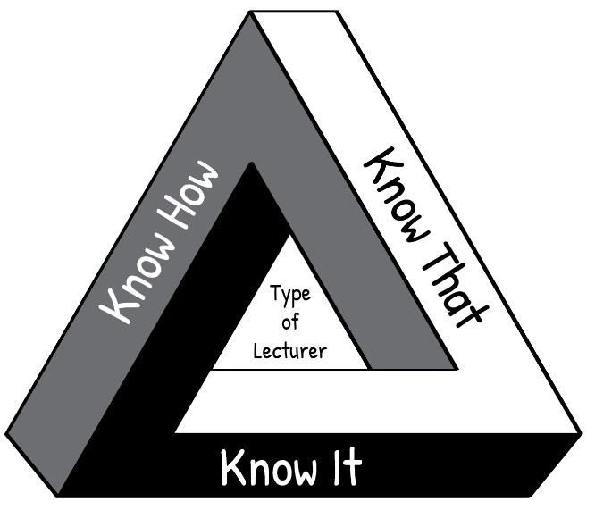
“Know How” is procedural knowledge, “in our bodies” or embodied knowledge.
For example, following a bread recipe.
“Know It” is recognition, the knowledge of what counts as good; wisdom; technical and theoretical judgments.
For example, is this sourdough good quality bread?
“Know That” is propositional knowledge or
theoretical knowledge, the knowledge of how and why, cognitive knowledge.
For example, the science of bread baking.
Figure i: The HIT framework
Think about your own craft of teaching. The kind of teacher you want to be, is one who knows how (the techniques of teaching), knows that (the science and theory behind teaching AND learning) and knows it (knowing and reflecting on what makes a quality teacher). Such a teacher enables students to actively engage with their learning and to develop their full potential.
If you are interested, click on the link provided to watch a short video in which Wayne Hugo discusses the “HIT model” of TVET knowledge and learning.

Relating theory to practice
In this module new concepts are often introduced by developing them from a practical situation with which you are probably familiar. This process, which moves from your experience towards a more abstract level of theory is known as inductive learning. It makes learning easier and is very different from deductive learning, which starts by presenting abstract theories and principles, then requires you to “deduce” practical conclusions and concrete examples. You are encouraged to relate the ideas you learn from the Adv Dip programme to your own context and to try to think theoretically about your practice. In other words, to think about the rationale for your practice.

Reflective practice and the use of a learning journal
One of the Adv. Dip TVT modules is called Reflective Practice, if you are interested, you can access it here It covers the concept of reflection in the life of a TVET lecturer. Of particular importance is unit 2, which describes various models which facilitate reflection. The simplest reflective model that is discussed in this unit, is that of Terry Borton (1970). It consists of three steps as follows:

Figure ii: Reflective model (after Borton, 1970)

The three questions to prompt reflection leading to action:
- What?
What happened? In this step you remember or describe the situation or event you have experienced.
- So what?
So, if that happened, what does this show you or teach me? In this step you explore what new insights or knowledge the situation gives you.
- Now what?
Now that I have learnt something new by reflecting on the situation, what should I do about it? In this step you think about what to do with the new awareness you have gained – i.e. how to make use of it to act more effectively in future situations.
Throughout the Adv. Dip TVT programme, you are encouraged to reflect on your practices at work in the college so that you can improve how teaching and learning takes place. We have embedded reflective practice throughout the programme, and at the end of most units in the modules you will find a reflective activity to complete. The reflective activity will enable you to make the most of what you have learnt throughout the unit, as well as assisting you to apply your learning in your workplace.

Use a learning journal
Throughout the Adv. Dip TVT modules, we encourage you to use a learning journal. You can download a digital template to use for your learning journal. Save it where you can easily find it again. You can also use another template, or use a paper-based learning journal. You will use your learning journal to write notes and reflections and complete activities. Start your learning journal at the beginning of the programme, and keep it regularly updated throughout.

Active learning
Most learning theorists tell us that new understandings and learning depend on, and arise out of, action. All the modules in the Adv. Dip TVT programme include activities. Your learning will be more fruitful if you engage systematically with the activities. If you do not do the activities, you will miss out on the most important part of the programme learning pathway.

Thinking activities
At various points in the module you are asked to stop and think and to take some time to reflect on a particular issue. These thought pauses are designed to help you consolidate your understanding of a specific point before tackling the next section of the module. One of the habits many of us develop through a rote kind of learning is to rush through things. Work though each module slowly and thoughtfully. Read and think. This is how we develop a depth of understanding and become able to use the ideas we learn. Try to link the issues raised in each thought pause with what you have read, with what you have already learnt about learning, with your own previous experience, and so on. Think about the questions or problems raised in the module. Jot down your ideas in your learning journal so that you can be reminded of them at a later stage.

Linkages across modules
As you work through this and other modules, you will notice that topics or issues raised in one module may cross refer to the same issue or topic in another module, possibly in more detail. So for example, while there is an entire module dedicated to the investigation of curriculum, key issues related to curriculum will also be highlighted and discussed in a number of other modules including, modules dealing with pedagogy, psychology in TVET as well as in the method of teaching engineering and related design and electrical engineering modules.

Access to readings
There are links to readings throughout the activities. We have tried as far as possible to provide links to Open Educational Resources (OER). In cases where this was not possible you will be directed in the activity to access these through your university library. The website link is shown in the reference list.

Assessment
The activities contained in this module and the Adv. Dip TVT programme as a whole, promote a continuous and formative assessment process. This approach is intended to support your ability to relate ideas to practice and to contribute to your development as you work through the various modules of the programme.
You will also notice that each module includes a summative assessment task with the assessment criteria set out in an accompanying rubric. This summative assessment task is a model only, intended to illustrate the kind of assessment tasks that may be set by the university providing this programme.

Module overview
This three-credit module forms part of the eight credits allocated to industry-based work-integrated learning (WIL) in the qualification. The other five credits should be completed through a WIL placement in your area of specialisation in a workplace. The module supports your completion of this WIL placement and your integration into your lessons/lectures of the information and artefacts you collect during the placement.

Module purpose
This module will help prepare you for your own WIL experience and to eventually become a practitioner in your area of specialisation. It is designed to use your own WIL experience to explore, collect information and artefacts, collate them and share them to enhance your transition from the world of theory to the world of work.

Module outcomes
By the end of this module you will have:
- Prepared for and planned the WIL experience.
- Compiled a portfolio and captured, sorted and categorised the information, the artefacts and the experiences collected during the WIL process into a digital knowledge base.
- Reflected on the WIL process as part of vocational teaching and developed strategies to incorporate information and experiences into the curriculum, teaching and practical activities to enhance the quality of learning.

Module structure

Industry-based WIL: Structured learning experiences in a specialisation
Unit 1
Prepare for and plan the WIL experience
Unit 2
Processing WIL information
Unit 3
Enriching teaching and learning through WIL

Figure 1: Module structure

Module credits
This module carries three credits.

Module time (notional hours)
Three credits is equivalent to 30 notional learning hours. These hours include contact time with your higher education institution (HEI), reading and research, and the time required to complete your assignments based on the activities.
In this module the assignments will serve a very practical purpose. They will assist you to extract maximum value from your own WIL process to enhance the quality of your teaching and the quality of your students’ learning.

Caveat
The units in this module are each one credit or 10 notional hours. They serve as an introduction to the whole industry-based WIL process as a technical vocational education and training (TVET) lecturer. The WIL process you complete in a workplace constitutes five credits or 50 notional hours.
This module supports the following structure for completing the eight-credit industry-based WIL requirement of your qualification, as shown in Table 1.
Table 1: Industry-based WIL requirement of your qualification
 | Activity | Credits | Hours
1 | Complete Unit 1 of this module: Prepare and plan for the WIL experience | 1 | 10
2 | Complete an industry WIL placement based on the planning you did in Unit 1 | 5 | 50
3 | Complete Unit 2 of this module: Processing WIL information | 1 | 10
4 | Complete Unit 3 of this module: Enriching teaching and learning through WIL | 1 | 10
 | TOTALS | 8 | 80

This module can be used in conjunction with one of the references listed: Van der Bijl, A. and Taylor, V. (2019) Curriculum framework for industry/workplace-based work-integrated learning for qualifications for lecturers in technical and vocational education and training. Potchefstroom: Ivyline CC BY SA. The link to this document is provided here
The document by Van der Bijl and Taylor (2019) includes Attachment 2: Student Materials and Guide: Industry Work-Integrated Learning (WIL) for the Advanced Diploma in Technical and Vocational Teaching. Students can use the materials in this attachment to guide, record and reflect on their WIL learning and experiences during a placement. Activities completed as part of these materials can then be included in the portfolio of evidence (PoE) submitted toward the five credits of WIL experience, completed as per the above structure.

Unit 1: Prepare and plan for the WIL experience

Introduction
The activities in this unit will help you prepare to extract the most value from your WIL experience. By envisioning the work process, you will be able to decide what information or artefacts you want to collect. The plan you develop as part of this unit will guide and remind you what you need to look for during your WIL placement.
The way you approach this module will depend in part on:
- The work process in your area of specialisation.
- The amount of experience you have in your area of specialisation.
If you have a lot of experience in your area of specialisation and you have spent time as a practitioner, you may already have collected information and artefacts that you use. You may then want to think about what more you can collect, how technologies or new work processes have affected the way people perform their work, and what the future may hold for practitioners.
If you have some experience in your area or specialisation, then you may want to add to that.
If you have no experience in your area of specialisation, you may want to find an experienced practitioner to assist you. You may also want to use the internet to research what companies in your area of specialisation offer in terms of products or services and then compile your plan.

Unit 1 outcomes
By the end of this unit, you should be able to:
- Compile an initial workflow or process map you would expect in your area of specialisation.
- Plan a WIL experience for yourself.
- Arrange or confirm the WIL experience with the relevant employer.

Setting the scene
Activity 1: Read and discuss: A practical guide for work-integrated learning
Suggested time: 90 minutes (reading 45 minutes, discussion 45 minutes)
The purpose of this activity is simply to set the scene and introduce you to a resource that can give you more insights into WIL. Those insights will give you the basis for discussing the topic with others.
Scan the booklet A Practical Guide for Work-integrated Learning as listed in the References. Specifically,
- Look at the first chapter headed “Theoretically grounded WIL: Application of Kolb’s Experiential Learning Theory”, especially the summary on pp. 30–31.
- Briefly consider each chapter by focusing on the first two or three pages and the summary.
- Read Chapter 8, “Concluding recommendations” (p. 161).
As you progress through this module you may want to look at Chapter 3, ‘Reflection’, and later in Unit 3, as you work to reflect on your WIL, you may want to refer back to the booklet for more detail.
List and describe some key ideas that you identified during your reading. We suggest that you write your answers in your learning journal (see Programme Introduction).
Share your insights with your fellow students.

Discussion of the activity
What value have you got out of your reading and the discussions? Has it influenced the way you think about WIL? Reflect on these insights as you engage with the rest of this module. Capture your reflections and what you have learned from others to include in your portfolio of evidence (PoE – see Unit 2).

Envisaging work

The dilemma of rigour or relevance
Consider this depiction demonstrated in visual form here.
In the varied topography of professional practice, there is a high, hard ground overlooking a swamp.
On the high ground, manageable problems lend themselves to solution through the use of research based theory and technique.
In the swampy lowlands, problems are messy and confusing and incapable of technical solution.
The irony of this situation is that the problems of the high ground tend to be relatively unimportant to individuals or society at large, however great their technical interest may be, while in the swamp lie the problems of greatest human concern.
The practitioner is confronted with a choice.
Shall he remain on the high ground where he can solve relatively unimportant problems according to his standards of rigour, or shall he descend to the swamp of important problems where he cannot be rigorous in any way he knows how to describe? (Schön, 1995)
This description is a metaphor. Donald Schön contrasts the world of academic researchers with that of professional practitioners. The knowledge gained from the academic approach finds its way into journal articles, books which eventually may be summarised in textbooks. This is the “hard, high ground”.
But the real world is a swamp. A swamp is a confusing place, half land, half water. Trees make it difficult to see where you are going and dangerous creatures inhabit the water. The real world requires movement and action. Movement and action require a “knowing” that is not captured in textbooks, i.e. knowing where, knowing how, knowing when, knowing who and so on. Practitioners only develop this kind of knowing from experience: being exposed to the realities of workplace problems and challenges. The experience is not set in stone; it will vary from one organisation to the next.
However, what Donald Schön’s description does not deal with is how to get the most value out of both worlds. We will look at practical ways of achieving this in Units 2 and 3. Your role as a lecturer will be to help your students to descend from the high ground and navigate the swamp. What will help them navigate and make sense of what is happening in the swamp?

Workflow maps and process flow diagrams
To navigate the swamp it would be helpful to have a map. This will save you time and prevent you from getting lost. From the high ground you can look down and develop a simple map. Later when you are in the swamp you can expand it, adding details and nuances.
To relate this to work you can create a map or diagram that describes the flow of work. The map/diagram will help you and your students form a mental picture of how the work is done, how it is structured and how it is evaluated. It will help you understand how various tasks are performed by a range of people in the workplace.
Here, we consider two tools or techniques used to map the flow of work (Table 2)
Table 2: Tools to map workflow
Type of diagram | Suitable for:
Workflow map | A set of simple tasks to achieve a result, e.g. process an invoice for payment
Process flow | Sequencing a set of tasks, e.g. order materials, receive and store the materials, prepare the materials for production…, etc.

There is some overlap between the different types of diagrams and the terms are sometimes used interchangeably. But in general they map out how work is performed. In this unit your choice of map is not critical. All you are aiming to do is to create a draft map. The result will be a diagram summarising work in some form.
But ultimately, you will want to test both types of diagram, to give yourself a more rounded picture.

Workflow diagram
A workflow map describes how a person, or a group of persons, performs an activity. The activity consists of a set of tasks. Each step in the workflow represents one of these tasks. View the following diagram (Figure 2).
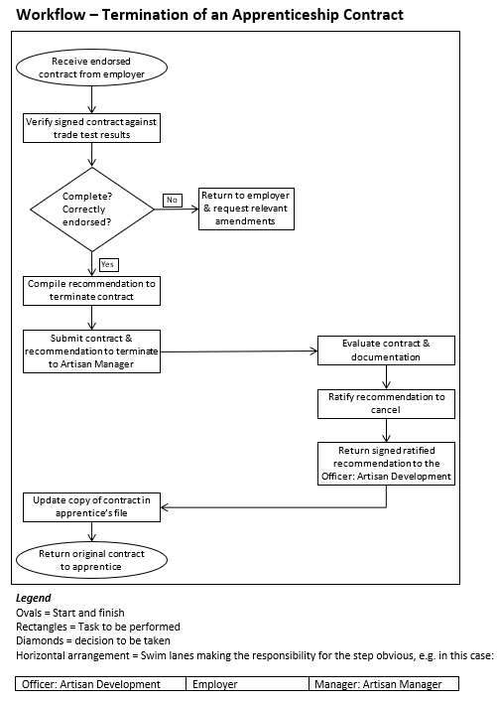
Figure 2: Example of a workflow map (Public Domain)
At each rectangle someone performs a task. For each task there is an input, an action and an output. Some tasks may have an “if, then” condition attached to them. This step requires a decision, shown in Figure 2 as a diamond shape, with two possible options:
- If the decision is “yes”, then, do x.
- If the decision is “no”, then do y.
Workflow maps are, for the most part, to guide employees for lower level, routine entry-level jobs. This will be of interest to students who graduate in your area of specialisation.
You may be able to collect examples of workflow diagrams during your WIL. They are often used as work instructions or included in procedures. Most companies using quality management systems (QMS) from the International Organization for Standardization (ISO) use workflow diagrams in their documentation.

Business process mapping
Business process maps or simply process maps (see Figure 3) have a broader focus than a simple workflow diagram. They summarise a whole range of activities. Process maps link together a number of activities.
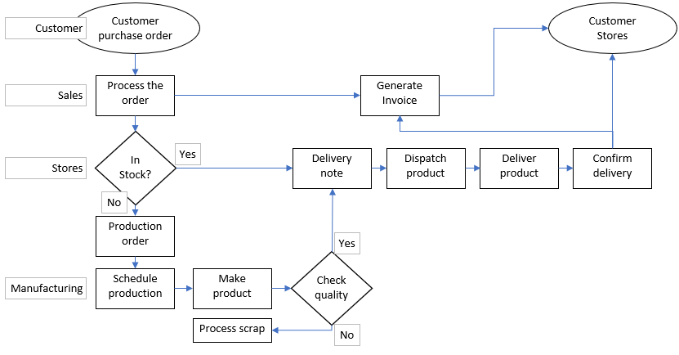
Figure 3 : Example of a simple business process map (Public Domain)
Such diagrams can depict visually how an entity conducts its business. “Business” means what any entity needs to do to achieve its purpose or mandate. Entities include for-profit companies, non-profits, government departments or educational institutions.
Business process maps assist us to understand how entities operate their business, and are often used for:
- compliance with regulatory requirements
- internal and external audits
- managing quality
- standardising processes
- improving processes
- training employees
- software and system development
- communicating complex sets of activities.

Business process maps will give you a sense of where entry-level employees such as student graduates will initially be employed. They will also assist your students to understand how they could fit into such entities.

Activity 2: Develop a workflow or process map for your area of specialisation
Suggested time: 45 minutes
Decide what type of map would suit your area of specialisation. Based on your knowledge of the area of your specialisation, develop the map. Start with pen or pencil sketches in your learning journal. These allow you to test out your understanding, identify gaps in your knowledge and adjust your diagram as needed. Consult the internet if necessary.
If you want to generate a more formal diagram, most word processing, presentation and spreadsheet applications allow you to generate such maps with standard shapes. There are also a variety of specialised computer programmes for this purpose.
Share your diagram with your fellow students, lecturers or people who work in your area of specialisation. Identify gaps or modify the diagram to reflect these work processes more accurately.

Discussion of the activity
Did you find it easy or difficult to develop the map? Did you struggle to envisage the diagram?
What could you construct from your own knowledge and experience? Could you find someone to help fill the gaps? Could you find additional information on the internet, or in specialist literature or textbooks?
Your map will depend on your experience in your area of specialisation:
If you have a lot of experience in your area of specialisation and you have spent time as a practitioner, did these tools help you better understand the sector, industry or the actual work itself? Did the exercise provide you with any new insights?
If you have some experience in your area of specialisation, did the exercise add to your understanding of the sector, industry or the work itself? Did you manage to close any gaps by looking for additional information? What sources of information provided the best value?
If you have no experience in your area of specialisation, could you find helpful information in books, on the internet or from others in the field? Did the exercise help you to understand the terrain better?
Capture your reflections and what you have learned from others, to include in your PoE (see Unit 2).

Stop and think
Consider how Activity 1 can help you prepare for your own WIL experience. Where would you like to get more information? What type of information will assist you the most?

We will consider these questions in the next section.

What are artefacts?
For each task or process step there may be associated documents, items, faulty products, waste and other evidence of the work being done. We can call such evidence artefacts (e.g. Figure 4). The term originates from items turned up in archaeological processes but it is now used more widely.
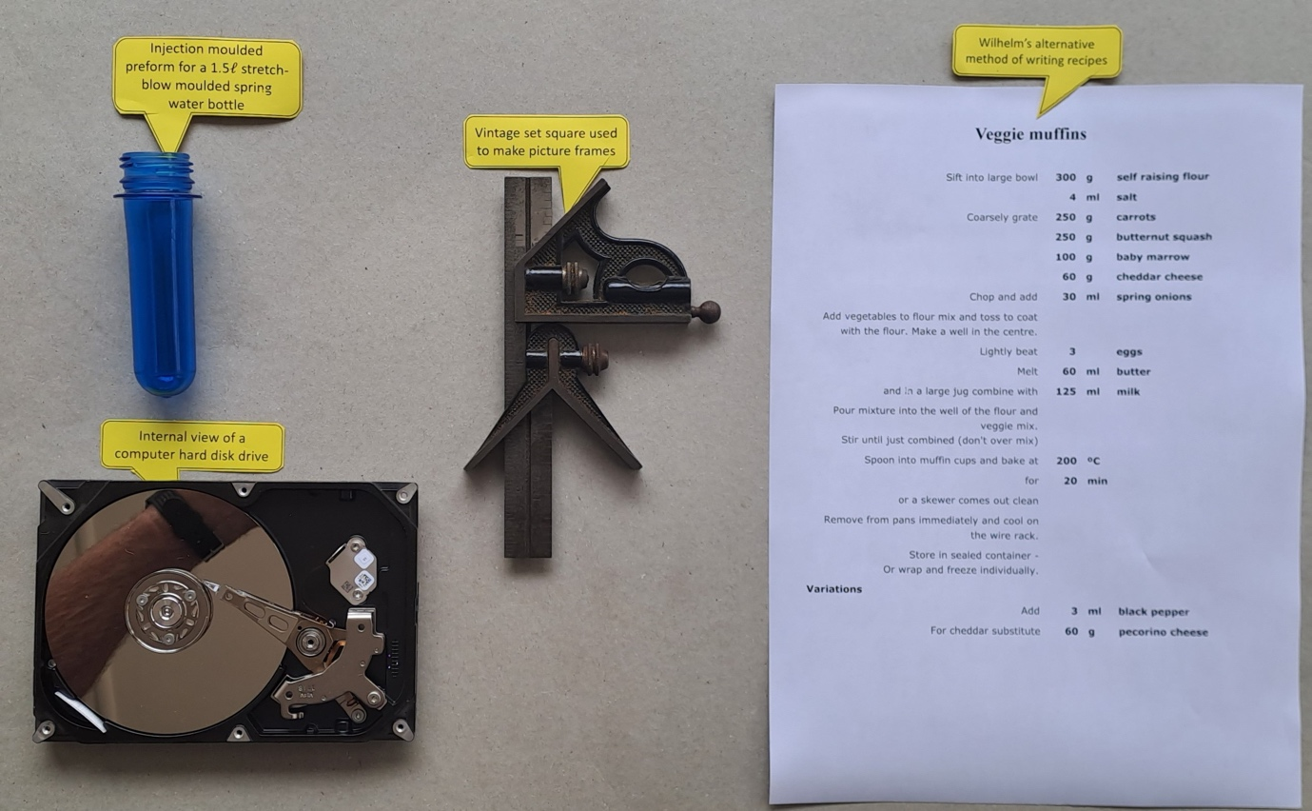
Figure 4: Examples of artefacts collected during WIL (Public Domain)

In our context, artefacts can be thought of as anything you collect to enable yourself and your students to bridge the gap between classroom texts and real life experience (e.g. Table 3)
Table 3: Examples of artefacts
Type | Examples
Documents | Work instructions, procedures, guidelines, action plans, product quality criteria, reports, forms, checklists, posters, training materials, one-point lessons on flipchart paper, graphs, Pareto diagrams, charts, menus, recipes…
Physical objects | Finished products, samples, first-off samples, cooked food, meals, packaging, faulty or out-of-specification items, waste materials, models…
Virtual objects | Screen shots, photos, videos, audio recordings, emails, messages, phone calls, computer-aided diagrams, computer programs, spreadsheet formulas, mind maps…
Other | Designs, layout diagrams and sketches, circuit diagrams, computer-aided drafting (CAD) outputs, architectural or building designs and plans, workflow diagrams, process flow maps, value stream maps, planning boards (agile and traditional), kanban cards…

Anecdote
A retired mechanical engineer was reminiscing about his own learning process. He said:
I thought a knew a lot by the time I graduated. But when I first started going into plants, I wasn’t prepared for the onslaught of the stuff that was going on, things that I was seeing – and hearing and feeling. I was lucky to have some very patient artisans teach me basic stuff.
A turner was standing next to me while we were watching a lathe in action. He bent down and picked up a curl of metal swarf that was coming from the lathe. He told me to look at it very carefully.
“This is perfect,” he said. “See the sharp edges, see the twist is regular, there’s no bluing...You don’t have to check the lathe settings or the machinist. This tells you that the cutting speeds are right, lubrication perfect, and the tool tip is sharp.”

Figure 5: Metal swarf curl
Source: Image extracted from this photo by Glenn McKechnie (CC BY SA)
The engineer went on.
I took the swarf from his hand and slipped it into my packet of smokes – I used to smoke then. But I kept that packet and the swarf – it sits on a shelf in my library. It taught me to look for all the tiny details, those that tell you the job is good and those that tell you there’s something going wrong. I’ve picked up so many problems in plants and construction sites as a result of that lesson.
Collecting such items will add great value to your own and your students’ learning. Authentic materials (artefacts) go beyond words, and bring to life what you or your students are experiencing.
Caution: Collecting photos, videos and audio recordings from your host employer is an attractive idea, but many entities have strict rules about making such records. Their concern is about protecting their intellectual property (IP) and their competitive edge in the market. You records could get into the hands of competitors. For these reasons, always get permission before you photograph or record anything in your host workplace.
Click to see a video of swarf formation in chip form (CC BY).

Activity 3: Collect artefacts
Suggested time: 60 minutes
- Go back to your workflow or process map and make a list of artefacts you could collect during your WIL visit. Write them in your learning journal.
- Consider the anecdote above. What implications does it have for what you will look for during your WIL?
- Think about what artefacts will bring your lectures to life for the students. What would help them get a feel for your area of specialisation?
For example, in a manufacturing operation you could collect:
- copies of the production order, the setting card, the product specifications
- first-off samples that are collected to weigh, measure and conduct quality checks
- samples or photos of good and bad products.

Caution: Keep it simple initially. You can later expand this activity to include other areas of work.

Discussion of the activity
Have you managed to compile an initial list of artefacts? How did the diagram you drew trigger ideas for what to collect?
What ideas did you have for artefacts to help your students to get a feel for the work in your area of specialisation?
What insights did you gain from the anecdote? Did the anecdote trigger new ideas for artefacts that you could collect during your WIL experience?
Share your ideas with your fellow students, lecturers and people you may know in your area of specialisation. What did you learn from these conversations? Capture your reflections and what you have learned from others to include in your PoE.

Stop and think
We need to shift our minds when moving from book or screen learning to learning in and for work. When we are in the workplace we need to rely more on our senses.
In your last activity did you consider collecting environmental cues and clues?

Cues are signs, hints or prompts that occur in the working environment. They may be an indication that something is happening or something needs a response. When dealing with people we need to be able to pick up cues to their state of mind. Are they angry, anxious, frustrated or happy? Cues help you diagnose what is happening. They involve things you hear, see, smell or feel.
Clues are signs or information in the working environment that help find an answer to a problem.

Anecdote:
I was on my way to a meeting with a client and I didn’t want to be late. But my car kept pulling to the side of the road, and this prompted me to stop and see if I could see what was wrong. I pulled to the side of the freeway and got out. As I walked around the car, I noticed the sidewall of the front tyre was bulging. The loss of pressure would increase the resistance of the tyre on the tarmac. That is what was causing my car to pull to the left.
What is the cue in this anecdote and what is the clue?
Cues and clues can also be very subtle. It takes attention and awareness to detect and decode them. This is especially true when you are engaging with people and interpreting facial expressions, body language or tone of voice.
One of the underestimated senses in the workplace is the sense of smell. Often a smell or a subtle change in smell is a cue or sign that something is changing in the process or the equipment. Some examples are:
- the changing smell of food or baked goods prior to burning
- the smell of the insulation in electrical switches and equipment overheating before it fails
- the smell of a motor vehicle when it overheats
- the smell of an overheated vehicle tyre because it is underinflated
- the smell of a polymer if you heat and melt or burn a tiny sample.

It’s very difficult to describe a sense of smell. You really have to experience it yourself. This is one of those bits of knowing that you can’t get from artefacts.

What else can’t you get from diagrams and artefacts?
Diagrams and artefacts provide you with explicit information about work and working. We have examined how you can access such information.
There is another level of knowledge related to work that is not explicit. It is embedded in the individuals and the communities in the workplace. It can be accessed through close observation of workplace behaviours and practices and through dialogue and conversations.
Conversation has magic to it. Dialogue is the most powerful learning technology on earth. Conversations are the stem cells of learning, for they both create and transmit knowledge. (Cross, 2007:13)
Some conversations are formal. They are required to make sure that efforts in the workplace align and are coherent. Examples are meetings and the issuing of instructions. Interviews with individuals or groups can also be classed as formal.
Informal conversations happen all the time. They are spontaneous, for example, an exchange of words in the passage, the toilets, around the water cooler, in the kitchen, or in a smoking area; or phone or messaging conversations.
You may have to listen to these conversations for a while before you can decode them. Often words take on a slightly different meaning in these contexts. Once you do learn to decode them and can participate in them you will find them to be rich sources of information.
Your participation in informal workplace conversations is your induction into a professional community of practice. At first you will be an outsider but in time you can drift closer to the real experts.
By becoming part of that community you can continue to engage with the people even after you have completed your WIL experience.

Activity 4: Plan conversations
Suggested time: 30 minutes
Use the diagram(s) you developed in Activity 2 to identify positions or people in the workplace you would like to observe or engage with. List them and any others in the workplace you would like to engage with, talk to or interview. These may be inside the organisation such as managers, research and development staff, or outside the organisation such as customers or clients.

Discussion of the activity
Were you able to make a list, even if it is short one? Lists are not finite – you can add to them at any stage, even during your WIL experience. Did this activity give you a little more to think about when you go into your WIL experience?
Did you identify some people you could talk to before going to the workplace for the WIL experience? How could they help you to get more value from the WIL?
Share these ideas with your fellow students, lecturers, and people you may know in your area of specialisation. What did you learn from these conversations? Capture your reflections and what you have learned from others to include in your PoE.
In the next section we use the work you have done to develop an action plan.

Developing a WIL action plan
Planning is a key workplace skill. If we don’t plan, we can make mistakes or the results may not be what we intended. By envisaging the work that we have to do, we can approach it in a methodical way and avoid surprises.
Simple plans are to-do lists we make for the day or for the week. Business and project plans are more complex and can take years to complete. Action plans fall between the two extremes. They are more formal than to-do lists but not as structured as project plans.
To do lists are generally a loose set of items. The items may not relate to each other. Nor are they necessarily in any order.
An action plan is more structured. It has a goal, a purpose and one or more objectives. The actions are often sequenced to achieve the objectives and subsequently the goal.

What is the minimum you need for an action plan?
Table 4 summarises the minimum requirements for an action plan. The terms used in the table are explained below.

Table 4: Minimum requirements for an action plan
Goal | Get the most value out of my WIL experience
Purpose | Improve my understanding of current workplace practices, to enhance the quality of my teaching, so that I can help my students understand better and to ease their transition into the workplace.
Objectives | - Interview key people in the organisation  - Collect artefacts to use in lectures  - Observe how practitioners work and conduct themselves  - Participate in conversations with a variety of people in the organisation
 | Actions | OVI
1. | Set up a meeting with the workplace representative | - Confirmation of the meeting invitation  - Entry in my calendar
2. | Clarify with the workplace representative how my WIL will be structured | - List of activities  - List of people to meet  - Company rules regarding my visit…
3. | etc. | - etc.

Goal: What is the overall result you want to achieve? This is your statement of intent.
Purpose: What motivates to you achieve your goal?
Objectives: What concrete results or outcomes would you like to achieve?
Actions: What you are going to do?
Golden Rule for actions: always start an action with a verb.
In textbooks, academic writing and theoretical discussions we tend to talk in concepts. Concepts don’t do anything. Only verbs trigger actions.
Consider the difference between daily planning as a concept and plan my day as an action to be performed. Also consider the difference between plan your day and plan my day. Which of the two statements will get you to do something?
OVI: Objectively verifiable indicator
Logical framework (log frame), or other variations of this planning process, are used by international and national aid agencies for development projects. One of critical elements in the framework is to establish how we will know that the project activities and the project itself have achieved the intended results. OVIs are the evidence used to monitor project progress and to evaluate project outcomes. They are the things, physical and virtual, that you can point to that are the results of your intervention.
The same logic applies here. How will I know that I have completed the action?
The OVIs can later form part of your PoE. In the same way as projects measure results so your portfolio will measure the success of your action plan and degree to which you got what you wanted out of your WIL experience.

Why are action plans flexible?
Action plans in this case are very personal. So, nothing stops you from making changes as you go. If circumstances change, you may have to cancel or revise your actions. Or you may have to tweak and add to them, to deal with new challenges or take advantage of new opportunities.
You may also find that you have made certain assumptions about what you will be able to achieve. If these assumptions prove incorrect then you will have to adapt your actions to address the new reality. We all make assumptions when we think that we control a situation; something that is outside of your power can disrupt your action plan.
Note: Action plans can also be used for teams, departments and groups. In that case, you need to list who is responsible for the action and by when it must be completed.

Activity 5: Develop an action plan
Suggested time: 45 minutes
Based on the activities you have previously done, develop a draft action plan in your learning journal for your WIL experience. Use the above format or one that appeals to you more. Consider it as your first draft.
Compare what you have prepared with the templates in Attachment 2 of Van der Bijl and Taylor (2019), especially ‘Template 3: Changes or developments in your subject field’. What are the key differences in the approach outlined in this unit versus the approach outlined in Van der Bijl and Taylor? How can they be combined?
Will this change or add to your action plan? List any areas you would like to have clarity on and add it to your list of observations or contacts who could help you clarify that those areas or provide more information.

Discussion of the activity
What difficulties did you encounter in developing the action plan? How did you overcome them?
An example could be: Your action plan could list an intention to find more information on a particular product. But then you realise that your host company doesn’t make that product. You could then change your action to ask one of the employees to refer you to a company who does make that product.
Share these ideas with your fellow students, lecturers, and people you may know in your area of specialisation. What did you learn from these conversations?
Some items in your action plan may be more of a wish list. Completing them may be unrealistic. Did this show up in your discussions with others or did you come to realise this yourself?
Capture your reflections and what you have learned from others to include in your PoE.

Arranging your WIL experience
Arrange or confirm the WIL experience with the relevant employer.

Introduction
To some extent your employer will depend on the arrangements your higher education institution (HEI) makes for your WIL experience.
If your HEI has arranged your WIL experience, find out from your lecturing staff:
- what these arrangements are
- who the contact person is
- whether you may contact that person.

If you are working on this module as part of a university-run Advanced Diploma in TVT, discuss your action plan with your lecturer, if you haven’t already.

Making your own arrangements
If you have a lot of experience in your area of specialisation and you have spent time there as a practitioner, you may already have knowledge of the entities in the field. You may already have contacts you could request to host your WIL.
If you have some experience in your area of specialisation, then you may already have some idea of where you could do your WIL. You may also have contacts whose advice you could ask for.
In both the above cases you may want to consider finding a new employer to broaden your experience.
If you have no experience in your area of specialisation, you may want to find a knowledgeable person at your TVET college to assist you. This should be a last resort. If you haven’t yet worked in your area of specialisation you will have to do some research to identify potential entities: Your options would be to:
- speak to lecturers in your area of specialisation
- find out if your HEI has a unit that deals with industry partnerships, and consult them.
- use the internet to research for entities in your area of specialisation
- talk to other students in your area of specialisation who have that kind of experience.
Note: if you have to “cold call” the company to arrange a WIL experience, you should start with the human resources department to establish whether they do host interns or WIL students. They could also help you to find the right person in the company to contact.

Conduct research on your host
Most companies these days have websites; these would be your first choice to find out about your host. Use platforms such as LinkedIn and Facebook to see if you can find the names of employees in your host company. If the employees are alumni of your HEI, they create a good starting point to engage with the company and the people who work there. These sites may also provide some information on the company itself.
Alternatively, you could visit the company prior to your WIL placement and collect any brochures or advertising material.

Workplace dynamics
The nature of your WIL experience will be governed by the dynamics that govern your host employer. Some of the factors that will influence the nature of the WIL are shown in Table 5.
Table 5: Factors influencing WIL
Feature | Variable
Size of entity | Small, medium or large
Type of entity | Government department, private company (profit or non-profit)
Scope of operations | Full range of operations, selected specialised operations
Nature of operations | Informal, formal, highly regulated
Governing legislation | Specialisation-specific legislation, general industrial relations or health and safety legislation
Partnerships or contact with HEI | Little or a lot
Partnerships or contact with TVET colleges | Little or a lot
Experience with hosting students | Little or a lot
Attitude of the responsible person | Helpful, fulfilling a duty, obstructive

These dynamics mean that it is difficult to provide comprehensive guidelines for how your WIL experience will play out. But by preparing yourself you will be able to adjust more easily and get the most value out of your action plan and your WIL experience in general.
Your attitude is very important. In discussions with employers and staff over the years, this author has often heard complaints that many students coming for their work experience have a negative attitude. The worst characteristics of the negative attitude are:
- displaying a lack of engagement, or even a total lack of interest
- waiting to be “given everything on a plate”
- thinking that they are more knowledgeable because they have studied the subject.
To counter these negative characteristics, prepare yourself to:
- Ask questions, be curious.
- Take the initiative and perform the work enthusiastically, when you are given an opportunity to complete a task.
- Shift from knowing to questioning, e.g. from “we were taught that this is how it should be done” to “why are you doing it this way”?
An open mind and a real interest will go a long way to forming relationships with the people you come into contact with. If you form these relationships, you will always be able to follow up with your contacts after your WIL experience is over.
In this way you will gain real value out of your WIL experience.

Conclusion to Unit 1
The focus of this unit was to prepare you for your WIL experience. The content and the activities were designed to prepare you for the transition from an HEI environment to gaining insights from workplaces in your area of specialisation by:
- envisaging how the workplace operates
- collecting artefacts that may be helpful when you engage with students
- developing an action plan to collect artefacts, information and experiences
- arranging your WIL experience.
In Unit 2 you will learn how to sort, order and collate the artefacts, information and experience in a way that you can access them quickly when you need to refer or use them. The unit will introduce you to digital tools that will make the process simple, speedy and searchable.

Unit 2: Processing WIL information

Introduction
The activities in this unit will help you prepare to use the artefacts and resources you have collected from your WIL experience. To do this in an efficient and effective way this unit will focus on creating a digital, freeform database to allow easy access to the artefacts and information you have collected during your WIL experience.
But this database will also be the foundation of future research, information gathering and keeping up to date in your area of specialisation.
The way you approach this module will depend in part on:
- your previous experience with cataloguing information
- your experience with programmes, apps, online sites, online information storage and other ways of capturing information and your work.
If you have a lot of experience in your area of specialisation, you may already have collected information and artefacts which you already use. Where and how you have stored them? You may then want to think about how easy you find it to access, share and use your information and resources and consider if you want to improve that process.
If you have no experience in your area of specialisation you will want to find a robust and long-term solution for storing your information and artefacts.

Unit 2 outcomes
By the end of this unit, you should be able to:
- Capture, sort and categorise the information, artefacts and experiences collected in the WIL process.
- Compile unit outcome 1 into a portfolio reflecting your WIL experience and learning.

Setting the scene
Several years ago, I was on a cross-country trip from Johannesburg to the West Coast. We stopped over at a guesthouse in Kuruman in the Northern Cape. The owner of the guesthouse and I got chatting. He had recently bought the place but was struggling because there was so much to fix up, and he had to train his staff, while still attending to his guests. I asked if he knew anything about the Japanese philosophy of Kaizen and 5S housekeeping. He didn’t.
So, I told him I had run several workshops with clients to get them started on the journey. I didn’t have my computer with me, so I used his computer to log on to my Microsoft account and open OneNote. I typed Kaizen into the search box and quickly found all the information and notes I had collected and used to prepare the first workshop. The first of the pages also contained hyperlinks to my online document storage – the slide deck, the workshop programme, the implementation plan, the before-and-after photographs and so on. There were also hyperlinks to external resources such as images, websites, academic research papers and books on the subject.
I exported the OneNote page to a PDF document and saved it on his computer. I also shared links to my online folders with the resources and the photographs.
We spent about an hour talking about the Kaizen and 5S but his eyes kept returning to the computer screen. He asked me about OneNote. I explained a bit how I used the programme and showed him some of the features. He was hooked. So, we downloaded the programme and installed it on his computer, and I helped him set it up. Then my family wanted to go and eat so we went off to a restaurant.
When I saw him the next morning, he was so happy with OneNote. He had copied information such as list of restaurants and fast-food places, pharmacies and other information guests frequently asked for, his price lists and other information related to the running of guest house. He insisted on giving us a hefty discount for our stay. We had given him so much value.
This anecdote illustrates aspects of the field of personal knowledge management (PKM) by mastering some of the power of online information storage and management. The example given is of a digital free form database. The power online information storage and management includes:
- ease of use
- keyword searches to quickly find relevant information
- hyperlinks to your own and external resources
- easy access wherever there is internet connectivity
- easy sharing of information and artefacts.
While OneNote is styled as a notetaking application, it can store or embed a variety of types of information, images, videos, music, dictation, clippings from websites, hyperlinks to own resources and external resources on the World Wide Web.
There are various versions of OneNote. You can find more information at the link OneNote versions.
While only one programme is mentioned in the anecdote there are many alternatives to OneNote. But the anecdote hints at an aspect of our professional life that we have to learn to master, the field of PKM.

Personal knowledge management
We live in an age of freely available data, information, practical knowledge and wisdom, and PKM is a core skill in the mastering our professional life and our context. PKM is not a new concept. Various writers and scientists, notably Carl Linnaeus (1707–1778) who developed plant and animal taxonomies, used slips of paper to organise knowledge. The underlying premise of capturing information, thoughts and insights on slips of paper is to sort, order and categorise these ideas. The technique came to be called a Zettelkasten (German for a box holding slips of paper.) These slips of paper later became formalised as index cards, as shown in Figure 6.
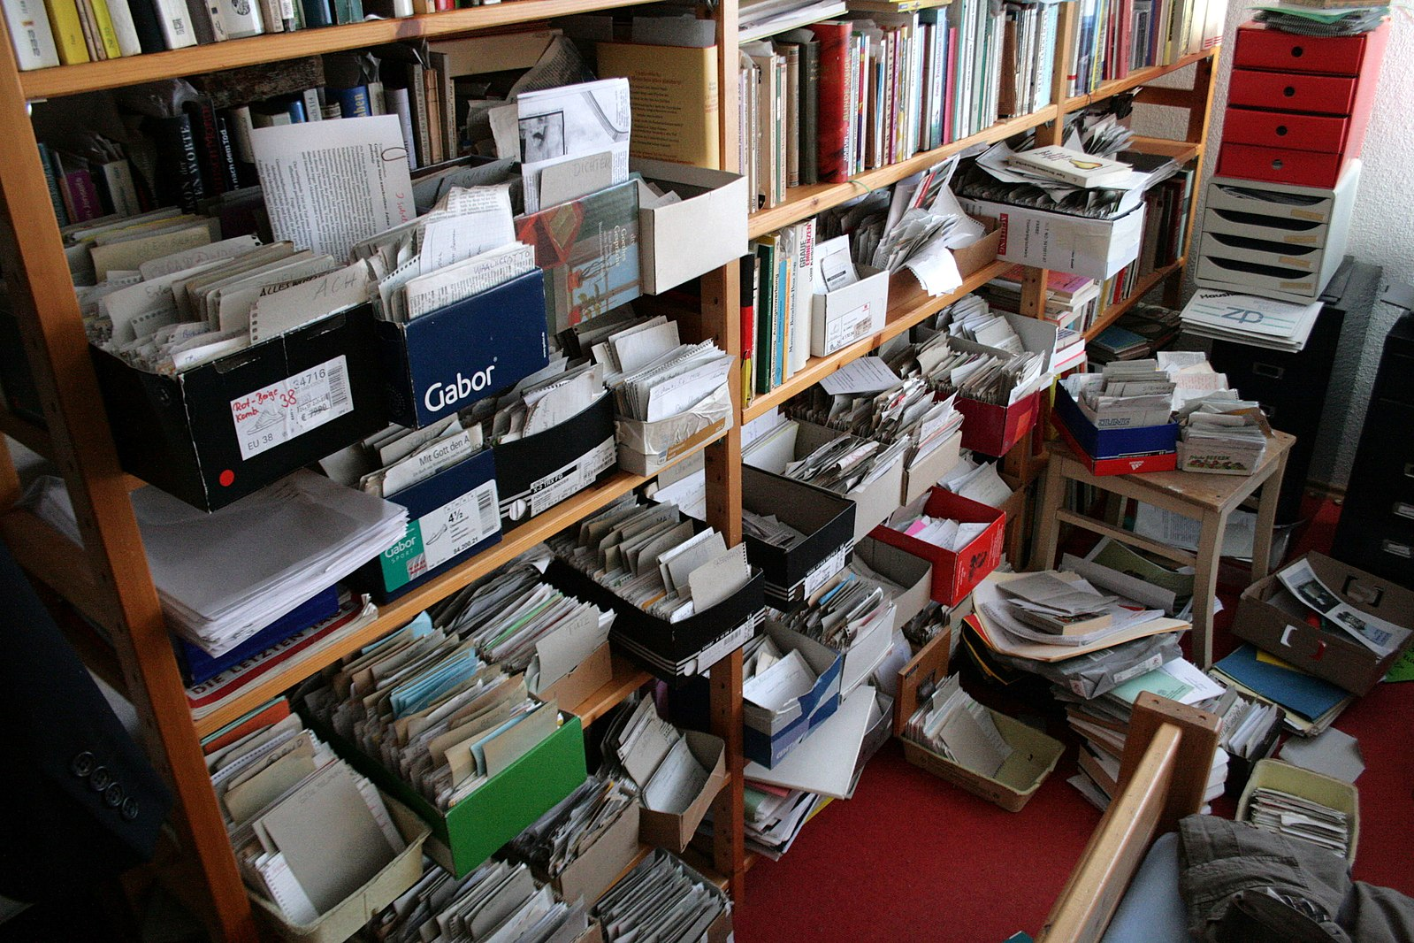
Figure 6: Multimedia, boxes with index cards and labels
Source: Kai Schreiber CC BY-SA

Today, instead of slips of paper or index cards, we can use digital notes and other digital tools to build our PKM system. Your WIL experience will more than likely be highly compressed and you will be exposed to many things in a short period of time. Some of the information will be in the form of artefacts. These you can collect and then sort and order later. Other information will be in the form of questions, impressions or snippets, such as names, hints or tips.
The first step in managing the knowledge you gain, is to capture artefacts and other information as they occur or as soon after as possible. You can, of course, use paper notebooks or index cards to do this, but a better option is to capture this kind of information digitally. Most of us carry smart phones. In additional to taking written notes, using pen and paper, you can use the smart phone’s camera, voice recorder and notetaking app to capture information in the flow of your current activity.
Once you have captured information digitally you can sort, categorise and organise it more easily. To do this effectively you will have to be able to share the information on your smartphone with your computer. You can copy images and voice recordings quite easily through a USB cable. But notes may be a bit more difficult. You can avoid this problem if you have a digital solution that synchronises the information between your smart phone and other devices. We discuss ways of doing this in the next few sections.
Once the information is available on your computer, you can copy and paste or modify it and put it into lesson plans, presentations and student handouts.
Some of the notes you take may be instructions to yourself to follow up and further explore an item of interest on the World Wide Web. For instance, if you are not allowed to use a camera in your workplace, you could make a note on your smart phone to search for an image or video through the internet.

Standard programmes
You can also start very simply using word processing documents or spreadsheet applications. These will give you a head start. You simply construct lists of resources, add descriptors and you have a way of sorting and organising the resources (see ‘Constructing an inventory’ below). If you plan carefully and are willing to put in the effort you could construct your own information management system.
However, these standard applications are not easily used to capture information such as notes, photographs, videos or sound recordings as things are happening. There are a range of other applications you can use to make the process of capturing, sorting and reusing information and artefacts easier and faster. We will first look at applications to capture information and resources. Then we will look at how we can access this information easily.

Simple notetaking applications
These are mostly text-only applications. They can act as an introduction to digital notetaking and storage. In additional to organising information and resources you have collected, you can expand these, to prepare lectures, practical activities and assessment tasks. Examples include:
- Laverna https://laverna.cc
- Notes https://www.icloud.com/notes (Apple only)
- SimpleNote https://simplenote.com

Sophisticated notetaking applications
In additional to text, sophisticated applications allow you to link to or embed multimedia, such as images, videos, sound recordings, dictation and podcasts. They also allow you to add clippings from websites. You can structure large amounts of information quickly and easily in notebooks, sections, pages and subpages, as can be seen in Figure 7.

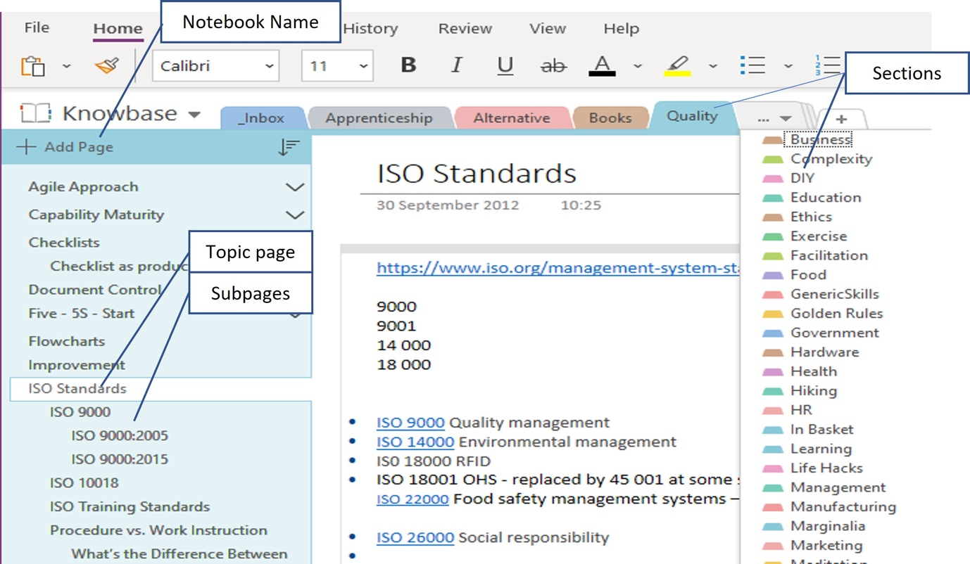
Figure 7: Example of a notebook structure using OneNote (Public Domain)

Examples of sophisticated notetaking applications are:
- Evernote https://evernote.com
- Google Keep https://keep.google.com
- Joplin https://joplinapp.org
- OneNote https://www.microsoft.com/en-za/microsoft-365/onenote/digital-note-taking-app
- Notion https://www.notion.so
- Zoho Notebook https://www.zoho.com/notebook/

Online storage
Online storage is the key to accessing your resources easily. When the information is online, you will be able to access it from any device, computer tablet or smart phone. You can also use someone else’s device so long as you remember your login details. You will need connectivity and data for this. Capturing resources online is, in general, also quicker and easier than collecting and processing them manually.
Most applications from the lists above include online storage. But you may also want to have a dedicated space for storing such information. Online storage applications are getting more sophisticated and now often link to other services. These services will allow you to edit documents, use planning tools and work with teams. Most of them offer a certain amount of data for free before you have to pay. The best known of these online storage systems are:
- Dropbox https://www.dropbox.com
- Google Drive https://www.google.com/drive/
- iCloud https://www.icloud.com
- OneDrive https://www.microsoft.com/en-za/microsoft-365/onedrive/online-cloud-storage
If you have a Microsoft account and use its Office or 365 Services you may find that you already have OneNote on your computer. You can then install it on your smart phone or tablet.

Constructing an inventory
An inventory is a list of everything you have collected during or after your WIL experience. It’s a starting point for making sense of what you have. There is no science to it. It is simply a way of giving you control over and keeping track of your resources.

Activity 6: Make an inventory
Suggested time: 30 minutes
In your learning journal, list each item you have collected during or after your WIL experience. Scan through and itemise these in your notetaking app, a table in Word, or a spreadsheet (e.g. Excel). You will later copy and paste your list into a spreadsheet. Your inventory could include the following items:
- Physical and digital documents.
- Images and photographs, including those of whiteboards and flipcharts.
- Recordings, interviews, comments.
- Notes.
- Answers people gave you, conversations where critical points were made, stories people told.
- Anything else that caught your attention – sights, sounds, smells, motions, movements, emotions, incidents, accidents, discomforts.
- People whom you could go back to, and ask questions, or for explanations.
For the last three bullets, create slips of paper, index cards or notes in your digital application to record them if you haven’t done so before. You can also digitise handwritten notes by photographing them and adding the photographs to your digital application.
For now, don’t analyse or question. Just capture. This is a critical activity to help you reflect on your experiences at a later stage. You may not use all the items later but they add to your global understanding of the context, of the swamp we discussed in Unit 1.
Share your inventory with your fellow students, lecturers, and people you may know in your area of specialisation.

Discussion of the activity
Did this activity help you remember information that could be of value? Did you create more “slips of paper” as a result of reflecting on your time at the workplace?
Did this activity help you to understand the value of what you have collected? Did you get additional insights into the value of your WIL experience?
What did you learn from the conversations with your fellow students, lecturers or people in your area of specialisation? Did what others shared or commented on give you additional ideas, or add value in some other ways?
Capture your reflections and what you have learned from others to include in your PoE (see below).

Categorising items in your inventory
To make items easier to sort you can use a set of categories, for example sort artefacts into various types such as spreadsheets, documents, images, samples, and so on.

Tables or spreadsheets
If you’ve created a list in a notetaking application or document, copy it into a spreadsheet so you can structure the information, like the example in Figure 8.

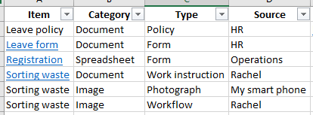
Figure 8: Example of a spreadsheet table inventory (Public Domain)
Your inventory is a personal artefact – you can make it work for you.
We often remember context. If we got some information from Rachel, we would remember that interaction. Putting her name in the inventory will help us find information as well as remember other information or details related to the event, which were perhaps not recorded.
You can also add filters to your spreadsheet to find items more quickly (see Figure 9).
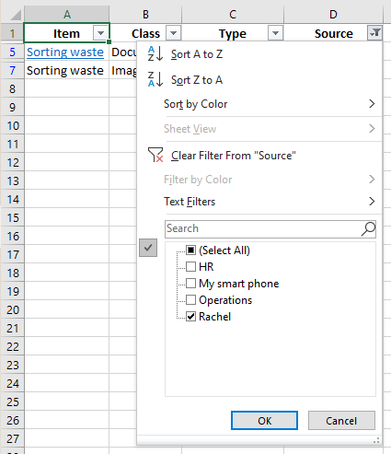
Figure 9: Example of filtering data in a spreadsheet (Public Domain)
In this case we have selected only resources given to us by Rachel. Alternatively, we can use the Sort feature to arrange the resources by class and type.
To make this type of inventory more useful we can add a hyperlink to where the document is stored, either local on a drive, or to an online service such as Dropbox (see Figure 10).

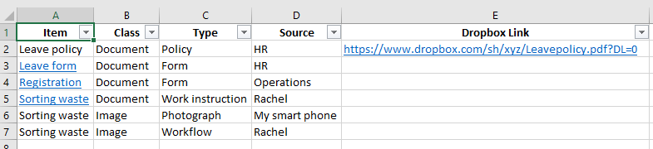
Figure 10: Examples of adding hyperlinks (Public Domain)
We can either paste the sharing link in a column or we can insert a hyperlink on the name of the resource, such as for Leave form, Registration and Sorting waste in Figure 9. This allows us to access the resource with a simple click.
Tip: In the online storage system we could create folders and subfolders to sort and organise our resources, using the same categories we have used in the spreadsheet.

Storing resources in a notetaking application
In a sophisticated notetaking application we can arrange notes in a hierarchy. The logic of the hierarchy is the same as we used in the spreadsheet.
Figure 11 provides an example of a hierarchical structure, using outlining features found in the more sophisticated notetaking applications. The Treepad app is no longer supported.

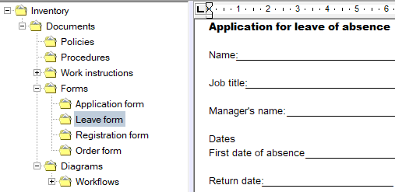
Figure 11: Example of hierarchical structure of pages and subpages in Treepad (Public Domain)
In this case you could add a copy of the document as text or image in the page. Alternatively, you could add a hyperlink to the document in your digital storage.

Tags
Tags are labels we can attach to artefacts and information. Many notetaking applications and computer filing systems allow the attachment of tags.
You can add tags to computer files such as documents, spreadsheets and images. In the Windows operating system you can right click on a file name and add tags under the Details tab (see Figure 12). For the Apple operating system, you can right click on a file name and choose Tags.

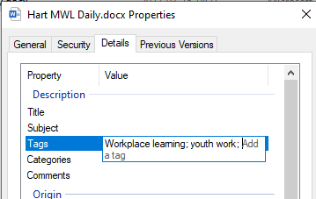
Figure 12: Adding tags to computer files in Microsoft Windows (Public Domain)
If you do a search for files on your computer drive, files with tags corresponding to your search term will show up in the results, as in Figure 13.
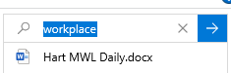
Figure 13: Search results showing file with the tag workplace in Microsoft Windows (Public Domain)
Many notetaking applications also allow you to use tags. For example, Figure 14 illustrates how some pages have been tagged with the word Attention and some have been tagged Awareness. Each instance is a clickable link to the relevant page. This allows you to surf through many pages very quickly to find a quotation or note you are looking for.

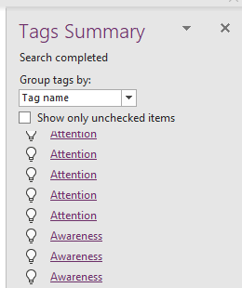
Figure 14: Showing tagged pages in Microsoft OneNote (Public Domain)

For more information on using tags, please refer to the relevant links below.
On the advantages of using tags:
https://www.thoughtco.com/tagging-advantages-3469879
On using tags for documents, recordings, videos and images in Windows or online in Microsoft OneDrive:
https://www.windowscentral.com/software-apps/windows-11/how-to-add-tags-to-files-on-windows-11
On using tags for documents, recordings, videos and images in Apple Mac:
https://support.apple.com/en-za/guide/mac-help/mchlp15236/mac#:~:text=Tag%20an%20open%20file%3A%20Hold,choose%20one%20from%20the%20list.
On using tags in digital knowledge bases e.g. OneNote:
https://www.youtube.com/watch?v=ymMGRYFhiNA&t=210s

Activity 7: Categorise items in your inventory
Suggested time: 60 minutes (including discussion time)
Use the suggested approach to tag your items and categorise them in your inventory.
Share your experiences with your fellow students, lecturers and people you may know in your area of specialisation.

Discussion of the activity
Did you find this way of categorising helpful? What did you learn from others when they described what they did? Would you apply any of those techniques or approaches to your inventory?
Did categorising the artefacts and information give you a better sense of what will be useful to use in the teaching process?
Did you also use tags? If yes, did they add value? If no, would you consider using them in future?
Capture your reflections and those you found useful from others, to include in your PoE.

Activity 8: Review your collection of artefacts and information against your action plan
Suggested time: 60 minutes
Review your action plan from Activity 5 and compare it to your inventory and the table you constructed in Activity 6.
- List concrete areas of success in the action plan.
- List any additional and useful information you obtained during the WIL that was not in your action plan.
- List gaps, where you may need to follow up on through your WIL contacts, or find other resources, or do further research.
- Review your activity logs and reflective journals for any additional information you could add to your inventory.
Consider if this review process triggers ideas for follow up, for example:
- going back to your contacts or to experts in your area of specialisation; or
- doing further research, especially any incidental knowledge you picked up that was not in your textbooks or other resources.
Share your thoughts and plans with your fellow students, lecturers and people you may know in your area of specialisation.

Discussion of the activity
The purpose of this activity is to begin the reflection process. What we plan to do and what actually happens can differ, especially if we are unfamiliar with the context we are going to experience. Was this the case for your planning?
What could also happen is that you find artefacts and information you didn’t plan for. Did you experience this?

Developing a portfolio of evidence (PoE)
An assessor can use a PoE to determine if you are competent and have achieved the outcomes. Some institutions may require the PoE to be printed and bound. You, however, already have a digital portfolio of evidence. Nearly all the activities in both unit 1 and unit 2 generate sufficient evidence that you have engaged with the learning process and have met the outcomes. if you have completed them all, you have most of your PoE, which now just needs editing.
What else would you need to tweak, to finalise your PoE? You may want to add the reports you have created as part of the PoE or as appendices. If you have used other resources of your own, for example information you found on the World Wide Web, you will want to compile a bibliography or list of additional resources. Finding, analysing and processing your own information is a critical skill at NQF Level 7.
If you have used a digital notetaking application you may want to rearrange the contents. This is quite easy in many applications. You can shift and copy pages to get them in a more suitable order.

Activity 9: Add your evidence to your portfolio of evidence
Suggested time: 60 minutes
- Establish what your institution’s requirements for a PoE are.
- Plan how you are going to format and present the WIL component of your PoE, based on those requirements.
- Decide on what you can use to effectively present your information, e.g. the tables you have prepared in the previous activities.
- Develop a list of what you still have to do to finalise the WIL portion of your PoE.
- Convert the list into an action plan.
- Add your evidence to the PoE, based on your action plan.
Discuss and share your experience with your fellow students, lecturers and people you may know in your area of specialisation.

Discussion of the activity
Was it easy to assemble the collected items into a PoE?
Did the exercise give you a sense of achievement when you saw what you had manged to produce?
Did the experiences of others show you other or better ways of developing your PoE?

Activity 10: Reflect on Unit 2
Suggested time: 60 minutes
Your PoE would have given some sense of what you have achieved in this unit.
Consider what you have learned about digital applications. Will this assist you in other areas of your personal and professional life? Note any thoughts and conclusions in your learning journal.
Share your experience with your fellow students and lecturers.

Discussion of the activity
Did your reflection and the experiences of others give you an appreciation of what digital tools can do for you? Did you gain any fresh insights, tips or tricks to use in future?

Conclusion to Unit 2
The focus of this unit was to create a digital platform for all the information and artefacts you collected during your WIL experience. You can extend and expand the digital platform later, as you discover more information and other resources. So the activities are not just for the purpose of satisfying the outcomes of your learning programme. They also give you a way of developing professionally on an ongoing basis.
The content and the activities were designed to prepare you to:
- bring what you have learned from your host employer back to the HEI environment
- sort and categorise the information
- consider how you will use the information in your teaching practice.
In Unit 3 you will reflect more deeply on the WIL process as part of vocational teaching and develop strategies to incorporate information and experiences into the curriculum, teaching and practical activities to enhance the quality of learning.

Unit 3 Enriching teaching and learning through WIL

Introduction
In the first unit you planned for your WIL experience. In the second you captured and collated information and artefacts. In this third unit you will be reflecting on the whole WIL experience and assess what you gained and how you can best make use of this in teaching and learning, planning of WIL experiences for your students and building college-industry/workplace collaboration.

Unit 3 Outcomes
By the end of this unit, you should be able to:
- Compile and present a summary of your major learning and how WIL can improve teaching and learning.
- Plan and structure a WIL placement for college students in an area of specialisation, based on your own experience.
- Reflect on college–industry/workplace collaboration.

Using your inventory to enrich your teaching and learning practice
The first step in the reflection process is to consider how you can best make use of your inventory of artefacts in your teaching and learning practice. When we began this module, we discussed the Donald Schön quotation of the high ground and the swamp.
We noted that your role as a lecturer would be to help your students to descend from the high ground and navigate the swamp. What will help them navigate and make sense of what is happening in the swamp? What will help them to integrate theory and practice?

Activity 11: Use your inventory in your teaching and learning practice
Suggested time: 60 minutes
Now that you have an inventory, you need to link the resources to your lecturing programme, practical activities and assessment.
Consider the following:
- Do you need to update your notes and presentations, or text in prescribed books with knowledge you gained during your WIL experience?
- Does the curriculum need to be updated?
- How can you best use the artefacts that you have collected?
  - Do you add them to your presentations?
  - Do you use them in practical activities?
  - Do you make them available as links for students to access?
  - Do you turn them into handouts?
  - Can you use them as part of your planned assessment activities?
- Will you have to edit or adapt any of the artefacts because of confidentiality issues?
Use the questions above to compile an action plan with the artefacts you have summarised in your inventory. Copy Table 6 into your learning journal. List each artefact and describe where, when and how you will use the artefact in the teaching and learning programme. Also add actions relating to what you have to do to include the artefact in the teaching and learning support materials.

Table 6: Action plan for teaching and learning
Goal To enrich my teaching and learning practice
Purpose To use artefacts to improve the link between theory and practice
Objectives To link my artefacts to specific teaching and learning activities

Goal | To enrich my teaching and learning practice
Purpose | To use artefacts to improve the link between theory and practice
Objectives | To link my artefacts to specific teaching and learning activities
Artefact | Where, when and how this artefact can be used (An example is provided)
Metal swarf curl (see Figure 5) | In a metal turning class using a lathe to show how turning should be done. The sample collected can be compared to those produced by students in the class.

Share your action plan with your fellow students and lecturers. Adapt your action plan, based on comments made or what you have learned through the action plans of other students.

Discussion of the activity
This action plan summarises the value you have gained from your WIL experience. If you already have lessons plans, lecturing notes and other documents to guide your teaching and learning programme, you can make notes in them, based on your action plan. If you don’t yet have such documents, you can refer to your action plan when you start your teaching and learning planning process.

Compiling a summary of your WIL
In this and the following activities you will critically evaluate your WIL experience, evaluating its strengths and weaknesses and its benefits and difficulties. This evaluation will enable you to plan and structure WIL experiences for students and to think more deeply about college and industry collaboration.

Activity 12: Summarise your WIL experience
Suggested time: 120 minutes (60 minutes for the report, 60 minutes to present the report and discuss)
Review the work that you did in Activities 8 and 11.
Summarise into a report:
- What you managed to achieve during your WIL
- What you didn’t manage to achieve during your WIL
- What additional artefacts or information you could use to enrich your teaching and learning processes and add value to your students’ understanding and skills in your area of specialisation.
Sometimes it’s not about the concrete experiences that you encounter; it’s about the people you meet and engage with. In reviewing your WIL experience, think back and compile a list of people who were compelling in what they did and how they did things, and how they communicated with you. As a contrast, create a list of people who did not seem to care about their work, beyond fulfilling their basic job function.
- How did the people on the first list add to your WIL experience?
- How did the people on second list make you feel?
- Did anyone make you feel inadequate, a hanger-on or a pretender?
- What interactions with people in the workplace added the most value to your WIL experience?
In your report, list what you have discovered about the people with whom you engaged.
Present your report to your fellow students and lecturers.
Listen to other students’ presentations.
Participate in discussions of the various reports with your fellow students and lecturers.
Consider if you would change or add anything to your report. Make those changes and add the report to your PoE.

Discussion of the activity
Reviewing what you have collected and experienced allows you to step back from the detail and start to consider the bigger picture. This, in turn, allows you to consider steps you can take to expand your current level of knowledge and skills. It fosters what is a called a growth mindset. Carol Dweck, a psychologist who researches motivation and mindset developed a theory that human beings exist on a continuum between fixed and growth mindsets.
Those with a growth mindset believe that "intelligence can be developed", and their abilities can be increased by learning. They tend to embrace challenges, persevere in the face of adversity, accept and learn from failure, focus on process rather than outcome, and see abilities as skills which are developed through effort. Feedback and failure are seen as opportunities to increase ability, signaling the "need to pay attention, invest effort, apply time to practice, and master the new learning opportunity". (Retrieved from https://en.wikipedia.org/wiki/Mindset )
Learning is also an intensely social activity. Recall the Jay Cross quotation from Unit 1:
Conversation has magic to it. Dialogue is the most powerful learning technology on earth. Conversations are the stem cells of learning, for they both create and transmit knowledge. (Cross, 2007:13)
Hearing how others have approached the activity or detailed their experiences can help you generate new ideas and avenues to explore.

Stop and think
Many websites and blogs and much research literature explore the concept of fixed and growth mindsets, which has been well-received. Understanding these dynamics could assist you in defining your role as a forward-thinking, constantly evolving and engaging lecturer. A key point that Carol Dweck herself highlights in a Harvard Business Review article is that:
Everyone is actually a mixture of fixed and growth mindsets, and that mixture continually evolves with experience. A pure growth mindset doesn’t exist, which we must acknowledge to attain the benefits we seek. (Dweck, 2016)
So it’s not about having a growth mindset – it’s about how to cultivate that mind set, respond to failures and challenges, learn from your exposure and from your experiences and others around you or whom you encounter.

Activity 13: Compile a report of the benefits and difficulties of the WIL experience
Suggested time: 30 minutes
Summarise the benefits you gained and the difficulties you encountered.
Create a list of recommendations you would make for future WIL experiences.

Discussion of the activity
The purpose of this activity is to start you thinking about how your own students will go into industry in the future. Your findings and recommendations will assist you to ensure that you enrich your students’ experiences. One of the outcomes of this activity could well be that you think about your own WIL experience a bit differently.

Activity 14: Present your findings and recommendations
Suggested time: 60 minutes
Present your findings and recommendations from Activity 13 to your fellow students and lecturers.
Listen to other students’ presentations.
Participate in discussions of the various findings and recommendations with your fellow students and lecturers.
What could you change or add to your report?
Make those changes and add the report to your portfolio.

Discussion of the activity
The purpose of this activity is to ensure that when your students go into industry they will benefit from the experience. If WIL is merely regarded as a compliance exercise, then neither the students nor the host employers will benefit. In these cases, the student is often assigned to menial or incidental tasks, which do not adequately prepare them for the kind of work they are being training for.

Planning a student WIL experience

Activity 15: Plan and structure a WIL placement for college students
Suggested time: 60 minutes
Consider your full WIL experience, from planning through to your current reflections:
What worked well?
What didn’t work well?
What should be avoided?
Was there sufficient collaboration between the institution and the employers?
Was the workplace suitable for what you had planned to achieve?
What could be added to improve the WIL experience?
Now consider the points you have made and think about how that could affect your own students in future, when they embark on the WIL component of their studies.
Based on your own experience develop a plan to structure a WIL experience for students in your area of specialisation.
Consider how you could:
Build on the positive aspects
Mitigate the risks and potential pitfalls
Enrich the students’ experiences in industry
Influence more employers to participate actively in planning and implementing the WIL process.
Your plan should cover the following:
Recruiting and preparing employers
Preparing your students for the process
Monitoring their WIL
Students feedback and reports.

Discussion of the activity
The purpose of this activity is to provide you with a blueprint (guide) that you can use in the future. It will act to ensure that you don’t forget your own experiences and insights. Blueprints of this kind act as a model to follow. When you do use the blueprint, it will be influenced by the context, your circumstances, the employers and the cohort of students you have at the time.

Activity 16: Present your findings and recommendations
Suggested time: 60 minutes
Present your WIL plans to your fellow students and lecturers.
Listen to other students’ presentations.
Participate in discussions of the various findings and recommendation with your fellow students and lecturers.
Consider if you would change or add anything to your plan.
Make those changes and add the report to your portfolio.

Discussion of the activity
Once again, the purpose here is to hear different views and to stimulate discussions. The conversation could trigger additional thoughts for you to modify or improve your own plan.

Reflecting on college–industry/workplace collaboration
This part of the unit links to the module Collaboration in Teaching and Learning.
As we have alluded to at various points in this module the success of WIL relies on collaboration between the college and the lecturers on the one hand and industry, employers and workplaces on the other. Key here are the partnerships that develop, sometimes over many years. This activity encompasses a wide variety of stakeholders and role players.
Lecturers play a key role in these partnerships, and in ensuring that the collaboration is successful where the students and the workplaces interface. Activities 17 and 18 explore these dynamics.
WIL is a mechanism to increase the chances of graduates obtaining employment. WIL therefore becomes an enabler: students can gain some experience; employers can select good candidates from those to whom they have given WIL opportunities.
Students benefit if the teaching, learning and WIL provide them with sufficient skills, knowledge and attitudes to help them transition from studying to working.
Keep these points in mind when completing Activity 17.

Activity 17: Develop a presentation on college–industry/workplace collaboration
Suggested time: 60 minutes
Use presentation software to summarise collaboration between colleges and industry. Use the following outline (1 and 2):
1. The benefits of WIL for each of the following:
- students
- employers
- lecturing staff
- the college as a whole.
2. How you think college–industry/workplace collaboration could be structured and expanded to enrich the lives of your students?
Share your presentation with your fellow students and lecturers.
What other insights did you get from listening to the comments made on your presentation, or comments made on the presentations of other students?
What changes would you make to your presentation as a result?
Revise your presentation and add it to your portfolio.

Discussion of the activity
The purpose of this activity is to shift your perspective from just being a passive participant to learning to make a difference.
Some lecturers may think that they have fulfilled their role if they pass on the knowledge in the textbooks and assess students’ abilities to recall the knowledge. Other lecturers may aspire to activate students to become excellent practitioners in a particular area of specialisation and to be able to apply for and get a job in that area of specialisation.

Stop and think
One of the greatest challenges of our time is to transition young people into the labour market, to help them to get and retain jobs, and to become influencers in their community and active citizens.
How can you facilitate this for your students?

Activity 18: Reflect on Unit 3
Suggested time: 60 minutes
Review the activities in this unit.
What were the most profound insights you developed during Unit 3? These insights could be based on your reflection on your writing activities, your conversations with others, or reading from provided texts or the suggested areas of research.
Compile some notes in your learning journal for yourself, to reflect on your journey.
- How did the step-by-step activities benefit or influence your way of thinking?
- How could these activities have been modified to make more sense to you and provide you with greater value when you start or continue with your career as lecturer?
- In which areas would you like to develop your knowledge and skills?
Compile your notes add them to your portfolio.

Discussion of the activity
The area of reflection can be an intensely personal one.
Have you grown to realise that lecturing in the TVET sector is not just about the transmission of knowledge, but linking such knowledge to the world of work?
What has changed for you as you worked through the activities?
How can you best use what you have learned to make you a better lecturer and a more knowledgeable person?

Activity 19: Reflect on the module as a whole
Suggested time: 60 minutes
This module prepared you to have your own WIL and to collect artefacts and information that could assist you in your teaching and learning processes. The module also focused on creating some order to the artefacts and information you collected and how to integrate that into your professional practice as a TVET lecturer. Finally, the module asked you to think about the system in which you are a participant and how you could add value to the teaching and learning process and to your students and the labour market in general.
What for you has changed and what insights have you had? Does this influence how you think about what your role is as a lecturer in the TVET system? If so, how?
Has this module influenced you or even inspired you to take a greater interest in in what happens in the world of work and how you could add value to enrich your teaching and learning practices? If so, how?
Compile your reflections on these questions or any other thoughts you may have at the end of this module and add this to your portfolio.

Discussion of the activity
This again is an intensely personal activity. It requires you not to look at how you can conform to institutional requirements, but to consider how you shape your life as a TVET lecturer in the future. Did this module help you to do that?

Conclusion
This brings us to the end of this module. We have explored a wide range of practices and tools that you can use to aid your own development and teaching, and the development of your students, in relation to WIL, based within industry.
The PoE that you have developed during the module can serve as a valuable resource going forward. If you find yourself struggling to work with your WIL or the WIL experience of your students, take out your PoE and review it. You should find that it provides you with insights and ideas that you can use in your TVET career.

Exemplar Summative Assessment
Your Portfolio of Evidence is a history of your learning journal during this module. It provides the basis for you and your lecturers to assess your level of learning and what you have achieved.
Your PoE will be assessed using the following rubric against the following elements:

Rubric
Element | Unsatisfactory | Needs Improvement | Proficient | Exemplary
Overall impression of the portfolio of evidence | Large number of gaps, poorly organised, limited number of module activities | Some gaps, evidence of organisation | Complete or very nearly complete, evidence of an organised approach | Well organised and information is indexed or tagged for easy retrieval
Artefacts and information gleaned | Very few artefacts, very little information collected | A small selection of artefacts | A useful number of artefacts and information collected | A wide range of artefacts and information collected; evidence of further research and follow up actions
Classroom activities | Very few module activities completed or module activities poorly done | Too few classroom activities completed or quality of classroom activities needs improvement | Most classroom activities completed and evidence of high level of engagement | All classroom activities completed and evidence of a thorough approach to their completion
1.Prepare and plan for the WIL experience. | Unsatisfactory | Needs Improvement | Proficient | Exemplary
Map out a core workflow in your area of specialisation. | Poor understanding of work processes | Some gaps in the understanding work processes | Good understanding of work processes | Excellent understanding of work processes
Prepare an action plan that details the activities and information collection methods. | Inadequate details and poorly conceptualised actions | Some gaps in the planning processes and methods of information collection | Well thought through plan and a range of information collection methods | Excellent planning and a range of information collection methods
Compile a list of documents and artefacts which you would like to collect. | Poorly detailed list of items to be collected | Some evidence of items to be collected | Well thought through list of items to be collected | Comprehensive list of times to be collected
Research your host employer and confirm WIL arrangements. | No or poor record of research or of interactions with the host employer | Evidence of some research and some effort to interact with the workplace | Useful research on the host employer and a good record of interaction | Evidence of excellent research on the host employer and a high level of engagement with workplace representatives
2. Compile a portfolio and capture, sort and categorise the information, the artefacts and experiences collected in the WIL process into a digital knowledge base. | Unsatisfactory | Needs Improvement | Proficient | Exemplary
List concrete areas of success against the action plan. | Very limited success | Some areas of success listed | A good range of success areas | An excellent range of success areas
List any unexpected additional and useful information. | Few if any items listed | Some items listed | A good range of items listed; evidence of an enquiring mind | An excellent range of items collected, demonstrating high levels of engagement
Arrange the information collected according to a logical framework. | Lack of a logical structure | Some structure | Well-structured and good accessibility to the information | Excellent structure and very accessible information
3. Reflect on the WIL process as part of vocational teaching and develop strategies to incorporate information and experiences into the curriculum, teaching and practical activities to enhance the quality of learning. | Unsatisfactory | Needs Improvement | Proficient | Exemplary
List areas where the curriculum and learning materials need to be updated. | Few or no items listed | Some items listed | A range of items to be updated. | A comprehensive review of items to be updated
List items that could be used to improve learning materials and practical activities. | Few or no items listed | Some items listed | A good range of items. | A comprehensive list of items
List ways in which the collected information can be used in the teaching process. | Few or no items listed | Some items listed | A good range of items listed. | A comprehensive list of items
Plan and structure a WIL placement for college students. | Little evidence of a practical plan or structure | A rudimentary plan and some evidence of structure | A practical, well-structured plan | A comprehensive, excellently structured plan
Critically appraise and report on lessons learnt and their applicability to teaching the subject. | Very limited review | Some attempt to engaged with the topic | Well thought through appraisal and application in teaching the subject | An excellent appraisal and good insight into application in teaching the subject
Critically reflect on the benefits of college-workplace collaboration. | Little insight | Some insight | A well-rounded reflection on the complexities | An excellent insight and understanding of the complexities

Bibliography
Cross, J. (2007) Informal learning – rediscovering the natural pathways that inspire innovation and performance. San Francisco: Pfeiffer
Dweck, Carol. (2016) What having a growth mindset actually means. Retrieved from https://hbr.org/2016/01/what-having-a-growth-mindset-actually-means
Higher Education Council of Ontario. (2016) A practical guide for work-integrated learning. Council. Toronto: Queen’s Printer for Ontario. Retrieved from:
https://heqco.ca/wp-content/uploads/2020/03/HEQCO_WIL_Guide_ENG_ACC.pdf
Making Cents International. (2017) Demand driven training for youth employment – toolkit interactive Retrieved from
https://makingcents.com/wp-content/uploads/2017/01/Making-Cents_Demand-Driven-Training-Toolkit_Interactive.pdf
National Training Board (1997) National Qualifications Framework – Engineering and Manufacturing Processes Pilot Project. Unpublished report. Retrieved from https://www.ontario.ca/page/copyright-information-c-queens-printer-ontario#section-0
Openly licensed (not Creative Commons)
Vorwerk, C. and Farquharson, F. (2014) Plastics Chamber Research Project Phase III - Final Report. Plastics Rubber Industry Value Chains 2013-06-26.pptx, a supplement. Unpublished report.
Porter, Michael E. (1985) Competitive advantage: Creating and sustaining superior performance. New York: Simon and Schuster
Schön, D.A. (1995) Knowing-in-action: The new scholarship requires a new epistemology. Change, Vol. 27, Issue: November/December, pp. 27–34
Services Education and Training Authority. (2012) AD-PR-008 Procedure for Terminating Apprenticeship Contracts. Unpublished Report
Van der Bijl, A. and Taylor, V. (2019) Curriculum framework for industry/workplace-based work-integrated learning for qualifications for lecturers in technical and vocational education and training. Potchefstroom: Ivyline CC BY SA
https://www.oerafrica.org/resource/curriculum-framework-industry-workplace-based-work-integrated-learning-qualifications

Artefacts will be discussed throughout the module. They are physical things or objects that could be collected in a workplace, as well as more abstract things like conversations, that could be transcribed or notes made about them.
Objectively Verifiable Indicator – see definition below

