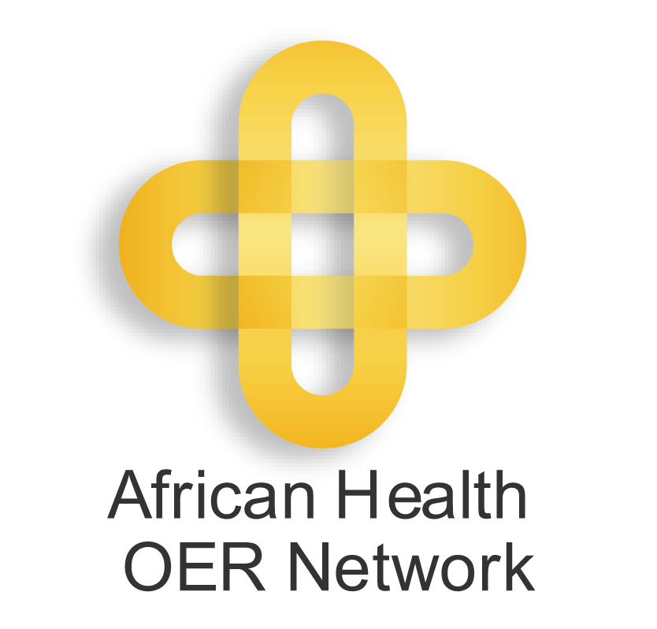 | Recommended Practices for  Packaging and Distributing OER  This guide is licensed under a Creative Commons Attribution 3.0 License  http://creativecommons.org/licenses/by/3.0/.  © 2011 Regents of the University of Michigan and Saide.  Version 6: 21 April 2011

OER may be distributed in a variety of formats, including electronically online, removable media (e.g. CD/DVD, or USB), and/or paper hard copies. In order to maximize its reach and visibility, OER is often distributed online which introduces new considerations such as managing file size and selecting appropriate descriptive data (commonly referred to as metadata). File size is an especially important consideration as small manageable files can be more easily downloaded in bandwidth-constrained areas.

The recommended practices below are intended for individuals involved in OER production at institutions that participate in the African Health OER Network (aka "the Network). As part of the Network, completed OER are often hosted on multiple servers: an institutional server, the official Network web space http://www.oerafrica.org/healthoer/, and on the University of Michigan (U-M) Open.Michigan website at http://open.umich.edu/education/med/oernetwork/.
The aim of these guidelines is to encourage the creation of OER that is easily discoverable, accessible, and adaptable. If you are interested in discussing this document or general technology questions around OER, consult the oer-tech Google Group: http://groups.google.com/group/oer-tech/.

POLICY AND LICENSING

- Select a Creative Commons license that allows Derivatives. Creative Commons offers six licenses and a waiver (see https://creativecommons.org/licenses/). If possible, have the content creator select a license that enables adaptations or derivatives. This means avoiding the Creative Commons Attribution No Derivatives (CC BY ND) and Creative Commons Attribution Noncommercial No Derivatives (CC BY NC ND) licenses. At present, if you select a license with an ND clause, the resource may still be posted on the OER Africa website, but not on Open.Michigan. (OER Africa is currently re-evaluating its policy on whether to host CC BY ND or CC BY NC ND works, so this may change.)

- Ensure that the OER has the proper disclaimer, license, and attributions. All published resources should contain the following information with the downloadable version:
  - A Creative Commons license or Creative Commons Zero waiver
  - The name of the Copyright Holder and Year of Publication
  - The name of author(s) (N.B., this may be different from the copyright holder)
  - Institutional Branding
  - General contact person – It may be helpful to have an email address like oer-info@yourinstitution.edu for managing inquires about the OER. Faculty may or may not want to include their personal emails. They may not be able to address technical issues or may not have time to respond to content inquiries.
  - Acknowledgements of those who contributed (media specialists, voiceovers, funders, collaborators, etc.)
  - Proper attributions for content objects – For any objects created by someone other than authors, such as images found on Flickr, you should include the author, the source, and the license. See https://open.umich.edu/share/cite for more details.
  - Necessary disclaimers – An OER may have several disclaimers depending on the content. You may have disclaimers for graphic medical content, recording of patients, student actors, animal experiments, or third-party (i.e., not created by you) objects. See https://open.umich.edu/wiki/Example_Disclaimers for example disclaimers.

- Confirm the license before distributing. It is vital that the Creative Commons license is confirmed with the content creator before distributing. It can be quite problematic to change a license (especially to a more restrictive license) on a resource after it's already been distributed. Once a resource has been made public, that license stays with that resource. Since the resources are online, people may download them and re-post them on other website. There will be the versions on the OER Africa website, Open.Michigan website, possibly other websites, and also on people's local hard drives. If you change the license, there would be two versions of the resource with different licenses in multiple physical and digital locations. Some people may stumble across either version and would use the license on the version that they find or become aware of both licenses and use the less restrictive one.

FILE FORMATS AND SIZES

- Each individual file - including zip archives - should be under 50 MB. Many Network participants live in low-bandwidth environments and large files can be difficult or impossible to download. Starting May 2011, OER Africa and University of Michigan will not be accepting individual files over 100 MB.

- Distribute native, editable, common file formats – One of the advantages of OER is the open license, which allows duplication and adaptation of the resource. If you distribute files only in non-editable formats like PDF or Shockwave Flash (SWF), you create technical obstacles to adaptation. It is best to distribute editable formats so that others are technically able to adapt the materials to their context. Additionally, try to use file formats that are commonly used and avoid proprietary formats if possible. You could, for example, use Microsoft Office 1997-2004 formats (e.g. DOC, PPT, XLS as opposed to DOCX, PPTX, XLSX) or a free, open source equivalent such as Open Office or Libre Office (ODP, ODF, ODS). Common formats for video include MP4 (H.264), MOV, FLV, and AVI; for audio there are MP3, FLAC, and WAV; for images there are JPEG, JPEG 2000, PNG, GIF, SVG, and TIFF. HTML also works well across operating systems and works with any Internet browser. YouTube and several popular video-editing applications do not accept SWF files. You may still desire to publish non-editable compressed formats for convenience of file sizes or embedding in an HTML page. In those cases, it best to distribute a second copy in an editable or easily adaptable format. If possible, it also useful to share your available source files for images (e.g. Adobe Photoshop), video clips, or Flash (such as FLA).

- Include high-resolution versions of videos if possible. If it is possible to include high- resolution videos that are under 100 MB per file, those high-res versions will be very useful for general adaption as well as video montages that partner institutions may put together for conference presentations. U-M and OERA would like to offer hi-res and low-res downloadable versions as well as streaming video where possible.

FILE STRUCTURE

- Present related OER as a collection of learning objects, not as a single file. Related materials should be presented as a collection or series of separate files. Bundling multiple large files like videos into a single package (e.g. embedding resources into an HTML module) can increase file size and cause confusion among learning objectives and scope. Instead, try to design learning objects (http://en.wikipedia.org/wiki/Learning_object), which gives students more control over their learning preferences and styles as well because they can scope their studies to something specific. For example, rather than packaging a procedural video as long clip, split it into discrete steps of the procedure. Additionally, distributing each OER (e.g., clinical video) as a single unit makes the title of the individual resource more prominent and therefore easier to find when browsing and searching. By distributing files as separate entities that are part of a collection or series, users will have direct access to the individual components of an OER, whether that is a video, a quiz, or a list of learning objectives. For an example, see http://open.umich.edu/education/med/resources/palliative-care/2010/materials.

- Avoid frames in HTML. If you are distributing resources as an HTML-based program, avoid the use of frames. The frame tags are no longer supported in HTML 5, since they interfere with browser navigability and accessibility (e.g., screenreaders). See http://www.456bereastreet.com/archive/200411/who_framed_the_web_frames_and_usability/ for a discussion about the drawbacks of frames. Cascading Style Sheets (CSS) represent one alternative to frames (see http://www.456bereastreet.com/lab/developing_with_web_standards/csslayout/2-col/ and http://www.smashingmagazine.com/tag/css/).

- Avoid opening pop-ups and new windows in HTML. Opening pop-ups and new windows for subtopics in a HTML-based OER module can be tempting, but in practice this can quickly lead to cluttered display and confusing navigation, which can impede accessibility. You can implement the CSS tips mentioned above instead. There are better methods to control window size so that users can view the resource as the same size on different devices (e.g., Apple iPads). Most web designers manage window size by setting the width of the body or the block (div) with the main content instead of the window itself. That also helps to keep all or most of the navigation within a single window and the content is fixed width. Generally, when you fix the width you don't need to fix the height. For example, this is implemented in the CSS of the http://open.umich.edu site as: #footer-inner { width: 980px; }

DESCRIPTIVE DATA (METADATA) AND PLATFORMS

- OER should include basic metadata. The policy section identified copyright and disclaimer information to include with OER. In addition, the resource should include a title, an introduction with a short description that explains what the resource is about, and, ideally, learning objectives and keywords. This can be included as a page within the OER or embedded directly in file (e.g. File > Properties in Microsoft Word). This descriptive information will be used to promote the resource on the U-M and OER Africa sites. Both organizations will include that information in their relevant metadata distribution other websites like OER Commons, YouTube, Internet Archive, GLOBE (Global Learning Objects Brokering Exchange), and the Learning Registry.

- Use a platform that makes it easy to view your metadata and latest OER. There are several content management systems with built-in functionality such as RSS (Really Simple Syndication) feeds or the Dublin core (oai_dc) metadata standard that makes it possible for search engines operated by OER Commons, the OpenCourseware Consortium, GLOBE (Global Learning Objects Brokering Exchange), the Learning Registry, and others to automatically track new content. Examples of platforms with this functionality include OERbit (https://open.umich.edu/wiki/OERbit), educommons (http://educommons.com/ http://educommons.com/), Drupal (http://www.drupal.org), and DotNetNuke (http://www.dotnetnuke.com/)

U-M and OER Africa memorandum of understanding excludes resources that have an ND clause from being posted to the Open.Michigan website. The definition of OER that the U-M team uses is: Open Educational Resources (OER) are learning materials offered freely and openly for anyone to use and under some licenses to adapt, copy, and redistribute (http://wiki.creativecommons.org/What_is_OER%3F). Since we want people to be able to adapt the resources to their local context, U-M does not offer the ND option to U-M faculty who wish to publish OER with Open.Michigan. Additionally, a ND clause means that the resource would be excluded from sample discs of OER that U-M occasionally distributes for marketing health OER.
Raw source files may be over the file size limit, which is fine, as only a smaller group will be interested in them. One way to share source files is to distribute a second file with all the assets or source files alongside the final resource.

