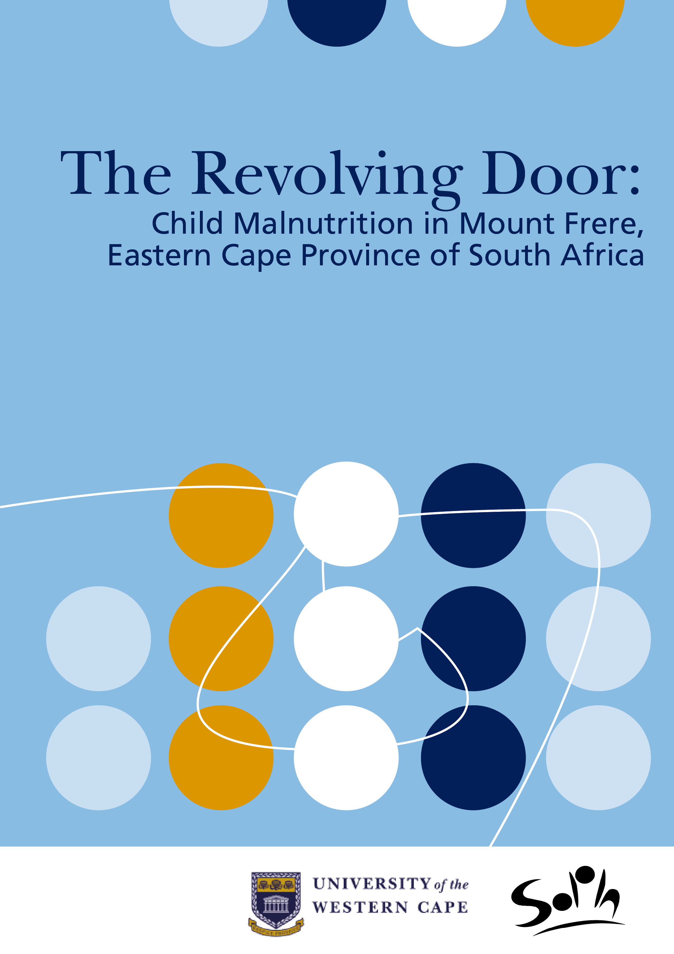
School of Public Health (SOPH), University of the Western Cape (UWC), South Africa
Open Education Resource

Abstract: This case study focuses on the multiple factors which feed into under 5 malnutrition (including the social determinants of disease). It is set in the Eastern Cape province of South Africa in 2002. The UNICEF Conceptual Framework is used as a tool for analysis.

The case is structured as a short narrative case study followed by an introduction to the UNICEF Conceptual Framework. In addition, contextual information is supplied and could be supplemented, using links to further sources of information, plus some tables and photographs. Also included are links to journal articles outlining possible responses to this situation.

Keywords: Malnutrition, UNICEF Conceptual Framework, Social Determinants of Disease, Millennium Development Goals 1,2,4,5

Learning object type: Public Health case study

Background: Developed from research conducted by the School of Public Health and other partners. The case was developed for teaching purposes in the SOPH, UWC Postgraduate Programme

Target audience: Individuals leading and/or participating in Public Health education

Auxiliary materials: Podcast: Causal Factors of Thembi’s Malnutrition - Emeritus Professor David Sanders, interviewed by Ms Nikki Schaay of the SOPH, UWC, 2011

Version: 1.0

Copyright holder: University of the Western Cape (UWC), School of Public Health

License:


Except where otherwise noted, this work is licensed under a Creative Commons Attribution - ShareAlike 3.0 Unported (CC BY-SA 3.0) http://creativecommons.org/licenses/by-sa/3.0/
Copyright© 2010 SOPH School of Public Health, UWC.

Date content created: October 2011

OER Description
This case study resource has been developed at the School of Public Health (SOPH), University of the Western Cape (UWC) and used in our teaching. It is based on a research project undertaken over 12 years in the Eastern Cape Province of South Africa by Emeritus Prof David Sanders and Prof Thandi Puoane of the SOPH, UWC with Prof Ann Ashworth from the London School of Hygiene and Tropical Medicine.

Institution: University of the Western Cape (UWC), School of Public Health (SOPH).

Content submitted by: Lucy Alexander, Senior Academic Programme Co-ordinator, SOPH, UWC.

Author/s: Prof Thandi Puoane, BCur, MPH (Berkeley), Dr PH (Berkeley), Professor at the SOPH, UWC, South Africa; Lucy Alexander, BA (Hons) (Wits), BAFA (Unisa), Dip (Adult Ed) (UCT), MPhil (Adult Ed) (UCT), Senior Academic programme Co-ordinator at SOPH, UWC; and Barbara Hutton, BA (Social Science) (Honours) (Wits); BEd (Honours) (Wits); Independent materials development consultant, SOPH.

Links to related Postgraduate Programme modules: Relevant to Population Health and Development: A Primary Health Care Approach I & II, Public Health Nutrition: Policy and Programming; Health Promotion for Public Health II.

Financial support provided by: Hewlett Foundation Education Program and facilitated by the African Health OER Project, University of Michigan and OER Africa. This acknowledgement in no way indicates endorsement of this work.

Contents
OER Description 3

SECTION 1 - TOPIC RATIONALE ................................................................................................................................ 6
SECTION 2 - LEARNING INPUT ................................................................................................................................ 8
2.1 Setting and Population ........................................................................................................................ 8
2.2 Learning Objectives ............................................................................................................................. 8
2.3 Student Learning Activity 1.............................................................................................................. 9
2.4 Case Study: Thembi’s Malnutrition .............................................................................................. 10
2.5 The UNICEF Conceptual Framework for Malnutrition ........................................................ 12
2.6 Linking the UNICEF Conceptual Framework with the Concept of Social
Determinants of Health ..................................................................................................................... 14
2.7 Student Learning Activity 2 ............................................................................................................. 15

SECTION 3 – SETTING DESCRIPTION FOR CASE ANALYSIS ....................................................................... 17

3.1 The Eastern Cape, South Africa ..................................................................................................... 17

3.2 Prevalence of Malnutrition in South Africa ……………………………………………………… 17

3.3 Background Information about Mount Frere ………………………………………………….. 18

3.4 Livelihoods and Unemployment ................................................................................................. 20

3.5 Eastern Cape Province Demographic and Health Information ..................................... 20

3.6 Social Security Grants ...................................................................................................................... 21
3.7 Student Learning Activity 3 .......................................................................................................... 24

REFERENCE LIST AND ADDITIONAL READINGS .......................................................................................... 25

SECTION 1 - Topic Rationale
In the late 1980s, a UNICEF Policy Review stated:
‘Freedom from hunger is a basic human right. Continued malnutrition is unacceptable. Goals are proposed for the 1990s for the control of protein-energy malnutrition and micronutrient deficiency disorders. This strategy, based on previous nutrition-oriented programmes, proposed to reduce and ultimately eliminate malnutrition in developing countries’ (UNICEF, 1990) [http://www.ceecis.org/iodine/01_global/01_pl/01_01_other_1992_unicef.pdf]

Eighteen years later, Margaret Chan, WHO Director, noted at the United Nations food summit in Rome in 2008: ‘The world already faces an estimated 3.5 million deaths from malnutrition each year. Many more will die as a result of this crisis’ (WHO Director-General Margaret Chan in a speech to the United Nations food summit in Rome, 2008).
‘Malnutrition is largely a silent and invisible emergency, exacting a terrible toll on children and their families. The result of multiple causes, including a lack of food, common and preventable infections, inadequate care and unsafe water, it plays a role in more than half of the nearly 12 million deaths each year of children under five in developing countries, a proportion unmatched since the Black Death ravaged Europe in the 14th century. Malnutrition blunts intellects and saps the productivity and potential of entire societies. Poverty, one of the causes of malnutrition, is also a consequence, a tragic bequest by malnourished parents to the next generation’ (UNICEF, 2008) [http://www.unicef.org/sowc98/]

The Executive Director of UNICEF, Ann M Veneman elaborates on this issue in relation to the United Nations Millennium Development Goals (Nov 2009) [http://www.un.org/millenniumgoals]:
‘The first Millennium Development Goal calls for the eradication of extreme poverty and hunger, and its achievement is crucial for national progress and development. Failing to achieve this goal jeopardizes the achievement of other MDGs, including goals to achieve universal primary education (MDG 2), reduce child mortality (MDG 4) and improve maternal health (MDG 5).

One of the indicators used to assess progress towards MDG 1 is the prevalence of children under 5 years old who are underweight, or whose weight is less than it should be for their age. To have adequate and regular weight gain, children need enough good-quality food, they need to stay healthy and they need sufficient care from their families’ (Veneman, 2009: 3)
[http://www.unicef.org/nutrition/files/Tracking_Progress_on_Child_and_Maternal_Nutrition_EN_110309.pdf]

Children between the ages of 6 - 24 months old in particular carry a great risk of malnutrition, because of the increased risk of infections arising from the decline in breastfeeding and the inadequate nutritional quality of complementary foods. The extent of the problem remains huge, particularly in Africa, Asia, and Latin America, and in 2004, it was estimated that up to
‘… 53% of all deaths in young children are attributable to underweight’ (Caulfield, de Onis, Blossner & Black, 2005 in de Onis, Blossner, Borghi et al, 2004) [http://jama.ama-assn.org/cgi/content/full/291/21/2600]

An orientation to under-nutrition seems imperative in any Public Health programme since even when the cause of death is measles or diarrhoea, mortality would not necessarily occur if the child was well nourished. If a child is even mildly underweight, the mortality risk is increased, as is evidenced by WHO’s estimate that malnutrition is associated with more than one third of all child deaths (UNICEF, 2008).

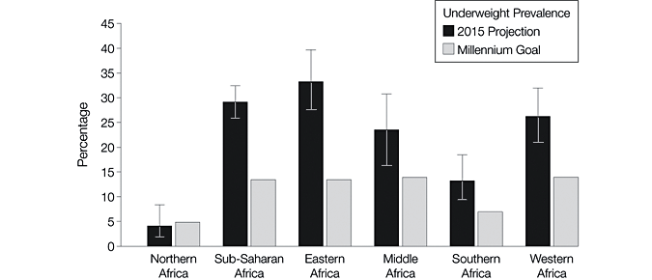

Fig 1: Projections of Underweight Prevalence in African Sub regions in 2015 Compared with the Millennium Development Goal Percentage with weight 2 SDs below the mean weight for age of the reference population from the National Center for Health Statistics and World Health Organization (de Onis, M. et al, 2004)

In clinical terms, children with severe malnutrition need specialised care and without correct treatment, death may occur, arising from infection, heart failure, hypoglycaemia and hypothermia. In Public Health terms, severe malnutrition cannot be tackled without understanding its causes, which are complex, multiple and interrelated, and include the broad determinants of poverty, healthcare and caring practices (UNICEF/WHO Joint Committee, 1989).

SECTION 2 - Learning Input

2.1 Setting and Population
- Mount Frere District in the Eastern Cape Province, South Africa
- Children under 5 years of age

2.2 Learning Objectives
- To identify the causes of under 5 child malnutrition in a specific context
- To use the UNICEF Conceptual Framework to analyse the relationship of child malnutrition and its social determinants
- To clarify the signs and physiological effects of severe malnutrition on children
- To investigate the determinants of severe malnutrition in a locale in one’s own working context
- To infer and explore possible interventions using the UNICEF Conceptual Framework
 | 2.3 Student Learning Activity 1 – Before you start  - Explore the meaning of these key concepts using books and the internet. Two resources are suggested below.  In each case, consider how the concept relates to malnutrition:  - malnourished child  - malnutrition  - under-nutrition  - severe acute malnutrition  - severe wasting  - stunting  - oedema  - marasmic-kwashiokor  - electrolytes  - electrolyte imbalance  - hypothermia  - ReSoMal  - starter formula  - Millennium Development Goals 1,2,4,5  - Millennium Development Indicators  - Describe the full range of visual signs of severe malnutrition in children.  - Describe key physiological effects of severe malnutrition on children.  - Try to find statistics for under 5 malnutrition globally and in your region for the last 5 to 10 years.

Resources for this Activity
WHO & UNICEF. (2009). WHO Child Growth Standards and the Identification of Severe Acute Malnutrition in Infants and Children. A Joint Statement by the World Health Organisation and the United Nations Children’s Fund. [Online], Available: http://www.who.int/nutrition/publications/severemalnutrition/9789241598163_eng.pdf [Downloaded: 20.10.10].

UNICEF. (2009). Tracking Progress on Child and Maternal Nutrition: A survival and development priority. UNICEF. [Online], Available: http://www.unicef.org/nutrition/files/Tracking_Progress_on_Child_and_Maternal_Nutrition_EN_110309.pdf [Downloaded: 20.10.10].

2.4 Case Study: Thembi’s Malnutrition
Thembi, an 18 month old girl, lives with her grandmother in a homestead in the Mount Frere district, about an hour from the Sipetu Hospital by bus. Her grandmother receives a pension of R948 per month (approx $135 in 2008), but this supports two other grandchildren and herself. She keeps chickens but cannot grow a vegetable garden because rain has been erratic and she does not have running water. Thembi’s mother has not managed to access the Child Support Grant* (see Social Security Grants in section 3) as she is not functionally literate and has struggled to apply for the South African identity document needed to access the grant. Thembi was breastfed for one week, but thereafter her mother returned to work as a domestic worker in the city. Although her mother tries to visit once a month, this is made difficult by the cost of transport and taking time off work.

For the past few months, Thembi’s grandmother has been feeding Thembi a thin porridge, but in the last two weeks she has not been eating well. She has become miserable and irritable, and prefers to be left alone, not moving at all unless her grandmother carries her.

On February 8th, grandmother became worried because Thembi’s stomach was distended, and gave her an enema. That night Thembi passed three loose stools and was very restless. She drank the water quickly that her grandmother gave her and then vomited. On the morning of the 9th February, grandmother took Thembi to the hospital, a journey which cost R20 one way. This involved walking for 20 minutes to reach the bus stop. As she was in a hurry, she did not manage to prepare porridge for Thembi.

Grandmother and Thembi waited for two hours for the bus. By the time they arrived at the hospital it was 11h00 and the Outpatient Department was packed with people. Thembi looked weak. She had not had anything to drink because her grandmother was afraid she would vomit on the bus. They waited in the outpatient queue for one hour and then Thembi was seen by the Sister. By this time she was very weak and she was taken to the ward immediately. There was no porter to escort grandmother to the ward so she did not get there until 13h30.

When Thembi was admitted, she was very thin on her shoulders, ribs, upper arms and thighs. Where her skin was loose, when the Sister pinched her skin and it took 4 seconds to flatten. Her feet were also swollen (oedematous) and a dent remained when the Sister put pressure on her ankle. The skin on her feet was dark and cracked. Her stomach was distended. Her little bit of thin hair had become reddish, and her weight was found to be 60% of what it was supposed to be. Her pulse was weak and fast (Ashworth & Burgess, 2003).

She was diagnosed with marasmic-kwashiokor (severe wasting and oedema), and dehydration. Because of her weak pulse she was regarded as “in shock”. She was immediately put on an intravenous drip of 15ml for an hour and warmly covered. A Sister stayed with her and monitored her pulse and respiration rate to avoid overload with fluids. In the second hour another 15ml was administered and then replaced with oral rehydration using ReSoMal (10ml per kg per hour) for five hours. Gradually Thembi’s pulse became normal and a starter formula was used for three hourly feeds with added potassium and magnesium (Ashworth & Burgess, 2003).

Thembi’s grandmother could not stay at the hospital because she had to go home to look after the other grandchildren. Two weeks later, when she returned, the nurses suggested she take Thembi home. She had gained weight in the last week, she had no oedema and was eating well. Because the child was still underweight, grandmother was given a packet of instant porridge and milk powder to take home. The nurses instructed grandmother to give Thembi eggs, vegetables and high-energy food (Ashworth & Burgess, 2003).

By the beginning of April, however, Thembi was back in the ward with the same condition. The nurses shouted at grandmother saying that she had neglected the child by not feeding her properly.

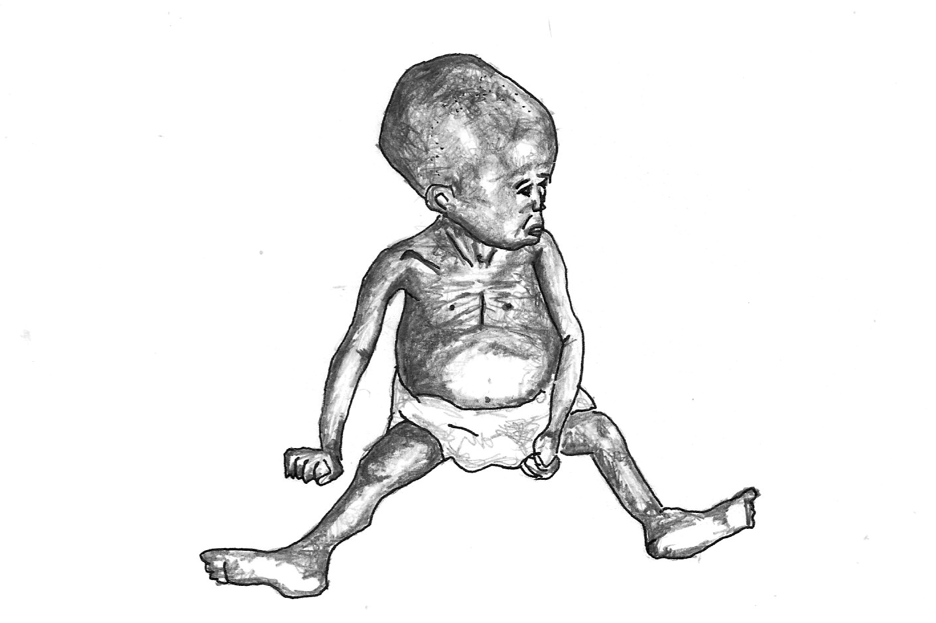

(Illustration : Sarah Allderman, 2012)

2.5 The UNICEF Conceptual Framework for Malnutrition
According to UNICEF, ‘there are multiple causes of malnutrition. It is not a simple problem with a single, simple solution. Multiple and interrelated determinants are involved in why it develops, and a similarly intricate series of approaches, multifaceted and multisectoral are needed to deal with it’ (UNICEF/WHO Joint Committee, 1989).

To assist in this process, UNICEF developed a Strategy for Improved Nutrition of Children and Women in Developing Countries with two key features: ‘… a method for assessment, analysis and action related to nutrition (Triple A Cycle) and a conceptual framework to guide the analysis of the causes of malnutrition in a given context’ (Pelletier, 2002: 2).

The UNICEF Conceptual Framework (See Fig 2 below), developed in 1990, remains a useful tool that systematically groups these factors. It is based on collective experience of working in nutrition programmes globally.
‘In the framework malnutrition and child death are viewed as two of the manifestations of a multisectoral development problem that can be analyzed in terms of the immediate, underlying and basic causes. The immediate causes are inadequate dietary intake and infectious disease; the underlying causes are household food insecurity, inadequate maternal and child care and inadequate health services and health environment; the basic causes include formal and non-formal institutions, political and ideological superstructure, economic structure and potential resources. Although more refined versions of this framework have since been developed, (e.g. adding female education just below the underlying causes and distinguishing human, economic and organizational resources), all of them contain the basic elements shown in the figure below’ [Pelletier, 2002. Available: http://www.tulane.edu/~internut/publications/WB_Bckgrd_Pprs/Narrative/NarrativeonePelletierfinal.doc].
This framework can be applied in different cultural, geographic and economic situations, and in each application, the particular causes of malnutrition will be local and specific which is where its strength lies. However, as with any tool, it is only as useful as the user allows it to be. The more specific you are about identifying the causes, the more useful it is in informing subsequent strategies to improve the nutritional status of the focus community (Swart et al, 2005).

What this framework also provides is a challenge to the way in which ‘… different observers tend to focus on different causes. Which causes capture our attention, and which we tend to overlook, depends to a large extent on our own social background and world view. [However, it is important to remember that] … the way we define the causes of human ills often determines the solutions we seek’ (Werner & Sanders, 1997: 12).
‘The framework shows that causes of malnutrition are multisectoral, embracing food, health and caring practices. They are also classified as immediate, underlying, and basic, whereby factors at one level influence other levels. The framework is used at national, district and local levels to help plan effective actions to improve nutrition. It serves as a guide in assessing and analysing the causes of the nutrition problem and helps in identifying the most appropriate mixture of actions’ (UNICEF, 1998).
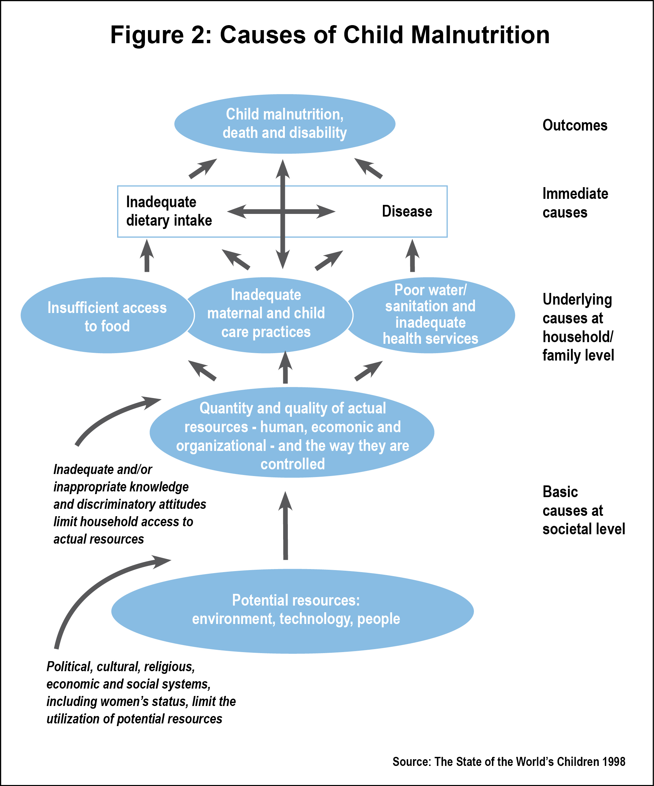
Fig 2: UNICEF. (1998). Causes of Malnutrition. The State of the World’s Children, 1998. [Online], Available: http://www.unicef.org/sowc98/ [Downloaded: 23.9.11]
After assessing the problem and analysing its causes, “Action”, the third stage of the Triple A Cycle can be more strategically and effectively planned.

‘The Triple A Cycle of assessing a problem, analyzing its causes and taking action based on this analysis can be used at all levels of society to create processes whereby people's right to good nutrition is fulfilled’ (UNICEF, 1998).

You will find information about the Triple A Cycle in Pelletier, D. L. (2002). Toward a Common Understanding of Malnutrition: Assessing the Contributions of the UNICEF Framework. World Bank/UNICEF. [Online], Available: http://www.tulane.edu/~internut/publications/WB_Bckgrd_Pprs/Narrative/
NarrativeonePelletierfinal.doc [Downloaded 20.1010]

Chopra, M. & McCoy, D. (2000). How to Conduct a Rapid Nutrition Situation Assessment, A Guide for Health Districts and Sub-districts in South Africa. Durban: Health Systems Trust. [Online], Available: http://www.hst.org.za/publications/396 [Downloaded: 20.10.10]

2.6 Linking the UNICEF Conceptual Framework with the Concept of Social Determinants of Health
The WHO defines the Social Determinants of Health as
‘… the conditions in which people are born, grow, live, work and age, including the health system. These circumstances are shaped by the distribution of money, power and resources at global, national and local levels, which are themselves influenced by policy choices. The social determinants of health are mostly responsible for health inequities - the unfair and avoidable differences in health status seen within and between countries …’ [WHO, 2008a. Available: http://www.who.int/social_determinants/en/]

The Basic Causes of malnutrition in the UNICEF Conceptual Framework are at the same level of influence as the Social Determinants of Health. Although there has been reluctance amongst governments to acknowledge the importance of the Social Determinants of Health in past decades, this perspective on health was given due importance starting March 2005, when former Director-General of WHO Dr J W Lee set up the Commission on Social Determinants of Health (CSDH). After almost three years, the Commission put forward the following recommendations to tackle the ‘corrosive effects of inequality of life chances’:

- ‘Improve daily living conditions, including the circumstances in which people are born, grow, live, work and age
- Tackle the inequitable distribution of power, money and resources – the structural drivers of those conditions – globally, nationally and locally
- Measure and understand the problem and assess the impact of action’.

To read more about the recommendations, download the Executive Summary of the CSDH from the web [WHO, 2008b. Available: http://www.who.int/mediacentre/news/releases/2008/pr29/en/index.html].

2.7 Student Learning Activity 2
Your task is to identify the causes of Thembi’s malnutrition using the UNICEF Conceptual Framework. In section 3 you will find selected contextual information about the setting or locale in which Thembi and her grandmother live. Using the background information and any additional information you can find about their context, answer these questions:

- What could be the immediate cause/s of Thembi’s malnutrition? What strategies and related resources are needed to address this problem, and who controls these resources?
- What could be the underlying cause/s of Thembi’s malnutrition? What strategies and related resources are needed to address this problem, and who controls these resources?
- What could be the basic cause/s of Thembi’s malnutrition? What strategies and related resources are needed to address this problem, and who controls these resources?
- Why is it important for health professionals and planners to investigate these different levels of cause in order to address malnutrition?
- What value does the UNICEF Conceptual Framework have for you as a Public Health practitioner? [See Pelletier, 2002. Available: http://www.tulane.edu/~internut/publications/WB_Bckgrd_Pprs/Narrative/NarrativeonePelletierfinal.doc].

You will find a blank UNICEF Conceptual Framework diagram over the page (Fig 3).

Three levels of interrelated causes | Causes | In each case, identify what resources are needed to address this problem and clarify who controls the resources
Immediate causes of Thembi’s situation
Underlying causes of Thembi’s situation
Basic causes of Thembi’s situation

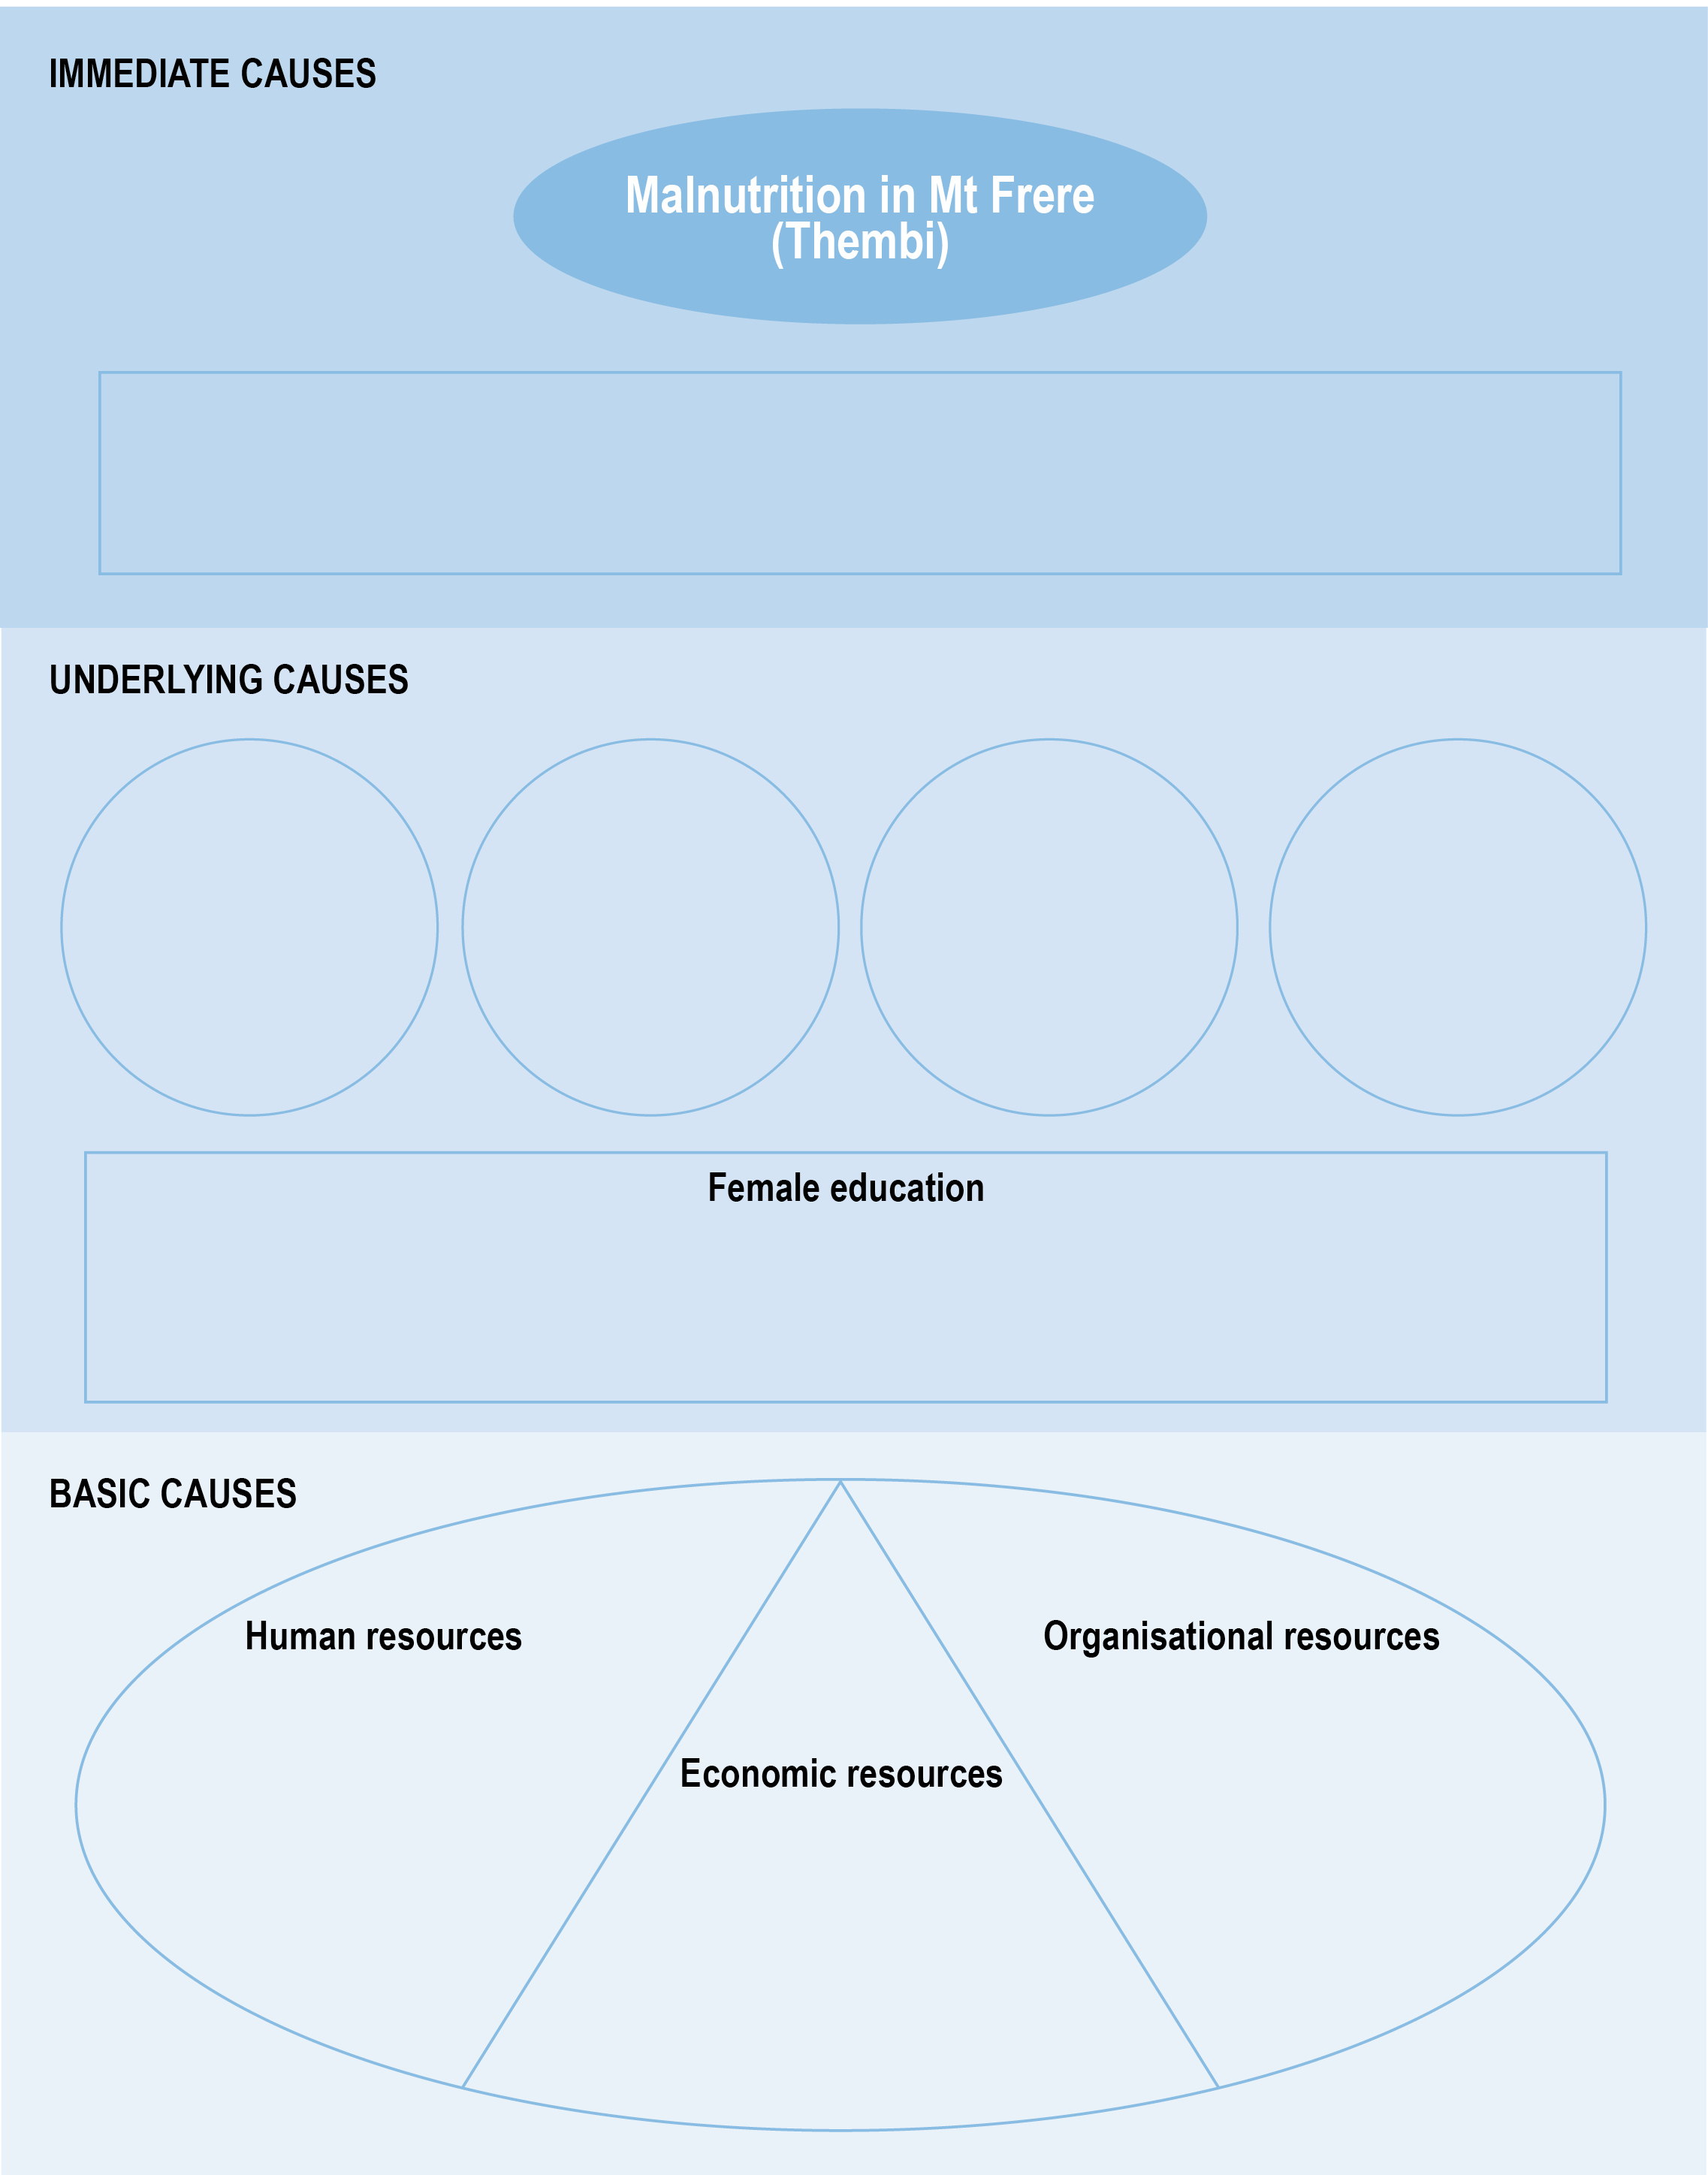
Fig 3: UNICEF. (1998). Causes of Malnutrition. The State of the World’s Children, 1998. [Online], Available: http://www.unicef.org/sowc98/ [Downloaded: 23.9.11]

 Related Resource
Once this activity has been completed, you may wish to listen to the accompanying podcast – Causal Factors of Thembi’s Malnutrition - in which Emeritus Professor David Sanders, a paediatrician and public health research scholar is interviewed by Nikki Schaay of the SOPH, UWC - and explores the causes of under-nutrition using the UNICEF Conceptual Framework to guide the analysis (2011).

SECTION 3 - Setting Description for Case Analysis

3.1 The Eastern Cape, South Africa
South Africa is divided into 11 provinces, one of the poorest being the Eastern Cape Province (EC): it has the third largest population in South Africa with a high percentage of the population living in rural areas. In 2010, it constituted 13,5% or 6 743 800 of South Africa’s population of 49 991 300 (Statistics SA, 2010). Rural areas in South Africa are home to 70% of the country’s poorest households [Statistics SA, 2010. Available: http://www.statssa.gov.za/publications/P0302/P03022010.pdf].

The Eastern Cape has a varied geography and climate, being mostly dry in the west, with scarce rainfall during winter and very hot summers. Further east, rainfall is more plentiful and the humidity increases so that it is subtropical along the coast. The interior is cold in winter and has heavy snowfalls in the mountainous regions.

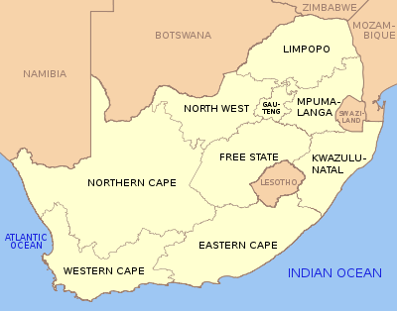
Map 1: Map of the Provinces of South Africa. Source: Wikipedia [Online] Available: http://en.wikipedia.org/wiki/Provinces_of_South_Africa [Downloaded 8/4/10]

The Eastern Cape is divided into six district councils and one metropolitan municipality, called Nelson Mandela Metropolitan Municipality. There are 39 local municipalities and six health districts. The majority of the population in the district are black Xhosa-speakers with 63% living in rural villages and homesteads (Statistics South Africa, 1999) [Available: http://www.statssa.gov.za/census01/Census96/HTML/].

3.2 Prevalence of Malnutrition in South Africa
The prevalence of under-nutrition is highest in rural areas, particularly on commercial farms and in informal (urban and peri-urban shack) settlements. The table below shows the percentage of children by province in South Africa who displayed symptoms of severe malnutrition between 1994 and 2005. In 2005 in the Eastern Cape, 18% of children showed stunting; 14% were underweight; 3% were wasting; and 6% were overweight. In total, 41% of children in the Eastern Cape displayed symptoms of under-nutrition.

Fig 4: Labadarios, D. et al. (1999). The National Food Consumption Survey (NFCS): Children aged 1-9 years, South Africa, 1999. [Online], Available: http://www.sahealthinfo.org/nutrition/vitamina.htm [Downloaded: 25.10.10].

HIV contributes to an increased prevalence and severity of under-nutrition and micronutrient deficiency in children. More than 50% of children with HIV-infection become stunted or underweight; and at least 1 in 5 develop wasting (HST, 2007). The resultant under-nutrition completes a vicious cycle linking poverty and inequality, food insecurity, under-nutrition, and HIV infection.

3.3 Background Information about Mount Frere
Mount Frere is in the northeast region of the Eastern Cape, and is part of the Alfred Nzo District – one of the poorest areas in the province. This district is based in the former Transkei (an apartheid-era homeland) and is one of the most under-resourced regions in South Africa. ‘Of the former homelands, the Transkei is said to have the highest poverty rate in the country’ (HST, 1997: 5).

The term ‘homeland’ refers to regions of South Africa set aside by the apartheid government for what they termed ‘separate development’ as self-governing states with compliant leadership. These areas were often agriculturally compromised and remained under-resourced and under-developed, contributing to current poverty levels.

The area is typical of many rural areas in South Africa: the terrain is rugged and the road infrastructure consists of poor gravel roads which are almost inaccessible in the rainy season. The climate is suitable for keeping livestock and growing subsistence crops of maize and vegetables. Over-grazing and soil erosion are widespread.

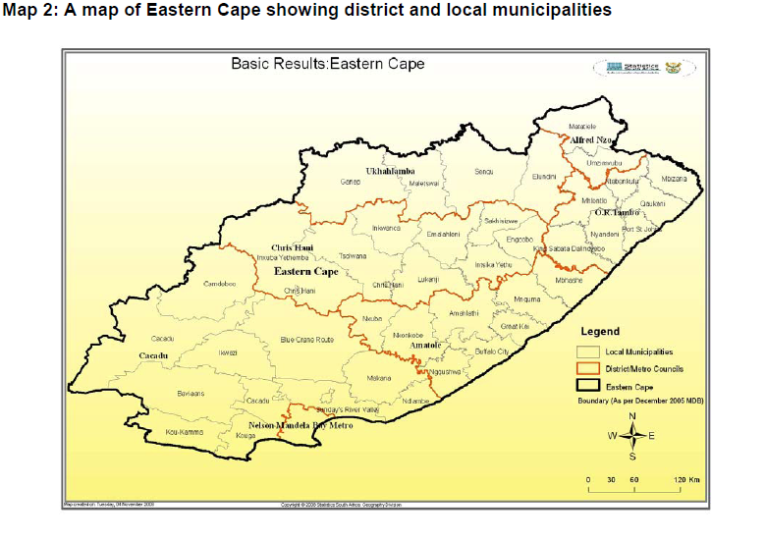

Source: Statistics SA. [Online], Available: http://www.statssa.gov.za/publications/Report-03-01-32/Report-03-01-322007.pdf [Downloaded: 20.10.11].

Like many other rural households in the Eastern Cape, those in Mount Frere experience widespread deprivation including poor access to basic services such as reticulated water, electricity and piped sewage.

Table 1. The percentage of households that had access to various services in the Alfred Nzo District in 2007 [Statistics SA, 2009. Available: http://www.statssa.gov.za/PublicationsHTML/Report-03-01-322007/html/Report-03-01-322007.html].
SERVICES | Percentage of households in the Alfred Nzo District Municipality that had access to services in 2007
Access to water | - 67% of households had access to piped water  - 4.3% had piped water inside their dwellings  - 12,4% had piped water inside the yard  - 50,3% had piped water from an access point outside the yard
Source of energy for lighting, cooking and heating | - 10,1% of households in the district use electricity
Toilet facilities | - 68,9% of households in the district use a pit latrine  - 1,6% use a bucket toilet  - 17,9% have no toilet facilities provided by the municipality
Refuse removal | - 8, 7% of households in the district have refuse removal by local authority or a private company  - 7,7% have no refuse removal

3.4 Livelihoods and Unemployment
Sheep and some cattle farming are important in this area, but livelihoods in the district are derived predominantly from subsistence agriculture, migrant labour and social security grants (pension, disability and child grants). Unemployment rates are high which can be expected to have a serious impact on health. According to the 1995 October Household Survey there was
41, 4% unemployment amongst the economically active age group (15-64 years) in the Mount Frere district [Statistics SA, 1995. Available: http://www.datafirst.uct.ac.za/wiki/images/5/58/OHS_1995_Release.pdf].

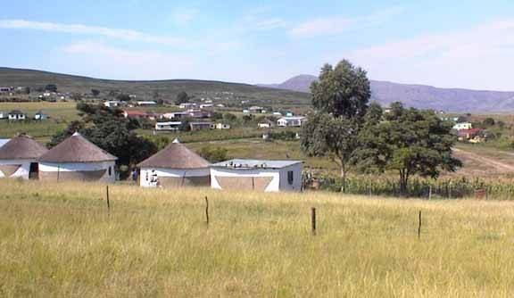
Homestead with maize crop in the Mt Frere district (Photo: SOPH, UWC)

3.5 Eastern Cape Province Demographic and Health Information
The population experiences high levels of socio-economic deprivation.
- A high proportion of the population (44% in 1997) was estimated to be under 15 years of age, the Eastern Cape being one of three provinces having higher proportions of this age group than the other provinces.
- Because economic opportunities were limited, many men had engaged in migrant work elsewhere in South Africa, and the population of females exceeded males by 24% (HST, 1997).
- In 1996, 42% of the population had some primary schooling or no schooling at all and less than 5% had completed higher education (Statistics South Africa, 1996).
- In 1996, 49% of the economically active population was employed but 31% earned R500 or less per month (Statistics South Africa, 1996).
- About 31% of the population was living in two rooms or less (Statistics South Africa, 1996); 8% of households were living in informal dwellings (HST, 2009).
- The Eastern Cape also had a very high percentage of households (30%) without any toilet facilities. The population thus stands out as being particularly vulnerable to diarrhoea and other infectious diseases through inadequate provision of water and sanitation (HST, 2004).
- 67% of households had access to piped water with inequities in access within the province (HST, 2009).
- 40% of households had their refuse removed by local authority/private company (HST, 2009).
- Only half of households use electricity for cooking (HST, 2009); 65, 9% of households had access to electricity for lighting (HST, 2009).
In 2007/8, the district health survey showed the following in this district:
- Only 67.3.2% of births occurred in health facilities.
- Immunization coverage for <1 year was 100%.
- HIV prevalence amongst ANC clients tested was 20.3%.

Further Resources
For further information on the health status of the population in the Eastern Cape Province and Alfred Nzo district in particular, you are directed to:

HST (Health Systems Trust) with Day, C. (ed)., Barron, P., Monticelli, F. & Sello, E. [eds]. (2009). District Health Barometer 2007/08. Health Systems Trust. [Online], Available:
http://www.hst.org.za/uploads/files/dhb0708_secB_ec.pdf. [Downloaded: 20.7.09].

Bradshaw, D., Bourne, D. & Nannan, N. (Dec 2003). What are the leading causes of death among South African children? MRC Bulletin, 3. Cape Town: Burden of Disease Research Unit, Medical Research Council, [Online], Available: http://www.mrc.ac.za/bod/bod.htm [Downloaded: 20.10.10].

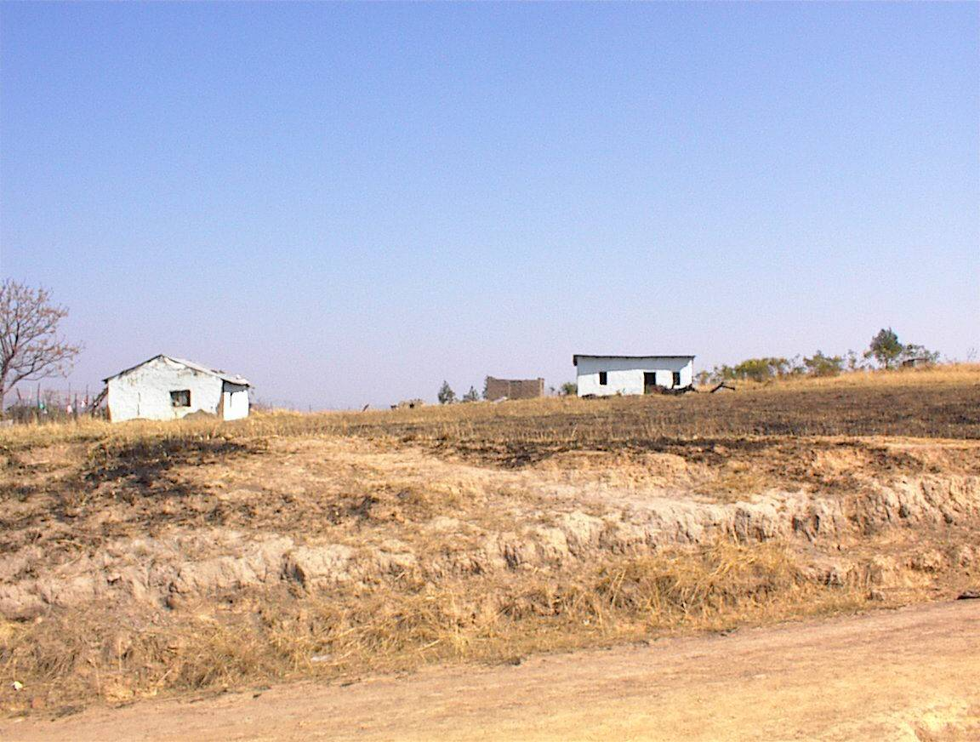
Heavy rains and overgrazing result in soil erosion and degradation of land (Photo: SOPH, UWC)

3.6 Social Security Grants
In South Africa, the two types of social grants that are most common are Child Support Grants and Old Age Pensions. These grants account for almost 40% of grant recipients each in South Africa (Die Burger, 2009).
‘The Child Support Grant is money paid by the government to the primary caregiver of a child to provide for his or her basic needs. The child and primary caregiver must be a South African citizen and reside permanently in the country. The child or children must be under the age of 14 years. The person who receives the money on behalf of the child must meet the means test requirement. A means test is the test used by government to measure the financial status of the person. In order to receive the grant, the applicant’s financial income should be below a certain level. A person can pass the test if he/she lives: in a rural area and earns less than R1 100 per month or R13 200 per year; an urban area in an informal house or a shack earning less than R1 100 per month or R13 200 per year; or an urban area in a house or flat and earns less than R800 a month or R9 600 per year. The person may not apply for support for more than six children of whom he or she is not the biological parent’ (Statistics SA, 2009).

The table below shows the monthly amount of the different social security grants in South Africa in 2010.

Fig 5: Monthly Amount of Each Security Grant, South Africa [The Black Sash. (2010). Social Assistance: A Reference Guide for Paralegals. [Online], Available: www.blacksash.org.za [Downloaded: 2/4/10]

Each grantee is subject to a means test:
- In the case of grants for children, the test includes the income of the biological parent or primary caregiver, the income of their partner or spouse, and in the case of the Child Support Grant, the income of the dependent child.
- In the case of grants for adults, both income and assets of the beneficiary – and their partner or spouse and/or dependent children, are tested.

To apply for a child grant, the adult needs:
- Proof of earnings/income.
- A 13-digit bar coded birth certificate for the child.
- A 13-digit bar coded South African identity document.
- A marriage certificate or proof of customary marriage. If no longer married, a copy of the divorce order, annulment or death certificate.
- A death certificate, if the parents of the child are dead.
- If the child’s parents are alive, an affidavit to say that the adult has permission to look after the child.

Barriers to accessing the Child Support Grant:
- No identity documents
- No birth certificates and difficulties in applying for the birth certificate
- Unable to pay for transport to get to the relevant government offices.

3.7 Student Learning Activity 3
Select a district in your own work area where there is childhood malnutrition.
- Brainstorm the immediate, underlying and basic causes of malnutrition in this district; be as detailed as possible. It may be interesting to compare these causes with your list of causes in the Mt Frere District.
- In South Africa, the following health and nutrition policies have been put in place to provide a safety net for children like Thembi: the Child Support Grant, the Integrated Nutrition Programme (2000) and the Infant and Young Child Feeding Policy (2008). As you have seen, the Child Support Grant is a good policy, but there are still problems in its practice. Find out which child nutrition policies have been developed in your own country. Take one example and analyse what “level of cause” (UNICEF Conceptual Framework levels) it seeks to address.
- Imagine you are the Nutrition Programme Manager for your district. Select one cause from each level (immediate, Underlying and Basic) and develop realistic strategies which could address these causes in your own context. In each case, list the challenges which may affect this strategy.

Three levels of interrelated causes | Causes | Policies that seek to address this cause | Challenges that may affect implementation of this policy | Strategies to address these causes
Immediate causes of Child X’s situation
Underlying causes of Child X’s situation
Basic causes of Child X’s situation

Reference List and Additional Readings
Ashworth, A., Chopra, M., McCoy, D., Sanders, D., Jackson, D., Karaolis, N., Sogaula, N. & Schofield, C. (2004). WHO Guidelines for Management of Severe Malnutrition in Rural South African Hospitals: Effect on Case Fatality and the Influences of Operational Factors. Lancet, 363:1110-1115.

Ashworth, A., Schofield, C., Puoane, T. & Sanders, D. (2001). Improving the Management of Severe Malnutrition: A Guide For Trainers. [Online], Available: http://www.foodsecuritynetwork.org/resources/food_security/health/improving_the_management_of_severe_malnutrition.pdf. [Downloaded: 27.10.10].

Ashworth, A. & Schofield. (2003). Improving the Management of Severe Malnutrition. Oxford: Macmillan Publishers/AED.

The Black Sash. (2010). Social Assistance: A Reference Guide for Paralegals [Online], Available: www.blacksash.org.za [Downloaded: 2/4/10].

Bradshaw, D., Bourne, D. & Nannan, N. (Dec 2003). What are the leading causes of death among South African children? MRC Bulletin, 3. Cape Town: Burden of Disease Research Unit, Medical Research Council, [Online], Available: http://www.mrc.ac.za/bod/bod.htm [Downloaded: 20.10.10].

Burger, D. (ed). South Africa Yearbook 2008/09. Pretoria: SA Government Communication and Information System. [Online], Available: http://www.gcis.gov.za/resource_centre/sa_info/yearbook/2008-09.htm [Downloaded 11 8 10]. Statistics SA

Department of Health (DOH), South Africa. (2000). Integrated Nutrition Programme in The Primary Health Care Package for South Africa - a Set of Norms and Standards. [Online], Available: http://www.doh.gov.za/docs/policy/norms/part2c.html. [Downloaded: 25.10.10].

Department of Health (DOH), South Africa. (2008). Infant and Young Child Feeding Policy. [Online], Available: http://www.doh.gov.za/docs/index.html [Downloaded: 25.10.10].

de Onis, M. & Blössner, M. (2003). The WHO Global Database on Child Growth and Malnutrition: Methodology and Applications. International Journal of Epidemiology, 32: 518-526.

De Onis, M., Blössner, M., Borghi, E. et al. (2004). Estimates of Global Prevalence of Childhood Underweight in 1990 and 2015. The Journal of the American Medical Association (JAMA). 291(21): 2600-2606 (doi:10.1001/jama.291.21.2600) [Online], Available: http://jama.ama-assn.org/cgi/content/full/291/21/2600. [Downloaded: 25 10.10].

HST (Health Systems Trust). (2004). South African Health Review 2003/04. [Online], Available: http://www.hst.org.za/generic/29 [Downloaded 12/3/10].

HST (Health Systems Trust) with Day, C. (ed)., Barron, P., Monticelli, F. & Sello, E. [eds]. (2009). District Health Barometer 2007/08: Health Systems Trust. [Online], Available: http://www.hst.org.za/uploads/files/dhb0708_secB_ec.pdf. [Downloaded: 20.7.09].

Irlam, J. & McCoy, D. (1998). Community Research as a Springboard for District Action. A Household Survey of Maternal and Child Health in Mount Frere Health District. Initiative For Sub-District Support Technical Report No. 7. Durban: Health Systems Trust. [Online], Available: http://www.hst.org.za [Accessed 12.8.09].

Kavishe, F. P. & Mushi, S. S. (1993). Nutrition Relevant Actions in Tanzania. United Nations. [Online], Available: http://www.unsystem.org/SCN/archives/tanzania/begin.htm#Contents [Downloaded: 20.10.10].

Labadarios, D. et al. (1999). The National Food Consumption Survey (NFCS): Children aged 1-9 years, South Africa, 1999. [Online], Available: http://www.sahealthinfo.org/nutrition/vitamina.htm [Downloaded: 25.10.10].

Mekonnen, A., Jones, N. & Tefera, B. (2005). Tackling Child Malnutrition in Ethiopia: Do the Sustainable Development Poverty Reduction Programme’s Underlying Policy Assumptions Reflect Local Realities? Working Paper No 19. Young Lives: An International Study of Childhood Poverty. Save the Children, UK. [Online], Available: http://www.younglives.org.uk [Downloaded: 28.10.10].

Pelletier, D. L. (2002). Toward a Common Understanding of Malnutrition: Assessing the Contributions of the UNICEF Framework. World Bank/UNICEF. [Online], Available: http://www.tulane.edu/~internut/publications/WB_Bckgrd_Pprs/Narrative/NarrativeonePelletierfinal.doc [Downloaded 20.1010].

Sanders, D., Reynolds, L., Westwood, T., Eley, B., Kroon, M., Zar, H. & Davies, M. with Nongena, P. & van Heerden, T. (2007). Decreasing the Burden of Childhood Disease Final Report. DoH Western Cape: Western Cape Childhood Diseases Workgroup. [Online], Available: http://www.capegateway.gov.za/Text/2007/6/cd_volume_7_childhood_diseases_overview.pdf [Downloaded: 20.10.10].

Schofield, E.C. & Ashworth, A. (1996). Why have mortality rates for severe malnutrition remained so high? Bulletin of the World Health Organisation, 74: 26-51.

Statistics SA. (1995). October Household Survey. 1995. P0317. [Online], Available: http://www.datafirst.uct.ac.za/wiki/images/5/58/OHS_1995_Release.pdf Statistics SA. [Downloaded: 25.10.10].

Statistics SA. (1999). Population Census, 1996: Census in Brief. Third edition. [Online], Available: http://www.statssa.gov.za/census01/Census96/HTML/ [Downloaded: 20.10.10].

Statistics SA. (2007). Community Survey - Eastern Cape, Statistics South Africa. Statistics SA, Community Survey. (Revised version). [Online], Available: http://www.statssa.gov.za/publications/P0301/P0301.pdf [Downloaded: 14/4/10].

Statistics SA. (2009). Community Survey 2007: Basic Results – Eastern Cape. Report No. 03-01-32. Pretoria: Statistics South Africa. [Online], Available: http://www.statssa.gov.za/PublicationsHTML/Report-03-01-322007/html/Report-03-01-322007.html [Downloaded: 20.10.10].

Statistics SA. (2010). Statistical Release P0302 Mid-year population estimates. [Online], Available: http://www.statssa.gov.za/publications/P0302/P03022010.pdf [Downloaded 20.10.10].

Swart, R., Sanders, D. & McLachlan, M. (2008). Chapter 9: Nutrition: A Primary Health Care Perspective. South African Health Review, 2008. Durban: Health Systems Trust: 129-147.

Swart, R., Chopra, M., Sanders, D., Gachuhi, D. & Alexander, L. (2005). Public Health Nutrition: Policy and Programming. Module Guide. Cape Town: School of Public Health, University of the Western Cape.

UNICEF/WHO Joint Committee. (1989). WHO/UNICEF Strategy for Improved Nutrition of Mothers and Children in the Developing World, 27th Session. Geneva: UNICEF/WHO Joint Committee on Health Policy.

UNICEF. (1990). Strategy for Improved Nutrition of Children and Women in Developing Countries. New York: UNICEF, [Online], Available: http://www.ceecis.org/iodine/01_global/01_pl/01_01_other_1992_unicef.pdf [Downloaded: 20.10.10].

UNICEF. (1998). The State of the World’s Children 1998. New York: UNICEF. [Online], Available: http://www.unicef.org/sowc98/mainmenu.htm [Downloaded: 20.10.10].

United Nations. The Official Site for the Millennium Development Goals. [Online], Available: http://mdgs.un.org/unsd/mdg/[Downloaded 8.810].

Veneman, A. M. (2009). Tracking Progress on Child and Maternal Nutrition: A Survival and Development Priority. UNICEF. [Online], Available: http://www.unicef.org/nutrition/files/Tracking_Progress_on_Child_and_Maternal_Nutrition_EN_110309.pdf [Downloaded: 20.10.10].

Werner, D & Sanders, D. (1997). Questioning the Solution: The Politics of Primary Health Care and Child Survival. Palo Alto, CA: HealthWrights.

WHO. (1999). Management of Severe Malnutrition: A Manual for Physicians and Other Senior Health Workers. [Online], Available: http://www.who.int/nutrition/publications/en/manage_severe_malnutrition_eng.pdf [Downloaded 24. 4.10].

WHO. (2000). Management of the Child with a Serious Infection or Severe Malnutrition: Guidelines for Care at the First-Referral Level in Developing Countries. Geneva: World Health Organization: 80-91. [Online], Available: http://www.who.int/child-adolescent-health/publications/referral_care/homepage.html [Accessed 12.8.09].

WHO. (2008a). The Social Determinants of Health. [Online], Available: http://www.who.int/social_determinants/en/ [Downloaded 17.12.09].

WHO. (2008b). The Commission on Social Determinants of Health. [Online], Available: http://www.who.int/mediacentre/news/releases/2008/pr29/en/index.html [Downloaded: 17.12.09].

WHO Director-General Margaret Chan. (2008). G8 urged to act on food crisis and health.WHO Bulletin, 86(7). [Online], Available: http://www.who.int/bulletin/volumes/86/7/08-020708/en/ [Downloaded: 27.3.10].

WHO & UNICEF. (2009). WHO Child Growth Standards and the Identification of Severe Acute Malnutrition in Infants and Children. A Joint Statement by the World Health Organisation and the United Nations Children’s Fund. [Online], Available: http://www.who.int/childgrowth/standards/en/ [Downloaded: 20.10.10].

