University of the Witwatersrand
Wits School of Education

Advanced Certificates in Education, 2009
Foundation Phase Professional Studies A



Let us make the difference in our Numeracy classrooms
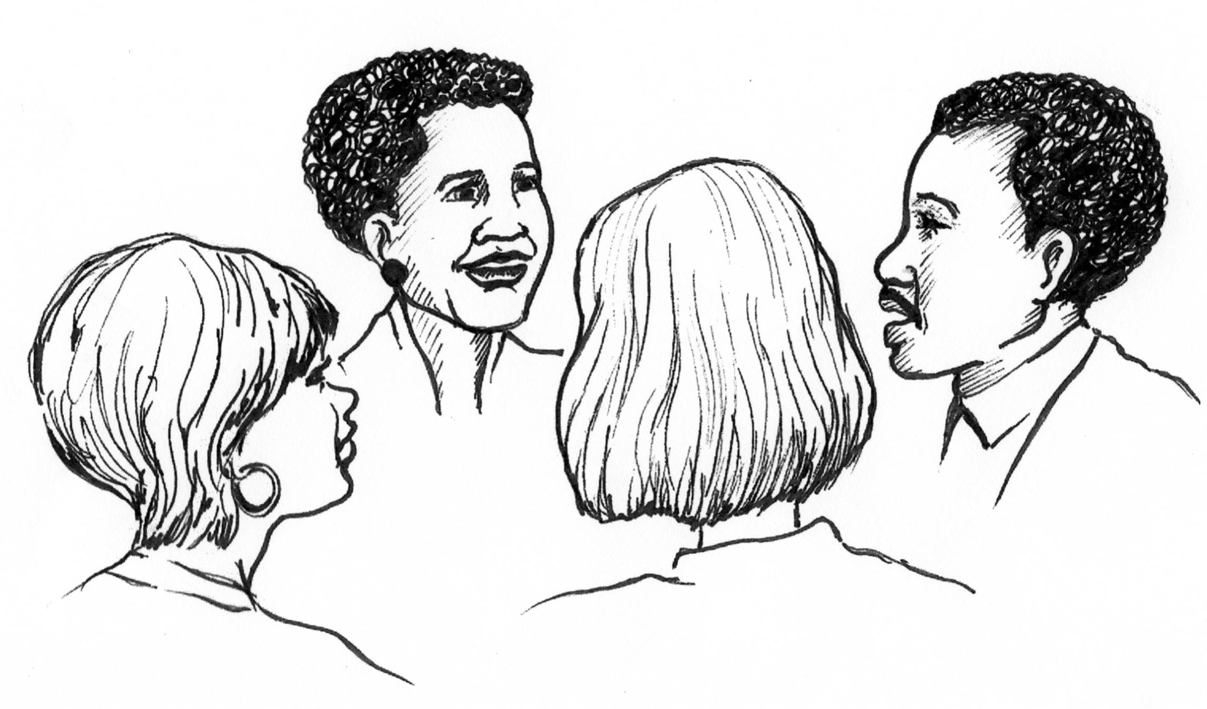

Compiled by Manono Angeline Mdluli
Reviewed by:
Dr Jean Place
Fiona Oldacre
Lucinda Pinto

Copyright 2009, Wits School of Education

What does this course involve?
This programme aims to support Foundation Phase numeracy and maths teachers to acquire a qualification, improve their teaching practice and to improve learner performance by:
- Exposing teachers to activity based teaching and learning situations that encourage active learner participation
- Enhancing teachers’ confidence and levels of motivation
- Instilling among the numeracy teachers a more positive attitude towards the teaching and learning of numeracy and mathematics
- Encouraging teachers to develop and use resources in the teaching and learning of numeracy.

This is both a theoretical and a practical course which focuses on both teacher accreditation and competence in the classroom. The programme carries 15 credits and 22 hours (11 weeks) of contact sessions. Teachers enrolled on this programme are expected to:

- Attend lectures and tutorials over a period of 11 weeks (Once for two to two and a half hours per week)
- Read background reading materials of theories of teaching and learning numeracy as required by their tutors
- Actively participate in lectures and tutorials
- Complete assignments as required
- Implement ideas learned in lectures and tutorials in their classrooms

How is the course structured?

Unit No | Unit Title | Key topics | Duration
1 | 1. Exploring what it means to do mathematics | This unit gives a historical background to mathematics education in South Africa, to outcomes-based education and to the national curriculum statement for mathematics. The traditional approach to teaching mathematics is then contrasted with an approach to teaching mathematics that focuses on ‘doing’ mathematics, and mathematics as a science of pattern and order, in which learners actively explore mathematical ideas in a conducive environment | 2 weeks
2 | 2. Developing understanding in mathematics | In this unit, the theoretical basis for teaching mathematics – constructivism – is explored. A variety of teaching strategies based on constructivist understandings of how learning best takes place are described. | 2 weeks
3 | 3.Teaching through problem solving | In this unit, the shift from the rule-based, teaching by telling approach to a problem-solving approach to mathematics teaching is explained and illustrated with numerous examples. | 2 weeks
4 | 4.Planning in the problem based classroom | In addition to outlining a step-by-step approach for a problem-based lesson, this unit looks at the role of group work and co-operative learning in the mathematics class, as well as the role of drill and practice in problem-based mathematics classes. | 2 weeks
5 | 5.Building assessment into teaching and learning | This unit explores outcomes-based assessment of mathematics in terms of five main questions – Why assess? What to assess? How to assess? How to interpret the results of assessment? and How to report on assessment? | 2 weeks

Assessment in the course
This course uses two forms of assessment: Formative and summative assessment.
Formative assessment
For this part of assessment, you need to hand in 3 assignments 5 portfolio tasks (identified below) that will be assessed in detail. However, in your Research File there are 17 other portfolio tasks. It is recommended that you try and do all these portfolio tasks as outlined in the file as these will assist you to gain a deeper understanding of the course content and to be able to apply this in your own classroom.
Summative Assessment
The summative assessment of this course comprises of a formal examination that will last for three hours. In the exam, you will be required to write 3 essays. There will be 4 questions. Question 1 will be compulsory and marked out of 100. You will be required to choose 2 questions from 3 other questions. These two questions will each be marked out of 50. Total for the exam is 200 marks.

Distribution of marks for formative and summative assessment
Assignment 1: 30%
Assignment 2: 30%
Assignment 3: 30%
Portfolio Activities: 10%
You need to at least get 50% from your year mark and 50% from the exam to pass the course.
The examination time table will be made available to you a few weeks before the commencement of exams.
Handing in of assignments and portfolio tasks
You are expected to hand in your assignments or portfolio tasks to your tutors in tutorials on or before the due date.

Applications for extensions
Applications for extensions must be made by telephone or in writing well in advance of the due date. Permission will only be granted in exceptional instances. Supporting documents such as the doctor’s certificate or death certificate must be attached to the application letter. If there are valid reasons why you were unable to request an extension before hand, it is possible to apply by phone on the due date and send the documentations afterwards. Please note that all the documentations you submit will be critically examined before an extension will be granted.
Applications for extensions can only be made to the course coordinator of the course. Your tutors do not have the authority to grant extensions.

Penalty for late submissions
If an assignment is submitted late and an extension was not granted in advance, your assignment will be marked. However, the maximum mark will be 50%. Please note that no assignment will be accepted later than 2 weeks after the submission date.
Assignment tasks
Assignment 1
Due date Week 3
Van de Walle (2004) claims that children construct their own knowledge. They are continually involved in making meaning and constructing their own understanding of the world.
With the above statement in mind, critically discuss what constructivism is all about. Use one of the lessons you have taught on basic operations to explain how children construct their own conceptual understanding of what they are taught in numeracy. In your discussion, highlight the implication of the use of constructivism in the Foundation Phase numeracy classroom with regard to the role of the teacher and the use of teaching and learning resources.

Assignment 2:
Due date week 6
According to Njisane (1992) in mathematics Education, Piaget distinguishes three types of knowledge.

2.1 In a 3 page essay format; discuss the key elements of each knowledge type.
2.2 Teaching rules and procedures before learners have developed meaning and understanding of basic operations in the Foundation Phase, results in learners making errors. Provide examples from your own classroom to show some of the errors learners have made with regards to basic operations as a result of your own teaching
2.3 Design a lesson where you will address errors learners have made relating to basic operations. In this lesson identify how each of the three knowledge types discussed above will be catered for. Hand in this lesson plan together with your essay and samples of learners work following this lesson.

Assignment 3
Due date week 9

Problem solving should be a primary goal of all mathematics teaching and should form an integral part of all mathematical activities.
Revised National Curriculum Statement for R-9 (Schools) (Department of Education – Mathematics: 2001, 16-18)
3.1 In a 3 page essay format, describe what problem solving entails. How different is problems based teaching from the traditional teaching in which teachers explain a rule, provide an example and then drill the learners on similar examples?

3.2 Develop with insight, a three part lesson for problem solving (using the concept of time). Describe in detail what you will do before, during and after the lesson. Present this lesson to your learners. Write 3 a page reflection on this lesson. Submit the lesson with the evidence of learners’ work as a result of this lesson. In your reflective essay include the following:
- A short description of what you did (activity, classroom organisation, resources you used and the assessment you conducted)
- Describe how the lesson went- what worked, what did not work
- What you might want to change if you were to do the same activity again
- What you think you need to do in your next lesson

Assessment Criteria
Form/structure 40%

- Does your essay have a clear structure?
- Is there a clear line of argument in your essay?
- Do the paragraphs have a main idea?
- Do you support your argument by drawing from your Research File?
- Are your introduction and conclusion related to the essay as a whole?

Content 60%

- Have you correctly identified and used Numeracy learning theories as used in your Research File?
- Have you related the knowledge you gained in the course to the question
- Have you discussed appropriate examples from your own teaching experience to support your argument?
- Do you have a clear position about the teaching and learning of Numeracy in the Foundation Phase and argued this clearly?

Submission of Portfolio Tasks
Portfolio | Activity | Submission
1. Exploring what it means to do mathematics | Use the verbs “order”  , “describe” and  ‘compare” as an example. Develop an activity on fractions (relevant to grade 2 or 3) that demonstrates the actions involved when learners order, describe and compare fractions.  Submit this activity | Week 3
2. Developing understanding in mathematics | Use TIME as skill that you would like learners to acquire with understanding. Develop a cognitive schema (mental picture) for the concept of time relevant to the grade you teach. As you do this, think about the following:  - Develop a network of connections between existing ideas (what Foundation Phase learners already know about the concept of time)  - What additional ideas/information do they need about time  - Draw in the connecting lines between learners’ existing ideas and the knew ideas  - Develop a series of 3 lessons (sequenced and numbered) on this concept of time  In a two page essay, discuss the importance of developing and using a conceptual schema in Numeracy  Submit your conceptual schema, 3 lessons on time as well as the essay. | Week 5
3.Teaching through problem solving | In a two page essay format, discuss the difference between problem solving and doing routine exercises. Discuss the advantages and disadvantages of using a problem based approach and traditional way of teaching Numeracy.  Use the topic of Shapes and Space in the Foundation Phase to give an example of a problem based problem and a routine problem.  Hand in both the essay and the two examples required | Week 7
4.Planning in the problem based classroom | 1. Use Data Handling as a topic and plan a lesson following the nine steps discussed in the tutorial.  2.In a 2 page essay format discuss the use of workstation activities or games and show how these fit within the definition of a problem based tasked as discussed in the Tutorial  Hand in both the lesson plan and the 2 page essay. | Week 9
5.Building assessment into teaching and learning | 1. Read the statements made by teachers on page 230 of Unit 5 in the Research File and then state which statements illustrate norm-referencing, which illustrate criterion-referencing and which illustrate self-referencing, giving reasons for your response in each case.  2. Design a formative assessment task on the concept of measurement in the Foundation Phase, a rubric on how to assess the task as well as the assessment criteria for the task.  Hand in the assessment task, and the rubric with your task 1 on types of assessment above | Week 10

Who can I contact if I find myself in difficulty?
Please consult with your course lecturer/tutor regarding any difficulties you might experience. For the ACE Foundation Phase Professional Studies contact the following people:

Dr Jean Place
Office (011) 717-3211
Manono Angeline Mdluli as follows:
Email: Manono.mdluli@wits.ac.za
Cell: 083 4837372
Office (011) 717 -3052

Unit 1: Exploring what it means to “do” mathematics

Exploring our beliefs and perceptions about mathematics and numeracy

Welcome to the first week of the course, Professional Studies. The course Coordinator and course Tutors are looking forward to working and learning with you. In this unit we will take a look at our perception about mathematics and numeracy and what mathematics and Numeracy are all about.

This section of work intends to guide and support Foundation Phase teachers on the teaching and learning of Numeracy. The Unit is informed by the Mathematics course materials developed by SAIDE Open Education Resource Project, COUNT (Cooperative Organisation for Upgrading of Numeracy Teachers) and various theories of teaching and learning.

In order for us to effectively teach Numeracy and Mathematics, we need to identify our own perceptions and attitudes towards mathematics and understand how children learn in a mathematics classroom. We also need to answer the following questions:

- What is Numeracy and mathematics in our own views?
- How do we teach Numeracy right now
- What exactly do we teach?
- What type of Numeracy teachers are we?
- What type of Numeracy teachers do we aspire to be?
- What type of learners do we want to produce at the end of the Foundation Phase?
- What is the difference between teaching and learning Numeracy in the Foundation Phase and teaching and learning Mathematics in the Intermediate Phase?
- How do we close the transition gap between Numeracy learning in the Foundation Phase and Mathematics learning in the Intermediate Phase?

The questions above are crucial for teaching and learning Numeracy in the Foundation Phase if we really want to prepare our learners to succeed in mathematics later on in life. Hence this course is designed to assist you as a Foundation Phase teacher to understand teaching and learning in your own phase and in the intermediate phase.

Week 1 and 2 Outcomes

Aim of this Unit is to engage teachers in a critical examination of their beliefs and personal theories that influence the way they teach Numeracy and mathematics in their classrooms.

After working through this Unit you will be able to do the following:
- Critically reflect on your own believes about what is mathematics and what the teaching and learning of mathematics involves
- Identify the source of our believes
- Identify dominant Numeracy and Mathematics teaching and learning behaviors
- Make a move towards making the links between theory and practice
- Describe the language used to define what it means to “Do mathematics”
- Define the type of numeracy and mathematics teachers we want to be
- Develop a numeracy activity which shows a new understanding of what “Doing Numeracy and mathematics is all about”

Week1. What is mathematics? People’s views
Most people acknowledge that mathematics is an important subject at school. However very few really understand what mathematics is about and what it means to ‘do’ mathematics. People often define mathematics as being about a collection of ‘rules’: arithmetic computations, mysterious algebraic equations or geometric proofs that need to be learnt in order to pass an examination. In general, people tend to feel that they are ‘no good at mathematics and that it is difficult’.

Activity 1:

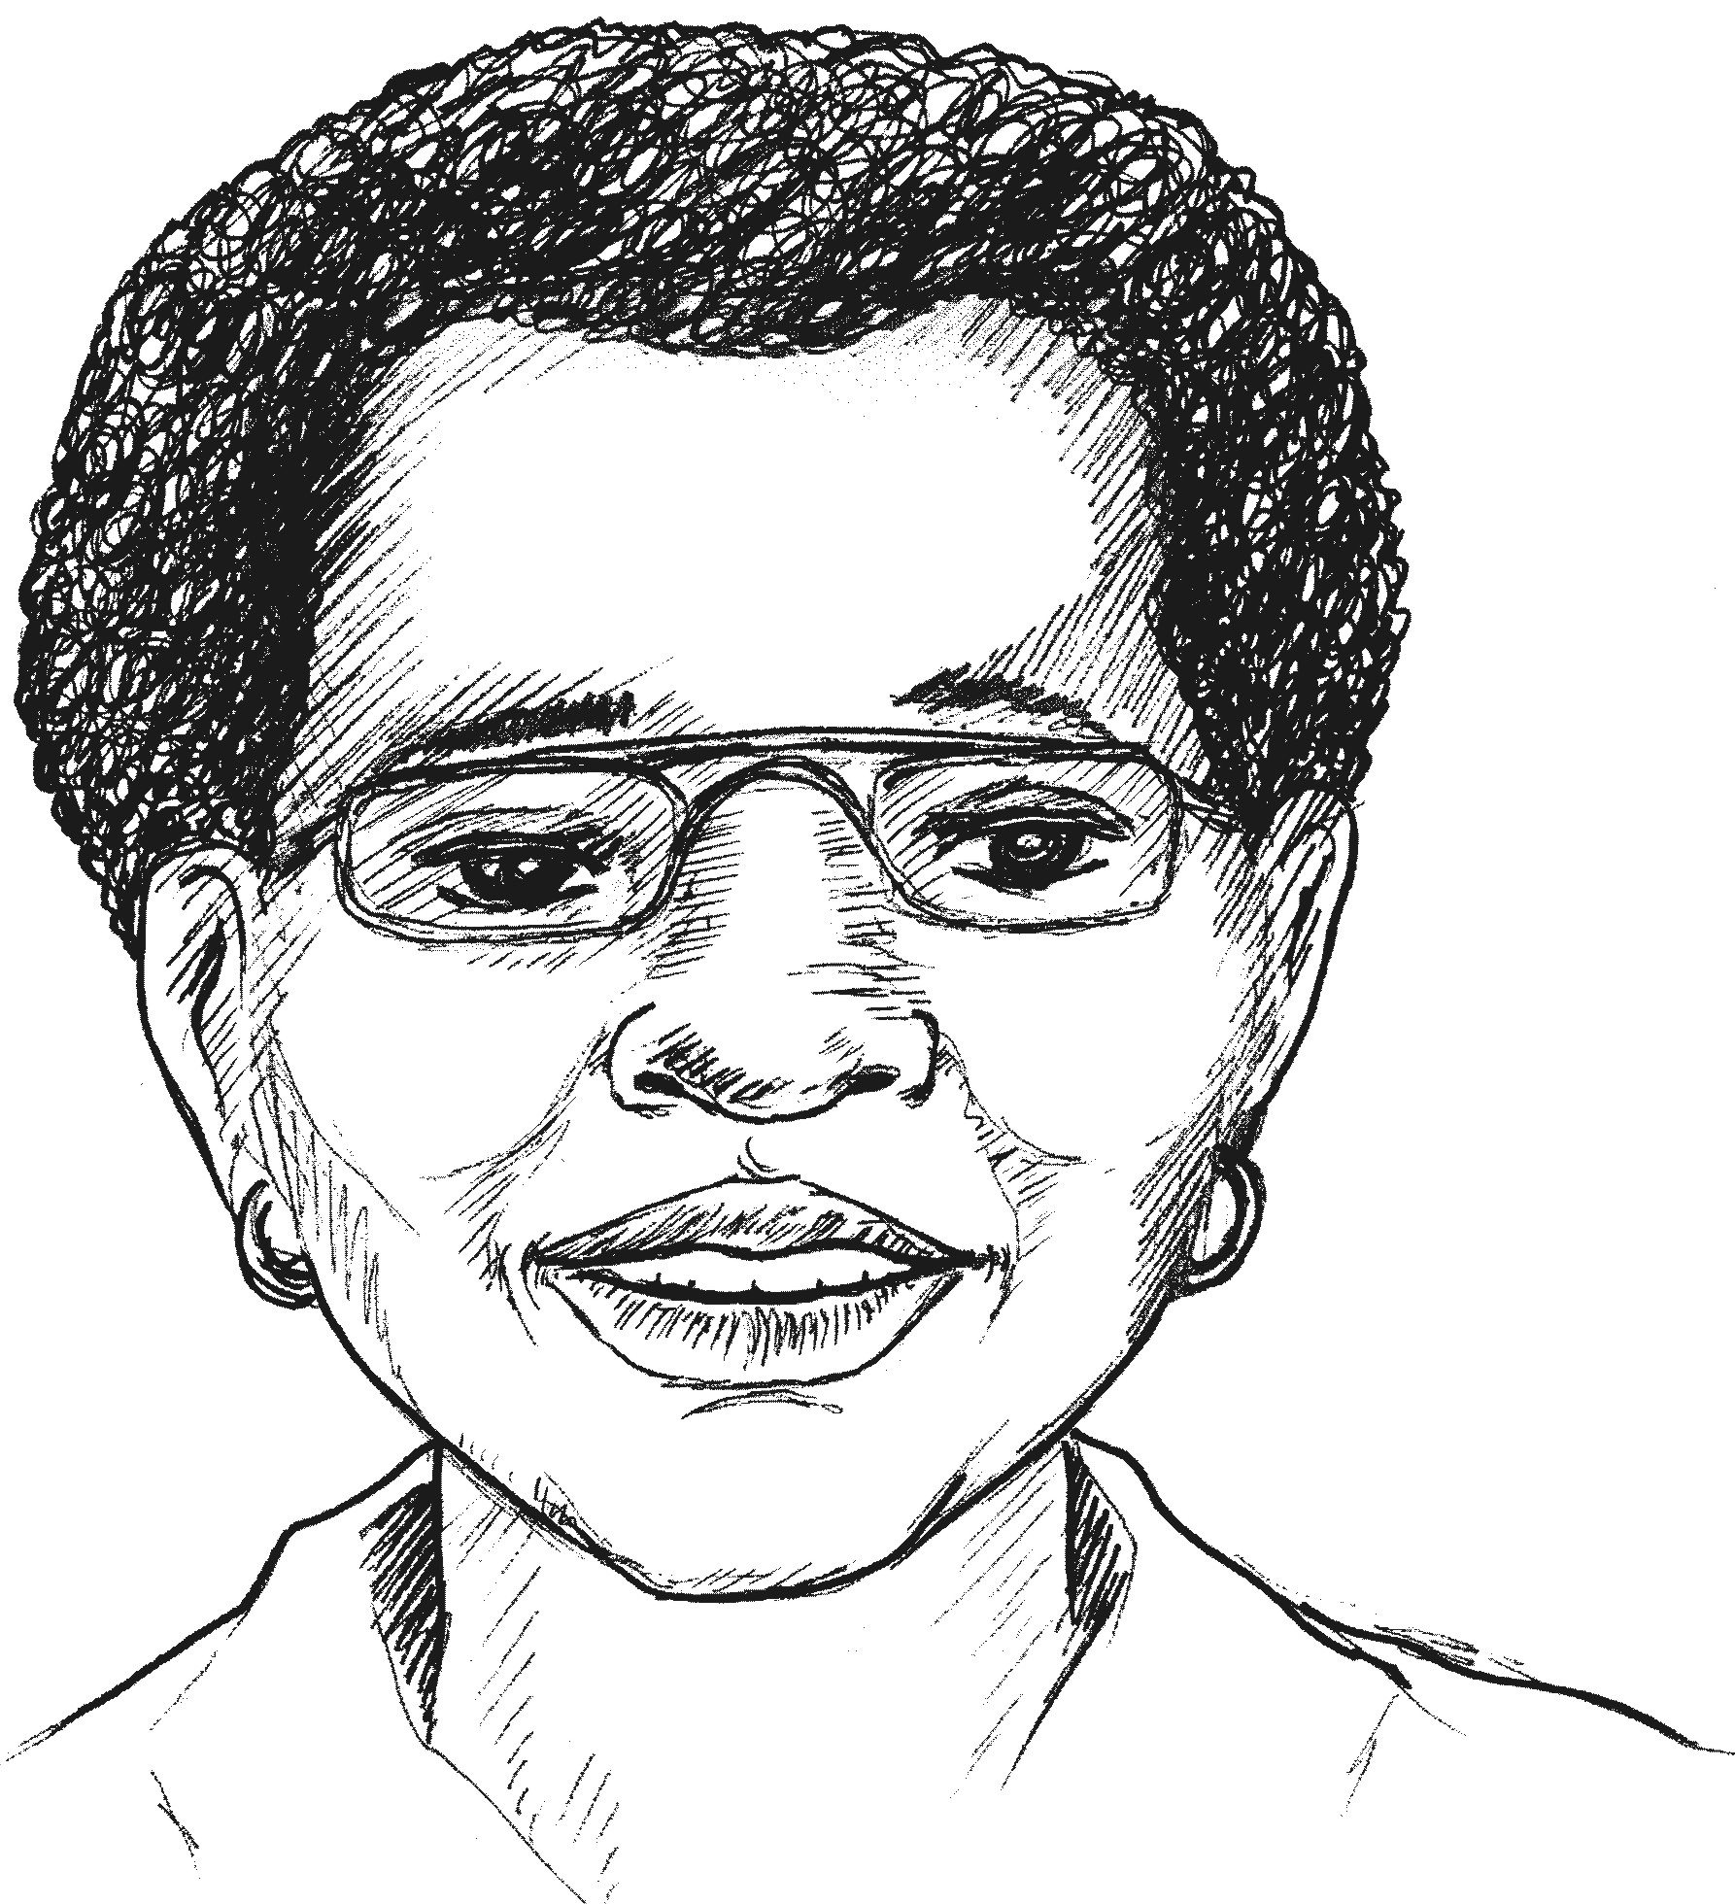

As an individual solve the following mathematical problems

- 8 ÷ ½

2. In servicing a car the attendant used 45ℓ costing petrol at R4, 25/ℓ and 2 tins of oil at R8.50 each.
What was the total cost for petrol and oil?

3. John covers ½ of a journey by car, ¹/₃ of the journey by bicycle, and walks the rest of the way.
a) What part of the journey does he cover by car and bicycle?
b) What part of the journey does he walk?

Activity 2

In your small groups of about 4 teachers per group, share your responses to the above questions

- Did you solve the problems in the same way?
- What is different and what is the same about your solutions?
- Do the different ways you used to solve the problems show any knowledge and understanding of mathematics
- What do you think motivated you to solve the problems in the way you did?

Very often the way we solve mathematical problems is influenced by our own views of what mathematics is all about.

The way in which we were taught mathematics as children also influences the way we approach and solve mathematical problems

Activity 3

Reflecting on our perceptions

Work in a small group of 4 teachers per group

In your own view, what is Numeracy and Mathematics? Write a short paragraph describing your own perceptions of Numeracy and Mathematics. Are we good mathematics teachers? What type of mathematics teachers do we want to be?

Activity 4: Tutor input

Different people have different perceptions about mathematics and Numeracy. Some people believe that:

- Mathematics requires a good memory
- Mathematics is based on memorization of facts, rules, formulas and procedures
- You have to have a special brain to do mathematics
- Mathematics is not creative
- There is a best way to do a mathematics problem
- Every mathematics problem has only one correct answer and the goal is to find THE answer
- Mathematics problems are meant to be solved as quickly as possible
- Mathematics is all symbols and no words
- Boys are better at mathematics than girls
- School mathematics is useless
- Mathematics is exact and there is no room for innovation, estimation or intuition.

What are the sources of these beliefs?

Check your own perceptions against the ones listed above. Which ones are common? What do you think is the source of this thinking? The way in which we were taught Numeracy and Mathematics contributes to the way we perceive mathematics and this influences the way we teach Numeracy and Mathematics to our learners today.

Tutor input: How does the National Curriculum Statement define Numeracy?
Numeracy is defined as the “a study of arithmetic” (Concise Oxford Dictionary, 2001). “the ability to do arithmetic” (English Language Dictionary, Collins 1987). The purpose of Numeracy as described in the Numeracy Learning Programme Statement for 1997 (Department of Education, Foundation Phase (Grades R-3) Learning Programme Document, Numeracy, Pretoria. June 1997) is to:

- Nurture continued perceptual, sensory and motor development
- Use the learner’s own innate, intuitive and experientially acquired knowledge and ability in number and space as a springboard into continued learning
- Ensure the enjoyment of the experiences provided
- Engender confidence in the young learner’s own mathematical abilities
- Encourage learners to develop their own approaches to working with number
- Enable learners to understand and appreciate relationships, logic pattern in number and space
- Build on learner’s experience of space, time and motion in their everyday lives in order to assist in structuring and interpreting it through concrete and diagrammatic representation, estimation and measurement, and
- Develop the ability to communicate mathematically, work cooperatively towards solving problems and use correct mathematical terminology and symbols

The Learning Outcomes from the Mathematics Learning Area form the backbone of the Numeracy Learning Programme and therefore, forms the basis of the teaching, learning and assessment that occurs in the Numeracy Learning Programme.

How does the new mathematics curriculum define mathematics?
The introduction to the National Curriculum Statement (NCS) for GET and FET mathematics defines mathematics based on certain characteristics of the discipline:
- Mathematics enables creative and logical reasoning about problems in the physical and social world and in the context of mathematics itself.
- It is a distinctly human activity practised by all cultures.
- Knowledge in the mathematical sciences is constructed through the establishment of descriptive, numerical and symbolic relationships.
- Mathematics is based on observing patterns which with rigorous logical thinking, leads to theories of abstract relations
- Mathematical problem solving enables us to understand the world and make use of that understanding in our daily lives.
- Mathematics is developed and contested over time through both language and symbols by social interaction and is thus open to change.

This means that mathematics:
- Is something that people create or invent. They can discuss and argue about their creation and in the process reach a shared understanding of what it is;
- Enables creative thinking;
- Enables logical thinking;
- Is based on patterns that lead to abstract ideas;
- Helps us solve problems in the real world;
- Helps us solve problems in the world of mathematics;
- Helps us better understand the world;
- Uses symbols and language to develop reasoning skills and to make meaning;
- Is always changing because the shared understanding reached may be overthrown or extended as the development of mathematics continues.

Week 2. What do we do when we do mathematics and numeracy in our classrooms?

Activity 1

Reflecting on teaching and learning of numeracy and mathematics?

Work in a small group of 4 teachers per group

As a group, discuss and write a paragraph about what we do when we do mathematics and Numeracy in our classrooms? Share your writing with a group next to your group.

Activity 2: Tutor input:

The traditional way of teaching and learning mathematics
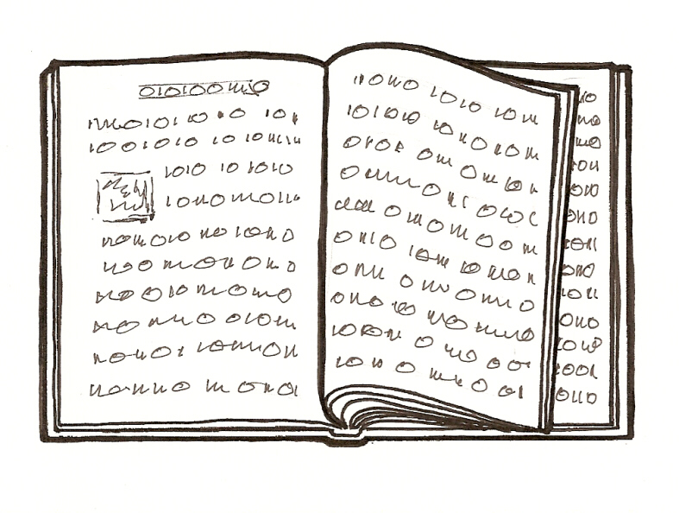

Mathematics lessons begin with the teacher telling the learners a fact, or giving them the steps in an algorithm or describing a prevalent concept (if at all possible). The teacher then works a textbook example and assigns learners to work exercises from the textbook to help them remember the fact or the process. There are no experiences through which learners discover, invent, or apply mathematics to problems they find meaningful.
This way of teaching mathematics has fostered perspective of mathematics as a collection of mysterious procedures and rules. Even with a hands-on activity, the traditional teacher is still guiding learners, telling them exactly how to use the materials in a systematically prescribed manner. The focus of the lesson is primarily on getting answers, and learners depend on the teacher to determine if their answers are correct. The learners begin to accept that every problem must have a ready and predetermined answer, and that there is only one unique way to solve a problem. This establishes a false perception that they are not expected to solve a problem unless they have been given a solution method (or procedure) ahead of time.
This follow-the-rule, computation-dominated, answer-oriented view of mathematics results in a gross distortion of what mathematics is really about. Apart from the fact that it is not very exciting, only a few learners are good at learning rules and thrive on performing procedures. These are not necessarily the best thinkers in the classroom. The traditional system rewards the learning of rules but offers little opportunity actually for learners to do mathematics.

Activity 3: Tutor input

Reflecting on the NCS Document: What is different about teaching and learning mathematics?

What verbs would you use to describe an activity in a classroom where learners are doing mathematics? Van de Wallet (2004: 13) gives a collection of verbs that can be associated with doing mathematics:

explorerepresentexplain
investigatediscoverjustify
conjecturedevelopformulate
predictsolveconstruct
justifyverifyuse
Order
Describe
Compare

Activity 3

The verbs of doing mathematics
- Reflect on the collection of ‘science verbs’ above. Do these verbs clearly indicate the type of action required of the learner during the process of mathematising?

Activity 4

Study the NCS for a grade to which you are currently teaching Numeracy.
  - Are the Assessment Standards expressed in terms of the science verbs?
  - Make a list of the verbs that you find in the Assessment Standards.
  - Do these verbs clearly indicate the type of action required of the learner during the process of mathematising?
  - Use the verb “solves” and “explains” to develop an activity relevant to grade 1, 2 or 3 that demonstrates the action involved when learners solve problems relating to equal sharing or grouping

Activity 5: Tutor input

What type of teachers do we want to be?

Given the understanding of what it mathematics is, are we teaching mathematics in a way that will assist our learners to develop meaning and understanding of concepts? What are our challenges?

Often, as teachers we do not see the link between the theories of learning and the way we teach. Our beliefs about teaching and learning also influence our practice.

What is mathematics?

What do when we “do” mathematics?

Activity 6: Tutor input

It is well known that teachers even in situations where they have particular knowledge and beliefs about the teaching and learning of Numeracy and Mathematics some still teach in ways that do not support their knowledge and beliefs. Very often acquiring new knowledge does not necessarily lead to improved teaching practice. Even if teachers really want to implement knew knowledge it is often far from easy for them to implement new ways of teaching in the classroom. In this course, we need to try to close the gap between theory and practice so that we are able to understand why learners do the things they do in the Numeracy and mathematics classrooms.

Many teachers possess weak knowledge and narrow views of mathematics and mathematics pedagogy that include understandings of mathematics as a closed set of procedures, teaching as telling, and learning as the accumulation of information (Ball, 1991; Brown, Cooney, & Jones, 1990; Even, 1993; Frykholm, 1996; Thompson, 1992; Wilson, 1994). These conceptions are bolstered by years of experience as students and teachers in traditional classrooms (Brown & Borko, 1992; Lortie, 1975; Zeichner & Gore, 1990). If change is to be effected in the mathematics classrooms, understanding of mathematics and teaching need to be challenged and developed in ways that will support sustained professional and personal development of mathematics teachers.

Unit 2: Developing understanding

Week 3 and 4 outcomes
After working through this unit you should be able to:
- Critically reflect on the constructivist approach as an approach to learning mathematics.
- Cite with understanding some examples of constructed learning as opposed to rote learning.
- Explain with insight the term 'understanding' in terms of the measure of quality and quantity of connections.
- Motivate with insight the benefits of relational understanding.
- Distinguish and explain the difference between the two types of knowledge in mathematics: conceptual knowledge and procedural knowledge.
- Critically discuss the role of models in developing understanding in mathematics (using a few examples).
- Motivate for the three related uses of models in a developmental approach to teaching.
- Describe the foundations of a developmental approach based on a constructivist view of learning.
- Evaluate the seven strategies for effective teaching based on the perspectives of this chapter.

Week 3: This section of work focuses on understanding in a numeracy and a mathematics classroom from a constructivist perspective.

Tutor input: Refer to pages 51, 53 and 54 of unit 2 in your Research File

- What is the constructivist view of learning?
- Historical background
- How different is this view from the way we currently teach in our classrooms?

Activity 1: In groups of 4 or 5 (Portfolio activity 2)

Read through the instructions carefully and then complete the task using your own experience of being a learner of mathematics. You can photocopy the page and place it in your journal.

Constructing ideas: the best approach
Read through the following approaches that a teacher may employ to help learners to construct concepts, rules or principles.
Instructing learners to memorize rules.
Explaining the rules /concepts to the learners
Repetitive drilling of facts /rules/principles
Providing opportunities to learners to give expressions to their personal constructions.
Providing a supportive environment where learners feel free to share their initiative conclusions and constructions.
Providing problem-solving approaches to enhance the learner construction of knowledge.
Providing for discovery learning which results from learner manipulating, structuring so that he or she finds new information.
Using games to learn mathematics.
Think about it for a while and then rate each approach from 1 to 4 to indicate its effectiveness in constructing meaningful ideas for the learner.

In the box next to the stated approach, write 1, 2, 3 or 4:
1 means that the approach is not effective.
2 means that the approach is partially effective.
3 means that the approach is effective.
4 means that the approach is very effective

Reflection on activity 1

- What criteria did you use in rating the above approaches?
- In each of the above approaches, consider the extend to which all learners are involved in “doing” mathematics

Activity 2: Developing a cognitive schema

Tutor input:

Explain what a cognitive schema is by referring to page 56

- What is assimilation?

- What is accommodation?

- As an example, use fractions as skill that you would like learners to acquire with understanding. As a class develop a cognitive schema (mental picture) for the concept of fractions. As you do this, think about the following:

  - Develop a network of connections between existing ideas (what Foundation Phase learners already know about fractions)
  - What additional ideas/information do they need about fractions
  - Draw in the connecting lines between learners’ existing ideas and the knew ideas
- Discuss the importance of developing and using a conceptual schema

Activity 3: Conceptual errors

As an individual, respond to questions below then discuss your thinking with your partner

Daniel, a learner in grade 3, gives the following incorrect response
$\frac{1}{2} + \frac{1}{2} = \frac{2}{4}$
- Explain the conceptual error made by the learner
- How do you think Daniel was taught to add fractions
- Think about the mental construct (or idea) that needs to be modified by the learner to overcome this misconception? (Think of the addition of whole numbers and so on.)
- Describe a useful constructive activity that Daniel could engage in to remedy the misconception.

Activity 4: What is understanding in a numeracy classroom?

156 ÷ 4
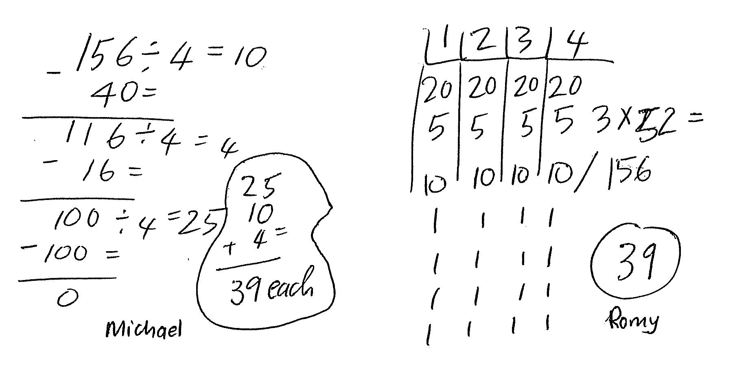

Consider the two solutions to a problem which are presented by Van de Walle (2005):

- What do you think of Michael and Romy’s solution to the problem
- Which of the two solutions do you think reflects understanding?
- What is understanding in your own view
Activity 5

Take a look at the calculation the learner made in the example below and then answer the questions that follow:
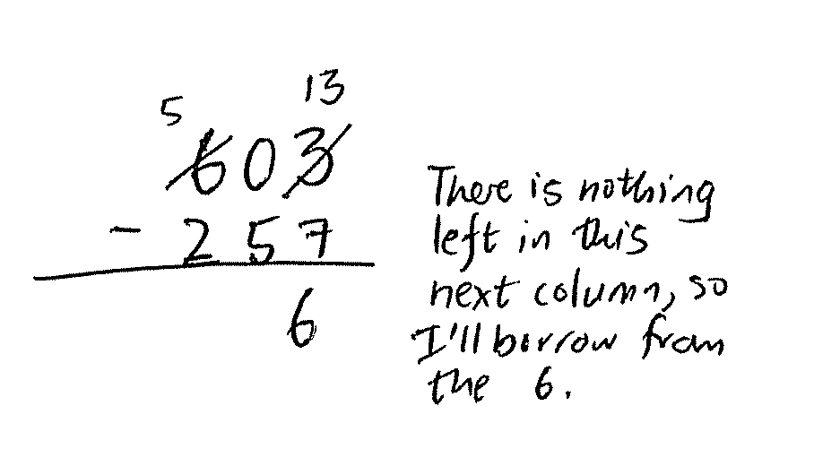

- How do you think this child was taught the concept of subtraction?
- What are the weaknesses of teaching Foundation Phase learners in this way?
- Read pages 58-59 of Unit 2 (Research File) what is your understanding of rote learning?
- What are the weaknesses of rote learning?

Activity 6: Tutor input (OHP notes required)

Read about understanding on pages 60 -72

- What is understanding?
- Two types of understanding
- 7 benefits of relational understanding

What is the constructivist view of learning?

What is rote learning?
What is understanding?

Week 4: Types of mathematical knowledge

Activity1: Tutor input (Unit 2 pages 73-83)

1. Define the following types of knowledge in detail and give examples for each:

- Social knowledge
- Physical knowledge
- Logico mathematical knowledge

- Define conceptual understanding and link this to Piaget’s logico mathematical knowledge and relational understanding
- Define the difference between primary and higher order concepts in mathematics

Activity 2: Logico mathematical knowledge

Having read about the different types of mathematical knowledge in the Research File (unit 2 pages 73-83), do you think that logico-mathematical knowledge can be transmitted from a teacher to a learner while the learner plays a passive role? Discuss your answer with your study partner. Write down your thinking on the space below

What is logico mathematical knowledge?

Activity 3: use of physical objects in learning numeracy in the Foundation phase

Do you think there are any limitations in the understanding of mathematical concepts learnt through the use of physical objects and concrete manipulative from the external world? Discuss in groups of four or five
- What are these limitations? In your answer refer to the teaching of primary and higher order concepts
- How can we as teachers overcome these limitations?
- What is the value of using physical objects and concrete manipulative when teaching numeracy? In your answer think about the development of logico mathematical knowledge
- Develop an activity on the concept of money relevant to Grade 1, 2 or 3. Describe the materials or manipulatives that you will use. As a group discuss how you will use concrete materials to support learners’ development of this concept.

Share your responses with other groups. Tutor please summarizes the main points raised in the discussion.

Activity 4: Using models and multiple interpretations in the classroom

The number 100 can mean different things to different learners.

You may talk of 100 people, 100 rand or 100 acts of kindness. Reflect on the above statement and then explain what is meant by the concept of 100. Discuss this concept of 100 with fellow colleagues. If you do not agree, establish why there is a difference of opinion in your understanding.
Activity 5: Tutor input
Seeing mathematical ideas in materials can be challenging. The material may be physical (or visual) but the idea that learners are intended to see is not in the material. The idea, according to Thompson (1994: Arithmetic Teacher) is in the way the learner understands the material and understands his or her actions with it. Let’s follow this idea through by considering the use of models in the teaching of fractions.
A common approach to teaching fractions is to have learners consider collections of objects, some of which are distinct from the rest as depicted in the following figure:
What does this collection represent?

The above collection is certainly concrete (or visual). But what does it mean to the learners?
Three circles out of five? If so, they see a part and a whole, but not a fraction.
Three-fifths of one? Perhaps. Depending on how they think of the circle and collections, they could also see three-fifths of five, five-thirds of one, or five-thirds of three.
A teacher of mathematics needs to be aware of multiple interpretations of models so as to hear the different hints that learners actually come up with. Without this awareness it is easy to presume that learners see what we intend them to see, and communication between teacher and learner can break down when learners see something different from what we presume.
Good models (or concrete materials) can be an effective aid to the learners' thinking and to successful teaching. However, effectiveness is dependent on what you are trying to achieve. To make maximum use of the learners' use of models, you as the teacher must continually direct your actions, keeping in mind the question: What do I want my learners to understand?

Explaining the idea of a model

Van de Walle (2004) concurs with Lesch, Post and Behr in identifying five 'representations' or models for concepts. These are:
- manipulative models
- pictures
- written symbols
- oral language
- real-world situations.
One of the things learners need to do is move between these various representations – for example, by explaining in oral language the procedures that symbols refer to, or writing down a formula that expresses a relationship between two objects in the real world. Researchers have found that those learners who cannot move between representations in this way are the same learners who have difficulty solving problems and understanding computations.
So it is very important to help learners move between and among these representations, because it will improve the growth and construction of conceptual understanding. The more ways the learner is given to think about and test out an emerging idea, the better chance it has of being formed correctly and integrated into a rich web of ideas and relational understanding.

Activity 6: Tutor input

Procedural knowledge (algorithms)

What are procedures? These are the step-by-step routines learned to accomplish some task - like a computation in the classroom situation.

Activity 7: In pairs reflect on the following example of a procedure:
To add two three-digit numbers, first add the numbers in the right-hand column. If the answer is 10 or more, put the 1 above the second column, and write the other digit under the first column. Proceed in a similar manner for the second two columns in order.
- What is been taught here?
- What are the implications of teaching the above procedure before learners have developed own meaning and understanding of addition of two and three digit numbers?
- What do you think learners in the Foundation Phase should first learn before they can be exposed to learning procedures
- What is the value of developing learners’ procedural knowledge?

Activity 8: Tutor summary

The general principles of constructivism are largely based on Piaget's principles of
  - Assimilation (the use of existing schemas to give meaning to experiences)
  - Accommodation (altering existing ways of viewing ideas that contradict or do not fit into existing schema)
The constructivist classroom is a place where all learners can be involved in:
  - sharing and socially interacting (cooperative learning)
  - inventing and investigating new ideas
  - challenging
  - negotiating
  - solving problems
  - conjecturing
  - generalizing
  - testing.

Take note that the main focus of constructivism lies in the mentally active movement from instrumental learning along a continuum of connected ideas to relational understanding. That is, from a situation of isolated and unconnected ideas to a network of interrelated ideas. The process requires reflective thought – active thinking and mentally working on an idea.

Activity 9: Self Assessment

Tick the boxes to assess whether you have achieved the outcomes for week 3 and 4 work. If you cannot tick the boxes, you should go back and work through the relevant part in unit 2 of your Research File.
I am able to:
Critically reflect on the constructivist approach as an approach to learning mathematics.
Cite with understanding some examples of constructed learning as opposed to rote learning.
Explain with insight the term 'understanding' in terms of the measure of quality and quantity of connections.
Motivate with insight the benefits of relational understanding.
Distinguish and explain the difference between the two types of knowledge in mathematics, conceptual knowledge and procedural knowledge.
Critically discuss the role of models in developing understanding in mathematics (using a few examples).
Motivate for the three related uses of models in a developmental approach to teaching.
Describe the foundations of a developmental approach based on a constructivist view of learning.

Unit 3: Teaching through problem solving
Week 5 and 6 outcomes
After working through this unit you should be able to:
- Motivate, with understanding, the need for a shift in thinking about mathematics instruction.
- Critically reflect on the value of teaching with problems.
- Select and analyze appropriate tasks and problems for learning mathematics.
- Describe, with insight, the three-part lesson format for problem solving referred to as before, during and after.
- Critically describe the teacher’s actions in the before, during and after phases of a problem solving lesson.
- Competently select and design effective problem-based lessons from the textbook and other resources.
- Explain competently how problem solving goals are developed while students learn.

In this section of work we explore problem-solving as a teaching strategy in the numeracy classroom. There are four main parts to our discussion:
- introducing problem-solving
- developing problem-solving activities
- reviewing the advantages of problem-solving
- planning and teaching lessons based on problem-solving.

Week 5: What is problem solving?
Activity 1: Case studies

Read through the two case studies on pages 112 and 113 of Unit 3 in your Research File. Answer the following questions
- Which of the two approaches is the most like the way that you teach?
- Which of the two approaches is the least like the way that you teach?
- Which approach allows for meaningful construction of ideas?
Discuss your responses with your study partner.
Reflection on the case studies
Which of the two approaches is the most like the way that I teach?

Which of the two approaches is the least like the way that I teach?

Which approach allows for meaningful construction of ideas?

Activity 2: Tutor input
- Summarize the ideas by referring to notes on page 114 -120 of Unit 3
- Empathize the advantages and disadvantages of each approach
- Show the disadvantage of teaching rules as opposed to teaching for understanding
- Explain what problem solving is
- What is a problem
- Emphasize the principles for setting problems for learners
  - Begin where the learners are
  - Engage learners on the aspect that they are required to learn
  - Require learners to explain and justify their methods as well as answers.
- Contrast problem solving as described here to the traditional approach where:
- The teacher gives input
- The learners practice for a while
- The learners are expected to use the skills in solving typical problems

Activity 3: How problem solving can be used to develop conceptual understanding.

Developing conceptual understanding
Think about the number 6 broken into two different amounts. Draw a picture to show a way that six things can be put into two different parts. Think up a story to go with you picture.
The following construction can be made by the learners:
STORY: Six rands are shared between Peter and Paul.
In how many different ways can the sharing take place?
None
R
R
R
R
R
R
R
R
R
R
R
R
R
R
R
R
R
R
R
R
R
R
R
R
R
R
R
R
R
R
R
R
R
R
R
R
R
R
R
R
R
R
None
PETER
PAUL
0 + 6 = 6

1 + 5 = 6

2 + 4 = 6

3 + 3 = 6

2 + 4 = 6

5 + 1 = 6

6 + 0 = 6
Connections

- What kinds of mathematical thinking are encouraged by this activity? Discuss this in your small groups.
- On the basis if your findings in the above activity, what would you say are some of the advantages of using a problem-solving approach in developing conceptual understanding in the Mathematics classroom?

Advantages of using problem solving approach in developing conceptual understanding

Tutor to summarize the activity by referring to the bottom of page 125
Activity 4: Developing procedures and processes
Van de Walle (2004) emphasizes that learners can develop procedures via a problem-solving approach, and that problem-solving is more effective than direct instruction for the teaching of basic skills and procedures
Grade 2 learners were challenged to find the sum of 48 and 25 and at least seven different solution methods were offered.
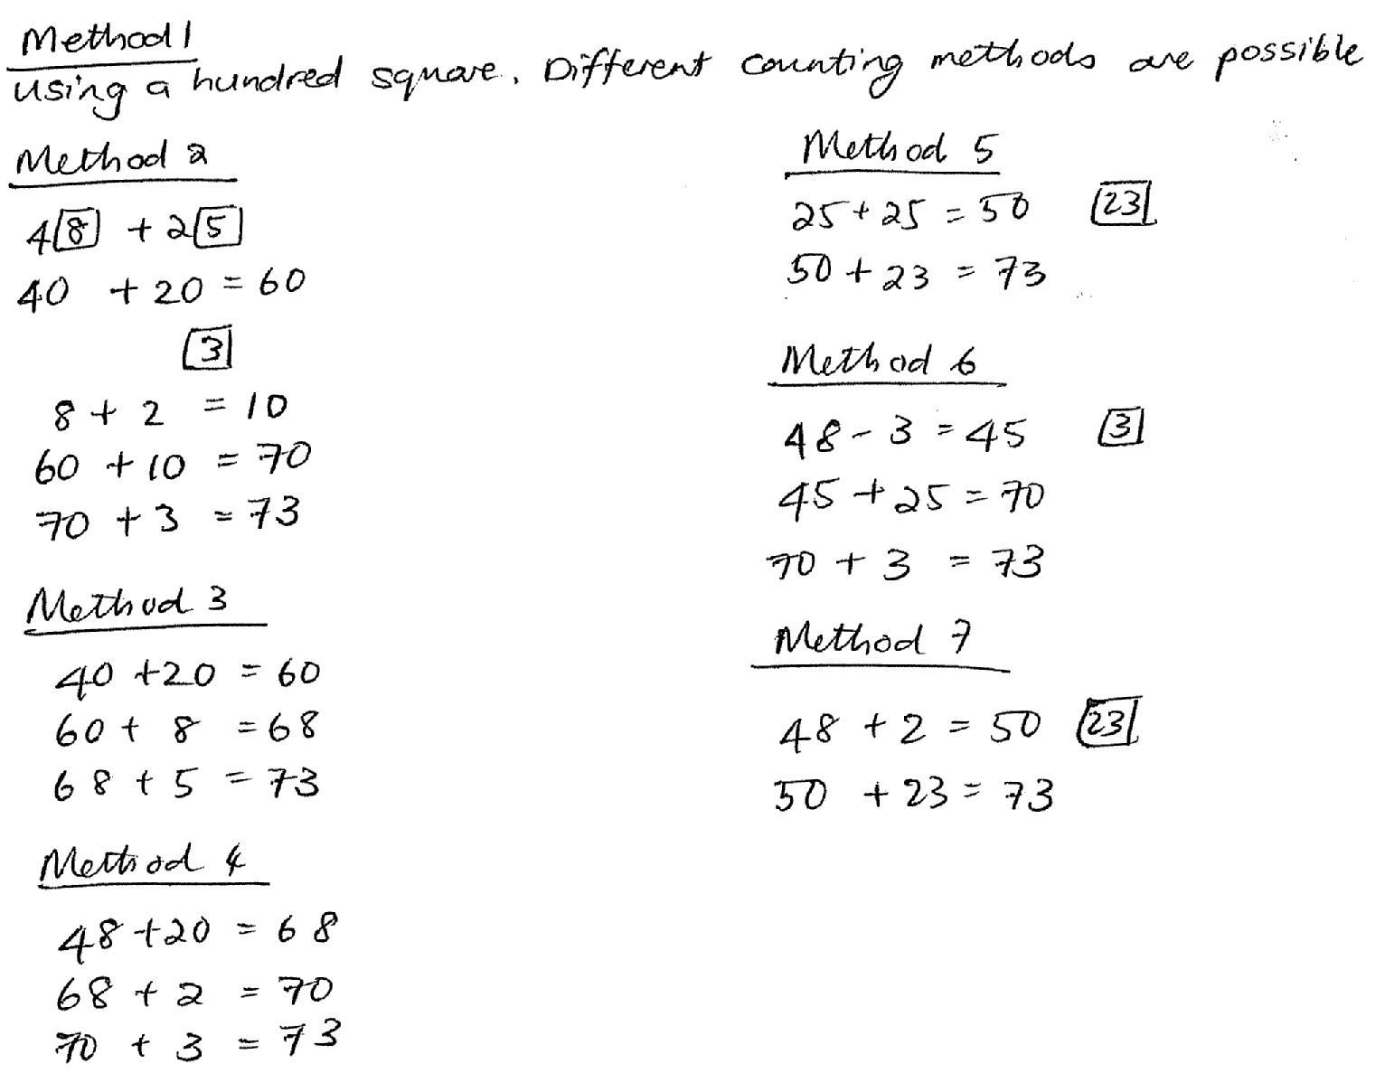

- What do you think of the way learners responded to the problem?
- How different is the problem posed here from the way we pose problems in our classes?
- What advantages can you see in using a problem-based approach to develop procedural or process understanding?
- How could you adapt the examples in the activity above to suit your classroom and your learners? Your response to this question illustrates another important design feature for the effective use of problem-solving.
Tutor input
- Problem-solving should not be an isolated strand or topic in the already crowded curriculum, rather, problem-solving should pervade the mathematics programme.
- Remind students that one advantage of a problem-based approach is that it can help accommodate the diversity of learners in every classroom (Van de Walle, 2004: 40):
- There is no need to dictate how a learner must think about a problem in order to solve it. When a task is posed, the learners may be told: ‘Use the ideas you own to solve this problem’.
- The learners in a class will have different ideas about how they can best solve a problem. They will draw on their own network of mental tools, concepts and ideas. This means that there will be many ways to tackle the problem - multiple entry points. Although most problems have singular correct answers, there are often many ways to get there.

Activity: 5 Designing good problem solving tasks

Having considered the different examples discussed in this section, can you now suggest some criteria for designing and developing effective problem-based tasks?
Effective problem based takes must meet the following criteria

Tutor input
Summarize this section of work by referring to page 131-133 of Unit 3 in your Research File:
- Highlight and discuss each of the four steps as described by Van de Walle on pages 131-133
Week 6: Before, During and After when teaching through problem solving

Activity 1: Tutor input
- Discuss the three part lesson format as described on pages 133-134 of Unit 3 in the Research File. Emphasize what the purpose of each stage is and the role of the teacher and the learners is at each stage.

Activity 2:
Use the activity (squares and patterns) on page 136 of Unit 3 in the Research File. Discuss and model what needs to be done before, during and after the activity. Involve your participants by asking them the following:
- How can the activity be used as a problem or task for the purpose of instruction (as described in the study unit)? Explain.
- If you were using this activity in the classroom, what specifically would you do during each of the ‘before, during and after’ section of the lesson? Describe each part clearly.
- What do you expect the learners to do during each of the phases of the lesson?

Activity 3: Tutor input (pages 140- 145) Unit 2 in the Research File
- Discuss the important goals of teaching through problem solving
- Practical problem solving strategies that teachers need to encourage
- Some looking back strategies
- Different levels of cognitive demands in tasks
- The value of teaching using problem based approach
Activity 4:
What have you learned about the three part planning in a problem based approach?
Before

During

After

Unit 4: Planning in the problem based classroom
Outcomes for weeks 7 and 8
After working through this unit you should be able to:
- Describe the step-by-step process of planning for a problem-based lesson.
- Write out a well thought out and concise lesson plan based on a problem-based strategy.
- Critically discuss some variations of the three-part lesson.
- Discuss how workstation activities or games can be profitably and meaningfully used to enhance a problem-based lesson.
- Discuss the effective use of group work
- Explain the differences between competitive learning, individualistic learning and collaborative learning
- Discuss the effective use of collaborative/co-operative learning
- Plan for reaching all learners through effective problem solving strategies - to be used in an increasingly diverse classroom.
- Differentiate between the two terms 'drill' and 'practice' as strategies in the context of problem solving.
- Analyse the inadequacy of the provision of repetitive 'drill' compared to the varied opportunities provided by practice in the problem solving situation.
- Critically reflect on the drill and practice as strategies underlying homework tasks or activities.

Week 7: Planning a problem based lesson
Activity 1: Tutor input
Discuss the 9 steps of lesson planning by referring to pages 152-155 of Unit 4 in the Research File.
Activity 2:

Let your participants sit according to the grades they teach. Let them do the following:
- Choose a topic (e.g. Group 1: Number, Group 2: Number Patterns: Group 3: Shape and Space, Group 4: Measurement and Group 5: Data Handling) and plan a lesson for a grade they teach, following the nine steps above. State what aspect of numeracy your learners will learn. Make/design/ describe a suitable resource that you will use to support learners to understand what you intend to teach them.
- Discuss your use of workstation activities or games (page 155 of your Research File) and how they fit within the definition of a problem-based task as discussed in Unit 3
Activity 3: Tutor input
Teaching and learning in small groups
One of the Critical Outcomes in the new curriculum centres on team work and requires that each learner can:
Work effectively with others as a member of a team, group, organization or community.
Small group interactions enable learners to develop certain skills such as:
- strong interpersonal skills because they have to learn to communicate with their peers and to negotiate towards a goal;
- strong co-operative and collaborative skills - these skills can help balance the strong competitiveness that is current in today’s world;
- strong problem solving and critical thinking skills - these skills are developed through the shared knowledge and abilities focused on the problem as well as from evaluation of each other's contributions.

While OBE is not all about group work, it does play a significant part in fostering new approaches to teaching and learning.

Activity 4: Perceptions and thoughts about group work

For this activity you have been provided with two different checklists. Work through the two checklists by recording your responses to the statements made. Once you have finished working through the checklists, go back and read your answers … highlight all the negative and positive statements you have made in different colours. Then discuss your attitude towards group work with your study partner.
- Tick the response that best fits how strongly you agree or disagree with the statements.
 |  | Strongly agree | Agree | Dis-agree | Strongly disagree
 | Everyone in a group can be involved in the learning.
 | It’s easy to do nothing in a group and to allow the others to do all the work.
 | OBE is all about learners working in groups
 | Mathematics lessons need to be specially designed to allow for group work.
 | You can use group work for other subjects but not for mathematics.
 | If you seat learners in groups then they will copy the work of the others in the group
 | Learners work best when they work on their own.
 | Learners work better in groups because they enjoy working with their friends
 | Learners work less effectively if they are in groups
 | Group work is not possible for learning mathematics
 | If you seat learners in groups then they will be involved in co-operative learning.
 | The learners will pass on incorrect information to each other and confuse one another
 | Group work means a lot of extra teacher preparation and administration

- Tick the response that best fits how you think group work might work/works in your classroom.
a) | I have tried having the learners work in groups but the class is too big
b) | I have never tried group work in my classroom as the learners are too noisy
c) | The learners always work in pairs so I do not need to have small groups
d) | The learners I teach do not like working in groups
e) | The learners in my classes often work in groups
f) | The desks in my classroom are arranged in lines so there is no opportunity for group work
g) | The desks in my classroom are arranged so the learners can work in pairs
h) | I teach in another teacher's classroom and I am not allowed to move the desks

Discuss with your study partner how you think learners working in small groups might change the teaching and learning that takes place in your classroom.

Activity 5: Tutor input (refer to pages 162-167 of Unit 4 in the research File)

- What is group work?
- What is competitive learning?
- What is individualistic learning?
- What is cooperative learning?
- What are the underlying principles for each of the different ways of learning above?
- What is cooperative learning? How different it is from simply putting learners in groups?
- What makes cooperative learning work?
- Different ways of arranging learners in groups

Request each participant to bring one Numeracy group assessment task that she/he has done in class with learners to be used in week 8

Week 8: Assessing group work

Activity 1: Tutor input
Discuss different ways of assessing and allocating marks for group work with your participants. Refer to pages 171-175

Activity 2:

Read each of the group assessment rubrics on pages 173-175 of Unit 4

- Evaluate them in terms of your learners and modify them if necessary.
- Use the teacher rubric to assess a group work task/activity that you brought from your classroom. Write a short reflection on how you used the rubric.
- Discuss with your study partner how you used the rubric and what you think of rubrics in group assessment tasks.

Activity 3: Tutor input

Dealing with diversity in a numeracy classroom

Discuss in depth the following four ways of dealing with diversity in the classroom as suggested by Van De Walle on pages 176-177 of Unit 4 in the Research File

- Be sure that problems have multiple entry points
- Plan differentiated tasks
- Use heterogeneous groupings
- Listen carefully to learners

Activity 4: Difference between drill and practice

In your small groups discuss and write what you think are the differences between drill and practice.
What is drill?

What is practice?

What is the difference between drill and practice?

Activity: 5 Tutor input (pages 178-179)
- What is drill?
- What are the weaknesses of using drill in a Numeracy class?
- What are the benefits of using drill?
- What is practice?
- What are the benefits of practice?
Activity 6: Drill and practice in your classroom

Reflection on your classroom practice
- Reflect on your classroom experience and then decide on which activity between drill and practice is more prevalent with the learners.

The drill definition requires that skills are already acquired before they are drilled. What implication will this have for planning problem-based lessons? Explain

Unit 5: Building assessment into teaching and learning
Outcomes for weeks 9 and 10
After working through this unit you should be able to:
- explain the term assessment
- identify the four purposes of assessment
- explain the principles of outcomes-based assessment (OBA)
- describe the role and purpose of assessment in mathematics
- implement a variety of types of assessment in assessing your learners' performance in mathematics
- identify and explain the aspects of mathematics learning you ought to consider when assessing learners
- reflect on the assessment potential of mathematical tasks used in the teaching of basic data handling concepts
- select appropriate methods, techniques and tools for assessing a learner's performance in mathematics
- draw up or design your own assessment tasks and rubrics to be used when assessing a learner's work
- compare various methods of recording a learner's performance

Week 9
Activity 1: Tutor input (What is assessment)
Identify what students know about assessment. Discuss what assessment is and what it is not by referring to pages 186-189 of Unit 5. In small groups let participants discuss and answer the following questions:

- When you think about assessment, what comes to mind in your head based on personal experience?
- Reflect on the uses of assessment in everyday life discuss these with your study partner.
- Look at the words in the block below, think about what each term signifies in the context of assessment:

evaluate appraise estimate competition
tests examinations fail pass
study poor marks stress worried
motor-vehicle test doctor's report sports coaching success

What is assessment?

Tutor: Allow groups to present their understanding of assessment and wrap up the activity by discussing the key features of Outcomes Based Assessment on page 190 of Unit 5 in your Research File.
Activity 2: Assessment methods

Tutor to group participants in 5 groups. Give each group information on a particular method of assessment (See pages 190- 193) to read and present to the whole class.
Each group should explain its method by answering the following questions:
- What is this type of assessment all about?
- What is the purpose of this method?
- When can this method of assessment be used?
- Give a practical example of how this method can be used in a Numeracy classroom
Group 1: Baseline assessment

Group 2: Formative assessment

Group 3: Diagnostic assessment

Group 4: Summative assessment

Group 5: Continuous assessment

Tutor allows each group to present its understanding of the method allocated. Wrap up the activity by summarizing what each the purpose of each method of assessment is.
Activity 3: When do we assess?
Tutor to discuss the three stages at which assessment takes place in the numeracy classroom by referring to page 193-194 of Unit 5 in the Research File.

Assessment before teaching

Assessment during teaching

Assessment after teaching

Activity 4: What do we assess in a Numeracy classroom?
When we assess in a Numeracy classroom, we assess Critical Outcomes, Developmental Outcomes, Learning Outcomes, Assessment Standards as well as reasoning, understanding and problem solving skills

Tutor input by referring to pages 200-201 of Unit 5 in the Research File.
Activity 5: Assessing for reasoning, understanding, and problem solving

In pairs, look at the operations work sheet on page 204 of Unit 5 in the Research File as well as the Pizza problem on page 205 and discuss the two problems by answering the following questions:

- In what way does ‘the pizza problem’ allow a learner to develop their reasoning skills?
  - Write out an example of a question (or a part of a question) from the task that allows for the development of reasoning skills.
  - What evidence of reasoning skills (or lack thereof) will the teacher be able to find in the learners’ work that they submit having completed this task?
Development of reasoning skills

- In what way does it allow learners to develop their understanding?
  - Write out an example of a question (or a part of a question) that allows for the development of understanding.
  - What evidence of understanding (or lack of understanding) will the teacher be able to find in the learners’ work that they submit having completed this task?
Development of understanding

- In what way does it allow learners to develop their problem solving skills?
  - Write out an example of a question (or a part of a question) that allows for the development of problem solving skills.
What evidence of problem solving skills (or lack thereof) will the teacher be able to find in the learners’ work that they submit having completed this task?

Development of problem solving skills

Tutor to summarize this activity by comparing the operations worksheet to the pizza problem and by ensuring that participants see the differences between the two.

Week 10: How do we assess in a Numeracy classroom

Activity 1: Tutor input by referring to pages 208- 214.

The most important thing to consider when choosing an assessment method is to link the method with what you are intending to assess and why you want to assess it. In this section, we give examples of a number of methods of assessment and ask you to reflect on whether they are ‘fit for purpose’.

In the input emphasize the four phases of the assessment process which are the following:

- Plan the assessment
- Gather the evidence
- Interpret the evidence
- Use the results

Divide the class into three groups and give each group a method of assessment and questions to discuss and present:

Group 1: Self assessment

Self assessment: Here is an example of a self-assessment form.
Self assessment form
Name: ............................................. Class: ...........................
Teacher: ........................................ Date: ............................
Learning area: ..........................................................................
Write down the two most important things you have learned in mathematics during the past month. ........................................................................................................................................
What would you like more help with?........................................................................................
How would you best describe how you feel in mathematics classes at the moment? (Circle the words that apply to you.)
(a) interested (b) relaxed (c) worried
(d) successful (e) confused (f) clever
(g) happy (h) bored (i) rushed

What is the biggest problem that you are currently facing in mathematics?
.................................................................................................
(adapted from Clarke: 1997)

Which of the following purposes are appropriate for self assessment? Circle the ones that you think are important.
  - Learners are guided to assess their own performance or work.
  - Self-assessment helps learners to think critically about their own work.
  - Self-assessment gives learners a good idea of their progress.
  - Teachers find out what learners value in their own work.
  - Learners come to appreciate and know their own work.
  - Self-assessment develops learners' confidence.
Learners become aware of their strengths and weaknesses

Would you use this method to assess learner performance and progress in the Foundation Phase? Give reasons for your answer
Self assessment

Group 2: Peer or group assessment

Peer or group assessment: Here is an example of a peer assessment form.

Peer or group assessment form
Name of peer/ group members: ..................................................
Date: ...........................................................................................
Name of assessor: .......................................................................
Grade: .........................................................................................
Task: ...........................................................................................
Competence (criteria) | Yes | No | Uncertain
Did the learner work in the team?
Did the learner listen to the peer group discussion?
Did the learner work with confidence?
Did the learner in the group show competence in his or her logical thought processes to formulate, test and justify?
Does the learner know and use mathematical language?
Can the learner read the data accurately?

- Who do you think this form of assessment would benefit?
- How do you think this form of assessment could be beneficial?
- What different types of group assessment have you used in your numeracy classes? Discuss with your study partner which of these assessment types were the most successful and why.
Would you use this method to assess learner performance and progress in the Foundation Phase? Give reasons for your answer

Peer or group assessment

Group 3: Observation

Observation: Here is an example of an observation sheet.
Observation sheet for Grade 4 lesson on data handling
Name of pupil: | Date:
Class: | Teacher:
Criteria | Not yet | Fine | Comment
- Takes time to read and understand the work before beginning to complete the task.
- Able to read the data from the table and draw up the tally table.
- Able to find the frequencies using the tally table.
- Able to draw the bar graph using tabled information.
- Bar graph completed with the axes correctly marked and labelled.
- Bar graph given the correct title.
- Able to summarise the information presented and interpret the findings correctly.
- Able to justify or explain work when questioned.

- Which of the criteria in the observation sheet relate to content issues?
- Which criteria in the observation sheet relate to problem solving skills?
- What do you think are some of the valuable contributions that observation can make to assessment?
- How could you adapt the observation sheet above to make it possible to use the sheet for a whole class?
Would you use this method to assess learner performance and progress in the Foundation Phase? Give reasons for your answer

Observation

Tutor allows each group to present its method and other group members to ask questions where necessary.

Activity 2: Performance based tasks in the Foundation Phase

Tutor input by introducing Performance based tasks. Refer to page 218 of Unit 5 in the Research File. Let participants do the following activity and individuals and pair up to discuss their responses.

Performance based task
You are going to find out about the different forms of transport learners use to come to school.
Draw up a list of questions that you can use to find out which different forms of transport are used by the learners in your class. (You should include at least four different means of transport on your list.)
- Ask all of the learners in your class which form of transport they use, and draw up a tally table of their responses.
- Find the frequencies from your tally table.
- Represent your data using a bar graph or a pictogram.
- What does your graph tell you about the forms of transport used by the learners in your class?
- Could you use this information to decide about the forms of transport used by the learners in your school? Explain your answer.

Use the following check list to evaluate the design of the performance based task above. In each case explain your answer and suggest improvements where necessary.
- Does the task enquire an integration of knowledge, skills and values?
- Does it require a variety of outcomes?
- Is the task based on a real-life context?
- Is the task practical enough to be done? (doable)
- Are multiple solutions possible?
- Is the nature of the task clear?
- Is the task challenging and stimulating to the learners?
- Are criteria for scoring included?
(DOE: Curriculum 2005 Assessment Guidelines)

Activity 3: Using rubrics

Assessment tasks cannot be effectively evaluated simply by adding up all the correct answers, or awarding a quantitative mark (say 60%). Such a mark gives no information to the learner on what, in particular, was good or bad about his or her work. We need to find ways to manage this information and make it useful. One very useful tool with which to do so is a rubric. Rubrics are rating scales that are used in the assessment of performance. They are formally defined as scoring guides, consisting of pre-established performance criteria, and are used in evaluating or assessing a learner's performance. The expansions of the criteria at the different levels are called level descriptors.

On page224 is an example of a learner friendly mathematics rubric. In your opinion is this rubric suitable to use in the Foundation Phase? Give reasons for your answer:
Rubric

In a group of 4 or 5 develop a Numeracy activity for Grade 3 learners and design a rubric that can be used to assess the activity. Discuss your activity as well as your rubric with the other groups.

Activity 4: How to interpret assessment: How to report?

Tutor Input: Refer pages 227-229 of Unit 5 in the Research File. Emphasize the differences between self- referencing, Criterion –referencing and norm referencing

In groups of 4 or 5 let your groups read the following statements made by teachers and then state which statements illustrate norm-referencing, which illustrate criterion-referencing and which illustrate self-referencing, giving reasons for your response in each case.

Teacher A
Sipho has done well this term. He can calculate the area of flat surfaces, which he had difficulty with last term. He has made good progress.

Teacher B
I am worried about Mary. She doesn't seem to be able to work as fast as the other learners in my mathematics class. I think she is unable to do computation involving two or three digits.

Teacher C
My class seems to be doing okay. They're about as far into division as last year's class was at this time of year.

Teacher D
Ernest is a born mathematician. His spatial perception is outstanding. He is able to convert 2D drawings into simple 3D working models. He has a good grasp of perspective.

What did I learn about self referencing, norm referencing and criterion referencing?

Self referencing

Norm referencing

Criterion referencing

Activity 5: How to report

Tutor Input: Refer to page 231 of Unit 5 in the Research File.

In pairs study the two different report cards shown below. Reflect on the questions that follow:

Report Card A for Numeracy | Out-standing | Achieved | Partially achieved | Not achieved

Project: Conducting a survey

Working with number patterns and patterns in nature

Graph work: Pictograms

Class Test

TEACHER

Strengths/

support needed

Report Card B for Mathematics | Term Mark | Comment

Data Handling

Number and Algebra

Space and Shape

Overall Average

TEACHER:

- Discuss the differences and similarities between the report cards.
- Which report card would you prefer to use?
- Which report card do you think the learners would prefer to receive?
- Think about how you could draw up a report card to reflect the work you cover in a term with your learners. Act on your ideas and design a report card for your class.
Activity 6: Self assessment

Self-assessment

Tick the boxes to assess whether you have achieved the outcomes for this unit. If you cannot tick the boxes, you should go back and work through the relevant part in unit again.
I am able to:
explain the term assessment
identify the four purposes of assessment and am able to implement these in my classroom instructional activities
explain the principles of outcomes-based assessment (OBA)
describe the role and purpose of assessment in mathematics
identify and explain the aspects of mathematics learning I ought to consider when assessing learners
reflect on the assessment potential of mathematical tasks used in the teaching of basic data handling concepts
select appropriate methods, techniques and tools for assessing a learner's performance in mathematics
draw up or design my own assessment tasks and rubrics to be used when assessing a learner's work
compare various methods of recording a learner's performance.

Week 11: Exam guidelines and support

The exam for this course will take place on the…

It is a 3-hour exam and you are required to answer 3 of the 4 questions provided. Question 1 is compulsory and you can choose 2 questions from the remaining three.

- Question 1 is compulsory and it deals with Understanding Numeracy and mathematics (100)
- Question 2 deals with developing understanding (50 marks)
- Question 3 deals with teaching through problem solving (50 marks)
- Question 4: Assessment (50 marks)

Total 200 marks

Activity1:

- Read through the question on below and make sure that you understand what the question is asking.

- Analyze and discuss the question in your small group

- Decide in your group on the content you would use in your answer

- Draw up a mind-map

- Each individual write up an introduction to the answer.

Example of an exam question

Critically discuss how workstation activities or games can be profitably and meaningfully used in a Foundation Phase classroom to enhance a problem based lesson.

Illustrate your understanding of the above questions by drawing from the work we have covered in the Research File and give practical examples from your classroom experience to support your answer.

50 Marks

Assessment Criteria

Form/structure 40%

- Does your essay have a clear structure?
- Is there a clear line of argument in your essay?
- Do the paragraphs have a main idea?
- Do you support your argument by drawing from your Research File?
- Are your introduction and conclusion related to the essay as a whole?

Content 60%

- Have you correctly identified and used Numeracy learning theories as used in your Research File?
- Have you related the knowledge you gained in the course to the question
- Have you discussed appropriate examples from your own teaching experience to support your argument?
- Do you have a clear position about the teaching and learning of Numeracy in the Foundation Phase and argued this clearly?

Reflection: Do you think you are now ready to prepare for the examinations? What are your fears and concerns about the examinations?

My fears about the exams
My concerns regarding the exams

