

Advanced Certificate in Education
Teaching and Learning Mathematics in the FET (w.r.t. Mathematical Literacy)

EDMA143E2

Module co-ordinator and lecturer

Sally Hobden

Phone: 031 2603435 (there is an answering machine to leave a message)
Email: hobdens1@ukzn.ac.za

Section One
Theory of teaching and learning mathematics

This section is an introduction to the theory of teaching and learning mathematics. This theory is applicable to all levels of mathematics and to all branches of the discipline (for example statistics, mathematical literacy).

The section begins with an invitation to consider your own ideas about mathematics and to think deeply about you really think it is all about. Some of the ancient philosophical debates about the nature of mathematics are then discussed. We then move on to consider the views that other stakeholders have about mathematics teaching and learning – the general public, the learners and finally the mathematics education specialists.

The final part of Section One is an overview of some of the “big ideas” in mathematics education. These are the ideas suggested by mathematics educators to explain or describe how people learn mathematics. It is important for us as teachers to become familiar with all these ideas and to consider our own thoughts and work in the light of what others are saying.

Some of the material used in these notes is extracted from the materials prepared for the
SAIDE Open Educational Resources Project

Draft pilot edition, 2007: Teaching and Learning Mathematics in Diverse Classrooms
Adapted from UNISA materials by: Ingrid Sapire, RADMASTE, University of the Witwatersrand
Project coordinated by: Tessa Welch, SAIDE
© South African Institute for Distance Education (SAIDE)

The nature of mathematics and mathematical thinking

This section invites you to take a fresh look at the learning area and discipline known as Mathematics. We begin by looking at some historical views of the nature of Mathematics and then try to articulate our own personal views and theories regarding Mathematics and the teaching and learning of this subject. These personal views are then examined in the light of some theories of educationists and some opinions of learners in South Africa. Finally we look at four “big ideas” in Mathematics education which influence and inform the teaching and learning of Mathematics in our schools.

What do you think about teaching and learning mathematics?

There must very few people who begin a teaching career without at least twelve years experience of being taught. These years of apprenticeship form the basis of what we consider good teaching - either by showing exemplary practice or things to avoid. The interesting thing is that the ideas we have about teaching and learning are deeply seated and we will probably struggle to explain our ideas clearly.

You need to think about mathematical knowledge and in particular:
1. Where does mathematical knowledge come from?
2. How does someone gain mathematical knowledge?

Your answers to these questions may reveal the basic beliefs you hold right now about mathematics. These are your personal beliefs about teaching and learning mathematics. There are no absolutely correct or incorrect answers to these questions. What we want to do here is help you reflect on your personal beliefs and see where they are rooted.

Metaphors for teaching and learning Mathematics.
Introductory remarks
For the purposes of this activity, we will consider a metaphor as an imaginative way of describing something or some situation by referring to another different thing or situation which has some similar characteristics. For example, we might refer to very caring people as “mother hens” because they show some of the nurturing behaviour of a hen with her chicks.

Consider the picture of the Potter. (Figure 1)
This picture can be seen as a metaphor for teaching and learning. Here are some ideas from people who have looked at the picture.
Tom thinks the potter represents the teacher and the clay is the learners. The Mathematics knowledge is the skill of the potter that is transforming the clay. The potter is trying to make the clay into the useful objects she has displayed on the shelf. The barrel contains the clay that she will use in the future and represents the learners that will come to her class in following years

Sylvie thinks the potter could represent the learner and the clay is the Mathematics she is learning. The barrel contains all the Mathematics she still has to experience. She is trying to make the Mathematics work for her so that she too can produce the examples shown on the shelf. The teacher has made the examples and shown the learner how the potter's wheel works and has gone out and closed the door leaving the learner to work on her own.

How would you interpret the picture?
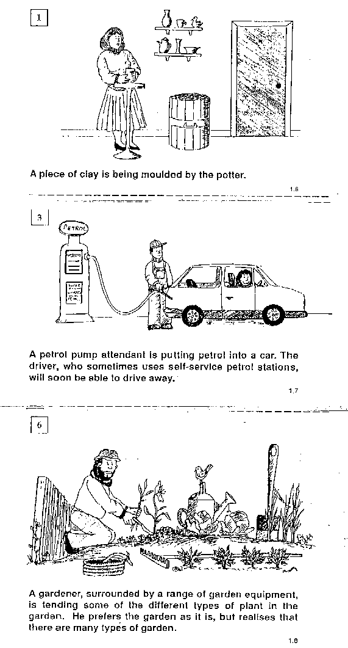

Figure 1: The Potter

Activity

1. The six pictures shown here are suggested metaphors for teaching and learning. We can assume that in the learning situation there is a teacher (facilitator), a learner and some mathematics to be learnt.
You must decide what each part of the drawing represents and then explain the modus operandi (way things work) of the teaching/learning situation.

2 Take time to make sense of the pictures and then spend some time considering which of them best represents your personal idea of teaching and learning mathematics. Write down your ideas and explain how they represent your viewpoint.

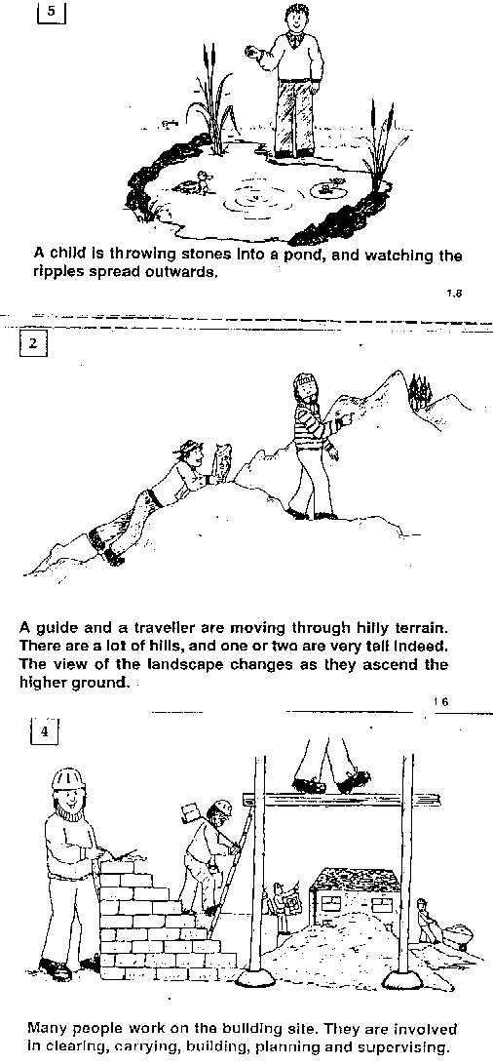
Figure 2: The boy throwing stones into a pool

Figure 3: The petrol attendant

Figure 4: The gardener

Figure 5: The traveller

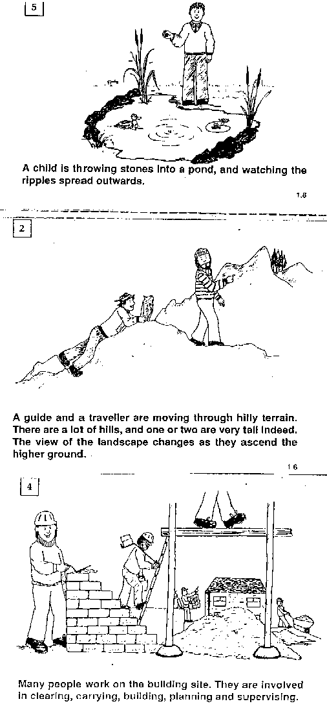
Figure 6: Construction workers

You may be surprised to discover that your ideas differ widely from others - this is because you are expressing your personal beliefs. These beliefs are influenced by past experiences, reading you may have done, stories you have heard, and of course your common sense. We should expect that each person will have had unique experiences to draw on.

I am sure that you have discovered that none of these metaphors really capture your own thoughts perfectly. So, as always, if want something done properly, you have to do it yourself……….

What do philosophers think about mathematics, and teaching and learning this subject?

Nature of Maths

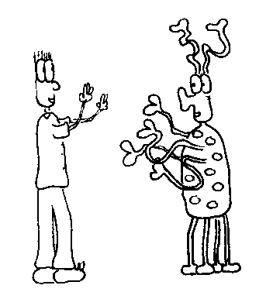
Teacher:
I teach Mathematics at a school

Alien: Tell me, what is Mathematics?

Student: (thinks a while)
It is what Mathematicians do!

How would you answer this question, “What is mathematics”?

It is easy to list some topics in mathematics such as Algebra, Geometry, Trigonometry, Calculus, Topology etc., but this does not provide an explanation of what mathematics is.

There are several different philosophical viewpoints on the nature of Mathematics and it is important for you, as a Mathematics teacher, to be aware of some of these different views since they influence the curriculum and style of teaching. It is also very important for you to have your own personal considered viewpoint, and to be aware of this. An American mathematician, Hersh, says this strongly:

“One’s conceptions of what mathematics is affects one’s conception of how it should be presented. One’s manner of presenting it is an indication of what one believes to be most essential in it ... The issue, then, is not, What is the best way to teach?, but, What is mathematics really all about?”( Hersh 1986, p 13).

Perhaps you will change your personal viewpoint over the course of this module, or over the course of your career - I certainly have changed and altered my own views considerably over time and hope that I will continue to do so. I would hate to think that I am stuck with a particular viewpoint forever!

Discussions and disagreements over what mathematics is (its nature) go way back to the times of the Greek philosophers in the fourth century BC. Plato and his student Aristotle debated the nature of mathematics.

For Plato, the objects of mathematics had an existence of their own beyond the mind, in the external world. Plato’s arguments support what is often referred to as the “external view” of mathematics: that it is an ideal body of knowledge, independent of people. For Plato only the philosopher kings (the elite of society) who are able to use pure reason, could engage in mathematics and through reason could get close to knowing that pure knowledge.

Aristotle, on the other hand, argued that mathematics was based on experienced reality, and that mathematical knowledge is only obtained from experimentation, observation and abstraction. This view is often referred to as the “internal view”.

The works and ideas of Plato and Aristotle and the arguments they had, model the two major contrasting themes concerning the nature of mathematics which still exist today. These two main contrasting views of what mathematics is really all about are described in more detail below.
The external view of mathematics:
People who believe that mathematics is external see mathematics as an unchanging body of knowledge (concepts, facts, principles, rules and skills) which exists independently of people and outside of our experiences of the world. It is a body of unchangeable truths, which lie outside of human action and wait “out there” to be discovered by people. (We can think of the example of an unknown star, waiting there for us to see it. When scientists have developed sufficient technology, we will find the star. This is, of course, a completely different idea to imagining inventing a star!) The way in which this knowledge could be discovered is through using deductive reason.
The internal view of mathematics:
People who believe that mathematics is internal, see mathematics as empirically constructed, from evidence in the real world. They see the ideas, concepts, principles, rules, and skills of mathematics as knowledge which has been developed and constructed by humans over time. Because of this human involvement in creating mathematical knowledge, they see mathematics as constantly changing and growing. They do not see it as an unchanging body of knowledge. The way in which this knowledge is created is through inductive reason.

Inductive and deductive reasoning have been part of your school and tertiary Mathematics experience, but perhaps not formally mentioned. See if you recognise the types of reasoning as they are described below.
Deductive reason
In brief, deduction involves starting with some “truths” about the world. That is statements which one knows for certain are true. The truth of these statements exists outside of human experience, i.e. they would be true even if no human mind had ever thought about it. In mathematics these basic truths are called axioms. An example of a basic “truth” in school geometry is “parallel lines never meet” i.e. “The distance between two lines which are parallel is a constant”. This can never be “proved” for certain, but is assumed to be true. Deductive reasoning involves using logical methods to make “valid” conclusions from that basic truth.

Since the original axiom is true the conclusion is also true. An example of a valid deductive argument is:

All carrots are orange basic truth
This is a carrot basic truth
Therefore it is orange. Valid conclusion

As long as the two statements “All carrots are orange” and “This is a carrot ” are true, and the argument is logically valid, then the conclusion (deduction) “it is orange” will also be true.

Of course what makes the final statement true is that the argument is logically valid. On the other hand, the following argument is not logically valid.

All carrots are orange basic truth
This is orange basic truth
Therefore this is a carrot not necessarily a valid conclusion

In this case we cannot believe the conclusion even if both statements (all carrots are orange and, this is orange) are true. It is also true that other objects may be orange and so the object could be a peach for example.

The following examples, taken from Geometry may help to show the difference between valid and invalid logical reasoning.

The sum of the interior angles of a triangle is 180 basic truth
ABC is a triangle basic truth
Therefore A + B + C = . 180 Valid conclusion

The sum of the interior angles of a triangle is 180 basic truth
A + B + C = . 180 basic truth
Therefore ABC is a triangle not necessarily a valid conclusion

Inductive Reason
On the other hand, inductive thinking involves: using experiences to look for patterns in a particular set of situations, or context; and, then making inferences from those patterns to come up with a conjecture (educated guess) for the general concept. For example, one might look carefully at the measurement of sides and angles in several triangles and conjecture that the longest side is opposite the largest angle. Usually coming up with a conjecture involves making a ‘jump’ to a new idea. It also involves using intuition to generalise from a number of specific examples.

Examples of inductive reasoning:

1 Investigate the sums of two odd numbers.
Firstly several specific examples are considered.

3+7=10 7+9=16 1+5=6 15+19=34 21+73=94

Notice that in each case the sum is an even number. We could use inductive reasoning to conjecture that the sum of two odd numbers is always an even number.

2 Investigate the angles of a triangle.
If several different triangles are drawn, and the angles measured, we would find that in each case the sum of the angles in a particular triangle add up to 180°. We could use inductive reasoning to conjecture that the sum of the interior angles of a triangle is 180°.

What does Joe Public think about mathematics, and teaching and learning this subject?

Most people acknowledge that mathematics is an important subject at school. However very few really understand what mathematics is about and what it means to ‘do’ maths. People often define mathematics as being about a collection of ‘rules’; arithmetic computations, mysterious algebraic equations or geometric proofs that need to be learnt in order to pass an examination. In general people tend to feel that they are ‘no good at mathematics and that it is difficult”.

Such people believe that:

• Maths requires a good memory
• Maths is based on memorisation of facts, rules, formulas and procedures
• You have to have a special brain to do maths
• Maths is not creative
• Maths is always only ever right or wrong
• There is a best way to do a maths problem
• Every maths problem has only one correct answer and the goal is to find THE answer
• Maths problems are meant to be solved as quickly as possible
• Maths is all symbols and no words
• Boys are better at maths than girls
• School maths is useless
• Maths is exact and there is no room for innovation, estimation or intuition.

Much of this restricted (even negative) view of mathematics stems from very traditional approaches to the teaching of mathematics. In such traditional teaching, the teacher ‘tells’ or explains a mathematical concept/idea to learners. The teachers ‘tells’ the learners how to ‘use’ a mathematical idea in a certain way in order to get a correct answer. The learners then practice the method and rely upon the teacher to tell them the correct answers.

This way of teaching produces a follow-the-rules, computation-driven, answer-oriented view of mathematics. Learners exposed to this way of teaching accept that every problem has only one solution and that they cannot solve a problem without being told a ‘solution method’ before hand. The ‘rules’ seldom seem to make sense and there is little excitement in lessons, particularly if you cannot remember the rule!

Nevertheless, almost everybody that you speak to agrees that mathematics is a very important subject and it is a good subject to do in order to gain access to good ad high paying careers. The role of the subject as a gatekeeper is seldom challenged.

What do learners think about mathematics, and teaching and learning this subject?

In this section we will explore some of the negative feelings people have about mathematics, and the phenomenon of maths anxiety.

Marylin Frankenstein in her book “Relearning Mathematics: A Different Third R – Radical Maths", suggests that most adults have had negative experiences with mathematics, and there are very few who have been through a traditional mathematics programme who come out feeling confident in their own ideas and really able to use mathematics in a meaningful and creative way.

Marylin Frankenstein suggests that there are some typical aspects of the traditional
mathematics syllabus which lead to negative feelings about mathematics, and, in bad cases to anxiety and anger. She quotes Peter Hilton, who is a prominent mathematician in the USA, as saying:

" the experiences which most children have of mathematics through their mathematics lessons and through mathematics texts which they use are .... very likely to lead them to seek to avoid mathematics" (Frankenstein, 1989, 17).

Hilton describes six features of a traditional mathematics curriculum which he feels are most responsible for these very negative feelings about mathematics. These are:

• Rote calculations: In a traditional mathematics classroom learners are often required to do pages and pages of “exercises” which get them to practice a method given to them by their teacher, often without really understanding what they are doing or why it works. Often the type of calculations done, particularly in the primary school (foundation and intermediate phases), do not increase mathematical thinking and are really unnecessary because of the availability of hand held calculators.

• Memory dependence: Often learners are asked to memorise many different methods and “rules” without real understanding. Memory overload can cause severe anxiety and dislike of maths. This is often seen in the geometry class in secondary school where learners learn theorems by heart. Hilton believes that there is no point in remembering a proof of something if one does not understand it, and, if one does understand the proof, then you do not have to memorise it because you can easily reconstruct it yourself!

• Unmotivated exercises: Often learners study particular skills independently of the situations in which they make sense and are given exercises to practice the skills, even though there is absolutely no indication of when the skill could be useful to them. For example learning to find the HCF or the LCM of a list of numbers, or multiplying two fractions like Why do it? When would it be necessary?

• Spurious applications: This refers to situations where learners are asked to apply methods to solve a particular problem, even when in real life you would never use a method like that to solve such a problem. For example, when a learner is asked to use subtraction to find an answer for a problem like:” Sipho goes shopping. His mother gives him R1,50 and he spends 89c How much does he have left.” In fact in real life one would just add up what is left in Sipho’s pocket after he has been shopping!!.

• Authoritarianism in mathematics education: This is where learners are told what to do, told how to do it, told that it works and they must practice the method, told they will understand it later on, and told that it will turn out to be useful to them one day in their future.

• Fragmentation of mathematics: An approach which assumes that mathematics can be divided up into tiny separate compartments, each with its own ideas and methods, and very little cross connection between topics: Traditional mathematical experiences often involve learning a whole lot of topics e.g. fractions (as if these are not just other numbers!), or multiples, or solving equations; or doing exponents, geometry etc. Each one is seen as a topic on its own with its own skills and things to practice, with little time given to making connections between topics and developing the ideas within a context which makes sense and gives rise to the ideas.

Many people we have spoken to believe that bad feelings about mathematics only develop in the secondary school and that children in primary school don’t have these problems. Let us assure you this is not the case. When young learners are unable to follow someone else’s logic, they can become stressed and this can lead to bad feelings.

Learners’ Images of Mathematics and Mathematics Teachers

Here are some poems that were written by grade 5 learners. They express very different feelings towards Mathematics. Consider that these learners were in the same class and had the same mathematics teacher. Why do you think such different feelings toward the subject Mathematics are expressed?

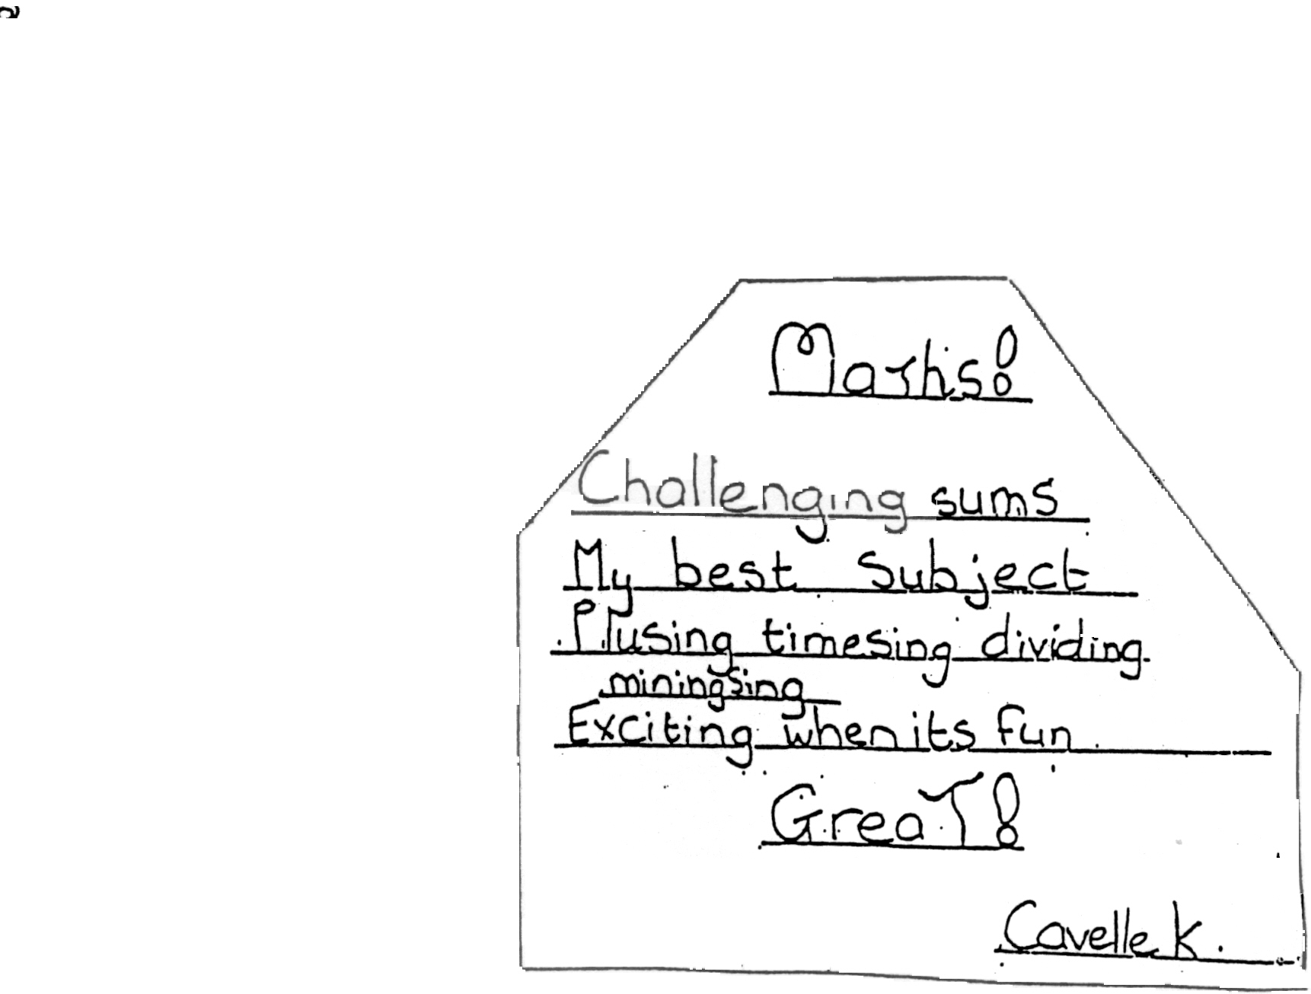
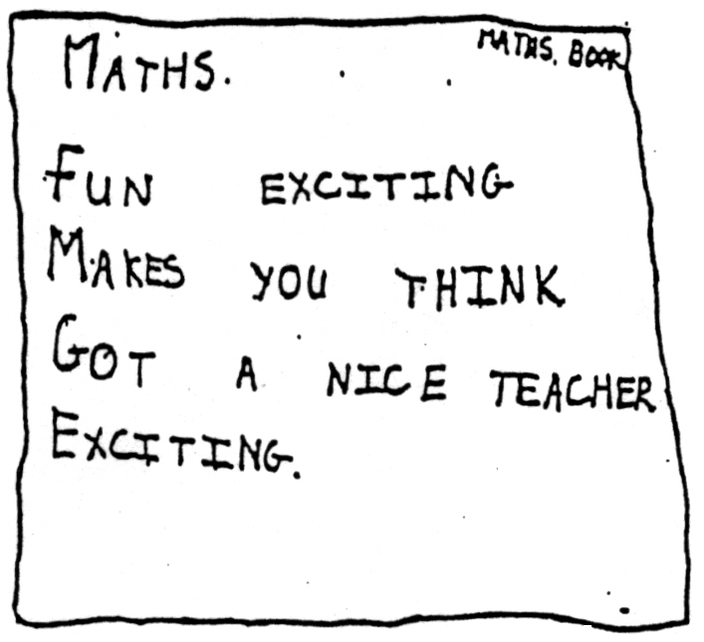
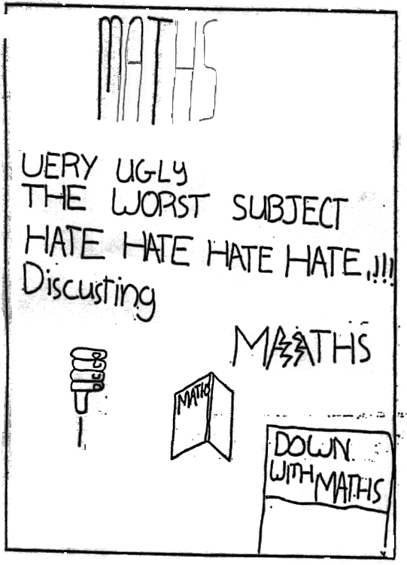
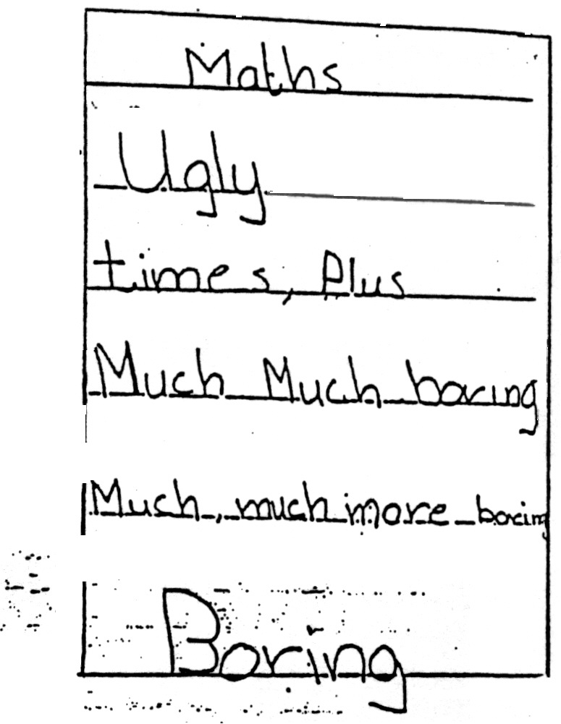

The poems were produced by more privileged learners attending an ex-model C school. In some other local research (Parker, 1999) 300 learners in grades 8 to 10 were asked to write poems and draw pictures to express their understanding of what Mathematics is and their feelings about learning this subject. These learners all came from rural, community or township schools and could generally be classified as disadvantaged.

Many of the responses show an attitude that puts Mathematics on a pedestal. The learners see Mathematics as the most important of all school subjects.
There is a belief that Mathematics achievers have opportunities to make untold fortunes and that success in Mathematics adds up to success in life. These beliefs permeate the thinking of the majority of the responses. The following selection of learner responses to the question ‘When I think about doing mathematics I feel ….’ reflects these dominant sentiments.

When I think about doing Maths I feel very happy. Because Maths is the only subject that is going to lead me into the green pastures.

When I think about doing Mathematics I feel very happy because I think Mathematics is bread forever By that time & works are many when you do Mathematics

I feel happy and am very proud of my self because mathematics is overly important subject in our days

In answer to the question ‘I think that learning Mathematics is all about ….’ many responses reflected the same sentiments again and did not actually mention any mathematics or mathematical concepts, a typical example is given below.

I THINK THAT LEARNING MATHEMATICS IS ALL ABOUT CHANCES OF JOBS

These expressions of Mathematics might make you believe that our learners generally feel fantastic about Mathematics. However this view of Mathematics seems to be one which is indoctrinated into students! They are convinced by everyone that Mathematics = success in life, and that economic prosperity and future opportunities are a result of doing it. As part of the same research learners were also asked to draw pictures of Mathematics teachers and what they do in the classroom. The majority of pictures drawn capture a view of mathematics teachers at the chalkboard holding a stick in their hand and often with a book. Some of these pictures show learners too. In most of these cases the learners are organised in rows and the pictures seldom show any positive interaction with learners, although pictures showing corporal punishment and verbal abuse were common.
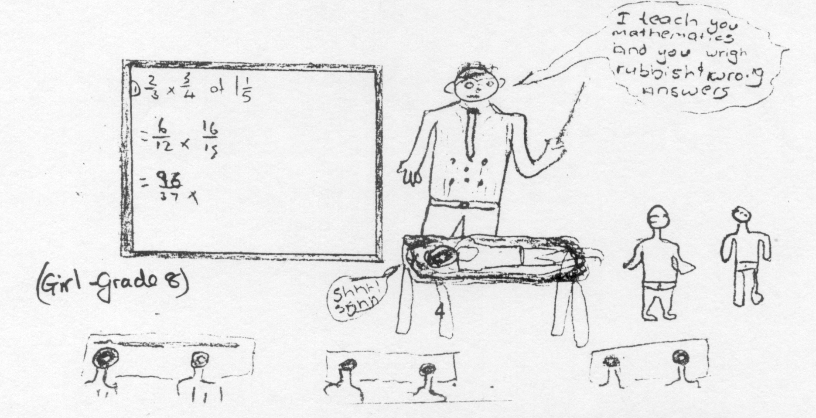

Student Teachers’ Feelings About Mathematics
At the beginning of 1999, about sixty students who were beginning their training to be primary school teachers, were asked to write down the thing the least liked about school Mathematics, and the thing they most liked. These were shared with the group, and then the "bad experiences" were burnt to symbolise a new beginning - learning Mathematics Education. Here is a sample of the things they disliked (Van Laren, 1999):

I didn't enjoy maths because when you asked the teacher to explain something, she said there was nothing to understand.

I hated maths because it was difficult, boring and pointless.

I didn't like maths because as soon as you start to understand what is going on, then the teacher decided to change the section.

Maths was a total bore. I dropped it in Std 7 because like alphabets and numbers going together doesn't really excite me.

The main reason why I didn't like Maths was because no matter what I did, I couldn't understand it.

The worst thing was half the stuff learnt was absolutely useless if you are not going to study Maths further - a waste of time.

The worst thing about Maths is when they taught you this long difficult way and by the time you were totally frustrates they told you the easy way anyway.

I found it very irrelevant and not practical
Our teacher didn't think we were stupid, she told us we were stupid. She refused to re-explain and shouted at the drop of a hat.

These quotes were extracted from an unpublished paper:
Van Laren, L. (1999) First Year Primary Student-teachers' Love/Hate Relationships with Mathematics.

Some "big ideas" in learning Mathematics

Mathematics Education has been the subject of a lot of research over the past years as researchers have worked to understand how people learn mathematics, and to describe the most promising ways of teaching and learning mathematics. What follows is a summary of the most common ideas – I hope you will be interested enough to read about them in more detail from the many books available in the library.

Piaget's Types of Mathematical Knowledge

According to Jean Piaget, a Swiss researcher, Mathematical knowledge can be classified into three categories:

Physical Knowledge
Physical knowledge is knowledge of objects in external reality. This knowledge comes from one of the five physical senses, possibly by practical experience of drawing, measuring, or counting manipulatives. A learner who has had “hands on “ experience knows in a way that is not possible to achieve by simply listening or reading about a concept. Because of the nature of physical knowledge, it is clear that it cannot be taught directly, it is assimilated through experience. A child cannot learn the concept of heaviness by being told - they must actually pick up a variety of objects. The teachers’ role in developing this physical knowledge lies in structuring and designing activities for the learners.

Social Knowledge
This involves learning the meaning given by society to particular symbols ( = , + , - X etc) , the names given to numerals, the way that digits are written and other mathematical terminology needed for communication with others. This sort of information cannot be deduced by the learners, it is conveyed by a teacher, parent or textbook. This social knowledge is required to understand and use the language of mathematics.

Logico - Mathematical Knowledge and Understanding
Logico-mathematical knowledge consists of relationships created by each individual through the process of thinking beyond the knowledge obtained from physical observation or handling and from listening to others. Possession of this knowledge enables a learner to reason logically, to see and understand the relationships between numbers and to solve problems creatively and independently. This ability comes as a result of problem solving activities, developing number sense (good intuition about numbers), insight and interest. While the teacher can, and should, provide problem solving experiences for the learner, opportunities to talk about his thinking to his peers and to the teacher, the time to think in a relaxed and supportive environment and promote an interest in the ideas of mathematics, the onus is on the learner to develop understanding, insight and reasoning and thinking skills. Certainly this logico - mathematical knowledge cannot be transmitted directly from the teacher to the learner.

Implications for teaching Mathematics
The teacher should decide which type of knowledge is being considered before the style of the teaching is determined. It is as fruitless to try to get learners to self discover social knowledge as it is to try to tell learners how to reason mathematically, or to explain what heavy means.

Skemp's types of Mathematical understanding

As teachers, we are always learners if they understand. So …

- What do you mean by “understanding”?

- How do you know that you understand?

- How would you know when a learner understands?

- Is understanding Mathematics different to understanding other subjects?

Richard Skemp has identified two types of understanding common in Mathematics teaching and learning. The great difference between these types of understanding has led Skemp to the belief that there are effectively two different subjects being taught under the name Mathematics.

Relational understanding is knowing what to do and why. This involves learning general principles and relationships between parts of Mathematics.

Instrumental understanding is knowing what to do without any necessarily any knowledge of why. Many people would not consider this to be understanding at all but it seems that this is what many learners and their teachers regard as understanding. Any explanation which focuses on rules for doing the Maths is an instrumental explanation. An emphasis on exams and getting the problems right has led to pupils becoming impatient with careful preparation for learning concepts and wanting to move on to some sort of rule for getting to the answer. Once they see the rule, all the introductory work is disregarded.

What are some advantages of teaching Mathematics relationally?
- It is more adaptable to new tasks since it relies on general principles rather than specific rules.
- It is easier to remember even though it may be harder to learn. Once relationships are established, a connected whole is easier to recall than a number of different rules.
- Relational knowledge can be effective as a goal in itself. There is a great satisfaction in making sense of a topic in Mathematics.
- Relational schemas are organic in quality. This means that a person who has developed relational understanding is often prompted to explore the subject further.
- The more complete a pupil’s schema, the greater his feeling of confidence in his own ability to find new ways to work out problems for himself.

Given the advantages of teaching for relational understanding, we have to wonder why instrumental teaching is so widespread. Can you think of any reasons for simply giving the rules?

Why do teachers teach Mathematics instrumentally?
- It is generally easier to learn a set of rules than it is to understand why the rules work.
- The learners are soon able to get routine sets of exercises correct and so achieve some success in Mathematics.
- The correct answer can often be obtained quickly and efficiently using instrumental thinking.
- It is often possible to do well in school examinations with only instrumental understanding and so this seems sufficient.
- The syllabus content is vast and teachers feel obliged to get through all the work even if it means going straight to the rules.
- Many teachers have themselves always learnt Mathematics instrumentally and they find it very difficult to change their long held ideas.
- It requires a teacher with personal relational understanding of Mathematics to assist learners to this deeper understanding. We are all familiar with the temptation to resort to a set of rules when we are not too sure of the work!

Constructivism as a way of understanding how children learn mathematics

Over the years, many psychologists have tried to explain how people learn, and more specifically how they learn mathematical concepts. If we have a better understanding of this, then we will be able to choose classroom practices that help children to learn mathematics, and avoid those practices that do not appear to be helpful.

In recent years there has been an interesting move away from the idea that teachers can best help their learners to learn mathematics by deciding in what order and through what steps new material should be presented to learners. It has become a commonly accepted goal among mathematics educators that learners should understand mathematics.
• A widely accepted theory, known as constructivism, suggests that learners must be active participants in the development of their own understanding.
• Each learner, it is now believed, constructs his/her own meaning in his/ her own special way.
• This happens as learners interact with their environment, as they process different experiences and as they build on the knowledge (or schema) which they already have.
Njisane (1992) in Mathematics Education explains that learners never mirror or reflect what they are told or what they read: It is in the nature of the human mind to look for meaning, to find regularity in events in the environment whether or not there is suitable information available. The verb “to construct” implies that the mental structures (schemas) the child ultimately possesses are build up gradually from separate components in a manner initially different from that of an adult.

Constructivism derives from the cognitive school of psychology and the theories of Piaget and first began to influence the educational world in the 1960s. More recently, the ideas of constructivism have spread and gained strong support throughout the world, in countries like Britain, Europe, Australia and many others.
Here in South Africa, the constructivist theory of mathematics learning has been strongly supported by researchers, by teachers and by the education departments. Important work on the new ideas has been done by the Research Unit for Mathematics Education at the University of Stellenbosch. This led to the so-called Problem-centred Approach which was implemented in the Foundation, Intermediate and Senior Primary phases in many South African schools.
Constructivism provides the teachers with insights concerning how children learn mathematics and guides us to use instructional strategies developmentally, that begin with the children and not ourselves. This chapter focuses on understanding mathematics from a constructivist perspective and reaping the benefits of relational understanding of mathematics, that is, linking procedural and conceptual knowledge to set the foundations of a developmental approach.

A constructivist view of learning
The constructivist view requires a shift from the traditional approach of direct teaching to facilitation of learning by the teacher. Teaching by negotiation has to replace teaching by imposition; learners have to be actively involved in ‘doing mathematics’. Constructivism rejects the notion that children are 'blank slates' with no ideas, concepts and mental structures. They do not absorb ideas as teachers present them, but rather, children are creators of their own knowledge. The question you should be now asking is: How are ideas constructed by the learners?

The construction of ideas
The basic feature of constructivism is simply this: Children construct their own knowledge. Van de Walle (2004) claims that it is not just children who do this. Everyone is involved all the time in making meaning and constructing their own understanding of the world.
The constructivist approach views the learner as someone with a certain amount of knowledge already inside his or her head, not as an empty vessel which must be filled. The learner adds new knowledge to the existing knowledge by making sense of what is already inside his or her head. We, therefore, infer that the constructive process is one in which an individual tries to organize, structure and restructure his / her experiences in the light of available schemes of thought. In the process these schemes are modified or changed. Njisane (1992) explains that concepts, ideas, theories and models as individual constructs in the mind are constantly being tested by individual experiences and they last as long as they are interpreted by the individual. No lasting learning takes place if the learner is not actively involved in constructing his or her knowledge.

Problem solving and Investigations
It is not difficult to teach mathematics as a series of skills and a collection of facts; to programme learners to be able to carry out routine procedures without really having to think about what they are actually doing. From the learners who emerge at the end of the system, and who go into the world, only a small percentage have any use at all for the mathematics they learnt, and most well use their knowledge of simple arithmetic assisted by the pocket calculator, to get them through everyday life. So do you agree that there must be more to the teaching of mathematics than simply being able to do calculations, solving equations or being able to memorise theories?

The word “problem” is loosely used in Mathematics and can mean anything from a simple routine computation to be carried out (just for exercise, we all know the answer) to a very complex and demanding mathematical puzzle whose solution is not known by anybody. Solving problems and using inductive reasoning to conduct investigations are both means by which people can come to learn Mathematics. The active engagement with the task which characterises both these approaches may lead to rich sense making experiences for learners.

The emphasis on problem solving and investigations arises out the conviction that mathematics can be considered both a verb and a noun.
Two questions arise from this statement:
1) “What do we do when we mathematise?” (use verbs)
2) “What do we obtain?” (use nouns).

Mathematics is about processes (expressed in ‘doing verbs’), but It is also about products (expressed by nouns). In the table below a few examples are given – the nouns in the “products” column and the “ing” form of verbs in the “processes” column:

PROCESSES OF MATHEMATICS  What mathematicians do | PRODUCTS OF MATHEMATICS  What mathematicians know
Generalising | Formula
Computing | Theorem
Assuming | Definition
Solving | Axiom
Proving | Corollary
Testing | Concepts (number etc.)

What verbs would you use to describe an activity in a classroom where learners are doing mathematics? Van de Walle (2005:13) gives a collection of verbs that can be associated with doing mathematics:

explore represent explain
investigate discover justify
conjecture develop formulate
predict solve construct
justify verify use

Study these verbs carefully – they describe what action or behaviour is expected from the learners when doing the classroom activity. As Van de Walle notes (2005:13):
They are science verbs, that is, verbs indicating the process of making sense and figuring things out. It is important to note that when learners are engaged in the kinds of activities suggested by the list, it is practically impossible for them to be passive observers and listeners. They will be actively thinking about the mathematical ideas that are involved.

The value of teaching using a problem based approach
Teaching using a problem-based approach requires the development of tasks that take into account the current understanding of learners, as well as the needs of the curriculum. The essence here is that learners gain conceptual understanding through the problems and investigations – as opposed to more traditional approaches where an attempt is made to teach the concepts and this is followed by practice.

The value of this approach includes:
• When solving problems learners focus their attention on ideas and sense making. This leads to the development of new ideas and enhances understanding. In contrast a more traditional approach emphasises ‘getting it right’ and following the directions supplied by the teacher.
• When solving problems, learners are encouraged to think that they can do maths and that maths makes sense. As learners develop their understanding, their confidence in maths is also developed.
• As learners discuss ideas, draw pictures, defend their own solutions and evaluate other solutions and write explanations they provide the teacher with an insight into their thought process and their mathematical progress.
• In solving problems, learners develop reasoning and communication, and make connections with existing knowledge. These are the processes of ‘doing’ maths that go beyond the understanding of mathematical content.
• A problem –based approach is more rewarding and more stimulating than a teach-by-telling approach. Learners are actively engaged in making sense of, and solving the problem. The development of their understanding is exciting for the learners and the teacher.

Investigations are a way of providing learners with opportunities to “mathematise” situations which is in line with a process orientation view of Mathematics. Characteristically, many investigations would take the form of open tasks and possibly be multiday activities. By this, I mean that the activity is not broken down into chunks to be done quickly and in a set way, but rather there is no set answer or end point to the task.

Example 1:
Find the perimeter of a rectangle with sides 12 cm and 9 cm.

This is a closed task. There is only one possible answer so that a learner will either succeed or fail. There is an expected method of solution and the task is aimed at a particular level of mathematical ability. The task is quickly completed.

Example 2
Draw some shapes that have the same perimeter as a rectangle with sides 12 cm and 9 cm.

This, on the other hand, is an open task. Partial success is possible for most students as there is no set answer and multiple solutions are encouraged. This task can be attempted at several levels of mathematical ability. For example, one learner may only get as far as determining the perimeter of the rectangle, while another may explore the possibilities of triangles and squares with the same perimeters. Yet another may conclude that while there are many rectangles with the given perimeter, there is only one circle and one square with that perimeter. This task may extend over several days.

This emphasis on open tasks and investigations leads to a particular style of teaching which is in line with the spirit of the Mathematics learning area in the RNCS, and with the FET mathematical Literacy curriculum. Section Three of this module deals with classroom practice in planning problem based lessons.

Knowledge, skills and values applied to mathematics

Success in Mathematics depends on more than simply learning the work – knowledge is not sufficient to solve a geometry rider for example. It is also true that good problem solving skills and spatial sense are not sufficient to solve a geometry rider either if the necessary facts, definitions and relationships are not known. Furthermore, knowing the necessary work, and having the required skills will only result in success if the learner has the disposition to engage in the task of solving the rider, and to persevere if the solution is not immediately obvious. Doing mathematics is clearly an affair of the head (knowledge), hands (skills) and heart (values and attitudes).

Clearly the three aspects are closely meshed and interdependent but I find it helpful as a teacher to unpick the process of doing a particular Mathematics problem into the knowledge, skills and values that come into play. This enables me to see clearly what learners need in order to do a problem, and also to identify sources of difficulty. To summarise: I see a distinction between what learners should know (definitions, properties, relationships etc), what they should be able to do (solve equations, identify parallel lines etc) and the development of positive attitudes such as confidence and perseverance.

Example 1
Solve for $x$; $x^{2}+8x+\text{12}=0$

In order to successfully do this problem, a person would need to
• Be prepared to start
• Know the zero product property
• Be able to factorise quadratic expressions and solve simple linear equations

Learner A might not solve the problem because he doesn’t choose to even try. Learner B may fail because he lacks the knowledge of a property that is helpful in this case and so doesn’t call his skills at factorisation into play. Learner C could fail because he lacks the algebraic skills to factorise even though he knows that it is the required course of action. It is very helpful for both learners and teachers to identify the area that is causing a problem.

Example 2
If I have a stack five rand coins from the floor to the ceiling of this classroom, will I have enough money to buy an air ticket to London?

In order to successfully do this problem, a person would need to the following knowledge, skills and values:
Knowledge

Skills

Values

Mathematical Proficiency as a way of describing successful mathematics learning

Against an American background of political debate over fuzzy math, whole math and the back-to-basics movement, the U.S. National Academy of Science was asked in 1998, by the National Science Foundation and the U.S. Department of Education to undertake a study of mathematics learning. This was done by the National Research Council (NCR) which is a department of the Academy devoted to studies pertaining to public policy. The main goal of this NCR Mathematics Learning Study was to synthesize the research on pre-kindergarten through eighth grade mathematics learning and to make recommendations for best practice in these initial years of schooling. An important by product was the introduction of notion of mathematical proficiency as a description of what successful mathematics learning means. The report of the committee was released as a book in 2001 (Kilpatrick, Swafford, & Findell, 2001), in which a call was made for a concerted effort to develop mathematical proficiency in all students, across divides of class, socio - economic status and race where differences in the U.S. still persist.
For students to be able to compete in today’s and tomorrow’s economy, they need to be able to adapt the knowledge they are acquiring. They need to be able to learn new concepts and skills. They need to be able to apply mathematical reasoning to problems. They need to view mathematics s a useful tool that must be constantly sharpened. In short, they need to be mathematically proficient” (Kilpatrick, 2001b, p144).
It is interesting to consider the alternative names considered to capture the notion of successful mathematics learning. Kilpatrick (2001a, p.106) lists mathematical literacy, numeracy, mastery of mathematics and mathematical competence as possible names, discarded due to limited scope and/or undesirable connotations in the mathematical education discourse in the U.S. The term eventually chosen was mathematical proficiency, described as an elaborated view of mathematical literacy, which was defined in terms of five interwoven strands to be developed in concert. The five strands identified bring together ideas that have been discussed in mathematics education for a long time and by a variety of educationists. "The idea of the strands resonates with lots of previous work in cognitive science and mathematics education" (Kilpatrick, 2001a, p.118). Although originally conceived to describe mathematics learning in the first 8 years of schooling, Kilpatrick et al (2001) contend that these strands provide a framework to describe proficiency in teaching mathematics and also, I suggest, to describe the proficiency status of mathematics students at all levels of study.

Mathematical proficiency is conceptualised in terms of five interwoven strands, as illustrated in Figure 1, intended to be developed in concert over the first eight years of schooling. These are:

Figure 1. Strands of mathematical proficiency (Kilpatrick, 2001 p.117)

Conceptual understanding - an integrated and functional grasp of mathematical ideas resulting in the ability to see connections between ideas and the big picture of procedures. Students with conceptual understanding know more than isolated facts and methods - they understand why a mathematical idea is important and the kinds of contexts in which it is useful. "A significant indicator of conceptual understanding is being able to represent mathematical situations in different ways and knowing how different representations can be useful for different purposes" (Kilpatrick, 2001a, p.119). The ideas of connections are important. It is hoped that learners can see connections between ideas and the big picture of procedures so that they do not look for a novel procedure for each different type of problem. "Conceptual understanding frequently results in students having less to learn because they can see the deeper similarities between superficially unrelated situations" (Kilpatrick, 2001a, p.120).

Procedural Fluency - a knowledge of procedures, when and how to use them appropriately, and skill in performing them flexibly, accurately and efficiently. "Students need to see that procedures can be developed that will solve entire classes of problems, not just individual problems" (Kilpatrick, 2001a, p.121), in other words, the structure of mathematics is such that similar procedures work in different situations and it is not necessary to develop a new procedure for each novel problem type. Without sufficient procedural fluency, students have trouble deepening their understanding of mathematical ideas or solving mathematics problems since "the attention they devote to working out results they should recall or compute easily prevents them from seeing important relationships" (Kilpatrick, 2001a, p.122). Goals associated with procedural fluency are accuracy, efficiency (practice is important to develop these) and flexibility. The link with conceptual understanding is clear- it requires great effort to learn procedures that are not understood and whose steps are disconnected.

Strategic Competence - the ability to understand the key features of a problem, model it mathematically and solve it appropriately. Kilpatrick (2001a, p.124) reminds us that "although in school, students are often presented with clearly specified problems to solve, outside of school they encounter situations in which part of the difficulty is to figure out exactly what the problem is." When faced with a novel non-routine problem situation, students are required to think productively (as opposed to reproductively when simply recalling procedures) in order to understand and solve the problem. Key in this strand is the possession of, and appropriate selection of strategies to solve such non-routine problems.

Adaptive reasoning - the capacity to think logically about the relationships among concepts and situations, the ability to reason out answers without computation and to justify and explain answers. Research by Alexander, White and Daugherty (cited in Kilpatrick, 2001) "suggests that students are able to display reasoning ability when three conditions are met: They have a sufficient knowledge base, the task is understandable and motivating and the context is familiar and comfortable" (p.130).

Productive Disposition - the tendency to see sense in mathematics, to perceive the subject as both useful and worthwhile, and to see oneself as an effective learner and doer of mathematics and to be convinced that steady effort in learning mathematics pays off. In other words, a productive disposition towards mathematics provides the motivation to engage with the mathematics in the first place, and to persevere in the second place.

The illustration in Figure 1 does more than show the five strands - the important feature is the strong intertwining that imparts strength to the rope. The analogy makes clear the futility of developing only one or two strands, or failing to make the connections.

The subtraction example in Figure 2, is used to exemplify the interaction of the strands.

Subtract  6000  − 2369 | A 4369  B 3742  C 3631  D 3531
Figure2. Test item used to assess basic computation skills
Procedural fluency would result in quick and efficient computation using any of the many non-standard methods or algorithms. Faced with this computational challenge, a learner must choose a strategy that is most appropriate for the numbers in question, or even choose a strategy that he believes has he has the best chance of successfully implementing. In this case, for example, it is quite efficient to "add up" to the subtrahend by saying one more to 2370, then 30 more to 2400 and then another 600 to 3000 and then another 3000 making 3631 in total. This selection requires strategic competence. This method, of course requires conceptual understanding of place value and the comparative aspect of subtraction, and some skill at manipulating the numbers. Actual computation aside, one could hope that the learner would apply adaptive reasoning to reason that the difference between 2369 and 6000 is somewhat less than 4000 which should preclude the choice of 4369 as an answer, and affirm the correct answer. All of this requires effort which is most readily offered when there is some expectation of success and a sense of efficacy, in other words when the learners have productive dispositions.

So while it is understood that, in this model, it is not viable to completely separate the strands as they operate in an individual's conceptual schema, it can nevertheless be helpful to consider the strength and resilience of each strand in order to understand the overall proficiency of a cohort of learners. It is also a good idea for teachers to think about which strands they are developing in a particular lesson, and which strands tend to be neglected.

Activity:

Think about how the strands of proficiency could be evident in successfully completely the following mathematical tasks:

1. Determine the maximum value of the function $y=x^{2}+2x−3$

2. What whole number is $\frac{\text{12}}{\text{13}} +\frac{7}{8}$ closest to? Choices are 1 2 19 21

3. If a fair coin is tossed, the probability that it will land heads up is $\frac{1}{2}$. In four successive tosses, a fair coin lands heads up each time. What is likely to happen when the coin is tossed a fifth time?

A it is more likely to land tails up than heads up  B it is more likely to land heads up than tails up | C it is equally likely to land heads up or tails up.  D more information is needed to answer the question.

References:
Frankenstein, M. (1989) Relearning Mathematics: A different Third R – Radical Maths. London: Free Association Books.
Kilpatrick, J. (2001a). The Strands of Mathematical Proficiency. In J. Kilpatrick, J. Swafford & B. Findell (Eds.), Adding it up: Helping Children Learn Mathematics (pp. 117-155). Washington D.C.: National Academy Press.
Kilpatrick, J. (2001b). Understanding Mathematical Literacy: The Contribution of Research. Educational Studies in Mathematics, 47, 101-116.
Kilpatrick, J., Swafford, J., & Findell, B. (Eds.). (2001). Adding it Up: Helping Children Learn Mathematics. Washington, DC: National Academy Press.
Njisane, RA (1992) Mathematical Thinking. In Moodley, Mathematics education for in-service and pre-service teachers. Shuter and Shooter, Pietermaritzburg, 26 – 27, 65
Skemp, R.R. (1978). Relational understanding and instrumental understanding. Arithmetic Teacher, 26(3), 9-15.
Van de Walle, JA (2004). Elementary and middle school mathematics – teaching developmentally. Pearson, New York.

Section Two
Mathematical literacy – a competency, a field of study and a FET subject

In this section we look firstly at the field of mathematical literacy and think about our personal conceptions and the history of the concept internationally and in South Africa. The key differences between mathematics and mathematical literacy and finally the motivation for including it as a school subject in the South African school FET curriculum is discussed.

Secondly we turn our attention to the issue of what should be in the mathematical literacy curriculum. This involves thinking about what work requires of schools, and what mathematics we think everybody should know. This has to be considered in the light of the NQF levels for the three years of Mathematical Literacy and the SAQA approved unit standards for mathematical literacy.

In this section we will take another look at the school mathematical literacy curriculum that you have studied in the separate Learning Outcomes in the course of the four content modules. Now we want to a take a more holistic view, and to look at the spirit and content of the subject Mathematical Literacy as described in the curriculum document in the light of the theoretical issues dealt with in this module.

What is mathematical literacy?
A good place to begin is to think about the idea of being mathematically literate and what we ourselves think it means. We can get some clues from our ideas of language literacy. What do you think it means to be a literate person? This has hopefully given you some ideas to carry over to thinking about mathematical literacy. I am reminded about the idea that number sense, like common sense is best described by thinking about the characteristics of a person who displays it. I think this applies to some extent to mathematical literacy as well.

We continue then by looking at some characteristics that I have thought of, and maybe some you have come up with, and deciding if we consider them to be necessary, sufficient or irrelevant in assessing a person’s mathematical literacy.

 | Necessary | Sufficient | Irrelevant
Knowing basic primary school mathematics content.
Knowing basic secondary school mathematics content.
Knowing basic university level mathematics content.
Being able to do mental arithmetic
Being aware of situations in daily life that require a mathematical solution
Being able to deal with numbers in financial and other everyday situations
Being able to cope with computers and calculators to deal with numbers.

In South Africa, mathematical literacy is also a school subject. We can think about the subject for a moment. It is sometimes helpful to approach things from the back – so, let’s think what mathematical literacy is NOT.

Mathematical Literacy is NOT …………………………………………………………………

We know this because

Mathematical Literacy is NOT …………………………………………………………………

We know this because

Mathematical Literacy is NOT …………………………………………………………………

We know this because

Hopefully by now you have some personal idea of the field of mathematical literacy and so it is time to turn to the literature and to find out what mathematics educators around the world have suggested.

Evolving definitions of mathematical literacy
Date | Source | Term | Definition
1959 | Crowther Report; England. | Numeracy | In its report the committee said that "numeracy" should "represent the mirror image of literacy." It should imply "on the one hand…an understanding of the scientific approach to the study of phenomena…"and "on the other hand…the need in the modern world to think quantitatively, to realize how far our problems are problems of degree even when they appear as problems of kind".  (Central Advisory Council for Education, 1959, par 401)
1982 | Cockcroft report; England | Numeracy | We would wish numerate to imply the possession of two attributes. The first of these is a 'at -homeness' with numbers and an ability to make use of mathematical skills which enable an individual to cope with the practical mathematical demands of everyday life. The second is ability to have some appreciation and understanding of information which is presented in mathematical terms, for instance in graphs, charts or tables or by reference to percentage increase or decrease.  (Cockcroft, 1982, par 39)
1983 | Frankenstein; USA | Critical mathematics education | Critical mathematics education "compels teachers to probe the nonpositivist meaning of mathematical knowledge, the importance of quantitative reasoning in the development of critical consciousness, the ways in which math anxiety helps sustain hegemonic ideologies, and the connections between our specific curriculum and the development of critical consciousness"  (Frankenstein, 1983, p. 324)
1985 | D'Ambrosio; Brazil  Skovmose; Denmark | Matheracy | Matheracy is the capability of drawing conclusions from data, inferring, proposing hypotheses and drawing conclusions. It is a first step towards an intellectual posture… Mathemacy is closer to the way Mathematics was present in both classical Greece and in indigenous cultures. The concern was not with counting and measuring, but with divination and philosophy. Mathemacy, this deeper reflection about man and society, should not be restricted to the elite, as it has been in the past.
1988 | Paulos: America | Innumeracy | Innumeracy is an inability to deal comfortably with the fundamental notions of number and chance.  (Paulos, 1988)
Date | Source | Term | Definition
1993 | National Adult Literacy survey: America | Quantitative Literacy | The knowledge and skills required to apply arithmetic operations, either alone or sequentially, using numbers embedded in printed material (e.g. balancing a checkbook, completing an order form)
1997 | OECD; International | Quantitative Literacy | The knowledge and skills required to apply arithmetic operations, either alone or sequentially, to numbers embedded in printed materials, such as balancing a checkbook, figuring out a tip, completing an order form, or determining the amount of interest on a loan from an advertisement.
2000 | ILSS: International | Quantitative Literacy | An aggregate of skills, knowledge, beliefs, dispositions, habits of mind, communication capabilities, and problem solving skills that people need in order to engage effectively in quantitative situations arising in life and work.
2000 | OECD  (PISA); International | Mathematical Literacy | The capacity to identify, to understand and to engage in mathematics and to make well founded judgements about the role that mathematics plays, as needed for an individual's current and future life, occupational life, social life with peers and relatives, and life as a constructive, concerned and reflective citizen.
2000 | Evans; England | Numeracy | Numeracy is the ability to process, interpret and communicate numerical, quantitative, spatial, statistical,, even mathematical information, in ways that are appropriate for a variety of contexts, and that will enable a typical member of the culture or subculture to participate effectively in activities that they value.
2000 | Devlin; America | Quantitative Literacy | Roughly speaking, quantitative literacy-sometimes called numeracy- comprises a reasonable sense of number, including the ability to estimate orders of magnitude within a certain range, the ability to understand numerical data, the ability to read a chart or graph, and the ability to follow an argument based on numerical or statistical evidence
2003 | Bass  Forum summary; America | Quantitative Literacy | In our collective minds, QL appears to be some sort of constellation of knowledge, skills, habits of mind, and dispositions that provide the resources and capacity to deal with the quantitative aspects of understanding, making sense of, participating in, and solving the problems in the worlds that we inhabit, for example, the workplace, the demands of responsible citizenship in a democracy, personal concerns, and cultural enrichment.
2003 | Department of Education  South Africa | Mathematical Literacy | Mathematical Literacy provides learners with an awareness and understanding of the role that mathematics plays in the modern world. Mathematical Literacy is a subject driven by life-related applications of mathematics. It enables learners to develop the ability and confidence to think numerically and spatially in order to interpret and critically analyse everyday situations and to solve problems.  (Department of Education, 2003)
2006 | OECD  (PISA); International | Mathematical Literacy | An individual's capacity to identify and understand the role that mathematics plays in the world, to make well-founded judgments and to use and engage with mathematics in ways that meet the needs of that individual's life as a constructive, concerned and reflective citizen.  (OECD, 2006, p. 12)

Political Dimensions and the notion of Critical Numeracy
As always, there are political dimensions to all of this. Evans (1989, p.205) poses the following questions for our consideration:

• Which social classes, gender groups, races etc. benefit in terms of getting more than their fair share of numeracy, and which lose in terms of being deprived of numeracy?
• What advantages flow from being numerate, and what are the disadvantages of lacking numeracy?
• What are the ideological, as well as material, consequences of whatever inequalities there may be in the distribution of numeracy?

Refer to the article provided on Critical Numeracy.

Critical Numeracy
Stoessiger (2003) identifies four major aspects of critical numeracy:
1. being able to critique or make critical interpretations of mathematical information. (this includes asking where the numbers come from, thinking about the motives of the people supplying the numbers and asking what other numbers could have been published but about which there is silence.)
2. being able to unpack, interpret or decode mathematical situations.
3. using mathematics in a self-reflective way
4. using mathematics to operate more powerfully in the world. This empowerment comes from being a confident citizen who is not intimidated by a deluge of statistics, and is confidently able to select and correctly use the mathematical tools he/she requires in daily circumstances.

What curricula have been suggested for mathematical literacy courses?
Mathematical literacy is a preparation for life and work, so it makes sense to consider what the workplace requires of schools. This has been the focus of research over the years and a recent report from America, (What Work Requires of Schools: A SCANS Report for America 2000) identified three areas requiring attention:
Our particular interest in this course is the mathematics component of the basic skills area, and so we return to a consideration of what makes a person mathematically literate.

The term numeracy describes the aggregate of skills, knowledge, beliefs, dispositions, and habits of mind as well as the general communicative and problem solving skills that people need in order to effectively handle real-world situations or interpretative tasks with embedded mathematical or quantifiable elements.
Gal (1995)

If we accept the definition of mathematics literacy suggested by Gal (1995), (and I think most people would), then we are faced with the task of identifying the skills, knowledge, beliefs, dispositions, and habits of mind as well as the general communicative and problem solving skills that we deem people to need in their everyday lives. Many mathematics education specialists have given this matter some thought, and much of the research is situated in the realm of adult basic education and workplace education. However, as prospective teachers and citizens of the world, you will have your own views as to what is required, and consequently what should form the basic content of a mathematics literacy curriculum.

It might be instructive, before we go further, to consider the following extract from the AMESA response to the draft Mathematical Literacy curriculum statement:

Given the nature of Mathematical Literacy we believe that the subject statement should foreground the teaching approach. That is, rather than listing mathematical skills in the form of assessment standards, the statement should suggest contexts and then demonstrate how those contexts can be exploited to develop the habits and behaviours that constitute Mathematical Literacy in learners. Outcomes could be framed as behaviours rather than topics in Mathematics and assessment standards as demonstrations of ways of behaving in contexts rather than lists of mathematical skills.
AMESA submission to DoE in response for call for comment on Draft Curriculum Statements.

However, just as the context will suggest suitable content, so will the content deemed necessary, suggest promising contexts. We have to start somewhere!

A comparison between formal and informal mathematics

Informal mathematics | Formal mathematics
Embedded in the task
Motivation is functional

Objects of objectivity are concrete
Processes are not explicit
Data is ill-defined and noisy
Tasks are particularised
Accuracy is defined by situation
Numbers are messy
Work is collaborative, social
Correctness is negotiable
Language is imprecise and differentiated
Harris and Evans 1991:129

Mathematical Literacy in the South African context

Political motivation for the subject Mathematical Literacy
The current South African school curriculum has a strong agenda of social transformation and redress of the past disadvantages experienced by many learners under the apartheid regime (Department of Education, 2003, p. 2). In 2003, more than forty percent of South African learners attended schools rated by teachers and principals as having a low resource base for mathematics teaching and learning, a low school climate and low school and class attendance (Reddy, 2006). In particular, the poor state of primary mathematics education in many schools had led to learners discontinuing their study of mathematics at Grade 9 level "thus contributing to a perpetuation of high levels of innumeracy" (Department of Education, 2003, p. 9), and the introduction of mathematical literacy was designed to "ensure that our citizens of the future are highly numerate consumers of mathematics" (Ibid, p.9).

Historical background
And now we should consider the South African response to the international move towards mathematical literacy.
The following definition is provided in the South African curriculum documents:

Mathematical Literacy provides learners with an awareness and understanding of the role that mathematics plays in the modern world. Mathematical Literacy is a subjet driven by life-related applications of mathematics. It enables learners to develop the ability and confidence to think numerically and spatially in order to interpret and critically analyse everyday situations and to solve problems (Department of Education, 2003, p. 9)

This has to be seen in the context of the National Qualifications Framework. I found the following table useful in getting the “big picture”.

 | Level | Mathematics | Mathematical Literacy
Further Education and Training | NQF 4  NQF 3  NQF 2 | Algebra, trigonometry, logarithms, calculus, sequences, series … | Applications of NQF 1 in increasingly complex situations.
General Education and Training | NQF 1  ABET 4  ABET 3  ABET 2  ABET 1 | Mathematics and Mathematical Literacy
General Education and Training | NQF 1  ABET 4  ABET 3  ABET 2  ABET 1 | Number concept (whole, negative, fractions, decimals) and applications involving: the four operations, average, ratio, proportion, percentage, measurement, area, volume, graphs, data, shapes, space, formulae, patterns, simple relationships …

A misconception seems to exist that if people do not do mathematics at levels 2 –4 (or Grades 10 – 12) they will be disadvantaged in real life situations. To address this misconception, it should be pointed out that there is little development in arithmetical skills (and Mathematical Literacy) beyond NQF1/Grade 9 through mathematics alone. The key concepts and skills needed for applications in everyday life should be in place by the end of Grade 9, if not earlier. Taking mathematics beyond NQF 1 will increase mathematical ability, but will not necessarily increase mathematical literacy. In fact it is quite possible that learners who achieve mathematics at NQF4 may not be mathematically literate at NQF4, unless they have the opportunity to be developed in mathematical literacy.
Erik Hallendorff (2003) Background to SAQA commissioned Mathematical Literacy Investigation. http://www.saqa.org.za/news/mathliteracy/background.html accessed 2003-07-05.

It should be noted that AMESA, the FET SGB Task Team and the Curriculum Task Team seemed to agree that although it is important to develop people mathematically up to NQF level 1, not all people will necessarily need to be developed mathematically beyond level 1.

What is important is to develop mathematical literacy, not as a watered down version of mathematics, but as the application of level 1 mathematics in various contexts, of varying complexity. In this sense, mathematical literacy can progress in complexity from level 2 – 4, even though the mathematics remains at level 1.
Erik Hallendorff (2003) Background to SAQA commissioned Mathematical Literacy Investigation. http://www.saqa.org.za/news/mathliteracy/background.html accessed 2003-07-05.

The task of the curriculum team is to translate the level descriptors produced by the SGB (Standards Generating Body) into a sensible curriculum for schools (or Further Education Certificates in Catering, Plumbing or whatever). The level descriptors are reproduced below for your interest.

 | Level 2 | Level 3 | Level 4
Mathematics | Mathematics from the GET Band together with what is required in the range statements of the Specific Outcomes for mathematical literacy at this level. | Mathematics from the GET Band together with what is required in the range statements of the Specific Outcomes for mathematical literacy at this level. | Mathematics from the GET Band together with what is required in the range statements of the Specific Outcomes for mathematical literacy at this level.
Applications | Well defined routine problems set within real life, cultural and societal contexts relevant to teenagers.  To deepen appreciation of the use of mathematics in real life situations  Applicable in the potential and actual workplace | Familiar non-routine problems set within real life, cultural, societal and political contexts relevant to the young adult.  To deepen appreciation of the use of mathematics in more complex real life situations  Applicable in the potential and actual workplace | Open-ended problems within a broader set of real life parameters involving cultural, societal and political contexts relevant to the young responsible adult.  To deepen appreciation of the use of mathematics in complex real life situations  Applicable in the potential and actual workplace
Cognitive demand | Recall  Reproduce  Give an opinion  Make a conjecture | Summarise  Gather information  Interpret  Argue for a position  Justify | Gather information  Critique  Communicate reliably  Make judgements  Prove
Societal concerns | Peer groups  The school/workplace community  Teen concerns | The broader community  Small business  Young adult concerns | Country  Concerns of the young adult with increasing responsibilities

A fresh look at the SA curriculum

The notes on this part will be provided in the September contact session

References:
Curry, D., M. J. Schmitt, et al. (1996). A Framework for Adult Numeracy Standards: The Mathematical Skills and Abilities Adults Need To Be Equipped for the Future., The Adult Numeracy Practitioners Network System Reform Planning Project.

Department of Education. (2003). National curriculum statement Grades 10-12 (General) Mathematical Literacy. Pretoria: Author.

Evans, J. (1989). The Politics of Numeracy. Mathematics Teaching: The State of the Art. P. Ernest. Oxford, The Falmer Press: 203-220.

Gal, I. (1995) Big picture: What does numeracy mean? GED, 12 (4/5). http://forum.swarthmore.edu/teachers/adult.ed/articles/gal.html

Hallendorff, E. (2003) Background to SAQA commissioned Mathematical Literacy Investigation. http://www.saqa.org.za/news/mathliteracy/background.html accessed 2003-07-05.

OECD (2000). Measuring Student Knowledge and Skills. The PISA 2000 assessment of reading, mathematical and scientific literacy. Paris: OECD.

Reddy, V. (2006). Mathematics and science achievement at South African schools in TIMSS 2003. Cape Town: HSRC Press.

Stoessiger, R. (2003). An Introduction to Critical Numeracy. Proceedings of VC2003: Springboards into Numeracy – Jumping In. Virtual Conference organised by Australasian Association of Mathematics Teachers.

Ollerton, M. and A. Watson (2001). Inclusive Mathematics 11-18. London, Continuum.

•Tobias, S. (1978). Overcoming Math Anxiety. Boston, Houghton Mifflin Company.
Secretary’s Commission on Achieving Necessary Skills (SCANS). What Work Requires of Schools: A SCANS Report for America 2000. Washington, D.C. U.S. Department of Labor, 1991.

Section Three
Classroom practice in teaching and learning mathematics and mathematical literacy

This section begins with a discussion of the learners we can expect to find in a mathematical literacy class. This is important to think about because we know that those learners who had achieved well in mathematics in the GET phase are likely to have elected to continue with Mathematics, leaving the less successful learners to do the Mathematical Literacy option.

The rest of Section Three consists of an adaptation of Unit Four of Teaching and Learning in Diverse Classrooms. This unit has been adapted to include part of Unit Three of the same module, and to utilise examples pertinent to teaching and learning Mathematical Literacy in the FET.

After working through this section you should be able to:

- Discuss some research evidence of the mathematics learnt by Grade 9 in many schools.
- Discuss the problem of mathematics anxiety and suggest some practices to help learners who fear mathematics.
- Describe the step-by-step process of planning for a problem-based lesson.
- Write out a well thought out and concise lesson plan based on a problem-based strategy.
- Critically discuss some variations of the three-part lesson.
- Discuss how workstation activities or games can be profitably and meaningfully used to enhance a problem-based lesson.
- Discuss the effective use of group work
- Explain the differences between competitive learning, individualistic learning and collaborative learning
- Discuss the effective use of collaborative/co-operative learning
- Plan for reaching all learners through effective problem solving strategies - to be used in an increasingly diverse classroom.
- Differentiate between the two terms 'drill' and 'practice' as strategies in the context of problem solving.
- Analyse the inadequacy of the provision of repetitive 'drill' compared to the varied opportunities provided by practice in the problem solving situation.
- Critically reflect on the drill and practice as strategies underlying homework tasks or activities.

Who can we expect in a Mathematical Literacy class?
The FET school subject is providing a new experience for everyone and so it is a good idea to think ahead to the school learners who are going to do this subject. They will provide all the usual challenges of teaching adolescents, and possibly more besides. Our thoughts on this will be framed by some insights gleaned from a competency test in a rural area, and some research done with first year preservice teachers.

Use this space to summarise your insights from the data presented to you, and discussions with your colleagues.

10.2 Attitudes to Maths and Maths anxiety

In this section we will recall the discussion in Section One on some of the negative feelings people have about mathematics, and the phenomenon of maths anxiety.

This is what one adult student wrote about maths (as reported by Marilyn Frankenstein):

‘And on the eighth day God invented mathematics. He took stainless steel, and he rolled it out thin, and he made it into a fence forty cubits high, and infinite cubits long. And on this fence, in fair capitals, he did print rules, theorems, axioms and pointed reminders. “Invert and multiply”. “The square on the hypotenuse is three decibels louder than one hand clapping”. “Always do what is in the parenthesis first”. And when he finished, he said, “One side of this fence will reside those who are good at math. And on the other will remain those who are bad at math, and woe unto them, for they shall weep and gnash their teeth.”

Maths does make me think of a stainless-steel wall - hard, cold, smooth, offering no handhold, all it does is glint back at me. Edge up to it, put your nose against it, it doesn’t take your shape, it doesn’t have any smell, all it does is make your nose cold. I like the shine of it - it does look smart, intelligent in an icy way. But I resent its cold impenetrability, its supercilious glare.

‘Anger, frustration, resentment, panic - I’m trying to write about what maths is, and what I come up with is how it makes me feel. I resent it right now that I can’t think of an intelligent definition of maths - maths is what you do with numbers when you’re little, and what you can’t do with letters when you’re older- if you are me.’

This piece of prose is obviously written by someone who is intelligent. And yet her experience of mathematics is one which has made her completely confused. She does not see it as something human, but rather as cold and uninviting. Many adults have similar negative feelings.

In many ways, the mathematics literacy subject could be an opportunity for learners to give themselves a second chance with maths. They have to do the subject for a further three years and so must be encouraged to get over their previous bad experiences and make a fresh start. The challenge for the teacher is to make this possible, and not to perpetuate bad attitudes by the same style of teaching that has not proved successful in the first nine years of schooling for many learners.

I think a good way to begin the FET Mathematical Literacy is to open the debate on what is expected and hoped for by the learners, and also what you expect and hope for. Are you prepared to allow your learners all of these rights?

Math Anxiety Bill of Rights
By Sandra L Davis

I have the right to learn at my own pace and not feel put down or stupid if I’m slower than someone else.
I have the right to ask whatever questions I have.
I have the right to need extra help.
I have the right to ask the teacher for help.
I have the right to say I don’t understand.
I have the right not to understand.
I have the right to feel good about myself regardless of my abilities in math.
I have the right not to base my self worth on my maths skills.
I have the right to view myself as capable of learning math.
I have the right to evaluate my math instructors and how they teach.
I have the right to relax.
I have the right to be treated as a competent adult.
I have the right to dislike math.
I have the right to define success in my own terms.

Of course all rights have corresponding responsibilities and you might find it interesting to discuss these with your learners.

Maths Bill of Responsibilities

I have the responsibility to come to every lecture prepared to listen, to participate, and to learn.

I have the responsibility to read the notes or textbook carefully, noting important ideas and rephrasing concepts in my own words.

I have the responsibility to work through the examples in the notes or textbook, as well as the examples given in class.

I have the responsibility to consult other students, the lecturer, a tutor, and other resources whenever I need extra help.

I have the responsibility to understand that the teacher is not principally responsible for making me understand, but that it is my job to study and learn.

I have the responsibility of keeping an open mind and trying to comprehend what the lecturer is trying to get across.

I have the responsibility to do every bit of assigned homework with proper attention and thought.

I have the responsibility to view my lecturer as a partner in my education, not someone who is bent on causing me pain and frustration.

I have the responsibility to understand that I am not the only student in the class, and that if I fall behind in the class, not all my questions are appropriately asked in the classroom setting. I have the responsibility of going to the lecturer's office, or to a tutorial period for help on these occasions.

I have the responsibility to act as a competent adult.

I have the responsibility of trying to integrate the mathematics being taught into other courses, and other areas of my life.

I have the responsibility to be polite and open to my lecturer.

I have the responsibility to accept that my work will be evaluated in terms of what skills any student in the course is expected to master.

Source: Rodell, L.M. (1984). Math Anxiety Bill of Responsibiities. The Teaching Professor 7(8). p.3

SAIDE Open Educational Resources Project

Teaching and Learning Mathematics in Diverse Classrooms

Unit Four
Planning in the problem-based classroom
PILOT VERSION


February 2007

South African Institute for Distance Education
P O Box 31822
Braamfontein
2017
South Africa
Tel: +27 11 403 2813
Fax: +27 11 403 2814
http://www.saide.org.za

© South African Institute for Distance Education (SAIDE)
Draft pilot edition, 2007: Teaching and Learning Mathematics in Diverse Classrooms
Adapted from UNISA materials by: Ingrid Sapire, RADMASTE, University of the Witwatersrand
Project coordinated by: Tessa Welch, SAIDE

The copyright for this work is held by the South African Institute for Distance Education (SAIDE). However, to maximise distribution and application, the work is licensed under the Creative Commons Attribution-Non-commercial-Share Alike 2.5 License. To view a copy of this license, visit http://creativecommons.org/licenses/by-nc-sa/2.5/ or send a letter to Creative Commons, 543 Howard Street, 5th Floor, San Francisco, California, 94105, USA.
The Creative Commons Attribution-Non-commercial-Share Alike 2.5 License allows you to copy, distribute, and display the work under the following conditions:
- By attribution: You must attribute the work in the manner specified by SAIDE.
- For non-commercial use: You may not use this work for commercial purposes. Profit-making entities who charge a fee for access to the work are not permitted to copy, distribute and display the work.
- Share alike: You allow others to distribute derivative works only under a license identical to the license that governs your work.
Any of these conditions can be waived if you get permission from SAIDE.

Introduction to the module
This is the fourth unit of a six unit module entitled Teaching and Learning Mathematics in Diverse Classrooms.
The module is intended as a guide to teaching mathematics for in-service teachers in primary schools. It is informed by the inclusive education policy (Education White Paper 6 Special Needs Education, 2001) and supports teachers in dealing with the diversity of learners in South African classrooms.
In order to teach mathematics in South Africa today, teachers need an awareness of where we (the teachers and the learners) have come from as well as where we are going. Key questions are:
Where will the journey of mathematics education take our learners? How can we help them?
To help learners, we need to be able to answer a few key questions:
- What is mathematics? What is mathematics learning and teaching in South Africa about today?
- How does mathematical learning take place?
- How can we teach mathematics effectively, particularly in diverse classrooms?
- What is ‘basic’ in mathematics? What is the fundamental mathematical knowledge that all learners need, irrespective of the level of mathematics learning they will ultimately achieve?
- How do we assess mathematics learning most effectively?
These questions are important for all learning and teaching, but particularly for learning and teaching mathematics in diverse classrooms. In terms of the policy on inclusive education, all learners – whatever their barriers to learning or their particular circumstances in life – must learn mathematics.
The module is divided into six units, each of which addresses the above questions, from a different perspective. Although the units can be studied separately, they should be read together to provide comprehensive guidance in answering the above questions.
Unit 1: Exploring what it means to ‘do’ mathematics
Unit 2: Developing understanding in mathematics
Unit 3: Teaching through problem solving
Unit 4: Planning in the problem-based classroom
Unit 5: Building assessment into teaching and learning
Unit 6: Teaching all children mathematics

Process of developing the module
The units in this module were adapted from a module entitled Learning and Teaching of Intermediate and Senior Mathematics, produced in 2006 as one of the study guide for UNISA’s Advanced Certificate in Education programme. The original guide was based on the following textbook:
Van de Walle, JA (2004). Elementary and middle school mathematics: teaching developmentally. New Jersey: Pearson Education.
A team of mathematics educators collaborated in the adaptation of the module so that issues related to inclusive education (the teaching of diverse learners), as well as a more representative selection of ‘basic’ mathematical knowledge could be included. In addition, to avoid the need to purchase the van der Walle textbook, the adapted version summarises relevant excerpts, rather than simply referring to them.
The team of mathematics educators consisted of the following:
- Constance Babane (University of Limpopo)
- Sam Kaheru / Nicholas Muthambi (University of Venda)
- Norman Khwanda (Central University of Technology)
- Marinda van Zyl / Lonnie King (Nelson Mandela Metropolitan University)
- Sharon Mc Auliffe / Edward Chantler / Esmee Schmitt (Cape Peninsula University of Technology)
- Ronel Paulsen / Barbara Posthuma (University of South Africa)
- Tom Penlington (Rumep at Rhodes University)
- Thelma Rosenberg (University of KwaZulu-Natal)
- Ingrid Sapire (Radmaste at University of the Witwatersrand).

Permissions
Permission has been granted from UNISA to adapt the following study guide for this module:
UNISA (2006). Learning and teaching of Intermediate and Senior Mathematics (ACE ME1-C) (Pretoria, UNISA)
Permission has also been sought for the additional materials included in the various units specified below.

Unit 1
RADMASTE Centre, University of the Witwatersrand (2006). Chapters 1 and 2, Mathematical Reasoning (EDUC 263).
UNISA (2006). Study Units 1 and 2 of Learning and Teaching of Intermediate and Senior Phase Mathematics.
RADMASTE Centre, University of the Witwatersrand (2006). Number Algebra and Pattern (EDUC 264).
Stoker, J. (2001). Patterns and Functions. ACE Lecture Notes. RUMEP, Rhodes University, Grahamstown.
Unit 2
UNISA (2006). Study Unit 3: Learning and Teaching of Intermediate and Senior Phase Mathematics.
Penlington, T (2000). The four basic operations. ACE Lecture Notes. RUMEP, Rhodes University, Grahamstown.
RADMASTE Centre, University of the Witwatersrand (2006). Number Algebra and Pattern (EDUC 264).
Unit 3
UNISA (2006). Study Unit 4: Learning and Teaching of Intermediate and Senior Phase Mathematics.
Malati (1999). Geometry activities: Geometry Module 3: Representations (nets, models and cross sections), Grades 4 to 7 Learner Materials.
RADMASTE Centre, University of the Witwatersrand. (2006). Mathematical Reasoning (EDUC 263) Chapter 7.
Unit 4
UNISA (2006). Study Unit 5: Learning and Teaching of Intermediate and Senior Phase Mathematics.
RADMASTE Centre, University of the Witwatersrand (2006). Mathematical Reasoning (EDUC 263) Chapter 6.
Malati (1999). Geometry Module 3: Representations (nets, models and cross sections). Grades 4 to 7 Learner Materials.
Unit 5
UNISA (2006). Study Units 7 to 10: Learning and Teaching of Intermediate and Senior Phase Mathematics.
MM French (1979). Tutorials for Teachers in Training Book 7, SIZE, Oxford University Press, Cape Town.
RADMASTE Centre, University of the Witwatersrand (2005). Data Handling and Probability (EDUC 187) Chapters 3, 8 and 9.
Unit 6
UNISA (2006). Study Unit 6: Learning and Teaching of Intermediate and Senior Phase Mathematics.
University of the Witwatersrand (2006). Module 3 of the Advanced Certificate for Learner with Special Education Needs: Understanding Cognitive, Emotional and Motivational Differences in Development.
Department of Education (2005). Guidelines for Inclusive Learning Programmes. http://curriculum.wcape.school.za/resource_files/20091831_Guidelines_for_Curriculum_June_2005.doc.

Introduction
One of the major hurdles facing teachers is translating the theoretical constructs into action in the classroom (Moodley, 1992). Your own understanding of the model and more importantly your confidence and conviction in using it is crucial to its implementation. This unit will focus on planning in the problem-based classroom – in an attempt to give you the confidence and competence to pursue this approach with your learners. You know that people involved in a teaching – learning situation would find it difficult to teach effectively without using a good lesson plan.

The three-part lesson format described below provides a basic structure for problem-based lessons. That basic framework resulted from the need for learners to be engaged in problems followed by discussion and reflection.

We need to keep in mind that teachers, according to Lester (1994): Play a key role in the development of their students’ conceptualisation of a mathematical self. When planning the lesson, make provision for the teacher's role – which should be that of a guide or facilitator and not an authority. This means that the teacher chooses which problems and tasks to use, and guides the discussion of these problems, but the teacher does not pronounce solutions.

It is also an important strategy not to tell the learners everything they need to know as this will restrict the development of learner initiated activity that is a natural consequence of learners curiosity - and will encourage them to take a passive role in their education (Lester,1994).
Teaching is a practical activity. However, this challenging activity demands reflection and insight. As you work through this study unit, develop an inquiring mind and continually ask why certain activities are performed in a particular way. Think and do should be the key words. Krüger and Müller (1988) insist that this act of teaching demands that one should perform teaching activities skillfully.

The three-part lesson format (from Unit 3)
You may inclined to agree that teachers typically spend a small portion of the allocated time in explaining or reviewing an idea, followed by learners working through a list of exercises – and more often than not, rehearsing the procedures already memorized. This approach conditions the learners to focus on procedures so that they can get through the exercises.

This is in stark contrast to a lesson where a class works on a single problem and engages in discourse about the validity of the solution – more learning occurs and much more assessment information is available.

Before, during and after
Teaching through problem solving does not mean simply providing a problem or task, sitting back and waiting for something to happen. The teacher is responsible for making the atmosphere and the lesson work. To this end, Van de Walle (2004) sees a lesson as consisting of three main parts: before, during and after. He proposes the following simple three-part structure for lessons when teaching through problem solving (p.42):

If you allow time for each of the before, during and after parts of the lesson, it is quite easy to devote a full period to one seemingly simple problem. In fact, there are times when the “during” and “after” portions extend into the next day or even longer!
As long as the problematic feature of the task is the mathematics you want learners to learn, a lot of good learning will result from engaging learners in only one problem at a time.

Before
During
After
GETTING READY
Get learners mentally ready to work on the task
Be sure all expectations for products are clear.
LEARNERS' WORK
Let go!
Listen carefully
Provide hints
Observe and assess
CLASS DISCOURSE
Accept learner solutions without evaluation
Conduct discussions as learners justify and evaluate results and methods.

Activity: Lessons - before, during and after

Each of the main three parts of a lesson – before, during and after – are considered critical for successful problem solving lessons.

1) Analyse the three-part structure of a lesson described above.
2) What is the teacher’s purpose or agenda in each of the three parts of a lesson – before, during and after?
3) Compare critically the three-part structure of a lesson proposed here to the structure of a routine lesson conducted in your classroom. What are the implications of this comparison to your teaching? You may discuss this with some of your colleagues.

Teacher’s actions in the before phase
What you do in the before phase of a lesson will vary with the task. The actual presentation of the task or problem may occur at the beginning or at the end of your “before actions”. However, you will have to first engage learners in some form of activity directly related to the problem in order to get them mentally prepared and to make clear all expectations is solving the problem.

The following strategies may be used in the before-phase of the lesson (Van de Walle, 2004):

- Begin with a simple version of the task – reduce the task to simpler terms.

- Brainstorm – Where the task is not straight forward, have the learners suggest solutions and strategies – producing a variety of solutions.

- Estimate or use mental computation – for the development of computational procedure, have the learners do the computation mentally or estimate the answer independently.

- Be sure the task is understood – This action is not optional. You must always be sure that learners understand the problem before setting them to work. Remember that their perspective is different from yours. Have them restate the problem in their own words – this will force them to think about the problem.

- Establish expectations – This one is also essential. Learners need to be clearly told what is expected of them. For example: Explain (in writing) why you think your answer is correct. When learners are working in groups, only one written explanation should come from the group. Share your ideas with a partner and then select the best approach to be presented.

Consider the following problem that is designed to develop some ideas about area and perimeter:

Problem to think about

Assume that the edge of a square is 1 unit. Add squares to this shape so that it has perimeter of 14 units and 15 units.

What would you, as a teacher, do in the before phase?

Teacher’s actions in the during phase
Once you are comfortable that learners are ready to work on the task, it is time to let go – Your role now shifts to that of a facilitator:

- You must demonstrate confidence and respect for your learners' abilities.

- Your learners should get in the habit of working in groups – to indulge in co-operative group work.

- Listen actively – find out what your learners know, how they think, and how they are approaching the task.

- Provide hints and suggestions – when the group is searching for a place to begin-, when they stumble. Suggest that they use a particular manipulative or draw a picture if that seems appropriate.

- Encourage testing of ideas – Avoid being the source of approval for their results or ideas. Instead, remind the learners that answers without testing and without reasons are not acceptable.

- Find a second method – This shifts the value system in the classroom from answers to processes and thinking. It is a good way for learners to make new and different connections. The second method can also help learners who have made an error to find their own mistake.

- Suggest extensions or generalisations – Many of the good problems are simple on the surface. It is the extensions that are excellent. The general question at the heart of mathematics as a science of pattern and order is: What can you find out about that? This question looks at something interesting to generalize. The following questions help to suggest different extensions: “What if you tried…….? “Would the idea work for …….?

Teacher’s actions in the after phase
This ‘after’ phase is critical – it is often where everyone, learners as well as the teacher, learn the most. It is not a time to check answers, but for the class to share ideas. As Van De Walle comments (2005:46): Over time, you will develop your class into a community of learners who together are involved in making sense of mathematics. Teach your learners about your expectations for this time and how to interact with their peers.

Van de Walle also provides the following teacher actions in the “after phase” of a lesson”:
- Engage the class in discussion:

- List the answers of all groups on the board without comment.

- Learners explain their solutions and processes.

- Allow learners to defend their answers, and then open the discussion to the class.

- Resist the temptation of judge the correctness of an answer.

- Make sure that all learners participate, that all listen, and that all understand what is being said.

- Encourage learners to ask questions.

- Use praise cautiously:

You should be cautious when using expressions of praise, especially with respect to learners products and solutions. “Good job” says “Yes, you did that correctly”. However, “nice work” can create an expectation for others that products must be neat or beautiful in order to have value – it is not neatness, but good mathematics that is the goal of mathematics teaching.
In place of praise that is judgemental, make comments that encourage learners to extend their answers, and that show you are genuinely interested. For example: “Please tell me how you worked that out?”

Rule number one is that the discussion is more important than hearing an answer. Learners must be encouraged to share and explore the variety of strategies, ideas and solutions – and then to communicate these ideas in a rich mathematical discourse.

The second suggestion is to begin discussion by calling first on learners who are shy, passive or lack the ability to express themselves – because the more obvious ideas are generally given at the outset of a discussion. These reticent learners can then more easily participate and thus be valued.

Unrelated ideas should be listened to with interest, even if they are incorrect. These can be written on the board and testing the hypothesis may become the problem for another day – until additional evidence comes up that either supports or disproves it.

Planning a problem based lesson
It is very important that you give adequate thought to the planning of your lesson. Remember that every class is different, and choices of tasks and how they are presented must be made daily to best fit the needs of the learners and the defined outcomes. Van de Walle (2004) recommends the following steps for planning a problem-based lesson.

STEP 1: Begin with the mathematics!
• Articulate clearly the ideas you want learners to construct - something new or unfamiliar.
• Describe the mathematics, not the behaviour.
• For skills as intended outcomes – identify the underlying concepts and relationships.

STEP 2: Consider your students
• Consider what the learners already know or understand about the topic. Are there any background ideas that they need to still develop?
• Be sure that your objectives are not out of reach.
• For learning to take place, there must be some challenge - some new idea within the grasp of learners.

STEP 3: Decide on a task
• Keep it simple! Good tasks need not be elaborate.
• Build a task bank – from resource books, journals, workshops, in-service programmes and conferences.

STEP 4: Predict what will happen.
• Predict, don’t hope! Use the information about what learners know to predict all of the things your learners are likely to do with this task.
• If they flounder, provide hints or modifications in the tasks for different learners.
• Think about whether your learners will work alone, in pairs, or in groups.
• Revisit the task if you find it inappropriate at this stage – modify the task if necessary.

These first four decisions define the heart of your lesson. The next four decisions define how you will carry out the plan out in your classroom.

STEP 5: Articulate learner responsibilities.
• For nearly every task, you want learners to be able to tell you:
What they did to get the answer.
Why they did it that way.
Why they think the solution is correct.
• Plan how learners would supply this information. They could write individually or prepare a group presentation - in their journals, worksheet, chart-paper and so on. There is an option of no writing - learners could report or discuss their ideas.

STEP 6: Plan the 'before' portion of the lesson.
• Prepare the learners by working quickly through an easier related task or some related warm-up exercise.
• Articulate what is required of the learners in terms of their responsibilities.
• Present the task and 'let go'! They could brainstorm ideas or estimate ideas.
• Consider how the task can be presented – written on paper, taken from the text and so on.

STEP 7: Think about the 'during' portion of the lesson.
• What hints can you plan in advance for learners who may be stuck?
• Think of extended questions or challenges you can pose to learners who finish quickly.
• Tell learners in advance how much time they have to complete the task but be flexible.

STEP 8: Think about the 'after' portion of the lesson.
• How will you begin the discussion? List the options and then return to individual learners or groups to explain their solutions and justify their answers.
• For oral reports, think about how you would record on the board what is being said.
• Plan an adequate amount of time for your discussion.

STEP 9: Write your lesson plan.
The outline here is a possible format of the critical decisions:
• The mathematics or goals.
• The task and expectations.
• The ‘before’ activities.
• The ‘during’ hints and extensions for early finishers.
• The ‘after’-lesson discussion format.
• Assessment notes (whom you want to assess and how).

Variations of the three-part lesson
According to Van de Walle (2004) not every lesson is developed around a task requiring a full period to complete. The basic concept of tasks and discussions can be adapted to form mini-lessons. The three-part format can be compressed to as little as 10 minutes. This will allow you to plan two or three cycles in a single lesson.

Consider the use of mini-lessons when the learners do not require the full period - where the basic concept of tasks and discussions can be adapted to problem-based lessons. Another strategy for short tasks is ‘think-pair-share’. Learners first work on their own, then pair with classmates and discuss each other’s ideas, before sharing their ideas and solutions with the whole class.
Work stations and games as problem-based activities
Getting learners to work at different tasks or games at various locations around the room can also be a useful teaching and learning strategy for a number of reasons:

- The use of workstations is a good way to manage materials without the need to distribute and collect them. This strategy can also be useful in large classes giving all learners the opportunity to interact with various materials. In this instance it is important that the teacher ensures that meaningful activities are taking place at each of the stations.

- Another advantage of using workstations is that they allow you to differentiate tasks when your learners are at different stages in the development of concepts.

- These work stations can be used for problem solving activities or for the opportunity for learners to have several opportunities to practise a skill in different contexts.

It is important to note that for a given topic, you may prepare from four to eight different activities and so it is advisable to teach or explain about the activity to the full class ahead of time so that the learners get on with the task without wasting time.

In order to make sense of the nine steps presented above, it will be helpful to plan a mini-lessons around the following short problem tasks, extracted from the mathematical literacy section of the PISA test

NCS Learning Outcome 3
Shape, Space and Measurement. Grade 10: The learner is able to solve problems in 2-dimensional… contexts by estimating, measuring and calculating…perimeters and areas of common polygons and circles (p. 24).

Mathematics Example 20: THE PIZZA
A pizzeria serves two round pizzas of the same thickness in different sizes. The smaller one has a diameter of 30 cm and costs 30 zeds. The larger one has a diameter of 40 cm and costs 40 zeds. [© PRIM, Stockholm Institute of Education]

Which pizza is better value for money? Show your reasoning.

NCS Learning Outcome 4
The learner is able to collect, summarise, display and analyse data and to apply knowledge of statistics and probability to communicate, justify, predict and critically interrogate findings and draw conclusions. In particular in Grade 10, to calculate and use appropriate measures of central tendency and spread to make comparisons and draw conclusions (p. 34).

Mathematics Example 21: STUDENT HEIGHTS
In a mathematics class one day, the heights of all students were measured. The average height of boys was 160 cm, and the average height of girls was 150 cm. Alena was the tallest – her height was 180 cm. Zdenek was the shortest – his height was 130 cm. Two students were absent from class that day, but they were in class the next day. Their heights were measured, and the averages were recalculated. Amazingly, the average height of the girls and the average height of the boys did not change. 10 5© OECD 2006 Assessing Scientific, Reading and Mathematical Literacy: A Framework for PISA 2006 Mathematical Literacy 3

Which of the following conclusions can be drawn from this information? Circle ‘Yes’ or ‘No’ for each conclusion.

Conclusion
Both students are girls.  One of the students is a boy and the other is a girl.  Both students have the same height  The average height of all students did not change.  Zdenek is still the shortest | Yes | No
 | Yes | No
 | Yes | No
 | Yes | No
 | Yes | No

NCS Learning Outcome 3
Shape, Space and Measurement. Grade 10: The learner is able to solvereal-life problems in 2 dimensional situations by the use of geometric diagrams to represent relationships between objects (p.16).

Mathematics Example 18: DISTANCE
Mary lives two kilometres from school, Martin five.

How far do Mary and Martin live from each other?

What can go wrong?
The flower beds problem shown below was used by teachers in a project to introduce learners to the idea of mathematical investigations. They shared photographs of their experiences, some learner work and their reflections on the experience.

You will need to do this investigation yourself in order to understand the discussion of this experience.

Flower beds



The municipality wish to create 100 flower beds and surround them with hexagonal paving slabs according to the pattern shown above. (The flower beds are the black part, and the white is the paving slabs). In this pattern, 18 slabs surround 4 flower beds.

How many slabs will the municipality need?

Find a formula that they municipality can use to decide the number of slabs needed for any number of flower beds.

A suggestion:
This problem is best approached by drawing diagrams but the hexagons are a bit tricky to draw. So in order to prevent the lesson being wasted in drawing carefully, suggest that rough diagrams with circles to represent the paving slabs will suffice.

Teaching and learning in small groups
A key strategy for problem-based lessons is organising for teaching and learning in small groups. The material in this section is from a module entitled Mathematical Reasoning from the RADMASTE Centre, University of the Witwatersrand.

4.1.1 Why ‘group work’?
The new curriculum emphasises the importance of group work as one of the ways in which teaching and learning activities can occur. We have already discussed the importance of the active participation of learners in the teaching and learning process, and the place of communication in this process. When learners are allowed to work together in small groups they can talk and discuss things amongst themselves. If learners in small groups are supplied with appropriate activities and tasks, they can use the opportunity to talk to each other to construct meaningful understandings of concepts. One of the Critical Outcomes in the new curriculum centres on team work and requires that each learner can:

Work effectively with others as a member of a team, group, organization or community.

Small group interactions enable learners to develop certain skills such as:

- strong interpersonal skills because they have to learn to communicate with their peers and to negotiate towards a goal;

- strong co-operative and collaborative skills - these skills can help balance the strong competitiveness that is current in today’s world;

- strong problem solving and critical thinking skills - these skills are developed through the shared knowledge and abilities focussed on the problem as well as from evaluation of each other's contributions.

While OBE is not all about group work, it does play a significant part in fostering new approaches to teaching and learning.

Activity

- Tick the response that best fits how strongly you agree or disagree with the statements.
 |  | Strongly agree | Agree | Dis-agree | Strongly disagree
 | Everyone in a group can be involved in the learning.
 | It’s easy to do nothing in a group and to allow the others to do all the work.
 | OBE is all about learners working in groups
 | Mathematics lessons need to be specially designed to allow for group work.
 | You can use group work for other subjects but not for mathematics.
 | If you seat learners in groups then they will copy the work of the others in the group
 | Learners work best when they work on their own.
 | Learners work better in groups because they enjoy working with their friends
 | Learners work less effectively if they are in groups
 | Group work is not possible for learning mathematics
 | If you seat learners in groups then they will be involved in co-operative learning.
 | The learners will pass on incorrect information to each other and confuse one another
 | Group work means a lot of extra teacher preparation and administration

- Tick the response that best fits how you think group work might work/works in your classroom.
a) | I have tried having the learners work in groups but the class is too big
b) | I have never tried group work in my classroom as the learners are too noisy
c) | The learners always work in pairs so I do not need to have small groups
d) | The learners I teach do not like working in groups
e) | The learners in my classes often work in groups
f) | The desks in my classroom are arranged in lines so there is no opportunity for group work
g) | The desks in my classroom are arranged so the learners can work in pairs
h) | I teach in another teacher's classroom and I am not allowed to move the desks

3) Write a short paragraph describing how you think learners working in small groups might change the teaching and learning that takes place in your classroom

What is group work?
The main idea behind group work is that learners can help each other in the learning process. But, we wish them to share more than just the answers. They help each other to understand concepts better and to build new knowledge. Learners who are not familiar with working in groups may feel uncomfortable initially but, with perseverance, they can develop sound co-operative behaviour.
Whilst working in groups learners can get clarity about their ideas and practice their skills. This usually occurs by means of discussion to reinforce concepts and practical activities that allow the practice of skills already learnt. Usually special worksheets are designed by the teacher, to guide the learners’ discussions and activities.

Another form of group work is problem-based and requires learners to work in small groups in order to discover or ‘uncover’ new concepts and ideas. Through experimenting, thinking and talking the learners interact with each other and with the problem, and construct new knowledge. The teachers’ role is to mediate the learning within the groups.

In any classroom a teacher may structure lessons so that learners:
- The learners compete in a win-lose struggle to see who is the best .
- Work independently on their own learning goals as individuals learning at their own pace and in their own space to achieve a pre-set criterion of excellence
- Work co-operatively in small groups, ensuring that all members master the assigned material.

Below are three different ways of learning, with the principle behind each type.
COMPETITIVE LEARNING
The principle here is:
I swim, you sink; I sink, you swim. If I achieve my goals you cannot achieve yours

- This learning fosters negative interdependence.
- Learners obtain assigned goals if and only if others fail.
- The teacher is perceived as the major source of support; as a referee and/or judge.
- If learners do not feel that they have an equal chance to win they often give up and do not try.

A typical teacher response is:
‘Who has the most so far?’ or ‘what do you need to do to win next time?’

INDIVIDUALISTIC LEARNING
The principle here is:
We are each in this alone. I do not depend on you to achieve my goal

- Learners work on their own; there is no interaction.
- Learners seek help only from the teacher; the teacher is seen as the major source of information.
- The learner celebrates only his own success.
- Learners are encouraged to compete with themselves to strive for excellence.
- Learners are not held back by those learners who have no interest in learning anything.

A typical teacher response is:
‘Do not bother Mike while he is working. Raise your hand if you need help.’

CO-OPERATIVE LEARNING
The principle here is:
We sink or swim together. I can only achieve my goal if you achieve your goal.

- There is positive interdependence.
- Learners are working together to achieve shared goals.
- There is prolonged interaction with much helping, sharing, general support. and encouragement.
- Learners only reach goals if others also reach them.
- The teacher monitors and intervenes in learning groups.
- The teacher facilitates the learning of collaborative skills.
A typical teacher response is:
‘Mike can you explain your group’s answer to question 3?’ or
‘Ask for help only when you have consulted all group members’.

The goal of co-operative learning is the instructional use of small groups so that learners work together to maximise their own and each other’s learning.

What makes co-operative learning work?
There is more to co-operative learning than a seating arrangement! For co-operation to work well, teachers have to explicitly structure five essential elements for any lesson in which group work plays a part.

Positive interdependence
The members of the group must believe that they cannot succeed unless everyone succeeds.

Examples of strategies that encourage this are:
- the overall group score has to be above a certain amount
- each member of the group has to score at least a set level
- the group must produce one product

Activities and tasks need to be carefully structured so that each member of the group has some resource or material that others need. They therefore cannot achieve the desired goal on their own. To help achieve this, members of the group are often assigned a specific role, e.g. reader, checker, scribe.

Individual and group accountability
The purpose of co-operative groups is to make each member of the group a stronger individual in his or her own right. The group members must understand that they cannot ‘hitch-hike’ on work of others. They are required to work as a whole and they may need to help one another to achieve the desired goal.
It is important to provide a structure in which group members can hold each other accountable; this might take the form of peer assessment within the group.
For example:

REFLECTION ON GROUP PROGRESS
 |  | agree |  |  | disagree
My group | - had clear goals | A | B | C | D
 | - made good progress | A | B | C | D
 | - stayed on task | A | B | C | D
 | - helped each other | A | B | C | D

If groups are kept small it is possible to observe and record the frequency of participation of the group members. An example of a teacher-observation sheet is shown below:

OBSERVATION FORM
NAME | contributes information and ideas | encourages participation; invites others to speak | checks for understanding | gives the group direction | listens to others

The table below (taken from the Learning Programme Guidelines for Mathematics) shows a checklist for the teacher on group work skills. (Other criteria assessing group work skills may also be used.)

Criteria | Yes | No
Does the learner perform designated task in the group?

Does the learner participate fully in group activities?

Does the learner listen to other group members?

Is the learner focused on the group activities?
Does the learner assist other group members when there is a need?

The teacher should try to find time to listen to each group, to intervene when necessary, to encourage improvement of academic skills and small group skills.
Face to face interaction
It must be made clear that groups must meet to do the work. Some time must be scheduled into class time as you cannot assume that they are all able to meet for homework.
Interpersonal and small group skills
Interpersonal and small-group skills do not magically appear. If you are going to use co-operative learning successfully, you have to find ways to teach the learners how to behave towards each other, so that their groups are productive. All learners must be taught the skills for high quality collaboration; learning how to work together is a process and there is a need to develop certain ‘small-group skills or behaviours’. Learners do not always find these skills easy to identify or to put into practice. Skills and behaviours necessary for effective co-operative learning include the following:

- encouraging participation  - expressing warmth  - contributing ideas  - summarising  - checking for understanding  - relieving tension by joking  - keeping the peace | - expressing support and acceptance  - listening  - giving direction  - staying on the task  - using quiet voices  - explaining answers  - criticising ideas without criticising people

The learners need to trust each other; communicate accurately, accept and support each other and resolve conflicts constructively.
Teachers play a vital role in ensuring that groups function effectively. The teacher must continually reinforce the behaviours that he/she wishes to see by encouraging the learners to persevere in practising the skills they have highlighted.
Reflecting on the work of the groups
While groups should be consistently monitored to assess academic progress and to assess the use of the small group skills, the teacher needs to reflect on each session to assess the quality of the interactions. It might be necessary to decide what actions/interactions within the groups worked well and which did not; which interactions were or were not helpful etc. This enables the teacher to set goals as to how to improve the effectiveness of the groups.
International research has found that group work enables:
- higher achievement and increased retention
- more frequent higher level reasoning, deeper understanding and critical thinking
- more ‘on task’ and less disruptive behaviour
- greater achievement motivation and intrinsic motivation to learn
- greater ability to view situations from the perspective of others
- more positive accepting and supportive behaviours with peers regardless of gender, ability, ethnic, social class or handicap differences
- greater social support
- more positive attitudes towards teachers, principals and other staff
- more positive attitudes towards subject areas, learning and school
- greater psychological health adjustment and well-being
- more positive self-esteem based on self-acceptance
- greater social competencies

Arranging learners into groups
There are many ways of organising learners into groups. There may be times when the teacher prefers to group learners with similar ability, at other times he/she might want to group learners with different levels of ability. Much of the research on co-operative learning seems to indicate that heterogeneous (mixed-ability) groups are best. Educationalists point out that a mix of ability, gender, language, culture and social background allows more diversity of thought, with more giving and receiving of explanations. However, when using mixed-ability grouping, it is not a good idea to put very weak learners with high-achievers, as the learners who struggle may be too shy to offer their suggestions. Some educationalists have indicated in their research that all learners tended to be active participants in groups with narrow ranges of ability.

To begin, it is best to start by working in pairs. After any whole class discussion, simply suggest that learners help each other complete their worksheets or exercises. When new concepts are introduced the pairs can be encouraged to explain these concepts to each other, and to check for understanding. This ensures that all students are actively involved.
After a time of working in pairs, learners could be assigned to groups of 3 or 4. When assigning learners to groups the teacher should try to ensure that each group has at least one good learner. To encourage a co-operative and supportive group atmosphere it is best to keep learners in the same group for at least one marking cycle. Working together for an extended period of time allows a team spirit to grow and encourages a working relationship to develop. However, for various reasons, learners do not always feel comfortable with their groups, so if necessary they can be regrouped.

Researchers have found that groups of 3 or 4 students are the most successful because:
- groups of 4 can be split into 2 pairs where suitable;
- if one group member is absent, there is still enough support;
- sometimes, if there are only 2 learners working together, the initial conversation may falter;
- when learners work in groups of 3 or 4, each should have enough opportunity to ask questions, and to give ideas.
- learners are more likely to offer suggestions and to express their concerns to 2 or 3 others than to do so in front of the whole class.

Depending on the activity, it might be necessary to define and assign different roles to the members of a group. Roles can describe what is expected of a learner, ensuring that he/she participates in the activity. Suggested roles are:
- explainer of ideas - shares ideas and elaborates on them when necessary
- recorder - writes down conjectures, proposed steps, conclusions
- encourager of participation - makes sure that all members are contributing
- support giver - gives support by acknowledging and praising ideas
- checker of understanding -checks that everyone in the group can explain how to arrive at an answer
- voice monitor - ensures that everyone speaks in quiet voices
- initiator - initiates discussion, suggests a plan of action
- peace-maker - mediates differences; effects compromise

It may be easier to introduce the idea of group roles by using a sports team as an illustration. If your learners are enthusiastic about soccer, for example, you can look at the roles of the manager, the coach, the centre, etc. Ask the learners to define these roles and say why they are important. You can also discuss what would happen if players did not do their jobs properly. Learners can then identify the roles that they would like to see active in their own groups. Keep the labels simple and decide on only a few roles such as coach, reader, summariser, encourager, etc. Roles can be rotated so that each group member has a chance to practice the different behaviours. Learners should also see that each group member can take on different roles at different times.

Activity
Try this game with your learners to teach them about working in a group; how to co-operate with the others in the group
This game is called BROKEN SQUARES and is taken from Getting Practical About Outcomes-based Education, Gultig and Stilau (eds), Oxford University Press, 2002.
- Arrange the learners in groups of 5. You will need to prepare 5 squares per group.
- Prepare the squares
  - Cut up squares of paper into different shaped pieces as shown here:
  - Place three pieces (each one from a different square) into an envelope – one envelope per member of the group. Make sure that no envelope contains only pieces of a single square.
D
E
A
B
E
B
A
E
B

C
C
A
E
D
B

- Apparatus:
- Give each group of 5 learners a set of 5 envelopes. In each envelope there should be 3 pieces of a broken square.
- Task instructions:
- Each group must form 5 squares from the apparatus given them.
- They must do this in silence. Group members may not signal each other to give them a piece of a square. However, members may give pieces of squares to other players in their group if they see that this will assist the member to complete a square.
- Groups have 20 minutes to form 5 squares of equal size. No group’s task is complete until all five members have squares of the same size.
- After about 20 minutes, ask the learners to talk about what happened. Was it difficult to work co-operatively? What made it difficult?

Reflect back on an Activity
The stars activity that you did was a good example of an investigation where you needed to work together.

Some of the things to reflect back on are:
- Did some groups work better than others? Try to explain why you think this was so.
- Were all members of the group participating in the activity?
- Were the learners being encouraged/distracted by the others in the group?
- Were there problem groups? Why were they experiencing problems?
- Did you enjoy the activity, and do you think your learners would?
- Do you have any ideas that could be used to promote the ethos of working in groups.

4.1.5 Assessing group work

Assessment plays a vital role in the new curriculum and assessment in group work might affect how the learners will interact in the group. If the teacher believes that co-operative group work promotes individual learning he/she should design the assessment to facilitate this. Some ways to do this are discussed below.
Group average for each member
Learners work in their pairs or groups and then hand in a group product to be assessed. This group assessment is given to each member of the group. This can be done occasionally to encourage learners to support their partners. Some learners might find this frustrating, particularly if the rest of the group is weak or not interested. This could discourage them from giving their best. Teachers need to be on the lookout for this and guard against it.
Individual mark and group average
Assignments are assessed individually but then count for only a portion of the final mark, say 70%, while the group average makes up the other 30%. This weighting of the marks does not have a great effect on the individual’s mark, but it does provide an incentive to take responsibility for others in the group.
Marks for good co-operative behaviour
Other assessments during the year should also count. Continuous assessment can take place at appropriate times when the teacher is able to walk around and observe, while the groups are busy with work. A simple rating scale of 0, 1 or 2 could be given to the group depending on the involvement of the group members. At the end of the lesson each group should hand in a group effort assessment and marks can be awarded when a serious attempt has been made to reach the goals of an activity.
Below are some examples of assessments that might be used when your class participates in group work. While these assessment sheets or rubrics are specifically designed for group work they can obviously be modified to be used when learners work individually or in pairs.
Self assessment in group participation
It is important that group members learn to assess themselves. They can ask themselves questions such as:
• How did I feel about working in a group?
• Did I contribute to the group?
This rubric that follows can be used for this sort of assessment.

My participation in the group | Almost always | Often | Sometimes | Rarely
I did my fair share of the work
I was considerate to the other members of the group
I gave ideas and suggestions that helped the group
I completed my allocation of work properly and in time.

Peer assessment of group participation
As learners become more familiar with working in groups you can ask them to assess each other, either individually or how they worked as a group.

Fill out the group assessment rubric based on the numbered legend. You are assessing how the members of your group worked together.
4 – excellent; 3 – good; 2 – satisfactory; 1 – inadequate
Group Names | Interaction with members of group | Listened to other members of group | Helped and encouraged other members of the group | Shared the work of the task | Completed assigned work

Teacher assessment of group interaction
Obviously the assessment of learners’ group work by the teacher is an important aspect of learners working together.

 | Excellent | Good | Satisfactory | Inadequate
Group participation | All learners participate enthusiastically | Most of the learners actively participate | At least half the learners contribute ideas | Only one or two learners actively participate
Shared responsibility | Responsibility for task is shared evenly | Responsibility is shared by most group members | Responsibility is shared by less than half the group members | There is reliance on one person in the group
Quality of interaction | Excellent listening skills exhibited; learners’ behaviour reflects awareness of others' views and opinions in their discussions | Learners show some interaction; lively discussion centres on the task | Little ability to interact; some attentive listening; but dominance by one or two group members | Little interaction; very brief conversations; some learners are disinterested or distracted
Roles within group | Each learner assigned a clearly defined role; group members perform roles effectively | Each learner assigned a role but roles not clearly defined or consistently adhered to | learners assigned roles but roles were not consistently adhered to | No effort made to assign roles to group members
Co-operative nature of group | All learners take responsibility for their assigned work and ensure that all work by the group is of a very good standard | Learners work on assigned work and most show co-operation in completion of task | Learners work on assigned work but less than half are concerned that task is completed | Learners work individually on assigned work and show no co-operation in completion of task

Another way of assessing group work activities is to use a checklist. Checklists consist of statements describing a learner’s expected performance in a particular task. When a particular statement (criterion) on the checklist can be observed as having been satisfied by a learner during the activity, the statement can be ticked off. All the statements that have been ticked off on the list describe the learner’s performance in the group work activity. Checklists are also very useful for peer assessment of activities. The checklist on the next page comes from the LPG for Mathematics in NCS.
Other criteria for assessing group work skills may also be included, as you identify them for the group of learners that you teach.

Criteria | Yes | No
Does the learner perform the designated task in the group?
Does the learner participate fully in group activities?
Does the learner listen to other group members?
Is the learner focused on the group activities?
Does the learner assist other group members when there is a need?

Dealing with diversity
One of the most difficult challenges facing teachers today is the need to reach all of the learners in an increasingly difficult classroom van de Walle (2004) summarises this simply by saying
Every classroom contains a range of learners' abilities and backgrounds.

In a traditional teacher directed lesson, it is assumed that all learners will understand and use the same approach and the same ideas - and follow the teacher’s rules or directions in an instrumental manner. This approach does not cater for the range of learner differences in ability. The problem-based approach to teaching is considered to be the best way to teach mathematics and accommodate the range of learner abilities at the same time. In a problem-based classroom, learners make sense of the mathematics in their own way, bringing to the problems only the skill and ideas that they own.

Van de Walle (2004) suggests the following specific things that you can do to attend to the diversity of learners in your classroom:

• Be sure that problems have multiple entry points.
• Plan differentiated tasks.
• Use heterogeneous groupings.
• Listen carefully to learners.
Plan for multiple entry points
Many tasks can be solved with a range of methods – especially computational tasks where learner - invested methods are encouraged and valued. This can be achieved by telling the students to use their own ideas to solve a problem. In this way the students will inevitably come up with a number of different ways to complete the task they are given.
Manipulative models can be used effectively to vary the entry points. Learners can also be challenged to devise rules or methods that are less dependent on manipulatives or drawings.

Listen carefully to learners
It is always important to listen to your learners. Try to find out how they are thinking, what ideas they have and how they are approaching problems causing difficulty.
Develop an accurate hypothesis as possible about the ideas they have on the current topic.
Every child is capable - by listening carefully you will be in a better position to guide the learners.

The following activity comes from the Malati open source materials, Geometry Module 3 (1999). Discuss how this activity can be altered and expanded to cater for different learners by giving multiple entry points to the activity. Write out the differentiated activity sheet in full.

Activity
This box without a lid can be unfolded to form a net as shown:

- Draw two different nets for the same box.

- Draw a net which could be used to make a box with a lid.

- How would you change the net to make a cubic box?

- Why is a problem-based approach a good way to reach all learners in a diverse-ability classroom?
- Discuss with your fellow mathematics teachers what is meant by tasks with multiple entry points and differentiated tasks.
- What sort of groupings should be used in a diverse classroom? Why?

Drill and practice
Usually drill and practice refers to the repetitive procedural work that learners are expected to do in the hope that this will help them learn the new ideas they have been introduced to. However, in the interest of developing a new or different perspective on drill and practice, Van de Walle (2004) offers the following definitions that differentiate between these terms as different types of activities rather than link them together:
• Practice refers to different problem-based tasks or experiences, spread over numerous class periods, each addressing the same basic ideas.
• Drill, on the other hand, refers to repetitive, non-problem-based exercises designed to improve skills or procedures already acquired.

What drill provides
Drill can provide learners with the following:
- An increased facility with a strategy that they have already learned.
- A focus on specific methods i.e. no use of flexible alternative methods.
- A false appearance of understanding.
- A rule oriented view of what mathematics is about.

If you had to convince a traditional teacher why drill alone does not adequately benefit the learner in terms of effective learning you could motivate your argument using the following points:

- Drill is not a reflective activity
- Drill narrows ones thinking, rather than promotes flexibility
- There is no indication of conceptual understanding - procedures are easily and quickly forgotten and confused

- There is little joy, interest and enthusiasm
- Drill does not provide any new skills or strategies

There are some profitable uses of drill:
- An efficiency strategy for the skill to be drilled which is already in place.
- Automaticity, with the skill or strategy is a desired outcome.

It is possible that the skills that learners need to acquire are weak and unperfected. They then need to be repeated in order to acquire a state of efficiency. However, it is important to note that if the skill is not there to begin with, no amount of drill will create it.

Automaticity means that the skill can be performed quickly and mindlessly - for example, performing long division without thinking about the meaning behind the steps. The mental mathematics of the intermediate phase calls for some drill, to enable learners to work easily with numbers. However, there should always be room for learners to perform their mental mathematics using different strategies that suit them best.

Flexibility is important in computations because the demands of the context suggest different approaches. Even with basic facts, we know that different learners use different strategies. Learners need to learn how to sift through different methods of thinking, which requires problem-based tasks and adequate opportunities with varied contexts.

What practice provides
In essence practice is what your study material is about - providing learners with ample and varied opportunities to reflect on or create new ideas through problem-based tasks.

Activity: Drill and practice

1) Analyse these two contrasting terms (drill and practice) as defined above.
2) A possible distinction is made between drill and practice. Explain the difference.
3) Reflect on your classroom experience and then decide on which activity between drill and practice is more prevalent with the learners.
4) Will your observation have any implications on your future classroom practice? Explain your response.
5) The drill definition requires that skills are already acquired before they are drilled. What implication will this have for planning problem-based lessons? Explain.

Summary
It would be appropriate here to concur with Gagnè & Briggs (1979) who state that the processes involved in an act of learning are, to a large extent, activated internally, however, these processes may be influenced by external events, and this is what makes instruction (or teaching) possible.
Typically then:
Instruction (or teaching) is a set of events external to the learner which is designed to support the internal process of learning (Gagnè & Briggs, 1979).
So you see that the events of planning in the problem-based classroom are designed to make it possible for the learner to proceed from where he or she is, to the achievement of the capability of the mathematics (in the form of ideas, relationships and connections) - these are embedded in the tasks and activities.

The steps given in this unit provide a very practical model for planning in a problem-based classroom:
The first four steps are intended to prepare the teacher. This is crucial - decisions made here will define the content, what learners should already know, the prerequisite and the tasks that your learners will work on. The next four steps are intended to implement the lesson - to make sure that the lesson runs smoothly in the ‘before, during and after’ portions of the lesson.

Finally, you can write a concise lesson plan, knowing that you have thought it out thoroughly.
Planning should reach all the learners in their increasingly diverse classrooms - by using differentiated tasks, allowing for multiple entry points, listening carefully to students and using heterogeneous groupings. Now definitions of drill and practice are used here to further differentiate between the traditional and problem-based approaches.

The lesson structure that you use should promote appropriate reflective thought about the ideas you want learners to develop. Without actively thinking about the important concepts of the lesson, learning will not happen.

How can we make it happen? When planning for a problem-based classroom, take the following suggestions into account:

- Create a mathematical environment.
- Pose worthwhile mathematical tasks.
- Use models and calculators as thinking tools.
- Encourage discourse, discussion and writing.
- Require justification of learner responses.
- Listen actively.

Self-assessment
Tick the boxes to assess whether you have achieved the outcomes for this unit. If you cannot tick the boxes, you should go back and work through the relevant part in unit again.

I am able to:
Describe the step-by-step process of planning for a problem-based lesson.
Write out a well thought out and concise lesson plan based on a problem-based strategy.
Critically discuss some variations of the three-part lesson.
Discuss how workstation activities or games can be profitably and meaningfully used to enhance a problem-based lesson.
Discuss the effective use of group work
Explain the differences between competitive learning, individualistic learning and collaborative learning
Discuss the effective use of collaborative/co-operative learning
Plan for reaching all learners through effective problem solving strategies - to be used in an increasingly diverse classroom.
Differentiate between the two terms 'drill' and 'practice' as strategies in the context of problem solving.
Analyse the inadequacy of the provision of repetitive 'drill' compared to the varied opportunities provided by practice in the problem solving situation.
Critically reflect on the drill and practice as strategies underlying homework tasks or activities

References

Bell, FH (1982). Teaching and learning mathematics. WM.C.Brown Publishers: Iowa.
Campbell, PE, & Bamberger, HJ (1990). Implementing Standards. In TE Rowan (Ed), The vision of problem solving in the Standards. Arithmetic Teacher, Vol 37, Number 9, Reston, V.A. NCTM.

Department of Education (2001). Revised national curriculum statement of grades R-9 (schools).

Hiebert et al (1997). Making sense: teaching and learning mathematics with understanding. Partmouth, NH: Heinemann.

NCTM (1989). Commission on standards and evaluation for school mathematics. Reston, VA. NCTM.

Malati (1999). Geometry Module 3: Representations (nets, models and cross-sections). Grade 4 to 7 Learner Materials.

Nicholson, MJ (1992). Problem solving. In M Moodley et al, Mathematics education for in-service and pre-service teachers.Shuter & Shooter: Pietermaritzburg.

Polya, G (1980). On solving mathematical problems in high school. IN NCTM, Problem solving in school mathematics 1980 Yearbook. NCTM.

RADMASTE Centre, University of the Witwatersrand (2006). Mathematical Reasoning (EDUC 263). Chapter 6.

Van de Walle, JA (2004). Elementary and middle school mathematics – teaching developmentally. Pearson: New York.

