

Preface
“Strategy without tactics is the slowest route to victory.
Tactics without strategy is the noise before defeat.”
–– Sun Tzu, The Art of War
Following Sun Tzu's advice, this document contains a mixture of strategy (rationale) and tactics (what it is we will do). It is intended to provide guidelines for the creation of the eLearning Support and Innovation unit within the KIM portfolio, so that the new manager can 'hit the ground running'. It is hopefully a rapid route to victory in eLearning, but it is not cast in stone. It should be revisited after one year, or sooner if necessary, with a view to improving on it and incorporating new developments where it is necessary or useful to do so. There are many parts of it that will need to be further developed by the eLearning manager once the unit is operational, and much more detail regarding the institutionalization and operation of eLearning will be necessary. This document should be sufficient for us to get started.

Document history

Date | Item | Author
2009 07 26 | Document created, added Background section, headings, and some information about TIPS | Derek Keats
2009 08 01 | Completed first draft suitable for sharing within the KIM portfolio (version 0.2) | Derek Keats
2009 08 11 | Second draft with limited feedback edited and uploaded (version 0.3) | Derek Keats
2009 08 16 | Third draft with feedback from some stakeholders (version 0.4) | Derek Keats
2009 08 19 | Fourth draft after feedback from members of the KIM strategic planning group (version 0.5) | Derek Keats

Last edited by Derek Keats on Wed 19 August 2009 at 12:10 PM.

Background

History of KIM & what has been done to date

In 2008 it was recognized that eLearning at the University of the Witwatersrand, Johannesburg (Wits) is lagging behind what it could be, despite some progress in certain areas, and some lighthouses of innovative activity. Greyling (2009) reviewed the eLearning activities during 2008, and concluded:

The eLearning drive at Wits is unlikely to be successful if left up to individual lecturers in schools and departments; it should be a coordinated and strategic effort, backed up by appropriate research and support.

The Knowledge and Information Management (KIM) portfolio was established under the leadership of a Deputy Vice Chancellor (DVC), which began operating in late January 2009. Recognizing the need to deal with the eLearning gap, the DVC:KIM (Prof. Derek Keats) proposed creating an eLearning Support and Innovation unit (eLSI) under the KIM portfolio. This was approved by the Senior Executive Team (SET) in March of 2009, along with the principle of Technology-Innovation-Pedagogy-Support (TIPS). TIPS provides a means for leaping ahead in eLearning and building both institutional capacity and international reputation, which must go together in achieving the kind of quality the institution needs in order to achieve its mission and goals. It will be described in more detail later in this document.

Purpose of this strategy

This eLearning strategy is developed to guide the implementation of eLearning at Wits, and to lay the foundation for rapid progress in establishing the eLearning Support and Innovation unit (eLSI) and guiding its first year of operation. The goals of this strategy are:

- to create the intellectual framework for support and innovation in eLearning at Wits according to the TIPS model;
- to embark upon a process to establish Wits as a leader in the field of e-learning and e-learning research;
- to ensure that our core operational areas of teaching-and-learning and research benefit optimally from our eLearning capability.

This should not be seen as the final strategic plan. That will evolve as the eLearning unit evolves during its first year of operation. In particular, the eLearning unit will need to create an operational plan.

Defining eLearning in the Wits context

Wits is predominantly a face-to-face institution with a strong emphasis on classroom teaching supported by a small-group tutorial approach (Senate 2005a), and this is not expected to change markedly except in certain niche areas for the next few years. Therefore, eLearning will primarily be used to support and supplement that approach, rather than to replace it. The concept of eLearning as used here refers to any use of information and communications technology in teaching-and-learning or postgraduate studies to enhance or support student learning and research. In the Wits context, its application domain will be in supporting and enhancing our established face-to-face approaches, and does not currently include reference to distance learning unless demand arises.

The KIM mission

eLearning strategy and tactics need to articulate with the KIM purpose and mission statement, which says that KIM actively contributes to developing and sustaining Wits as a world class university in teaching-and-learning, research and community engagement through:

- The comprehensive and coherent provision of effective, efficient and sustainable knowledge and information resources, technologies, systems and services that focus on the needs of customers;
- Innovation and continuous improvement preferably through creating an ecosystem based on Free and Open Resources;
- Sustaining and developing a Knowledge and Information team that engages with students and researchers to stimulate innovation.

This implies that eLearning should focus on bringing solid teaching-and-learning practice together with technologies that are at the cutting edge or beyond to bear on the needs and opportunities of our academic staff and students. The focus should be on academics and students. It also implies that we should foster innovation and continuous improvement, and that collaboration and partnership with relevant academic areas will be an important focus of the unit. Research in eLearning is one of the core activities of eLearning staff.

Key drivers for eLearning?

The question of why eLearning is one that is often asked. At one level, it is impossible to imagine students leaving any university today not having been exposed to the 21st Century technologies that enable knowledge work. This is particularly important in a university where a significant number of students have not been exposed to technology to the degree that would qualify them as 'digital natives' (sensu Prensky, 2001). Therefore, eLearning is a sine qua non for a university aspiring to world class status. More than that, however, eLearning has the potential, if used effectively, to address some of the key challenges that we face as a university in present-day South Africa.

The Wits Principles of Teaching and Learning (Senate 2005b) also provide for eLearning in stating that a Wits graduate should have the following attributes and thus the curricula and teaching and learning processes at Wits must promote:
- a demonstrated capacity and skill to use information and information resources effectively to solve problems and to access and develop knowledge
- an ability to communicate effectively orally and in writing making use of appropriate language, technology and concepts to demonstrate the value of reason, engagement and intellectually driven argument
- familiarity with communication and information technologies that will enable participation in the modern world beyond the University

The University of Kent's eLearning strategy (Anon, 2007) lists some of the reasons eLearning is worth an institutional investment, providing additional drivers for eLearning. These are adapted to the Wits context below, and the reasons include:
- Increasing student expectations that technology will play a role in their learning and communication with various facets of the institution;
- Enhancing the student learning experience, including allowing students with little or no technology background to gain experience with technologies that support learning;
- Developing and enhancing the curricula, including allowing students to create their own learning resources to support their learning;
- Providing for a wider variety of learning opportunities and assessment approaches than is typically used in the classroom;
- Providing a media rich learning and teaching environment with an increased range and quality of teaching resources, including free and open educational resources to which we contribute and from which we draw;
- Accessing learning content and networking with people in an increasingly connected world (connectivism);
- Developing more flexible and accessible ways of working, including mobility and the use of ubiquitous technologies such as mobile phones and music players;
- Providing access to common resources, including real time learning, over multiple campuses including the Wits rural campus;
- Allowing different modes of delivery and extending access to knowledge resources independently of space and time;
- Catering for some of the needs of students with disabilities;
- Increasing support for student learning including choice of learning approach, help with revision and retention;
- Facilitating communication among students, between students and lecturer, and among students and the outside world;
- Encouraging creativity, including student creation of learning resources as a pedagogical approach;
- Moving from the industrial era, dominated by a mentality of scarcity, to a knowledge era dominated by a mentality of plenty.

This is not an exhaustive list, but it is illustrative of some of the reasons for embracing eLearning at Wits. In addition, one can view eLearning as a way to build the literacies that are required to function well in the 21st Century world of knowledge work.

Vision

Wits has technology savvy staff and students who are able to use technology effectively and efficiently to achieve their academic goals. They are supported by an eLearning Support and Innovation unit that is sensitive to our context yet innovative in its approach to applying technology to pedagogy, and pedagogy to technology. Wits is a leader in eLearning research and innovation, and uses this to continuously improve the quality of teaching-and-learning at the University.

Conceptualizing eLearning and the requisite literacies
The concept of digital literacies can be useful in conceptualizing how eLearning can be implemented in the Wits context. There is a vast literature on the various concepts of literacy associated with information technology, and no general agreement on terms or set of skills and competencies that they imply (Bawden, 2001). The literature is replete with arguments for and against various sets of terminologies, and delving into it can easily divert one from the tasks at hand, which are:
- to ensure that students have the required competencies to perform their academic work while they are students at Wits;
- to ensure that they have the competencies reasonably expected of them in the workplace in relation to information technology and its application in a 21st Century, connected world.
Bawden (2001) concluded that the terminology of literacy is not important, the precise way in which literacies are defined is not important, what is important is that the broader literacies around ICT be promoted as a central core of principles and practice.

In developing an eLearning strategy for the University of the Western Cape, Keats et al. 2004 adopted such a pragmatic approach, and defined four levels of literacies, which are adapted here with developments since 2004 (Illustration 1). For practical purposes, we can view the various digital literacies as being layered with respect to time, skills and competencies (Illustration 1). At the bottom of the layer is computer literacy, where the focus is on the use of the technology itself, with a focus on computers, other devices, and desktop packages such as office tools and web browsers. At this level, there is a high degree of training and support required for those first-year students who do not have much experience with technology, but this may change in time, allowing the stack to be grounded in the digital information literacy layer.

Computer literacy grades into digital information literacy (Illustration 1), where the focus is on using technology to interact with information. Here it is expected that many of the processes are embedded in the curriculum, although there may be some training in support of the use in the classroom. The focus is on information consumption, and on refining the basic computer literacy skills to interact with information from websites and library databases, as well as to interact with other learners and lecturers.

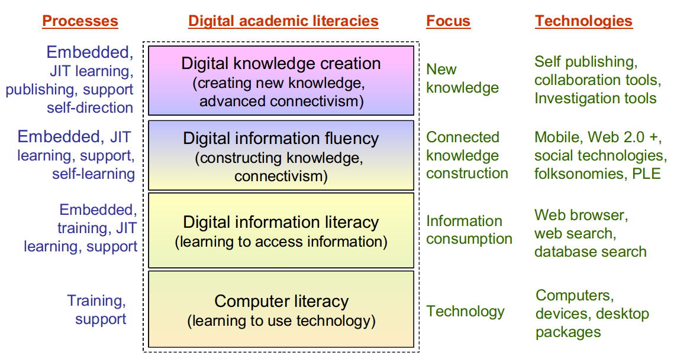Illustration 1: Digital academic literacies, after Keats et al. 2004.

Digital information fluency (Illustration 1) evolves as students gain more practice in connecting with information and other learners, and are guided in such a way that they are able to connect elements of digital information and construct them into their own knowledge in a meaningful way. Information fluency has been described in terms of the combining of critical thinking skills with basic computer literacy and information literacy. Broadly, information literate students are able to identify and develop a topic, find background information both in print electronic and audiovisual formats, critically evaluate and assimilate found information, organise and synthesise information and use information ethically and legally. Digitally fluent students are mobile, and able to adapt to technology and circumstance. They are highly connected, and use a variety of social networking tools, participating actively in the use and creation of folksonomies. They take a connected approach to learning, and are able to make use of a number of tools that enable their personal learning environment to be created and controled by themselves. Here the processes are fully embedded in the curriculum, under the responsibility of the student, and to a lesser degree, the lecturers. It is supported by access to just in time learning, mainly via the Internet, and some support is available through the e-learning structures. It is, however, expected that self-directed learning will be a key practice at this level.

Digital knowledge creators (Illustration 1) build and publish new knowledge, which may be via formal research or the interpretation of information from a variety of sources. They are supported by effective research library services that are distributed and available independently of time and space. They publish blogs, contribute to global information resources, and may publish in the formal academic literature. They are highly connected, and collaboration is second nature to them, whether collaboration within formal learning situations or outside of them.

Currently, computer and information literacy is handled in a variety of ways that are not coordinated, or implemented with a common sense of purpose. The library has programmes targeted particularly at the skills needed to be effective library users. Some faculties and schools have computer literacy programmes, but often they do not know about one another, and there is little synergy among them. One of the tasks of the eLearning manager will be to take stock of the current approach, and develop a plan for improving the digital academic literacies of our students.

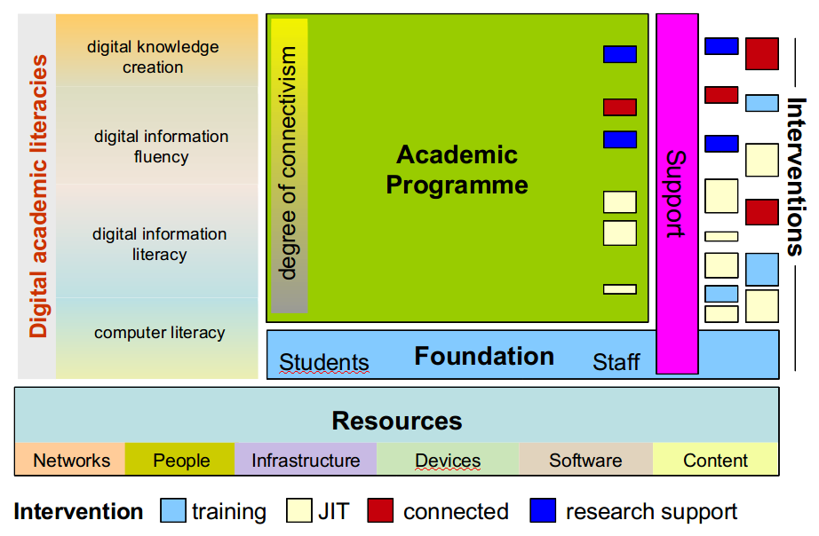Illustration 2: Schematic model of digital academic literacies in relation to the academic programmme. and the type and frequency of interventions.
Basic computer literacy is a requirement for effective and efficient acquisition of sound information literacy skills. For many undergraduates and postgraduates, computer and information literacies are not always sufficient to optimally take advantage of e-learning. In this context, the basic computer and information literacy would form basis for a foundation-building programme that all students who do not have the basic competencies will be expected to engage with until such time as the student profile changes and it is no longer necessary in the same form (Illustration 1). Support must be available through the foundation-building programme, as well as in different forms throughout the academic programme. However, the number of formal interventions decreases as the students move up through the levels of digital academic literacy, and they change from training interventions to more just-in-time (JIT) learning opportunities and self-directed study.

Interventions must be available not only for students, but also for academic staff who are going to have to take responsibility for ensuring that their students progress in their digital academic literacies. An important concept here is just in time learning, and helping students wean themselves off dependency on training to be come more connected in their approach. Examples of skills and competencies for students and academic staff at each of the four levels of digital information literacy are presented in the table below.

Table 1: Level of academic literacies and key competencies for students and academic staff at each level (Sources consulted: Anon 2000; Anon 2003a; Bawden, 2001).
Level | Students | Staff
Computer literacy | - Able to interface with a computer and view it as a simple tool;  - Able to create, manipulate and share documents, spreadsheets, presentations, and other digital forms of information  - Able to use email, mailing lists, discussion forums, social networks and text chat for to communicate with lecturers, administrative structures, and fellow students  - Able to use the worldwide web to conduct basic searches and access information  - Understands the computer as an information tool | - Are themselves computer literate to an appropriate level  - Understand the requirements of, and limitations on, students at this level and provide appropriate challenges within the curriculum  - Demand that students use computers to do assignments  - Interact with students by email and other means of electronic communication
Digital information literacy | - Understands the power and limitations of IT tools  - Defines the problem or task  - Recognizes the need for information  - Plans a search strategy and locates sources of information  - Organizes information appropriately for the task  - Synthesizes information from different sources and presents information logically in relation to the problem or task  - Creates a product, such as essay, podcast, presentation or video, to communicate the synthesis  - Cites and references information correctly and does not plagiarize  - Assesses the product and reflects on the processes | - Provides clear guidelines for assessment of assignments submitted digitally (e.g. using rubrics)  - Creates assignments that are explicit in what is being asked, and uses a variety of assessment tools and techniques  - Uses the web to reduce incidences of plagiarism  - Helps the student to reflect on the product and the processes
Digital information fluency | - Information is used for problem solving  - Uses flexible, advanced search strategies  - Collects the information necessary to consider a problem or issue  - Uses and synthesizes information from a variety of sources  - Employs critical thinking skills in the evaluation and analysis of the information and its sources  - Formulate logical conclusions and present those conclusions in an appropriate and effective way  - Engages in independent, self-directed learning as and when needed  - Shows persistence and attention to detail in accessing and using information  - Makes effective use of software tools to create a personal learning environment  - Maintains an ePortfolio  - Understands the economic, legal, and social issues surrounding the use of information, and accesses and use information ethically and legally | - Understands the competencies expected of students at this level  - Demands the synthesis of different sources of information  - Provides assessment items that challenge the students  - Engages students in meaningful discussion, for example using a threaded discussion forum  - Encourages students to build their own personal learning environment, including maintaining an ePortfolio
Digital knowledge creation | - Recognizes a gap in existing information or knowledge and seeks to find ways to create it  - Is able to model processes and analyze problems by combining ideas from different domains  - Is able to use a computer to display an analysis graphically to create visual models  - Writes blogs and communicates independently of formal requirements including the use of social networking, podcasting and videocasting for their knowledge creation and promotion purposes. | - Supervise and mentor independent learners  - Encourages collaboration, active public writing and other forms of communication (e.g. blogs, podcasts, videocasts) for their knowledge creation and promotion purposes

It is clear that in the implementation of this approach to digital information literacy will require considerable interaction with the academic staff on whom the success hinges. In this regard, it becomes essential to realize that:
- not all staff are able to use technology effectively in support of teaching-and-learning;
- not all staff have attitudes conducive to their active participation in the use of technology in support of teaching-and-learning;
- current promotion structures are not designed to reward excellence in the use of technology in teaching-and-learning, although they do not preclude doing so.
Therefore, it will be necessary to address all three of these areas of concern before the approach of Digital Academic Literacies across the curriculum will be effective.

In terms of abilities and attitudes, we can imagine a series of user stages at which any given academic may be at in relation to individual readiness to participate in the use of technology in teaching-and-learning (Illustration 3). Each case will require a different kind of intervention, and the eLearning basket of offerings to academic staff will take appropriate consideration of all stages.

At the pre-entry stage, they may be ignorant of the technology and its academic potential, or they may show avoidance of technology (Illustration 3). Different interventions will be necessary, and it may be that some will continue to avoid using technology no matter what intervention is applied.

Academic users may be at the stage of considering the use of technology already, or as a consequence of one of the interventions (Illustration 3). At this stage they will be mainly individual users, experimenting with what technology may do for them, but not yet fully converted to seeing the benefits of technology in their academic programme. Here a different kind of intervention will be required so that the staff members at this stage undergo conversion to the use of technology in the classroom. Further interventions may be required to help academics gain a level of confidence and trust in technology so that they become committed to its use, and therefore dependent on it for their academic programmes. It is beyond the scope of this document to design those interventions, but this framework will help guide the design and implementation of interventions with academic staff to ensure that digital academic literacies are fully catered for in the academic programme.
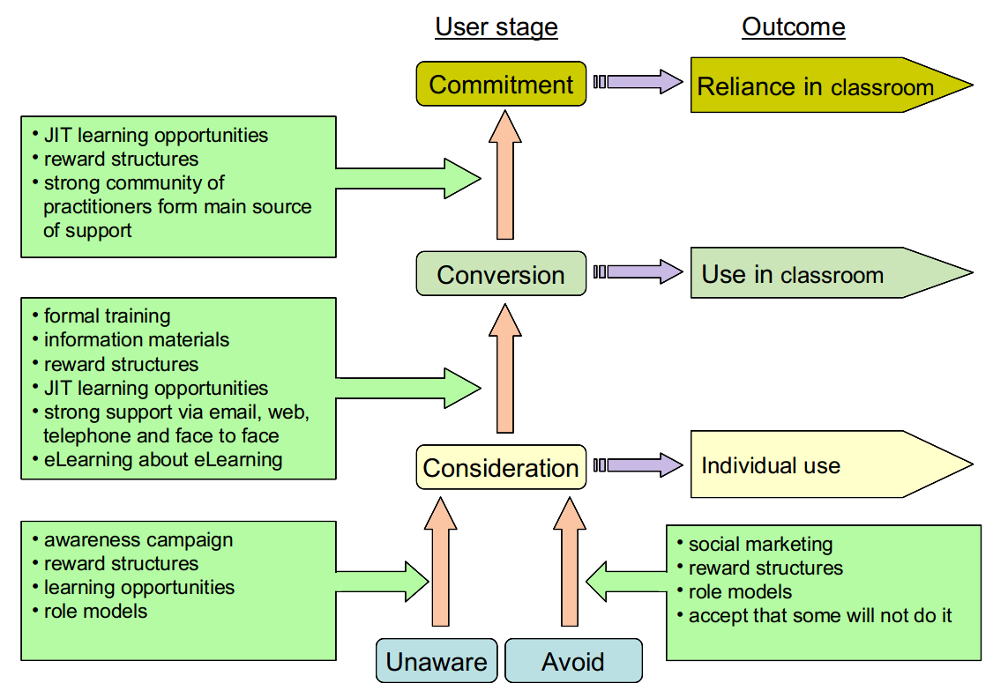Illustration 3: Schematic model for different interventions at different user stages to achieve desired outcomes (based on a conversation with Karolina O'Donoghue).

Rewarding eLearning work
Participation in e-learning initiatives by academic staff has been shown to be related to:
- experience and familiarity with technology;
- positive experiences in the past;
- positive attitudes and innovative thinking;
- adequate support structures and access to the appropriate technology;
- incentives and reward structures.

The first four of these are addressed in the above section. However, it must also be realized that the approach described here places a significant component of digital academic literacies in the hands of the academic staff by promoting an “across the curriculum” approach. Academics will therefore need to be provided with incentives and encouragement for active participation in digital academic literacy work, as this represents a change in the nature of academic work itself, although correctly implemented it should not mean an increase in the work load.

One way to achieve this is through the promotion system within the University. Currently, promotion at Wits is dependent on a number of criteria, including teaching-and-learning, academic citizenship, and research output. Teaching-and-learning output is assessed via a teaching-and-learning portfolio that must be submitted when a promotion is being sought by an academic staff member. Promotion criteria will need to be modified to ensure that academic staff who are seeking promotion address how they have engaged with their students around digital academic literacy issues and other aspects of eLearning as part of their teaching portfolio.

Another way to deal with this is within an academic performance appraisal framework where deans have regular conversations with heads of schools about their school's participation in e-learning activities, and heads of schools have regular conversations with their academic staff in relation to performance in the area of e-learning. This would have to happen in a performance management framework within the academic sector, something that is not yet specified.

A third way to deal with rewarding eLearning work is to provide for research opportunities, as explained in the TIPS model. According to this model, the researcher who is part of the eLearning team will assist academic staff wishing to innovate in teaching-and-learning through eLearning. This will lead to academic publications, which is one of the criteria used for personal promotion.

For schools that allocate teaching loads according to a model, eLearning contribution could be built into the model if staffing and funding level alow.

eLearning preparation grants could provide another incentive. They could be small grants of R10-20 000 of which a limited number are made available each year, administered by the Senate Teaching-and-Learning committee. Making 50 grants of R10 000 available would cost R 500 000 should they all be taken up in any given year.

The TIPS model of eLearning
The Technology-Innovation-Pedagogy-Support (TIPS) model is designed to foster both innovative and routine use of eLearning, and ensure that both aspects are supported (Illustration 4). TIPS was developed based on work done at the University of the Western Cape (UWC) as well as on observations made on visits to other institutions. It is based on the process model (process-technology-people) of technology implementation in which the process is pedagogy for eLearning. This model has been presented to SET as a general model for innovation within the KIM portfolio, and has been approved as part of the proposal for incorporating eLearning into KIM.

There are four quadrants in the innovation cycle (Illustration 4):
- defining the pedagogical innovation (top right);
- negotiating the practical aspects of the pedagogical approach and translating it into the first iteration of an achievable technical design;
- creating the technical innovation, typically involving software development, at times in conjunction with some innovative choice and use of hardware;
- translating the technical innovation back into the improved pedagogy, and supporting the new technology

The most important aspect of TIPS is the pedagogical end (teaching-and-learning, postgraduate support). There are opportunities to be innovative in pedagogy, which can be enabled by technology (Illustration 4). While there are some opportunities for innovative pedagogy with packaged eLearning software, the best opportunities arise where the technology is supported and there is local development capability.

Both ordinary (inner pink-shaded area) and innovative eLearning require a high level of support (Illustration 4). Therefore support is at the heart of TIPS, and the eLSI unit support the institutional eLearning processes and applications (Illustration 4). This support should be structured and organized, highly focused, and led by a champion of both ordinary and innovative eLearning who is the manager of the eLSI unit. While the eLSI unit is responsible for supporting the application and providing systems administration at the application level, the hardware technology, operating system and database level support is the responsibility of Computer and Networking Services (CNS).

The primary interaction with academic staff will be via the instructional design team. The instructional designers will offer workshops, formal training, one-on-one consultation and generally support the lecturers in becoming involved in eLearning. A link will be developed with the Academic Planning Office (APO) so that anyone approaching APO would be advised to talk to someone in eLSI with respect to designing course activities. The eLSI will not, however, be directly involved in creating content for the lecturers. In the Wits blended approach, it is not economically viable to provide content development for academic courses by staff within the eLSI unit.
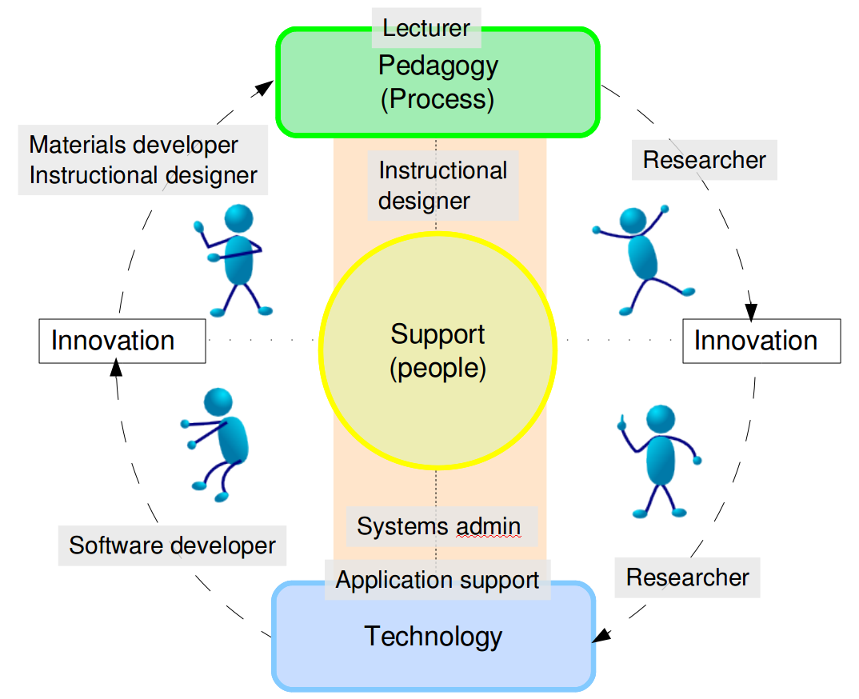Illustration 4: Diagrammatic representation of the TIPS model.
The innovation cycle surrounds the support area, with innovation being separate from general systems improvement. It should be something tangible, that can be evaluated, and that can generate a research output if the cycle is completed. It begins when a lecturer has an idea for an improvement to teaching-and-learning and expresses it to an instructional design team member. Alternatively, an innovative idea may be expressed to one or more lecturers by the instructional designer or anyone else involved in the eLearning process, or may be simply expressed as a systems improvement that is then implemented and researched. It is important to allow for some flexibility in how innovation happens.

Central to this process is fortnightly research meetings which comprise the eLearning team who may invite academic staff members to attend. Innovative ideas are then discussed with the researcher and team leader of software development, and viable options are implemented as a project under the leadership of the researcher and lecturer(s). Some of these projects may become research projects for postgraduate students in eLearning within the School of Education or other areas. Software projects may also be suitable for research projects in the School of Electrical Engineering or Computer Science.
In the Wits blended approach, it is not economically viable to provide content development for academic courses by staff within the eLSI unit.
Once a research project is agreed to, the specifications of the software end are drawn up in a simple, agile manner that includes the software development team in the planning. The software development team then create the tools necessary to bring the idea to fruition, and this may include partnership with the relevant school or the use of interns. Agile methodologies will be used, and there will be opportunities for refinement before the software is brought into production.

The researcher and the instructional design team will work with the lecturer to bring the innovation back into the classroom. The materials development team will be responsible for providing documentation for the new or improved tools, including documentation for both lecturers and students. Appropriate, ethical research methodologies will be used to evaluate the application of the new or improved technology, and the researcher and lecturer(s) will jointly author one or more research papers, as well as give presentations at relevant conferences funded through normal sources of conference funds.

In addition, continuous systems improvement may also take place independently, both in the Wits TIPS cycle, as well as elsewhere in the AVOIR network of which Wits is a part. Innovations that happen elsewhere in the network may also lead to innovations in pedagogy at Wits. These may also lead to research outputs, which may happen collaboratively with academics outside of Wits.

The TIPS model will benefit from strong collaborations with the School of Education, the School of Electrical and Information Engineering, the School of Computer Science and possibly other schools within the University. Establishing those relationships will be the responsibility of the eLearning Manager, who may delegate some of this to the researcher or other eLSI team members.

A bi-weekly eLearning seminar series will be initiated and promoted so that academics may showcase their eLearning experience. While there may be occasional guest lecturers, it is expected that most of the presenting at these seminars will be done by academics using eLearnin in their teaching and learning. The seminars will feed into the community of practice, and will be captured and available via the eLearning site.

Technology for eLearning
While the focus of eLearning must be on the processes of learning (pedagogy, autogogy), some technologies are necessary for eLearning to be effective at an institutional level. The choice of core technologies for eLearning arise out of the TIPS model and the acknowledgement that Wits aspires to be world class but to do so within its African context. At the time of writing, Wits runs a proprietary 'Learning Management System', WebCT/Blackboard. To achieve TIPS, the ideal scenario would be one in which we have a Free Software (Open Source) eLearning application that is close to the cutting edge of technology, as well as the team to collaborate in producing enhancements in response to the innovation requirements.

WebCT/Blackboard will be phased out as soon as is feasible, before the expiration of its license in 2011. Staff using this technology will be assisted with moving their course onto the new system. Where functional compatibility does not exist between systems, alternative approaches will be sought, and if necessary functionality will be added to the new system provided it is reasonable to do so.

eLearning system

To achieve the TIPS model, the eLearning system should meet the following criteria:

Principle | Reason
Be Free Software (open source) according to the 4 freedoms | Consistent with the KIM mission, and gives us complete control over the full stack of applications that impact our content and data.
Based on a sound architecture that embeds good software engineering principles | TIPS includes relationship with Electrical Engineering and Computer Science students, who should be exposed to appropriate architecture. Good architecture also facilitates both innovation and stability.
Modular design permitting new functionality to be developed without compromising existing functionality | Reducing the risk that innovation will lead to system breakage.
Scalability to thousands of users, and able to integrate into both public and private cloud, ability to distribute processing across multiple servers and technologies | The system must be able to grow as demand increases, and growth should be seemless and not require rebuilding to increase capability.
Have an open API and be easily integrated with other software that has open APIs, including XML based RPC | Consistent with life in a post-Web 2.0 world of open connections among software, content and conversations.
Be able to create interfaces that can be used on mobile devices such as cellphones (e.g. by XMPP) and other devices | Ensures that we are able to take advantage of ubiquitous technologies, whatever they may be at a particular time.
Create synergy with other software initiatives that we are engaged in at Wits | Allows us to leverage a common skills base.
Be supported by a community which Wits can easily belong to, contribute to and derive benefit from and which presents minimum barriers to participation | Allows for the rapid building of our ecosystem, which is necessary to move as quickly as possible.
Preferably has a strong Africa-led focus | Allows us to be consistent with the desire of Wits to be World Class within its African context.

To achieve these principles, we will work with the African Virtual Open Initiatives and Resources (AVOIR), building on, deriving benefit from, and contributing to its Chisimba application development framework, and the KEWL third generation eLearning instance of Chisimba. Capacity to do this has already been established, and interns have been trained in basic and advanced Chisimba development by making use of the AVOIR network. A node of the AVOIR network has been established in the Joburg Centre for Software Engineering (JCSE), and this will be developed further over time.

Release management for stability

While no software is ever completely free of flaws (bugs), where systems are under continuous development and improvement as demanded by the TIPS model, it is vital that a release management process exist and that it follow change management principles (Illustration 5). A change management board for eLearning will be established to oversee the release management process.
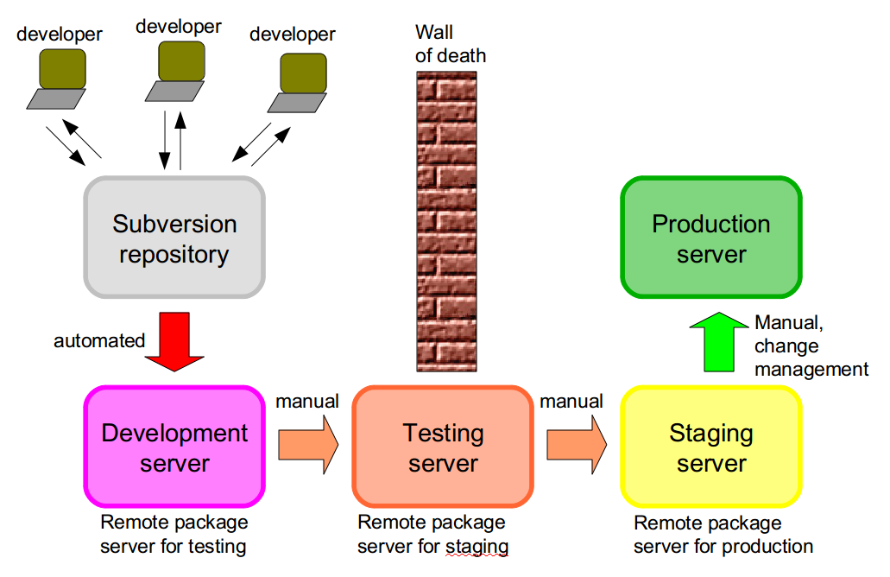Illustration 5: Release management for eLearning software

Hosting the eLearning system

CNS will host the eLearning system in a private cloud that is within the Wits data centre. The application and content will be placed into full enterprise backup, including the application and its settings, user generated content, and database. CNS will provide for the administration of the technology at the level of the private cloud, the operating system, database, storage and backup. CNS will also provide for Memcached servers to improve data access performance.
The infrastructure will be available 24/7 and will be treated as any other mission-critical enterprise application.

Web 2.0 applications

A variety of Web 2.0 and post-Web 2.0 applications exist that can benefit eLearning. The eLearning software will support such applications wherever possible. The eLearning team will support academics who wish to employ such applications in their eLearning and encourage the incorporation of them into the course presence on the eLearning system. These include content applications such as YouTube, SlideShare and others; communication applications such as Twitter; and widget-based applications.

Innovation on ubiquitous technologies

We tend to think of eLearning as being web-based, and this is substantially the case. However, there are ubiquitous technologies such as music players and cellphones that students and lecturers possess. The eLearning team will be familiar with the opportunities presented by such technologies, and will work with software developers where necessary to ensure that Wits is able to provide for eLearning opportunities using such technologies.

Classroom technology

Wits will create and sustain technology-enabled classrooms. The minimum classroom technology for eLearning includes:
- wired or wireless network access;
- operating system independent presentation facilities that include a data projector and screen;
- in larger classrooms, a sound system;
- fixed or mobile podcasting capability.

We should also investigate the potential of 'smartboard' type of technologies for selected classrooms, with the requirement that any such technologies be compatible with GNU/Linux, Apple Mac, and Windows.

Student labs

Wits will create and sustain an appropriate number of student labs by a mixture of central labs under CNS control, and labs established by faculties and schools in collaboration with CNS. Labs will employ a diversity of technologies, so that students leave Wits having been exposed to personal computing operating systems besides the current standard very old version of Microsoft Windows. These include, but are not limited to, the following:
- Microsoft Windows;
- Apple Mac OS
- GNU/Linux
- Open Solaris via thin clients

eLearning will be possible irrespective of what platform is used in the labs or on other client machines.

Student ownership of computers

Wherever possible, students will be encouraged to own computers or other personal computing devices. Wits will investigate possible means for students to finance their ownership of computers, via third parties, by will not enter into any arrangement that requires the University to accept or own any risk.

Mobility

eLearning make use of mobile options, and Wits will provide wireless hotspots throughout our campuses to ensure that students and staff are able to participate in eLearning activities where ever they are. eLearning systems will facilitate mobile engagement between staff and students.

Collaboration and synergy

Fostering collaboration and synergy

The eLearning team's modus operandi will be collaborative and they will seek synergy wherever it is feasible to do so. The following are some of the collaborative and synergy creating practices of the eLearning team:

- The eLearning manager may hold an adjunct role in the School of Education and may co-supervise postgraduate students working in the area of eLearning where this is beneficial to Wits;
- Staff and postgraduate students of the School of Education may assist the eLearning team from time to time, and may conduct research and case studies on work carried out in eLearning at Wits;
- The eLearning researcher may hold an adjunct role in the School of Education and may co-supervise postgraduate students working in the area of eLearning where this is beneficial to Wits, and may also research eLearning opportunities in the school in accordance with the TIPS model;
- The eLearning team will establish and play active roles in eLearning communities of practice, especially involving other sites implementing the same software and similar approaches;
- The eLearning team will collaborate with international researchers in the field of eLearning;
- The eLearning development team will participate actively in AVOIR, and will contribute and improve code, fix bugs on bug days, will participate actively in the mailing list of AVOIR developers, and will collaborate with other Chisimba developers at Wits (for example the Web team);
- eLearning technology will be shared via a private cloud in order to achieve efficiency and scalability;
- Internships will be offered to students in a variety of faculties where benefit to eLearning can ensue, including Education, Arts, Electrical and Information Engineering, Computer Science, and any others for which an appropriate match can be found (a particular focus will be on content developers collaborating with Wits TV to supervise interns in the area of video production);
- eLSI will work closely with the Academic Planning Office so that new programmes are referred and encouraged to engage in eLearning activities from the start;
- eLSI will work closely with CLTD to seek mutually benefical opportunities to use eLearning to develop Wits staff and to use CLTD to help develop eLearning;
- eLSI will work closely with CNS within the KIM portfolio on the technology for eLearning, including the back end systems, classroom technologies, network infrastructure, and faculty ICT committees;
- eLSI will work closely with the project office of CNS within the KIM portfolio where project management services are needed;
- eLSI and the library will collaborate within the KIM portfolio to ensure that library services are integrated into eLearning, and that eLearning opportunities exist to learn about library offerings;
- eLSI and Management Information Unit within the KIM portfolio will work together to improve the BI reporting opportunities provided by a common, shared eLearning platform over which we have complete technical control.

These are examples of where collaboration and synergy can be created. Others are not precluded by not being mentioned in this section.

Community of practice

Communities of practice are important as a means of creating and sustaining a knowledge ecosystem. A community of practice can be thought of as a group of peers who share a common interest, deal with a common class of issues or problems, or that share common methods, procedures or tools. A community of practice benefits from shared knowledge, ideas, attitudes and best practices. They are a way of co-creating better, more effective or efficient ways to meet their commitments.

Communities of practice should not be confused with teams. Teams are driven by deliverables (project orientation) so they tend to be tightly-integrated, while communities of practice are driven by organizational and individual value so they tend to be more loose-knit. A team may exist within, or adjacent to, a community of practice in an organization.

Virtual communities of practice are those that are not co-located in space or time. They recognize the need to share information, ideas, and experiences both within and among the organizations in which the members work. They understand both the possibilities and limitations of information and communications technologies, and accept and support processes that make use of computer technology.

Communities of practice can be deliberately established around any area of endeavour, and ideas from community of practice can be used effectively in building support mechanisms for learning. Fundamental to such communities of practice is the notion of peer-peer learning in which learning is supported not by a mentor or teacher, but by communities of peers some of whom possess competencies that may benefit others in the community.

In terms of implementing this e-learning strategy, it is crucial to build in peer-peer learning opportunities supported by other components of a knowledge ecology such as frequently-asked questions, topic-specific online peer-peer support forums, in addition to adequate institutional support mechanisms. There are probably five communities of practice that apply here, the software developer community that is already established, the eLearning practitioner community of practice which needs to be restarted, a lecturer community of practice, a eLearning researcher community of practice, and a student eLearner community of practice. The eLearning team will participate in or create these communities in order to facilitate the implementation of this strategy.

Pedagogical approaches

The eLSI will not demand particular pedagogical approaches, but will support whatever pedagogy academic staff wish to employ, while at the same time raising awareness of appropriate pedagogies, including constructivist approaches and will ensure that there is awareness of emerging approaches, such as connectivism, autogogy and personal learning environments.

eLearning Support and Innovation unit structure

Consistent with the TIPS model, the eLearning Support and Innovation unit will be structured as indicated in Illustration 6.

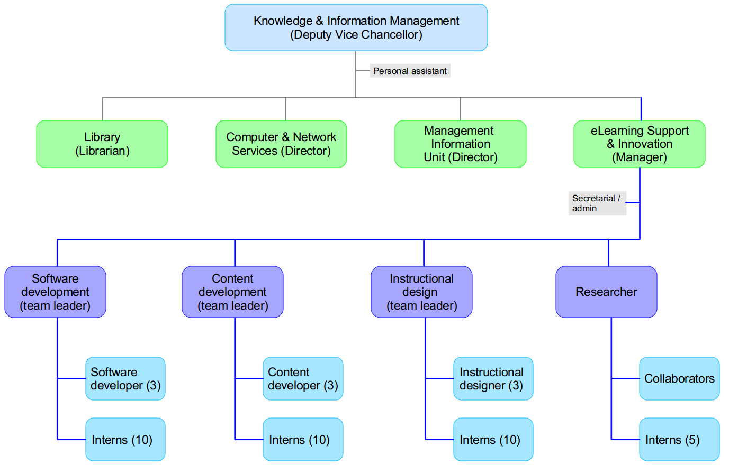Illustration 6: Organogram of KIM with the eLearning Support and Innovation unit.

Five year growth plan

As eLearning takes off in Wits, there will be increasing demands on the eLearning team to provide more support and cater for more innovation. There will be a real risk that the eLearning initiative will be killed by success unless plans re made for increasing the size of the team and its operational budget to cater for increasing demand. It is likely that the greatest pressure will be on the instructional design team, but all areas have potential for growth.

It is anticipated that this situation should stabilize in about five years (there is no way to estimate this with any accuracy), so we should cater for this growth in our planning and budgeting. However, the entire growth requirement does not have to be met from the University's core funding. The suggestions below will have to be revisited as eLearning develops at Wits.

Growing research

Research is an area that presents a number of development opportunities, including seeking NRF and other research funding, international projects, endowed chairs, funding for postdoctoral fellows, and postgraduate bursaries. This will demand an excellent research output, so it is important to ensure that a competent researcher is appointed to the research position. Research output will also generate internal research funds. It is not anticipated that Wits will fund additional posts in this area beyond providing for research internships.

Growing software development
Software development capacity will probably need to grow and diversify as more Wits academics realise the power or pedagogical innovation through technology. While it might be necessary to grow the software development team beyond the four that we envisage by 2010, it is likely that this can be accomplished by strengthening our relationship with other organizations within the FOSS AVOIR network and therefore 'collabsourcing', as well as through bilateral relationships with certain AVOIR universities that are most active in the eLearning aspect of AVOIR.

Growing instructional design

Growth in the instructional design area will probably require investment from the university, and it is envisaged that one additional instructional designer will be needed in 2010, with two more by 2011, with any further enhancements will be met through providing internships which will also have to be funded.

Growing content development

In 2010, it is envisaged that we will need to add one content developer to oversee the video interns who will be mainly managed by WitsTV in the School of Arts. Any additional content development requirements will be met through internships.

Digital academic literacies (DAL)

Pending the recommendations that arise out of the investigation into current DAL practices, it may be necessary to budget for improvements in this area. It is premature, however, at this stage to delve further into this area.

Critical success factors
The following critical success factors are extracted from the text of this document..

Critical success factor | Implication for eLSI | Responsibility
Academic staff will have the educational and theoretical background, as well as the skills, competencies and technologies needed to develop and manage courses that include access to and use of information and communications technology, and an understanding of the key competencies implied by each of the four digital academic literacies | eLSI prepares and implements marketing plan, creates training programme, arranges consultations, and creates just-in-time learning content | Primary: eLSI  Secondary: Deans, Heads of Schools, Academic staff
Basic computer and information literacy will be investigated with a view to establishing the current situation, and building an institutional approach that creates as much synergy as possible. | This is the foundation on which any further interventions are built. If we cannot have common literacy levels, other interventions are harder and more inefficient | Primary: eLSI  Secondary: Library
Basic computer literacy will be provided for by offering classes and programs at different levels of learning, teaching and research. | Training programmes, online tutorials, marketing and consultation | Primary: eLSI Secondary: CLTD, Library, Academic staff
Library staff will collaborate with academic staff and eLSI to incorporate information literacy into the normal academic curriculum, and this will be supported by a number of interventions that include short courses and other just-in-time learning opportunities such as pamphlets, brochures, website content, non-credit online courses, seminars, etc. | Collaborate with the library and academic staff in providing online tutorials, marketing and consultation. | Primary: Library staff Secondary: Academic staff & eLSI
Except for the basic computer literacy, digital academic literacies will be incorporated into the normal academic curriculum by all academic staff, and this will be supported by a number of interventions that include short courses and other just-in-time learning opportunities such as pamphlets, brochures, website content, non-credit online courses, seminars, etc. | Marketing, training, consultation, just-in-time learning, case studies | Primary: eLSI  Secondary: Deans, Heads of Schools, Academic staff
Academic staff seeking promotion will be afforded an opportunity to address how they have engaged with their students around digital academic literacy issues as part of their teaching-and-learning portfolio. | Clearly spelled out criteria for use in decision making | Primary: Faculty staffing and promotions committees  Secondary: eLSI (researching and providing example criteria), providing advice when asked
Academic staff wishing to use eLearning as an opportunity for innovation in teaching-and-learning will be assisted with turning their innovation into a research project that will generate research outputs that will contribute to the research profile of the staff member. | Research in the eLSI is strong, and led by a 'neurotically productive' researcher | Primary: eLSI  Secondary: Partner academics
Pedagogical innovation will be promoted via the TIPS model, with strong research capability leading, supported by software development, content development (documenting the innovations for users) and instructional desigh (assisting with the design of implementation). | The full ecosystem to support TIPS is in place and functioning effectively | Primary: eLSI  Secondary: Research partners such as School of Education
Technology to support eLearning and the TIPS model is in place and supported at an institutional level, including the KEWL3 eLearning system. | CNS will host the eLearning system in a private cloud, and fully supported, within the Wits data centre | Primary: CNS  Secondary: eLSI (application level)
The eLearning team will support academics who wish to employ such applications in their eLearning and encourage the incorporation of them into the course presence on the eLearning system. | Knowledge and content resources are developed and used by the instructional design team | Primary: eLSI
The eLearning team will be familiar with the opportunities presented by ubiquitous technologies, and will work with software developers where necessary to ensure that Wits is able to provide for eLearning opportunities using such technologies. | Knowledge and content resources are developed and used by the instructional design team; software enhancements are made by the development team | Primary: eLSI
Wits will create and sustain an appropriate number student labs by a mixture of central labs under CNS control, and labs established by faculties and schools in collaboration with CNS. | CNS collaborates with the faculty ICT committees and schools to determine accurately the current student:computer ratio, and develops a joint plan of action, taking cognizance of the potential for students to own computers. | Primary: CNS
Students leave Wits having been exposed to a diversity of personal computing operating systems | CNS develops the capacity to support GNU/Linux, Open Solaris thin clients, and Mac OS in addition to the current Microsoft Windows support. Student labs are appropriately equipped, including single boot systems, multiple boot systems and virtualized systems. | Primary: CNS
Technology enhanced classrooms are the norm for Wits | PIMD & CNS conduct an audit of technology enhanced classrooms at present, and produce an action plan. | Primary: PIMD  Secondary: CNS
Wherever possible, students will be encouraged to own computers or other personal computing devices. | Investigate possible means for students to finance their ownership of computers, and produce a plan of action. | Primary: CNS  Secondary: Finance
eLearning make use of mobile options, and Wits will provide wireless hotspots throughout our campuses to ensure that students and staff are able to participate in eLearning activities where ever they are. eLearning systems will facilitate mobile engagement between staff and students. | Provision of hotspots and other mobile technologies, | Primary: CNS  Secondary: eLSI
The Wits network needs to be made more stable both internally and externally, and more compatible with the academic demands of a world class university. | KIM lead project to investigate the network, and redesign it to meet our requirements | Primary: CNS  Secondary: DVC KIM
The eLearning manager and researcher may hold an adjunct role in the School of Education and may co-supervise postgraduate students working in the area of eLearning where this is beneficial to Wits. | Negotiate the appropriate institutional arrangements | Primary: eLSI  Secondary: School of Education
Staff and postgraduate students of the School of Education may assist the eLearning team from time to time, and may conduct research and case studies on work carried out in eLearning at Wits | Negotiate the appropriate institutional arrangements | Primary: eLSI  Secondary: School of Education
The eLearning team will establish and play active roles in eLearning communities of practice, especially involving other sites implementing the same software and similar approaches | eLearning manager to take a lead in setting up and sustaining communities of practice | Primary: eLSI
The eLearning team will collaborate with international researchers in the field of eLearning wherever it is feasible and desirable to do so; | eLearning manager to take a lead, together with the researcher | Primary: eLSI
The eLearning development team will participate actively in AVOIR, and will contribute and improve code, fix bugs on bug days, will participate actively in the mailing list of AVOIR developers, and will collaborate with other Chisimba developers at Wits (for example the Web team); | Team Leader, software development has this as a KPI | Primary: eLSI
Internships will be offered to students in a variety of faculties where benefit to eLearning can ensue, including Education, Arts, Electrical and Information Engineering, Computer Science, and any others for which an appropriate match can be found (a particular focus will be on content developers collaborating with Wits TV to supervise interns in the area of video production); | This must be common practice throughout eLSI | Primary: eLSI
eLSI will work closely with CLTD to seek mutually benefical opportunities to use eLearning to develop Wits staff and to use CLTD to help develop eLearning; | Both eLSI and CLTD and the campus community benefit from creating this synergy | Primary: eLSI  Secondary: CLTD
eLSI will work closely with CNS within the KIM portfolio on the technology for eLearning, including the back end systems, classroom technologies, network infrastructure, and faculty ICT committees; | This ensures that the eLearning infrastructure is present and supported adequately | Primary: eLSI  Secondary: CNS
eLSI will work closely with the project office of CNS within the KIM portfolio where project management services are needed; | We should not duplicate project management services, although project management costs will have to be costed into projects | Primary: eLSI  Secondary: CNS
eLSI and the library will collaborate within the KIM portfolio to ensure that library services are integrated into eLearning, and that eLearning opportunities exist to learn about library offerings; | This ensures that library resources are used effectively, and that eLearning supports the training and JIT learning requirements of the library | Primary: Library  Secondary: eLSI
eLSI and Management Information Unit within the KIM portfolio will work together to improve the BI reporting opportunities provided by a common, shared eLearning platform over which we have complete technical control | Improving the quality of information available to support improvements to teaching-and-learning | Primary: MIU  Secondary: eLSI
Pedagogical approaches that foster active learning, connected learning, personal learning, etc are supported. | Improving the quality of teaching and learning | Primary: eLSI  Secondary: academic staff participating in eLearning

Milestones

Below are a list of milestones to be achieved in eLearning at Wits in the short term (< 6 months). In the responsibility column, the person or structure responsible for seeing that the milestone is achieved is given. This person or structure might not be the one responsible for doing the work, but is accountable for seeing that it is done. These are the milestones most important with respect to setting up the eLSI, other milestones will be determined together with the eLSI manager, and this document updated accordingly.
Milestone | Date | Responsibility | Status
Establishment of eLearning Support and Innovation Unit – appointment of manager | September 31, 2009 | Prof Derek Keats
Establishment of eLearning Support and Innovation Unit – appointment of Team Leader, Instructional Design | September 31, 2009 | Prof Derek Keats
Establishment of eLearning Support and Innovation Unit – appointment of Team Leader, Content Development | September 31, 2009 | Prof Derek Keats
Establishment of eLearning Support and Innovation Unit – appointment of Team Leader, Software Development | September 31, 2009 | Prof Derek Keats
Establishment of eLearning Support and Innovation Unit – appointment of Researcher | January 31, 2010 | Prof Derek Keats
Provide a demonstration eLearning server | August 14, 2009 | Prof Derek Keats
Complete testing and evaluation, and provide list of feature requests | September 30, 2009 | Fatima Rahiman
Provide private cloud infrastructure for eLearning and other initiatives | November 30, 2009 | Nhlanhla Mabaso
Ensure that eLearning software is installed and operational in Wits private cloud | December 7, 2009 | Nhlanhla Mabaso
KEWL3 / Chisimba training for academics (initially to be incorporated with CLTD training) | September 1, 2009 | Fatima Rahiman
Full compliment of staff for eLSI in place | March 1, 2010 | eLSI manager

Dictionary of acronyms
AVOIR – African Virtual Open Initiatives and Resources, see http://avoir.uwc.ac.za/
BI – Business Intelligence
CLTD – Centre for Learning and Teaching Development
DVC – Deputy Vice Chancellor
eLSI – eLearning Innovation and Support Unit
ICT – Information and Communications Technologies
JCSE – Joburg Centre for Software Engineering
KIM – Knowledge and Information Management
SET – Senior Executive Team (the VC, DVCs and Deans)
TIPS – Technology, Innovation, Process (Pedagogy) and Support
UWC – University of the Western Cape
VC – Vice Chancellor

Literature cited

Anon, 2003a. Information Fluency Working Definition. At http://www.colleges.org/~if/if_definition.htm, viewed 2003 05 21.
Anon, 2000. Information Literacy Competency Standards for Higher Education. Association of College and Research Libraries, Chicago. At http://www.ala.org/Content/NavigationMenu/ACRL/Standards_and_Guidelines/standards.pdf, viewed 2003 05 22
Anon, 2007. University of Kent e-Learning Strategy 2007. At http://www.kent.ac.uk/uelt/
ced/themes/elearning/University%20E-Learning%20Strategy.pdf, downloaded 2009 07 31.
Bawden, D. 2001. Progress in documentation, information and digital literacies; a review of concepts. Journal of Documentation 57: 218-260.
Brandon, B. (ed.), 2007. The eLearning Guild’s Handbook of e-Learning Strategy. The eLearning Guild, Santa Rosa, CA, USA. 88 pp.
Keats, D.W., D. Meerkotter, K. O'Donoghue, C. Tapscott, E. Tise, J. van Bever Donker, I. Venter, S. Walters & T. Wood, 2004. An e-learning strategy for the University of the Western Cape. UWC Strategy Document.
Prensky, M. 2001. Digital Natives, Digital Immigrants. On the Horizon, MCB University Press, Vol. 9 No. 5, October 2001, at http://www.marcprensky.com/writing/Prensky%20-%20Digital%20Natives,%20Digital%20Immigrants%20-%20Part1.pdf, downloaded 2009 07 31.
Senate, 2005a. The University’s academic aims and values: a commitment to scholarship. The University of the Witwatersrand, Johannesburg, Senate document S2005/547B, 14 pp.
Senate, 2005b. Principles of teaching and learning. The University of the Witwatersrand, Johannesburg, Senate document, S2005/548a
Siemens, G. 2005. Connectivism: A Learning Theory for the Digital Age. International Journal of Instructional Technology and Distance Learning, Vol. 2 No. 1, Jan 2005 at http://www.itdl.org/Journal/Jan_05/article01.htm, viewed 2009 06 23.

any use of information and communications technology (ICT) in teaching-and-learning or postgraduate studies to enhance or support student learning and research
Connectivism is a learning theory “for the digital age” developed by George Siemens (2005) based on his analysis of the limitations of behaviourism, cognitivism and constructivism to explain the effect technology has had on how we live, how we communicate, and how we learn. Some argue that it is not a learning theory but a "pedagogical view,” but here it is used as a way to encapsulate how learning can happen in a digital world of connected conversations and knowledge.
I could not find a word to express the notion of using the network to accomplish tasks that would normally be undertaken in-house or outsourced to a third party. 'Collabsourcing' attempts to capture the notion of giving work to a network of which we are a part. It can be done for pay, much as traditional outsourcing, or by relying on community processes.

