Open access journals and publishing options in health sciences
Lisbeth Levey, OER Advisor, William and Flora Hewlett Foundation

January 2013
This paper is shared under a Creative Commons Attribution 3.0 License.

The term “open access” refers to resources (often scholarly journal articles) that are freely and publicly accessible to anyone worldwide. Depending the particular terms of use of a given open access journal, the journal may also allow people to copy, modify, or distribute the content of the articles under one of the Creative Commons licenses.

Research (from University of California at Berkeley, University of Toronto, Research Libraries UK, and others) has demonstrated that publishing in open access journals brings increased visibility, usage, and impact to the work of academics, researchers, and students. Open access publishing is compatible with copyright law and with scholarly traditions of peer review, and indexing of articles and citations as indicators of impact and prestige. For example, if an individual uses ideas or words from an open access article, he or she must include the article as a source. Likewise, if using excerpts or direct quotes from an open access article, he or she must designate them with quotation marks and attribution to the original author. There is even an Open Access Search Project in order to detect plagiarism.

Open access is particularly important within the African context. Journal subscriptions are expensive. Even though most African universities and research institutions can read journals in the biomedical sciences online at no charge through the World Health Organization’s HINARI Access to Research in Health Programme, these services are conditional, temporary, and the collection may be incomplete for an institution's research and curricular needs. Moreover, if Africa’s research output is to reach the scientific community worldwide, it must be widely accessible. Governmental and other organizations in several countries have therefore adopted open access policies for the research they fund and publish in order to promote the widest dissemination as possible. Some examples of particular relevance to the biomedical sciences:

- In the United States, the National Institutes of Health requires that the published results of the research it funds is made publicly available through its digital archive PubMed Central (PMC).
- Europe has established its own PubMed Central Europe PMC. Although the US and the European collections feed into each other and overlap significantly, the article collections are not identical and each offers different navigation and search options. Many important donors, such as the Wellcome Trust and the World Bank require open access deposit of the research they support. Some but not all of this research is deposited in PubMed Central US or Europe.

Due to accessibility and visibility considerations, many universities, such as the Massachusetts Institute of Technology, Harvard, and the University of California at Berkeley to name a few, encourage their academics to publish in open access journals and provide funds to cover author publishing fees required by some open access journals. Open access journals, in general, cover their costs not through subscription fees but rather through charging the author. The South African Department of Higher Education and Training has published a list of open access journals that qualify for a subsidy to cover the publishing fee.

Members of the African Health OER Network might want to explore open access journals for their own publishing efforts. There are a number of African open access journals in the health sciences. For example, African Journals Online (AJOL) includes 133 in the broad based medical sciences. (Note: The publication frequency of journals within AJOL differs significantly by title.)

In table 1 below, you will find a sample of African journals for health sciences that are open access.

Table 1: Sample of African Open Access Journals in the Health Sciences
Journal | Focus
African Health Sciences | African Health Sciences, a quarterly publication published by Makerere University in Uganda, is an internationally refereed journal publishing original articles on research, clinical practice, public health, policy, planning, implementation and evaluation, in the health and related sciences relevant to Africa and the tropics. African Health Sciences acknowledges support provided by the African Health Journals Partnership Project that is funded by the US National Institutes of Health (through the National Library of Medicine and the Fogarty International Center) and facilitated by the Council of Science Editors.
African Journal of Infectious Diseases | The African Journal of Infectious Diseases is published twice yearly at Obafemi Awolowo University in Nigeria. The journal accepts original research papers on the pathogenesis, diagnosis, epidemiology and treatment of infectious diseases, as well as the impact of infectious agents on the environment and related disciplines. Reports of research related to any aspect of microbiology, parasitology, infection, and host response, whether laboratory, clinical, or epidemiologic, will be considered for publication.
African Journal of Paediatric Surgery | The African Journal of Paediatric Surgery is a quarterly journal published by MedKnow Publications. It aims to promote research, post- graduate training and further education among pediatric surgeons, students, and paramedical personnel in the surgery of newborn infants and children, particularly in Africa and other tropical regions of the world.
African Journal of Reproductive Health | The African Journal of Reproductive Health is a quarterly journal published by the Women's Health and Action Research Centre in Nigeria. It publishes original research, comprehensive review articles, short reports, and commentaries on reproductive heath in Africa. The journal strives to provide a forum for African authors, as well as others working in Africa, to share findings on all aspects of reproductive health, and to disseminate innovative, relevant and useful information on reproductive health throughout the continent.
Ethiopian Journal of Health Sciences | The Ethiopian Journal of Health Sciences is a quarterly journal published by Jimma University in Ethiopia. The journal focuses on general health sciences, addressing clinical medicine, public health and biomedical sciences. It occasionally covers veterinary medicine.

In addition to the sample of African journals listed above, there are a number of journals that are pertinent to African academics, researchers, and students that are worth mentioning. Some of these journals are open access in entirety; others permit authors to designate their articles as open access. Table 2 below lists a few of them.

Table 2: Other Health Sciences Journals with Open Access Options
Title | Open Access Policies
Public Library of Science family of journals | PLOS is a nonprofit publisher and advocacy organization. Its mission is to accelerate progress in science and medicine by leading a transformation in research communication. Every article that it publishes is open-access and freely available online for anyone to use. PLOS publishes seven journals in the biomedical sciences, including one on neglected tropical diseases.
British Medical Journal Group | The BMJ Group publishes BMJ Open, an online-only, open access general medical journal, dedicated to publishing medical research from all disciplines and therapeutic areas. The journal publishes all research study types, from study protocols to phase I trials to meta-analyses, including small or potentially low-impact studies. Publishing procedures are built around fully open peer review and continuous publication, publishing research online as soon as the article is ready. There are six BMJ Open editions—in dermatology, HIV/AIDS, infectious diseases, neurology, obstetrics and gynecology, and oncology.
The Lancet | The Lancet is not an Open Access journal. However, articles reporting research that has been funded by agencies with which The Lancet has a sponsorship agreement are made available free of charge on the journal’s website. In addition, The Lancet permits authors to post a word processed version of their peer-reviewed, accepted, and edited article on their personal or institutional website.
New England Journal of Medicine | The NEJM is not an open access journal. It is not possible for authors to designate their article as Open Access. But the NEJM does provide delayed free online access to its research articles (six months after publication, dating back to 1990). Readers from countries designated as low income by the World Bank have free access to the journal through HINARI.
Nature | Nature is not an open access journal. But it encourages authors to deposit encourage authors to deposit the unedited version of their manuscript with PubMed Central and to post their contributions on their own website. In addition, the Nature group publishes an open access journal.

What is an author to do? Where should he or she publish? How is it possible to determine whether a journal is open access, hybrid, or is fully protected by copyright? In addition, some journal publishers (including Elsevier, Springer, and John Wiley, and others) may permit authors to designate their article as open access, but authors will be required to pay an extra publishing fee or “page charge.” It is therefore very important for authors to include publishing fees with his or her research budget. These fees are often reduced or eliminated for authors from developing countries.

The following are points to consider for submitting your article to the most appropriate journal:

- If you are a student, talk to your supervisor about likely journals that might be interested in your article. If you are a lecturer or researchers, consult with your colleagues. Do some research yourself too. Which journals do you cite in your work? Skim the tables of contents and abstracts of journals in your discipline to see which ones print articles that match the subject about which you want to write. Journals that are interested in Africa and developing regions of the world might be more interested in your work.

- As you think about which journal, first search for open access journals. If you identify a journal that restricts readership to subscribers, determine whether you can designate your article as open access. In addition, for journals that do not have any Open Access policies, find out the extent to which they allow you to self-archive (i.e. host your article on your personal or institutional).

- Since various journals have different policies pertaining to copyright, you should consult SHERPA/RoMEO, an excellent website maintained by the University of Nottingham. SHERPA/RoMEO provides publisher information on copyright policies and self-archiving. It uses four colors to categorize archiving policies—green (pre-print, post-print, publisher PDF permitted); blue (final draft, post referee, and publisher PDF permitted); yellow (pre-referee permitted); and white (nothing permitted). Below is a screen capture for the SHERPA/RoMEO entry for the journal, Science.

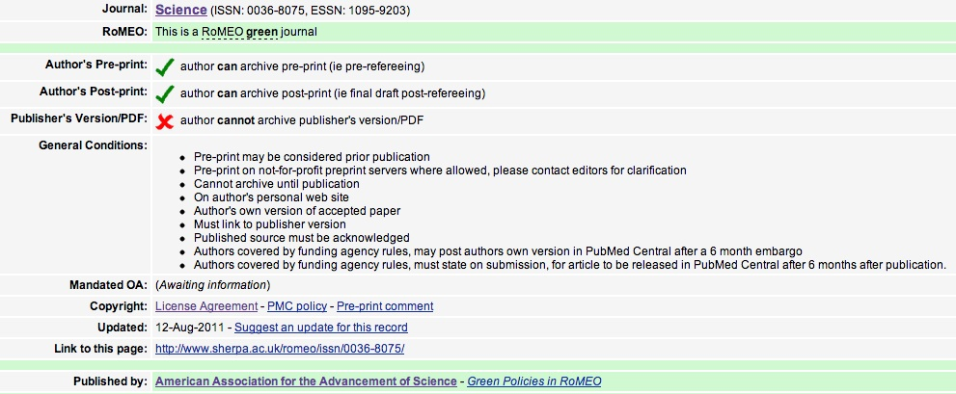
You should also check the publisher’s website to confirm this information. When in doubt, write the publisher and ask the following questions:
  - Do you offer an open access option?
  - If so, how much does it cost?
  - May I deposit a version of my article in my institutional repository?
  - If so, which version?
  - Is there an embargo period?

- Determine the publication frequency of the journal and whether their publication schedule meets your needs. Some journals have faster review and editorial processes than others.

- Where is the journal indexed? Important indexing and abstracting services include PubMed/Medline, Web of Science, Google Scholar, Science Citation Index, and Current Contents. Indexing and abstracting enhance the possibility that people in your field will find and read your article.

- Does the publishing board represented international scholars who are respected in your field? Do a web search if you are not familiar with any of them.

- Weigh all of the information you obtain about the journal in which you are interested in publishing to ensure that the journal is bona fide and respected in its field. There are some journal publishers that are more interested in accepting articles in order to receive the author’s fee than they are in publishing quality research.

- Budget for page charges (i.e. publishing fees). Many journals, particularly open access ones, charge authors to publish their articles. Page charges range from US$300-US$3,000. Page charges are frequently reduced or eliminated for authors in developing countries.

