Sharing the Garden: Working with OER in African Contexts
Tessa Welch, SAIDE, 12 January 2010
A presentation for the Learning Futures Festival Online 2010, Beyond Distance Research Alliance, University of Leicester

Abstract
This presentation will argue that the key usefulness of OER in African context is that it creates an impetus for the discovery and sharing of high quality existing resources as OER that are otherwise unknown or simply the preserve of individual institutions or publishers. In contexts in which human and material resources are constrained, the existence of OER also stimulates collaborative course design in which there are opportunities for participants in communities of practice to develop the shared understanding that results in successful adaptation of OER for different contexts and programmes. In this way the OER are grown, rather than merely consumed.

The context
The title for this presentation comes from my favourite children’s story, Oscar Wilde’s The Selfish Giant, enhanced with wonderful illustrations by Michael Foreman. The story is of a giant who went away from his castle for seven years only to come back and find that the garden, full of beautiful flowers and fruit trees was also the place where every day after school, children used to come and play. The story is of particular relevance to working with OER.
[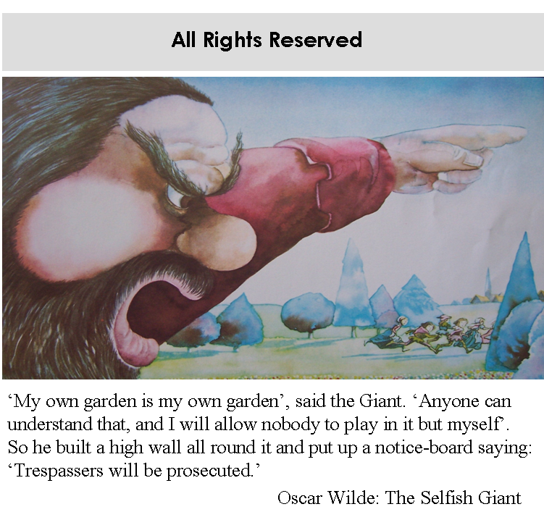
But the story does not end there. The Selfish Giant, moved by one particularly vulnerable child who with the other children crept into his garden through a hole, came to his senses. The giant lifted the child into a bare tree, which at once broke into blossom, and the little boy stretched out his two arms and flung them round the Giant’s neck and kissed him.
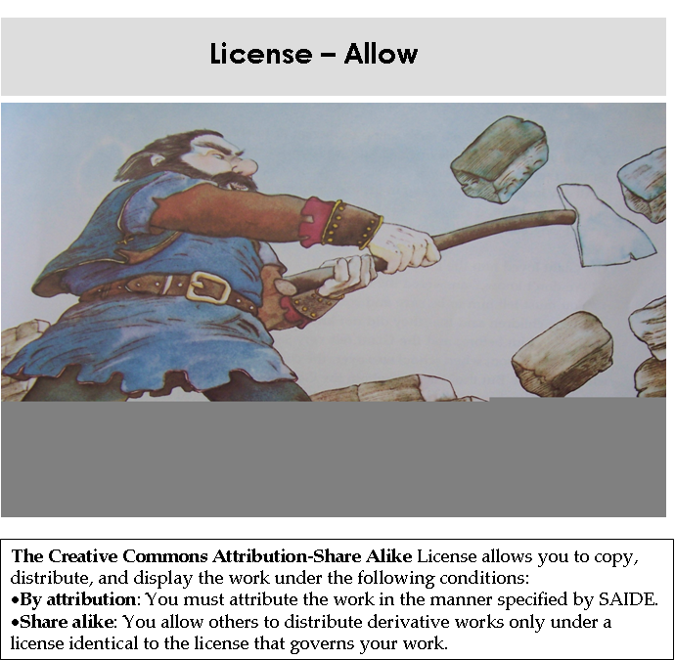
In South Africa, we have not been particularly good at sharing the garden, particularly the garden of education, not only under apartheid, but also under the new government. The evidence of poor sharing is starkly before us in the results of numerous systemic tests (TIMSS, PIRLS, MLA, SACMEQ, and the systemic evaluations carried out by the Department of Education) demonstrate what Brahm Fleisch (2008) refers to as a ‘bimodal distribution of learner achievement’, with the largest majority of scores on these tests at very low levels, below norms even for developing countries, and a small minority at levels comparable with results from the developed world. As Fleisch (2008) summarises:
While a small minority of primary schoolchildren attending privileged schools are achieving a curriculum benchmarked ‘grade level’, which is comparable to countries such as Germany and the United States, the vast majority of children attending disadvantaged schools do not acquire a basic level of mastery in reading, writing and mathematics. It is these South African children who struggle to read for meaning and to perform simple numerical operations – whose learning remains context-bound and non-generalisable. (Fleisch 2008: 30)
The results of the PIRLS study or 2006 (Progress in International Reading Literacy Study) were that Grade four and five learners achieved the lowest score of 45 national education systems (2008: 18). The results of the 2009 systemic tests conducted by the Department of Education nationally in South Africa are equally shocking. In the grade three maths tests, learners had to interpret simple bar graphs and add amounts in rands and cents. In the grade three literacy tests, they had to draw conclusions from a text and understand the use of tenses. In all the tests the percentage of learners functioning at the 50% to 69% level was lower than 34%.
This is the context that informs our approach to OER:
- Lack of equity – those who have continue to receive more, while for those who have not, the little they do have is increasingly being taken away
- Lack of literacy – the urgency of addressing unnecessary barriers to reading for learning – such as the high prices of books, the poor quality of teaching and teacher education.
OER have a role to play – open licensing assists in removing the need for permissions and payment. And digitally available material enhances the potential for access, adaptation and reuse. But to offer a learning future for Africa, there are a number of problems that have to be addressed.
Considering the broader African context, Angus Scrimgeour who heads up the International Association for Digital Publications in which SAIDE is involved, has identified five obstacles to the use of digital content in Africa (Scrimgeour, 2009).
- Affordability of technology [The relative price for ICT services is highest in Africa – the ICT price basket represents 41% of the region’s monthly average income, as opposed to 1 or 2% in Europe; broadband costs go through the roof in developing countries (ITU Telecom 2009)]
- Connectivity [latest figures global broadband divide Africa 1 in every 1000; in Europe 200 in every 1000, and in China 6.2 per 100 (ITU Telecom 2009)]
- Relevance [most of the OER available are not African, and there are major issues with relevance and ownership; there is also an absence of local language digital material]
- Culture [partly as a result of the expense and/or lack of availability of published educational materials, the culture of reading is in decline; a prevalence of content teaching from photocopied extracts instead of conceptual teaching and independent research]
- Capacity [educators do not enough time to look for or create educational material, particularly digital content]
To expand on one of these points: the IADP project is attempting to make available e-books at affordable rates in higher education in Africa. Research done in area of teacher education to identify 20 to 40 common titles, as a prelude to arranging substantial discounts in return for large numbers of sales, could not generate a common list of more than 14. The project report on this was as follows:
Lack of commonality suggests that either there may be no ‘key’ texts in the view of faculties, or that there are other reasons why they have not been identified and put into use. Some possible reasons:
Associated with workload demands and limited scholarship activity in some faculties there might be an absence of serious monitoring of what is on the market. This could explain why titles submitted were of what is currently in use rather than what might really be needed.
Ironically, it might be the very need for high quality standard text books that makes it difficult for faculties to identify the titles that are really needed. Because they’ve not been able to afford books, other practices may have become fairly widespread. One dean who did not supply titles wrote: “As far as I know, most of our lecturers do not use textbooks as such, but extracts from different sources. I shudder when I think about the copyright implications.“ There may be subthemes to this: students don’t read.
Titles submitted could reflect a range of ideological stances that diminish prospects of commonality.
All of this evidence underlines the urgency not only of making more educational resources more freely available, but also of supporting teachers in their core work of designing and delivering programmes that encourage active fully literate learning appropriate for their own learners and contexts.
This paper outlines key features of SAIDE’s work through OER Africa, and with the International Association Digital Publications Project, to respond to this context.

Sharing our own garden
As SAIDE, we are doing this in two ways:
- Releasing all new materials under a Creative Commons licence
- Digitising and re-licensing our own published print materials as OER.
One of SAIDE’s first projects as an organization was funded by the WK Kellogg project to produce an eight module series in the Study of Education in order to provide an alternative to the prevailing authoritarian education philosophy and support the transformation of the teacher education curriculum. The project was collaborative:
  - 36 core writers
  - 11 development writers
  - 3 specialist writers
  - 37 critical readers from 23 institutions
  - 15 teachers involved in the reference group
  - 60 teachers involved in the production of video and audio material.
The project ran from 1998 to 2002, before Creative Commons and OER discourse emerged. Now that six of these modules are out of print, but still contain useful material, we wish to make them available as OER on our OER Africa website.

What did we do way back then that is helping us now?
Firstly, we knew that we couldn’t simply give our copyright to the publisher, and developed a contract in which we were the copyright holders, but they had the licence to publish. Secondly, we built in a clause that required publishers to consult us before pulping or otherwise disposing of dormant stock. Thirdly, we built in an agreement that, once the titles were declared out of print, the film would be made available to us at cost.

What could we have done better for a 21st century OER context?
This is our current understanding of the issues, and we would welcome advice and input from participants in this conference.
Aside from licensing, a key issue for digital release of materials as OER is that the files must be of easily downloadable size and in formats that can be adapted by teachers and learners, that is, not requiring specialist expertise to manage and manipulate.
We initially thought that to meet this need, it would be necessary to have versions of the materials in a simple Word format. This would involve taking our final drafts and getting them re-designed in a Word template. For users wanting the designed materials, scanned copies could also be made available.
What we have realised is firstly that copies of learning guides scanned as graphics make such large files that it is difficult to download them. Secondly, we now understand that it is not absolutely necessary to have Word versions for adaptation: PDFs in renderable text can be relatively easily manipulated using Adobe 9. However, to create such PDFs, simply having the designed and published print copies is not good enough. Although the optical character recognition process from print copies is do-able for uncomplicated texts such as novels, for intensively designed learning guides it would involve so much tidying up, that it would be better re-type and design from scratch. So for PDFs in renderable text to be made, the open files are needed, not the film/print copies.
Our key lesson of experience from all of the above is that in future contracts with publishers, we will state that once the books are out of print, the open files should be returned to us rather than the film. Film is suitable only for litho printing of further print copies of the materials. By this stage however the technology may have moved on in ways we cannot predict!

Encouraging others to share their gardens
With the experience gained from our efforts to digitise our own conventionally published materials, we are encouraging others to share their conventionally published materials.
One part of our approach involves sourcing existing out of date but high quality published materials in areas of particular need (such as the teaching of reading in primary schools) and approaching authors and publishers to release these out of print or almost out of print materials for digital publishing under a Creative Commons licence.
Our argument is as follows:
We are keen to take forward our mission of making high quality materials available to African higher education institutions as Open Educational Resources and would therefore like to explore with you the possibility of making some or all of these resources in digital format on our OER Africa website (www.oerafrica.org) under a Creative Commons license of your preference so that they can be accessed and adapted freely by African teacher educators.
We understand that you are the publisher of the following titles in the Primary Education Project series:
- Language and Learning in Junior Classes
- Reading and Writing in Junior Classes
- 20 Story Books, with accompanying text charts and picture charts.
We will shortly be launching the teacher education space on OER Africa, with resources in two priority areas:
- Education Studies
- Junior Primary/Foundation Phase.
The first editions of SAIDE’s own Study of Education series will form the core of the Education Studies area. We would like as many of the xx Primary Education Project materials to be available to form the core of the Junior Primary/Foundation Phase area.
We were imagining that, since the series is now over 10 years old, the substantive revenue that will be earned has already been earned on the existing versions of the material. Release as OER would give the material a new life.
The negotiations for this are still in process. What we have found interesting, however, is that while print media are hot property, there is little concern to keep ownership of video and audio material.
The second example we wish to share with you is that of a distance education institution and its study guides. In 2006, in response to a request from the South African Department of Education for materials to support large scale roll out of in-service teacher upgrading, we conducted a pilot project (the ACEMaths project) to identify and adapt existing high quality materials on the teaching and learning of mathematics. We found a good core module on the subject at Unisa, and approached them for permission to take their module and release it under a Creative Commons licence. This was their response:
UNISA hereby grants to the South African Institute for Distance Education (SAIDE), the non-exclusive, non-transferable, perpetual right, worldwide and free of charge, to make adaptations and to create derivative works, and to reproduce and publish said works, or parts thereof, in any format whatsoever.
The permission granted by not be transferred, ceded or sub-licensed to another person, without the written authorization of UNISA. The parties agree however, that derivative and adapted works may be sub-licensed.
The interesting point about this was that they retained All Rights Reserved Licence for the original version, but gave us permission to re-license the adapted version. This provides a model for an approach to the same institution for other materials, or to other institutions.

Working together in the garden
As mentioned above in the context, part of the solution to the educational problems currently being experienced in Africa is access to materials. However, simply importing content into Africa from other parts of the world will do nothing to solve capacity and resource constraints in African education systems.
The objectives of SAIDE’s OER project, OER Africa, are therefore not only to
- Increase the availability of relevant, need-targeted learning materials, and
- Reduce the cost of accessing educational materials through removing restrictions on copying resources,
But also to
- Stimulate active engagement in course design through adaptation or development of materials for learning programmes that are relevant to African contexts and students, and
- Build capacity for learning design through collaborative partnerships and communities of practice, both within and across educational systems and organizations.
The benefits only come with engagement and use, although making use of OER can reduce the time spent on developing materials.

Example 1: ACEMaths project, South Africa
http://www.oerafrica.org/Default.aspx?alias=www.oerafrica.org/acemaths
In the ACEMaths project referred to above, the adaptation and engagement of the core module from UNISA was carried out by a community of 14 Maths teacher educators from seven different South African teacher education organizations. A key aim of the project was to pilot a process of enabling institutions to respond quickly to departmental needs without having to resort either to recirculation of existing (often poor-quality) material, or to commissioning of new material in timeframes that make it impossible to achieve quality.
Even though the adaptation work required was more extensive than originally envisaged, a pilot version of the adapted six unit module was ready 6 months after the inception of the project, with a variety of quality checks built into the process. The following diagram shows the process followed.
In the second phase of the project – preparing the revised version in the light of the pilot experience – we were able to reduce substantially the cost and time spent on design by using an OER tool, the instructional design template developed by the Commonwealth of Learning (COL). This template is available free of charge for downloading and adapting on an Attribution ShareAlike Creative Commons licence on the COL website. It took a day to learn how to use this template and customise it for the ACEMaths units. And it took five days to place the revised version of the 350 pages into the template, ready for posting on the OER Africa website. The final units, set in the COL template and enhanced by a continuous case study locating the units in the experience of a group of teachers, as well as six commissioned illustrations of conversations between these teachers, are both accessible and attractive.
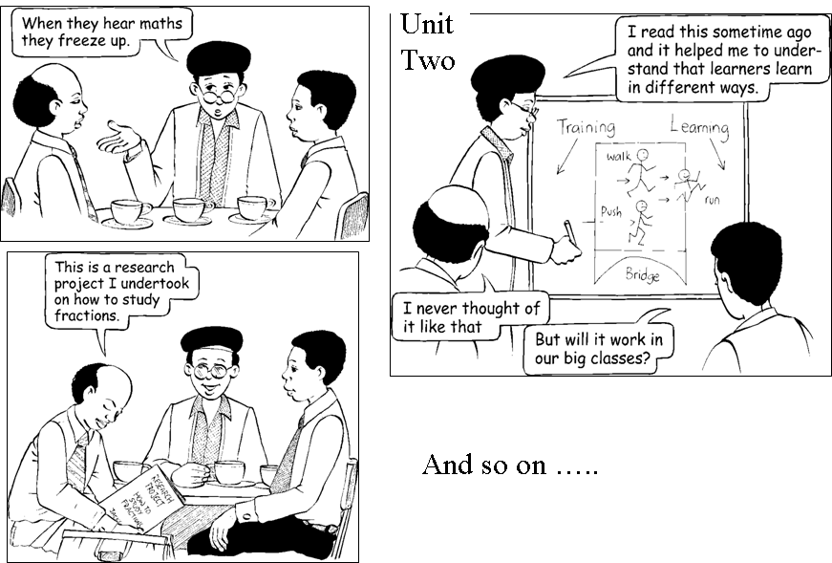
A major lesson of experience from this project was that even though adapting existing materials is less time-consuming than working from scratch, the time required must not be underestimated, particularly for the project leader and key content expert. Adaptation is a process of re-creation rather than merely of revision. However, it is in this adaptation, and adaptation through a community of practice, that the benefit comes.
I think it is a brilliant idea that we finally got to this stage where some universities get together and work in a direction to try and get sort of a more generic message in this country. (Site F)
We all have common understandings, but we don’t have shared understandings… We don’t communicate, we don’t have a collegial kind of thing, and this created that opportunity to be able to meet everyone … it was wonderful! (Site C)
Unless projects are specifically set up to facilitate this process, this benefit will not be experienced.
A second lesson of experience was that the community of practice worked because SAIDE, as the coordinating agency, made it a requirement that the costs of workshops and materials development would be funded, but participating institutions needed to use the materials. This created a motivation for contribution to the adaptation and enhancement of the core materials, as well as a great deal of creativity in course design based on the materials. A research study of take up was conducted from 2007 to 2008, and the following was found:
Site | Programme / OER | Adaptation
A  UKZN | ACE FET Maths Literacy 2nd year (mixed mode)  Unit 6  Unit 4 with a section taken from Unit 3 | OER combined into two separate stand-alone guides for two different modules  Module 1 Guide – Unit 4 used in full with an extract from Unit 3 with other materials.  Module 2 Guide – Unit 6 used in full with other materials.
B | ACE GET Maths 1st year (mixed mode)  Unit 3 and Unit 6 | No adaptation. OER used as an additional resource to complement existing ACE GET programme materials.
C | B Ed for GET 3rd year and 4th year (contact)  Units 1, 2 and 6 | No adaptation. OER used as resources for two PGCE for GET programme modules.  3rd year - Units 1 and 2 used in full  4th year – Unit 6 used in full
D | ACE LSEN 2nd year (mixed mode)  Whole module (Units 1 – 6) | All units used in full without adaptation. Units presented in a single guide with consecutive page numbering.
E | ACE FET and GET Maths 2nd year (mixed mode)  Whole module (Units 1 – 6) | All units used in full without adaptation. Units presented in a single guide with consecutive page numbering.
F | ACE Special Needs/Remedial Education (part time)  Whole module (Units 1 – 6) | All units used in full without adaptation. Units printed as loose sets of material.

Example 2: Kamuzu College of Nursing, Malawi
http://www.oerafrica.org/malawi/Pilot2OERMidwifery/tabid/1350/Default.aspx
Through Hewlett grants to OER Africa, as well as through the IADP project, SAIDE is conducting a number of OER projects in Malawi and Botswana to assist various colleges to access and adapt OER for a variety of courses. One of these is the Kamuzu College of Nursing: OER project to develop a course for the 5th year of midwifery training.
The request arose in the context of extremely high maternal mortality rates in childbirth, and the inadequate purely theoretical training that midwives currently receive in Malawi. Through independent research, practitioners at the Kamuzu Nursing College arrived at the conclusion that what was needed was a problem-based course relating to birth, delivery and post-natal mother care. The need for resources for each student was also urgent because of the scarcity of textbooks. The Resource Centre at Kamuzu has a limited number of textbooks available for students on midwifery topics, and these are seldom available to nursing students when they need them.
At the start of the project, the assumption was that relevant OER would be sourced, and then adapted for the Malawi context. But it was not as simple as that.

First hurdle: finding the resources
Relevant resources did not exist in OER repositories, and a great deal of time was spent combing through website after website to no avail. Eventually a link was made with the University of Michigan, but the resources but the resources were not cleared for OER use before the start of the adaptation process.
The resources found were also not entirely relevant. The adaptation involved changing drug names, childbirth protocols and using Malawian scenarios. For example in developed contexts women usually go to a hospital and are attended by a doctor but in Malawian contexts women go to the clinics and the midwife is the central person.

Second hurdle: curriculum development as a basis for selecting resources
One of the first tasks was to convert the current midwifery content driven syllabus to a competency based framework. The team worked on this framework as part of the strategy to design appropriate assessment tasks. This framework provided a basis for the critical appraisal of the identified resources.
The major problem here was that though a range of resources were eventually identified, the internet linkage was so slow and intermittent that critical engagement was difficult, and the workshop time set aside for this was not sufficient.

Third hurdle: understanding the new approach - problem based learning
Key to this was analysing examples of scenarios for a problem-based approach, and then generating relevant scenarios for the Malawian context. Problem based learning new to everyone, and the teams kept reverting to the case study and problem solving approach.

Fourth hurdle: designing the problem-based learning pack, with relevant assessment
The input of instructional design (for the learning pathway) as well as technical expertise (for the design of the CDROM and website was important here.

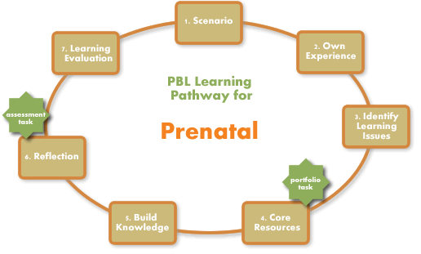

Lessons of experience
Firstly, in terms of human resources, there must be
- a strong in country champion, supported by the management of the institution,
- people who want to change their practice, and see a need for a new approach,
- external instructional design as well as technical expertise.
Secondly, at the outset of the project, enough time needs to be spent establishing a common understanding - then the excitement of the unfolding course can keep the momentum going.
Thirdly, there needs to be sufficient time to source suitable resources. Where no OER exist in a particular subject, enough time must be set aside to approach relevant institutions and organize negotiations to clear resources for use as OER.
Fourthly, where resources are not OER and therefore cannot be quoted directly without payment/permission, a great deal of time has to be spent integrating and synthesizing them, raising questions about whether it would not have been better to start from scratch.
Fifthly, it takes time to internalise a new curriculum approach - even if supported by good materials. It will be interesting to see what happens when the course is implemented in 2010.

Conclusion
The two examples briefly described above worked with OER in different ways.
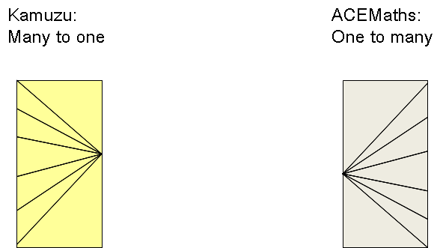

Ultimately, the vision of the Creative Commons is from all to one to all:
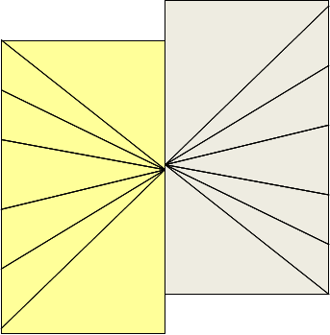
Thank you!

References
Fleisch B (2008) Primary Education in Crisis. Why South African Schoolchildren Underachieve in Reading and Mathematics. Cape Town: Juta & Co.
ITU Telecom (2009) The World in 2009: ICT Facts and Figures. http://edutechdebate.org/creating-electronic-educational-content/asymmetrical-oer-country-problems-and-needs/. Accessed 14 Dec 2009.
Howie S et al (2008) PIRLS 2006: South African Children’s Reading Literacy Achievement: Summary Report. Pretoria: Centre for Evaluation and Assessment at the University of Pretoria.
Moore A (2009) OER Capacity Building in Midwifery, Kamuzu College of Nursing, Blantyre & Lilongwe: Perceived Needs & Project Design. http://www.oerafrica.org/malawi/Pilot2OERMidwifery/tabid/1350/Default.aspx Accessed 20 January 2010.
Scrimgeour A (2009) Asymmetrical OER Country Problems and Needs. http://edutechdebate.org/creating-electronic-educational-content/asymmetrical-oer-country-problems-and-needs/. Accessed 14 Dec 2009.
Welch T & Sapire I (2009.Developing and using quality learning resources in an Open Educational Resources environment: The SAIDE ACEMaths project. www.oerafrica.org/acemaths
Wilde O, with illustrations by Michael Foreman (1995) The Selfish Giant. Picture Puffin.

Trends in International Mathematics and Science Study; Progress in International Reading Literacy Study; Monitoring Learning Achievement; Southern and Eastern African Consortium for Monitoring Educational Quality
Definition from http://www.pcmag.com/encyclopedia_term/0,2542,t=renderable+text&i=58643,00.asp Renderable text can be structured as font characters, which represent specific letters (a, b, c, etc.) or as pure line drawings that contain no knowledge of which character they represent. The term is used to contrast such text with text that is contained within a bitmapped image, which is merely displayed on screen without any major conversion.
Definition from Wikipedia. http://en.wikipedia.org/wiki/Optical_character_recognition Optical character recognition, usually abbreviated to OCR, is the mechanical or electronic translation of images of handwritten, typewritten or printed text (usually captured by a scanner) into machine-editable text. It is used to convert paper books and documents into electronic files.
ACE stands for Advanced Certificate in Education, a qualification for in-service and/or upgrading of teachers in South Africa.

