**22**

MODULE5: **Agribusiness Management for Farmer Organisations**

LESSON 2: **Basic Principles of Economics**

TIME: **1 hour 36 minutes**

AUTHOR: **Prof. Francis Wambalaba**



This lesson was made possible with the assistance of the following organisations:

[Creative Commons License](http://creativecommons.org/licenses/by/3.0/)  
  
Farmer's Agribusiness Training by [United States International University](http://www.usiu.ac.ke/) is licensed under a  
 [Creative Commons Attribution 3.0 Unported License](http://creativecommons.org/licenses/by/3.0/).  
Based on a work at [www.oerafrica.org](http://www.oerafrica.org/agshare/AgShareHome/tabid/1290/ctl/Tab/Default.aspx)

**MODULE 5**

**Agribusiness Management for Farmer Organisations**

**2**



**BASIC PRINCIPLES OF ECONOMICS**

## INTRODUCTION:

## :

This lesson will cover the basic governing principles of economic thinking including the key economic questions, factors of production, efficiency and the market structure.

**LESSON**

By the end of this segment, the learner should be able to:

* Explain the meaning of the four factors of production from an economic perspective in the context of farming (production inputs).
* Identify the type of market structure that they belong to and make appropriate decisions depending on their type of market structure and interpret the role of prices as signals of communication in their context.
* Describe the central questions that govern economic thinking.
* Discuss the principles governing efficient allocation of resources including concepts of supply and demand, competitive market, market equilibrium and competitive strategies.

**Prof. Francis Wambalaba**

## AUTHOR:

## TIME:

## 1 hour 36 minutes

## OUTCOMES:

## :

Factors of Production

As the term implies, the issues relating to factors of production relate to the ***production process*** side of a farmer’s practices as a firm. There are four traditional factors (land, labour, capital and entrepreneurs).

**Land / Natural Resources**

This first factor is defined as land resources and includes all natural resources on the ground (such as vegetation, animals, insects, soil, water etc.), those underground (such as minerals, rocks, soil, water, etc.) and those above ground (such as air, clouds, air space and also climate). Issues that impact on this factor of production can include land size, distribution, influence of culture on land uses, etc. Competition between farming activities and urbanization is another contentious issue. Value addition per acre/hectre (or plot size) increases as the urban areas spread into rural areas because the value for urban uses of similar land is higher. While competition for land is economic, it can lead to political competition and therefore conflicts.

**Capital Resources**

Capital resources are any man-made products that are used in the production of other products. They include items such as machinery, tools and equipment, infrastructures such as housing, transport and communication, and other types such as money and human capital. It should be emphasized that these resources directly affect the ability of the farmer to be competitive in the market place.

**Labour**

Labour resources such as human energy and skills used in the production process are the third factor of production. It should be emphasized that unemployment is not about finding a job but about a person not using their energy and skills to produce.

**Entrepreneurship**

Fourthly, entrepreneurship can be defined as human resources with ability to take risks and invest in ideas (business farming activities especially in value addition). Access to capital (money) and other inputs in the factor markets, access to consumers in the goods market and manufacturers in the factor market are issues related to this factor of production.

Finally, allow for discussion on any ***other resources issues*** that come up, such as importance of time, access to information, role of technology, human capital development etc.

## 



Group Discussion (15 minutes)

## Activity 1

Work in groups of 5, consider and record experiences from the group on how local issues have impacted on each of the four factors described above. (e.g. Describe your access to land, urbanization pressures, access to capital, your competitiveness at markets, access to skilled labour, and of course, your entrepreneurial skills.) Be prepared to present your findings to the whole class.

Market Structure (10 Minutes)

In general, issues relating to market structure impact on the ***marketing process*** side of the farmer’s practices as a firm.We mentioned these in the previous lesson so here is a brief revision:

***Perfect competition*** is the extreme situation where products are exact, there are very many producers/sellers, very many consumers/buyers, and therefore no seller or buyer can dominate the market. Perfect competition can lead to sellers undercutting each other.

Secondly, ***perfect monopoly*** is the extreme opposite to perfect competition where products are unique; there is only one producer/seller who therefore dominates the market. If there is only one consumer/buyer, they are called a ***monopsony***. In farming, however, this rarely exists and farmers find themselves almost always in a competitive environment rather than in a monopoly.

Thirdly, ***monopolistic competition*** is a situation where there are many competitors and it is closer to perfect competition market. This is realistic of what we typically call competition in our markets, but for purposes of this course, we will combine it with perfect competition and simply refer to the environment as ***competitive market*.**

Finally, an ***oligopoly*** is a situation where there are few competitors and is closer to the monopoly market. It is the most realistic of what we typically call monopoly in our markets, but for purposes of this course, we will combine it with perfect monopoly and simply refer to the environment as ***monopoly market*.**



Work in the same group as before.

1. List the advantages and disadvantages of operating in a competitive market.
2. List the advantages and disadvantages one would face if they belonged in a monopoly market.
3. Determine which market the group would prefer and provide reasons why.
4. What actions could you take to move closer to a monopoly situation and gain from economies of scale?

Shifting from competition to Monopoly (10 minutes)

## Activity 2

Economics of Scale (5 Minutes)

This concept refers to the cost advantages that a business obtains due to expansion or collaboration. There are factors that cause a producer’s average cost per unit to fall as the scale of output is increased. Farmer organizations, for example, can leverage this type of advantage. Economies of scale include product specific economies, plant specific economies and firm specific economies.

***Product specific economies*** are related to output of one product which may allow for greater specialization in use of labour and capital.

***Plant specific economies*** are related to total output of one plant (with multiple products). For example, an investment in a larger pipeline may cost almost the same but have more capacity, or an overhead of one supervisor managing many people, or the use of existing spare parts and personnel on various activities.

***Specific economies*** are related to total output of a firm’s operations from different regions and can benefit from production and distribution from various plants with capacity, discounts and fixed costs for marketing and sales promotions spots, or even technological innovations using in-house resources.



See the Feedback section at the end of this lesson to see a model answer or comments about this activity

Answer these questions but keep in mind the concept of ***consumer sovereignty*** - the buyer’s needs nearly always dictate the answers to these questions.

*What to Produce?*

* What determines whether we build more homes or make more VCRs?
* How do these choices change over time?
* How are they affected by changes in technology?

*How to Produce?*

* Why do we use machines in some places and people in others?
* Does technology destroy jobs?

*When to Produce?*

* How do seasons affect production?
* What makes production rise and fall?

*Where to Produce?*

* What determines where goods and services are produced?
* How do changing patterns of production location affect types and wages of jobs we have?

*For whom to Produce?*

* What constitutes demand?
* Why do doctors earn more than nurses?

The five key fundamental economic questions include; ***What*** goods and services are produced and ***what*** quantities; ***How*** are goods and services produced; ***When*** are goods and services produced; ***Where*** are goods and services produced; ***Who*** consumes the goods and services produced.

Five fundamental Economic Questions

The 5 Fundamental Questions

# Key Questions of Economic Thinking (10 minutes)

## Activity 3

Economic Ways of Thinking

Economic theory can be applied at both the personal level as well as at a regional or national level. However, the perspective is different according to your involvement. Contrast these two perspectives:

From a ***Microeconomic*** Perspective:

* A choice is a tradeoff (opportunity cost)
* Choices are made at the margin (additional benefit from an additional cost instead of total benefits from total cost)
* Exchange is voluntary (& markets are an efficient way of exchange)
* Markets can and do fail.

From a ***Macroeconomic*** Perspective:

* For the economy as a whole, *Expenditure = Income = Value of Production*
* *Productivity* improves standards of living
* *Inflation* occurs when the quantity of money increases faster than production
* *Unemployment* can result from market failure but some unemployment is productive.

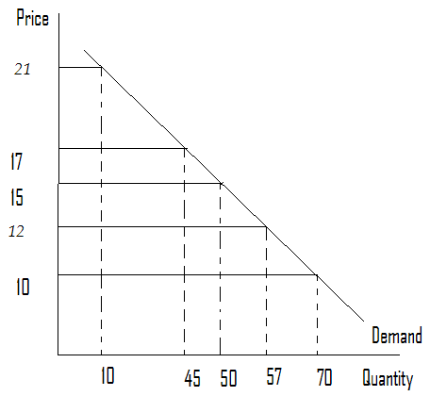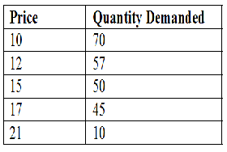

**Fig. 2: Individual Demand Curve**

**Fig. 1: Individual Demand Schedule**

What is demand?

The forces of supply and demand help us not only to appreciate the significance of the customer (demand) but also from a farmers’ perspective, how unwise competition can be destructive. In this section, we define and discuss demand and supply and the role that price plays as a signal and communication for action.

Demand exists only when there is **willingness and ability** **to buy** a product (goods or service) or resource. It is a relationship between the quantity demanded and price of a product or resource. To have a demand for an item means: you want it; you can afford it; and you have made a definite plan to buy it.

***Determinants of Demand*** include; Price of the good (x); Price of related/substitute goods (y) and complementary goods (z); Income (Normal goods or abnormal or given goods); Population; Tastes & preferences; and Future expectations (on all of the above)

a) Deriving an ***Individual Demand Curve*** (Due to changes in price of good x)

The slope of the demand curve is *only* influenced by changes in price of the commodity in question(x). In fig 1 and 2 above, the demand schedule provides changes in quantity demanded in response to changes in price. From fig. 1, we notice that the lower the price the greater the number of goods purchased. When we plot these combinations we get the demand curve in fig. 2. This results in a movement along the demand curve referred to as ***change in quantity demanded***.

# Market Forces of Supply and Demand

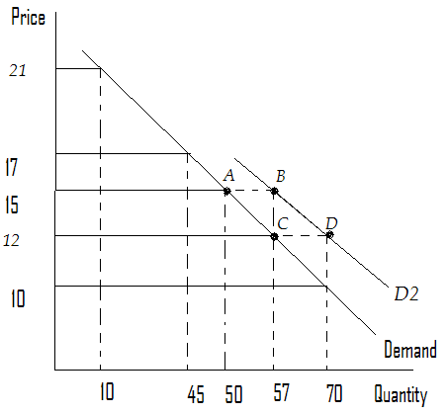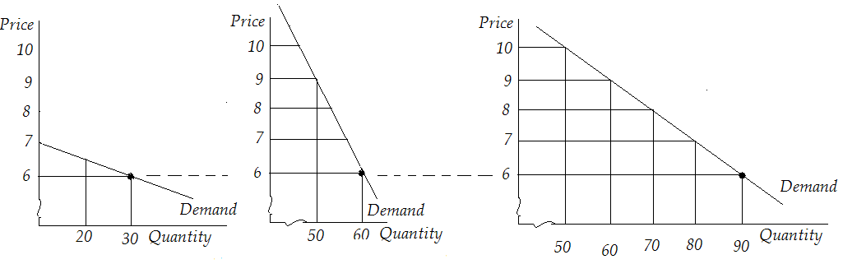

**Fig. 4: Shifts in Demand Curve**

A summary of the effects from changes in price (change in quantity demanded) and changes from other factors (change in demand) is presented below.

* Quantity demanded decrease ↓ if there is an:

↑ in price of x

* Demand decrease ↓ if there is a:

↓ in price of substitute

↑ in price of complement

↓ in income

↓ tastes & preferences

↓ in population

↓ Time

Expect above change

c) ***Change in Demand*** – shifts (due to change in other factors)

As we noted in lesson 1 with respect to the PPC, similarly, an increase in demand shifts the demand curve to the right while a decrease in demand shifts the demand curve to the left. Usually, this is simply referred to as ***change in demand***. Shifts usually result from changes in other factors (other than price of good x). One way of testing this is to ask, why would anyone buy more (or less) when the price of x is held constant?

**Fig. 3: Market Demand**

b) Deriving a ***Market Demand Curve***

The market demand curve is a horizontal addition of the individual demand curves as shown in fig. 3 below. For example, when the price is 6 shillings, consumer one (left) purchases 30 units while consumer two (middle) purchases 60 units. The total market (right) demand is 90 units.

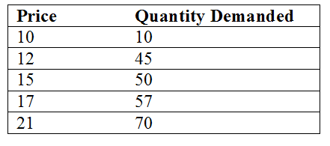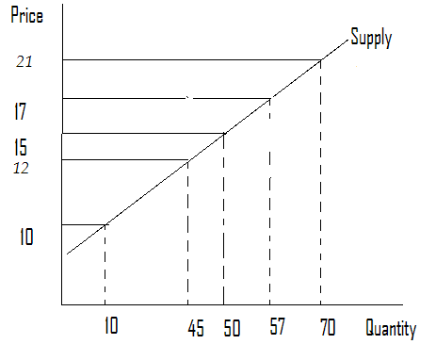

What is supply?

**Fig. 6: Individual Supply Curve**

**Fig. 5: Individual Supply Schedule**

Supply exists only when there is ***willingness and ability to produce and sell*** a product (good or service) or resource.It is a relationship between the quantity supplied and price of a product or resource.To be able to supply an item means one has; resources and technology to produce it; can profit from producing it; has made a definite plan to produce and sell it.

Determinants of Supply are; Price of the good (x); Price of related goods such as substitute goods (share inputs, e.g., plot of land) or complementary goods (jointly produced, e.g., beef & hides); Price of resources used to produce it such as land, labour, capital & entrepreneurship; Number of suppliers; Technology; and future expectations (on above)

a) Deriving an ***Individual Supply Curve*** (due to changes in price of good x)

The slope of the supply curve is *only* influenced by changes in price of the commodity in question (good x). In fig 5 and 6 below, the supply schedule provides changes in quantity supplied in response to changes in price. From fig. 5, we notice that the lower the price, the lower the goods sold. When we plot these combinations we get the supply curve in fig. 6. This results in a movement along the supply curve referred to as ***change in quantity supplied***.

Just as in the case of the market demand curve, the market supply curve too is a horizontal addition of the individual supply curves at a given price.

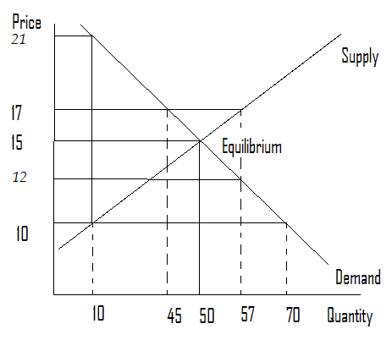

**Fig. 8: Surplus Disequilibrium**

When the supply curve and demand curve are again overlapped on each other, they again reveal either a disequilibrium or equilibrium. However, in this case in fig. 8 on the left reveals a **shortage disequilibrium**. For example;

At P = 10,

Quantity demanded = 70 while

Quantity supplied = 10

A shortage of 60 results (or 10-70)

With a shortage, consumers outbid each other pushing prices up towards equilibrium.

c) Forces of ***Supply and Demand (Shortage)***

**Fig. 7: Surplus Disequilibrium**

When the supply curve and demand curve are overlapped on each other, they reveal either a disequilibrium or equilibrium. Fig. 7 on the left reveals a ***surplus disequilibrium***. For example;

At P = 17,

Quantity demanded = 45 while

Quantity supplied = 57

A surplus of 12 results (or 45-57)

With a surplus, suppliers undercut each other pushing prices down towards equilibrium.

b) Forces of ***Supply and Demand*** (***Surplus***)



d) ***Market Equilibrium***

**Fig. 7: Surplus Disequilibrium**

Finally, when the supply curve and demand curve are once more overlapped on each other, they again reveal either a disequilibrium or equilibrium. However, in this case as shown in Fig. 9 on the left reveals equilibrium.

For example;

At P = 15,

Quantity demanded = 50 and

Quantity supplied = 50

Therefore at P = 15, there is an equilibrium (i.e., Qs = Qd = 50).

Neither surplus nor shortage results so the market clears and is stable

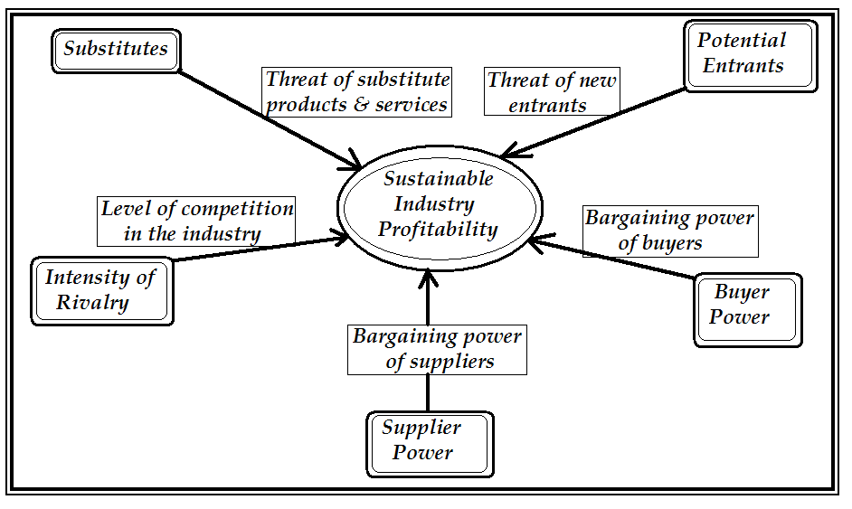

# Porter’s Competitive Strategy (5 minutes)

**Substitutes**  
In this case, the farmer must expect that others will produce substitute goods (similar but not exact) that will compete with the farmer’s products in the market place and should therefore have a plan on how to compete with competitors.

**Potential Entrants**Even where there is no competition, the farmer must always anticipate new competitors. This may mean satisfying customers even when there is no competition.

**Buyer Power**  
In cases such as farming, buyers in the ***goods market*** tend to have power to dictate the prices. This is especially true with middlemen. In other cases, there tend to be too many producers that give buyers more power to dictate prices. These and many other similar challenges should be anticipated.

**Supplier Power**  
This is where suppliers in the ***factor market*** and ***product market*** may have power over the farmer and thus dictate prices of land, labour, capital and other raw materials.

**Intensity of Rivalry**  
Typically, this occurs in the competitive market where others produce exact products, such as in farming where there are very many producers of the same product. This may mean fighting each other by cutting prices while improving quality and increasing amounts per unit price.

In each of these cases, the farmer who intends to transform into a firm should anticipate and plan for five key challenges as envisioned by Michael Porter. These include substitutes, potential entrants, buyer power, supplier power and intensity of rivalry as shown in figure 10 below.



# Conclusion

Hopefully, you can now see that an understanding of the basic principles of economics can be an advantage when involved with agricultural enterprises. These principles can provide you with an understanding of how the market operates but can also provide you with a set of strategies to respond to changes in the market. It can also provide you with ideas on how to make yourself more competitive within that same market.

In this lesson we studied…

* Four factors of production: ***land / natural resources, capital resources, labour and entrepreneurship***.
* Market structures: ***competitive, monopoly, monopolistic*** and ***oligopoly***.
* Central questions that govern economic thinking, namely the five fundamental questions: ***What*** goods and services are produced and ***what*** quantities?; ***How*** are goods and services produced?; ***When*** are goods and services produced?; ***Where*** are goods and services produced?; ***Who*** consumes the goods and services produced?
* The principles governing efficient allocation of resources including concepts of ***supply*** and ***demand*** and ***market equilibrium or disequilibrium with shortages or surpluses***.
* Competitive strategies as defined by Porter. These include being aware of and responding to the existence of ***substitutes***, ***potential entrants***, ***buyer’s power***, ***supplier’s power*** and competitive ***rivalry***.

# Summary



# Glossary

**Demand**In economics, demand is the desire to own anything, the ability to pay for it, and the willingness to pay. The term demand signifies the ability or the willingness to buy a particular commodity at a given point of time. (Perkin, 1997) or

<http://en.wikipedia.org/wiki/Demand>

**Economies of Scale**

Economies of scale, in economics, refers to the cost advantages that a business obtains due to expansion. There are factors that cause a producer’s average cost per unit to fall as the scale of output is increased. "Economies of scale" is a long run concept and refers to reductions in unit cost as the size of a facility and the usage levels of other inputs increase. (Perkin, 1997) or

<http://en.wikipedia.org/wiki/Economies_of_Scale>

**Factors of Production**

Factors of production… refer(s) specifically to the primary factors, which are stocks including land, labour (the ability to work), and capital goods applied to production. The primary factors facilitate production but neither become part of the product (as with raw materials) nor become significantly transformed by the production process (as with fuel used to power machinery). (Perkin, 1997) or

<http://en.wikipedia.org/wiki/Factors_of_production>

**Supply**

In economics, supply is the amount of some product producers are willing and able to sell at a given price all other factors being held constant. Usually, supply is plotted as a supply curve showing the relationship of price to the amount of product businesses are willing to sell. (Perkin, 1997) or

<http://en.wikipedia.org/wiki/Supply_(economics)>



(What to produce?)

* Consumer demand
* Tastes and preferences change over time
* Resources available and potential

(How to produce?)

* Resource endowment and the need to meet the consumer’s budget.
* In reality, it restructures them and in many instances reinvents new ones.

(When to produce?)

* While each product has a season for production, strategic farmers focus on season for demand.
* Changes in consumer demand.

(Where to produce?)

* Access to customers.
* Location of the consumers.

(For whom to produce?)

* Willingness (tastes & preferences) and ability to pay (income and prices).
* Forces of supply & consumer demand.

# Feedback

## Feedback Activity 3