Unit 1: Space and Shape

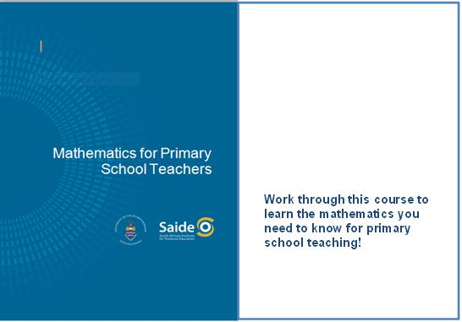

About the course “Mathematics for Primary School Teachers” 3
Unit 1: Space and Shape 6
Introduction 6
The raw material of geometric shapes 6
Plane figures 12
Polygons and other plane figures 23
Space figures 33
Pattern work and transformations 43
Unit summary 52
Assessment 53

© Saide, with the Wits School of Education, University of the Witwatersrand
Permission is granted under a Creative Commons Attribution licence to replicate, copy, distribute, transmit, or adapt this work freely provided that attribution is provided as illustrated in the citation below. To view a copy of this licence visit http://creativecommons.org/licences/by/3.0/
or send a letter to Creative Commons, 559 Nathan Abbott Way, Stanford, California, 94305, USA.

Citation
Sapire, I. (2010). Mathematics for Primary School Teachers. Saide and the Wits School of Education, University of the Witwatersrand, Johannesburg.
ISBN: 978-0-9869837-5-7

Saide
Fax: +27 11 4032813
E-mail: info@saide.org.za
Website: www.saide.org.za
P O Box 31822
Braamfontein
2017 Johannesburg
South Africa

About the course “Mathematics for Primary School Teachers”
Mathematics for Primary School Teachers has been digitally published by Saide, with the Wits School of Education. It is a revised version of a course originally written for the Bureau for In-service Teacher Development (Bited) at the then Johannesburg College of Education (now Wits School of Education).
The course is for primary school teachers (Foundation and Intermediate Phase) and consists of six content units on the topics of geometry, numeration, operations, fractions, statistics and measurement. Though they do not cover the entire curriculum, the six units cover content from all five mathematics content areas represented in the curriculum.
Unit 1 Space and Shape
This unit presents an analytical approach to the study of shapes, including the make-up of shapes, commonalities and differences between shapes and a notation for the naming of shapes.
On completion of the unit students should be able to:
- Identify and describe fundamental properties of shapes.
- Differentiate between and illustrate two dimensional (2-D) and three dimensional (3-D) shapes.
- Categorize and compare two dimensional (2-D) and three dimensional (3-D) shapes.
- Describe and design patterns using tessellations and transformations.
Unit 2 Numeration
This unit is designed to give insight into a few specially chosen ancient numeration systems. After the presentation of historic numeration systems, there is an in-depth look at the Hindu-Arabic numeration system, still in use today, with its base ten and place value.
On completion of the unit students should be able to:
- Record numbers using a range of ancient numeration systems.
- Explain the similarities and differences between the numeration system that we use and those used in ancient times.
- Demonstrate the value of multi-base counting systems for teachers of the base ten numeration system in use today.
- Discuss the use of place value in the development of number concept.
- Demonstrate an understanding of number systems that make up real numbers.
- Apply inductive reasoning to develop generalisations about number patterns and algebraic thinking.
Unit 3 Operations
In this unit, the four operations – addition, subtraction, multiplication and division – are discussed. Each operation is first introduced as a concept, and then the different algorithms that can be used to perform the operations with ever-increasing efficiency, are given and explained. Divisibility rules, multiples, factors and primes and topics related to operations are also included in this unit.
On completion of the unit students should be able to:
- Explain and use the algorithms for addition, subtraction, multiplication and division.
- Demonstrate and illustrate the use of various apparatus for conceptual development of the algorithms for addition, subtraction, multiplication and division.
- Define and identify multiples and factors of numbers.
- Explain and use the divisibility rules for 2, 3, 4, 5, 6, 8 and 9.
- Discuss the role of problem-solving in the teaching of operations in the primary school.
- Apply the correct order of operations to a string of numbers where multiple operations are present.

Unit 4 Fractions
Since fractions are the numerals (symbols) for a group of numbers, the fraction concept is a part of number concept. Fractions can be used to express all rational numbers. In this unit, it is proposed that learners need to be exposed to a range of activities and conceptual teaching on fractions as parts of wholes, ratios, decimals and percentages in order to fully develop their understanding of multiplicative reasoning and rational numbers.
On completion of the unit students should be able to:
- Differentiate between continuous and discontinuous wholes.
- Demonstrate and explain the use of concrete wholes in the establishment of the fraction concept in young learners.
- Illustrate and use language patterns in conjunction with concrete activities to extend the fraction concept of learners from unit fractions to general fractions.
- Identify improper fractions and be able to convert from proper to improper fractions and vice versa.
- Determine the rules for calculating equivalent fractions which are based on the equivalence of certain rational numbers.
- Compare different fractions to demonstrate an understanding of the relative sizes of different rational numbers.
- Describe the differences between the different forms that rational numbers can take on.
Unit 5 Statistics
In this very short introductory unit, the most important statistical terminology is introduced, information on statistical representations and interpretation of data is given and measures of central tendency are discussed.
On completion of the unit students should be able to:
- Define and cite examples of key statistical concepts used in primary schools.
- Identify graphical forms of data representation.
- Differentiate between different measures of central tendency.
- Explain and cite examples of how statistics can be used in misleading ways.
Unit 6 Size and Measurement
In the first section of this unit the conceptual groundwork needed for the topic of measurement is presented. The second part of the unit investigates some of the conservation tests for measurement concepts. These tests enable the teacher to establish whether or not a learner has understood a certain measurement concept.
On completion of the unit students should be able to:
- Explain and cite examples of general measurement concepts as they may be used in the primary school to lay a foundation for measurement and calculations with measurements in later years.
- Apply the conservation tests of Piaget to establish a learner’s understanding of length, mass, area, volume and capacity.

Unit 1: Space and Shape

Introduction
In this unit we will look at shapes analytically. We will look carefully at what makes up shapes, and what makes one shape the same as or different from another, and we will set up a notation for the naming of shapes according to this.
There are many people who are unfamiliar with this field of mathematics. They sometimes see it as inaccessible and impossible to master. If you are one of these people (to whatever degree) this course hopes to give you a fresh look at shapes, their characteristics and components, where we find them in our everyday lives, and how the study of shapes can be both useful and interesting for everyone. We will break things down and rebuild them, we will analyse them and make patterns with them. We hope that this will enable the shapes to come alive again in your minds! And for those of you who are already enthusiastic about geometry – we hope that this course will further stimulate and teach you about one of the most fascinating fields in the study of mathematics.
Upon completion of this unit you will be able to:
Outcomes | - Identify and describe fundamental properties of shapes.  - Differentiate between and illustrate two dimensional (2-D) and three dimensional (3-D) shapes.  - Categorize and compare two dimensional (2-D) and three dimensional (3-D) shapes.  - Describe and design patterns using tessellations and transformations.

The raw material of geometric shapes

Points
The first thing that we need to ask ourselves is "What is a point?" The answer to this question clearly may vary according to the context in which it is asked, but here in this mathematics course we are thinking of a point as a geometric figure.

Reflection | How would you define a point?

How did you answer that question?
Look carefully at your answer – does it define a point, or is it more of a description of where to find a point or of what a point might look like? The reason for this is that we cannot define a point! We know that points exist, and we can find points because they have a position. But a point has no size or shape, and we do not have to see points for them to be there – they are all around us all of the time whether we are aware of them or not. Some things that we see make us think of points – for instance: the tip of a pencil or the corner of a desk.

Reflection | What other things make you think of points?  What do all of these suggestions of points have in common?

Essentially what you will have noticed by now is that we see and think of points as particular, precise locations – location more than substance! If you think about this a little further you should agree that points are not only found at the tips or corners of things, but anywhere on or along them. As soon as we isolate a location we are happy to say that there is a point at that location. This means that points exist everywhere in space, and everything around us consists of points ... so we call points the raw material of geometry.

Reflection | Think for a moment and then write down your ideas on what we learn and teach in geometry – our study of space and shapes.  How do you feel about learning and teaching geometry?

We begin our study of geometry by looking at points, and then out of these points we will build up the body of shapes which we need to know about in order to teach geometry in the primary school.
The curriculum is aimed at children who are learning about shapes for the first time, whereas you are adults looking at shapes from a different perspective. You have already made certain generalisations about shapes which young learners may not yet have made. Their fresh view on shapes enables them to distinguish shapes in different ways. You as a teacher can tap into this fresh and clear perspective on shapes.

Reflection | Why do you think it is appropriate for young learners to study space shapes like balls, cones and boxes before they study circles, triangles and rectangles?

In abstract geometry we work with points all of the time. We need to be able to draw them, and to name them clearly. We draw dots to represent points and we use capital letters to name points.
Remember that points have no size. It does not matter what size dot you draw, although we usually draw the dots quite small, to help us to focus on the point. P and Q below are both points. We visualise the point at the centre of the dot we have drawn, no matter the size of the dot.
•Q •P
Activity | Activity 1.1  - If points have no size, what difference does the size of the dot make?  - If you were to join P and Q with a line segment, could you locate some more points on the line between P and Q?  - How many points can you find between any two other points?
The use of capital letters to name points is simply a convention. There are many conventions (the generally accepted correct form or manner) in mathematics. We need to know and use these correctly and pass on this knowledge to our learners so that they will be able to speak and write correctly about the shapes they are dealing with.

The Cartesian plane
We don't only need to name points. Sometimes we need to locate points in particular locations. To do so we use the Cartesian plane. This is a system of two axes drawn perpendicular to each other, named after Descartes, a French mathematician and philosopher who thought about the idea of placing the two axes perpendicular to each other to facilitate the location of points in a two-dimensional plane.
When we name points in the Cartesian plane we name them as ordered pairs, also known as coordinate pairs. The coordinates come from each of the axes and must be given in the order of x-co-ordinate first and then y-co-ordinate. The x-axis is the horizontal axis and the y-axis is the vertical axis. Look at the following diagram of a Cartesian Plane:
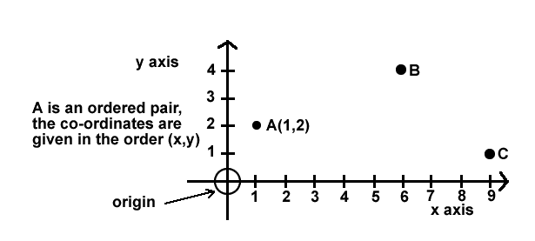
Activity | Activity 1.2  - Did you know all of the terminology used in naming the points and axes above? If not, spend a little time studying and absorbing the terms you did not know. They should all be familiar to you.  - What are the co-ordinates of B and C? Write them up as ordered pairs.  - What shape do you form if you join points A, B and C with line segments?  - Could you have formed a different shape if you did not have to join the points with line segments? Experiment on the drawing to see what shapes you can make!

Plane and space shapes
Now look at the drawings of shapes below.
We call each of them a geometric figure or shape.

A | 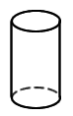 | B |  | C | 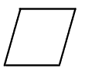 | D | 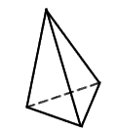
E | 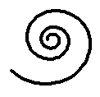 | F | 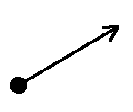 | G | 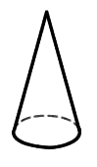 | H
I | 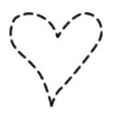 | J |  | K | 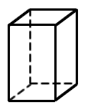

Activity | Activity 1.3  - Can you name each shape? Write the names next to the letter corresponding to each shape.  - Look carefully at each shape again. As you do so, think about their characteristics. Write down some of the characteristics that you thought about. Try to think of at least one characteristic per shape.
Whether you could name the shape or not and whatever characteristics of the shape you could give, if you look again you will quickly notice (if you have not already) that some of the shapes are FLAT and some of the shapes protrude into SPACE.
This is the first major distinction that we are going to make in terms of geometric figures – some are called PLANE FIGURES (they are flat and lie in a plane or flat surface; examples are B, C, E, F, H, I and J above). Others are SPACE FIGURES (they are not flat and protrude from the surface on which they are resting; examples are A, D, G and K above). Plane and space are separate from the dimension of the shape – they tell us whether the shape is flat or not.

Dimension
Dimension tells us something else. Let us see how dimensions are defined.
If we look even more closely at the shapes we can see that they are not all made in the same way. Some are solid, some are hollow, some are made of discrete (separate) points; others are made of line segments, curves or surfaces.
Note | Refer again to the drawings of shapes above when you read these notes.  Look at shape B. It is made of points. We call this kind of shape zero-dimensional (0-D).  Look at shapes E, F and I. They are made of lines or curves. We call this kind of shape one-dimensional (1-D).  Look at shapes C, H and J. They are made of flat surfaces. They can lie flat in a plane. We call this kind of shape two-dimensional (2-D).  Look at shapes A, D, G and K. They protrude into space. They do not sit flat in a plane. We call this kind of shape three-dimensional (3-D).
This definition of dimension might be a bit more detailed than definitions of dimension which some of you may already have heard or know. You may only have thought about 2-D and 3-D shapes. It is analytical and corresponds closely to the make-up of each shape. It could also correspond with a very close scrutiny of each shape, such as a child may subject each shape to, never having seen the shape before and looking at it with new and eager eyes. To teach well we need to be able to see things through the eyes of a child.

Activity | Activity 1.4  - Remember that we distinguished between plane shapes and space shapes. What is the main difference between plane shapes and space shapes?  - What dimensions could plane shapes be?  - What dimensions could space shapes be?  - Here are some sketching exercises for you to try. On a clean sheet of paper sketch and name the following shapes:  a zero-dimensional plane shape  a one-dimensional plane shape  a two-dimensional plane shape  a three-dimensional space shape.  - Sketch any three other shapes of your own (or more if you would like to), and then classify them according to plane or space and dimension.

Plane figures
We now take a closer look at the flat geometric shapes. They are called plane figures (or shapes) because they can be found in a plane (a flat surface).

Reflection | Think of the geometric figures that are studied in the primary school – which of them are flat? Write down the names of all the FLAT shapes of which you can think.  The first plane figure that we define is a curve. What do you think a curve is? Sketch it in your notebook. Do more than one sketch if you have more than one idea of what a curve looks like.

Curves
Did your curve(s) look like any of the following shapes?
A | 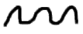 | B | 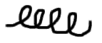 | C | 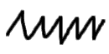
D | 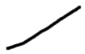 | E |  | F

Study the above shapes carefully. A, B, C and D are all curves. They are all one-dimensional connected sets of points. They can be drawn without lifting your pen from the paper. You may have thought that only A and B are curves and the idea that C and D are also curves might surprise you. Curves are allowed to be straight! Don't forget this!
Several of the plane shapes that we study are made up of curves. We will now have a look at some different kinds of curves.

Reflection | Look at the sketches below. Circle all those that represent single curves. (Try this without looking at the solutions first!)

A |  | B | 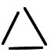 | C | 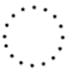
D |  | E |  | F | 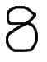
G | 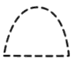 | H | 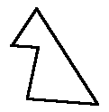 | I | 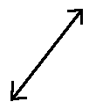 | J | 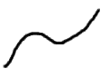

Discussion | Check your answers and correct them if necessary. The sketches that you should have circled are A, D, E, F, H, I and J. You can draw each of these without lifting your pen.  B and G are made of more than one curve.  C is zero dimensional – it is made of discrete points.

Reflection | Examine all of the shapes which we have said are curves.  What do they all have in common?  Are there also differences between the shapes which are curves? Try to describe these differences.

Kinds of curves
Because of the differences which you have just been recording, we can categorise curves into different groups, according to the following terms: open/not open (closed); and simple/not simple (complex).
Study the drawings below to see if you can come up with your own definitions of the terms open, closed, simple and complex.

All of these are simple closed curves |  |  |  |  | None of these are simple closed curves
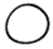 | 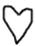 | 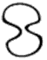 | 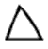 |  | 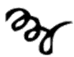 | 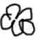 | 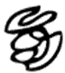
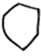 | 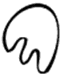 | 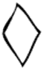 |  |  | 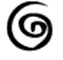 | 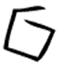 | 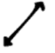

Activity | Activity 1.5  - Remember that we distinguished between plane shapes and space shapes.  - Which of these shapes is a simple, closed curve?  a b c d  e f g h  - Write your definitions of the different kinds of curves (based on what you have noticed):  - A simple curve is …  - A closed curve is …  - A complex curve is …  - An open curve is …

Discussion | Can you see how you were able to work out the definitions for yourself through examining the examples?  Remember this technique for your own teaching of definitions – rather than dictating meaningless definitions, allow learners to work out definitions for themselves by giving them sufficient information to do so!

Think of the shapes that you work with at primary school – how would you classify them in terms of simple, complex, open and closed? These might be characteristics of shapes that you haven't thought of before – but can you see how fundamental they are to the shapes?

Reflection | Look at the shapes below. What do they all have in common?

They all have an interior, an exterior and a boundary (the curve). This is special! As you should now be aware, not all shapes have these characteristics.
Reflection | Which of the shapes that you work with in the primary school are simple, closed curves? Name them.

The names of some other special curves which are commonly used and spoken about at school will now be mentioned. You should be familiar with all of the terms – if not, spend some time studying them!

Lines, rays and line segments
First look at the diagram and examples given below of lines, rays and line segments. Then read the given definitions and try to give some of your own “real life” examples for each. We use two points to name lines, rays and line segments.
Example | Here are some sketches of a line, a ray and a line segment.  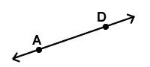  AD is a line.  The arrows on either end of AD indicate that AD continues infinitely in both directions.  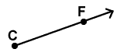  CF is a ray.  The arrow on the one end of CF indicates that CF continues infinitely in the direction of F.  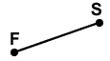  FS is a line segment.  The points at F and S indicate that the line goes from F to S and no further.

Note | A line is a straight curve that is infinite and has no thickness. Lines are 1-D.  A ray is a straight path that has a starting point and continues from there infinitely. Rays are 1-D.  A line segment is a finite piece of a line that has a starting point and an ending point.

Reflection | Give a few examples of things from real life that suggest lines. Draw them.  Give a few examples of things from real life that suggest rays. Draw them.  Give a few examples of things from real life that suggest line segments. Draw them.

Angles
An angle is the opening formed between two rays which have a common starting point.

Reflection | Give a few examples of things from real life that suggest angles. Draw them.

A degree is the unit used to measure angles.
In terms of angles you need to know the names of the different angle types, how to measure angles using a protractor and to be able to estimate the size of an angle without actually measuring the angle. The angle types are described in the diagram below:
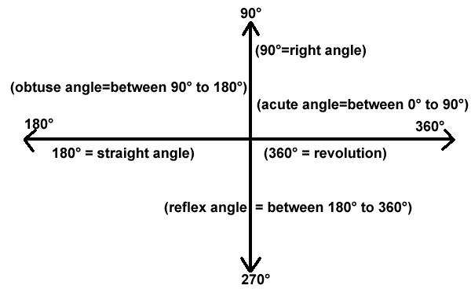

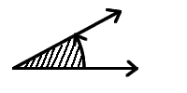 | 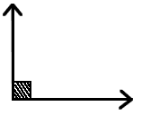 | 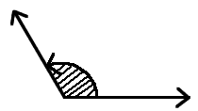
Acute angle | Right Angle (90°) | Obtuse Angle
 | 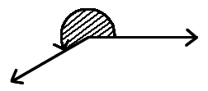 | 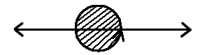
Straight Angle (180°) | Reflex Angle | Revolution (360°)

Activity | Activity 1.6  - Use a protractor to confirm the measurements of 90°, 180°, 270° and 360°.  - Draw the other pairs of lines at various angles to each other and measure the angle you have found between the lines.  - Did you know that it was the Babylonians who determined that there are 360° in one revolution? Try to find some more information about this.  - Draw other pairs of lines at various angles to each other and measure the angle you have formed between the lines.

You might need to do some research when you work on the next activity. Use a good school textbook or, if you have access, use the internet.

Activity | Activity 1.7  Parallel and perpendicular lines. There are also the relationships between parallel and perpendicular lines. What are these?  - Parallel lines are …  - Perpendicular lines are…  - What things in real life give suggestions of parallel lines?  - What things in real life give suggestions of perpendicular lines?  - Sketch a pair of parallel lines and a pair of perpendicular lines.

Activity | Activity 1.8  - How many line segments can you draw between the points shown below? Can you make a generalisation about higher numbers of points?  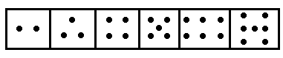  - In the drawings below which line segment is longer? Decide first and then measure.  - Can you draw four straight lines that will go through all of the dots below?  - Name some lines, rays, line segments and angles in the diagram below. Be sure that you know what you are naming – is it an infinite or a finite path? Which is which?  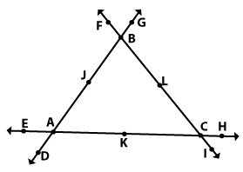

It is important that we think of and present angles to our learners not just as static drawings, but also as openings formed by a turning movement.

Activity | Activity 1.9  Look at the drawing below, and then answer the questions that follow.  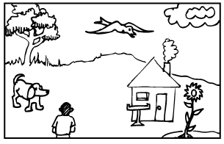  - What angle would be formed if the boy turned from looking at the tree to looking at the house?  - What angle would be formed if the bird turned from looking at the flower to looking at the seed-tray in front of the house?  - Try to make up two of your own questions like the two above that would form different angle types.

Polygons and other plane figures
At primary school, many polygons and other plane figures are studied. All polygons, and many of the other plane shapes studied, are simply further specialised curves. A polygon is a simple, closed plane shape made only of line segments.

Look again at the definition of a polygon which you have just read above. Do you see how it is made up of many of the terms that we have defined so far? Mathematical definitions involve mathematical terminology! We need to know it, use it and teach it to our learners! If your learners are having difficulty with mathematical definitions – check and see if they understand each of the terms involved in the definition and you may find the root of their problem. Be very sure that you always use mathematical language all of the time so that through listening to you, your learners will become acquainted with the terminology: you have to set the example!
Activity | Activity 1.10  Look at the shapes below and use them to answer the following questions.  - Which of them are polygons? If not, why not?  - Which of them are 1-D?  - Which of them are closed?  - Which of them are open?  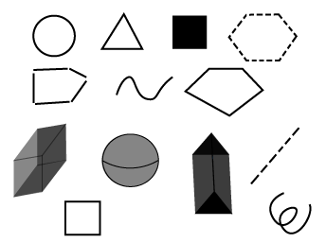  - Do you find that as you look at shapes you are looking more closely now than you did before? You should be!
Polygons are named according to the number of sides (line-segment edges) they have. Would you agree that the least number of sides that a polygon can have is three sides? Think about it! You should know how to name and draw the following polygons:
- a polygon with three sides is a triangle;
- a polygon with four sides is a quadrilateral;
- a polygon with five sides is a pentagon;
- a polygon with six sides is a hexagon;
- a polygon with seven sides is a heptagon;
- a polygon with eight sides is an octagon;
- a polygon with nine sides is a nonagon;
- a polygon with ten sides is a decagon;
- a polygon with twelve sides is a dodecagon; and
- a polygon with twenty sides is an icosagon.
Remember that the word polygon is a general term and can be used for any of the above shapes, and any other shape made of line-segments.
Polygon means "many-angled". The corners of a polygon are called vertices. The number of sides of a polygon corresponds with the number of angles of that polygon. Polygons also have many sides.

Reflection | Think about the number of sides and internal angles compared to the number of vertices (corners) that a polygon has?

Some polygons have all of their sides the same length and all of their internal angles the same size. These are known as regular polygons. The vertices of a regular polygon always lie on a circle. A square, for example, is a regular quadrilateral.

Activity | Activity 1.11  Look at the drawings of shapes below and circle all of the regular polygons. Name all of the polygons using the names given above.  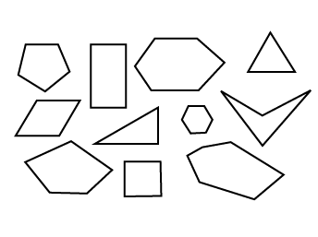

Reflection | How many different polygons could you draw?  How many different regular polygons could you draw?

At school the triangles and quadrilaterals are studied in greater depth than other polygons. You therefore need to know all of their more specialised names and characteristics. Study the drawings below and be sure that you know all of the names given.

Types of triangles
If you name them according to their angle size:
Acute angled triangle (has three acute angles) | Obtuse angled triangle (has one acute angle) | Right angled triangle (has one right angle)
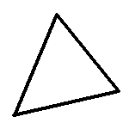 | 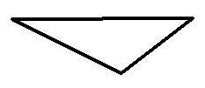 | 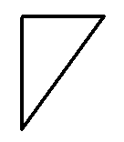
Equilateral triangle (three angles equal 60) | Isosceles triangle (has two equal sized angles)
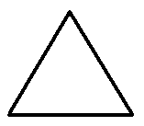 | 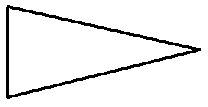

If you name them according to the lengths of their sides:
Scalene triangle (all three sides different lengths) | Isosceles triangle (two sides of equal length | Equilateral triangle (all three sides of equal length)
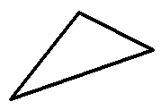

You can also name triangles according to the lengths of their sides AND their angle sizes – for example, you could talk about a right-angled scalene triangle. You should be able to name or draw any triangle.

Reflection | Draw a right-angled isosceles triangle and an obtuse-angled scalene triangle.  Think about this: how many different triangles could you draw with one side that is 5cm long? This is a more open-ended, discovery type question, to which there is more than one answer. You should try to set questions like these for your learners fairly often, so that they do not develop the attitude that mathematical questions only ever have one correct answer.

Types of quadrilaterals

Square (regular quadrilateral) (four sides of equal length and four right angles) | Rectangle (two pairs of opposite sides equal in length and four right angles) | Parallelogram (two pairs of opposite sides parallel and equal in length) | Rhombus (all four sides equal in length
 |  |  | 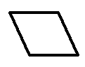
Kite (two adjacent pairs of sides equal in length | Trapezium (at least one pair of sides parallel) | Irregular quadrilateral (all sides different lengths)
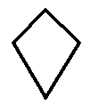

You do not just need to be able to name the shapes but you should be aware of the inter-relationships between the shapes. Most people know and agree that a rectangle can also be a parallelogram, but what about other relationships between shapes? How would you answer the questions below? Try to discuss these questions with your colleagues – you might have some lively debates over some of them!

Activity | Activity 1.12  Answer SOMETIMES or ALWAYS or NEVER to the following questions:  - When is a parallelogram a kite?  - When is a square a trapezium?  - When is a kite a square?  - When is a rectangle a parallelogram?  - When is a parallelogram a rhombus?  - When is a square a rectangle?  - When is a rectangle a trapezium?  - When is a rhombus a square?

Discussion | Do your answers to the questions in Activity 1.12 agree with the following? Think about them if they do not.  - A parallelogram is sometimes a kite, when it is a rhombus.  - A square is always a trapezium.  - A kite is sometimes a square when both pairs of adjacent sides are equal in length.  - A rectangle is always a parallelogram.  - A parallelogram is sometimes a rhombus when it has all four sides equal in length.  - A square is always a rectangle.  - A rectangle is always a trapezium.  - A rhombus is sometimes a square, when it has right angles.

When you become aware of the inter-relationships between the shapes you see the shapes as less static and rigid, which is an important progression in your awareness of shapes!
You could use paper-folding activities in your teaching on the polygons. This would be a hands-on type of activity through which the learners could discover the characteristics of and inter-relations between shapes. Try this out and then record what skills and opportunities you think paper-folding exercises would offer to your learners.

Number patterns and geometric shapes
We now divert our thoughts from pure geometric thinking to number patterns and their link to geometric shapes. There are many number patterns of which we are aware, and which we take quite for granted, though we are often not aware of how these patterns are generated and why they actually are patterns.
A few of the patterns have names that link them to shapes – and not without reason. Sometimes when we lay out counters in patterns of ever-increasing designs of exactly the same thing, we form geometric number patterns. We can use any type of counters to do this, for example bottle tops, blocks, buttons, etc. It is important when children study number patterns that they are made aware of the pattern presented to them, so that they do not need to become bogged down in sets of meaningless rules.

Reflection | Think about laying out a sequence of ever-increasing squares. Draw the pattern you would find.  What is the number pattern that you have "discovered" above?  Try laying out increasingly large cubes, and see what number pattern you find.  What type of apparatus is necessary for such an activity?  Draw the pattern you would find.

Activity | Activity 1.13  There are other geometric number patterns that have also been given names, such as gnomons and triangular numbers. These two patterns are drawn for you below. Count the number of dots in each sketch to discover the pattern. (Write this on the lines below each sketch.)  - Gnomons  - Number of dots in each term of the sequence.  - Number pattern.  - Predict what the next three numbers in the sequence will be.  - Draw the next three sketches in each pattern to check your prediction.  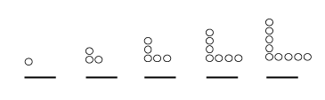  - Triangular numbers  - Number of dots in each term of the sequence.  - Number pattern.  - Predict what the next three numbers in the sequence will be.  - Draw the next three sketches in each pattern to check your prediction.  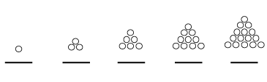  - Are these number patterns familiar to you? Write about some other similar patterns that you know.

Discussion | Can you think of ways of geometrically illustrating other number patterns that you know?  Experiment with number patterns and discuss them with your colleagues or lecturer.

Before we leave the plane and take a look at shapes in space, let us review some other familiar plane shapes that are not polygons. You should know all about these shapes, so try to remember their names and the terms relating to them if you don't already know them or if you have forgotten them.
Round shapes can roll. There are some special round shapes that you should know about.
Regions are shapes that include the flat surface surrounded by the outline of the shape. They are two dimensional. Here are some round shapes and regions. When we draw a region we usually colour it in to show that the inner surface is included.
Circle and circular region
Ellipse and elliptical region
Oval and oval region

Planes
Planes are infinite two dimensional surfaces without thickness.
Activity | Activity 1.14  - How many points do we need to name a plane unambiguously?  - Could two planes be parallel to each other?  - How would planes intersect?  - How would lines and planes intersect?  - Before we move out of the plane, we consider some two-dimensional shapes. Look at the shapes below, and circle the ones that are 2-D.  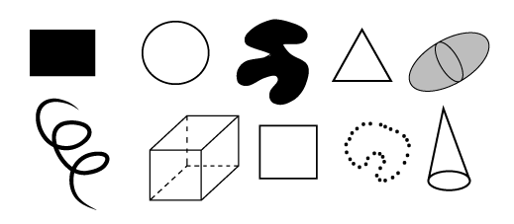
Before you go on, be sure that you are familiar with all of the information given so far. Why not take some time to recap now?

Space figures
A figure that is not a plane figure is called a space figure. Space figures take up space; they do not lie flat in a plane. They can be solid, made of surfaces, hollow skeletons (also called frameworks), or just simply collections of points which are not flat.
Space shapes are three dimensional (3-D). They have height which makes them protrude up above the plane in which they lie.

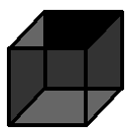 | 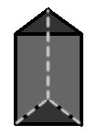 | 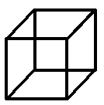
SOLID  (shaded)  3-D  e.g.wood | HOLLOW  (lines and dashes)  3-D  e.g. cardboard | FRAMEWORK  (lines)  3-D  e.g. wire | DISCRETE POINTS  (dots)  3-D  e.g. dust cloud
The closed space figures that are made entirely of plane surfaces (such as cardboard or paper) are called polyhedra. (Sometimes they are called polyhedrons). Polyhedra are three-dimensional.
Polyhedra are made entirely of faces (the flat surfaces which are all polygonal regions), edges (where the faces meet, they are all line-segments), and vertices (where the edges meet, they are all points). You need to apply this terminology in to next activity.
Activity | Activity 1.15  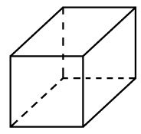  - How many faces does the shape have?  - How many edges does the shape have?  - How many vertices does the shape have?  - How would you name the shape?  - What dimension is the shape?  - What do we call a space figure that includes its interior?  - What do we call a space figure made only of line segments?  - What do we call a space figure that is made only of discrete points?
We can name polyhedra according to the number of faces they have.
We use the same prefixes as for the polygons, but the names end in the word -hedron. (penta-, hexa-, hepta-, octa-, nona-, deca-, dodeca-, icosa-, poly-.). For example, a polyhedron with six faces is called a hexahedron. Polyhedron means "many faced". The smallest possible number of faces a polyhedron can have is four. This is called a tetrahedron. (Be careful here – this differs from the naming of polygons.)
A net is a fold-out (flat, 2-dimensional) shape that can be folded up into a space shape. We can make nets for all of the polyhedra. (There are also nets for some other space shapes which are not polyhedra.) You need to be able to draw nets of polyhedron with up to eight faces.

Regular polyhedra
A regular polyhedron is any polyhedron with all of its faces the same size and interior angles the same size. Both conditions (faces and interior angles) need to be satisfied for a polyhedron to be regular. Plato discovered that there are only five regular polyhedra, and in their solid form they are known as the platonic solids.

Activity | Activity 1.16  There are sketches of the five regular polyhedra and their nets below. Count the number of faces in the nets and pair up each regular polyhedron with its matching net.  - Tetrahedron  - Hexahedron  - Octahedron  - Dodecahedron  - Icosahedron  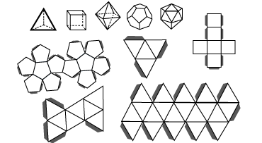

There are several polyhedra, but if we look more closely at them, we can identify two special groups of polyhedra that can be more specifically classified: pyramids and prisms. These are shapes commonly spoken about in schools and so we take a closer look at them too.

Pyramids
The set of polyhedra in which one face is called the base, and all of the other faces are triangular regions having a common vertex called the apex. The triangular faces are called lateral (side) faces. The BASE determines the kind of pyramid.
We can name pyramids according to their base, or according to how many faces they have. For example, a pyramid with five faces is called a pentahedron, its base could be a square and so we can also call it a square pyramid.
To sketch a pyramid, it is usually the easiest to draw the base, set the position of the apex, and drop down the edges where necessary. You must practise drawing them!
Activity | Activity 1.17  Here are a few examples of pyramids: they have been named according to their bases. Name each one according to the number of faces it has.  For example, a hexagonal pyramid has a hexagon (six-sided polygon) as its base. It has seven faces altogether and so is called a heptahedron.  Triangular pyramid (solid) Square pyramid (framework) Pentagonal pyramid (surfaces) Octagonal pyramid (surfaces)  - Triangular pyramid  - Shape of base  - Number of sides in base polygon  - Number of faces in polyhedron  - Name of polyhedron according to number of faces  - Square pyramid  - Shape of base  - Number of sides in base polygon  - Number of faces in polyhedron  - Name of polyhedron according to number of faces  - Pentagonal pyramid  - Shape of base  - Number of sides in base polygon  - Number of faces in polyhedron  - Name of polyhedron according to number of faces  - Octagonal pyramid  - Shape of base  - Number of sides in base polygon  - Number of faces in polyhedron  - Name of polyhedron according to number of faces

Prisms
Prisms are the set of polyhedra with two faces called bases, which are congruent polygonal regions in parallel planes, and whose other faces, called lateral faces, are parallelogram regions.
As with pyramids, the BASES determine the kind of prism. We can also name prisms according to how many faces they have, and according to their bases.
For example, a hexagonal prism has a hexagon (six-sided polygon) as its base. It has eight faces altogether and so is called an octahedron.

Activity | Activity 1.18  Here are a few examples of prisms: they have been named according to their bases. Name each one according to the number of faces it has.  Triangular prism (solid) Square prism (framework) Pentagonal prism (surfaces) Heptagonal prism (surfaces)  - Triangular prism  - Shape of base  - Number of sides in base polygon  - Number of faces in polyhedron  - Name of polyhedron according to number of faces  - Square prism  - Shape of base  - Number of sides in base polygon  - Number of faces in polyhedron  - Name of polyhedron according to number of faces  - Pentagonal prism  - Shape of base  - Number of sides in base polygon  - Number of faces in polyhedron  - Name of polyhedron according to number of faces  - Heptagonal prism  - Shape of base  - Number of sides in base polygon  - Number of faces in polyhedron  - Name of polyhedron according to number of faces

To sketch a prism, it is usually the easiest to draw the congruent bases, and then draw in the edges where necessary. You must also practise drawing these!
Activity | Activity 1.19  Draw the nets of all of the pyramids and prisms in the previous two activities. Label each of your nets so that you will remember what they are. Two examples have been done for you.  Triangular prism Pentagonal prism
Most of the prisms and pyramids that you see are known as right prisms or pyramids, because they stand at right angles to the surface on which they rest. This is not always the case, and drawn below is a parallelopiped, which is a prism made entirely of parallelograms (not rectangles).
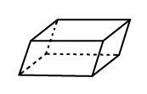
There are several other very common space figures that are not part of the polyhedron family at all. If you look closely at them you will see that this is because they are not made entirely of flat faces, edges and vertices. They have curved surfaces (which cannot be called faces) and we cannot always make nets for these shapes. You should know and be able to draw all of these shapes.

Reflection | Look at these shapes for most of which nets cannot be drawn, and try to think why this is so.  Which of these shapes have nets?  SPHERE HEMISPHERE  CYLINDER CONE  OVOID ELLIPSOID  DIHEDRAL ANGLE

Reflection | Are you able to recognise all of the special polyhedra and the other space shapes and their nets?  Are you able to name them in every way possible.?  Are you able to sketch them?

Truncated figures
Truncated figures are figures that are not part of the polyhedra family. They are formed by making one or more cuts or slices through other space figures to form a new and different shape. Many thought-provoking and fascinating exercises can be devised using truncations.

Reflection | What would the base of the cone below look like if it were cut in the two places indicated?  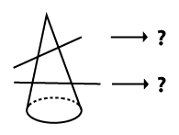  Think of some other questions you could set using truncations. Write up your ideas and discuss them with your lecturer if there's time.

Activity | Activity 1.20  Make sketches below to satisfy the following descriptions:  - A framework space shape.  - A solid space shape.  - A plane shape.  - A simple closed curve.  - A two dimensional region.  - A space shape made of surfaces.  - A zero dimensional plane figure.

Activity | Activity 1.21  - Complete the table below by referring to models or sketches of the shapes given in the first column of the table.  Polyhedron Number of vertices Number of faces Number of edges  Cube  Triangular pyramid  Octagonal pyramid  Triangular prism  Square pyramid  Hexagonal prism  - What do you notice about the number of edges compared to the number of faces plus the number of vertices for these polyhedra?

Pattern work and transformations
One of the wonderful things about teaching geometry is that it has some lovely potential for artistic and creative pattern work. We will now look at some of the possibilities for patterns using tessellations, symmetry and other transformations.

Tessellation
Tessellation is the art of covering an infinite surface without leaving any gaps between the shapes used to cover the surface. Tiling of a floor or wall is an example. If a single shape is able to be used to cover an infinite surface, that shape is said to tessellate. For example, squares can tessellate. If a pattern is made that covers a surface using more than one shape, we call that a multiple shape tessellation. Tessellations can be made out of simple geometric shapes but also out of complex and creative shapes.
Look at the examples of tessellations given below.
The three on the right were drawn by some grade four learners. Do you see how different the tessellations can be?
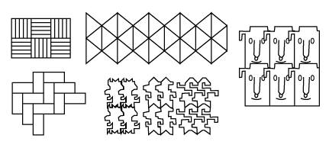

Activity | Activity 1.22  - Design your own shape that can tessellate.  - Experiment with tessellations of polygonal shapes to find out which of them tessellate. Cut out about six of any polygon that you wish to tessellate and see if it will tessellate. Paste down your tessellations on paper and keep them for future reference.  - Will any triangle tessellate?  - Will any quadrilateral tessellate?  - Will any polygon tessellate?

Isometric transformations
Isometric transformations are also known as rigid motions. They are motions since they involve moving shapes around (in the plane and in space), and they are rigid motions since the shape does not change in SIZE at all when it is moved. We will study reflections, rotations and translations of shapes.

Symmetry

Line symmetry
When we say symmetry we mean line symmetry. Line symmetry is also called reflection symmetry (because it has a lot to do with reflections) and bilateral symmetry (because of the 'two-sided' nature of symmetrical figures).
We say line symmetry because of the line of symmetry – the line (or axis) about which the symmetry occurs. When two points are symmetrical to each other we say that the one is the reflection of the other.
Note | We can define symmetry in a formal mathematical way, as follows:  - Line symmetry for a pair of points:  Two points, $P_{1}$, and $P_{2}$, are symmetrical with respect to a line L if the line L is the perpendicular bisector of $P_{1}P_{2}$,.  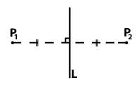  - Line symmetry for a pair of congruent figures:  Two congruent figures are symmetrical with respect to a line L if for each point $P_{1}$ in the one figure there is a point $P_{2}$ in the other figure, such that $P_{1}$and $P_{2}$ are symmetrical w.r.t. line L.  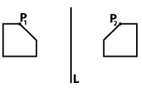  - Line symmetry for a single figure:  A figure is symmetrical w.r.t. a line L if for each point $P_{1}$in the figure we can find a point $P_{2}$ in the figure, such that $P_{1}$and $P_{2}$ are symmetrical w.r.t. the line L.  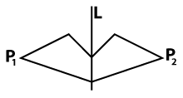
A figure needs to have only ONE axis of symmetry to be symmetrical, though it may have MORE THAN ONE axis of symmetry.

Activity | Activity 1.23  - Identify which of these shapes are symmetrical figures:  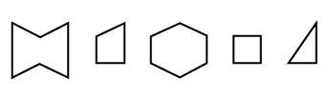  - Identify which figures represent congruent pairs of symmetrical shapes with respect to the given line:  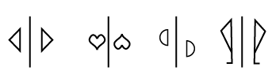  - Draw a pair of congruent symmetrical figures, a shape with one axis of symmetry, a shape with two axes of symmetry and a shape with four axes of symmetry (four separate drawings).

Reflection | You could experiment with drawing many other symmetrical shapes. You must be able to draw shapes with various numbers of axes of symmetry, and to recognise how many axes of symmetry a shape has.

The topic of symmetry lends itself well to practical activities in the classroom. You could use any of the following:
- Folding and making holes in paper with compass/pen nib.
- Folding and cutting paper shapes – experiment with one and more folds and cutting on the different edges, too. Let the children predict what the shape will look like before they open it up.
- Point plotting on the Cartesian plane (work out the unknown co-ordinates of a given symmetrical shape).
- Use mirrors – with real objects (pens, pencils, sharpeners, etc.) and with drawings (crazy ones and familiar ones).
- Paint blobs on one side of a piece of paper and then squash two sides of the paper together along a fold – see what interesting symmetrical images you can produce.

Rotational symmetry
Rotational symmetry is a different type of symmetry that results from rotating shapes in the plane. Rotate means TURN like you turn a door handle when you open a door. We can turn ANY object around, in a variety of ways: in space, in the plane, about a point (inside the shape), or about a point (outside of the shape). We can also turn the shape through any number of degrees. The rectangle below has been rotated through a few different degrees. You can see this because you see the same rectangle but lying at different angles.
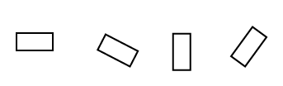
Sometimes, even if we have rotated a shape, it appears not to have moved. This leads us to the idea of rotational symmetry. A figure is said to have rotational symmetry about a centre of rotation if it appears not to have been moved by the rotation. Look at the square below. It looks as if it is lying in the same position, but if you look at the cross inside the square you can see that it is in a different position in each of the shapes. Make a square out of a piece of paper and rotate it so that you reproduce the sequence of illustrations below.
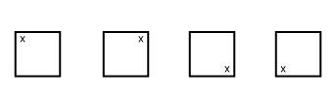
We talk about angles of rotational symmetry (the angle through which a figure turns such that it lands in a position where it appears not to have moved) and order of rotational symmetry (the number of times a figure lands in its starting position, as it does one full revolution).
When we speak about rotational symmetry, we will always assume CLOCKWISE direction of rotation unless otherwise specified. The angles of rotational symmetry must lie from 0° to 360°, and 0° to 360° are considered the same thing.
The illustrations on the next page describe the rotations of a rectangle through 0°, 90°, 180°, 270° and 360°.

Original position - 0° rotation. (The same as a 360° rotation of the shape, since 360° returns the shape to its original position). | Rotation of the square through 90° from its original position.  Notice how the marker in the one corner of the square has moved. | Rotation of the square through 180° from its original position.  Notice how the marker in the one corner of the square has moved. | Rotation of the square through 270° from its original position.  Notice how the marker in the one corner of the square has moved.
 | 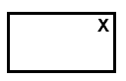

You must be able to identify angles through which shapes have been rotated, and draw shapes in the position they would land if they have rotated through a given number of degrees.

Activity | Activity 1.24  - Through what angle has the following shape been rotated about S?  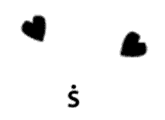  - Rotate the given shape about G through 270°.  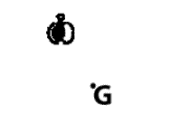

Reflection | Can we make a generalisation about the relationship between the number of axes of (line) symmetry of a shape and its order of rotational symmetry?

Activity | Activity 1.24  Complete the information in the following table. Then study the completed table and see what you can conclude.  Figure Number of lines of symmetry Angles of rotational symmetry Order of symmetry  Square  Equilateral triangle  Regular octagon  Regular nonagon  Rectangle  Circle  Parallelogram
A 180⁰ rotation in a plane about a point results in what we call point symmetry (i.e. point symmetry is a particular type of rotational symmetry.)
As with line symmetry, we talk about point symmetry with respect to a point and point symmetry for pairs of figures. You must be able to draw and recognise when a shape has point symmetry with another shape. The figures below are point symmetrical.

Translations
When a shape has been translated, every point in the shape is moved the same distance. You can involve the learners in point plotting exercises and get them to pull or push shapes ALONG a line, BELOW or ABOVE a line, and so on, to draw translations. The shapes in the grid below have been translated.
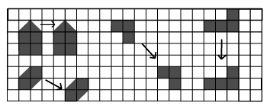
The arrows show the direction of the translation each shape has undergone.
- Horizontal translations move the shape to the left or right without any upward or downward movement.
- Vertical translations move the shape up or down without any sideways movement.
- Oblique translations move the shape to the left or right and upward or downward movement at the same time. The arrow indicating the movement is at an angle to the horizontal.

Reflection | What is the difference between the description of a horizontal/vertical translation and an oblique translation?

Activity | Activity 1.25  - Draw a few shapes on grid paper and then translate them. Record what translations you make the shapes undergo.  - Shapes can be translated vertically, horizontally and obliquely. On a grid translate a shape in each of these ways. Record the translations made by each shape.

Non-isometric transformations
If a shape is changed in any way when it is moved then the movement is not isomorphic. We will not study these motions in any detail, but we mention them to complete our study of shapes in motion. Enlargements or reductions of a shape are examples of non-isometric transformations.
Here are some further exercises on transformations for you to try.

Reflection symmetry (Grade 4)
- Design an interesting and creative shape which displays reflection symmetry. Plot your shape on a grid and draw it in.
- Use your shape in a lesson involving revision of point plotting in the two-dimensional plane and consolidation of the concepts relating to line symmetry.
- Give instructions to the class as to how to get started.
- Ask questions that will call on their understanding of line symmetry and reveal any problems they may be experiencing with the topic.
- Set a task that they will have to do (in pairs) relating to the exercise that you have completed.
- What outcomes could the learners achieve through completing this task?

Rotational symmetry (Grades 5 or 6)
- Draw three shapes on the grid with each in several different rotated positions. Indicate clearly the rotation each shape has undergone in each position.
- Devise a lesson that teaches the concept of rotational symmetry to a class of Grades 5 or 6(specify which). Take note that this is "enrichment" work.
  - You might use your sketches (done above) or other sketches.
  - Call for sketches from the learners.
  - Record the questions you will ask in the process of teaching the concept.
  - Let the learners work in pairs and do an activity that involves rotations of:
    - themselves
    - real shapes from their school bags
    - geometric figures.
  - What outcomes could the learners achieve through completing this task?

Translations (Grades 5 or 6)
- Sketch four different shapes on your grid. Translate each shape in a different way. Draw the shape in its new position, after it has been translated. Indicate what translation each shape has undergone.
- Set a worksheet consisting of 5 questions (activities, sketches, or interpretation of sketches, for example) that call for an implementation of an understanding of translations. Use grid paper where necessary. Questions must be clearly worded.

Unit summary
In this unit you learned how to
- Identify and describe fundamental properties of shapes.
- Differentiate between and illustrate two dimensional (2-D) and three dimensional (3-D) shapes.
- Categorize and compare two dimensional (2-D) and three dimensional (3-D) shapes.
- Describe and design patterns using tessellations and transformations.

Assessment
Space and Shape
- Make accurate nets for the following shapes:
  - a cube or a cuboid
  - a triangular prism
  - any rectangular pyramid
  - a hexagonal prism
  - a pentagonal pyramid
  - Your nets must be handed in FLAT, but you should have folded them along all of the edges and the flaps so that they can readily be made into the space shapes. Do not make them too small; they should be useful for demonstrations in the classroom.
  - Label each net in two different ways. Write these names onto each net.
- Design a tessellation that is made with four different polygonal shapes. Draw the tessellation onto grid paper.
- Design a creative shape that will be able to tessellate on its own. On a grid paper draw in a tessellation using at least six of your shapes.
- Look around in all the media resources available to you (such as newspapers and magazines), to find pictures of symmetrical shapes. Using appropriate resources, design a worksheet on the topic of line symmetry for a grade of your choice. The grade must be clearly indicated on the worksheet.

