Mathematics for Primary School Teachers

© Saide, with the Wits School of Education, University of the Witwatersrand
Permission is granted under a Creative Commons Attribution licence to replicate, copy, distribute, transmit, or adapt this work freely provided that attribution is provided as illustrated in the citation below. To view a copy of this licence visit http://creativecommons.org/licences/by/3.0/
or send a letter to Creative Commons, 559 Nathan Abbott Way, Stanford, California, 94305, USA.

Citation
Sapire, I. (2010). Mathematics for Primary School Teachers. Saide and the Wits School of Education, University of the Witwatersrand, Johannesburg.
ISBN: 978-0-9869837-5-7

School of Education,  University of the Witwatersrand  Tel +27 11 717 3001  www.wits.ac.za  23 St Andrew’s Road  Parktown  2193 Johannesburg  South Africa | Saide  Tel +27 11 4032813  E-mail: info@saide.org.za  www.saide.org.za  P O Box 31822  Braamfontein  2017 Johannesburg  South Africa

Contents
About the course “Mathematics for Primary School Teachers” 1
Unit 1: Space and Shape 5
Introduction 5
The raw material of geometric shapes 5
Plane figures 11
Polygons and other plane figures 22
Space figures 32
Pattern work and transformations 42
Unit summary 51
Assessment 52
Unit 2: Numeration 53
Introduction 53
Multi-base 62
Developing number concept 71
Number systems we use at school 77
Reasoning, algebra and number patterns 84
Unit summary 91
Assessment 92
Unit 3: Operations 93
Introduction 93
Background and algorithms for addition and subtraction 94
Background and algorithms for multiplication and division 101
Multiples, factors and primes: divisibility rules 108
Problem-solving, word problems and order of operations 117
Unit summary 123
Assessment 124
Unit 4: Fractions 125
Introduction 125
Fractions and wholes: introductory concepts and activities 126
Further activities in the teaching of fractions 134
Equivalent fractions and comparison of fractions 144
Categories of the whole – a review of concepts and apparatus 153
Apparatus 156
Rational numbers 164
Unit summary 173
Assessment 174
Unit 5: Statistics 175
Introduction 175
Random numbers, population and sample 177
Graphical forms of data representation 180
Measures of central tendency 188
Misleading statistics 191
Statistics in the classroom 193
Unit summary 195
Assessment 196
Unit 6: Size and Measurement 197
Introduction 197
Introduction to concepts and relevant ideas 197
Conservation of size – some practical exercises 203
Unit summary 209
Assessment 210

About the course “Mathematics for Primary School Teachers”

Mathematics for Primary School Teachers has been digitally published by Saide, with the Wits School of Education. It is a revised version of a course originally written for the Bureau for In-service Teacher Development (Bited) at the then Johannesburg College of Education (now Wits School of Education).
The course is for primary school teachers (Foundation and Intermediate Phase) and consists of six content units on the topics of geometry, numeration, operations, fractions, statistics and measurement. Though they do not cover the entire curriculum, the six units cover content from all five mathematics content areas represented in the curriculum.
Unit 1 Space and Shape
This unit presents an analytical approach to the study of shapes, including the make-up of shapes, commonalities and differences between shapes and a notation for the naming of shapes.
On completion of the unit students should be able to:
- Identify and describe fundamental properties of shapes.
- Differentiate between and illustrate two dimensional (2-D) and three dimensional (3-D) shapes.
- Categorize and compare two dimensional (2-D) and three dimensional (3-D) shapes.
- Describe and design patterns using tessellations and transformations.
Unit 2 Numeration
This unit is designed to give insight into a few specially chosen ancient numeration systems. After the presentation of historic numeration systems, there is an in-depth look at the Hindu-Arabic numeration system, still in use today, with its base ten and place value.
On completion of the unit students should be able to:
- Record numbers using a range of ancient numeration systems.
- Explain the similarities and differences between the numeration system that we use and those used in ancient times.
- Demonstrate the value of multi-base counting systems for teachers of the base ten numeration system in use today.
- Discuss the use of place value in the development of number concept.
- Demonstrate an understanding of number systems that make up real numbers.
- Apply inductive reasoning to develop generalisations about number patterns and algebraic thinking.
Unit 3 Operations
In this unit, the four operations – addition, subtraction, multiplication and division – are discussed. Each operation is first introduced as a concept, and then the different algorithms that can be used to perform the operations with ever-increasing efficiency, are given and explained. Divisibility rules, multiples, factors and primes and topics related to operations are also included in this unit.
On completion of the unit students should be able to:
- Explain and use the algorithms for addition, subtraction, multiplication and division.
- Demonstrate and illustrate the use of various apparatus for conceptual development of the algorithms for addition, subtraction, multiplication and division.
- Define and identify multiples and factors of numbers.
- Explain and use the divisibility rules for 2, 3, 4, 5, 6, 8 and 9.
- Discuss the role of problem-solving in the teaching of operations in the primary school.
- Apply the correct order of operations to a string of numbers where multiple operations are present.
Unit 4 Fractions
Since fractions are the numerals (symbols) for a group of numbers, the fraction concept is a part of number concept. Fractions can be used to express all rational numbers. In this unit, it is proposed that learners need to be exposed to a range of activities and conceptual teaching on fractions as parts of wholes, ratios, decimals and percentages in order to fully develop their understanding of multiplicative reasoning and rational numbers.
On completion of the unit students should be able to:
- Differentiate between continuous and discontinuous wholes.
- Demonstrate and explain the use of concrete wholes in the establishment of the fraction concept in young learners.
- Illustrate and use language patterns in conjunction with concrete activities to extend the fraction concept of learners from unit fractions to general fractions.
- Identify improper fractions and be able to convert from proper to improper fractions and vice versa.
- Determine the rules for calculating equivalent fractions which are based on the equivalence of certain rational numbers.
- Compare different fractions to demonstrate an understanding of the relative sizes of different rational numbers.
- Describe the differences between the different forms that rational numbers can take on.
Unit 5 Statistics
In this very short introductory unit, the most important statistical terminology is introduced, information on statistical representations and interpretation of data is given and measures of central tendency are discussed.
On completion of the unit students should be able to:
- Define and cite examples of key statistical concepts used in primary schools.
- Identify graphical forms of data representation.
- Differentiate between different measures of central tendency.
- Explain and cite examples of how statistics can be used in misleading ways.
Unit 6 Size and Measurement
In the first section of this unit the conceptual groundwork needed for the topic of measurement is presented. The second part of the unit investigates some of the conservation tests for measurement concepts. These tests enable the teacher to establish whether or not a learner has understood a certain measurement concept.
On completion of the unit students should be able to:
- Explain and cite examples of general measurement concepts as they may be used in the primary school to lay a foundation for measurement and calculations with measurements in later years.
- Apply the conservation tests of Piaget to establish a learner’s understanding of length, mass, area, volume and capacity.

Unit 1: Space and Shape

Introduction
In this unit we will look at shapes analytically. We will look carefully at what makes up shapes, and what makes one shape the same as or different from another, and we will set up a notation for the naming of shapes according to this.
There are many people who are unfamiliar with this field of mathematics. They sometimes see it as inaccessible and impossible to master. If you are one of these people (to whatever degree) this course hopes to give you a fresh look at shapes, their characteristics and components, where we find them in our everyday lives, and how the study of shapes can be both useful and interesting for everyone. We will break things down and rebuild them, we will analyse them and make patterns with them. We hope that this will enable the shapes to come alive again in your minds! And for those of you who are already enthusiastic about geometry – we hope that this course will further stimulate and teach you about one of the most fascinating fields in the study of mathematics.
Upon completion of this unit you will be able to:
Outcomes | - Identify and describe fundamental properties of shapes.  - Differentiate between and illustrate two dimensional (2-D) and three dimensional (3-D) shapes.  - Categorize and compare two dimensional (2-D) and three dimensional (3-D) shapes.  - Describe and design patterns using tessellations and transformations.

The raw material of geometric shapes

Points
The first thing that we need to ask ourselves is "What is a point?" The answer to this question clearly may vary according to the context in which it is asked, but here in this mathematics course we are thinking of a point as a geometric figure.

Reflection | How would you define a point?

How did you answer that question?
Look carefully at your answer – does it define a point, or is it more of a description of where to find a point or of what a point might look like? The reason for this is that we cannot define a point! We know that points exist, and we can find points because they have a position. But a point has no size or shape, and we do not have to see points for them to be there – they are all around us all of the time whether we are aware of them or not. Some things that we see make us think of points – for instance: the tip of a pencil or the corner of a desk.

Reflection | What other things make you think of points?  What do all of these suggestions of points have in common?

Essentially what you will have noticed by now is that we see and think of points as particular, precise locations – location more than substance! If you think about this a little further you should agree that points are not only found at the tips or corners of things, but anywhere on or along them. As soon as we isolate a location we are happy to say that there is a point at that location. This means that points exist everywhere in space, and everything around us consists of points ... so we call points the raw material of geometry.

Reflection | Think for a moment and then write down your ideas on what we learn and teach in geometry – our study of space and shapes.  How do you feel about learning and teaching geometry?

We begin our study of geometry by looking at points, and then out of these points we will build up the body of shapes which we need to know about in order to teach geometry in the primary school.
The curriculum is aimed at children who are learning about shapes for the first time, whereas you are adults looking at shapes from a different perspective. You have already made certain generalisations about shapes which young learners may not yet have made. Their fresh view on shapes enables them to distinguish shapes in different ways. You as a teacher can tap into this fresh and clear perspective on shapes.

Reflection | Why do you think it is appropriate for young learners to study space shapes like balls, cones and boxes before they study circles, triangles and rectangles?

In abstract geometry we work with points all of the time. We need to be able to draw them, and to name them clearly. We draw dots to represent points and we use capital letters to name points.
Remember that points have no size. It does not matter what size dot you draw, although we usually draw the dots quite small, to help us to focus on the point. P and Q below are both points. We visualise the point at the centre of the dot we have drawn, no matter the size of the dot.
•Q •P
Activity | Activity 1.1  - If points have no size, what difference does the size of the dot make?  - If you were to join P and Q with a line segment, could you locate some more points on the line between P and Q?  - How many points can you find between any two other points?
The use of capital letters to name points is simply a convention. There are many conventions (the generally accepted correct form or manner) in mathematics. We need to know and use these correctly and pass on this knowledge to our learners so that they will be able to speak and write correctly about the shapes they are dealing with.

The Cartesian plane
We don't only need to name points. Sometimes we need to locate points in particular locations. To do so we use the Cartesian plane. This is a system of two axes drawn perpendicular to each other, named after Descartes, a French mathematician and philosopher who thought about the idea of placing the two axes perpendicular to each other to facilitate the location of points in a two-dimensional plane.
When we name points in the Cartesian plane we name them as ordered pairs, also known as coordinate pairs. The coordinates come from each of the axes and must be given in the order of x-co-ordinate first and then y-co-ordinate. The x-axis is the horizontal axis and the y-axis is the vertical axis. Look at the following diagram of a Cartesian Plane:
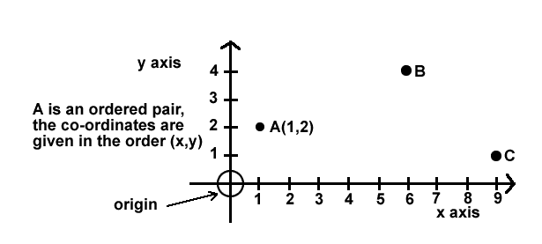
Activity | Activity 1.2  - Did you know all of the terminology used in naming the points and axes above? If not, spend a little time studying and absorbing the terms you did not know. They should all be familiar to you.  - What are the co-ordinates of B and C? Write them up as ordered pairs.  - What shape do you form if you join points A, B and C with line segments?  - Could you have formed a different shape if you did not have to join the points with line segments? Experiment on the drawing to see what shapes you can make!

Plane and space shapes
Now look at the drawings of shapes below.
We call each of them a geometric figure or shape.

A | 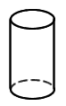 | B |  | C | 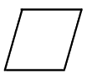 | D | 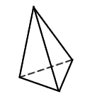
E | 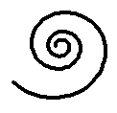 | F | 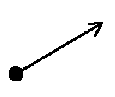 | G | 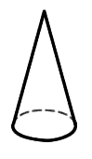 | H
I |  | J |  | K | 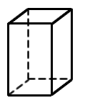

Activity | Activity 1.3  - Can you name each shape? Write the names next to the letter corresponding to each shape.  - Look carefully at each shape again. As you do so, think about their characteristics. Write down some of the characteristics that you thought about. Try to think of at least one characteristic per shape.
Whether you could name the shape or not and whatever characteristics of the shape you could give, if you look again you will quickly notice (if you have not already) that some of the shapes are FLAT and some of the shapes protrude into SPACE.
This is the first major distinction that we are going to make in terms of geometric figures – some are called PLANE FIGURES (they are flat and lie in a plane or flat surface; examples are B, C, E, F, H, I and J above). Others are SPACE FIGURES (they are not flat and protrude from the surface on which they are resting; examples are A, D, G and K above). Plane and space are separate from the dimension of the shape – they tell us whether the shape is flat or not.

Dimension
Dimension tells us something else. Let us see how dimensions are defined.
If we look even more closely at the shapes we can see that they are not all made in the same way. Some are solid, some are hollow, some are made of discrete (separate) points; others are made of line segments, curves or surfaces.
Note | Refer again to the drawings of shapes above when you read these notes.  Look at shape B. It is made of points. We call this kind of shape zero-dimensional (0-D).  Look at shapes E, F and I. They are made of lines or curves. We call this kind of shape one-dimensional (1-D).  Look at shapes C, H and J. They are made of flat surfaces. They can lie flat in a plane. We call this kind of shape two-dimensional (2-D).  Look at shapes A, D, G and K. They protrude into space. They do not sit flat in a plane. We call this kind of shape three-dimensional (3-D).
This definition of dimension might be a bit more detailed than definitions of dimension which some of you may already have heard or know. You may only have thought about 2-D and 3-D shapes. It is analytical and corresponds closely to the make-up of each shape. It could also correspond with a very close scrutiny of each shape, such as a child may subject each shape to, never having seen the shape before and looking at it with new and eager eyes. To teach well we need to be able to see things through the eyes of a child.

Activity | Activity 1.4  - Remember that we distinguished between plane shapes and space shapes. What is the main difference between plane shapes and space shapes?  - What dimensions could plane shapes be?  - What dimensions could space shapes be?  - Here are some sketching exercises for you to try. On a clean sheet of paper sketch and name the following shapes:  - a zero-dimensional plane shape  - a one-dimensional plane shape  - a two-dimensional plane shape  - a three-dimensional space shape.  - Sketch any three other shapes of your own (or more if you would like to), and then classify them according to plane or space and dimension.

Plane figures
We now take a closer look at the flat geometric shapes. They are called plane figures (or shapes) because they can be found in a plane (a flat surface).

Reflection | Think of the geometric figures that are studied in the primary school – which of them are flat? Write down the names of all the FLAT shapes of which you can think.  The first plane figure that we define is a curve. What do you think a curve is? Sketch it in your notebook. Do more than one sketch if you have more than one idea of what a curve looks like.

Curves
Did your curve(s) look like any of the following shapes?
A | 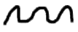 | B | 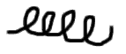 | C | 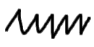
D | 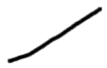 | E |  | F

Study the above shapes carefully. A, B, C and D are all curves. They are all one-dimensional connected sets of points. They can be drawn without lifting your pen from the paper. You may have thought that only A and B are curves and the idea that C and D are also curves might surprise you. Curves are allowed to be straight! Don't forget this!
Several of the plane shapes that we study are made up of curves. We will now have a look at some different kinds of curves.

Reflection | Look at the sketches below. Circle all those that represent single curves. (Try this without looking at the solutions first!)

A |  | B | 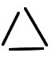 | C | 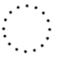
D |  | E |  | F | 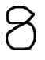
G | 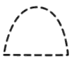 | H | 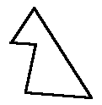 | I | 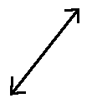 | J | 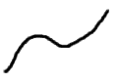

Discussion | Check your answers and correct them if necessary. The sketches that you should have circled are A, D, E, F, H, I and J. You can draw each of these without lifting your pen.  B and G are made of more than one curve.  C is zero dimensional – it is made of discrete points.

Reflection | Examine all of the shapes which we have said are curves.  What do they all have in common?  Are there also differences between the shapes which are curves? Try to describe these differences.

Kinds of curves
Because of the differences which you have just been recording, we can categorise curves into different groups, according to the following terms: open/not open (closed); and simple/not simple (complex).
Study the drawings below to see if you can come up with your own definitions of the terms open, closed, simple and complex.

All of these are simple closed curves |  |  |  |  | None of these are simple closed curves
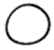 |  | 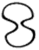 | 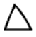 |  | 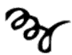 | 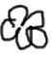
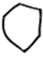 | 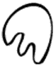 | 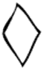 |  |  | 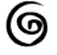 |  | 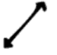

Activity | Activity 1.5  - Remember that we distinguished between plane shapes and space shapes.  - Which of these shapes is a simple, closed curve?  a b c d  e f g h  - Write your definitions of the different kinds of curves (based on what you have noticed):  - A simple curve is …  - A closed curve is …  - A complex curve is …  - An open curve is …

Discussion | Can you see how you were able to work out the definitions for yourself through examining the examples?  Remember this technique for your own teaching of definitions – rather than dictating meaningless definitions, allow learners to work out definitions for themselves by giving them sufficient information to do so!

Think of the shapes that you work with at primary school – how would you classify them in terms of simple, complex, open and closed? These might be characteristics of shapes that you haven't thought of before – but can you see how fundamental they are to the shapes?

Reflection | Look at the shapes below. What do they all have in common?

They all have an interior, an exterior and a boundary (the curve). This is special! As you should now be aware, not all shapes have these characteristics.
Reflection | Which of the shapes that you work with in the primary school are simple, closed curves? Name them.

The names of some other special curves which are commonly used and spoken about at school will now be mentioned. You should be familiar with all of the terms – if not, spend some time studying them!

Lines, rays and line segments
First look at the diagram and examples given below of lines, rays and line segments. Then read the given definitions and try to give some of your own “real life” examples for each. We use two points to name lines, rays and line segments.
Example | Here are some sketches of a line, a ray and a line segment.  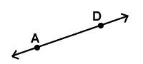  AD is a line.  The arrows on either end of AD indicate that AD continues infinitely in both directions.  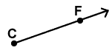  CF is a ray.  The arrow on the one end of CF indicates that CF continues infinitely in the direction of F.  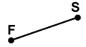  FS is a line segment.  The points at F and S indicate that the line goes from F to S and no further.

Note | A line is a straight curve that is infinite and has no thickness. Lines are 1-D.  A ray is a straight path that has a starting point and continues from there infinitely. Rays are 1-D.  A line segment is a finite piece of a line that has a starting point and an ending point.

Reflection | Give a few examples of things from real life that suggest lines. Draw them.  Give a few examples of things from real life that suggest rays. Draw them.  Give a few examples of things from real life that suggest line segments. Draw them.

Angles
An angle is the opening formed between two rays which have a common starting point.

Reflection | Give a few examples of things from real life that suggest angles. Draw them.

A degree is the unit used to measure angles.
In terms of angles you need to know the names of the different angle types, how to measure angles using a protractor and to be able to estimate the size of an angle without actually measuring the angle. The angle types are described in the diagram below:
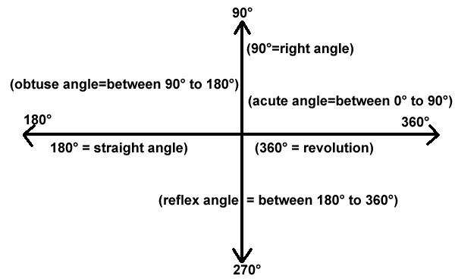

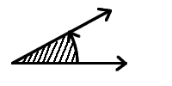 | 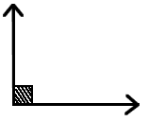 | 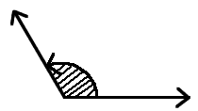
Acute angle | Right Angle (90°) | Obtuse Angle
 | 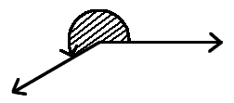 | 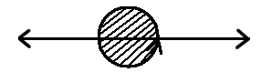
Straight Angle (180°) | Reflex Angle | Revolution (360°)

Activity | Activity 1.6  - Use a protractor to confirm the measurements of 90°, 180°, 270° and 360°.  - Draw the other pairs of lines at various angles to each other and measure the angle you have found between the lines.  - Did you know that it was the Babylonians who determined that there are 360° in one revolution? Try to find some more information about this.  - Draw other pairs of lines at various angles to each other and measure the angle you have formed between the lines.

You might need to do some research when you work on the next activity. Use a good school textbook or, if you have access, use the internet.

Activity | Activity 1.7  Parallel and perpendicular lines. There are also the relationships between parallel and perpendicular lines. What are these?  - Parallel lines are …  - Perpendicular lines are…  - What things in real life give suggestions of parallel lines?  - What things in real life give suggestions of perpendicular lines?  - Sketch a pair of parallel lines and a pair of perpendicular lines.

Activity | Activity 1.8  - How many line segments can you draw between the points shown below? Can you make a generalisation about higher numbers of points?  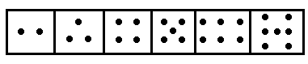  - In the drawings below which line segment is longer? Decide first and then measure.  - Can you draw four straight lines that will go through all of the dots below?  - Name some lines, rays, line segments and angles in the diagram below. Be sure that you know what you are naming – is it an infinite or a finite path? Which is which?  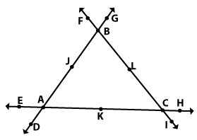

It is important that we think of and present angles to our learners not just as static drawings, but also as openings formed by a turning movement.

Activity | Activity 1.9  Look at the drawing below, and then answer the questions that follow.  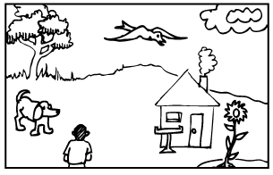  - What angle would be formed if the boy turned from looking at the tree to looking at the house?  - What angle would be formed if the bird turned from looking at the flower to looking at the seed-tray in front of the house?  - Try to make up two of your own questions like the two above that would form different angle types.

Polygons and other plane figures
At primary school, many polygons and other plane figures are studied. All polygons, and many of the other plane shapes studied, are simply further specialised curves. A polygon is a simple, closed plane shape made only of line segments.

Look again at the definition of a polygon which you have just read above. Do you see how it is made up of many of the terms that we have defined so far? Mathematical definitions involve mathematical terminology! We need to know it, use it and teach it to our learners! If your learners are having difficulty with mathematical definitions – check and see if they understand each of the terms involved in the definition and you may find the root of their problem. Be very sure that you always use mathematical language all of the time so that through listening to you, your learners will become acquainted with the terminology: you have to set the example!
Activity | Activity 1.10  Look at the shapes below and use them to answer the following questions.  - Which of them are polygons? If not, why not?  - Which of them are 1-D?  - Which of them are closed?  - Which of them are open?  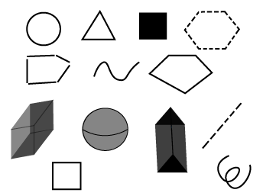  - Do you find that as you look at shapes you are looking more closely now than you did before? You should be!
Polygons are named according to the number of sides (line-segment edges) they have. Would you agree that the least number of sides that a polygon can have is three sides? Think about it! You should know how to name and draw the following polygons:
- a polygon with three sides is a triangle;
- a polygon with four sides is a quadrilateral;
- a polygon with five sides is a pentagon;
- a polygon with six sides is a hexagon;
- a polygon with seven sides is a heptagon;
- a polygon with eight sides is an octagon;
- a polygon with nine sides is a nonagon;
- a polygon with ten sides is a decagon;
- a polygon with twelve sides is a dodecagon; and
- a polygon with twenty sides is an icosagon.
Remember that the word polygon is a general term and can be used for any of the above shapes, and any other shape made of line-segments.
Polygon means "many-angled". The corners of a polygon are called vertices. The number of sides of a polygon corresponds with the number of angles of that polygon. Polygons also have many sides.

Reflection | Think about the number of sides and internal angles compared to the number of vertices (corners) that a polygon has?

Some polygons have all of their sides the same length and all of their internal angles the same size. These are known as regular polygons. The vertices of a regular polygon always lie on a circle. A square, for example, is a regular quadrilateral.

Activity | Activity 1.11  Look at the drawings of shapes below and circle all of the regular polygons. Name all of the polygons using the names given above.  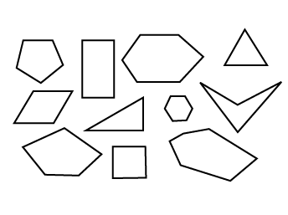

Reflection | How many different polygons could you draw?  How many different regular polygons could you draw?

At school the triangles and quadrilaterals are studied in greater depth than other polygons. You therefore need to know all of their more specialised names and characteristics. Study the drawings below and be sure that you know all of the names given.

Types of triangles
If you name them according to their angle size:
Acute angled triangle (has three acute angles) | Obtuse angled triangle (has one acute angle) | Right angled triangle (has one right angle)
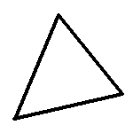 | 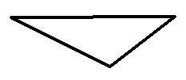 | 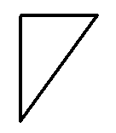
Equilateral triangle (three angles equal 60) | Isosceles triangle (has two equal sized angles)
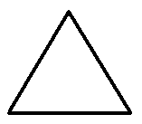 | 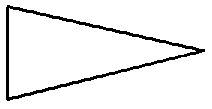

If you name them according to the lengths of their sides:
Scalene triangle (all three sides different lengths) | Isosceles triangle (two sides of equal length | Equilateral triangle (all three sides of equal length)
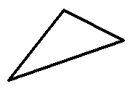

You can also name triangles according to the lengths of their sides AND their angle sizes – for example, you could talk about a right-angled scalene triangle. You should be able to name or draw any triangle.

Reflection | Draw a right-angled isosceles triangle and an obtuse-angled scalene triangle.  Think about this: how many different triangles could you draw with one side that is 5cm long? This is a more open-ended, discovery type question, to which there is more than one answer. You should try to set questions like these for your learners fairly often, so that they do not develop the attitude that mathematical questions only ever have one correct answer.

Types of quadrilaterals

Square (regular quadrilateral) (four sides of equal length and four right angles) | Rectangle (two pairs of opposite sides equal in length and four right angles) | Parallelogram (two pairs of opposite sides parallel and equal in length) | Rhombus (all four sides equal in length
 |  |  | 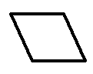
Kite (two adjacent pairs of sides equal in length | Trapezium (at least one pair of sides parallel) | Irregular quadrilateral (all sides different lengths)
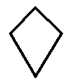

You do not just need to be able to name the shapes but you should be aware of the inter-relationships between the shapes. Most people know and agree that a rectangle can also be a parallelogram, but what about other relationships between shapes? How would you answer the questions below? Try to discuss these questions with your colleagues – you might have some lively debates over some of them!

Activity | Activity 1.12  Answer SOMETIMES or ALWAYS or NEVER to the following questions:  - When is a parallelogram a kite?  - When is a square a trapezium?  - When is a kite a square?  - When is a rectangle a parallelogram?  - When is a parallelogram a rhombus?  - When is a square a rectangle?  - When is a rectangle a trapezium?  - When is a rhombus a square?

Discussion | Do your answers to the questions in Activity 1.12 agree with the following? Think about them if they do not.  - A parallelogram is sometimes a kite, when it is a rhombus.  - A square is always a trapezium.  - A kite is sometimes a square when both pairs of adjacent sides are equal in length.  - A rectangle is always a parallelogram.  - A parallelogram is sometimes a rhombus when it has all four sides equal in length.  - A square is always a rectangle.  - A rectangle is always a trapezium.  - A rhombus is sometimes a square, when it has right angles.

When you become aware of the inter-relationships between the shapes you see the shapes as less static and rigid, which is an important progression in your awareness of shapes!
You could use paper-folding activities in your teaching on the polygons. This would be a hands-on type of activity through which the learners could discover the characteristics of and inter-relations between shapes. Try this out and then record what skills and opportunities you think paper-folding exercises would offer to your learners.

Number patterns and geometric shapes
We now divert our thoughts from pure geometric thinking to number patterns and their link to geometric shapes. There are many number patterns of which we are aware, and which we take quite for granted, though we are often not aware of how these patterns are generated and why they actually are patterns.
A few of the patterns have names that link them to shapes – and not without reason. Sometimes when we lay out counters in patterns of ever-increasing designs of exactly the same thing, we form geometric number patterns. We can use any type of counters to do this, for example bottle tops, blocks, buttons, etc. It is important when children study number patterns that they are made aware of the pattern presented to them, so that they do not need to become bogged down in sets of meaningless rules.

Reflection | Think about laying out a sequence of ever-increasing squares. Draw the pattern you would find.  What is the number pattern that you have "discovered" above?  Try laying out increasingly large cubes, and see what number pattern you find.  What type of apparatus is necessary for such an activity?  Draw the pattern you would find.

Activity | Activity 1.13  There are other geometric number patterns that have also been given names, such as gnomons and triangular numbers. These two patterns are drawn for you below. Count the number of dots in each sketch to discover the pattern. (Write this on the lines below each sketch.)  - Gnomons  - Number of dots in each term of the sequence.  - Number pattern.  - Predict what the next three numbers in the sequence will be.  - Draw the next three sketches in each pattern to check your prediction.  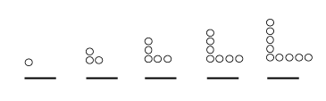  - Triangular numbers  - Number of dots in each term of the sequence.  - Number pattern.  - Predict what the next three numbers in the sequence will be.  - Draw the next three sketches in each pattern to check your prediction.  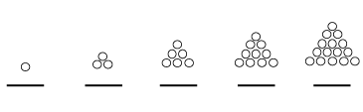  - Are these number patterns familiar to you? Write about some other similar patterns that you know.

Discussion | Can you think of ways of geometrically illustrating other number patterns that you know?  Experiment with number patterns and discuss them with your colleagues or lecturer.

Before we leave the plane and take a look at shapes in space, let us review some other familiar plane shapes that are not polygons. You should know all about these shapes, so try to remember their names and the terms relating to them if you don't already know them or if you have forgotten them.
Round shapes can roll. There are some special round shapes that you should know about.
Regions are shapes that include the flat surface surrounded by the outline of the shape. They are two dimensional. Here are some round shapes and regions. When we draw a region we usually colour it in to show that the inner surface is included.
Circle and circular region
Ellipse and elliptical region
Oval and oval region

Planes
Planes are infinite two dimensional surfaces without thickness.
Activity | Activity 1.14  - How many points do we need to name a plane unambiguously?  - Could two planes be parallel to each other?  - How would planes intersect?  - How would lines and planes intersect?  - Before we move out of the plane, we consider some two-dimensional shapes. Look at the shapes below, and circle the ones that are 2-D.  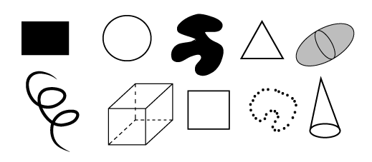
Before you go on, be sure that you are familiar with all of the information given so far. Why not take some time to recap now?

Space figures
A figure that is not a plane figure is called a space figure. Space figures take up space; they do not lie flat in a plane. They can be solid, made of surfaces, hollow skeletons (also called frameworks), or just simply collections of points which are not flat.
Space shapes are three dimensional (3-D). They have height which makes them protrude up above the plane in which they lie.

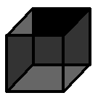 | 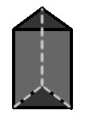 | 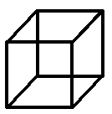
SOLID  (shaded)  3-D  e.g. wood | HOLLOW  (lines and dashes)  3-D  e.g. cardboard | FRAMEWORK  (lines)  3-D  e.g. wire | DISCRETE POINTS  (dots)  3-D  e.g. dust cloud
The closed space figures that are made entirely of plane surfaces (such as cardboard or paper) are called polyhedra. (Sometimes they are called polyhedrons). Polyhedra are three-dimensional.
Polyhedra are made entirely of faces (the flat surfaces which are all polygonal regions), edges (where the faces meet, they are all line-segments), and vertices (where the edges meet, they are all points). You need to apply this terminology in to next activity.
Activity | Activity 1.15  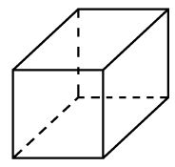  - How many faces does the shape have?  - How many edges does the shape have?  - How many vertices does the shape have?  - How would you name the shape?  - What dimension is the shape?  - What do we call a space figure that includes its interior?  - What do we call a space figure made only of line segments?  - What do we call a space figure that is made only of discrete points?
We can name polyhedra according to the number of faces they have.
We use the same prefixes as for the polygons, but the names end in the word -hedron. (penta-, hexa-, hepta-, octa-, nona-, deca-, dodeca-, icosa-, poly-.). For example, a polyhedron with six faces is called a hexahedron. Polyhedron means "many faced". The smallest possible number of faces a polyhedron can have is four. This is called a tetrahedron. (Be careful here – this differs from the naming of polygons.)
A net is a fold-out (flat, 2-dimensional) shape that can be folded up into a space shape. We can make nets for all of the polyhedra. (There are also nets for some other space shapes which are not polyhedra.) You need to be able to draw nets of polyhedron with up to eight faces.

Regular polyhedra
A regular polyhedron is any polyhedron with all of its faces the same size and interior angles the same size. Both conditions (faces and interior angles) need to be satisfied for a polyhedron to be regular. Plato discovered that there are only five regular polyhedra, and in their solid form they are known as the platonic solids.

Activity | Activity 1.16  There are sketches of the five regular polyhedra and their nets below. Count the number of faces in the nets and pair up each regular polyhedron with its matching net.  - Tetrahedron  - Hexahedron  - Octahedron  - Dodecahedron  - Icosahedron  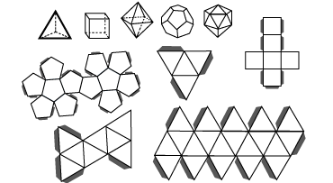

There are several polyhedra, but if we look more closely at them, we can identify two special groups of polyhedra that can be more specifically classified: pyramids and prisms. These are shapes commonly spoken about in schools and so we take a closer look at them too.

Pyramids
The set of polyhedra in which one face is called the base, and all of the other faces are triangular regions having a common vertex called the apex. The triangular faces are called lateral (side) faces. The BASE determines the kind of pyramid.
We can name pyramids according to their base, or according to how many faces they have. For example, a pyramid with five faces is called a pentahedron, its base could be a square and so we can also call it a square pyramid.
To sketch a pyramid, it is usually the easiest to draw the base, set the position of the apex, and drop down the edges where necessary. You must practise drawing them!
Activity | Activity 1.17  Here are a few examples of pyramids: they have been named according to their bases. Name each one according to the number of faces it has.  For example, a hexagonal pyramid has a hexagon (six-sided polygon) as its base. It has seven faces altogether and so is called a heptahedron.  Triangular pyramid (solid) Square pyramid (framework) Pentagonal pyramid (surfaces) Octagonal pyramid (surfaces)  - Triangular pyramid  - Shape of base  - Number of sides in base polygon  - Number of faces in polyhedron  - Name of polyhedron according to number of faces  - Square pyramid  - Shape of base  - Number of sides in base polygon  - Number of faces in polyhedron  - Name of polyhedron according to number of faces  - Pentagonal pyramid  - Shape of base  - Number of sides in base polygon  - Number of faces in polyhedron  - Name of polyhedron according to number of faces  - Octagonal pyramid  - Shape of base  - Number of sides in base polygon  - Number of faces in polyhedron  - Name of polyhedron according to number of faces

Prisms
Prisms are the set of polyhedra with two faces called bases, which are congruent polygonal regions in parallel planes, and whose other faces, called lateral faces, are parallelogram regions.
As with pyramids, the BASES determine the kind of prism. We can also name prisms according to how many faces they have, and according to their bases.
For example, a hexagonal prism has a hexagon (six-sided polygon) as its base. It has eight faces altogether and so is called an octahedron.

Activity | Activity 1.18  Here are a few examples of prisms: they have been named according to their bases. Name each one according to the number of faces it has.  Triangular prism (solid) Square prism (framework) Pentagonal prism (surfaces) Heptagonal prism (surfaces)  - Triangular prism  - Shape of base  - Number of sides in base polygon  - Number of faces in polyhedron  - Name of polyhedron according to number of faces  - Square prism  - Shape of base  - Number of sides in base polygon  - Number of faces in polyhedron  - Name of polyhedron according to number of faces  - Pentagonal prism  - Shape of base  - Number of sides in base polygon  - Number of faces in polyhedron  - Name of polyhedron according to number of faces  - Heptagonal prism  - Shape of base  - Number of sides in base polygon  - Number of faces in polyhedron  - Name of polyhedron according to number of faces

To sketch a prism, it is usually the easiest to draw the congruent bases, and then draw in the edges where necessary. You must also practise drawing these!
Activity | Activity 1.19  Draw the nets of all of the pyramids and prisms in the previous two activities. Label each of your nets so that you will remember what they are. Two examples have been done for you.  Triangular prism Pentagonal prism
Most of the prisms and pyramids that you see are known as right prisms or pyramids, because they stand at right angles to the surface on which they rest. This is not always the case, and drawn below is a parallelopiped, which is a prism made entirely of parallelograms (not rectangles).
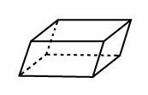
There are several other very common space figures that are not part of the polyhedron family at all. If you look closely at them you will see that this is because they are not made entirely of flat faces, edges and vertices. They have curved surfaces (which cannot be called faces) and we cannot always make nets for these shapes. You should know and be able to draw all of these shapes.

Reflection | Look at these shapes for most of which nets cannot be drawn, and try to think why this is so.  Which of these shapes have nets?  SPHERE HEMISPHERE  CYLINDER CONE  OVOID ELLIPSOID  DIHEDRAL ANGLE

Reflection | Are you able to recognise all of the special polyhedra and the other space shapes and their nets?  Are you able to name them in every way possible.?  Are you able to sketch them?

Truncated figures
Truncated figures are figures that are not part of the polyhedra family. They are formed by making one or more cuts or slices through other space figures to form a new and different shape. Many thought-provoking and fascinating exercises can be devised using truncations.

Reflection | What would the base of the cone below look like if it were cut in the two places indicated?  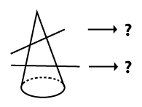  Think of some other questions you could set using truncations. Write up your ideas and discuss them with your lecturer if there's time.

Activity | Activity 1.20  Make sketches below to satisfy the following descriptions:  - A framework space shape.  - A solid space shape.  - A plane shape.  - A simple closed curve.  - A two dimensional region.  - A space shape made of surfaces.  - A zero dimensional plane figure.

Activity | Activity 1.21  - Complete the table below by referring to models or sketches of the shapes given in the first column of the table.  Polyhedron Number of vertices Number of faces Number of edges  Cube  Triangular pyramid  Octagonal pyramid  Triangular prism  Square pyramid  Hexagonal prism  - What do you notice about the number of edges compared to the number of faces plus the number of vertices for these polyhedra?

Pattern work and transformations
One of the wonderful things about teaching geometry is that it has some lovely potential for artistic and creative pattern work. We will now look at some of the possibilities for patterns using tessellations, symmetry and other transformations.

Tessellation
Tessellation is the art of covering an infinite surface without leaving any gaps between the shapes used to cover the surface. Tiling of a floor or wall is an example. If a single shape is able to be used to cover an infinite surface, that shape is said to tessellate. For example, squares can tessellate. If a pattern is made that covers a surface using more than one shape, we call that a multiple shape tessellation. Tessellations can be made out of simple geometric shapes but also out of complex and creative shapes.
Look at the examples of tessellations given below.
The three on the right were drawn by some grade four learners. Do you see how different the tessellations can be?
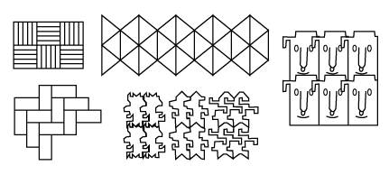

Activity | Activity 1.22  - Design your own shape that can tessellate.  - Experiment with tessellations of polygonal shapes to find out which of them tessellate. Cut out about six of any polygon that you wish to tessellate and see if it will tessellate. Paste down your tessellations on paper and keep them for future reference.  - Will any triangle tessellate?  - Will any quadrilateral tessellate?  - Will any polygon tessellate?

Isometric transformations
Isometric transformations are also known as rigid motions. They are motions since they involve moving shapes around (in the plane and in space), and they are rigid motions since the shape does not change in SIZE at all when it is moved. We will study reflections, rotations and translations of shapes.

Symmetry

Line symmetry
When we say symmetry we mean line symmetry. Line symmetry is also called reflection symmetry (because it has a lot to do with reflections) and bilateral symmetry (because of the 'two-sided' nature of symmetrical figures).
We say line symmetry because of the line of symmetry – the line (or axis) about which the symmetry occurs. When two points are symmetrical to each other we say that the one is the reflection of the other.
Note | We can define symmetry in a formal mathematical way, as follows:  - Line symmetry for a pair of points:  Two points, $P_{1}$, and $P_{2}$, are symmetrical with respect to a line L if the line L is the perpendicular bisector of $P_{1}P_{2}$,.  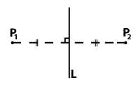  - Line symmetry for a pair of congruent figures:  Two congruent figures are symmetrical with respect to a line L if for each point $P_{1}$ in the one figure there is a point $P_{2}$ in the other figure, such that $P_{1}$and $P_{2}$ are symmetrical w.r.t. line L.  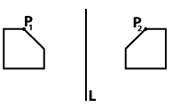  - Line symmetry for a single figure:  A figure is symmetrical w.r.t. a line L if for each point $P_{1}$in the figure we can find a point $P_{2}$ in the figure, such that $P_{1}$and $P_{2}$ are symmetrical w.r.t. the line L.  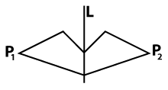
A figure needs to have only ONE axis of symmetry to be symmetrical, though it may have MORE THAN ONE axis of symmetry.

Activity | Activity 1.23  - Identify which of these shapes are symmetrical figures:  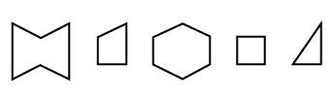  - Identify which figures represent congruent pairs of symmetrical shapes with respect to the given line:  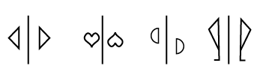  - Draw a pair of congruent symmetrical figures, a shape with one axis of symmetry, a shape with two axes of symmetry and a shape with four axes of symmetry (four separate drawings).

Reflection | You could experiment with drawing many other symmetrical shapes. You must be able to draw shapes with various numbers of axes of symmetry, and to recognise how many axes of symmetry a shape has.

The topic of symmetry lends itself well to practical activities in the classroom. You could use any of the following:
- Folding and making holes in paper with compass/pen nib.
- Folding and cutting paper shapes – experiment with one and more folds and cutting on the different edges, too. Let the children predict what the shape will look like before they open it up.
- Point plotting on the Cartesian plane (work out the unknown co-ordinates of a given symmetrical shape).
- Use mirrors – with real objects (pens, pencils, sharpeners, etc.) and with drawings (crazy ones and familiar ones).
- Paint blobs on one side of a piece of paper and then squash two sides of the paper together along a fold – see what interesting symmetrical images you can produce.

Rotational symmetry
Rotational symmetry is a different type of symmetry that results from rotating shapes in the plane. Rotate means TURN like you turn a door handle when you open a door. We can turn ANY object around, in a variety of ways: in space, in the plane, about a point (inside the shape), or about a point (outside of the shape). We can also turn the shape through any number of degrees. The rectangle below has been rotated through a few different degrees. You can see this because you see the same rectangle but lying at different angles.
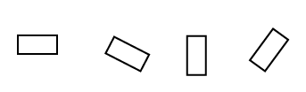
Sometimes, even if we have rotated a shape, it appears not to have moved. This leads us to the idea of rotational symmetry. A figure is said to have rotational symmetry about a centre of rotation if it appears not to have been moved by the rotation. Look at the square below. It looks as if it is lying in the same position, but if you look at the cross inside the square you can see that it is in a different position in each of the shapes. Make a square out of a piece of paper and rotate it so that you reproduce the sequence of illustrations below.
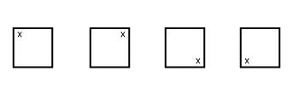
We talk about angles of rotational symmetry (the angle through which a figure turns such that it lands in a position where it appears not to have moved) and order of rotational symmetry (the number of times a figure lands in its starting position, as it does one full revolution).
When we speak about rotational symmetry, we will always assume CLOCKWISE direction of rotation unless otherwise specified. The angles of rotational symmetry must lie from 0° to 360°, and 0° to 360° are considered the same thing.
The illustrations on the next page describe the rotations of a rectangle through 0°, 90°, 180°, 270° and 360°.

Original position - 0° rotation. (The same as a 360° rotation of the shape, since 360° returns the shape to its original position). | Rotation of the square through 90° from its original position.  Notice how the marker in the one corner of the square has moved. | Rotation of the square through 180° from its original position.  Notice how the marker in the one corner of the square has moved. | Rotation of the square through 270° from its original position.  Notice how the marker in the one corner of the square has moved.
 | 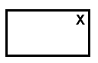

You must be able to identify angles through which shapes have been rotated, and draw shapes in the position they would land if they have rotated through a given number of degrees.

Activity | Activity 1.24  - Through what angle has the following shape been rotated about S?  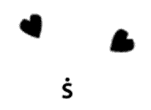  - Rotate the given shape about G through 270°.  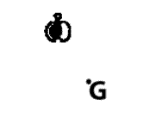

Reflection | Can we make a generalisation about the relationship between the number of axes of (line) symmetry of a shape and its order of rotational symmetry?

Activity | Activity 1.24  Complete the information in the following table. Then study the completed table and see what you can conclude.  Figure Number of lines of symmetry Angles of rotational symmetry Order of symmetry  Square  Equilateral triangle  Regular octagon  Regular nonagon  Rectangle  Circle  Parallelogram
A 180⁰ rotation in a plane about a point results in what we call point symmetry (i.e. point symmetry is a particular type of rotational symmetry.)
As with line symmetry, we talk about point symmetry with respect to a point and point symmetry for pairs of figures. You must be able to draw and recognise when a shape has point symmetry with another shape. The figures below are point symmetrical.

Translations
When a shape has been translated, every point in the shape is moved the same distance. You can involve the learners in point plotting exercises and get them to pull or push shapes ALONG a line, BELOW or ABOVE a line, and so on, to draw translations. The shapes in the grid below have been translated.
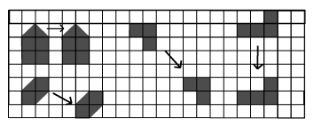
The arrows show the direction of the translation each shape has undergone.
- Horizontal translations move the shape to the left or right without any upward or downward movement.
- Vertical translations move the shape up or down without any sideways movement.
- Oblique translations move the shape to the left or right and upward or downward movement at the same time. The arrow indicating the movement is at an angle to the horizontal.

Reflection | What is the difference between the description of a horizontal/vertical translation and an oblique translation?

Activity | Activity 1.25  - Draw a few shapes on grid paper and then translate them. Record what translations you make the shapes undergo.  - Shapes can be translated vertically, horizontally and obliquely. On a grid translate a shape in each of these ways. Record the translations made by each shape.

Non-isometric transformations
If a shape is changed in any way when it is moved then the movement is not isomorphic. We will not study these motions in any detail, but we mention them to complete our study of shapes in motion. Enlargements or reductions of a shape are examples of non-isometric transformations.
Here are some further exercises on transformations for you to try.

Reflection symmetry (Grade 4)
- Design an interesting and creative shape which displays reflection symmetry. Plot your shape on a grid and draw it in.
- Use your shape in a lesson involving revision of point plotting in the two-dimensional plane and consolidation of the concepts relating to line symmetry.
- Give instructions to the class as to how to get started.
- Ask questions that will call on their understanding of line symmetry and reveal any problems they may be experiencing with the topic.
- Set a task that they will have to do (in pairs) relating to the exercise that you have completed.
- What outcomes could the learners achieve through completing this task?

Rotational symmetry (Grades 5 or 6)
- Draw three shapes on the grid with each in several different rotated positions. Indicate clearly the rotation each shape has undergone in each position.
- Devise a lesson that teaches the concept of rotational symmetry to a class of Grades 5 or 6(specify which). Take note that this is "enrichment" work.
  - You might use your sketches (done above) or other sketches.
  - Call for sketches from the learners.
  - Record the questions you will ask in the process of teaching the concept.
  - Let the learners work in pairs and do an activity that involves rotations of:
    - themselves
    - real shapes from their school bags
    - geometric figures.
  - What outcomes could the learners achieve through completing this task?

Translations (Grades 5 or 6)
- Sketch four different shapes on your grid. Translate each shape in a different way. Draw the shape in its new position, after it has been translated. Indicate what translation each shape has undergone.
- Set a worksheet consisting of 5 questions (activities, sketches, or interpretation of sketches, for example) that call for an implementation of an understanding of translations. Use grid paper where necessary. Questions must be clearly worded.

Unit summary
In this unit you learned how to
- Identify and describe fundamental properties of shapes.
- Differentiate between and illustrate two dimensional (2-D) and three dimensional (3-D) shapes.
- Categorize and compare two dimensional (2-D) and three dimensional (3-D) shapes.
- Describe and design patterns using tessellations and transformations.

Assessment
Space and Shape
- Make accurate nets for the following shapes:
  - a cube or a cuboid
  - a triangular prism
  - any rectangular pyramid
  - a hexagonal prism
  - a pentagonal pyramid
  - Your nets must be handed in FLAT, but you should have folded them along all of the edges and the flaps so that they can readily be made into the space shapes. Do not make them too small; they should be useful for demonstrations in the classroom.
  - Label each net in two different ways. Write these names onto each net.
- Design a tessellation that is made with four different polygonal shapes. Draw the tessellation onto grid paper.
- Design a creative shape that will be able to tessellate on its own. On a grid paper draw in a tessellation using at least six of your shapes.
- Look around in all the media resources available to you (such as newspapers and magazines), to find pictures of symmetrical shapes. Using appropriate resources, design a worksheet on the topic of line symmetry for a grade of your choice. The grade must be clearly indicated on the worksheet.

Unit 2: Numeration

Introduction
A study of the development of numeration systems over time could be very interesting and revealing for our learners. It will give them insight into the development of the numbers that they see and use daily. They would realise that these numbers have not always existed, and they could also develop an appreciation of the beauty and efficiency of our numeration system in comparison to some of the older numeration systems which are no longer used. It could also draw on their own personal background (social and cultural) – we can look at systems of counting and recording used in the not-so-distant past and even in the present by different cultural groups.
This unit is designed to give you some insight into a few specially chosen ancient numeration systems. As you work through the unit you should try to think about how the systems which are presented differ from each other, where they are similar to each other, and how they differ from, or remind you of our own numeration system that we use today. After the presentation of historic numeration systems, an in-depth study follows of the Hindu-Arabic numeration system, still in use today, with its base ten and place value.
Upon completion of this unit you will be able to:
Outcomes | - Record numbers using some ancient numeration systems.  - Explain the similarities and differences between the numeration system that we use and those used in ancient times.  - Demonstrate the value of multi-base counting systems for teachers of the base ten numeration system in use today.  - Discuss the use of place value in the development of number concept.  - Develop your understanding of number systems that make up the real numbers.  - Apply inductive reasoning to develop generalisations about number patterns and algebraic thinking.

History of numeration
In the very early days of cavemen, there is no evidence of the use of numeration systems, probably because such systems were not needed. Numeration systems developed because people began to feel the need to record the idea of "how many". What we are thinking of when we think "how many" is an idea of number. The symbols used to record "how many" are called numerals. A structured system for the use of these numerals is called a numeration system. People have used various numeration systems and symbols over time, but common to all of these systems is the idea of "how many", which is the abstract concept of number.
Reflection | How would you explain the difference between a number and a numeral?
Tallying was one of the first commonly used methods of recording numbers.
When we tally we set up a one-to-one correspondence between the set of discrete objects that we wish to count (such as the number of cokes in the tuck-shop) and a set of easily stored tallies (such as dash marks on a piece of paper). Early tallies that were used were pebbles in furrows in the ground, knots in pieces of string or notches carved into sticks.
When people began to settle in groups, numeration systems began, because the need arose to record numbers more formally, amongst other things.
Reflection | Would you describe tallying as a numeration system? Explain your answer.  Where do we still use tallying today and why do we use it?  Why do you think the need for more formal numeration systems arose when people began to live in communities?

Egyptian numeration system
The Egyptian numeration system consisted of certain hieroglyphic numerals and a system for their use. Hieroglyphics were commonly painted onto various surfaces, such as, for example, on the walls and pillars of temples. The symbols are given in the table below. To write numbers, the symbols could be used in any order, as long as the necessary symbols were used to total up the number that the writer wished to record.
Thus the system could be described as repetitive and additive, and it is not very compact. A base of ten is evident in the choice of grouping into consecutive symbols.

Egyptian Numeral | Description | Our numeral
 | Vertical line | 1
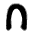 | Heelbone | 10
 | Scroll | 100
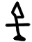 | Lotus flower | 1 000
 | Bent Finger | 10 000
 | Barbot fish | 100 000
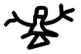 | Astonished man | 1 000 000

Here are some conversions into Egyptian numerals and vice versa:
34 572 =

2 025 =

Activity | Activity 2.1  - What is meant if we say that the system is repetitive and additive?  - Why is the system not compact? Is our system more compact?  - In what way(s) does the Egyptian numeration system resemble our own numeration system?  - Try some conversions of your own, such as:  - 489  - 1 000 209 =

Babylonian numeration system
The Babylonians used symbols known as cuneiform. In about 3000 BCE, clay was abundant in Mesopotamia where they were settled, and so they used clay tablets to make their records. The marks they made were wedge shaped, made in the clay with a stylus while the clay was still soft. They then baked the clay tablets in ovens or in the sun to preserve them. They had only two numerals initially, but introduced a third symbol to clarify some ambiguity that arose in the interpretation of numerals written with only the two symbols.

They used the following three symbols:
Babylonian Symbol | Number | Our numeral
 | One | 1
 | Ten | 10
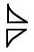 | Place marker | 0
They did use place value, in a base of 60, which makes their system very difficult for us to read because it is so different from our own. Initially to indicate a new place or an empty place they just left a gap, but later they used their place holder symbol to indicate an empty place. We will look at numerals in the later Babylonian system.
Here are some conversions into Babylonian numerals:
23 = |  | 56 =
63 = |  | 679 =
603 = |  | 3 601 =

Activity | Activity 2.2  - Why do you think ambiguity arose when the Babylonians used only two symbols?  - Would you describe their system as repetitive and additive, and why?  - How does the Babylonian numeration system differ from the Egyptian numeration system?  - In what way(s) does the Babylonian numeration system resemble our own numeration system?

Roman numeration system
The Roman numeration system developed from tallying systems, as did the Egyptian and Babylonian numeration systems. The early Roman numeration system dates from about 500 BCE and was purely additive. The later Roman numeration system used the idea of subtraction to cut down on some of the repetition of symbols.
It is this later Roman numeration system that is still used in certain places today. We will give the symbols and describe how this later system is used. The symbols are given in the table below. Although they do not have place value, Roman numerals must be written from left to right, because of the subtractive principle which they applied. Whenever a numerically smaller symbol appears before a numerically bigger symbol, the value of the smaller symbol is subtracted from the value of the bigger symbol. Only certain numbers (all included in the table below) could be written using the subtractive principle. All other numbers are written additively. To write bigger numbers, a line is written above the symbol of a smaller number to indicate multiplication by 1 000. An example of this is also given in the table.

Standard symbols Roman numeral | Our numeral | Subtraction allowed  Roman numeral | Our numeral
I | 1
V | 5 | IV | 4
X | 10 | IX | 9
L | 50 | XL | 40
C | 100 | XC | 90
D | 500 | CD | 400
M | 1000 | CM | 900
$\overline{M}$ | 1 000 × 1 000 | $\overline{CM}$ | 900 × 1 000
Here are some conversions into Roman numerals and vice versa:
34 = XXXIV 1 652 = MDCLII 6 545 = $\overline{V}$MDXLV
XCIX = 99 CDLXIX = 469 $\overline{V}$MMDCCCXXIII = 7 823

Activity | Activity 2.3  - How is it evident that the Roman numeration system evolved from a tallying system?  - Where do we see Roman numerals still being used today?  - In what way(s) does the Roman numeration system resemble our own numeration system?  - Try some conversions of your own, such as:  a) 489 = b) 1 789 209 =  c) CMLIV = d) $\overline{CXLIV}DLV$=

Greek numeration system
The ancient Greek numeration system is important because they avoided some repetition by introducing a system of different symbols for each number from 1 to 9, from 10 to 90, from 100 to 900, and so on. You have examined several numeration systems now, and so we give you simply the table of symbols followed by some questions to allow you to come to an understanding of how their system worked.

Greek Numeral | Our Numeral | Greek Numeral | Our Numeral | Greek Numeral | Our Numeral | Greek Numeral | Our Numeral
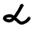 | 1 |  | 10 | 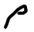 | 100 | 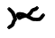 | 1 000
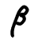 | 2 | 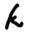 | 20 |  | 200 | 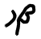 | 2 000
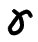 | 3 | 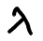 | 30 | 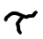 | 300 | 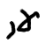 | 3 000
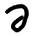 | 4 | 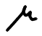 | 40 |  | 400 | 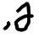 | 4 000
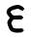 | 5 |  | 50 | 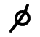 | 500 | etc.
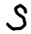 | 6 |  | 60 | 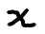 | 600
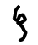 | 7 | 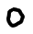 | 70 | 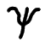 | 700
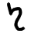 | 8 | 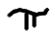 | 80 |  | 800
 | 9 | 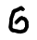 | 90 | 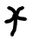 | 900

Here are some conversions into Greek numerals and vice versa:
Greek Numeral | Our Numeral | Greek Numeral | Our Numeral
 | 34 |  | 99
 | 469 |  | 717

Activity | Activity 2.4  - Did the Greek numeration system employ place value?  - Did the Greek numeration system employ the idea of a base? If so, which one?  - Did the Greek numeration system have a symbol for zero?  - Is the Greek numeration system repetitive and in what way is this so?  - Is the Greek numeration system additive and in what way is this so?  - In what way(s) does the Greek numeration system resemble our own numeration system?  - Try some conversions of your own, such as:  a) 773 = b) 9 209 =  c) = d) =

Hindu-Arabic numeration system
The Hindu-Arabic numeration system is the name given to the system of numeration currently in use all over the world. The elegant numeration system which we use today is thought to have been invented by the Hindus from approximately 1 000 BCE onwards. It probably spread via trade with the Arabs over centuries to their civilisation, and then by trade and conquest via the Moors to Spain, and so to Europe.
Using only ten symbols (including a symbol for zero), and the concept of place value (with places being marked by increasing powers of ten) aligning with the system of a base of ten, we can represent any number we please. We can also perform computation on our numbers in convenient and efficient algorithms. The characteristics of the Hindu-Arabic numeration system are summarised below:
(As you read this, try in your mind to compare our system with the systems you have just studied – and appreciate the elegance of our system!)

Note | CHARACTERISTICS OF THE HINDU-ARABIC NUMERATION SYSTEM  - The Hindu-Arabic numeration system uses a base of ten.  - The Hindu-Arabic numeration system employs place value, in powers of ten.  - The Hindu-Arabic numeration system has a symbol for zero.  - The Hindu-Arabic numeration system has nine other digits: 1, 2, 3, 4, 5, 6, 7, 8 and 9.  - The Hindu-Arabic numeration system is additive and multiplicative in accordance with correct use of place value and base.

Reflection | When we write numbers in expanded notation we reveal some of the properties of our numeration system, which is why this is a useful activity. Look at the example below and explain how expanded notation exposes the meaning behind the symbols recorded.  4673 = 4 x 1 000 + 6 x 100 + 7 x 10 + 3 x 1  Having examined the various ancient numeration systems, how would you say the Hindu-Arabic numeration system might have evolved over time into the system that is in use today?  Why is it easier to perform operations using the Hindu-Arabic numeration system than it would be to perform the same operations using some of the ancient numeration systems that you have studied?  How could you draw on the personal background of your learners with regard to numeration systems?

Multi-base
A study of multi-base numeration systems can enlighten us about the problems that young children might encounter when learning about the base ten numeration system for the first time. There are rules in our numeration system that we take for granted and begin to see as so "obvious" that we might have difficulty appreciating that children could find these rules complicated. Multi-base numeration will open your eyes to the potential strangeness that could confuse learners who are coming to grips with ideas of base and place value in the use of our numeration system.
Your study of the different ancient numeration systems should have made you sensitive to the idea that using symbols, a base and place value is not just straightforward. One needs a full understanding of a numeration system to be able to use it efficiently to represent the numbers you wish to record.
Because our numeration system has only ten symbols, children learn these easily. They are also exposed to numerals between 0 and 100 a lot, and so they generally do not struggle to learn how to record these numbers and say their number names. It is in the recording of bigger and smaller numbers that learners may experience difficulties, if their understanding of our numeration system is inadequate.

Reflection | All of the ancient numeration systems that we studied had a notion of a base of ten. Why do you think this is so?

Imagine in a group of beings who have only four fingers on each hand (three fingers, and a thumb) – their hands would look something like this:
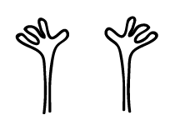
Reflection | If their hands looked like that, how do you think they might group numbers of things that they were counting?  Why do you say so?  If they used our numerals as their symbols, which of our numerals do you think they would need to record any number they wished, assuming they were as advanced as us and used a base and place value?

Let us now take a look at how they would group and record their numbers, using their base of eight. We will always indicate when we are working in a foreign base, so that we do not get confused and interpret the numerals as base ten representations.
Reflection | How would we write the following in base eight?

Discussion | To write these amounts in base eight we group the given number of items into eights and then record the base eight numerals  Here illustrations of the way in which these different numbers of items can be grouped into eights so that they can be written as base eight numerals. This is one way of grouping them. You might group them in another way but you would still come up with the same numerals.  17 _{base eight} 34 _{base eight}  55 _{base eight} - _{base eight}

What you might have worked out in your reflection above, is that we need to use grouping according to base and place value when we record numbers. In base eight we have to use groups of eight to guide our recording of the numbers.
Let us now examine some more formal tables that we could use for recording numbers in base eight. These tables reveal in a structured way the base groupings and the place value being used.

Activity | Activity 2.5  8x8x8x8 8x8x8 8x8 8 1  A B C D E  - What does a 1 in place B stand for?  - What does a 4 in place E stand for?  - What does a 2 in place A stand for?  - What does a 7 in place C stand for?  - What does a 5 in place D stand for?  - Why do we not need the numeral 8 in base eight?
We have used base eight in our discussion above, relating to imaginary group of beings with eight fingers. We could actually talk about any base we wish to – if we realise what type of grouping is being done, and what place value is being used, then we can understand the use of any base.

Reflection | Look at the illustrations below. Which bases are being illustrated, and why do you say so? In each case, record the number as a numeral in the particular base. Give reasons for your answer.

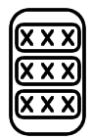

Reflection | Why is it possible to identify the base in use?  How is it possible to identify the place value which is being used?  Could you design a similar set of illustrations in base ten for your learners?

The following displays are given using Dienes' blocks of various bases.

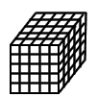 | 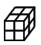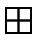 |  | 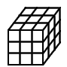
 |  |  | 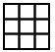

The reflection below is based on these Dienes’ block representations.

Reflection | Record the base for each diagram above, and give a reason for your answer.  Write the numeral that represents the number of blocks in each diagram above.  How do the Dienes' blocks make it clear what base is in use?  How do the Dienes' blocks make it clear what the face value of the numeral is?  How do the Dienes' blocks make it clear what the place value of each numeral is?

The following displays are given using Abacuses of various bases.
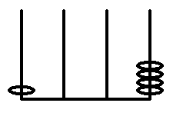 | 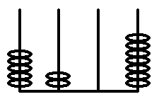 | 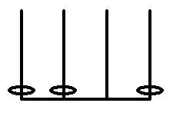

Reflection | Does each abacus make it clear what base is in use?  Do the abacuses make it clear what the face value of the numeral is?  Do the abacuses make it clear what the place value of each numeral is?

Activity | Activity 2.6  - Write down different numerals to show how you would represent the number of things drawn in the three sets below. You will write each set in three different ways, using the given base. In each case indicate the grouping on the diagram (redraw it for each illustration).  Set 1 Set 2 Set 3  - Base two  - Base five  - Base eight  - What are the possible bases that the following numbers could be recorded in? (Do not give any bases bigger than base ten):  - 4 210  - 7 650  - Write down the numeral with its base number which is represented by the three different groupings below:  Group 1 Group 2 Group 3  - Draw an illustration of the following numbers that makes it clearly evident how the numeral was chosen:  - 103 (base 4)  - 18 (base 9)  - 11010 (base 2)  - Convert these to base ten numerals using a place value grid:  - 314 (base six)  - 4005 (base twelve)  - Do you need to know "how much" 517 (base eight) and 601 (base eight) are, in order to know which numeral represents the bigger number?  - Why?  - Which one is greater?
Activity | Activity 2.7  - This is a base five abacus. Add 3 (base ten) to the given number represented on the abacus above (give your answer in base five).  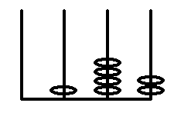  - This is also a base five abacus. Add 17 (base ten) to the given number represented on the abacus above (give your answer in base five).  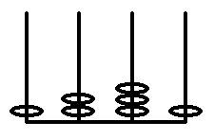  - Look at the abacuses below and say which number represented is greater in each pair? Do you need to know the base of the abacus in order to work out your answer?  Pair One:  Or  Pair two:  Or

Activity | Activity 2.8  - Examine the two base four Dienes' block illustrations below. What number was added to the first number to result in the second number represented?  a) b)  - Illustrate 1253 (base six) in base six Dienes' blocks.

Reflection | In what way does multi-base numeration help you to come to grips with the multiplicative and additive nature of our numeration system?  In what way has this study of multi-base numeration been useful to you as a teacher?  Would you use multi-base numeration systems with your learners?  How will your study of multi-base numeration influence the way in which you teach base ten numeration to your learners?

Developing number concept
Number concept is one of the most important concepts established in the foundation phase of primary education. Children love to say rhymes and learn from an early age how to "count to ten".
Initially they will simply be reciting these numbers as a rhyme, without attaching any number (idea of “how many”) significance to them. This is called counting. We say "counting out" to signify that a child can count out a number of items correctly.
The first counting out activities that our learners should do would be counting in ones. Counting in larger groups (such as twos, threes, fives or tens) should be reserved for later when they can count out correctly to at least 100. Counting in larger groups too soon can lead to problems in the understanding of addition at a later stage. Learners are ready to solve addition and subtraction problems when they can count out in ones correctly.
Learners need to understand the cardinal (how many) and ordinal (position) aspects of number. They also need to learn about the difference between a number (idea) and its numeral (symbol), and they need to learn how to record any number they wish to, using our numerals in the Hindu-Arabic numeration system.
Piaget spoke about conservation of number, in relation to the cardinal aspect of number. To test if a learner has achieved conservation of number, one would show them displays of the same number of items, spread out differently each time. If the learner clearly shows that she is aware that the number of items remains the same despite changes in display, she has achieved conservation of number.
Examine the displays below:
1st
2nd

A learner who says that the second display contains more, or represents a bigger number, has not yet achieved conservation of number.
Learners generally have more difficulty expressing the ordinal aspect of number. The ordinal aspect relates to the position of a number in a sequence. A learner who can count out 15 marbles may still have difficulty in pointing out the eighth marble. We should give them ample opportunity to develop the ordinal as well as the cardinal aspects of number.

Reflection | Identify the cardinal and ordinal numbers in the following list:  - 30 pages,  - the second week of term,  - page 73,  - a seven week term,  - grade 6,  - 24 eggs.  In what way do these different examples illustrate the difference between cardinal and ordinal numbers?

The association between numbers, number names and numerals also needs to be established. The idea of "five-ness" is established by counting five of many different items, in different situations. The name "five" for this number of items is thus established, and the numeral 5 is learnt as the symbol for that number of items.
Once basic counting from one to nine is established, we move on to the need for an understanding of place value to write the numerals for the numbers we are talking about.
We will now discuss the use of various apparatus to aid the teaching of an understanding of base ten numeration.
Reflection | Why might a learner think that 12 sweets are less than 8 sweets?  What could we do to rectify the error in his/her understanding?

The idea of grouping according to a base of ten needs to be explained. Sucker sticks (or toothpicks), elastic bands and base ten Dienes' blocks can be used as an aid.

Activity | Activity 2.9  - How would you expect a learner to group the sucker sticks below, to reveal the number of sucker sticks as a base ten numeral?  - How could they represent the same number using base ten Dienes' blocks?  - Set out 29 sucker sticks. Group them in base ten. Add 1 sucker stick. Regroup. What property of our number system is illustrated by working with sucker sticks in this way?  - Draw displays of 257 and 275 in Dienes' blocks. Which has the most wood? Which represents the biggest number?

You could work with Dienes' blocks as you work through the following type of activity, to demonstrate the relationship between units in different places.
Activity | Activity 2.10  Complete the following:  - 60 tinies can be exchanged for __ longs, so 60 units = __ tens.  - 480 tinies can be exchanged for __ longs, so 480 units = __ tens.  - 40 longs can be exchanged for __ flats, so 40 tens = __ hundreds.  - 500 longs can be exchanged for __ flats, so 500 tens = __ hundreds.  - 33 longs can be exchanged for __ tinies, so 33 tens = __ units.  - 33 longs can be exchanged for __ tinies, so 33 tens = __ units.  - 422 longs can be exchanged for __ tinies, so 422 tens = __ units.  - 83 flats can be exchanged for __ tinies, so 83 hundreds = __ units.  - 78 flats can be exchanged for __ longs, so 78 hundreds = __ tens.  - 909 flats can be exchanged for __ longs, so 909 hundreds = __ tens.  - 765 tinies can be exchanged for __ tinies, __ longs, and __ flats, so 765 units = __ units, __ tens, and __ hundreds.  - 299 tinies can be exchanged for __ tinies, __ longs, and __ flats, so 299 units = __ units, __ tens, and __ hundreds.

Reflection | In what way do the Dienes' blocks clarify the ideas of face value, place value and total value?

Activity | Activity 2.11  - An abacus can be used to count and display numbers. If you use an abacus to count up to 37 (starting from one), which of the properties of the Hindu-Arabic numeration system will this reveal?  - If you display the number 752 on an abacus, which of the properties of the Hindu-Arabic numeration system does this reveal?  - Illustrate the numbers 3, 68, 502 and 794 on an abacus like the one below, and then write out the number in expanded notation.  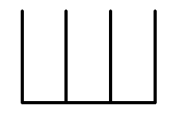

Reflection | In what way does an abacus clarify the ideas of face value, place value and total value?

We may think of the number 439 as written on three separate cards, which could be placed one behind the other to look like this (these are known as place value cards).
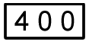 | 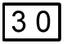 | 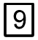 | 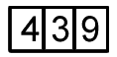

Reflection | You could make yourself an abacus, a set of Dienes' blocks and a set of place value cards to assist you in your teaching of our Hindu-Arabic numeration system.

Using these cards we can say that 400 is the total value of the first digit in the numeral that has a face value of 4 in the 100s place.
Your learners ultimately need to be able to answer questions relating to the understanding of the relative positioning of numerals, involving whole numbers and fractions, such as:
In the number 566 the 6 on the right is _ times the 6 on the left.
In the number 202 the 2 on the right is _ times the 2 on the left.
In the number 1 011 the 10 on the far right is _ times the 1 on the far left.
In the number 387, the face values of the digits are _ , _ and _; the place value of the digits (from left to right) are _ , _ and _; and the total values represented by the digits (from left to right) are _ , _ and _.
A calculator game that can be used here is called "ZAP". One player calls out a number for the other players to enter onto their calculator displays (e.g. 4 789). The player then says "ZAP the 8", which means that the other players must replace the 8 with the digit 0, using one operation (i.e. to change it into 4 709). The player who is the quickest to decide on how to ZAP the given digit could call out the next number.
Reflection | What property of number does this calculator game exercise?
Expanded notation is a notation that reveals what is hidden behind the numerals that we see. It is thus a useful exercise for learners to write out numbers in expanded notation.

Activity | Activity 2.12  Write out both of the following numbers in expanded notation in four different ways:  - 456  - 3 095

So far, we have looked at numbers up to hundreds (and a few up to thousands). Our apparatus is limited, and our time and patience would also be limited in the working with large numbers using concrete material. However, you need to be able to read and work with large numbers. You need to learn their number names, and how our number system is used to record them.
Reflection | Which apparatus is suited to displays for discussion of larger numbers, say from thousands to millions?

Study the table below that outlines how large numbers are named and recorded according to the official system followed in South Africa. (Notice that in this system, one billion is a million million. This is different from the American system, where one billion is only one thousand million. The newspapers and other media in South Africa most often use the American system, which can be a little confusing!)

billiards | billions | milliards | millions | thousands | ones
H T U | H T U | H T U | H T U | H T U | H T U

Activity | Activity 2.13  - Write the following in numerals, and then in words (use the table above to assist you):  - 1 million  - 1 milliard  - 1 billion  - 1 billiard  - 1 trillion  - Write the following numbers in words:  - 9 091  - 2 345 607  - 123 400 800  - Write the following numbers as numerals:  - One billion four hundred and twenty two million seven thousand and seven.  - Seven thousand and eleven.  - Which whole number comes just before each of the following numbers:  - 20 000  - 300 000  - 490 000  - 8 000 000  - 9 999 000

Number systems we use at school
Once learners have established a sound understanding of our base ten numeration system, they will be able to work with it easily and comfortably. Their knowledge of the finer aspects of the number systems within our numeration system will then be developed.
In this section, we will discuss some set theory (needed for our discussion on number systems) and the number systems which are defined within our numeration system (such as the real numbers). We will then look at the use of number lines to plot numbers in relation to each other.

Sets
Human beings seem to like to categorise and classify things into groups, and to focus on similarities rather than differences between things. This may be because our intelligent brains look for patterns and order amongst things. In mathematics the idea of a set is used to talk about a group of items sharing a common characteristic. A set is a collection of objects that belong together. The different number systems that we use are all actually sets. Although we don’t talk about sets much these days, it is still useful to use some of the set terminology when we learn about number systems.

Reflection | An example of a set is the people in this room. Why do they belong together? What characteristic(s) might they share?

Within our numeration system, there are different sets made up of slightly different kinds of numbers. Because of this nature of our numeration system, we need some set terminology if we are to study number systems.
We call the members of a set the elements of that set.
When we list (or write out) the elements of a set we use brackets to enclose the listed items. For example, the set of natural numbers can be listed as {1; 2; 3; 4; 5; 6; ... }.
This set we have just listed is called an infinite set because there is no limit to the number of elements in the set. A finite set is a set which has a limited number of elements, for example, the set of the factors of 24 is {1; 2; 3; 4; 6; 8; 12; 24}.

Reflection | You need to know about and bear in mind the concepts of finity and infinity when you teach young learners about numbers. They need to get a sense of the infinite scope of the number types with which they work as they grow in their understanding of numeration.  Do you think the concepts of finity and infinity are beyond the scope of primary school learners. Discuss this with a colleague.

Pattern recognition is part of mathematical reasoning. Activities that involve deciding whether or not numbers fall into the same set call on this pattern recognition skill. Once we can see the pattern in a set, we do not have to (and sometimes we cannot) list all of the elements of the set, for example, the set of multiples of 5 is {5; 10; 15; 20; 25; ... }.

Activity | Activity 2.14  - List the elements of the following sets:  - The even numbers between 2 and 24  - The odd numbers greater than 45  - Say whether sets A and B (above) are finite or infinite.

Checking whether or not numbers satisfy certain conditions is also part of pattern recognition, or at a higher level, algebraic reasoning. An empty set expresses what we mean when we say “there is nothing that satisfies this condition”.

Activity | Activity 2.15  Which of the following numbers can be found and which cannot. If they cannot be found, we could call them expressions of an “empty set”.  - The multiples of 56.  - The even factors of 9.  - The odd factors of 8.  - The natural numbers less than zero.

Number systems
Our numeration system, which can represent any number we choose, can be subdivided into sets of specialised number systems that share common properties. We will examine each of these number systems to determine some of their characteristics.
The first set we consider corresponds with the first numbers invented and used by people – the natural numbers. The natural numbers are {1; 2; 3; 4; 5; 6; 7; ... }. This is an infinite set. The natural numbers have a first element, called one. Each element has a successor element which is one bigger than the element it follows.
We can check the set of natural numbers for closure under addition, subtraction, multiplication and division. Closure under an operation is satisfied if when an operation is performed on two elements of a set the result (answer) is also an element of the set.
Checking for closure is an activity that develops mathematical reasoning. You have to think about whether or not particular numbers belong to a set and then decide whether you can make a generalization about all such numbers. This kind of reasoning is an important mathematical skill that can be applied in many contexts.

Activity | Activity 2.16  In this activity we are checking for closure of the set of natural numbers. For each part of this activity you need to think of pairs of numbers. You can think of ANY pair of numbers, and you test it for inclusion in the given set. The first one is done for you.  - Are the natural numbers closed under addition?  - To check this I am going to test the whether the natural numbers are closed under addition. I think of a pair of natural numbers, such as 5 and 7. 5 + 7 = 12. 12 is a natural number.  - Will this work for any pair of natural numbers? Is the set of natural numbers closed under addition?  I think of lots of other pairs. I cannot think of a pair of natural numbers that when I add them do not give a natural number. I decide that the set of natural numbers is closed under addition.  - Are the natural numbers closed under subtraction?  - Check for any pairs of natural numbers that you would like to check.  - Decide if this work for any pair of natural numbers? Then decide if the set of natural numbers closed under subtraction.  - Are the natural numbers closed under multiplication?  - Check for any pairs of natural numbers that you would like to check.  - Decide if this work for any pair of natural numbers? Then decide if the set of natural numbers closed under subtraction.  - Are the natural numbers closed under division?  - Check for any pairs of natural numbers that you would like to check.  - Decide if this work for any pair of natural numbers? Then decide if the set of natural numbers closed under subtraction.
The need for more numbers is apparent from the lack of closure in the set of natural numbers. First of all, we introduce zero, and we call the new set the whole numbers or counting numbers. These numbers include {0; 1; 2; 3; 4; 5; 6; 7; ... }. This is also an infinite set.
This extension gives us just one more element, and not much greater scope, so we move straight on to introducing the negative numbers to the set, which are called the integers. A negative number is found when the sum of two numbers is zero – then the one number is said to be the negative of the other number. The integers are the numbers { ... ; -7; -6; -5; -4; -3; -2; -1; 0; 1; 2; 3; 4; 5; 6; 7; ... }
Reflection | If you check the set of integers for closure under addition, subtraction, multiplication and division, what do you find?  We still have problems with closure! Discuss this with a colleague. We now have the negative numbers which helps with subtraction but we don’t have fractions, so closure under division does not hold!

So we need to introduce more numbers – and this time we include all fraction numerals – to make the set of rational numbers. The rational numbers include zero, all of the whole numbers, all fractions and some decimals.

Reflection | If you check the set of rational numbers for closure under addition, subtraction, multiplication and division, what do you find?  We have introduced the fractions, which helps a lot with division, but there are still some numbers that we can’t write as fractions, and so they are not rational numbers. Closure under division is still a problem.

There are some real numbers that we cannot write as fraction numerals. Examples are surds such as , , etc. We encounter them often, but they are not rational numbers. We call them irrational numbers.
The big set that includes all of the sets that we have mentioned so far is called the set of real numbers. Real numbers can be rational or irrational.
There are other numbers in our numeration system which we do encounter at school although we do not perform any calculations on them. These numbers are called non-real or imaginary numbers.

Reflection | Examples of non-real or imaginary numbers that we come across at school are:  - square roots of negative numbers.  For example, you cannot calculate $\sqrt{-4}$ . It does not exist in the real number system.  Can you think of some other non-real numbers? Look at the message your calculator gives you when you try to find the square root of a negative number.

The set that hold all of the sets that we have mentioned so far, including the sets of real and non-real numbers, is called the complex numbers.

Activity | Activity 2.17  - Look at the diagram below that shows the relationship between the various sets of numbers. Write about the way in which the different number systems, which are all different sets of numbers are related to each other using words.  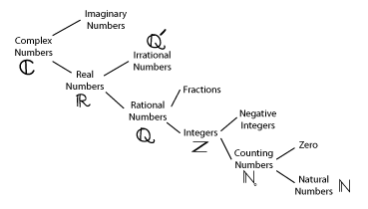  - Define an irrational number.  - Give five examples of irrational numbers.  - What does it mean if we say that one number is the negative of another number?

Number lines
Number lines are often used to represent numbers. To draw a number line correctly you need to choose an appropriate scale. You must measure accurately when you do number line representations.
The markers on the number line must all be exactly the same distance apart. The scale of the number line is the gap between the consecutive markers. You can choose different scales for number lines, depending what you want to fit onto the number line.
Here are some exercises for you to try.
Activity | Activity 2.18  - Label all of the graduations on each of the number lines below, using the given points that are labelled.  a)  b)  c)  d)  - Mark in 5 on each number line.  - Mark in 17 and 717 on a suitable number line.  - Choose a different scale to expand the short line segment containing the point • representing 717, so that you can give a more clear representation of 717.  - Label the number lines below to display the given numbers precisely:  a) 34  b) 500  c) 673

Reasoning, algebra and number patterns

Inductive and deductive reasoning
A lot of mathematical activity involves the use of reasoning, to prove or disprove certain statements or results. When your reasoning involves drawing a general conclusion from your observation of a set of particular results, or group of data, this is known as inductive reasoning.
If your teaching style is something of a guided discovery approach, you will be calling on your learners to exercise their powers of inductive reasoning regularly. This is very sound in terms of their mathematical training, because mathematicians need to be creative thinkers and to follow up on hunches or to clarify and generalise patterns that they identify in various situations.
Inductive reasoning can lead to errors however, since what may be true in several situations or on several occasions may not always be true in general. If, for example, one of our learners tells us that "when you multiply the answer is always a bigger number" they have come to an invalid conclusion, inductively.
We need to guard against invalid inductive reasoning in our learners.
Reflection | Why would a learner make the above conclusion?  How could we enable him to see the invalidity in his conclusion?

Activity | Activity 2.19  - Completing patterns involves inductive reasoning. Write down the next five numbers in the following sequences:  - 2, 4, 6, 8, …  - 1, 4, 9, 16, …  - 2, 9, 16, 25, 36, …  - 1, 5, 25, 125, …  - What type of reasoning did you use to complete the above activity?  - How can you be sure that your reasoning is correct?

Reflection | Why do we say that guided discovery teaching will allow children to exercise their powers of inductive reasoning?
If we reason from the general to the particular it is known as deductive reasoning. Deductive reasoning is not susceptible to the same errors as inductive reasoning since it is based on previously known or proven facts or axioms.
Applying a general formula in a particular instance is a use of deductive reasoning. If you wanted to calculate the volume of water contained in a cylindrical container you could find out the dimensions of the container and then calculate the volume of the liquid in the container by using the formula for the volume of a cylinder.
However, deductive reasoning can be flawed if the "facts" on which it is based are not true. You need to be very certain of your generalisations if you wish your deductive reasoning to be sound. We need to equip our learners with the necessary mathematical axioms (mathematical truths which stand without proof) and previously proven results on which to base their reasoning.

Activity | Activity 2.20  Are the following examples of inductive or deductive reasoning?  Are they valid or invalid? Give a reason for your answer.  - All computers have a word processing programme. I have a computer. I have a word processing programme.  - My cockatiel is called Peekay. My friend's cockatiel is called Peekay. All cockatiels are called Peekay.  - All peach trees have green leaves. That tree has green leaves. That tree is a peach tree.  - Some learners have scientific calculators. Thabiso is a learner. Thabiso has a scientific calculator.  - All medical doctors use Panado. My mother uses Panado. My mother is a medical doctor.  - The sum of the angles of a triangle is 180°. All polygons can be triangulated. Find a formula for the sum of the angles of any polygon.  - How could you use a calculator to assist you to predict the last three digits in the number 5 to the power 36?  - Prove that the sum of two odd numbers is an even number.

Algebra
In algebra we use variables to represent numbers. This is an important tool in the making of generalised statements.
Learners are introduced to algebraic notation in the late senior primary or early junior secondary phase, but teachers of the intermediate and even foundation phase need to feel comfortable reading and using algebraic notation because it is used in curriculum and other teacher support materials.

Reflection | If a document said you should introduce sums of fractions of the form $\frac{1}{n}+\frac{1}{m}$  what would you understand this to mean?

We take a brief look at algebraic notation and generalisations to equip you to read and interpret simple algebraic expressions.
Suppose you are going to pull a number out of a hat in order to determine the winning ticket in a raffle. Until you have actually pulled the number out of the hat, in your mind there is a space for a number, which is unknown, but you know that you will find a number which is going to end the mystery and tell you who will win the prize. In algebraic notation you could call that number $x$ (or $a$, or any letter you please) until you have determined its specific value. The letter x is called a variable, and it is written in the place of a numeral.
Sometimes there are restrictions on the numbers that can replace a variable, but unless these are stated or can be found, it is assumed that any number can replace the variable.
You should be able to read and interpret at least simple algebraic expressions.
Activity | Activity 2.21  Write down the meanings of the following algebraic expressions:  - $3y$  - $y+4$  - $y^{2}$  - $a\left(bc\right)$  - $a+a$  - $a+b=b+a$  - $a×b=b×a$  - $a-b=b-c$  - $yb$  - $y+d$  - $y^{m}$  - $a\left(b+c\right)$  - $3×a×a$

We can create algebraic expressions using flow diagrams.
Look at the example below and then construct algebraic expressions for the flow diagrams that follow.
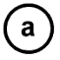 |  |  |  | 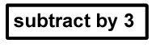 |  | $$4a-3$$
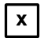 |  |  |  |  |  | __________
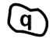 |  | 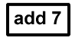 |  |  |  | __________
 |  | 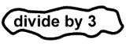 |  | 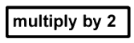 |  | __________

Use the given flow diagrams to complete the output row in each of the tables below:
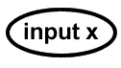 |  | 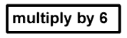
Input $(x)$ | 0 | 1 | 2 | 3 | 7
Output $(y)$

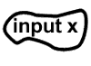 |  | 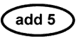 |  | 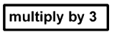
Input $(x)$ | 0 | 2 | 3 | 6 | 10
Output $(y)$

When we wish to calculate a specific value for a given algebraic expression we need to replace the symbols (the variables) with particular numeric values. We were doing this above when we calculated the output variables given the flow diagrams and the input variables. This process is known as substitution. For example, if we are told that the value of a in the expression 6a is 7, we can calculate that 6a = 6 x 7 = 42.

Number patterns
Looking for patterns in number sequences is a common mathematical activity. By now you should have learnt that this activity involves inductive reasoning.
When you work out the next few terms in a number sequence you are actually trying to read the mind of the person who wrote up the first few terms in the sequence. You can often do this successfully, but you could make a perfectly valid decision, based on the given information, and still not give the "correct" solution, if the writer had something else in mind.
What would you say are the next four terms in the sequence 4, 11, 18, 25, …
If you said 32, 39, 46, 53, you could be right. But you would be wrong if you were writing up the dates of all Mondays, starting with Monday 4 January 1999.
Exercises where learners discover patterns, and the rules which govern these patterns, lay a foundation for algebra in later schooling. These exercises would be similar to those you went through in finding the algebraic expressions using the flow diagrams earlier in this unit. In your module on SHAPE we investigated a few geometric number patterns, such as the square, cubic and triangular number patterns. We now look at some other number pattern work.
Activity | Activity 2.22  - Look at the triangle below. Can you see the pattern that governs the inclusion of numbers in each row? If so, add the next two rows to the triangle.  1  1 1  1 2 1  1 3 3 1  1 4 6 4 1  1 5 10 10 5 1  - Find the sum of each of the rows in the triangle (known as Pascal's triangle) above:  - Do you see a pattern here?

Activity | Activity 2.23  - Check if the following statements are true:  a) 1 + 2 = 3  b) 4 + 5 + 6 = 7 + 8  c) 9 + 10 + 11 + 12 = 13 + 14 + 15  - Now can you write the next three rows in the pattern?

Activity | Activity 2.24  What do you notice about ever-increasing sums of consecutive odd numbers? Use the display below to investigate the pattern.  1 + 3 =  1 + 3 + 5 =  1 + 3 + 5 + 7 =  1 + 3 + 5 + 7 + 9 =

Activity | Activity 2.25  Counting triangles  Take a triangle and fold it repeatedly through one of its vertices.  Count the total number of triangles after each fold. What pattern emerges?  etc  Number of folds 0 1 2 3 4 5 10  Number of triangles

Unit summary
In this unit you learned how to:
- Record numbers using a range of ancient numeration systems.
- Explain the similarities and differences between the numeration system that we use and those used in ancient times.
- Demonstrate the value of multi-base counting systems for teachers of the base ten numeration system in use today.
- Discuss the use of place value in the development of number concept.
- Develop your understanding of number systems that make up the real numbers.
- Apply inductive reasoning to develop generalisations about number patterns and algebraic thinking.

Assessment
Numeration
- Discuss the differences and similarities between the following ancient numeration systems and our own Hindu-Arabic system of numeration that we use today.
  - The ancient Greek numeration system and the Hindu-Arabic numeration system.
  - The ancient Roman numeration system and the Hindu-Arabic numeration system.
  - The ancient Egyptian numeration system and the Hindu-Arabic numeration system.
- What activities would you use to help young learners establish their understanding of our place value system? Write up the activities and explain what you think learners would learn through doing them.
- Give an example of the following:
  - A valid statement involving deductive reasoning.
  - An invalid statement involving deductive reasoning.
  - A valid statement involving inductive reasoning.
  - An invalid statement involving inductive reasoning.
- Calculate the values of the following expressions:
  - 3(x + 5) if x = 6
  - 2x – 7y if x = 4 and y = 1

Unit 3: Operations

Introduction
In this unit, the four operations – addition, subtraction, multiplication and division – are discussed. Each operation is first introduced as a concept, after which different algorithms that can be used to perform the operations with ever-increasing efficiency, are then given and explained.
You are encouraged to teach your learners following a similar process, concepts first and then algorithms. But remember that ultimately, especially by the time the learners reach the senior phase, they should know and understand how the vertical algorithm works by employing place value simply and efficiently.
Upon completion of this unit you will be able to:
Outcomes | - Explain and use the algorithms for addition, subtraction, multiplication and division.  - Demonstrate and illustrate the use of various apparatus for conceptual development of the algorithms for addition, subtraction, multiplication and division.  - Define and identify multiples and factors of numbers.  - Explain and use the divisibility rules for 2, 3, 4, 5, 6, 8 and 9.  - Discuss the role of problem-solving in the teaching of operations in the primary school.  - Apply the correct order of operations to a string of numbers where multiple operations are present.
In the two sections that follow, we will look at the four operations. These four operations relate to a large part of the mathematical knowledge and skills that learners gain in the primary school. We will look at what is involved when each operation is performed, as well as a variety of methods (known as algorithms) for performing the operations.
All of the operations are known as binary operations because they are performed on two numbers at a time. If we need to operate on a string of numbers, we actually break the string up into pairs in order to do so.

Reflection | Think of solving the following sum:  2 + 17 + 28 + 73 =  How would you go about it?

Before we can introduce our learners to the operations, we need to be sure that they have a good concept of number, because the operations all work on numbers. Imagine trying to add 5 to 7, if you are still a little uncertain about exactly how much these symbols represent.
Whole number concept is usually well established in the foundation phase; teachers in higher phases need to ensure that bigger numbers, fractions and decimals are all soundly taught. This will help to eliminate the struggle that many learners have with operating on such numbers. Remember that we can use Piaget's test for conservation of number to check whether a sound number concept has been achieved (refer to Unit 2: Numeration).
When we operate on numbers, we get new numbers, depending on the operation performed. In order to get the correct new number, we need to have the correct understanding of the operation – this is what we first teach our learners, so that they will know what to do when called on to add, subtract, multiply or divide. We must teach them the terms, concepts, symbols and methods which are involved in each of the operations.

Background and algorithms for addition and subtraction
We can now move on to looking at addition and subtraction, and the algorithms (methods) for performing these operations.
There is very clear terminology which we should use if we wish to speak about the numbers involved when we add and subtract. You need to study this terminology so that you know it and use it. Remember that if we do not use correct mathematical terminology, we cannot expect our learners to do so!
All of the terms are given below:
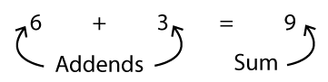
The concept of addition involves putting together certain amounts, to find out how much we have altogether. This amount is called the sum. You should try not to use the word "sum" incorrectly, to avoid unnecessary confusion for the learners.
Reflection | Where do we often use the word "sum" incorrectly?  Do you think that this misuse could be problematic for learners and if so in what way?

Subtraction
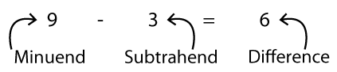
The concept of subtraction involves taking a given amount away from another given amount, to find out the difference between the two amounts.
You should notice that subtraction "undoes" what addition "does". Because of this relationship between the two operations, they are known as inverse operations. Give your own example that clarifies the meaning of addition and subtraction as inverse operations.
When we introduce any operation we should begin by using numbers in a real context – we tell stories that lead to the addition or subtraction of numbers. This makes it clear to the learners what they need to do, and also lays a foundation for their own problem-solving later, when they will have to read and interpret word problems.
Reflection | Give one example of an addition story and one for subtraction.

Another thing that we must do is show all the working that we do using concrete apparatus. We can use counters such as sticks or buttons, we could use paper pictures and Prestick on the board, or we could use felt boards and pictures, or other such apparatus depending on what is available.

Reflection | Illustrate and explain one addition and one subtraction question done using concrete apparatus.

Initial addition strategies are defined in terms of different ways of counting.
The first thing that learners do is called counting all. Here the learner groups together the two amounts he has to add and then counts how many items he has altogether, starting his counting from one.
The next strategy used is called counting on. Here the learner starts counting on from one of the addends (usually the first). For example, if he is required to add 5 and 3, he would start with 5 and count on 6, 7, up to 8. This represents some progress, as his counting does not have to go back all the way to one.
As the learner becomes more familiar with the adding process, he then moves on to accelerated counting on. Here he counts on in jumps, of 2 or 3 or 5 or 10 (etc.) depending on the sizes of the numbers involved in the question.

Activity | Activity 3.1  Give your own examples of:  - Counting all  - Counting on  - Accelerated counting on.
Subtraction can also be worked out first by taking away in ones, and then by taking away in twos or bigger jumps, very similar to these initial adding strategies.
We move the learners on to recording their working using symbolic notation. Arrow diagrams can be useful in the recording of early counting, because arrow diagrams can show incomplete working. To establish good habits of recording mathematical working correctly, when learners use arrow diagrams it is good to get them to conclude their working with a correct mathematical sentence.
For example, a learner could write:
8 + 5 → 8 + 2 → 10 + 3 → 13, and so 8 + 5 = 13.

Activity | Activity 3.2  Apparatus that can be used in the teaching of addition and subtraction  For each apparatus mentioned give one practical way in which that apparatus could be used in the teaching of addition and subtraction.  - Abacus – learners can manipulate the beads and observe the workings of the base 10 numeration system.  - Dienes' blocks – these can be used for simple addition and subtraction of small numbers as well as for addition and subtraction of up to three digit numbers.  - Unifix cubes – these are plastic blocks that can be stuck together and taken apart as desired. These are useful to use in introductory exercises, if available.  - Hundred squares – a ten by ten square with the numbers from 1 to 100 laid out in rows. Can be used for counting on as well as for demonstrations of bigger number addition and subtraction, using accelerated counting on or taking away.  - Number lines – single hops along a number line for early addition and subtraction examples, as well as bigger hops can be illustrated on a number line. The use of number lines is very good in consolidating number concept.

Drill
There has been some debate about whether or not conscious drilling of basic number facts is needed. We believe that learners who do not have a good grasp of all the basic number facts will be disadvantaged.
Addition and subtraction of all the single digit numbers, which can be extended to addition and subtraction of bigger numbers, is what we need to focus on. Drill sessions can be made into fun experiences for the children involving games, activities or competitions in groups or for the whole class. Drill must not be done in such a way that it puts the learners off learning, but rather in a way which excites them and assists them to learn and remember the essential number facts which they need to have at their fingertips.
Reflection | Brainstorm with some colleagues and record some ideas for interesting ways of drilling basic addition and subtraction facts.  Try your ideas out in the class!
There are certain laws of operations that you need to know about. Learners need not know the formal names of these laws, but they will be aware of them from quite an early stage. You need to know the names and functioning of these laws.
Remember that we have said that addition and subtraction are inverse operations. But addition and subtraction do not behave in exactly the same way.
Look at the following:
Addition is commutative: this means that we can add a pair of numbers in any order and still get the same answer.
For example, 5 + 9 = 9 + 5, or in general we say that a + b = b + a.

Reflection | Give an example that demonstrates the commutativity of addition.

Subtraction in NOT commutative.

Reflection | Give an example that illustrates that subtraction is not commutative.

Addition is associative: this means that when we add three or more numbers together, we can pair them in any order we choose, without changing the final answer.
We write this in general as: a + (b + c) = (a + b) + c.
Reflection | Give a worked example that demonstrates the associativity of addition.

Subtraction is NOT associative.

Reflection | Give an example that illustrates that subtraction is not associative.

Both addition and subtraction have an identity element.
Addition has the identity element on the right and on the left, while subtraction only has a right identity element.
The identity element for addition and subtraction is zero, since:
0 + a = a + 0 = a, and a – 0 = a.

Reflection | How would you explain what operating under the identity element results in?

Addition and subtraction algorithms
As we have mentioned before, algorithms are the methods of calculation of the operations.
We should encourage learners to experiment with different algorithms and we should therefore be able to do several different algorithms ourselves. Remember to be flexible and to accept any correct algorithm.
At all times insist on logical, meaningful work that you are able to interpret. Watch out for the use of correct mathematical sentences, and correct use of symbols.
Here are some different algorithms. Try them out yourselves – don't just read through them! There are explanations of the different algorithms under the table.
Vertical algorithm
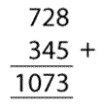 | 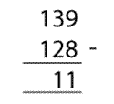 | 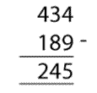 | 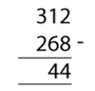
Example 1:  Regrouping | Example 2:  No impasse | Example 3:  Decomposition | Example 4:  Equal additions
Regrouping could be used in the first example because if you add 8 and 5 you get 13. This is actually one ten and 3 units. The units can be recorded in the units column, but the ten needs to be grouped and carried to the tens column, where it can be added to the other tens. Regrouping is done in any of the places, using base ten grouping of consecutive place values.
No impasse is how we describe the subtraction demonstrated in the second example. The subtraction can be done in columns without any decomposition since there are enough tens and units in the minuend to subtract the subtrahend without complication. There is an impasse in examples 3 and 4.
Decomposition is one way in which one can overcome the impasse. This involved breaking down the tens in the minuend to add to the units of the minuened, so that the number of units in the minuend is greater than the number of units in the subtrahend. Decomposition is done in any of the places, using base ten grouping of consecutive place values.
Equal additions is another way of overcoming an impasse. This is done by adding ten units to the minuend while at the same time adding one ten to the subtrahend. This is a form of compensation, carried out in the vertical algorithm. Equal additions is done in any of the places, using base ten grouping of consecutive place values.
Horizontal algorithm
$23+89 →23+9 →32+70 →102+10 →112$
i.e. $23+89=112$
$348+741 →300+700 →1 000+40+40 →1 080+8+1 →1 089$
i.e. $348+741=1 089$
$37-24 →7-4 →30-20+ 3→10+3 →13$
i.e. $37-24=13$
$102-68 →100-60 →40-8→32+2 →34$
i.e. $102-68=34$

Compensation
$18+26=\left(18+2\right)+ \left(26-2\right)=20+24=44$
$1387+359=\left(1 387+13\right)+ \left(359-13\right)=1 400+346=1 746$
$528+871=\left(528-28\right)+ \left(871+28\right)=500+899=1 399$

Reflection | What is a general rule that you could state for compensation under addition?

$56-47=\left(56+3\right)- \left(47+3\right)=59-50=9$
$476-379=\left(467+21\right)-\left(379+21\right)=488-400=88$
$612-425=\left(612-25\right)-\left(425-25\right)=587-400=187$

Activity | Activity 3.3  Now try some of your own algorithms. You should be able to make up questions for yourself!  - Write as many different examples as you can and work them out using different algorithms.  - Discuss the different algorithms with a colleague.  - Which algorithms are more efficient?  - Is efficiency a useful criterion for evaluating an algorithm.

Background and algorithms for multiplication and division
In this section, multiplication and division are discussed. They are also binary operations (they act on two numbers at a time). Learners first need to establish the concept of the operation and then learn how to work with expressions involving these operations.
Multiplication
Multiplication is repeated addition of the same addend. We could introduce this idea of repeated addition by sketching or laying out the following using counters:

3 | + | 3 | + | 3 | + | 3 | + | 3 | = | 15
Or five lots of three, or five threes, $5×3=15$

By the time a learner knows that 5 × 3 = 15, they are not actually performing the operation, they are recalling this basic fact of multiplication from memory.
As with addition and subtraction, when we introduce multiplication to our learners, we should use number stories that will lead to simple multiples. Make up stories yourself and call on the learners to make up some of their own too. If you allow them to make up their own questions from this early stage, they will develop their independence and ability to think creatively about mathematical situations.

Reflection | Make up a story that would lead to a number sentence involving multiplication.

You need to know and use the terminology of multiplication that is recorded below. Study it carefully.
5 | x | 3 | = | 15
Multiplier |  | Multiplicand |  | Product

You should use the correct language when you talk about multiplication. It is not correct to say "times this number by 7". The correct language is "multiply this number by 7". We do however speak about "7 times 5" which means "multiply 5 by 7".
Learners need a lot of drill in their multiplication tables. You as a teacher should certainly know all of the tables up to 9 × 9. This would cover all the basic facts of multiplication (all of the digit multiples from 1 × 1 to 9 × 9). Clearly, drilling of the basic facts is done after the operation concept has been thoroughly established. Remember also that the way in which drilling is done should be made exciting and interesting for the learners by using games and other classroom activities.
Like addition, multiplication adheres to certain of the laws of operations. You need to know these laws and what they imply.
Multiplication is commutative: This means that we can multiply a pair of numbers in either order, without changing the product.
For example, 7 × 9 = 9 × 7 = 63.
You should be able to think of many such examples.
In general we write this as a × b = b × a.
Reflection | Can you think of an example that contradicts the statement that multiplication is commutative? If so, write it down.

Multiplication is associative: This means that if we have to multiply a string of three or more numbers, we can do so by pairing them in any order that we choose. In general we express this by writing a × (b × c) = (a × b) × c.

Reflection | Test the associativity of multiplication by calculating the following by pairing in different ways: 17 × 50 × 2 =  Was there an order that was easier for you to do? If so, which one and why was it easier?

One of the strategies that we can teach our learners is to look out for "easier" ordering in questions involving multiplication of more than one number.
Multiplication has an identity element: This is the number which, when we multiply by, it has no effect on the multiplicand. The identity element of multiplication is the number 1, since, for example, 1 × 8 = 8 × 1 = 8.
How would you express this in a general way?
Multiplication by zero is defined as follows: 0 × a = a × 0 = 0

Multiplication is distributive over addition and subtraction
In general, we write this as follows:
over addition:
a × (b + c) = (a × b) + (a × c) or (b + c) × a = (b × a) + (c × a)
over subtraction:
a × (b - c) = (a × b) - (a × c) or (b - c) × a = (b × a) - (c × a)

Reflection | Try out the following example to check for the distributivity of multiplication:  13 × (15 + 5) = 13 × 15 + 13 × 5 =  or  13 × (15 + 5) = 13 × 20 =  You should get the same answer in both cases.

Apparatus
Use apparatus such as Dienes' blocks and number lines.
Think about the use of calculators. When would you allow learners to use calculators in the class?

Algorithms
As with addition and subtraction, you need to be flexible and to encourage experimentation while insisting on correct, logical work at all times.
Learners can be encouraged to use horizontal and vertical algorithms as well as compensations. You must be able to use a variety of algorithms yourselves.

Activity | Activity 3.4  - 32 × 15 (use a vertical algorithm)  - 17 × 3 (use a horizontal algorithm)  - Use compensations to calculate:  - 16 × 8 =  - 11 × 21 =  - 14 × 19 =  - What is wrong with saying "when we multiply, the number gets bigger"?

Division
There are two ways of conceptualising division. They are known as grouping and sharing. The two examples below will clarify the difference between the two conceptualisations.

Example | Sharing division  If I share 65 sweets among 7 children, how many sweets will each child get? The answer is 65 ÷ 7 sweets. The way in which we do it is we share out the sweets, until they are all given out, and then we find out how many sweets each child got. This is known as sharing division. Many division word problems are phrased in this way.

Example | Grouping division  I have 90 pieces of fudge. I want to sell them at the cake sale in little bags with 6 pieces of fudge per bag. How many bags can I make? The answer is 90 ÷ 6 bags. But, to work it out, I put six pieces in each bag, until all the fudge is used up and then I count how many bags I was able to make. This is known as grouping division. This division strategy is often neglected, though it does occur in real situations.

Number questions out of a real context could be solved in a grouping OR a sharing way, because whether we think of 10 divided by 2 in a grouping or a sharing way, the answer is the same, only the strategy is different.
Look at the illustrations below and label them as "grouping" or "sharing" solutions to 10 divided by 2:
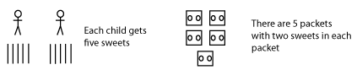

We must be sure to explain both division strategies to our learners.

The terminology for a division number sentence is recorded below. Be sure you know and use it.
15 | ÷ | 3 | = | 5
Dividend |  | Divisor |  | Quotient

Division by zero and division of zero sometimes confuses learners. We define the following:
$0÷a=0$ (division of 0 leads to a quotient of 0)
BUT $a÷0$ is undefined (we cannot divide a number by zero)

Laws of operations and division
Division does not adhere to the commutative and associative laws, and it is not distributive over addition and subtraction. Division has a right identity element, since 16 ÷ 1 = 16 (but 1 ÷ 16 ≠ 16, and so on the left, the identity element does not work).
Division and multiplication are inverse operations. This means that division "undoes" what multiplication "does".

Reflection | Give an example that illustrates multiplication and division as inverse operations.

Apparatus
Bottle tops and egg boxes, and pegs and boards, are the type of apparatus that can be used for early division exercises.
The children can also share items amongst themselves (in set groups).
For later questions on bigger numbers, Dienes' blocks can be used.
Algorithms
Once again a variety of algorithms should be encouraged and explained.
The horizontal algorithm is essentially a grouping strategy, while the old "long division" algorithm is a sharing strategy. Both are fairly long-winded and one needs to think of their application to reality.

Reflection | Many people have argued against pen and paper long division.  What would you say is its place in a mathematics education?

Activity | Activity 3.5  Try out some examples of your own such as the following which have been done for you:  - Use a horizontal algorithm to solve the following  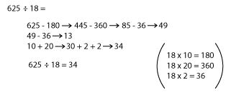  - Use a vertical algorithm to solve the following  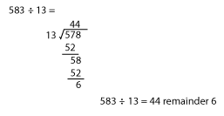  - Use compensations to solve the following  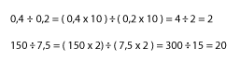

Multiples, factors and primes: divisibility rules
Multiples and factors are terms which we encounter in multiplication and division. Prime numbers are special numbers defined in terms of their factors.
These terms need to be understood so that they can be used, particularly in work on fractions. In this section, these and some other important related terms will be discussed.
Multiples
Learners use the idea of multiples when they do repeated addition, or drill their multiplication tables. One would expect this to be a commonly known term, and yet research has shown that it is not well understood at all. This may be because the term is not used sufficiently, and so you as educators need to be sure to use and explain the term multiple to your learners.

Example | Examples of multiples:  2, 4, 6, 8, 10 are multiples of 2  7, 14, 21, 28 are multiples of 7  The 60 minutes in an hour are broken up into multiples of 5 on a clock face that has standard markings.

Reflection | List the first 8 multiples of 9.

Common multiples
All numbers have an infinite number of multiples, while some pairs of numbers share certain multiples. To find common multiples, we simply write out some of the multiples of the given numbers and then look for those which are common to both.

Reflection | List the multiples of 2.  List the multiples of 3.

Numbers that are multiples of both 2 and 3 are called common multiples of 2 and 3.

Reflection | Which is the smallest of all the common multiples that you have circled?

This is called the lowest common multiple, or LCM, of 2 and 3.

Activity | Activity 3.6  Find the LCM of:  - 2 and 5.  - 3 and 5.  - 2, 3 and 4.  - 2, 4 and 5.

Factors
A factor is a number that can divide completely into another number without leaving any remainder. We can find the factors for given numbers.

Example | The factors of 12 are 1, 2, 3, 4, 6 and 12.  The factors of 25 are 1, 5, and 25.

Activity | Activity 3.7  - List the factors of 8.  - List the factors of 16.  - Now that you have listed the factors of 8 and of 16, can you identify the common factors of 8 and 16? List them.

Reflection | Which of the common factors you listed in the activity above is the biggest one?

This is the most important of the common factors, and it is called the highest common factor or HCF.

Activity | Activity 3.8  Find the HCF of:  - 12 and 18.  - 15 and 30.  - 15, 20 and 35.

Prime numbers
Prime numbers are a special group of numbers which have only two particular factors. (Not all numbers have many factors like those in the examples chosen above). The two factors which prime numbers have are 1 and the number itself. For example: the factors of 7 are 7 and 1 and the factors of 23 are 23 and 1. These numbers are all examples of prime numbers.
Reflection | What are the factors of 31?  List a few other prime numbers that you can think of.

A composite number is any number that has at least one factor other than one and itself. Any number that is not a prime number is a composite number.

Reflection | What are the factors of 4?  What are the factors of 26?

Both 4 and 26 are examples of composite numbers.
The number 1 is neither prime, nor composite, since it has only one factor.
The smallest prime number, and only even prime number, is 2.

Prime factors
These are the factors of a number which are prime numbers in their own right. They are sometimes useful, since we can write a number entirely as a product of its prime factors.

Reflection | List the factors of 12  Which of these are prime numbers? List them. These are prime factors of 12.

Activity | Activity 3.9  - What are the prime factors of 18?  - Write the following numbers as a product of prime factors:  - 8  - 36  - 51  - 53  - Twin primes are primes with a difference of 2, such as 3 and 5, and 11 and 13. How many pairs of twin primes are there in the first 100 natural numbers?

Divisibility rules
The section on divisibility rules also falls within our study of the operations since it relates to division of certain numbers by other numbers. Divisibility rules are rules (some are simple, some more complex) whereby we are able to check whether certain numbers are divisible by other numbers (without leaving a remainder) WITHOUT actually dividing. Divisibility rules therefore enable us to check quickly whether a number is a factor of another number.
You will all know the rule for divisibility by 2, even if you are unaware of it. The rule is to examine the last digit of the given number: if it is even, the given number will be divisible by 2, if it is odd, the number will not be divisible by 2.
For example, 49 553 is not divisible by 2, but 49 554 is divisible by 2 ... you should not actually have to divide to know this.
Think of any number, and you will immediately be able to say whether it is divisible by two or not. This is because you know the divisibility rule for two.
Other divisibility rules that you should know are those for 5 and 10. They also have to do with examining the last digit(s) of the given number. You should be able to apply these rules with hardly any effort at all, because they are simple and familiar to you.

Reflection | Think of the numbers 346, 380, 865, 1000 and 991.  List those that are divisible by 5.  List those that are divisible by 10.  This should not have required any calculation on your behalf, and should not have taken you very long to do.

We have discussed these commonly known divisibility rules to make the nature of divisibility rules clear to you. They make checking for divisibility by a certain number into a quick, easy mental checking process, and because of this they are useful.
There are rules for divisibility by 3, 4, 6, 8 and 9 that you must also know.
The rules for divisibility by 4 and 8 are related to the rule for divisibility by 2, because 2, 4, and 8 are all powers of 2.
To check for divisibility by 4 examine the last two digits of the given number. If those two numbers (on their own, ignoring all the other digits in the given number) form a number that is divisible by 4 then the whole original number is divisible by 4.

Reflection | In what way is this similar to the divisibility rule for 2?

To check for divisibility by 8 examine the last 3 digits of the given number (on their own, ignoring all the other digits in the given number). If these three digits form a number that is divisible by 8 then the whole original number is divisible by 8.

Activity | Activity 3.10  Check the following numbers for divisibility by 4 and by 8:  - 386  - 1000  - 572 450  - 1 259 080

The divisibility rules for 3 and 9 are a little different, and slightly more complicated, but learners enjoy them, and once you have grasped them, it is not difficult to apply them fairly quickly. It is certainly quicker than doing an actual division of the bigger numbers.
To check for divisibility by 3 and 9, we use the face values of the digits.
If, when the face values of all the digits in the number are added, the sum obtained is divisible by 3, then the whole number is divisible by 3.
For example, 304 233 is divisible by 3, since 3 + 0 + 4 + 2 + 3 + 3 = 15, which is a multiple of 3, and hence is divisible by 3. Check this for yourselves!
If, when the face values of all the digits in the number are added, the sum obtained is divisible by 9, then the whole number is divisible by 9.
When you are adding the face values of the digits, you do not have to keep a running total, as you reach multiples of 3 (or 9 depending on what you are checking for) you can cast out or drop these multiples, and so keep the addition very simple.

Activity | Activity 3.11  - Check the following numbers for divisibility by 3 and 9:  - 111 080 234  - 876 957 642  - 111 111 111  - Make up other numbers for yourselves, write them down, and check whether or not they are divisible by 3 and 9.

To check for divisibility by 6 we have to check for divisibility by 2 and 3. If the given number is divisible by both 2 and 3, it will also be divisible by 6. This might be a little time consuming, but it still only involves simple mental checking, which does not actually take too long. For example, an easy number to think of is 66 – it is divisible by 2 and by 3, and as you should know, it is also divisible by 6.
The rule is useful for bigger numbers, such as those in the problems below:
Activity | Activity 3.12  Which of the following are divisible by 6?  - 2 937 810  - 607 001  - 345 102

This rule for divisibility by 6 works because 2 and 3 are relatively co-prime. This means that the numbers 2 and 3 have no common factors apart from the number 1. The rule is true for all pairs of relatively co-prime factors of other given numbers.
For example, using this extension of the rule, you can also check for divisibility by 24, if you check for divisibility by 8 and by 3 (since 8 and 3 have no common factors apart from the number 1).

Activity | Activity 3.13  - Is 203 016 divisible by 24?  - How would you check for divisibility by:  a. 45?  b. 42?  c. 18?

The divisibility rule for 7 is fairly long and tedious. There is one and it does work, but it's not a "time saver" by any means! Here it is for your interest. You do not need to learn this one for your exam.
Step 1: Remove the last digit to obtain a new number
Step 2: Take twice the last digit away from this number
Step 3: If the result of step 3 is divisible by 7, the original number is divisible by 7
Note that if, after steps 1 and 2, the divisibility or otherwise of the number by 7 is not obvious, repeat steps 1 and 2 on the result of step 2.
Activity | Activity 3.14  Test the following numbers for divisibility by 7:  - 45 607  - 62 692  - 31 934  - 2 448 810

Learners especially enjoy the rule for divisibility by 9. It is easy and almost "magical" and puts some fun into division. Why not introduce some of these rules to your learners and see how they like them!

Problem-solving, word problems and order of operations
Problem-solving
Solving problems is one of the best exercises you can give to your brain. Mathematics is a subject that lends itself to problem-solving activities. We can exercise our own brains (and those of our learners) if we apply our minds to mathematical problems. "Word problems" (often spoken about in maths) are branded by some people as impossible and not worthy of spending time on. People with this attitude are cutting back on the potential impact of mathematics on the development of their learners.
Problem-solving is not an activity which should be reserved for an elite few – we can develop our skills of problem-solving through following guidelines for the structuring of their solutions and through perseverance. We must not expect to solve all problems in a few minutes – this would be unrealistic. Not all problems are so simple! Some do require deep thought and careful consideration in order to be solved. This is where problem-solving trains us for real life, and where our mathematics training can be seen as equipping us for everyday situations and some of the problems we are confronted with in life.
You need to approach a problem systematically. Consider the following steps which could guide you towards successful problem-solving.
Step 1:
Read the problem carefully and ensure that you understand what the problem is about. Restating the problem in your own words is a good exercise, which will make it clear to you whether or not you have understood the meaning of the problem. It is often a good idea to try and sketch a diagram that assists you to illustrate what is required by the problem.

Step 2:
Once you have understood what the problem is asking, you have to think of your strategy for solving the problem. Think about what operations you may have to use in the solution. Have you got all the information that you need in order to solve the problem? Have you solved other similar problems which can guide your solution to the current problem? And, can the problem be broken up into smaller parts if it seems too big to solve all at once?
Step 3:
This step should not present you with large problems if step 2 has prepared you adequately to solve the problem. Here you go about implementing your problem-solving strategy to get to the actual solution to the problem. It is important that you realise the difference between devising a strategy to solve a problem and the actual solution to the problem. Both are important activities. It will become clear to you if you need to change your strategy or find a new one, or if your original strategy was adequate.
Step 4:
Once you have solved the problem, a final "logic check" of your solution is never a waste of time. Careless errors can slip into your working (though your strategy may be correct) and lead you to an answer which is not correct. Re-read your work just to be sure that it makes sense and presents a valid, satisfactory solution to the problem. This step of verification may seem like a waste of time, but will often prove its usefulness when on verification, you make small changes and improvements to your answers.

Reflection | How would you summarise each of steps 1 to 4 above in one sentence or phrase?

In this course you will have to demonstrate your problem-solving ability. In you classroom you will have to develop the problem-solving ability of your learners. To do so, you will have to ensure that you set them sufficient challenging problems and insist on the learners themselves solving these problems. DO NOT DO THE WORK FOR THEM.
You will also have to ensure that your class is divided into functional groups, where meaningful interaction occurs. Problem-solving can (and should) be an interactive activity: do not leave the learners on their own to solve all the problems you set them; let them work in groups (pairs, fours, etc., depending on the nature of the problem and the size of the class).
Reflection | Why do you think problem-solving is such a good activity in a maths classroom?  Why do you think group work is valuable in a problem-solving context?

There are different types of problems that we can set. We should try to include a range of problems, rather than set problems that are essentially the same all of the time.
Problems will usually have some relevance to real life situations though some can be abstract and call for thought on a more abstract level.
Many problems set in maths have a single solution. As a real life model, this is not adequate, since many real life problems have more than one solution depending on varying circumstances. We need to try and include some multiple solution problems in our range of problems set.
The same applies to ambiguity in problems: not all problems should be simple and straightforward, as this does not equip our learners for the ambiguities that arise in real life.
Problems need to be graded and we need to include problems from the most simple to those which are more complex and difficult, if we are to give our learners experience in solving the range of problems which they might encounter in real life.
As we said earlier, you need to be confident about problem-solving yourself.
Here are some problems for you to try. The very best way to improve your own problem-solving skill is to put it to the test. Remember that advice from friends on the solutions can be useful, but don't rely too much on others – exercise your own brain as much as possible! Look back at the guidelines for problem-solving strategies at this stage – they might be helpful.
The problems below are on mixed operations and mixed levels. You should work through all of these problems, the solutions to which you will of course receive at a later stage.
Activity | Activity 3.15  - There were 563 learners in the school hall for assembly. The juniors (297) went back to class early. How many seniors were left in the hall?  - There were 20 shoes in a cupboard. How many pairs of shoes were there?  - Mbongeni is mad about jigsaw puzzles. He has one puzzle with 500 pieces, one with 1 250 pieces and a real giant with 2 500 pieces. How many puzzle pieces are there in these three puzzles altogether?  - Find the difference between the product of 3 and 31 and the product of 2 and 46.  - You have 364 apples and you want to put them into 31 packets. How many apples would you put into each packet?  - The distance from Johannesburg to Cape Town is approximately 1500km. If I have done 786 km of the journey, about how far do I still have to go?  - Siphiwe and Rose had to fold serviettes for their older sister's wedding. Their little brother ran past with a jug of water and fell, spilling water on some of the 232 serviettes that they had folded. They quickly sorted them, but still had to throw away 87 serviettes. How many folded serviettes do they still have that they can use for the wedding celebration?  - Franklin Primary School has 3 Grade 7 classes with 31 learners in each class. There are only 2 Grade 4 classes, each with 52 learners. Are there more Grade 4 or Grade 7 learners? How many more?  - Thembi can type 60 words per minute. How many words can she type in 35 minutes?  - THIS ONE IS A CHALLENGE: You are given 4 separate pieces of chain that are each 3 links in length. It costs R2,20 to open a link and R1,30 to close a link. All the links are closed. What is the cheapest possible way of making a single closed chain?

Order of operations
The order in which we perform the operations when we are operating on more than one pair of numbers, is determined by a few simple rules.
If you do not adhere to the rules, you might come up with incorrect answers, not because you have performed the wrong operation, but because you did so in the wrong order. It is therefore crucial that you know and are able to teach the correct order of operations.
The first (and general) rule for operating on a string of numbers which has 3 or more terms, is to work from left to right.
There are some instances where we go against the "left to right" rule, but these instances are set. We cannot do so in any way we choose.
The word BODMAS is often used to assist us to remember that certain operations take priority over other operations when they appear together in the same string. We interpret BODMAS in the following way:
B stands for brackets. Anything which is in brackets must be evaluated before anything else in the expression.

Example | 3 x 5 + 2 = 15 + 2 = 17 is different to  3 x (5 + 2) = 3 x (10) = 30, where brackets prioritise the addition of 5 and 2.

D and M stand for division and multiplication. These must be done BEFORE addition and subtraction, which are represented by the letters A and S.

Example | 3 x 4 + 5 x 6 = 12 + 5 x 6 = 17 x 6 = 102 is NOT correct, while  3 x 4 + 5 x 6 = 12 + 30 = 42 is the correct order in which to perform this operation string.  The multiplication is done BEFORE the addition, against the general "left to right" rule. This is how it has to be done here.

Note | If division and multiplication appear together, you simply work from left to right. Division does not come before multiplication. Similarly, if addition and subtraction appear together, again, you simply work from left to right. Addition does not come before subtraction.
Example | Study the following examples carefully, watching the order in which the operations are performed:  - $16×8÷2=128÷2=64$  - $50+6-15+1-3-15=56-15+1-3-15=41+1-3-15=42-3-15=39-15=24$  - $6×2-3×1=12-3=15$  - $7÷1+6=7+6=13$  - $4-2×2=4-4=0$  - $5+3\left(2+2\left(4+3\right)\right)=5+3\left(2+2\left(7\right)\right)=5+3\left(2+14\right)=5+3\left(16\right)=5+48=53$  - $2\left(14-3\left(7-6\right)-5+10\right)=2\left(14-3\left(1\right)-5+10\right)=2\left(14-3-5+10\right)=2\left(11-5+10\right)=2\left(6+10\right)=2\left(16\right)=32$

Activity | Activity 3.16  Now try the following examples yourself. Write down all of your working, so that when you check your work you are able to pick up where you made your mistakes. The numbers chosen for the examples are all small because the focus here is on the order of the operations, not the difficulty of the computation with the numbers involved.  - $100-18-8=$  - $7÷50÷2=$  - $30+5×15=$  - $16\left(2\left(4÷2\right)\right)=$  - $6÷3×4÷2+1=$  - $\left(12+5\right)×100=$  - $20+3-2+5-7=$  - $4×7×3÷2+1=$  - $4+\left(20-7\right)+12=$  - $45÷9\left(5+1\right)=$

Unit summary
In this unit you learned how to:
- Explain and use the algorithms for addition, subtraction, multiplication and division.
- Demonstrate and illustrate the use of various apparatus for conceptual development of the algorithms for addition, subtraction, multiplication and division.
- Define and identify multiples and factors of numbers.
- Explain and use the divisibility rules for 2, 3, 4, 5, 6, 8 and 9.
- Discuss the role of problem-solving in the teaching of operations in the primary school.
- Apply the correct order of operations to a string of numbers where multiple operations are present.

Assessment
Operations
- Explain what is meant by the following statements which refer to the different numeracy skills. Remember to go into sufficient detail.
  - Learners should know, by heart, number facts such as number bonds up to 20, multiplication tables up to 10 × 10, division facts, doubles and halves.
  - Learners should be able to calculate accurately and efficiently, both mentally and on paper, drawing on a range of calculation strategies.
  - Learners should be able to make sense of number problems including non-routine problems, and recognise the operations needed to solve them.
- Suggest a creative activity that could be used to drill the multiplication tables.
- Solve the following using compensations: (Show your working.)
  - 495 + 382
  - 649 – 478
  - 25 × 16
  - 328 + 874
  - 295 × 0,4
- Solve the following using horizontal algorithms:
  - 32 × 67
  - 254 + 14
- Solve the following using vertical algorithms:
  - 4 967 + 3 424
  - 495 ÷ 15 (use long division)
- c. 314 × 26

Unit 4: Fractions

Introduction
Fraction concept is a part of number concept, since fractions are the numerals (symbols) for a group of numbers. But a fraction is no simple group of numbers.
Fractions can be used to express all rational numbers. This was discussed in Unit 2 of this course. Rational number concept involves an understanding of fractions which involves more than just the finding of parts of a whole. Learners need to be exposed to a range of activities and conceptual teaching on fractions as parts of wholes, ratios, decimals and percentages in order to develop fully their understanding of multiplicative reasoning and rational numbers.
Fraction numerals are written as a numerator over a denominator. In your numeration course we discussed the difference between a number and a numeral.

Reflection | Do you remember the difference between a number and a numeral?  How does this difference start to speak to you about the difference between knowing how to write a fraction numeral and knowing the numeric value of that numeral?

Upon completion of this unit you will be able to:
Outcomes | - Differentiate between continuous and discontinuous wholes.  - Demonstrate and explain the use of concrete wholes in the establishment of fraction concept in young learners.  - Illustrate and use language patterns in conjunction with concrete activities to extend the fraction concept of learners from that of  $\frac{1}{n}$ to $\frac{m}{n}$  - Identify improper fractions and be able to convert from proper to improper fractions and vice versa.  - Determine the rules for calculating equivalent fractions which are based on the equivalence of certain rational numbers.  - Compare different fractions to demonstrate an understanding of the relative sizes of different rational numbers.  - Describe the differences between the different forms that rational numbers can take on.

Fractions and wholes: introductory concepts and activities
Fractions can be used to represent numbers which are not whole numbers. As such, they are slightly more difficult to come to terms with than whole numbers.
The first two sections of this unit will look in a detailed manner at sound methods for the teaching of fractions to young learners. You should be able to follow these ideas and ensure that all of this information given is part of your own knowledge.
It is vital that all teachers of mathematics have a good concept of fractions themselves.
We need to ensure that the learners are given adequate exposure to a great enough variety of examples of fractions in concrete demonstrations, so that they are able to form their own abstract concept of what number the fraction numeral represents. So we will begin by looking at fractions as parts of concrete wholes and progress from there to more abstract working with fractions.
The first important thing we should stress is that we can find fractions of continuous and discontinuous wholes. These two types of wholes are not always given equal representation. We should not emphasise one more than the other or we risk giving an unbalanced idea of concrete wholes.
A continuous whole is a single item which is cut/folded/broken/divided up into parts of equal size in one way or another in order to find its fraction parts.
Examples of continuous wholes are: an orange, a piece of paper, a slab of chocolate, a circular disc, a loaf of bread etc.

Reflection | List five more of your own examples of continuous wholes.

A discontinuous whole is a group of items that together make up the whole. To find a fraction part of such a whole, we can divide it up into groups, each with the same number of items. We call such groups "equal-sized groups" or "groups of equal size". It is important that we always mention that the groups are equal in size to emphasise this aspect of the fraction parts of a whole.
Examples of discontinuous wholes are: 15 oranges, 6 biscuits, 27 counters, 4 new pencils, etc.

Reflection | List five more of your own examples of discontinuous wholes.

To assist the learners establish their fraction concept, we must use good language patterns consistently. It is thought that our language is linked to our thought, and so by talking about what they see, we help the learners to transfer what they see in the concrete demonstrations into their abstract thought. The language patterns that we are talking about are recorded below.
 | 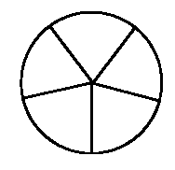 | 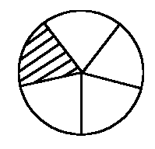
Whole | Whole divided up into  5 parts of equal size | $\frac{1}{5}$ of the whole shaded

Language patterns for a continuous whole
To find $\frac{1}{5}$ of my circular disc, I first divide the whole circular disc into 5 parts of equal size. Each part is $\frac{1}{5}$ of the whole, and if I shade one of these parts, I have shaded $\frac{1}{5}$ of the whole.
Example | Find $\frac{1}{8}$ of 32 counters  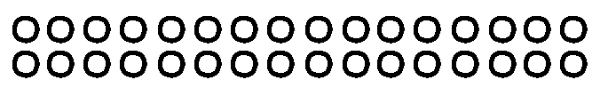  32 counters (shown above) represent the whole  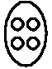  I put my counters into 8 groups of equal size. There are four counters in each group.  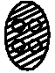  One of the groups of equal size is $\frac{1}{8}$ of the whole.
Language patterns for a discontinuous whole
To find $\frac{1}{8}$ of 32 counters, I first divide the counters into 8 groups of equal size. I find eight groups with four counters in each group. Each group is $\frac{1}{8}$ of the whole, and so 4 counters is $\frac{1}{8}$ of 32 counters.
When you introduce fractions to learners, you will begin by finding unit fractions (as we have done above). A unit fraction is a fraction of the form $\frac{1}{n}$ – the numerator is one and the denominator can be any number. You must allow the learners to experiment with finding unit fractions of a broad variety of wholes. At the beginning you will restrict your discontinuous wholes according to the denominator.
For example, if the denominator is 6, you will only ask the learners to find fraction parts of 6 counters, or 12, 18, 24, etc. counters (multiples of 6). You must also remember to set them tasks involving unit wholes as well as discontinuous wholes.
Vary your apparatus as widely as you can. Use pieces of paper, string, sand, water, beads, counters, strips of paper, bottle tops – whatever is easily available.

Activity | Activity 4.1  Illustrate and record your solutions to the following questions:  - Find $\frac{1}{7}$ of the rectangle given below:  Record your language pattern.  - Find $\frac{1}{9}$ of 27 beads, as given below.  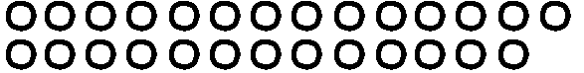  Record your language pattern.  - Now try these additional exercises (illustrate and give the language pattern each time):  - Find $\frac{1}{3}$ of 30 biscuits.  - Shade $\frac{1}{10}$ of a 15 cm-long strip of paper.  - Illustrate and explain how to find $\frac{1}{6}$ of a circular cake.  - Find $\frac{1}{4}$ of 20 beads.

You could turn some of your fraction finding into games or activities. In this way, you could keep the learners busy for slightly longer periods of time, while they are learning and discovering ideas in an interesting and enjoyable way.
Example | "Full House"  In this example, learners are given 20 counters. They must then try to find all the possible fraction parts that they can, of 20 counters. They could work in groups of two to four members (not more, as they would not have enough of a chance to express themselves). The discussion of the different fraction parts, could go on in the whole group. Once the group thinks that they have found all the possible fraction parts they can put up their hands and say "Full House!", to call you to come and check up on them. As a follow up, ask each learner to record in full and good language one of the fraction parts which they found. Try this activity out yourself!

Reflection | Look around for other ideas of games and activities, or make them up yourself and share them with your colleagues.  Record your ideas so that you don't forget them!

Once you are satisfied that your learners have established the general result:
$\frac{1}{n}$ of = ÷ , you can move on to finding non-unit fractions. We will discuss these in the next section.

Activity | Activity 4.2  - What does $\frac{1}{n}$ of = ÷ mean to you?  - Give 2 examples, one of a continuous whole and one of a discontinuous whole.  - Illustrate each of your examples.

You should now be able to do all of the exercises in the activities that follow.
Activity |  | Activity 4.3  How many equal sized parts have the wholes below been divided into?
 | A | 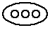 |  |  |  | F | 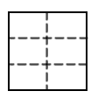 | I | 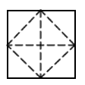
 | B | 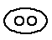 |  |  |  | G | 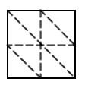 | J | 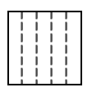
 | C | 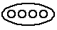
 | D | 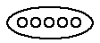 |  |  |  | H | 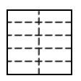 | K | 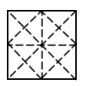
 | E | 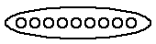

Activity |  | Activity 4.4  Identify what part of the whole has been shaded in each case.
 | A | 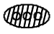 | F
 |  |  | G
 |  |  | H | 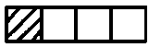
 | B |  | I
 |  | 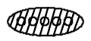 | J
 |  |  | K
 | C | 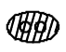 | L
 |  |  | M
 | D
 |  | 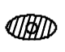
 | E | 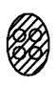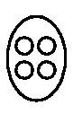

Activity |  | Activity 4.5  Shade the fraction part requested in each case.
 | A | 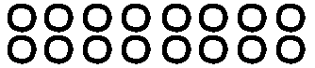$\frac{1}{8}$ | F | 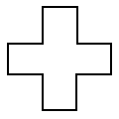$\frac{1}{2}$ | I | $\frac{3}{4}$
 | B | 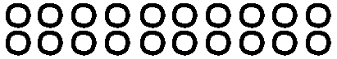$\frac{1}{4}$ | G | 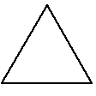$\frac{2}{3}$ | K | $\frac{1}{2}$ | N | $\frac{3}{4}$
 | C | $\frac{1}{2}$ | H | $\frac{1}{4}$ | L | $\frac{2}{3}$ | O | $\frac{5}{9}$
 | D | 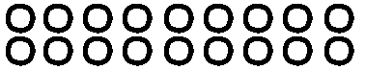$\frac{1}{6}$ | I | 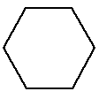$\frac{1}{2}$ | M | $\frac{2}{3}$ | P | $\frac{5}{6}$
 | E | 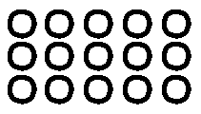$\frac{1}{5}$

Activity |  | Activity 4.6  Which of the following illustrations correctly give the fraction parts as indicated?
 |  | Halves?
 | A | 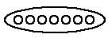
 |  | Thirds? |  |  |  | Thirds?
 | C |  |  |  | B
 |  | Quarters? |  |  |  |  |  | Quarters?
 | E |  |  |  |  |  | D | 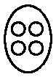
 |  | Halves? |  | Halves? |  |  |  | Halves? |  | Halves?
 | F | 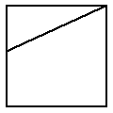 | G | 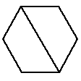 |  |  | H | 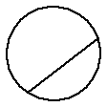 | I | 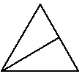
 |  | Thirds? |  | Thirds? |  |  |  | Thirds? |  | Thirds?
 | J | 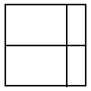 | K | 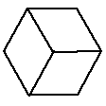 |  |  | L | 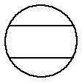 | M | 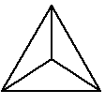
 |  | Quarters? |  | Quarters? |  |  |  | Quarters? |  | Quarters?
 | N | 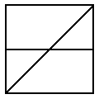 | O | 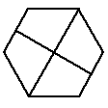 |  |  | P | 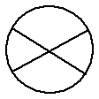 | Q | 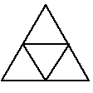

Further activities in the teaching of fractions
The activities described in the first topic would cover fractions work in the foundation phase. At the beginning of the intermediate phase, you would even spend time revising the idea of finding unit fractions of a variety of wholes. You could then move on to finding other fractions of the form where $n≠0$, that is, fractions where the numerator can be any number , and the denominator can be any number , except zero ($n≠0$).
At this point, let us establish that you are sure which of the numerals is the numerator and which is the denominator. We have already used these terms, but this is where you would introduce your learners to them.

Reflection | 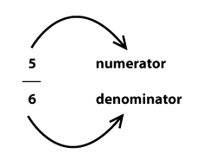  You must learn these names if you do not already know them. This is important terminology in the section of fractions. You could set exercises where the learners use the terminology repeatedly, to help them build the words into their regular speech. You could ask questions such as (try these yourselves):  Which numeral is missing in each fraction below? Fill it in and name it.  In the fractions below, double each denominator and add 5 to the numerator. Do you create a fraction that has the same value as the one you started off with?  - $\frac{2}{4}$  - $\frac{7}{3}$  - $\frac{15}{30}$  - $\frac{6}{7}$

You will now set tasks for your learners to find fraction parts of wholes, where the fraction is of the type $\frac{m}{n}$ where $n≠0$. This is purely an extension of the previous activities, where you found $\frac{1}{n}$ of a whole. The learners should not experience too many difficulties here if unit fractions have been grasped well. Study the examples below.

Example |  | Discontinuous whole: Find $\frac{3}{4}$ of 36 beads
 |  | The whole
 |  | 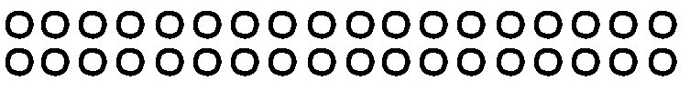
 |  | The whole divided into quarters
 |  | 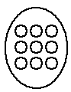
 |  | Three of the four groups (representing $\frac{3}{4}$ of 36) have been shaded
 |  | 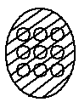
Language pattern
The whole is 36 beads. I divide the whole up into four groups of equal size in order to find quarters. There are 9 beads in each group. One group of 9 is $\frac{1}{4}$ of 36, and so 3 groups of 9 are $\frac{3}{4}$ of 36, i.e. 27 is $\frac{3}{4}$ of 36.

Example |  | Find $\frac{5}{6}$ of the square sheet of paper below.
 |  | The whole | The whole divided up into 6 parts of equal size |  | 5 of the 6 parts of equal size have been shaded. i.e. $\frac{5}{6}$ of the whole has been shaded
 |  |  | 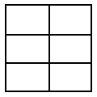 |  | 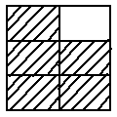
Language pattern
The whole is a square sheet of paper. I fold the whole up into six parts of equal size in order to find sixths. Each part is $\frac{1}{6}$of the whole, so 5 of the six equal sized parts is $\frac{5}{6}$ of the whole.

Activity | Activity 4.7  Try these examples on your own. Write out the full language pattern you would use in each case, so that you can check your own ability to talk fluently about the fraction parts you are finding.  - Illustrate $\frac{2}{3}$ of a pizza.  - Show how you find $\frac{2}{5}$ of 25 bricks.  - Shade $\frac{7}{12}$ of a rectangular sheet of paper.  - What is $\frac{8}{9}$ of 27 liquorice strips?

Until now we have only found fraction parts where the denominators relate to the number of units in the discontinuous wholes.
Now we look at a slightly more complex form of discontinuous wholes. Examine the following examples. Notice that the first examples relate to unit fractions, while the later examples relate to non-unit fractions.

Example | What is $\frac{1}{5}$ of 3 Tex bars?  The whole is 3 Tex bars: We cannot just hand out Tex bars because there are only 3 bars and we want to find fifths. What we do is the following:  Cut each Tex bar into 5 pieces of equal size. If you take $\frac{1}{5}$ from each of the 3 bars, you have found $\frac{1}{5}$ of each of the 3 bars. But what you have in your hand is actually $\frac{3}{5}$ of one Tex bar. So $\frac{1}{5}$ of 3 = $\frac{3}{5}$ of 1.  3 Tex Bars 1 Tex Bar
Example | Find $\frac{1}{7}$ of 2 Cokes.  The whole is 2 Cokes. We cannot just pour out the cokes because there are only 2 cokes and we want to find sevenths. What we do is the following:  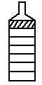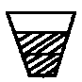  Pour $\frac{1}{7}$ from each Coke into a glass.  Each glass receives $\frac{1}{7}$ of a Coke from 2 Coke bottles, and so in total each glass receives $\frac{2}{7}$ of a Coke.  So $\frac{1}{7}$ of 2 = $\frac{2}{7}$ of 1.

Activity | Activity 4.8  - Find $\frac{3}{8}$ of 5, using the grid below to assist you.  Record your language pattern.  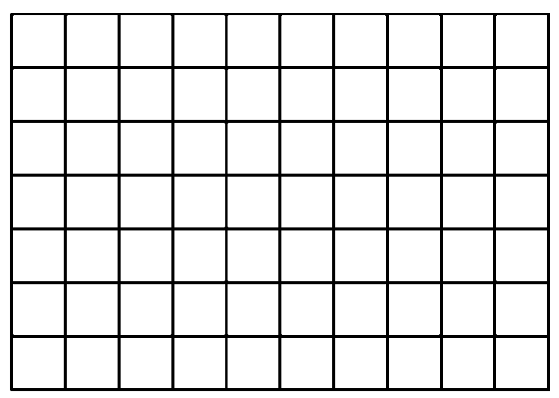  - Find $\frac{3}{4}$ of 9 cupcakes.  Record your language pattern.  (Each circle below represents one cupcake)  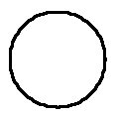  - Find $\frac{2}{5}$ of 8 strips of paper.  Use the grid paper below to assist you.  Record your language pattern.  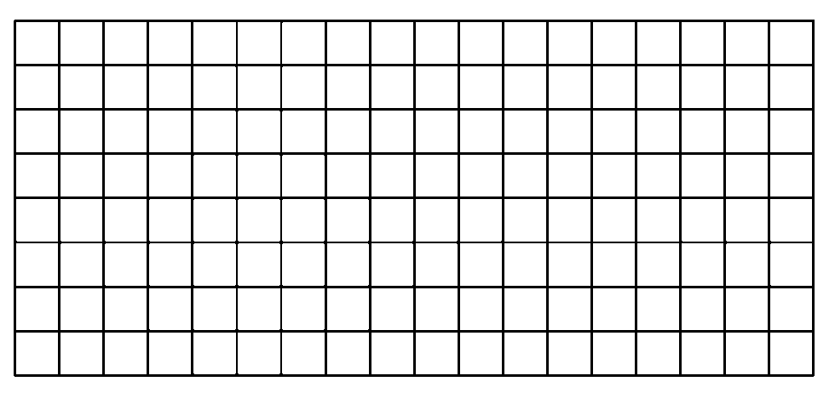  - Find $\frac{6}{7}$ of 2.  Use the grid paper below to assist you.  Record your language pattern alongside.  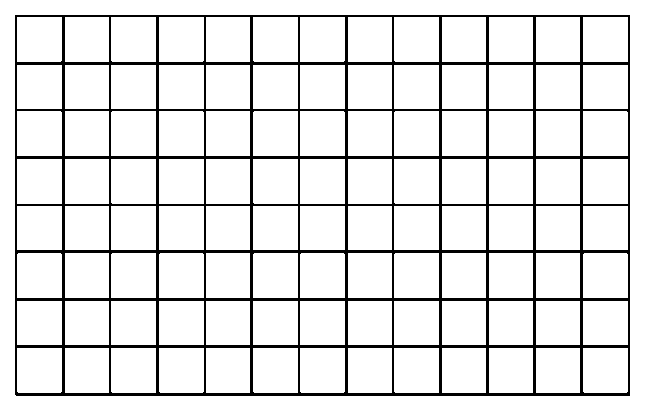

Activity | Activity 4.9  Make your own drawings or grids to illustrate your solutions.  - What is $\frac{2}{3}$ of 5 pizzas?  - Find $\frac{4}{5}$ of 3 chocolate slabs.  - Use grid paper to illustrate how to find $\frac{5}{6}$ of 8.  - Use grid paper to illustrate how to find $\frac{2}{9}$ of 4.  - Use grid paper to illustrate how to find $\frac{7}{10}$ of 12.  - Use grid paper to illustrate how to find $\frac{3}{5}$ of 4.
You must allow your learners ample chance to come to terms with the type of examples we have done above. They often find it quite tricky. Be sure that you feel completely comfortable with illustrating and explaining the solution to questions like those above. In general terms, the idea that we have established is stated as $\frac{1}{n}$ of m = $\frac{m}{n}$ of 1.
Give your own numeric contextualised example of a question involving the idea that
$\frac{1}{n}$ of m = $\frac{m}{n}$ of 1.
At this stage we have covered the finding of fractions of many different wholes. We will begin to hope that our learners are starting to think of fractions also as numerals for numbers, and have started to recognise certain fractions which look different but which actually represent the same number (such as $\frac{1}{2}$and $\frac{2}{4}$). The last thing we need to cover in this introductory section is a little more terminology, relating to types of fractions.
We call fractions which have the same denominators like fractions.
For example $\frac{3}{7}$, $\frac{6}{7}$, have 7 as their denominator.

Activity | Activity 4.10  - Is $\frac{7}{12}$ like to $\frac{8}{12}$ ?  - Give 5 other fractions which are like to each of the given fractions below  - $\frac{ 4}{15}$  - $\frac{13}{23}$

Example | $\frac{4}{7}$, $\frac{15}{18}$, $\frac{2}{9}$, $\frac{3}{8}$ are proper fractions

Reflection | Give your own 6 examples of proper fractions.

When the numerator of a fraction is bigger than the denominator of a fraction, the fraction is called an improper fraction.

Example | $\frac{14}{7}$, $\frac{15}{8}$, $\frac{22}{9}$, $\frac{3}{2}$ are improper fractions

Activity | Activity 4.11  - Give your own 6 examples of improper fractions.  - Can you change a proper fraction into an improper fraction, and if so, how do you do this?  - Are like fractions equal in number?  - Are the fractions such as $\frac{2}{2}$, $\frac{4}{4}$, $\frac{5}{5}$ and $\frac{18}{18}$ proper or improper fractions?

Equivalent fractions and comparison of fractions

Equivalent fractions
Your learners will already have begun to notice certain equivalent fractions before you consciously introduce the topic in class. They might have begun to say things to you like "but $\frac{2}{4}$ is the same as $\frac{1}{2}$". You should encourage this early observation. You could possibly even comment that they have noticed an important quality that you will examine later in more detail.
Let us now look at equivalent fractions using concrete wholes. (As usual, we first use concrete wholes before we work with purely numeric examples.)

Equivalence of fractions using a continuous whole
Try the following activity yourself as you read through the instructions and follow the illustrations.

Activity |  | Activity 4.12  - Take 5 pieces of paper that are the same size. Fold each of them into thirds, as illustrated below:
 |  | 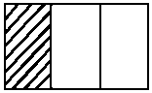
 |  | A | B | C | D | E
 |  | - Shade in the first third on each piece of paper. Now fold pieces B, C, D and E as indicated below:
 |  |  | 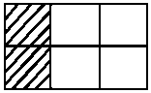 | 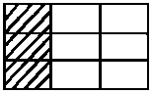 | 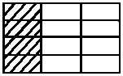 | 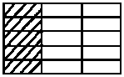
 |  | A | B | C | D | E
 |  | - What fraction of each piece of paper has been shaded?

Discussion | The fraction represented by the shaded part on each piece of paper is the following:  A $\frac{1}{3}$ is shaded  B $\frac{2}{6}$ is shaded  C $\frac{3}{9}$ is shaded  D $\frac{4}{12}$ is shaded  E $\frac{5}{15}$ is shaded  All of these fractions have the same value ( $\frac{1}{3}$ ) although they are written in different ways with different fraction numerals.

Reflection | You know that the shaded part of each piece of paper in Activity 4.12 is the same size. You can verify this for yourself by putting all of the pieces of paper on top of each other. So although we name each shaded part differently, these names (the fraction numeral) represent the SAME AMOUNT. We call these fractions equivalent fractions. (They are different numerals which represent the same number.) We can equate these equivalent fractions and discover a numeric rule to find other such equivalent fractions.  $\frac{1}{3}$ = $\frac{2}{6}$ = $\frac{3}{9}$ = $\frac{4}{12}$ = $\frac{5}{15}$

Examine the numerators and denominators of the fractions above, to see if you can identify a rule for the relationship between equivalent fractions.
You' should notice something similar between the relationships indicated below.
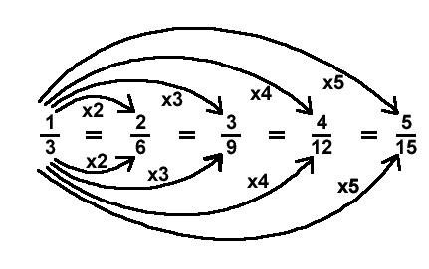
From this we can see that if you multiply the numerator by a number, and then multiply the denominator by the same number, you will generate an equivalent fraction.

Equivalence of fractions using a discontinuous whole
Once again you should try this activity out for yourself, as you read through the instructions and follow the illustrations.
Activity | Activity 4.13  - Take 24 counters. This is the whole. Each single counter represents $\frac{1}{24}$ of the whole.  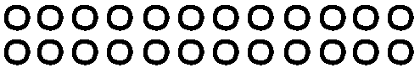  - Now put the counters into pairs. You should get 12 pairs.  Each pair of counters represents $\frac{1}{12}$ of the whole.  - Now put the counters into threes. You should get 8 threes. Each group of three counters represents $\frac{1}{8}$ of the whole.  - Now, regroup the counters into fours. You should get 6 fours. Each group of four counters represents $\frac{1}{6}$ of the whole.  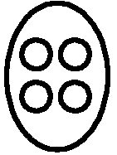  - Similarly, group the counters into sixes, eights and twelves.  - How many groups of six do you find?  - Each group of six is therefore what fraction of the whole?  - How many groups of eight do you find?  - Each group of eight is therefore what fraction of the whole?  - How many groups of twelve do you find?  - Each group of twelve is therefore what fraction of the whole?

Reflection | So we have found that:  12 counters out of 24 counters is $\frac{1}{2}$ of the whole  12 counters out of 24 counters is also $\frac{2}{4}$ of the whole  12 counters out of 24 counters is also $\frac{3}{6}$ of the whole  12 counters out of 24 counters is also $\frac{4}{8}$ of the whole  12 counters out of 24 counters is also $\frac{6}{12}$ of the whole  12 counters out of 24 counters is also $\frac{12}{24}$ of the whole  In this way we have found some more equivalent fractions. We can equate them as follows, since they all represent the same number:  $\frac{12}{24} = \frac{6}{12} = \frac{4}{8} = \frac{3}{6} = \frac{2}{4} = \frac{1}{2}$

Once again we can examine the numerators and the denominators in the above fractions to look for a relationship between them.
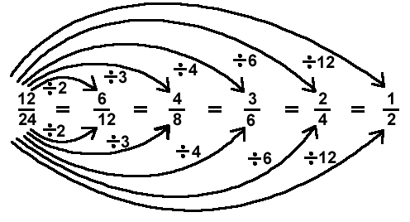
This gives us the other general rule for finding equivalent fractions, which is that if you divide the numerator by one number, you divide the denominator by the same number in order to find an equivalent fraction.

Reflection | What is wrong with the rule that many people state for finding equivalent fractions? They state that to find equivalent fractions "what you do to the top, you do to the bottom".  Rephrase this general rule differently, in a more mathematically correct way.

You should now be able to recognise, name and work with equivalent fractions.
Equivalent fractions come in particularly handy when we add and subtract fractions, as you will see later. Try the following exercises (look for more in school textbooks):

Activity | Activity 4.14  - Give four fractions which are equivalent to $\frac{3}{8}$ .  - Give four fractions which are equivalent to $\frac{54}{60}$.  - Complete the following by filling in the missing numbers:  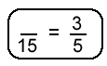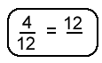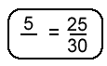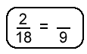  - There is one further term that comes up in this context: What do we mean by a fraction that is in "lowest terms"? In the list of fractions below, identify the ones that are in lowest terms:  $\frac{4}{16}$ $\frac{3}{7}$ $\frac{2}{6}$ $\frac{5}{15}$ $\frac{8}{21}$ $\frac{1}{2}$ $\frac{35}{20}$  - What made you choose the ones that you chose?

A fraction is in lowest terms when there is no common factor other than the number 1 for the numerator and the denominator.

Comparing Fractions
It is natural to compare whether or not certain numbers represent more or less than other numbers. When we do so for fractions, this process is sometimes fairly involved. We can start by comparing fractions using concrete wholes, and then move onto the purely numeric examples.
When we compare fractions, we often ask or need to find out "which one is greater and by how much?" The solution to this is not always as clearly evident as it is in whole number questions.
Example | Here is an example of the comparison of $\frac{2}{3}$ and $\frac{3}{4}$, using a concrete whole. Let 12 counters be our whole (so we are using a discontinuous whole):  The whole  $\frac{2}{3}$ of 12 is 8  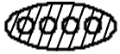  $\frac{3}{4}$ of 12 is 9  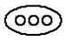  So $\frac{3}{4}$ is greater than $\frac{2}{3}$ by one counter.  But what is the value of one counter? If there are 12 counters in the whole, then one counter is $\frac{1}{12}$ of the whole. We can thus say that $\frac{3}{4}$ is greater than $\frac{2}{3}$ by $\frac{1}{12}$.

Let us now compare $\frac{1}{3}$ and $\frac{1}{2}$, using a continuous whole.
Let the circular disk below be the whole:

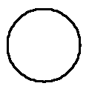 | 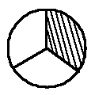 | 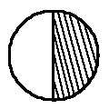
Whole | Thirds  $\frac{1}{3}$ is shaded | Halves  $\frac{1}{2}$ is shaded

Reflection | Which one is greater?  By how much?

To answer the "by how much" question properly, we need to cut the whole up into smaller parts. Examine the drawings below:

 | 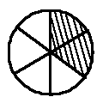 | 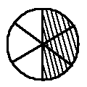
Whole | Thirds  $\frac{1}{3}$ is shaded  $\frac{2}{6}$ is shaded | Halves  $\frac{1}{2}$ is shaded  $\frac{3}{6}$ is shaded

From this illustration is becomes clear that $\frac{1}{2}$ is greater than $\frac{1}{3}$ by $\frac{1}{6}$.
Find out which is greater, $\frac{2}{3}$ or $\frac{3}{5}$ and by how much, using a concrete whole.

Comparing fractions using equivalent fractions
If you look closely at the numerals involved in the comparisons above, you will see that our concrete working simply leads us to finding equivalent fractions when we want to say how much bigger the one fraction is than the other. Once we are familiar with equivalent fractions, we can do simple numeric conversions to compare fractions. You should be able to answer questions like the ones below on your own by now.

Activity | Activity 4.15  Compare the following pairs of fractions, stating which one is greater and by how much.  The first one has been done for you:  - $\frac{4}{7}$ and $\frac{3}{4}$  $\frac{4}{7} × \frac{4}{4} = \frac{16}{28}$ $\frac{3}{4} × \frac{7}{7} = \frac{21}{28}$ $∴ \frac{3}{4} > \frac{4}{7} by \frac{5}{28}$  - $\frac{5}{30}$ and $\frac{2}{3}$  - $\frac{6}{25}$ and $\frac{2}{10}$

Once the topic of decimals has been covered, you can also convert to the decimal form of the fraction in order to find relative values of different given numbers. To do so, you could use equivalent fractions (convert to decimal fractions) or you could simply use a calculator. We can use a calculator when the conversion to decimal form is too complicated for us to waste time on it manually. Here are some examples (you should make up some other examples like these for yourself once you have completed these two).
Compare $\frac{23}{25}$ and $\frac{47}{50}$ using decimal fractions and hence decimals:

$\frac{23}{25} × \frac{4}{4} = \frac{92}{100}=0,92$

$\frac{47}{50} = \frac{94}{100} = 0,94$

$∴ \frac{23}{25} < \frac{47}{50} by 0,02$

Compare $\frac{34}{37}$and $\frac{39}{43}$ using a calculator

$\frac{34}{37} ≈ 0,919$ (use your calculator to get this approximation)

$\frac{39}{43} ≈ 0,907$ ($≈$ means approximately equal to)

$∴ \frac{34}{37} > \frac{39}{43}$ by approximately 0,12

Activity | Activity 4.16  Compare using fractions, decimal fractions and then using a calculator:  - $\frac{13}{17} and \frac{21}{25}$.  - $\frac{3}{10} and \frac{24}{50}.$  - $\frac{5}{7} and \frac{3}{4}$  - $\frac{19}{25} and \frac{17}{20}$

Categories of the whole – a review of concepts and apparatus
In the first three sections of this unit we looked at finding fractions of different wholes and there we found equivalent fractions and compared different fractions using both concrete wholes and numeric algorithms. As we progressed through this unit, we used different types of wholes, though we just referred to them as different types of continuous and discontinuous wholes. We can name these different types of wholes according to several categories. You need to know these categories and be sure to expose your learners to all of them, in a logical sequence of ever-increasing difficulty.
The categories are listed in order of complexity. The examples are all left for you to solve, as a revision of work we have already done.

Category 1: Continuous
The unit whole. All wholes which consist of a single item fall into this category. To find a fraction part of a unit whole, we have to cut/fold/break, etc. because the whole is a single thing.

Reflection | Find $\frac{4}{7}$ of an apple pie. Illustrate and explain your solution.  Whole

Category 2: Discontinuous (made of more than one item)
The whole consists of more than one unit, but the number of units is limited to the same number as the denominator. It is thus made up of more than one item and is a discontinuous whole.

Reflection | Find $\frac{5}{8}$ of 8 Crunchie bars. Illustrate and explain your solution.

Category 3: Discontinuous (made of more than one item)
The whole consists of more than one unit, but the whole is always a multiple of the denominator. This is also made up of more than one unit and so it is a discontinuous whole.

Reflection | Find $\frac{1}{6}$ of 24 Cadbury's Chocolate Eclair sweets. Illustrate and explain your solution.

Category 4: Discontinuous (made of more than one item)
The whole consists of more than one unit, but less than the number of units in the denominator.
This is also a multiple unit whole, and so it is a discontinuous whole.

Reflection | Find $\frac{3}{4}$ of 3 slabs of chocolate. Illustrate and explain your solution.

Category 5: Discontinuous (made of more than one item)
The whole consists of more than one unit, and more than the number in the denominator. This is another discontinuous whole.

Reflection | Find $\frac{2}{3}$ of 10 pieces of bread. Illustrate and explain your solution.

Apparatus
When we draw examples and imagine using apparatus, it is often very useful to refer to food items to make up our wholes. Where we want to use actual concrete apparatus, it is not such a good idea to use food. We now discuss other concrete apparatus that you can use in your class.
For discontinuous wholes we use counters of whichever type are readily available, such as bottle tops, beans (which can be spray-painted in different colours), discs, etc. Depending on how many counters you need in the whole, you use them in various numbers. You have seen several examples of working done with counters in the various categories of the whole.
Scrap paper can very successfully be used for unit wholes, as it can be folded, cut and coloured according to instructions relating to different fraction activities – but if you want to make something more durable, you can make a "fraction kit", as described below.
Fraction kit
To make this kit you need 7 squares of cardboard, 24 cm x 24 cm.
You need to mark and cut the parts very accurately as indicated, so that your apparatus is useful in the teaching of fractions as like parts of a whole. Measure, label and cut the 7 pieces of cardboard as follows: If you have different colours of cardboard, this makes an even nicer apparatus, but this is not essential. (Paint or colour them if you want to.) Don't use cardboard that is too soft, as it will bend and be torn easily.

Whole  24 cm x 24 cm | $\frac{1}{12}$ each  2 cm wide strips | $\frac{1}{8}$ each  3 cm wide strips | $\frac{1}{6}$ each  4 cm wide strips

$\frac{1}{4}$ each  6 cm wide strips | $\frac{1}{3}$ each  8 cm wide strips | $\frac{1}{2}$ each  12 cm wide strips

You will cut the strips as indicated, so that you can use them to demonstrate different fractions fitting into each other (equivalent fractions). You can also allow the learners to manipulate the apparatus. Make sure that you always pack the whole kit safely into a box or bag so that no pieces get lost, and keep them flat so that they don't get bent. Here are some examples of activities you could work on using your kit.

Reflection | Find out which fractions in your kit can make equivalent fractions for a half.  How many twelfths are there in $\frac{1}{4}$ ? Lay out the necessary pieces from the fraction kit to demonstrate the answer. Illustrate this.

Fraction wall
This is less flexible than a fraction kit because you draw a fraction wall on a chart and don't cut it up. But fraction walls are very useful in work on fraction parts and equivalent fractions. It is easy to make several fraction walls of related groups of fractions, because you do not need so much cardboard for each wall. They can also be used to demonstrate more than one fraction kit is able to do. The fraction walls illustrated below would be useful as aids in a classroom. You could put them up as charts on the wall (for permanent display) and refer to them when necessary. Or you could bring them out when you work on equivalent fractions and the operations with fractions. These charts have been drawn so that you could photocopy them and use them, if you have the facilities and would like to do so.
$$\frac{1}{10}$$ | $$\frac{1}{10}$$ | $$\frac{1}{10}$$ | $$\frac{1}{10}$$ | $$\frac{1}{10}$$ | $$\frac{1}{10}$$ | $$\frac{1}{10}$$ | $$\frac{1}{10}$$ | $$\frac{1}{10}$$ | $$\frac{1}{10}$$
$$\frac{1}{5}$$ |  | $$\frac{1}{5}$$ |  | $$\frac{1}{5}$$ |  | $$\frac{1}{5}$$ |  | $$\frac{1}{5}$$
$$\frac{1}{2}$$ |  |  |  |  | $$\frac{1}{2}$$
Whole

$$\frac{1}{24}$$ | $$\frac{1}{24}$$ | $$\frac{1}{24}$$ | $$\frac{1}{24}$$ | $$\frac{1}{24}$$ | $$\frac{1}{24}$$ | $$\frac{1}{24}$$ | $$\frac{1}{24}$$ | $$\frac{1}{24}$$ | $$\frac{1}{24}$$ | $$\frac{1}{24}$$ | $$\frac{1}{24}$$ | $$\frac{1}{24}$$ | $$\frac{1}{24}$$ | $$\frac{1}{24}$$ | $$\frac{1}{24}$$ | $$\frac{1}{24}$$ | $$\frac{1}{24}$$ | $$\frac{1}{24}$$ | $$\frac{1}{24}$$ | $$\frac{1}{24}$$ | $$\frac{1}{24}$$ | $$\frac{1}{24}$$ | $$\frac{1}{24}$$
$$\frac{1}{12}$$ |  | $$\frac{1}{12}$$ |  | $$\frac{1}{12}$$ |  | $$\frac{1}{12}$$ |  | $$\frac{1}{12}$$ |  | $$\frac{1}{12}$$ |  | $$\frac{1}{12}$$ |  | $$\frac{1}{12}$$ |  | $$\frac{1}{12}$$ |  | $$\frac{1}{12}$$ |  | $$\frac{1}{12}$$ |  | $$\frac{1}{12}$$
$$\frac{1}{8}$$ |  |  | $$\frac{1}{8}$$ |  |  | $$\frac{1}{8}$$ |  |  | $$\frac{1}{8}$$ |  |  | $$\frac{1}{8}$$ |  |  | $$\frac{1}{8}$$ |  |  | $$\frac{1}{8}$$ |  |  | $$\frac{1}{8}$$
$$\frac{1}{6}$$ |  |  |  | $$\frac{1}{6}$$ |  |  |  | $$\frac{1}{6}$$ |  |  |  | $$\frac{1}{6}$$ |  |  |  | $$\frac{1}{6}$$ |  |  |  | $$\frac{1}{6}$$
$$\frac{1}{4}$$ |  |  |  |  |  | $$\frac{1}{4}$$ |  |  |  |  |  | $$\frac{1}{4}$$ |  |  |  |  |  | $$\frac{1}{4}$$
$$\frac{1}{3}$$ |  |  |  |  |  |  |  | $$\frac{1}{3}$$ |  |  |  |  |  |  |  | $$\frac{1}{3}$$
$$\frac{1}{2}$$ |  |  |  |  |  |  |  |  |  |  |  | $$\frac{1}{2}$$
Whole

$$\frac{1}{18}$$ | $$\frac{1}{18}$$ | $$\frac{1}{18}$$ | $$\frac{1}{18}$$ | $$\frac{1}{18}$$ | $$\frac{1}{18}$$ | $$\frac{1}{18}$$ | $$\frac{1}{18}$$ | $$\frac{1}{18}$$ | $$\frac{1}{18}$$ | $$\frac{1}{18}$$ | $$\frac{1}{18}$$ | $$\frac{1}{18}$$ | $$\frac{1}{18}$$ | $$\frac{1}{18}$$ | $$\frac{1}{18}$$ | $$\frac{1}{18}$$ | $$\frac{1}{18}$$
$$\frac{1}{9}$$ |  | $$\frac{1}{9}$$ |  | $$\frac{1}{9}$$ |  | $$\frac{1}{9}$$ |  | $$\frac{1}{9}$$ |  | $$\frac{1}{9}$$ |  | $$\frac{1}{9}$$ |  | $$\frac{1}{9}$$ |  | $$\frac{1}{9}$$
$$\frac{1}{6}$$ |  |  | $$\frac{1}{6}$$ |  |  | $$\frac{1}{6}$$ |  |  | $$\frac{1}{6}$$ |  |  | $$\frac{1}{6}$$ |  |  | $$\frac{1}{6}$$
$$\frac{1}{3}$$ |  |  |  |  |  | $$\frac{1}{3}$$ |  |  |  |  |  | $$\frac{1}{3}$$
Whole

Quad paper or grid paper
This is an area marked into squares of equal size.

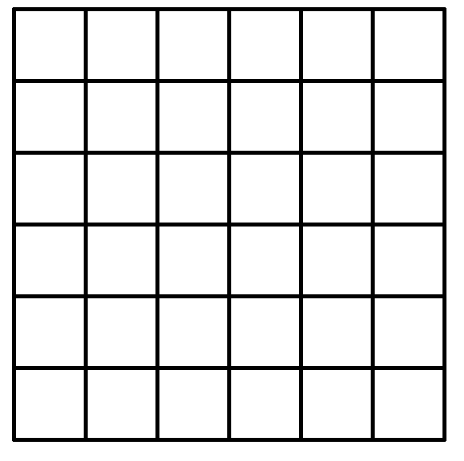

The squares can readily be used to draw up unit wholes of different convenient sizes, depending on the fractions you are working on. Your learners will become very good at choosing a useful unit size if you do a lot of work using quad paper. Here are some examples of solutions using quad paper, followed by some examples for you to try:
Illustrate the finding of $\frac{8}{3}$ using quad paper:
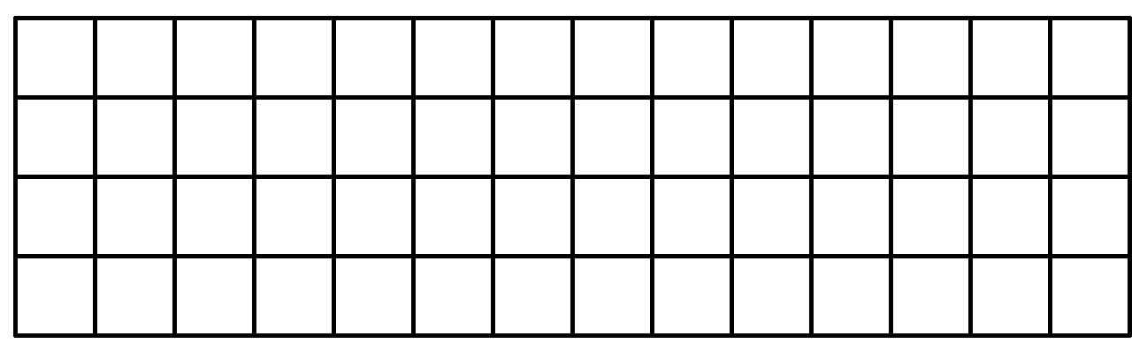

Choose a whole that is 3 blocks long so that it is easy to find thirds.

Draw a table that shows that $\frac{5}{10}=\frac{1}{2}$ using quad paper: Choose a whole that is 10 blocks long so that you can divide it into tenths and halves.

Activity | Activity 4.17  - Illustrate and explain how to find the following fractions using quad paper:  - $\frac{1}{8}$  - $\frac{3}{5}$  - $\frac{2}{9}$  - $\frac{1}{2}$  - $\frac{7}{10}$  - Find $\frac{1}{4}$ of 7 using quad paper.  - Find $\frac{2}{7}$ of 3 using quad paper.  - Illustrate the equivalence of $\frac{2}{3}$, $\frac{4}{6}$ and $\frac{8}{12}$ using quad paper.

Number lines
Number lines are not concrete apparatus in the sense that the apparatus discussed above is. They are more abstract and assist us to check that the learners are beginning to grasp the number concept involved in the fraction work which we have done. Number lines can be drawn and reproduced very easily and are a must in your teaching of fractions. You need to be sure that you (and your learners) are able to plot any fractions on a number line. You need to know how to choose the correct scale for number lines which are not already marked for you.
Consider the following examples:
Example | Plot $\frac{1}{2}$, $\frac{3}{8}$, $\frac{3}{4}$ and $\frac{9}{8}$ on the same number line.  We look at the denominators to assist us in choosing a good scale. They are 2, 4 and 8, and so we will choose 8cm to represent one unit. Then  1cm = $\frac{1}{8}$ and 2cm = $\frac{1}{4}$, etc. Look at the number line below.  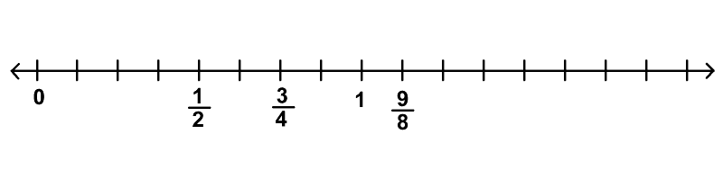

Example | Plot $\frac{2}{7}$, $\frac{5}{14}$, 1, $\frac{13}{14}$, $\frac{15}{14}$, $\frac{14}{14}$, $\frac{5}{7}$ and $\frac{8}{7}$ on the same number line.  The denominators are 7 and 14, so we choose 14cm to represent one unit. Then 1cm = $\frac{1}{14}$, etc.  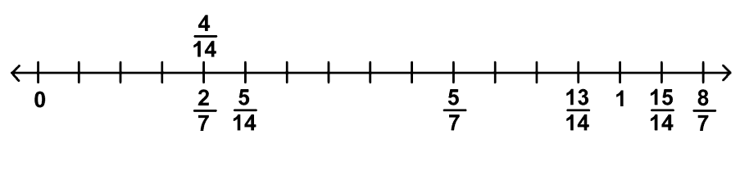

Activity | Activity 4.18  Now try the following on your own. Think carefully about your choice of scale before you begin:  - Plot $\frac{2}{6}$, $\frac{2}{3}$, $\frac{3}{3}$, $\frac{5}{6}$, $\frac{7}{6}$, $\frac{4}{3}$ on the same number line.  - Plot $\frac{1}{2}$, $\frac{2}{5}$, $\frac{7}{10}$, $\frac{11}{10}$, $\frac{6}{5}$, $\frac{3}{10}$, $\frac{4}{5}$ on the same number line.  - Plot $\frac{2}{3}$, $\frac{2}{3}$, $\frac{5}{6}$, $\frac{6}{5}$, $\frac{5}{3}$, $\frac{1}{6}$ on the same number line.

Here is a grid for you to print and copy to use when necessary

Rational numbers
We have spoken about fractions as the numerals for numbers several times in this module. In this unit, we name those numbers: They are the RATIONAL NUMBERS. When we studied numeration, there was a unit on the number systems. If you look back at that unit, you will see where the rational numbers fit into our numeration system. In this unit we will look more closely at the rational numbers, and our work with those numbers.
You might recall that we were unable to list the set of rational numbers in the way in which we were able to list, for example, the natural numbers and the integers. We had to use set notation, and described the set like this
Rational numbers give the solution to the question a ÷ b, since, as we have seen in this unit,
$\frac{a}{b}$ = a ÷ b
In unit 3 we studied equivalent fractions. Here we saw that several different fraction numerals can represent exactly the same number.

Example | For example $\frac{15}{20}$, $\frac{60}{80}$, $\frac{24}{32}$ are all different ways of writing $\frac{3}{4}$.

Because of this possibility in the field of fractions, we say that a rational number has many names.

Reflection | What does it mean to say "a rational number has many names"? Give an example to illustrate what you say.

Activity | Activity 4.19  In the table below, several fraction numerals represent the same rational number.  $$÷$$ 0 1 2 3 4 5 6 7 8 9 10  0 0 $$\frac{0}{1}$$ $$\frac{0}{2}$$ $$\frac{0}{3}$$ $$\frac{0}{4}$$ $$\frac{0}{5}$$ $$\frac{0}{6}$$ $$\frac{0}{7}$$ $$\frac{0}{8}$$ $$\frac{0}{9}$$ $$\frac{0}{10}$$  1 $$\frac{1}{0}$$ $$\frac{1}{1}$$ $$\frac{1}{2}$$ $$\frac{1}{3}$$ $$\frac{1}{4}$$ $$\frac{1}{5}$$ $$\frac{1}{6}$$ $$\frac{1}{7}$$ $$\frac{1}{8}$$ $$\frac{1}{9}$$ $$\frac{1}{10}$$  2 $$\frac{2}{0}$$ $$\frac{2}{1}$$ $$\frac{2}{2}$$ $$\frac{2}{3}$$ $$\frac{2}{4}$$ $$\frac{2}{5}$$ $$\frac{2}{6}$$ $$\frac{2}{7}$$ $$\frac{2}{8}$$ $$\frac{2}{9}$$ $$\frac{2}{10}$$  3 $$\frac{3}{0}$$ $$\frac{3}{1}$$ $$\frac{3}{2}$$ $$\frac{3}{3}$$ $$\frac{3}{4}$$ $$\frac{3}{5}$$ $$\frac{3}{6}$$ $$\frac{3}{7}$$ $$\frac{3}{8}$$ $$\frac{3}{9}$$ $$\frac{3}{10}$$  4 $$\frac{4}{0}$$ $$\frac{4}{1}$$ $$\frac{4}{2}$$ $$\frac{4}{3}$$ $$\frac{4}{4}$$ $$\frac{4}{5}$$ $$\frac{4}{6}$$ $$\frac{4}{7}$$ $$\frac{4}{8}$$ $$\frac{4}{9}$$ $$\frac{4}{10}$$  5 $$\frac{5}{0}$$ $$5$$ $$\frac{5}{2}$$ $$\frac{5}{3}$$ $$\frac{5}{4}$$ $$\frac{5}{5}$$ $$\frac{5}{6}$$ $$\frac{5}{7}$$ $$\frac{5}{8}$$ $$\frac{5}{9}$$ $$\frac{5}{10}$$  6 $$\frac{6}{0}$$ $$\frac{6}{1}$$ $$\frac{6}{2}$$ $$\frac{6}{3}$$ $$\frac{6}{4}$$ $$\frac{6}{5}$$ $$\frac{6}{6}$$ $$\frac{6}{7}$$ $$\frac{6}{8}$$ $$\frac{6}{9}$$ $$\frac{6}{10}$$  7 $$\frac{7}{0}$$ $$\frac{7}{1}$$ $$\frac{7}{2}$$ $$\frac{7}{3}$$ $$\frac{7}{4}$$ $$\frac{7}{5}$$ $$\frac{7}{6}$$ $$\frac{7}{7}$$ $$\frac{7}{8}$$ $$\frac{7}{9}$$ $$\frac{7}{10}$$  8 $$\frac{8}{0}$$ $$\frac{8}{1}$$ $$\frac{8}{2}$$ $$\frac{8}{3}$$ $$\frac{8}{4}$$ $$\frac{8}{5}$$ $$\frac{8}{6}$$ $$\frac{8}{7}$$ $$\frac{8}{8}$$ $$\frac{8}{9}$$ $$\frac{8}{10}$$  9 $$\frac{9}{0}$$ $$\frac{9}{1}$$ $$\frac{9}{2}$$ $$\frac{9}{3}$$ $$\frac{9}{4}$$ $$\frac{9}{5}$$ $$\frac{9}{6}$$ $$\frac{9}{7}$$ $$\frac{9}{8}$$ $$\frac{9}{9}$$ $$\frac{9}{10}$$  10 $$\frac{10}{0}$$ $$\frac{10}{1}$$ $$\frac{10}{2}$$ $$\frac{10}{3}$$ $$\frac{10}{4}$$ $$\frac{10}{5}$$ $$\frac{10}{6}$$ $$\frac{10}{7}$$ $$\frac{10}{8}$$ $$\frac{10}{9}$$ $$\frac{10}{10}$$  How many different rational numbers are recorded in the table?  Find out by eliminating all the equivalent fractions and all numbers that are not rational. The table is a grid of division facts.  How many different rational numbers are there on the table?
When you do exercises with equivalent fractions, you are working with rational numbers which are the same but have different names.
We have often emphasised the importance of using number lines in our teaching. In our fraction work, we can get the learners to plot different fractions onto number lines. This can be very revealing in terms of the learners' actual understanding of the relative size (or amount) that each fraction represents. If you (or your learners) are unable to plot numbers on number lines, you need to spend more time thinking about how to do it and practise doing it.

Reflection | When you plot fractions on the number line, you might have found that you need to name the same point on the number line more than once. When did this need arise?

We say that each rational number has a single point at which it can be found on a number line. This means that if we are asked to plot equivalent fractions, because these fractions represent the same number, they will all be plotted at the same point. So some points may have just one name, while others have several names.
Let us plot 1, $\frac{2}{3}$, $\frac{4}{3}$, $\frac{4}{6}$, $\frac{3}{3}$, $\frac{5}{6}$, $\frac{6}{6}$ and $\frac{2}{6}$ on a number line.
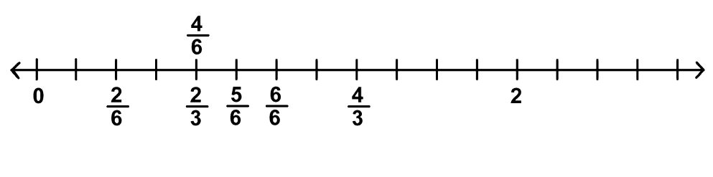

Reflection | How many different rational numbers did we plot on the number line above?

Many people experience difficulty in plotting fractions on number lines. Here are two more examples for you to try. Choose a good scale before you label the number line. This is vital if you are to plot the points correctly.

Activity | Activity 4.20  - Plot $\frac{1}{4}$, $\frac{6}{8}$, $\frac{9}{8}$, 1, $\frac{3}{4}$, $\frac{4}{4}$, $\frac{2}{8}$, $\frac{3}{8}$ on the number line below.  - Plot $\frac{1}{10}$, $\frac{2}{5}$, $\frac{11}{10}$, $\frac{8}{10}$, $\frac{12}{10}$, $\frac{5}{5}$ on the number line below.

Reciprocals
The reciprocal of a fraction is what you find if you invert (turn over) the fraction. The numerator becomes the denominator and the denominator becomes the numerator.
The reciprocal of $\frac{3}{7}$ is $\frac{7}{3}$. They are called a reciprocal pair, because of the special relationship between their numerators and denominators. They are not equal in value!
We discuss reciprocal values here under the topic of rational numbers because the possibility of finding reciprocals is a special property of rational numbers. There are times when you will need to find reciprocals and so you have to know what this term means. The most common instance when you will need to find reciprocals is when you are dividing fractions. This will be dealt with in more detail in your module on operations with fractions.

Activity | Activity 4.21  - Give the reciprocals of the fractions below:  - $\frac{5}{4}$ b. $\frac{11}{12}$ c. $\frac{4}{9}$ d. $\frac{23}{5}$  - In a pair of reciprocal fractions, what type of fractions (proper or improper) do you find?  Plot $\frac{2}{3}$ and $\frac{3}{2}$ on the number line below to check before you answer this question. Let the chosen scale guide you when you plot the points.  - What do you notice about the distance from 1 on the number line of the two points that you plotted above?

Decimals
We will not deal with decimals in any detail here because there will be another module on decimals in the second part of this course. We take a little time here to look at conversions from fraction form to decimal form and vice versa. Decimals are also numerals for rational numbers, but not all decimals are rational numbers. (If you look back to your notes on the number systems, you will see that some decimals are irrational numbers.)
Conversion from fraction form to decimal form
To convert a fraction to a decimal, we use division. We use the property that $\frac{m}{n}$ = $m÷n$, and calculate $m÷n$ using long division. Study the examples below. These three examples are all examples of terminating decimals:

Example | - $\frac{2}{5}=\underline{0,4 }$  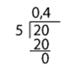  - $\frac{7}{16}=\underline{0,4375 }$  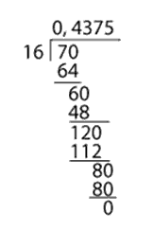  - $\frac{25}{100}=\underline{0,25}$  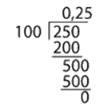
Here are some examples of non-terminating, recurring decimals that we sometimes encounter when we convert fractions to decimals. These are also rational numbers:

Example | - $\frac{2}{3}=0,666666…$  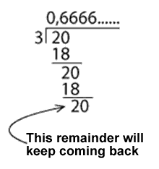  - $\frac{4}{7}=0,571428$  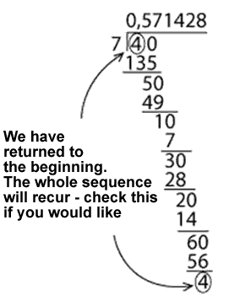  - $\frac{7}{11}=\underline{0,63 }$  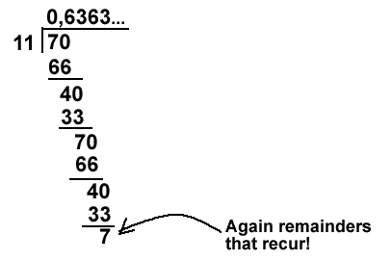

Note | We use two alternative forms of notation for recurring decimals: You should know and be able to use this notation.  Single digit pattern  Place a dot above the digit that recurs. Write the recurring digit only once. If you record the decimal as a repeating string, put three dots after the last numeral you record.  $0,\dot{6}=0,66666666…$  Double digit pattern  Place a dot above each digit that recurs. Write the recurring digits only once. Another possibility is to draw a single line that stretches above the two recurring digits. Do not let this line go over the decimal comma or beyond the two recurring digits. If you record the decimal as a repeating string, put three dots after the last pair of digits you record.  $0,\dot{6}\dot{3}=0,6363636363636363…$  A string of digits that recur  Place a dot above the first and the last of the digits in the sequence that recurs. Write the recurring sequence of digits only once. Another possibility is to draw a single line that stretches above the whole recurring sequence from the first digit to the last digit in the sequence. Do not let this line go over the decimal comma or beyond the last recurring digit of the sequence. If you record the decimal as a repeating string, put three dots after the last digit of the sequence that you record.  $0,\dot{6}3\dot{8}=0,638638638…$  Or  $0,571428571428571428…=0,\dot{5}7142\dot{8}=0,\overline{571428}$

Activity | Activity 4.22  Try the following conversions: Convert from fraction form to decimal form using long division (some will not recur and some will recur).  - $\frac{7}{8}$  - $\frac{5}{12}$  - $\frac{33}{100}$  - $\frac{2}{9}$  - $\frac{3}{7}$  - $\frac{12}{33}$

Conversion from decimal form to fraction form
We will look only at conversions from terminating decimals to fractions. This is a simple procedure where we put the numerals occurring after the decimal comma over a denominator of 10, 100, 1000 or whatever is necessary. Look at the worked examples and then try the activity for yourself. Notice that some of the fractions can simplify, in which case we simplify them, but others cannot, and we leave them as they are.

Example | Here are some decimals that have been converted into fraction form.  - $0,15=\frac{15}{100}=\frac{3}{20}$  - $0,8=\frac{8}{10}=\frac{4}{5}$  - $0,417=\frac{417}{1000}$

Activity | Activity 4.23  Convert into fraction form:  - 0,67  - 0,55  - 0,4  - 0,75

Unit summary
In this unit you learned how to:
- Differentiate between continuous and discontinuous wholes.
- Demonstrate and explain the use of concrete wholes in the establishment of fraction concept in young learners.
- Illustrate and use language patterns in conjunction with concrete activities to extend the fraction concept of learners from that of $\frac{1}{n}$ to $\frac{m}{n}$.
- Identify improper fractions and be able to convert from proper to improper fractions and vice versa.
- Determine the rules for calculating equivalent fractions which are based on the equivalence of certain rational numbers.
- Compare different fractions to demonstrate an understanding of the relative sizes of different rational numbers.
- Describe the differences between the different forms that rational numbers can take on.

Assessment
Fractions
- Make a fraction kit as described in your notes on fractions.
- Illustrate and describe in full how you would find $\frac{2}{5}$ of 15 marbles.
- Which is greater, $\frac{1}{3}$ or $\frac{1}{2}$, and by how much? You must illustrate your solution using a continuous whole of your choice.

- Use equivalent fractions to compare:

- $\frac{6}{7}$ and $\frac{7}{8}$

- $\frac{25}{30}$ and $\frac{10}{15}$

- Use decimals to compare:
- $\frac{2}{5}$ and $\frac{7}{50}$

- $\frac{13}{17}$ and $\frac{34}{53}$

- Convert from fraction form to decimal form using long division:
$\frac{3}{5}$, $\frac{5}{9}$, $\frac{12}{25}$, $\frac{12}{23}$
- Convert from decimal form to fraction form:
0,37 and 0,4
- Plot the following numbers on a number line:
$\frac{3}{4}$, $\frac{5}{8}$, 1, $\frac{5}{4}$, $\frac{9}{8}$
- What do we mean when we say that a rational number has many names?

Unit 5: Statistics

Introduction
Statistics is the name given to that mathematical field which tries to give numeric representations and assists us to interpret situations. If, for example, someone quite simply says to you, 55% of the children at their school are boys, while only 5% of the teaching staff are males, they have given you some statistical information. In statistics, we are usually not so much concerned with the exact original figures as we are with comparisons, which often involve percentages. Statistical results are often shown in a graphical form rather than purely in words and numbers. These graphs are also meant to make interpretation and analysis of the information represented easier for us.

Reflection | Which do you think would be easier to interpret – graphical or written information?

In this very short introductory course on statistics, we will outline the most important terminology which is often used in statistics, we will look at ways of representing information and then we will look very simply at some statistical interpretations of given information.
Upon completion of this unit you will be able to:
Outcomes | - Define and cite examples of key statistical concepts to be used in primary schools.  - Identify graphical forms of data representation.  - Differentiate between different measures of central tendency.  - Explain and cite examples of how statistics can be used in misleading ways.

Statistics lends itself to group work and to projects – it is useful to remember this when you plan your work. In the earlier grades, statistics will simply be the collection, organisation and description of data. The interpretation, analysis and use of data will be developed in the later grades.
Reflection | Why does statistics lend itself to group work and projects?

First, let us have a look at some important statistical terminology. You need to be sure that you know the meaning of the terms described below. Examples are given for each term, but an example for you to work through (relating to each of the terms) is given after all of the terms have been explained.

Data
This is information collected relating to a given topic. For example, at a certain pet shop there are 205 goldfish, 6 puppies, 15 kittens, 37 budgies, 17 hamsters and 4 cockatiels.
Raw data
Raw data is data which has been collected but not yet sorted out in any way, such as into categories. For example, you might want to find out information about birthdays of the learners in your class. You could use a class list to do so – as you ask each person what day their birthday will fall on this year, you record the day next to their name. All you then have is a list of names with the corresponding days on which their birthdays fall, for example, X. Zulu – Thursday, etc. You cannot easily tell from just looking at the list if more birthdays fall on a Wednesday (or whatever other day) since you have not yet counted up the number of birthdays which fall on each day of the week. Raw data needs to be sorted.
Tally
This is a very common method used to sort through data. You could use tallying to sort the data in the raw data example given above. To do so, you would write a list of the days (Monday to Sunday) on a page, and then go through the class list, making a mark next to the correct day for each name on the list. The tallies could then be counted up.
Frequency
The totals that you get when you add your tallies give you the frequencies for the particular data collected. You could check that the total number of children in the class is the same as the total you get if you add up all of the frequencies, to be sure that your tallying has been correct.

Grouped data
Sometimes it is not practical to itemise each category for which we have collected data, because this will lead to too many categories. If we collect and sort birthdays according to days of the week, we would have seven categories, which is a reasonable number. If we wanted to record actual dates of birth (e.g. 12 September, 27 July, 25 December, etc), there is very little chance that we would have many children in one class with the exact same dates of birth, and so there would be almost as many categories as there are children in the class. In this instance, we would choose to sort the information according to the month of birth. This would group the data in a more sensible manner and still lead to meaningful comparisons. We would then have 12 categories, which is still quite a large number of categories, but it is a meaningful and manageable number to deal with and to use.
Range
This is the difference between the highest score and the lowest score in data which has been collected. For example, if we are analysing the test results of a class, an interesting piece of information would be to find out the difference between the highest result and the lowest result obtained by learners in the class. This would be called the range. It gives us some idea of the spread over which the results occurred.
Data collection
The data has to be selected using an appropriate strategy. This will depend on factors such as the data required, the time available for the research, the funding available for the research, etc. We could use questionnaires, observation, experiments, telephonic research, group or individual interviews which we record on tape, etc.

Random numbers, population and sample
Random numbers
Statisticians have lists of random numbers which they use in various ways to ensure that the information they collect is random and not biased in any way. You will not use random numbers, but you need to try to be aware of the necessity for a random selection of data, which is not influenced (and therefore biased) by any personal beliefs, or by simple laziness. If, for example, you want to find out information about who likes what food at the tuck shop at school, be sure not just to ask your friends (who might all have similar tastes) or people from only one class (if you want to speak about the whole school). You need to think of a way of getting the information from as broad a selection of learners as possible. Another way of selecting items randomly would be to draw them out of a hat – good mixing of the items in the hat is then very important, or otherwise the items which are placed last in the hat will have a better chance of selection than those which were placed first into the hat. This will lead to a bias in your data.

Population
The population is the whole group of people that you want to speak about. In the example above about what the favourite foods from the tuck shop are, if you want to speak about favourite foods of the learners in your class then your class would be the population, but if you want to speak about favourite foods of the learners in the whole school then all of the learners in the school would be the population.
Normally the population is quite large, but it depends on your statistical research. The larger your population (for example, you might want give information relating to "male South Africans") the more impossible it becomes to ask each member of that population the questions you want to ask. You then need to develop some form of random selection of individuals from your population, and you will give a generalised result based on information obtained from your sample.

Reflection | How big is the population of "all male South Africans"?

Sample
We collect information from a certain population, which can sometimes be large. If we want information from a whole school, we will not have time to ask everyone in the school the questions that we want to ask. Therefore, as randomly as possible, we ask a selection of learners whose answers we will use to make conclusions about the whole school. We would hope in our sample to have asked learners from each grade in the school, with a good spread across the school.
Activity | Activity 5.1  Now work through the following example, referring to the information in the previous pages. To complete the example, you need a small packet of Jelly Tots. (If you were to do a similar exercise with a class, it could be costly to buy several bags of Jelly Tots, so for them you could possibly make up little envelopes with a selection of different coloured squares of paper all mixed up together, for example.)  - What data do you want to collect?  - If you collected data initially as raw data, how would you record this data?  - Make a tally of your data – use the table below. Add lines as necessary.  Colour Tally Frequency  - On the table above, as indicated in the third column, record the frequencies of the colours (answer in same table).  - Is it necessary to group your data? Explain your answer.  - Can you find the range for this data? Explain your answer.  - What form of data collection did you use?  - Did you use random selection to find your data?  - What is the population of the data that you have collected?  - Did you need to choose information from a sample when you collected your data?

Once you have collected and recorded data in a table like you have in questions 3 and 4 of the activity above, you have a frequency table of your data. If you look at the frequency table, you can start to answer descriptive and interpretive questions about your data such as the questions in the following activity.
Activity | Activity 5.2  - Which colour was the most common in your packet of Jelly Tots?  - Which colour was the least common in your packet of Jelly Tots?  - Do you think that other packets of Jelly Tots would have the same numbers of different colours as you have found?  - How could you find out the general distribution of colours in Jelly Tots?

You can design other such "research" situations for yourself, and work through them in relation to each of the terms discussed.

Discussion | Discuss some other statistical research problems that you think of with a group of colleagues. Record your ideas. You will be able to use them for your own studying as well as for exercises for your learners to work through in class or at home, in groups or individually. Try to think of problems which have slightly different natures, such as:  - A problem that requires random selection to obtain the sample.  - A problem for which you are able to calculate the range of the data.  - A problem for which you are required to group the data.

Graphical forms of data representation
A frequency table is not the most elegant way of presenting your data. In this unit, we study various graphical forms of data representation which are often used by statisticians. Some forms of representation are used more commonly than others (as you would have noticed if you read newspapers or magazines). Some are useful very generally while others are better used for particular data in particular situations.
We will study each form of data representation separately.
Reflection | What types of data representation have you noticed in newspapers and magazines?  Are you able to read this graphically represented information easily? If not, why not?  Why do you think that it is generally accepted that information presented in a graph is easier to read and interpret quickly than information that is presented in paragraph style writing?

We will now have a look at five different forms of graphs used by statisticians. These are bar graphs, line graphs, pie charts, pictograms and stem and leaf displays. A worked example will be given for each one followed by an example for you to try on your own.
Bar graphs
A bar graph is a graph made of vertical columns. When the bars are right next to each other, the graph is called a histogram. Here is an example of a bar graph to represent the data from the following table.
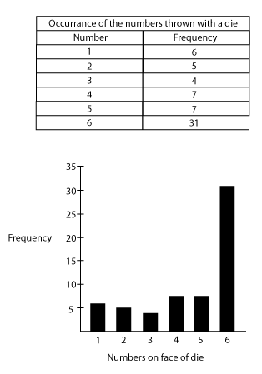
Try the following on your own, using the given frequency table. Remember to label the axes of the graph correctly.
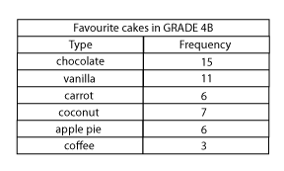
Use graph or grid paper to draw your bar graph on, as this makes it much easier to keep your scale consistent without having to go to any effort measuring.

Line graphs
A line graph is a graph made up of straight line segments joined together between points which are marked according to frequencies for the various categories under consideration. The line starts from the point marking the frequency of the first category and ends at the point marking the frequency of the last category.

MONTH | NUMBER OF EGGS SOLD
March | 135
April | 203
May | 178
June | 267
July | 250
August | 211

EGGS SOLD AT CORNER SPAR MARCH TO AUGUST
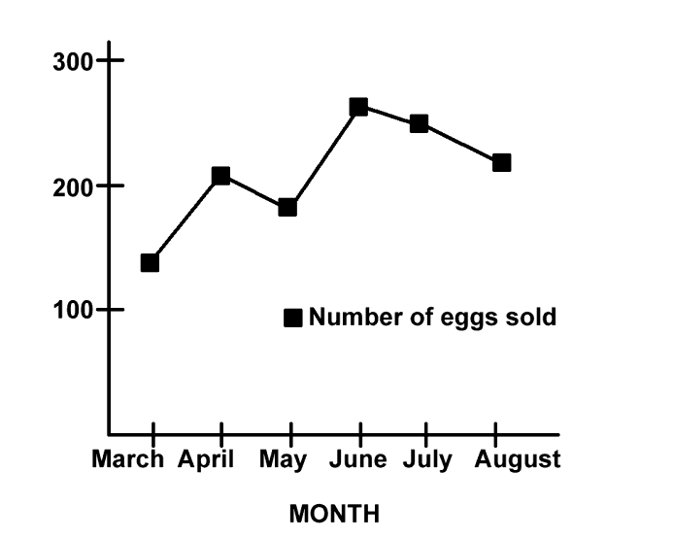
Now try the following: using the given frequency table, plot and draw a line graph representing the following information. Once again, use graph or grid paper.

ACTIVITY | AVERAGE RESULTS (%)
Test 1 | 56
Project | 68
Classwork | 65
Test 2 | 61
Oral | 63
Practical | 72

Pie charts
A pie chart is a circular representation, a bit like a pie which has been cut up into various sizes of slices. The different segments (the slices) represent the various relative frequencies of the data. The segments are usually labelled in percentages, and the total of all the percentages should be 100%.
The pie chart represents amounts spent by a family on various items in the month of September in a certain year. Take note of how the angle sizes of the segments are calculated.

ITEM | AMOUNT SPENT (Rands) | AMOUNT SPENT (%) | ANGLE SIZE OF SEGMENT
Food | 2000 | 40 | $\frac{40}{100}×360 =144$
Household | 1250 | 25 | $\frac{25}{100}×360 =90$
Recreation | 250 | 5 | $\frac{5}{100}×360=18$
Savings | 500 | 10 | $\frac{10}{100}×360=36$
Other | 1000 | 20 | $\frac{20}{100}×360 =72$

AMOUNTS SPENT FROM FAMILY BUDGET ON VARIOUS ITEMS
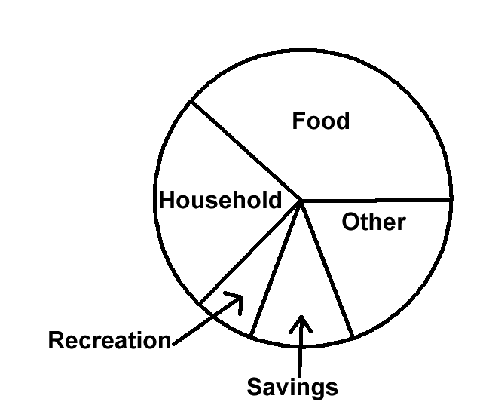

Pictograms
A pictogram looks and functions a bit like a bar graph does. The difference is that the bars are made up of little icons (pictures) which represent certain numbers of things as is indicated in the key, which must accompany the pictogram. The picture usually relates in some way to the data being represented. Below is a frequency table for the number of cars passing through various tollgates on 24 September in a certain year.
TOLL GATE | NUMER OF CARS PASSED THROUGH
Mooiriver | 40 500
Grassmere | 52 000
Kranskop | 43 000
Middelburg | 32 000
Kroonvaal | 40 500
Below is a pictogram representing the number of cars passing through the tollgates:
Tollgate
Mooiriver | 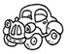 |  |  |  | 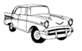
Grassmere |  |  |  |  |  | 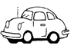
Kranskop
Middleburg
Kroonvaal

KEY
Represents 10 000 cars
Represents 1000 cars
Represents 500 cars
Now make up your own pictogram to represent the following information relating to numbers of aeroplanes taking off and landing at various airports in South African cities:

AIRPORT CITY | NUMBER OF PLANES PER DAY
JHB International | 240
Cape Town | 160
East London | 45
Durban | 130
Port Elizabeth | 115

Stem and leaf displays
Stem and leaf displays are not all that common, but they are useful for teachers and so they have been included in this module. They are also very simple to set up, as you will see. They function in a similar way to bar charts, excepting that the bars are made up of the actual data (recorded in a particular way) and no detail is lost since every item of data is used to draw up the bars.
In the table below are Grade 4F marks for Test 3, Term 3: (given as raw data from the class list )
88 | 67 | 94 | 72 | 77 | 64 | 77 | 83 | 75 | 85
87 | 63 | 74 | 80 | 95 | 81 | 84 | 81 | 81 | 70
84 | 63 | 68 | 71 | 52 | 56 | 74 | 69 | 65 | 48
56 | 41 | 82 | 65 | 70 | 69 | 81 | 53 | 40 | 64
63 | 69 | 78 | 96 | 45 | 75 | 58 | 59 | 52 | 54
First we draw the unsorted stem and leaf display.
The "stem" consists of the categories into which we group the data. In this case it will be the symbol ranges, such as 30-39, 40-49, 50-59, 60-69, etc. The "leaf" part is taken from the actual data, recording the units within the correct percentage range. Look carefully at the diagram.

Below is the unsorted stem and leaf display of Grade 4F marks for Test 3, Term 3:

4 | 8 1 0 5 (which came from scores 48, 41, 40, 45)
5 | 2 6 6 3 8 9 2 4
6 | 7 4 3 3 8 9 5 5 9 4 3 9
7 | 2 7 7 5 4 0 1 4 0 8 5
8 | 8 3 5 7 0 1 4 1 1 4 2 1
9 | 4 5 6
Now we sort the "leaf" detail, for easier analysis, to obtain a sorted display.
Below is the sorted stem and leaf display of marks obtained by Grade 4F, Test 3, Term 3:

4 | 0 1 5 8
5 | 2 2 3 4 6 6 8 9
6 | 3 3 3 4 4 5 5 7 8 9 9 9
7 | 0 0 1 2 4 4 5 5 7 7 8
8 | 0 1 1 1 1 2 3 4 4 5 7 8
9 | 4 5 6

Activity | Activity 5.3  Provide a sorted stem and leaf display for the following data:  Marks obtained by learners in Grade 7G, Test 6, Term 4.  51 64 56 53 72 45 42 46 57 41  51 63 50 45 64 53 48 47 34 48  39 52 36 55 58 46 50 39 48 44  57 47 54 41 36 54 46 44 57 52  49 77 70 49 41 60 54 69 53 65

Reflection | Earlier in this unit you were required to think of some other statistical research problems. For further exercises, calculate the necessary frequencies (etc.) and select a form of data representation from the above five forms to represent your data. Try to select a different form of data representation for each problem.

Measures of central tendency
In the previous two units, we have looked at basic statistical terminology and graphs. We have asked a few analytical questions, but not many. We need to begin interpreting information and asking questions that will lead to answers which give some insight into the information. One of the most simple yet frequently used ways of describing and analysing data is to use measures of central tendency. You will have heard of an average. This is one of the measures of central tendency. There are also two other ways in which statisticians discuss central tendency. What they are looking for is the score, or a number, which best describes all of the scores or data items. The average (or mean) is not always the ideal measure of central tendency, as you will see.
Mean or average
A single number, obtained through a mathematical calculation which is very often used to describe a set of data. To calculate the mean, we add all of the data items together and then divide that sum by the number of terms which we added.
You should now try to find the mean of 56, 34, 25, 38, 49, 80 and 73.
To do this you should add 56, 34, 25, 38, 49, 80 and 73 and then divide the sum of these numbers by 7.
The mean is not always useful as it does not give information about extreme scores – that is, the highest and lowest scores. Its value is influenced by the extremes and so often does not even reflect one actual recorded central score. We need to find a way of minimising the effect of extreme scores. The next two measures of central tendency minimise these extremes in different ways, but before we look at them, here are some exercises for you to try where you have to calculate the mean (or average). Note that statisticians use the word mean more often than they use the word average.
Activity | Activity 5.4  - Find the mean of the following numbers: 32, 24, 14, 18, 11, 10, 31  - If the rainfall in the Karoo was 12mm in January, 16mm in February, 80mm in March and in the remaining months of the year, no rainfall was recorded, calculate the mean rainfall for the Karoo for that year.  - Is this mean useful or misleading? Explain your answer.

Median
The median of a set of data is the value which divides the set into two equal numbered parts when the data has been ranked according to size. To rank data, we put it into ascending numeric order. If the number of scores is odd, then the central most score will be the median. If the number of scores is even, then the median will be the average of the two central most scores.
Study the following two examples.
Example | - Calculate the median of the following data:  2, 4, 9, 10, 13, 15, 19  The data has been ranked (it is in ascending numeric order), there are seven data items (scores) and so 10, which is the central most score (the one in the middle), is the median.  - Calculate the median of the following data:  12, 16, 80, 0, 0, 0, 0, 0, 0, 0, 0, 0  Rank the data: 0, 0, 0, 0, 0, 0, 0, 0, 0, 12, 16, 80.  There is an even number of data items. The two central most data items are both zero. The average of these two numbers is zero and so the median is zero. You can see through this example how the median eliminates the value of extreme scores. This is a better way of describing the Karoo rainfall, which was 0mm each month for most of the year.

Activity | Activity 5.5  - Calculate the median of 32, 24, 14, 18, 11, 10 and 31.  - Calculate the median of 50, 65, 35, 60, 40, 90, 50, 48, 63, 27, 68 and 53.

Mode
The mode is the score that appears the most often. It is the most common score. The mode is also a measure of central tendency which eliminates the effect of extremes. Not all sets of data have a mode, as there is not always one score which recurs. As educators, it is worth considering whether we should calculate modes more regularly than we do means of our class marks.

Reflection | Why do you think educators might find the mode a useful measure of central tendency?

Example | What is the mode of 1, 2, 2, 3, 3, 3, 3, 4 and 15?  The 3 appears more often than any other score and so it is the mode.  What is the mode of 2, 4, 9, 9, 10, 10, 13, 13, 13, 15, 19 and 19?  The 13 appears more often than any other score and so it is the mode.
Data may have two modes, in which case it is called bi-modal. We also talk about tri-modal data but we do not consider data with more than three modes worthy of discussion (too many repetitive scores do not have any particular significance).
Activity | Activity 5.6  - What is the mode of 1, 1, 2, 2, 3, 3, 3, 3, 4, 4, 4, 4, 5 and 6?  - What is the mode of 50, 65, 35, 60, 40, 90, 50, 48, 60, 27, 60 and 53?

Misleading statistics
Statistics can often be used to confuse the reader. You should not believe everything that you read, even if you are told that what you are reading has statistical backup. There could be faults or built-in flaws in the data. Some of the things that can go wrong or result in misleading statistics are the following:
The sample may not be representative of the population.

Reflection | When would the sample not be representative of the population?

The average does not always show extremes, and cannot be used to "summarise" information.

Reflection | Give an example of an average which is not a good descriptor of a set of data.

Graphical representation can be distorted to say what the presenter wants it to say. Scales may be chosen to exaggerate information, to make increases look large, or to make decreases look minimal, depending on the needs of the presenter.

Reflection | Think of an example where scale could be used to mislead an audience.  Who would often present data in this correct, but misleading manner?

Generalisations may extend beyond acceptable limits. As you are aware, statistical information is based on a sample – the generalisations made can apply only to the population whom this sample represents. For example, if you interview learners at your school only, you cannot make generalisations about the average South African learner based on these interviews.

Reflection | Think of another instance where a generalisation may have extended beyond acceptable limits.

It is not always clear how averages are calculated. The method should be made clear. Different orders of adding, particularly when many groups of data are involved, can alter the average. We need to be aware of this and ensure that the best manner of calculating the mean is chosen.
When you calculate term marks for a learner, could you find different averages by manipulating the marks differently? How would this happen?
Axes on graphs may not be clearly labelled. We have always said "label your axes clearly and correctly". Labels can be chosen to be purposefully misleading.
Reflection | Think of an example where labels on axes could mislead the reader of a graph.

Incorrect information might have been used. People can make mistakes – we need to be sure that no human errors have crept into the information which we are reading.

Statistics in the classroom
It is worthwhile to study and teach statistics for the following reasons:
- Learners will be able to formulate and solve problems that involve collecting, organising, describing and interpreting data.
- Learners will be able to produce their own statistics. In this way they will be producers instead of consumers of knowledge.
- Learners can develop an appreciation for statistical methods as a powerful means for communicating ideas and decision making.
- Learners will become aware of abuses of statistics and be less readily misled by data which is represented and used by salesmen, politicians, insurance agents, etc.
You need to present the learners with appropriate problems that require data collection. Look again at the problems that you formulated at the end of unit 1. Could you use any of them in your classroom?
It would also be useful to give your learners guidelines for data collection. You might point out to them some of the following things depending on the problem which has been set. Data should be found using the correct sample. If the population is large and a random sample is needed then a means of random selection should be used. One cannot estimate, guess, or make up data – actual data must be found. If special instruments are needed in the recording of the data, ensure that your learners know how to use these instruments and check that the instruments are in good working order.
Your learners might not know all of the graphical forms of representation. You should decide whether to instruct them as to which graph they should use, or you could give them a choice if you know that they already know a few graphs.

Reflection | What are the possible types of data representation that you have learned about?

Several mathematical concepts and skills are developed through data collection problems. The basic operations will be used and calculations with percentages will often be needed. Rounding off will have to be done.

Reflection | What other skills and concepts do you think could be developed through data collection problems?

Activity | Activity 5.7  - Here are questions that you could use to get learners to reflect on and interpret the data. Ask these questions of yourself too!  - Investigate the extreme data items.  - What do you find?  - What was the most or least popular score?  - What prediction could you make based on your findings?  - What is the average of your scores?  - What other questions do you think you could set for your learners?

Unit summary
In this unit you learned how to:
- Define and cite examples of key statistical concepts to be used in primary schools.
- Identify graphical forms of data representation.
- Differentiate between different measures of central tendency.
- Explain and cite examples of how statistics can be used in misleading ways.

Assessment

Statistics
This is an exercise for you to try out. You could also use it in your class, if it seems appropriate.
Find an article from a newspaper or magazine which includes a graphical form of data representation. Read the whole article and study the graph carefully before answering the following questions.
- What was the investigation about?
- How is the data represented?
- Is the presentation used to compare sets of data? If it is, then what is the comparison about?
- Is the data represented clearly? Give reasons for your answer. Explain any abuses of statistics which you feel are present, if there are any.
- Discuss the usefulness of the data.
- What technology (such as computers) do you think was used to collect the data?
- How will you use the knowledge you have obtained from this discussion to prepare a lesson on statistics for primary school learners?
- Will it be a useful exercise for the learners? Why?
- Where and at what level do you think data collection and interpretation should fit into the curriculum? Explain your answer.

Unit 6: Size and Measurement

Introduction
The topic of "size" or "measurement" is one in which we teach our learners how to measure. We need to ensure that our learners understand the measuring process fully. To do so, we need to look carefully at the concepts involved in measuring different physical characteristics of physical objects. It is most effective to teach for understanding and to teach skills. We must remember this in our teaching of measurement and facilitate it by giving a good conceptual grounding followed by sufficient practical exercises. In the first section of this unit we will look at the conceptual groundwork needed for the topic of measurement. In the second part of the unit we will investigate some of the conservation tests for measurement concepts. These give us a way to establish whether or not a learner has understood a certain measurement concept.
Upon completion of this unit you will be able to:
Outcomes | - Explain and cite examples of general measurement concepts as they may be used in the primary school to lay a foundation for measurement and calculations with measurements in later years.  - Apply the conservation tests of Piaget to establish a learner’s understanding of length, mass, area, volume and capacity.

Introduction to concepts and relevant ideas
Measurement involves quantifying physical characteristics. When we quantify we assign a numeric value to something. For example, we can say that a belt is 90cm long, or a cup holds 250ml, or the mass of the child is 34kg. We cannot quantify things to which we cannot assign a numeric value. For example, if the belt is black, we cannot say how black it is by giving a number ... black.
The topic of "money" traditionally falls into this part of the curriculum. Monetary value does not relate to physical characteristics. The monetary value which a coin has is assigned by the Central Reserve Bank and is printed on the coin. An old one cent coin and a new one cent coin will both be worth only one cent, even if the new coin is much smaller than the old one.
Children are aware of physical objects and their characteristics before they develop a concept of number and measurement. We must ensure that they fully understand the concepts (of volume or capacity for instance) of the things that we measure before we teach them how these are measured. This is because the way in which we assign numeric values to quantities is by comparing them to other quantities similar to themselves.
We can measure length in centimetres. For example, centimetres are just "little bits of length" which have been assigned an amount in terms of length and a name. In this unit, these concepts will be discussed in detail.

Reflection | Think about physical characteristics such as "motion", "time" and "surface".  How do these show themselves?  What characteristics do they display?

Some of the characteristics of physical objects have size or amount. We will call these physical quantities. Ultimately it is the physical quantities that we measure.
Think of some of the learners in your class.
- They have physical characteristics such as height and personality; they are made of substance; they are attracted by the force of gravity; they have eye colour, hair, a smile, length of hair, academic ability, artistic ability, sporting ability, shoe size; they take up space, and so on ...
- Some of these characteristics have size or amount – we call these physical quantities: length, mass, weight, volume ... (think to yourself which of the characteristics above relate to which of the quantities mentioned and write them as pairs in your notebooks).
- Ultimately we will be able to measure the characteristics which have “size”. For example,
  - How much space do they take up?
  - What is their volume?
  - What is their height?
  - What is their length from top to toe?
Remember this: we measure physical quantities not physical objects!
This must affect the language that we use in giving instructions and in phrasing questions. We must not say: "measure that boy" – we must specify which quantity relating to the boy must be measured, for example by saying "measure the height/mass/weight/volume/waistline ... of the boy".
Here then are some key questions relating to our teaching of size and measurement:
What do we measure? We measure the size (amount) of a physical quantity pertaining to a physical object. Length, for instance, may be great or small. We measure the length of an edge, not the edge itself. We may measure the mass of a ball. Then we would say "the mass of the ball = 3 kg". (We DO NOT say the ball = 3 kg.)
This shows the need for careful use of language in this topic of measurement, if we are to avoid speaking unclearly or ambiguously. We must say exactly what we mean, and give clear instructions to our learners, so that they will know to which quantities we are referring. We must not allow any confusion between a thing itself and its quantifiable characteristics.

Reflection | Write out a few clear instructions to learners, calling on them to measure some different physical quantities.

Is size absolute or relative?
Things which are absolute cannot be measured in degrees. They are, or they are not. They stand independent. Can you think of any absolutes? SIZE IS NOT ABSOLUTE. Size is relative and it is arrived at by comparison. We could say that something is long. What does this mean? How "long" is long? On the other hand, what is short? Perspectives differ, and different answers to these questions exist. That is what we mean by "size is relative" – it is given in relation to something else. It is this property of size that we use to quantify things. We compare them to "standard units" of themselves. Relativity of size is an idea we need to communicate to learners, even if in an intuitive way, without referring to relatives and absolutes!
Reflection | Use the example of the speed of a car compared to the speed of an aeroplane to discuss the idea of the relativity of size.

What is a standard unit?
We choose suitable units to measure with. The units must possess the property of that which we are trying to measure. For example, to measure the length of the edge of a desk we could use a pencil. Then a pencil = 1 unit, and the length of the desk would be … units. The pencil is then our chosen standard, its size taken to be 1.
Clearly, problems could arise if such a standard were used. More particularly, we call such a standard an ARBITRARY standard. There are certain accepted standard units used for measuring all of the physical quantities (for example, cm and mm). These are part of what we will teach when we teach about measurement.
Activity | Activity 6.1  - Name some other arbitrary units for length.  - Name some arbitrary units for area.  - Name some arbitrary units for mass.  - Name some arbitrary units for volume.

What is measuring?
Measuring is the process whereby we assign a number to a physical quantity by comparing it with a standard physical quantity, whose size we arbitrarily decide shall be the unit size (i.e. its size is taken to be one). In our teaching of measurement, we will use ARBITRARY standards to assist the formation of the concept we are teaching BEFORE we go on to teach the accepted standard units applicable to that which is being measured. It is vital that you understand the difference between arbitrary standards (used in concept development, such as the pencil, and your other examples, mentioned above) and internationally accepted standards (such as millimetres, litres, kilograms, newtons etc). You will use both in your teaching of size.

What are pure numbers and denominate numbers?
Pure numbers relate simply to the concept of number, of "how much", without concerning themselves with "of what". Denominate numbers specify what they are counting. "5" is a pure number, whereas "5 dogs" is a denominate number (dogs is the denomination). This is an important distinction for you to remember in the teaching of size, since all measurements will be denominate numbers.

Reflection | Why are all measurements given as denominate numbers?

You must teach your students to record their measurements correctly, giving the unit of measurement each time. (Arbitrary standards and standards will be used.) The denominate numbers (units) need to be properly used when it comes to computations involving these numbers, which we do teach, once the concepts and measuring skills have been taught.

Reflection | What is the key skill that learners need in order to perform operations correctly using denominate numbers?

Can a measurement be precise?
This is a similar question to "is size absolute?" NO. Because size is relative, a measurement will be as accurate/precise as the measuring instrument you are using allows you to be. If you use the same measuring instrument to measure two separate quantities, your measurements will have the same precision (if we take it that the same maximum error will occur in both instances) but the accuracy of the measurement will refer to the relative error possible in the measurement.
So these ideas relate to the errors involved in measuring. Precision relates to maximum error, while accuracy relates to relative error.
Here is an example of maximum error and relative error, which could occur if you were measuring amounts of liquid in a cylinder marked in ml. You find one amount of 15 ml and another amount of 60 ml – these measurements are equally precise since each time the maximum error is taken to be 0,5 ml. The second measurement is more accurate though, since the relative error in the first one is a $\frac{0.5}{15} =\frac{1}{30}$ error and in the second one is a $\frac{0.5}{60}=\frac{1}{120}$ error. The accuracy of the larger measurement is higher, since the error is relative to a larger measurement. This example shows you how the errors are computed – you will not be asked to do such computations yourself in the exams.
The precision measurements are affected by the instruments we use to measure. A measurement could be faulty if the instrument is faulty, or if an inappropriate instrument is used (such as using a 9 litre bucket to measure 250 ml). Human error can also lead to faulty measurements: simple errors of carelessness or incorrect reading of the instrument. Exact measurements are not possible, but a level of accuracy can be chosen which is appropriate to a situation. This is another of the elements in our teaching of size.

Reflection | Why do we say that no measurement can be exact?

What is indirect measurement?
Certain quantities can be measured directly. Think about the lengths of the edges of a piece of paper. A ruler can be used. Think about the volume of a cube. Unit cubes can be used. But what about the perimeter of a piece of paper which has been cut into an irregularly shaped region, or the volume of an irregularly shaped stone? They cannot be measured directly, but both of these measurements can be found by using a procedure we call indirect measurement. This requires a certain level of abstraction and a clear understanding of the concepts involved if it is to be grasped.
Let us look at the example of the perimeter of the irregular region. Remember that perimeter is the outside boundary of a shape. To measure the irregular perimeter we can use a piece of string. We take the string and lay it down carefully all along the border of our shape.
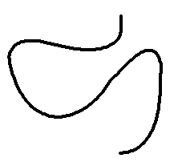 | 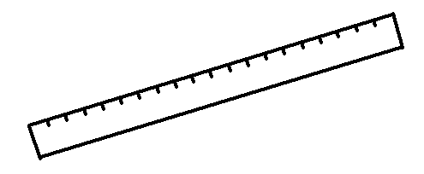
String | Measure length of ruler using string

Then we take the string away from the shape, straighten it up, and measure how long the perimeter of the shape is. This is indirect because we did not place the ruler along the boundary, because we could not. We used an indirect method which successfully enabled us to find out the perimeter.
To measure the volume of the stone we can submerge it in water and find out how much water it displaces.

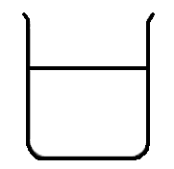 | 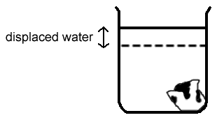
The amount of water displaced will equal the volume of the submerged stone.

Reflection | When you get into a bath, what happens to the level of the water in the bath?  Why do you think this happens?  What does this show you?

These ideas relate to the teaching of measurement in all grades. You need to understand and be able to apply all of them yourselves in order to teach the topic well to all grades. The topic of measurement should be taught using apparatus and practical exercises wherever possible. In the next section we look at some introductory exercises that can be used in the establishment of the size concepts.

Conservation of size – some practical exercises

Piaget's conservation tests
In the numeration module the psychologist Piaget was mentioned with respect to his ideas on conservation of number. In this topic of size and measurement we use his ideas again, to check our learners' readiness to proceed with the measurement of things such as length, mass, area, volume and capacity. As with number concept, we need to check that the learner has achieved conservation of these concepts before we can teach about their measurement. Conservation of the concept means that they have a clear understanding of the constancy or unchanging nature of length, mass, area, volume and capacity.
In this unit we will look at conservation tests for each of length, mass area, volume and capacity. As an example, in brief, before we look at each test separately, we could say that a child has achieved conservation of length once they are aware that the length of a piece of string remains the same, no matter if we lay it straight, curve it, roll it up or even cut it up. So the conservation tests are all designed to check whether the learners know that equal amounts remain equal even when their appearances have been distorted.
Why is it important that a child achieves conservation of length (for instance) before we teach the child to measure length?
Different children develop at different paces, and we cannot assume that "all 12 year olds" should have achieved conservation of the size concepts. It does not take very long to test for the conservation of these concepts, so we should always just take that little extra step to check for conservation before we proceed to teach the measurement of different amounts.
Piaget went further to say that if the learner was able to explain that the distorted amounts could be restored to their original appearance, then the learner has achieved the concept of reversibility.
Reflection | Give an example of what you think is meant by reversibility in relation to the concept of area.

Conservation of length
Length is the size of the edge (whether it be straight or curved). To check for conservation of length, show the learner two pieces of string that are the same length. Let her satisfy herself that they are the same length.
Now take one of the pieces of string and twist it around into a coil. Ask the learner if the two pieces of string are same length, or if their lengths are different (second display). You could then further distort the one piece of string by cutting it up into a few pieces (third display). Then ask again if the two displays contain the same length of string.

 | 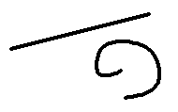 | 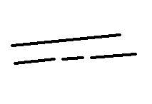
Initial display | Second display | Third display

If the child answers that the pieces of string are the same length, she has achieved conservation of length. If she answers no at any stage, then she is not sure that the length of the string remains the same even if its appearance is changed, and she has NOT achieved conservation of length.
If she can explain why they are still the same lengths in terms of restoring them to their original shapes, she has achieved reversibility of the concept of length.

Reflection | What other apparatus would be useful in tests for conservation of length?

Conservation of mass
Mass is the amount of matter which makes up an object. The density of the matter affects the mass of the object.

Reflection | In what way will density affect mass?

To test for conservation of mass, show the learner two balls of clay which have the same mass. Let her satisfy herself that they have the same mass.

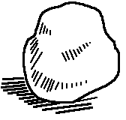

Now take one of the balls of clay and roll it into a thin sausage (second display). Ask the learner if the two pieces of clay have the same mass, or if their masses are different. You could then further distort the one lump of clay by cutting it up into a few pieces (third display). Then ask again if the two displays contain the same mass of clay.
 |  | 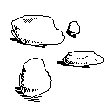
Initial display | Second display | Third display

If the child answers that the lumps of clay have the same mass, she has achieved conservation of mass. If she answers no at any stage, then she is not sure that the mass of the clay remains the same even if its appearance is changed, and she has NOT achieved conservation of mass.
If she can explain why they still have the same mass in terms of restoring them to their original shapes, she has achieved reversibility of the concept of mass.

Reflection | What other apparatus would be useful in tests for conservation of mass?

Conservation of area
Area is the amount of surface covered by a shape. To test for conservation of area, show the learner two postcards which are exactly the same. They have the same area. Let her satisfy herself that they have the same area.
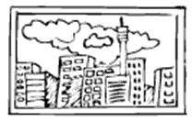
Now take one of the postcards and cut it into two parts (second display). Ask the learner if the two areas covered are still the same, or if they cover different areas. You could then further distort the one postcard by cutting it up into a few pieces (third display). Then ask again if the two displays still cover the same area.
 | 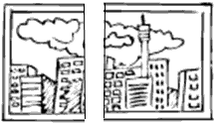 | 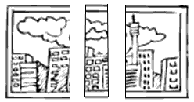
Initial display | Second display | Third display

Activity | Activity 6.2  - What will you ask the child as you show her the displays?  - How will you assess her responses in relation to conservation of area?  - If she can explain why they still have the same area in terms of restoring them to their original shapes, she has achieved reversibility of the concept of area.  - What other apparatus would be useful in tests for conservation of area?

Conservation of volume
Volume is the amount of space taken up. In testing for conservation of volume you could use the same balls of clay that you used in the tests for conservation of mass. Show the learner two balls of clay which have the same mass, and which therefore have the same volume. Let her satisfy herself that they have the same volume.
Activity | Activity 6.3  - What steps would you now go through to test the learner for conservation of volume? Explain in writing and illustrate your demonstrations for the initial, second and third displays.  - How would you know whether or not the child has achieved conservation of volume?  - How would you check whether or not the child has achieved reversibility of the concept of volume?  - What other apparatus would be useful in tests for conservation of volume?

Conservation of capacity
Capacity is the amount of space inside, or the ability of an item to hold something. You should have a good idea of the procedure for testing for conservation by now.

Reflection | Describe a test for the conservation of capacity, using the apparatus of your choice.  Draw sketches to add to your explanation.

Unit summary
In this unit you learned how to:
- Explain and cite examples of general measurement concepts as they may be used in the primary school to lay a foundation for measurement and calculations with measurements in later years.
- Apply the conservation tests of Piaget to establish a learner’s understanding of length, mass, area, volume and capacity.

Assessment
Measurement concepts
Give your own examples to explain the following:
- How do we measure?
- Why do we say that no measurement can be exact?
- What is indirect measurement?
- What is an arbitrary unit?
- Name five physical quantities that we can measure, and state one of the commonly used standard units for measuring each one.
- Describe a conservation test for capacity. Illustrate your explanation.

