New approaches to openness –

beyond Open Educational Resources

Gráinne Conole, University of Leicester, grainne.conole@le.ac.uk

Introduction
This chapter begins by discussing the characteristics of social and participatory media and considers their implications for learning, teaching and research. The notion of openness is then considered and different facets of open practices across learning, teaching and research are considered.

From Gutenberg to Zuckerberg
Naughton considers the nature of and implications of the Internet (Naughton 2012). He argues that we have seen a shift in terms of the Internet, a transition from the exotic (weird) to the mundane and that the Internet is now taken for granted and infiltrates all aspects of our lives. The result is that we are dependant on a network that (almost) no one understands. He referenced George Miller's paper from the fifties on the notion of 7 plus or minus 2, i.e. cognitively in short terms memory we can only hold this many chunks of information at any one idea. John took this idea and based his thoughts on the Internet and its implications around a small number of big ideas. These are summarised below.

Take the long view
We have seen a transformation of communication as a result of the use of the Internet. We tend to focus too much on the short terms trends, impact of fb, e-books etcc. Whereas we need to take a longer view and realise that the impact of emergent technologies is likely to be more transformative and disruptive that we can imagine. Think back to before the Internet – could anyone have predicted la emergent and la forma en que would infiltrate all aspects of our lives? In 1455 Gutenberg created a communication revolution with the development of the printing press, we are now, with the Internet, in the middle of another communication revolution. However, because we are in the middle of this revolution, we can't conceive or imagine how radical it is and the extent to which it will transform our practice.

The Web is not the Net
There is a common misconception that the Web and the Internet are synonymous, they are not. The Internet is the underlying infrastructure, the Web just one application. John drew on a railway metaphor, ie the tracks and signals of the railway are equivalent to the Internet, whereas the trains are one application, like the Web. John argued that the Internet is more important than anyone application that runs on it

For the Internet, disruption is a feature, not a bug
There are a number of architectural principles: i) there is no central ownership with the Internet, ii) the Internet is neutral towards the applications that run on it. The result is an explosion of 'permissionless innovation', ie there are endless possibilities and innovations. It is a global machine for springing surprises. John wrote a book in the mid-nineties about the history of the Internet and how it was developed. It's a great read and gives a real flavour of the people involved. He referred back to this in his talk. He said that the Internet was development because Tim Berners-Lee had a bad memory! He wanted to crear un sistema to be able to easily access his files and date. The result was the Web and the rest is history. Hence the Web is an example of a disruptive technology. Arguably everything we do now is shaped and affected by the web.
The second example of a distruptive technology John cited is Napster, a site which provided digitized music in the web. Within, 18 months it had 80 million users and almost all music that has ever been created was available from the site. Clearly howeverthere were copyright issues and eventually it was shut down. However it is interesting to see how sites like Napster and the power of the web for distributing materials has changed the nature of the industria de la música, music publishing houses are being seriously affected. For example Radiohead realizó uno de their albums available on the web and said that people could choose to download it for free or pay a donation. Interestingly many did pay for the album, introducing a new business model for buying content. An unpleasant example of a distruptive innovation is the rise of malware ormalicious software, which can invade computers piggy backing on commonly used programmes like Microsoft word. Second order surprises include Wikipedia andFacebook, which has 850 million users, of which about 50% check the site everyday.

Think ecology not just economics
Application of economics is not appropriate in a web-world dominated by abundance. John used the analogy of shifting fro a dessert to a rich biodiverse rainforest. The ecological metaphor is a useful metaphor or analytical framework for describing both the diversity of the activities occurring on the web, as well as the evolving dynamics ofdifferent tools.

Complexity is the new reality
The web provides an order of magnitude of complexity. Properties include: dense interconnectivity, highly dynamic, open, non-linear, extraordinary behavourial diversity and intrinsically unpredictable. Ashley's law of requisite variety is in effect and its implications. For a system to be viable it has to be able to handle the complexity of the environment.

The network is now the computer
In particular with the emergence of cloud computing the network is now the computer. Increasingly we use cloud-based tools and store data on the net rather than our computer. There are implications of this, for: users, the environment (cloud computer requires huge, energy hungry server farms, mainstream business, privacy, security and freedom.

The web is evolving
We pages are not static; they are made up on the fly. Arguably there is a web geology consisting of: Web 1.0 (1991-2003), Web 2.0 (2004-present), Web 3.0 (2012?), Web 4.0 (?).

Copyright and copyleft
Our intellectual property regime no longer makes any sense. Analogue copyright is about different, degenerative, costly, and hard to disseminate, whereas digital copyright is perfecta, easy, cheap, and easy to disseminate. Our IP was development in an analogue era; we are trying to apply it to a world dominated by a technology for which copying is an integral and essential part.

Orwell vs. Huxley – bookends of our future?
Naughton concluded by reflecting on the future and whether it will be an Orwellian oHuxleyian vision. Where is all this taking us? Is it the end of the techno-Utopia, ie the fantasy that the internet would change everything for the better. Orwell feared that we would be destroyed by the things that we fear – examples might include Government surveillance, ie the power to monitor everything that you do on the net. Huxley argued that it is easier to control people by making them happy rather that through fear. Are we controlled by our love and addiction to technologies?

Social and participatory media
New technologies have a unique set of characteristics: networked, distributed, peer reviewed and open, they are complex, dynamic and evolving – we co-evolve with the technologies, appropriating them into our everyday practice. Your network and who you connect with defines you. A number of useful reports give summaries of these new technologies and their implications for education, for example the NSF-commissioned report on Cyberlearning (Borgeman, Abelson et al. 2008), a review of Web 2.0 tools in HE (Conole and Alevizou 2010) and more recently the IPTS report on digital competences (Ala-Mutka 2012). Digital competence is defined as:
The confident, critical and creative use of ICT to achieve goals related to work, employability, learning, leisure, inclusion and/or participation in society (Ala-Mutka, 2012:1).

The IPTS report describes how new technologies are being used for work, leisure and communication, arguing that the network is the key. It also recognizes that new technologies are more participatory, promoting more open practices. However it also states that the digital divide (Norris 2001; Warschauer 2004) is still present – arguably narrower, but deeper. What are the implications of not being part of the net, when increasingly more and more information is only available online? The report outlines a digital competency framework, consisting of three aspects: information skills and knowledge, advanced skills and knowledge and attitudes. These can be broken down into the following components:
- Operational skills and knowledge – referring to the technical aspects of digital tools, such as using a mouse or manipulating particular tools.
- Medium-related skills and knowledge – referring to understanding how to purposefully and safely use specific media.
- Communication and collaboration – referring to the ability to effectively express and communicate, as well as understanding the potential and limitations of different media.
- Information management – referring to navigating the wealth of information available online and making informed judgments about which resources are appropriate in different contexts.
- Learning and problem solving – referring to acquisition of the skills needed to harness digital tools for learning, working and problem solving.
- Meaningful participation – referring to the ability to find and participate in digital activities, either individually or in collaboration with others.
- Intercultural and collaborative attitude – referring to the ability to be culturally sensitive and able to participate with others from different cultures in an appropriate manner.
- Critical attitude – referring to the ability to critically reflect on the quality and provenance of things they find on the net.
- Creative attitude – referring to the ability to adopt creative practices in harnessing technologies for learning, work and leisure activities, encouraging open and participatory approaches.
- Responsible attitude – referring to the need to be aware of the visibility and potential consequences of one’s own digital activities.
- Autonomous attitude – referring to the fact that the internet is not structured and has no rules or monitoring. Each individual needs to be clear of their own objectives and find and choose appropriate tools and resources to meet these objectives.

The report also lists the benefits in terms of: social, health, economic, civic, cultural and societal. Although it also points out that there are a number of implications/risks, in terms of: personal safety and privacy, the need to act responsibly, ethically and legally, understanding the nature of digital media and issues associated with inequalities.

It is interesting to reflect on how each of use are using these technologies and which are core to our daily practice. Beyond email and general use of the web, there as a number of core tools I now use on a regular basis. I have been blogging now since 2007. Blogging has become an important part of my professional practice, I blog about ideas in development, reports on conferences and project meetings, pointers to interesting research and articles and draft publications. Blogging now sits as a step towards completed publications such as articles or books, and is a good way of working up ideas and getting comments from the wider research community. I use Endnote to manage references and have bow built up a comprehensive library of references. Diigo and ScoopIt are useful as a means of keeping track of interesting links on the web. In terms of social networking I am an active user of Twitter with more than 4,000 followers. I also use facebook extensively, the later for more social interactions and the former for more professional activities. Clearly such tools have enormous potential, but not everyone is comfortable with blogging or participating in social networks. Indeed many have very strong views against these technologies, arguing that they are trivial and raise a host of ethical and privacy issues.

New social and participatory media have shifted the use of the web from an essentially static medium to one that is more participatory and interactive. Conole and Alevizou (2010) carried out a review of web 2.0 technologies and identified the following types of tools: media sharing tools (such as YouTube, Flickr and Slideshare), presentation tools (such as blogs, PowerPoint and Prezi), messaging tools, recommendation systems, virtual worlds and games, syndication tools, social bookmarking and curation tools (such as delicious, diigo and scoop.it), social networking tools (such as Facebook and LinkedIn). Collaborative editing tools (such as wikis and google docs), and mash ups.

They also indentified a set of characteristics of these technologies, which makes them distinct from the original characteristics of the web. These are:

- Peer critiquing – the ability to openingly comment on other people’s work. For example, many academics now keep research blogs and use these as a means of reflecting on their digital scholarship, development of research ideas and disseminating research and research projects. Many course now require students to keep blogs either as a space to reflect on their learning and consider how the course materials relate to their own professional practice or as a collective cohort blog to for example, collate relevant course materials and resources.
- User-generated content – there are now many different tools for creating content (ranging from those which are primarily text-based, through to rich multimedia and interactive tools), meaning that the web is no longer a passive media for consumption, but an active, participatory, productive media. Sites such as YouTube, Flickr and Slideshare facilitate sharing of user-generated content and the embedded code functionality means that content can be simultaneously distributed via a range of communication channels.
- Collective aggregation - which refers both to the ways in which individuals can collate and order content to suit their individual needs and personal preferences, as well as the ways individual content can be enriched collectively by the wider community (via tagging, multiple distribution, etc.). Social bookmarking, tag clouds and associated visualisation tools, tagging, RSS feeds and embedding code all enable collective aggregation to occur.
- Community formation – the connectivity and rich communicative channels now available on the web provides an environment for supporting a rich diversity of digital communities. Boundaries of professional and personal identity are eroding and the notion of tightly knit Communities of Practice (Wenger 1998) are giving way to a spectrum of communities from individualistic spaces through loosely bound and often transitory collectives, through to more established and clearly defined communities. Dron and Anderson (2007) identified three types of communities: collectives, networks and groups in social networking for e-learning.
- Digital personas – individuals need to define their digital identity and how they ‘present’ themselves across these spaces (Solove 2004). The avatars we choose to represent ourselves, the style of language we use and the degree to which we are open (both professionally and personally) within these spaces, give a collective picture of how we are viewed by others.

We are seeing evidence that these characteristics are beginning to have a significant impact on practice for learning, teaching and research.

Aspects of openness
This section will describe the types of open practices that are resulting from the use of social and participatory media and will consider their implications for learning, teaching and research. Conole (Forthcoming) argues that there are five principals associated with openness. Firstly, adopting more open practices will mean being ‘open’ in as broad a sense as possible. Secondly, it supports and enables dialogue around learning and teaching ideas and designs. Thirdly, one of the key aspects of social and participatory media is their ability to harness the power of collective aggregation, which has the potential to provide cumulative benefit for both learners and teachers. Fourthly, there are evident benefits of sharing good practice and peer critiquing, which supports good digital scholarship(Weller 2011). Fifthly, adopting open practices will encourage serendipity, lateral thinking and new perspectives, hence fostering creativity.

Open Educational Resources
The concept of Open Educational Resources (OER) and the associated movement have now been around for just over ten years. The vision behind them is the idea that education is a right and should be freely available. In addition, OER are seen as a means of fostering innovation in learning and teaching, by provide examples of good practice and enabling teachers to repurpose existing OER. Organisations such as UNESCO and the Hewlett foundation have been actively promoting the concept, along with funding for the development of OER repositories. There are now many OER repositories worldwide. Despite this investment, research shows that OER are not being used extensively by learners and teachers, and that they are certainly not being repurposed. As a result recent research has been exploring the notion of Open Educational Practices (OEP), i.e. investigating how OER are being created, repurposed and managed. This chapter will focus on the work that was carried out as part of the OPAL initiative, which defined the concept of OEP and identified associated dimensions of OEP, which were translated into a set of guidelines to enable individuals to benchmark their existing OER activities, along with the development of a vision and implementation plan for future work on OER. It will then broaden the discussion to consider how social and participatory media enable more open practices and what the implications of this are for learning, teaching and research.

Definitions and characteristics of OER
OECD define OER as:

Digitised materials offered freely and openly for educators, students and self- learners to use and reuse for teaching, learning and research (OECD, 2007, p. 133).

Whereas, the Hewlett foundation define them as:

Teaching, learning, and research resources that reside in the public domain or have been released under an intellectual property license that permits their free use or re-purposing by others.

The Cape Town Open Education Declaration bought together international OER experts to clarify the nature of the OER movement and to create a vision for the future. In particular it argues that the OER movement is based on:
The belief that everyone should have the freedom to use, customize, improve and redistribute educational resources without constraint.
The main characteristics of OER are: free access to resources ‘enabled by information and communication technologies’ and with a clear ‘non-commercial purpose” (UNESCO 2002, p.24). OER are intended to make ‘high-quality educational material freely available worldwide in many languages’ (Keller and Mossink, 2009).
The OLCOS Roadmap identified three core attributes of OER. Firstly, that access to open content (including metadata) is provided free of charge for educational institutions, content services, and the end-users such as teachers, students and lifelong learners. Secondly, that the content is licensed for re-use in educational activities, favourably, without restrictions, to modify, combine and repurpose the content; consequently, that the content should be designed for easy re-use in that open content standards and formats should be employed. Thirdly, that open source systems/tools software should be used, along with open Application Programming Intefaces (APIs).

The OPAL initiative
The International Council for Open and Distance Education (ICDE) define Open Educational Practices (OEP) as:

Practices which support the production, use and reuse of high quality open educational resources (OER) through institutional policies, which promote innovative pedagogical models, and respect and empower learners as co-producers on their lifelong learning path. OEP address the whole OER governance community: policy makers, managers and administrators of organisations, educational professionals and learners.

The OPAL initiative analysed 60 case studies of OER initiatives and from these extracted a set of OEP dimensions. Initially eight were identified, which were:

- Strategy and policy in the use of OER
- Barriers and enablers (success factors)
- Tools and tool practices
- Innovations
- Quality assurance models
- Partnership models
- Skills development and support
- Business models/sustainability strategies

Four target stakeholder groups were also identified: learners, teachers, institutional managers and policy makers. The dimensions were validated through an extensive consultation process, via a series of real and virtual events that culminated in an expert policy forum at UNESCO headquarters in Paris in November 2010. As a result, the initial eight dimensions were distilled into four dimensions:

- Strategies and policies
- Barriers and enabling (success) factors
- Tools and tool practices
- Skills development and support

These were then translated into a set of guidelines for OER stakeholders, which enabled individuals and institutions to: i) articulate and benchmark their existing OEP and ii) creation of a vision and implementation plan for their ongoing OER activities.

Step 1: Positioning organisations:

- To what extent are you using and repurposing OER in your organisation?
- Do you have a process for creating OER in your organisation?
- To what extent are you sharing OER and OEP in your organisation?
- To what extent is your organisation working with open learning architectures?

Step 2: Creating a vision of openness and a strategy for OEP:

- Is a vision for OEP shared across the organisation?
- Are OEP included in existing strategies and policies?
- Are OEP embedded in the organisation’s business models?
- Are you involved in any partnerships in relation to OEP?
- Are OEP perceived as relevant across the organisation?

Step 3: Implementing and promoting OEP:

- Are there any intellectual property rights and copyright regulations for OER?
- Does a motivational framework for OEP exist?
- Are OEP used?
- Do you have tools to support the sharing and exchange of information about OEP?
- Do you apply any quality concepts to OEP?
- What level of knowledge and skills do teachers have in relation to open learning architectures and OEP?
- What level of digital literacy skills do learners and teachers have in your organisation?
- Are support mechanisms in place to support the development of OEP?

For each question there is a series of indicators indicating the level of maturity of OEP that institutions can benchmark themselves against to determine their OER maturity. An interactive ‘OEP metromap’ of the guidelines was also produce (Figure 1). This enables learners, educational practitioners, organisational leaders and policy makers to plot their trajectory on the path to OEP. This begins with assessing their current position, through the creation of a vision for openness and a strategy for open practices, and finally to implementing and promoting OEP.

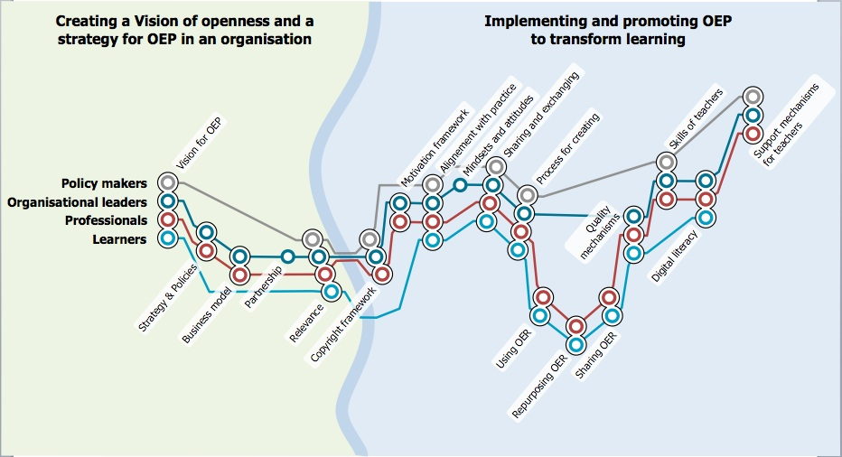
Figure 1: The OPAL OEP metromap

Open courses and delivery
With a shift towards more open learning and teaching practices the boundaries between traditional, formal educational contexts and other non-formal and informal learning contexts are changing. What would adopting a more open approach to delivery mean? What will be the impact of mixing institutional systems with freely available services? How can a more dialogic engagement for learning and teaching be fostered, starting as part of the design process described above, through to delivery and assessment? How might the vision of the use of Open Educational Resources be realised?

In the last few years a number of open courses have been developed. Siemens, Downes and Cormier were the original creators of these and refer to them as Massive Open Online Courses (MOOCs). Participation in these courses is free, as are the expertise of the facilitators and presenters and the associated course materials. Siemens argues that MOOCs are predicated on the notion of connectivism (Siemens 2005) and have a number of key characteristics. The first is aggregation. A Mooc provides a starting point to access a massive amount of content on a particular topic that has been produced in different places online. These are then aggregated as newsletters or as a web page, which are then made available to participants and are updated on a regular basis. This is in contrast to traditional courses, where the content is usually prepared in advance. The second is remixing, that is, linking and adapting materials created within the course with each other and with materials elsewhere. A key feature of a MOOC is that participants are active creators of resources for the course. The third is re-purposing of aggregated and remixed materials to suit the goals of each participant. There is now preferred learning pathway through the material and each participant creates their own personalised learning environment. The fourth is the notion of ‘feeding forward’, i.e. the sharing of re-purposed ideas and content with other participants and the rest of the world. Siemens and Downes argued that a central feature of a MOOC is a shift from a traditional, closed group, highly structured course, where students are dependent on tutors, to open networks of self-directed learners. Downes sees the design of the course - as a distributed connectivist-model course - created a structure in which the course contents formed a cluster of resources around a subject-area, rather than a linear set of materials that all students must follow. Participants create their own materials, selecting only those they found interesting and relevant, thereby creating a personal perspective on the materials (Downes 2007). McAuley et al. (2010) argue that MOOCs integrate the connectivity of social networking, the facilitation of an acknowledged expert and a collection of freely accessible online resources. MOOCs build on the active engagement of several hundred to several thousand learners who self-organize their participation according to learning goals, prior knowledge and skills, and common interests.

Mackness et al. (2010) report on one of the first MOOCs, CCK08 ‘Connectivism and Connective Knowledge’, lead by George Siemens and Stephen Downes. Over 2000 people registered for the course and of these 24 obtained a credit for completing the course. They argue that autonomy, diversity, openness, connectedness and interactivity are key characteristics of MOOCs, but they present paradoxes in that although they enable participants to interact with the course in a variety of ways, as a result participants can feel confused and overwhelmed by the sheer amount of materials and the diversity of ways in which they can participate with their fellow learners and the course facilitators. Mackness et al. conclude that the openness and diversity of the course meant that the usual support and moderation offered to learners was not possible in the MOOC and many participants stated that their experience of the course was not possible, this translated into a significant drop off of the number interacting in the course over time.

Open Design
Traditionally, the design of courses or learning interventions by teachers was based on their prior experiences and implicit beliefs. A new learning design methodology has emerged which aims to help teachers adopt a more design-based, rigorous and explicit approach. Initiated through the OU Learning Design Initiative, a set of conceptual design representations have been created, which enable teachers to think beyond content to the activities and the learner experience.

These can acts as mediating artefacts to help guide the teacher in their design practice and in particular enable them to make informed choices on the use of different technologies that are pedagogically effective. In addition, the created design representations can then act as mediating artefacts,(Conole 2008) which can be shared and discussed with others.

The design presentations are deceptively simple, but are based on empirical evidence and good pedagogy. A range of representations has been developed. Conole (Forthcoming) describes the rational behind the development of this learning design methodology and more detail on the design representations.

The resources and activities created as part of OULDI have recently been combined with the work that Leicester University has developed through a series of Carpe Diem learning design workshops. These in particular focus around e-tivities and the creation of a learning design storyboard. The result is a new 7Cs of design and delivery framework (Armellini 2012; Conole 2012). This consists of the following elements:

- Conceptualise – which initiates the design process and consists of imagine, design and prepare.
- Capture – which covers the ways in which search engines, OER repositories and social bookmarking can be used to find and collate relevant resources and activities.
- Create – which covers both the creation of content and activities.
- Communicate – which covers how to moderate asynchronous and synchronous forums
- Collaborate – which considers how tools like wikis, voicethread, pirate pad can be used to foster collaboration and how to work in virtual teams.
- Consider – which covers the ways in which tools such as blogs, e-portfolios and Multiple Choice Questions (MCQs) can be used to promote reflection and different forms of assessment.
- Consolidate - where the participants take stock of what they have learnt and create an action plan for taking things forward.

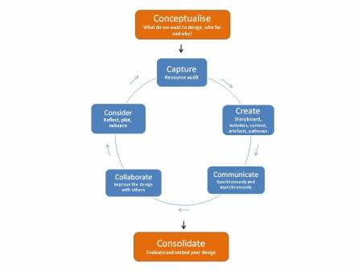
Figure 2: The 7Cs of design and delivery framework
As an illustration of this approach, four design representations are described here, namely: the course features, the course map, the pedagogy profile and the storyboard. The examples given are associated with the design of a module on learning design, as part of a new Master’s in learning innovation, which is being developed at the university of Leicester.

The first conceptual representation is the course features. With this view the designer is able to decide on a set of features that characterise the course, which they group into three: those features that are definitely included, those that are there to some extent and those that are not included. The designer is given a template in the tool linoit, which lists a suggested set of course features. They can then move this around and group into the three categories. It is also possible to add their own additional features. Figure 3 shows the course features view for the learning design module. In the first group are characteristics such as practice-based, inclusion of e-tivities and podcasts, theory-based and empirically based, collaborative, etc. Features that figure to a minor extent include reflective blogs,, student autonomy and rapid feedback. Those features that are not involved include: one-to-one tutorials, exams and portfolios.

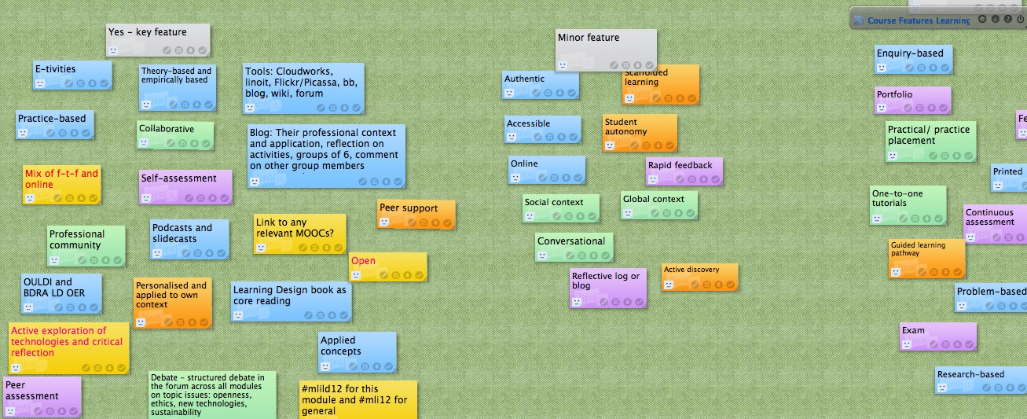
Figure 3: The course features view for a learning design module
The colour of the virtual sticky notes is significant and relates to the second of the conceptual design representations, the course view map. This consists of four aspects: the type of guidance and support offered on the course or module (orange), the type of content and activities that the students will engage with, the communication and collaborative opportunities (green) and evidence of reflection and demonstration (purple). Figure 4 shows the completed course map view for the learning design module. For each of the four categories the designer lists what tools and resources students will be using, as well as describing the roles and responsibilities of those involved and any prerequisites or special features that are promoted. So for example in this case there are links to relevant course resources and guidance in the guidance and support box, podcasts and slidecasts are listed under the content and activities box, along with links to relevant resources such as the OULDI site. They are expected to keep a reflective blog, which is an important element of reflection and demonstration. Finally, for communication and collaboration, they will use a variety of tools including a forum, a social networking site, Cloudworks and the linoit tool. The template for the course map view is available online.

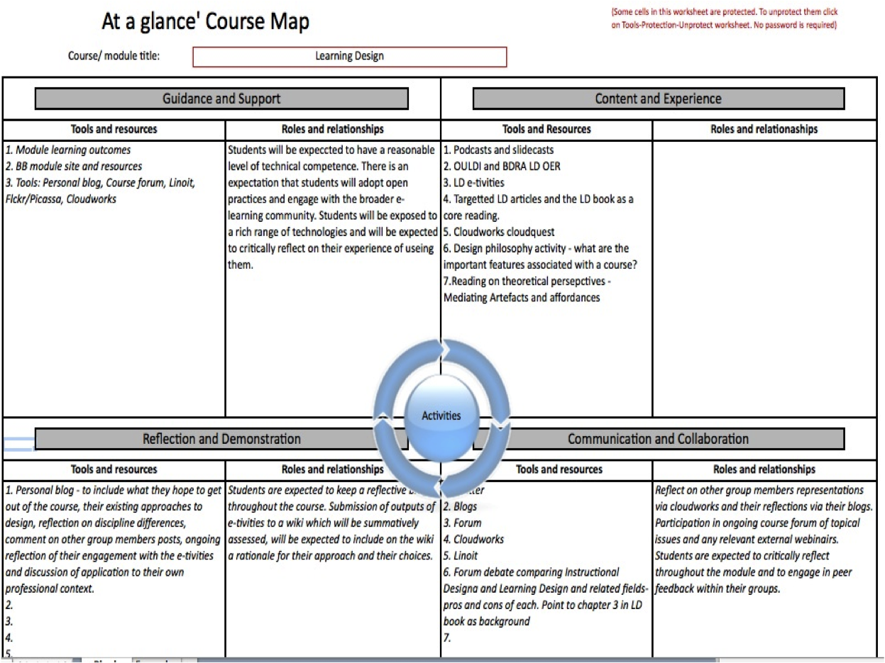
Figure 4: The course map view for the learning design module
The next conceptual design view is the pedagogy or activity profile. This enables the designer to ascertain the percentage of time learners will spend on different kinds of activities, which are characterised as follows:

- Assimilative – reading, viewing or listening to something
- Information handling – for example manipulating data in a spreadsheet
- Communication – with peer learners and tutors
- Productive – creating an artefact of some kind
- Experiential – practising or mimicking
- Adaptive – modelling or simulation
In addition, they calculate the amount of time spent on assessment activities. Figure 5 shows the activity profile for the learning design module. The students are engaging in a lot of assimilative, information handing and communication activities, and not much in terms of experiential or adaptive activities. This view was created using an online widget.

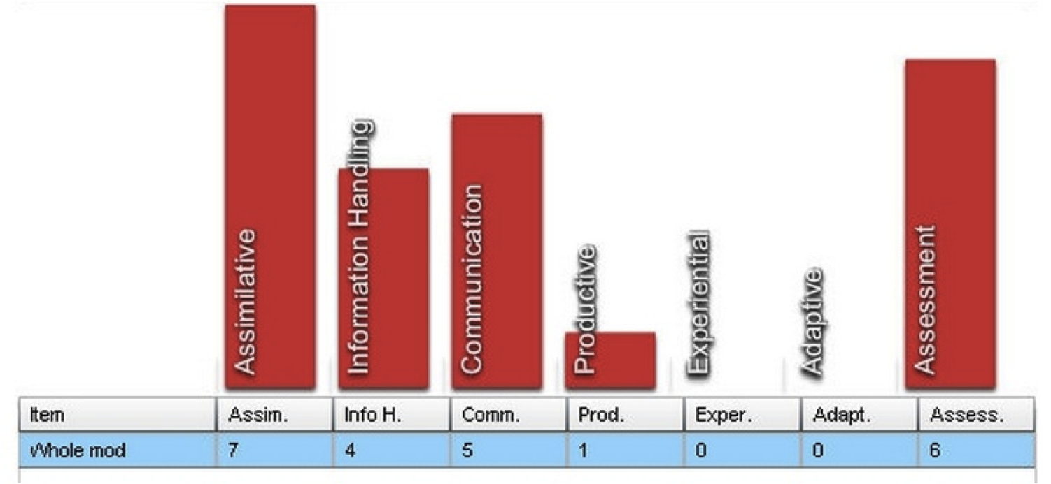
Figure 5: The activity profile for the learning design module
The final view is the storyboard, which helps the designer put everything together. This includes mapping learning outcomes to activities and assessment elements, as well as a temporal sequence of activities and associated tools and resources. Figure 6 shows the storyboard for the learning design module. On the right hand side in blue are listed the 5 learning outcomes associated with the module. Topics for each week are listed in pink, e-tivities in green and assessments in yellow.

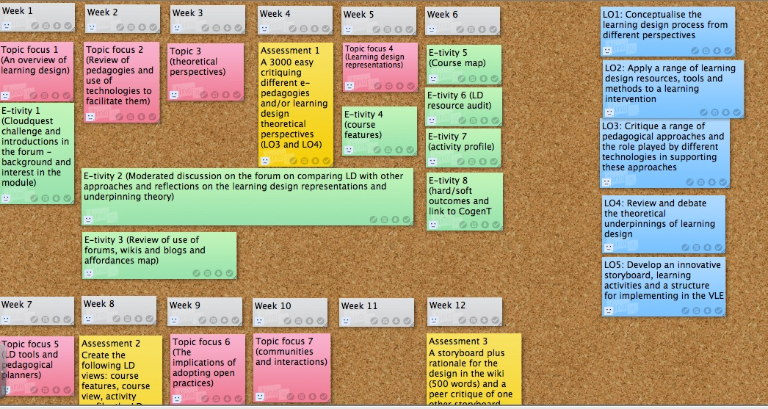
Figure 6: The storyboard for the learning design module
More information and additional resources are available from the OULDI website, and from the 7Cs OER resources website. Use of such learning design conceptual views potentially opens up and makes explicit the design process. Conole (Forthcoming) poses the following question: what would a vision of a truly open approach to design mean; beyond Open Educational Resources (OER) towards a more explicit representation and sharing of the whole design process? And puts forward the following future scenario for how an open design approach might be realised:
A newly formed course team brainstorm their initial ideas for the course, using visual representations, which make conveying and sharing the essence of their ideas easy. They share this openingly with others, through appropriate Web 2.0 technologies. They invite comments – from other subject experts, from past students, and from potential students. They use the Web 2.0 spaces to continue to develop and refine their ideas; incorporating peer critique and leaving a visible audit trail of their design decisions and the development process.

Open Scholarship
New technologies have tremendous potential in terms of supporting more open digital scholarship practices. Borgeman argues that the Internet can facilitate distributed, data- and information-intensive collaborative research (Borgeman 2007; Borgeman 2007). Researchers now have access to literature in their field, a growing body of research data, and sophisticated research tools and services. They can collaborate with others around the world. Social and participatory media offer new mechanisms for researchers to communicate and disseminate their research and to engage in peer review and reflection. Borgeman argues that communication is the essence of scholarship, which is inherently a social activity, involving a wide range of public and private interactions within a research community (Borgeman, 2007a, Borgeman, 2007b). She argues that publication is part of a continuous cycle of reading, writing, discussing, searching, investigating, presenting, submitting and reviewing research. Today’s technologies means that researchers can communicate in a variety of ways with others and at a much larger scale than was possible before.

Weller (2011) refers to Boyer’s definition of scholarship (Boyer 1990) in terms of discovery (i.e. the creation of new knowledge), integration (i.e. creating knowledge across disciplines), application (i.e. engagement with the wider community beyond education) and teaching (i.e. applying research to teaching). He lists three characteristics of digital scholarship: i) openness and sharing as a default, ii) digital and iii) networked, a global network of peers to generate and share ideas (Weller, 2011). He considers what these means for digital scholarship. He argues that new technologies mean we can do things differently. He cites the way in which Twitter, for example, can enable researchers to have access to immediate expertise.

Pearce et al. (2010) argue that the concept of openness is synergistic with the use of new technologies. They cite Anderson (2009) and Burton (2009), who suggest that as a result of new technologies the notion of the ‘open scholar’ has emerged. In terms of discovery, they argue that new technologies offer new ways of generating, analysing and discussing research data. In terms of integration, there is a tension between the fast, open access mechanism now possible for publishing research outputs with the traditional publication vehicles of journals and books. There are a number of issues with the latter: the long lag times between submission and publication, increasing subscription costs, and a growing resentment amongst academics in terms of them sending their own writing to the publishers for free and then having to buy them back. Also in terms of free reviewing and editing. New technology-mediated dissemination channels offer powerful opportunities for researchers to convey their ideas to a wider audience; through for example blogs, Twitter, YouTube and SlideShare. Finally, Pearce et al. (2010), consider teaching and in particular open education, which is where they argue we are seeing the biggest impact of new technologies and open approaches. They argue that the digitisation of learning and teaching resources means that they can easily be reproduced and shared on a global scale. They cite initiatives such as MIT’s OpenCourseWare project and the Open University’s OpenLearn repositories as examples. They conclude by reflecting on the ways in which technologies are changing practice and in particular scholarship:

It is clear from the foregoing discussion that new technologies hold out very real possibilities for change across all facets of scholarship. In each case these afford the possibility for new more open ways of working. Academic work has always contained a significant element of collaboration within academia but now it is increasingly easy to collaborate with more colleagues within but also beyond the academy and for the varied products of these collaborations to be available to the widest possible audience.

Open research
In the last decade the Open Access Movement (OEM) has emerged as a means of academics making their research outputs publicly available, rather than in closed publishing journals. This raises the issue of what will be the impact of the Open Access Movement (Harnard et al., 2004) for learning, teaching and research? How can we capitalise on the rich research data, which is now being made available on a global scale? How can we move to adopting more open approaches to research, open bibliographies and citations, making research outputs available online? What would it mean to make raw data publicly available for others to interrogate and use?

Social and participatory media offer researchers a plethora of ways in which they can communicate and disseminate their research and to engage in peer review and reflection. There are also a wealth of ways in which knowledge can be represented and co-constructed using these tools. This is resulting in a change in the way researchers work and collaborate. With the range of collaborative tools now available, researchers can more easily participate in global research networked, co-creating ideas in collaborative tools (such as wikis or google docs), participating in synchronous conferencing sessions (such as google hangouts or Learning Management System tools such as Blackboard collaborate). In addition, many researchers now keep research blogs and use social networking tools like Twitter and Facebook to communicate their research ideas and writings. Conole (2007) argues that blogging sits alongside, and complements, other forms of communication, namely academic papers and conferences and suggests the following as functions for these:

- Academic papers: reporting of findings against a particular narrative, grounded in the literature and related work; style – formal, academic-speak.
- Conference presentations: awareness raising of the work, posing questions and issues about the work, style – entertaining, visual, informal.
- Blogging: snippets of the work, reflecting on particular issues, style – short, informal, reflective.

These open research practices are challenging traditional publishing vehicles. Why put your content in a closed proprietary journal where only a handful of people might read it, when you can make it available openingly on a blog and through social media make it available to thousands of people?

There has been a drive in the last decade or so to making research outputs publically available through institutional research repositories. In the nineties Steven Harnard lead the development of the open access movement, aimed at making academic outputs freely available (Harnard and Hey 1995; Hey 1997; Hey 2004). As part of this the EPrints software was produced, as a vehicle for creating open access archives of research output. Since then more and more institutions have set up similar repositories and these are now recognised as important mechanisms for valuing and showcasing institutions’ intellectual assets. Reflecting on the evaluation of the implementation and uptake of ePrints at Southampton University, Hey (2004) concludes that:

To achieve a sustainable repository we need to integrate our archive within the natural processes of its staff and students; this gives them the bonus of a reusable resource. While immediate visibility leading to increased research impact is the primary aim of Stevan Harnard's campaigns, we can achieve this by example, practice and cooperation.

Digital literacies
Jenkins (2009) lists eleven digital literacies which he argues are needed to be part of what he terms today’s participatory culture. They are: play, collective intelligence, judgment, transmedia navigation, networking, negotiation, distributed intelligence, multitasking, appropriation, simulation and performance. I would add a twelfth, creativity. This list demonstrates the complex way in which we interact in digital networks and represents the set of skills we need to be able to harness and appropriate the affordances (Gibson 1979; Conole and Dyke 2004) of social and participatory media. Together these digital literacies enable us to find and manage information and to communicate and collaborate with others. These media offer rich multimedia representations and there are a plethora of ways in which we can interact and connect with others.

The statistics associated with social media are truly profound as this short YouTube video demonstrates. The figures are truly staggering; for example if facebook was a country it would be the third latest in the world, Clearly social and participatory media have significant potential to foster new approaches to learning, teaching and research, however to be used effectively we, as learners, teachers and researchers, need to develop a complex new set of digital literacy skills.

A body of research has emerged in recent years around the competences and skills needed to effectively use and interact with new technologies. Terms such as digital literacies, information literacies, 21st Century literacies have been used; each with subtle nuances and different foci (Jenkins, 2009; Goodfellow and Lea, 2007l Lankshear and Knobel, 2006). Literacies can be seen as a continuum from instrumental skills to productive competence and efficiency. Lankshear and Knobel (2006) adopt a ocio-cultural view of digital literacy and argue that they are the set of social practices and meaning making associated with interacting with digital tools. Fundamentally the central issue is about the literacies needed to communicate with others and make sense of information (and more specifically how to do this in a digital context).

Returning now to Jenkins list of digital literacies, I will now expand on some of the terms and demonstrate how they are realised through use of digital technologies. The web is complex and vast, transmedia navigation is a key skill needed to be able to navigate this terrain. Arguably any information we want is available on the web, but finding appropriate resources and tools and evaluating their relevance is non-trivial. A good example of this is how learners are interacting in a new form of open and free courses or MOOCs (Massive Open Online Courses) as described earlier. Thousands sign up to participate in these courses, although the number that complete them and get any form of accreditation is much larger. Evaluation of users’ perceptions of these MOOCs indicates that many get lost easily and find participation far from satisfying. The sheer size and complexity of MOOCs is overwhelming; with each learner having to define their own personal learning environment and learning pathway through the course.

Distributed cognition was defined by Saloman in the nineties (Salomon 1993). In essence this refers to the fact that our cognition is distributed between ours brains and our digital environment. We increasingly use a range of information management tools to collate and aggregate relevant resources; we harness our social networks in terms of getting answers to queries and participating in ongoing discourses and shared co-construction of knowledge. We are no longer isolated individuals, but part of a global distributed network of others and tools.

Anyone who has seen children interacting with technologies, will agree that play is an essential digital literacies. Children don’t reach for a manual when starting to use a new tool, they simply start to interact and explore, learning through playing. This active, learner-centred approach is a key facet of new technologies and increasingly the interfaces of new tools is intuitive and self-explanatory. Play can be mapped to particular pedagogical approaches such as role-play and problem solving. A nice example comes from the SWIFT project, which has developed a virtual Genetics laboratory in SecondLife. To orientate new users to the environment there is a maze that the users walk through, there are various activities they complete along the way and by the end of the maze they are equipped with the basic skills needed to interact in the environment. They can then enter and interact with the Genetics laboratory, playing with instruments, taking measurements and learning basic laboratory techniques.

Networking is also a key characteristic of new technologies; the nature of your network and how you use it defines who you are in digital space. A network is only meaningful if you are connected to those with shared interests. Furthermore, it is important to give as well as take, active participation is expected. Within each social network we interact with others in a variety of ways. With both facebook and Twitter, I have a number of ‘onion layers’ of those I interact with; there is an inner core of friends and followers who I interact with on a regular basis and then a set of layers of users I interact with less and less, and finally those that follow me, but that I don’t follow.

Collective intelligence refers to the ability to be able to work with others to solve a problem or aggregate a set of resources. A good example of harnessing the distributed collective intelligence of the network is the work being done as part of the iSpot project, on promoting scientific awareness. It is an online site where users can share and discuss sightings of fauna and flora around the UK.

The site is an excellent example of collective intelligence (Lévy 1997) and harnessing the power of the masses, as it enables the capture of sightings of flora and fauna from around the country on changes in patterns of nature that can then feed into ongoing research activities. Once registered, a user can add an observation to the Website, suggest an identification or see if anyone else can identify the species. Users can also contribute to existing observations and there is a forum to stimulate debate. Despite the overall look and feel of the site being focussed on ‘fun’, it feeds directly into real research activities and also enables users to transfer their informal learning/interests into more formal educational offerings if they wish. Evaluation of the use of the site indicates that it is increasing general interest in science and is also resulting in users then signing up for more formal courses (Clow and Makriyannis 2011). The data collected on the site is being used by scientists and is providing them with a rich understanding of the changing ecology across the UK. Galaxy Zoo is a similar initiative. The general public are invited to help astronomy researchers to categorise and chart the galaxy, using thousands of images derived from the Hubble Space Telescope Archive.

Performance is about how you present yourself on the web and the ways in which you interact with others. We each need to find our own digital identity and voice. Some choose to adopt a very professional stance, others are more light hearted. We each need to decide the degree to which we want to adopt open practices; what we share with others and the extent to which we share our experiences and activities. I have a very open approach to the way in which I interact with others online, I share my ideas and thoughts as I go, pass on interesting ideas and references received from other, ask queries of the network, as well as providing useful feedback to others. For researchers social and participatory media offer a rich set of ways in which we can communicate and discuss our research outputs. They extend the reach of the audience; a paper in a closed journal might at best be read by a handful of readers, in contrast a blog post can be virally communicated to thousands in a nano second. There are now a number of new tools emerging that can provide some indication of an individual’s research impact. For example Google Citation Indicator gives the H factor for an individual, along with a ranked listing of their most cited papers. It is evident to me that these kinds of tools will be used increasingly within institutions in terms of promotion and at a national level in terms of things like research assessment exercises. Whether you like it or not, your digital footprint is there and is being monitored.

In addition to Jenkin’s list of digital literacies I would add creativity as an important skills in harnesses the potential of new technologies. Creativity derives from the Latin word, ‘crea’, which means to create or make something. It is about creating something new (either a physical artefact or a concept) that is both novel and valuable. It is about the ability to transcend traditional ideas, rules, partners, and relationships, and create meaningful new ideas, forms, methods and interpretations. I would argue that it is an essential skill to deal with today’s complex, fast and changing society. Technologies over a wealth of ways to foster creativity; they provide a range of ways for us to communicate and collaborate with others. There are four aspects to creativity:

- Process: mechanisms needed for creative thinking
- Product: measuring creativity in people
- Person: general intellectual habits (openness, ideas of ideation, autonomy, expertise, exploratory and behavioural)
- Place: best circumstances to enable creativity to flourish.

There are five stages of creativity:

- Preparation: identifying the problem
- Incubation: internalisation of the problem
- Intimation: getting a feeling for a solution
- Illumination: creativity burst forth
- Verification: idea is consciously verified, elaborated and applied

Wall (2009) argues that creativity is the new technology:
I think that the 21st century will be a century of creativity in the same way that the 20th was of technology. Much of the creativity, interestingly enough, will be based on the tools provided by technology, especially tools that allow us to create, collaborate and communicate.

Along with the eleven digital literacies identified by Jenkins et al., creativity enables learners to connect and co-constructive meaning in rich authentic environments. iCreaNet (http://www.imv.au.dk/icreanet/) is a global research network of educational researchers focusing on support for development of creative skills in higher educational contexts. Fundamental to the work of the group is seeing ICT resources and environments as crucial means of providing the flexibility and diversity necessary to facilitate creative development and to bring education up to speed with the way that citizens of the earth learn and enhance themselves in the contexts of their daily lives in the 21st century.

Conclusion
This post has explored the types of digital literacies that are needed by learners, teachers and researchers to exploit the potential of new technologies and to enable them to connect and communicate in a plethora of ways. The digital literacies needed are far more participatory and interactive, the distributed network of others that we connect with is as important as the way in which we access and use information on the Internet. We each need to identify our own digital voice and identity, how we want to be perceived and how we want to interact with others. Used effectively social and participatory media offer a powerful means of us communicating and developing our ideas.

Conclusion
This chapter has considered how new social and participatory media are resulting in changes in practice in learning, teaching and research. In particular it has critiqued the notion of openness and open practices and considered this concept against different aspects of learning, teaching and research. These new media are challenging existing educational practices and structures. New business models are emerging as a result. In particular in a world where content and expertise is increasingly free and easily accessible, what is the role of traditional educational institutions?

Acknowledgements
My thanks to members of the OU and Leicester who were involved in creating the learning design resources described in this chapter. In particular I would like to thank Rebecca Galley and Juliette Culver from the OU and Gabi Witthaus, Ming Niew and Alejandro Armellini from Leicester. Funding is gratefully acknowledge from the JISC and the EU.

References
Ala-Mutka, K. (2012). Mapping digital competence: towards a conceptual understanding. IPTS report. Saville.
Anderson, T. (2009). Keynote presentation. ALT-C, Manchester.
Armellini, A. (2012). "Carpe Diem: the 7Cs of design and delivery." Beyond Distance Research Alliance blog http://beyonddistance.wordpress.com/2012/02/07/carpe-diem-the-7cs-of-design-and-delivery/.
Borgeman, C. (2007). The continuity of scholarly communication. Scholarship in the digital age: information, infrastructure and the Internet. Hong Kong, SNP Best-set Typersetter Ltd.
Borgeman, C. (2007). Scholarship in the digital age: information, infrastructure and the internet. Hong Kong, SNP Best-set Typesetter Ltd.
Borgeman, C., H. Abelson, et al. (2008). Fostering learning in the networked world: the cyberlearning opportunity and challenge, Report of the NSF task force on cyberlearning.
Boyer, E. L. (1990). Scholarship reconsidered: priorities of the professoriate. Princeton, NJ, Carnegie Foundation for the Advancement of Teaching.
Burton, G. (2009). The open scholar. Academic Evolution.
Clow, D. and E. Makriyannis (2011). iSpot analysed: participatoiry learning and reputation. 1st learning analytics and knowledge conference, Banff, Canada.
Conole, G. (2007). The nature of academic discourse. E4innovation: e-learning innovation: research, evaluation, practice and policy.
Conole, G. (2008). Capturing practice, the role of mediating artefacts in learning design. In L. Lockyer, S. Bennett, S. Agostinhi and B. Harper Handbook of learning designs and learning objects, IGI Global.
Conole, G. (2012). "The 7Cs of design and delivery." e4innovation.com http://e4innovation.com/?p=520.
Conole, G. (Forthcoming). Designing for learning in an open world. New York, Springer.
Conole, G. (Forthcoming). The nature of openness. Designing for learning in an open world. New York, Srpinger.
Conole, G. and P. Alevizou (2010) "Review of the use(s) of Web 2.0 in Higher Education."
Conole, G. and M. Dyke (2004). "What are the affordances of information and communication technologies?" ALT-J 12(2): 113-124 %U http://oro.open.ac.uk/6981/.
Downes, S. (2007). An introduction to connective knowledge. Media, Knowledge & Education - Exploring new Spaces, Relations and Dynamics in Digital Media Ecologies, Vienna.
Dron, J. and T. Anderson (2007). Collectives, networks and groups in social software for e-Learning. Proceedings of World Conference on E-Learning in Corporate, Government, Healthcare, and Higher Education Quebec. Retrieved Feb. 16: 2008.
Gibson, J. J. (1979). The ecological approach to visual perception. Hillsdale, New Jersey, Lawrence Erlbaum Associated.
Harnard, S. and J. Hey (1995). Esoteric knowledge, the scholar and scholarly publishing on the Net. London, Library Association Publishing.
Hey, J. (1997). "E-Journals for research: the user perspective." Serials 10(1): 65-68.
Hey, J. (2004). Targetting academic research with Southampton's institutional repository. Ariadne. 40.
Jenkins, H. (2009). Confronting the challenges of participatory culture: Media education for the 21st century, Mit Pr.
Lankshear, C. and M. Knobel (2006). "Digital literacies: Policy, pedagogy and research considerations for education." Nordic Journal of digital literacy 1(1): 226.
Lévy, P. (1997). Collective intelligence: Mankind's emerging world in cyberspace, Perseus Books Cambridge, MA, USA.
Mackness, J., S. Mak, et al. (2010). The ideals and reality of participating in a MOOC. 7th International Conference of Networked Learning, Lancaster Lancaster Univeristy.
McAuley, A., B. Stewart, et al. (2010). The MOOC model for digital practice.
Naughton, J. (2012). From Gutenberg to Zuckerberg, what you really need to know about the internet.
Norris, P. (2001). Digital divide: Civic engagement, information poverty, and the Internet worldwide, Cambridge Univ Pr.
Pearce, N., M. Weller, et al. (2010). Digital scholarship considered: how new technologies could transform academic work Education. 16.
Salomon, G., Ed. (1993). Distributed cognitions - pyschological and educational considerations. Cambridge, Cambridge University Press.
Siemens, G. (2005). "Connectivism: A learning theory for the digital age." International journal of instructional technology and distance learning 2(1): 3–10.
Solove, D. J. (2004). The digital person - technology and privacy in the information age. New York, New University Press.
Wall, R. (2009). "Creativity is the new technology." Zen and the art of being rob http://robwall.ca/2009/03/10/creativity-is-the-new-technology/.
Warschauer, M. (2004). Technology and social inclusion: Rethinking the digital divide, the MIT Press.
Weller, M. (2011). The digital scholar - how technology is changing academic practice. London, Bloomsbury Academic.
Wenger, E. (1998). Communities of Practice. Learning, Meaning and Identity. Learning in Doing: Social, Cognitive, and Computational Perspectives, Cambridge University Press, Cambridge.

http://e4innovation.com
youtube.com
http://www.flickr.com/
http://www.slideshare.net/
Definition on the Hewlett Website, http://www.hewlett.org/Programs/Education/OER/
http://www.capetowndeclaration.org/
http://www.open.ac.uk/blogs/OULDI/
http://linoit.com
http://cloudworks.ac.uk
http://www.tinyurl.com/ouldi-coursemap
http://cloudworks.ac.uk/cloud/view/2459
http://www.open.ac.uk/blogs/OULDI/
http://www2.le.ac.uk/projects/oer/oers/beyond-distance-research-alliance/7cs-workshop-resources
http://ocw.mit.edu/index.htm
http://openlearn.open.ac.uk
http://www.eprints.org/
http://www.youtube.com/watch?v=0eUeL3n7fDs
http://www2.le.ac.uk/projects/swift/
http://ispot.org.uk
http://www.galaxyzoo.org/
www.icde.org/en/resources/open_educational_quality_inititiative/definition_of_open_educational_practices
www.oer-quality.org

